Activity Diagram
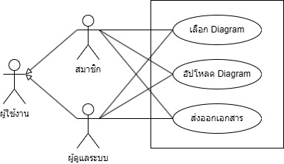
Reference (from Use Case diagram): UC-01 (สมาชิก)
Activity ID: ACT-01
Activity name: กหฟ
Preliminary activity (Activity ID):
Description:
กหฟ

Swimlanes: No
Lane No. | Type | Caption | Reference ID
L-01 | User | User Lane | REF-01
Start point:
From Lane No.:
To Action: A-01
End Points:
Lane No. | From |  | End State
Lane No. | Type | No. | End State
 | Action |  | Success
Note: End State – Success / Unsuccess
Action list:
Action No. | Lane No. | Caption | Description
A-01 |  | กหฟ | กหฟ
Decision Node List:
Decision No.: D-01
Lane No.: | From Action No.: A-01
Caption: กหฟ
Criteria:
Criteria No. | Detail | Refer ID
C-01 | กหฟ | A-01

