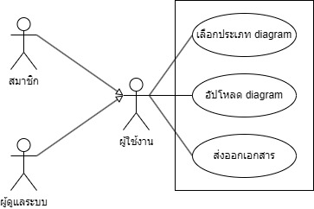

Class Description
Reference: UC-01
Class ID: CL-01
Class name: test01
Class Type: Class
Description:
ทดสอบ 1

Extend to (Class): None |  | Class ID: undefined
Implement for (Interface):
Class ID | Class name

The list of Attributes:
Attribute name | Encapsulation | Data type | Data size | Description | Example/Format
x1 | private | String | 10 | x1 | x1

Methods:
Type: Method
Encapsulation: public
Method name: y1
Description:
y1
Return:
Value | Data type | Description
z1 | void | z1
List of parameters
parameter name | Data type | Description
a1 | String | a1
Reference: UC-02
Class ID: CL-02
Class name: zxc
Class Type: Class
Description:
zxc

Extend to (Class): test01 |  | Class ID: CL-01
Implement for (Interface):
Class ID | Class name
CL-01 | test01

The list of Attributes:
Attribute name | Encapsulation | Data type | Data size | Description | Example/Format
zxc | private | String | 10 | zxc | zxc

Methods:
Type: Method
Encapsulation: public
Method name: zxc
Description:
zxc
Return:
Value | Data type | Description
zxc | void | zxc
List of parameters
parameter name | Data type | Description
zxc | String | zxc

