Activity Diagram
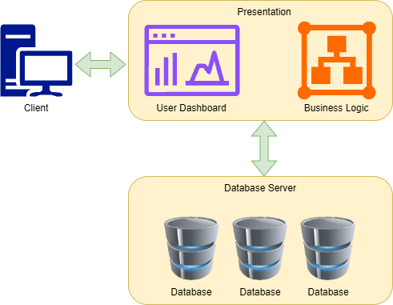
Reference (from Use Case diagram): UC-01
Activity ID: ACT-01
Activity name: Test Activity
Preliminary activity (Activity ID): -
Description:
Test Desc

Swimlanes: No
Lane No. | Type | Caption | Reference ID
Start point:
From Lane No.: -
To Action: -
End Points:
Lane No. | From |  | End State
Lane No. | Type | No. | End State
Note: End State – Success / Unsuccess
Action list:
Action No. | Lane No. | Caption | Description
Decision Node List:

