Requirement Specification Document for

“SwarmPulse”

v0.2

# Revision History

|  |  |  |  |
| --- | --- | --- | --- |
| Version | Author | Date | Comment |
| 0.1 | Prasad P. Pulikal | 21.07.2015 | Initial Draft |
| 0.2 | Prasad P. Pulikal | 05.10.2015 | After initial Implementation |
|  |  |  |  |
|  |  |  |  |
|  |  |  |  |
|  |  |  |  |

# Index

1. Introduction 4

1.1. Purpose 4

1.2. Project Scope 4

2. System Requirements 5

3. Functional Requirements 6

3.1. Mobile Client 6

3.2. Heat map visualization Website 7

4. Non Functional Requirements 8

4.1. Security / Privacy 8

4.2. Performance 8

4.3. Internationalization 9

4.4. Target Platforms 9

5. Proposed System 10

5.1. System Description 10

5.2. System Architecture 11

6. UI / Wireframes 12

6.1. Swarmpulse Mobile Client - Wireframes 12

6.2. Swarmpulse website - Wireframes 14

7. Issues 16

7.1. GPS / Location coordinates and Privacy Concerns: 16

7.2. Possible erroneous sensor values: 17

# Introduction

## Purpose

This document describes the software requirements for a project titled the “**Pulse”**. The basic requirement for the project is to build a heat map of Light and Noise levels for specific cities/regions by using Mobile Phone Sensors.

This project will be developed as part of the NervousNet platform being developed by the Team at the Department of Humanities and Social Sciences (D-GESS) at ETH Zurich.

## Project Scope

* Use an application stored within their mobile phones to collect data related to noise and light levels at a specific moment and location.
* To be able to view a heat map (from a browser/website) that shows a collective representation of the data so collected by the Mobile Applications.

The initial requirement is to build the mobile client for the IPhone and Android devices.

Additional features discussed during the meeting included features like:

* Awards, flags and recognition for users who allow the data to be collected.
* Inviting new users.

# System Requirements

Based on the discussion with the client, Tages-Anzeiger wants to provide their readers with a system that can show the Light, Noise levels for specific regions/ location at any given point in time. More sensors can be added for later versions of the system.

Functionalities required:

* Collection of data for Light, Noise levels from a specific location.
* Allow for detailed and customized visualization of this collected data.

For the above functionalities it is important to collect sensor data. Existing methods within the Nervousnet platform for collecting data is with Mobile Phone sensors and Bluetooth beacons. For building a heat map of Light and Sensor values within a city, mobile phones seem to be the best alternative. Bluetooth beacons have limited reach and hence we will require a large number of beacons strategically located within the city. A hybrid of Mobile phone sensors and Bluetooth beacons would also be a good option. However, since the Client has a large number of readers of their newspaper and magazine, it is planned that they will promote the mobile application through which we can collect the sensor data.

For visualization purpose, the best way would be to visualize the data through a web browser. Alternatively, such visualization can be also display within the mobile application.

# Functional Requirements

## Mobile Client

|  |  |
| --- | --- |
| ID | Requirement |
| TA-M-F-01 | Application should show the Terms of Usage and Privacy statement to the user and allow them to accept it before proceeding to use the application. Terms of Usage should only be shown and accepted after the first install and after possible version updates. |
| TA-M-F-02 | During first time start of application should prompt user for enabling sensors from the Settings Screen. By default Sensor settings should be disabled and only be enable after the user changes the settings. |
| TA-M-F-03 | Users can enable or disable collection of sensor data for individual sensors from the Settings screen. |
| TA-M-F-04 | Users can select the time interval at which sensor data is collected from the Settings screen. |
| TA-M-F-05 | Users have the option of uploading sensor data manually, i.e. at the press of a button. This feature is required when the user disables automatic collection of sensor data from the Settings Screen |
| TA-M-F-06 | Users should be able to view the current sensor reading for individual sensors (e.g. Light and Sound) |
| TA-M-F-07 | Users should be able to read the “Terms of Usage” statement from the About screen |
| TA-M-F-08 | Users should also have access to a FAQ section, related to working of the Application and data collected including the format and values collected with examples. |
| TA-M-F-09 | Once sensor data collection is enabled, application should run in the background and collect data at time intervals as specified in the settings and upload it to the server in the specific format. |
| TA-M-F-10 | Sensor data that is uploaded to the server has to be encrypted and cannot include any data that can identify a device or user uniquely. |

## Heat map visualization Website

|  |  |
| --- | --- |
| ID | Requirement |
| TA-W-F-01 | At the start, the website should make a request to the server for data specific to the default sensor and region and display it accordingly on a geographical map of the region. |
| TA-W-F-02 | Sensor data should be mapped over a geographical map and show the concentration and collective levels of sensor values at specific locations accurately |
| TA-W-F-03 | Collective levels of Sensor data should be represented appropriately using different colors and color indication should be shown to the user. E.g. location with higher levels of sound can be represented in shades of red color. Refer to figure 9 for exact implementation. |
| TA-W-F-04 | User should have the option of switching between sensors to visualize related heat maps. |
| TA-W-F-05 | User should have the option of manually refreshing the heat maps or allow for an Auto Refresh at specific time intervals. |
| TA-W-F-06 | User should be allowed to zoom in and zoom out within a map to get a better perspective of the region / city / country etc. |

# Non Functional Requirements

## Security / Privacy

The transfer of data collected from sensors from the Mobile Client and Server has to be encrypted. Data encryption functionality is part of the Nervousnet project on which this project is based.

In terms of privacy, it is highly important that the data collected from sensor is not linked to any particular mobile device or user. End-user privacy is of great importance for the Nervousnet platform and hence the Swarmpulse Project is expected to follow similar parameters when it comes to user privacy. Additionally end-users of the mobile client should have complete control over when and how sensor data is collected from their personal phones.

## Performance

**Mobile Client:** The performance of the Mobile client is expected to be highly responsive to user inputs. The collection of sensor data from mobile phones should not interfere with other functionalities or performance of the mobile handset. It is expected that the collection of sensor data occurs in a background thread or service and does not interfere with the functioning of a device. The system has to be designed in a way such that the battery life of the mobile phone is not affected due to the constant collection of Sensor data. The minimum interval of data collection has to be optimally designed for allowing collection of data and also keeping in mind various other factors like the battery life of the mobile device and the load on the server.

**Website:** The website used for visualization of noise and light maps with sensor data, is expected to show near real time data. Keeping in mind the performance of the server and collection of sensor data from mobile clients, it is expected that such visualizations can have a delay of a few seconds.

## Internationalization

In the initial phase the Swarmpulse mobile application and website front-end is to be developed for English speaking users. In addition keeping in mind the target users for the system, i.e. the German language speaking users, it would also be useful to support the mobile application and website in the German language. German language support can be supported in later versions of the Mobile Application and website.

|  |  |  |
| --- | --- | --- |
| System Component | Languages Supported | |
| Version 1.0 | Version 2.0 |
| Mobile Client | English | German |
| Website | English | German |

## Target Platforms

|  |  |
| --- | --- |
| System Component | Target Platforms |
| Mobile Client | IPhone 5 and greater, Android Phones supporting OS 4.x, 5.x |
| Website | Firefox, Safari, Chrome. Including Mobile platforms. |

# Proposed System

## System Description

The architecture of the proposed system is based on the Nervousnet project, which already has components that allows user to collect, store and upload data for research purposes using their Mobile phones.

|  |  |
| --- | --- |
| Figure 1: Proposed System Components | The three components that are part of the proposed system are (*Figure 1*):   1. **Swarmpulse Mobile Client / Application:** specifically designed and customized with Tages-Anzeiger branding and Nervousnet logos. This application will be designed to allow users to collect and upload multiple sensor data to the NervousNet Servers. Additionally users will have multiple privacy options and settings, which will only allow data to be collected when the user wishes to without compromising his privacy. 2. **Server:** The Server component will be used as a backend to store the collected sensor values and to process the so collected data for visualization purposes. 3. **Swarmpulse Website:** The website will be designed to allow user to visualize noise and light levels in various location on a map. The visualization will be based on heat maps according to concentration and levels of noise/light on a map. The website will also provide various customization option of zoom in/out on a map; select specific times of the hour, days of the week, month etc. |

## System Architecture

This Swarmpulse project is designed as extension of the Nervousnet project and hence most of the features and components will use the existing functionalities being developed as part of the Nervousnet project. The Swarmpulse mobile application and server will be developed over the NervousNet mobile and backend platform. The front-end or the Swarmpulsewebsite that will allow the users to visualize this data, will have to be developed anew. A complete architecture is shown in figure 2.

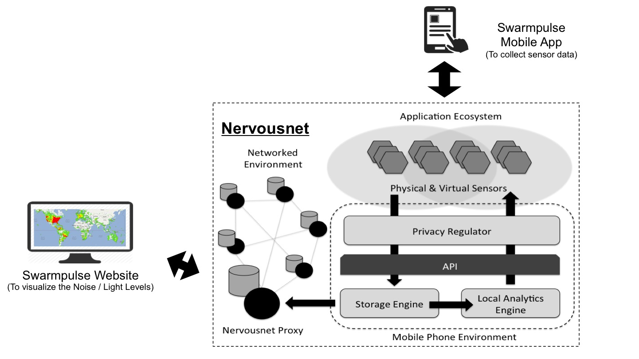

Figure 2: Architecture of the Proposed System

# UI / Wireframes

## Swarmpulse Mobile Client - Wireframes

|  |  |  |
| --- | --- | --- |
| Figure 3: Splash Screen | Figure 4: Home Screen | Figure 5: Settings Screen |
| Figure 6: Light Sensor Reading Screen |  | Figure 7: Sound Sensor Reading Screen |

## Swarmpulse website - Wireframes

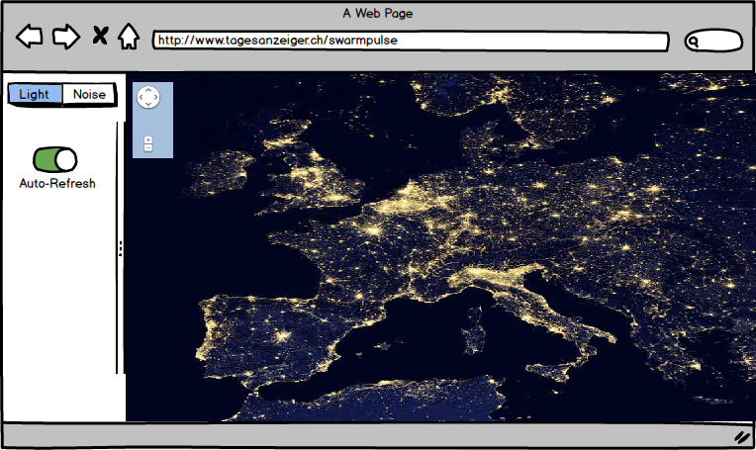

Figure 8: Website showing Light sensor heatmap

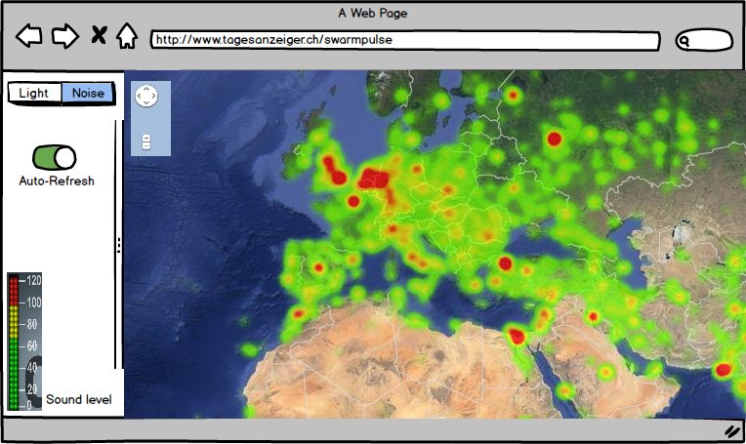

Figure 9: Website showing Sound Sensor values

# Issues

## GPS / Location coordinates and Privacy Concerns:

|  |  |
| --- | --- |
| **Description** | This project is based on the Nervousnet project, and Nervousnet has always been designed keeping in mind privacy concerns of the end-users. End user privacy is of high concern to our team at Nervousnet. The “SwarmPulse” project requires usage of location data for mapping the sensor values on the map for visualization purposes. In other words GPS location of has to be part of to the sensor data that is uploaded to the server. Without the GPS location data, it would be highly impossible to map the sensor values on a geological map. |
| **Possible Workarounds** | 1. Show a privacy notice to user that his location data is being collected but no unique identifier is associated with the data to identify a user or phone uniquely. 2. Android API’s allows applications to specify the level of exactness while collecting location data. i.e COARSE or FINE. “Coarse” settings collect location data from Cell tower triangulation and Wifi connections. “Fine” settings use the GPS to locate the phone. Using coarse value the location is relative and not exact. 3. Use of beacons strategically located at various locations across the city. |
| **Final Accepted Solution** | It has been decided to use the G |

## Visualization Map implementation for large amounts of data.

|  |  |
| --- | --- |
| **Description** |  |
| **Possible Workarounds** |  |
| **Final Accepted Solution** |  |

## Possible erroneous sensor values:

|  |  |
| --- | --- |
| **Description** | It is possible that mobile sensor gives erroneous values. For e.g. Light Sensors can give very low values when the mobile handset is inside a pocket or is covered in a sleeve. This might give an impression of zero light in that specific area, whereas the actual light reading is very high. |
| **Possible Workarounds** | 1. Collective representation of sensor data will help up avoid possible outliers within the sensor data collected. Sensor data falling outside the average readings can be ignored while representing the values. 2. Giving high priority to Manual collection of sensor data by the users, which will help avoid such incorrect sensor values. |
| **Final Accepted Solution** | To be decided. |