DIP – HW2 wet part results

Low Resolution images: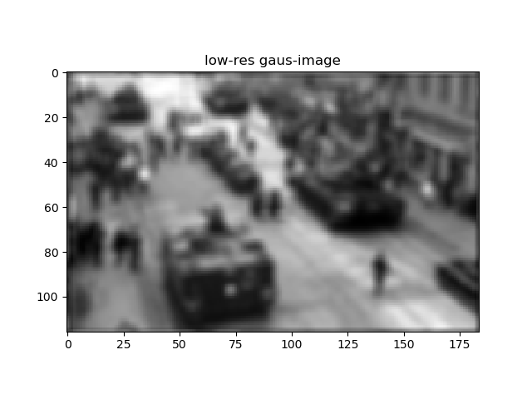 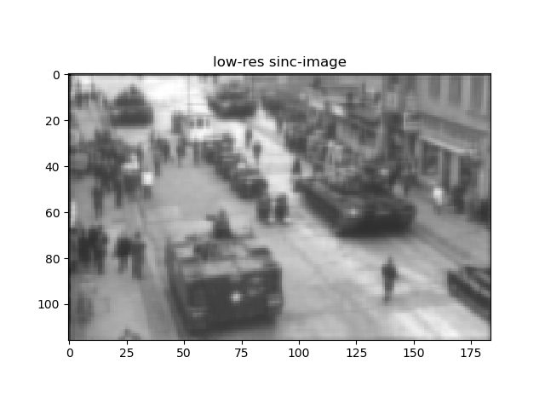

High-Res Images and PSNRs

Correct kernel: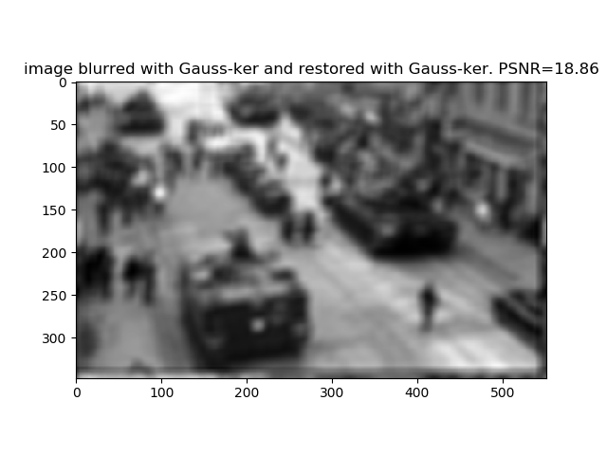 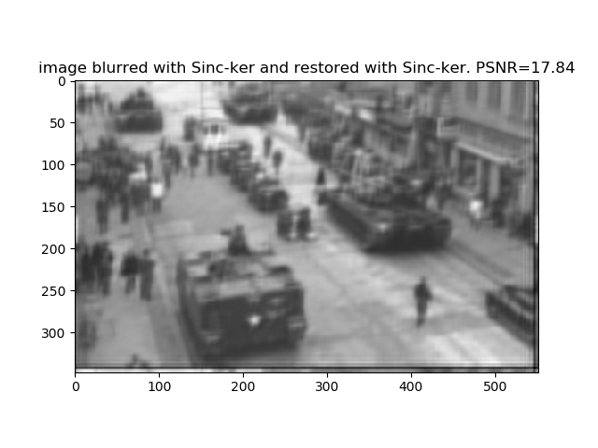

Wrong kernels:

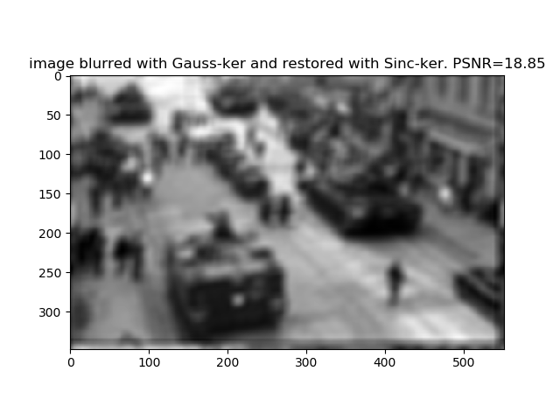 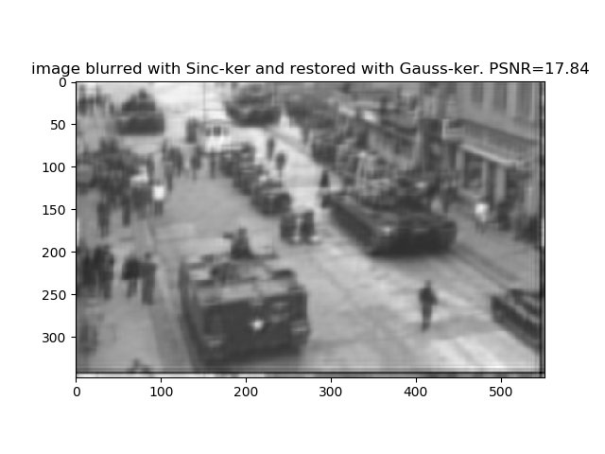

Explanation:

As we can see the restoration of the low-res image is smoothed than the low-resolution images, which is blurred. there is a noticeable increase in resolution in both gaussian and sinc images.

Regarding the reconstructions of the images using right and wrong kernels: on the image filtered with the gaussian filter we can see a slight improvement in the PSNRs, but on the image filtered with the sinc filter the PSNRs are equivalent.

Also, when trying to reconstruct using the original kernels, we got PSNR of 16.79 for the sinc and 17.76 for the gaussian. Both results lower than all the other reconstructions.

Our **main explanation** to all the above: our algorithm is based on the connection between patches with different resolutions in the picture, and this connection isn't really based on the kernel we used while passing from high resolution to low resolution.

Thus, our kernel is better in all cases than the original, and it is not significant if we used the right or wrong kernel.

Another explanation to the last point (it is not significant if we used the right or wrong kernel): the gaussian function and the sinc function have a very similar behavior in the frequency domain, both have high values on low frequencies and fades out towards high frequencies

As we explained in the dry part that our algorithm counts on that in natural scenes there are a lot of recurring patches, which our algorithm expects the optimal k based on these recurring patches in different sizes, and as we can see in the original image there are different types of similar vehicles appearing in different distances (sizes), and people standing in different positions, these recurring patterns help of the restoration of the optimal kernel.