Part 3 – Constrained Optimization:
Task 1:
- Is this problem convex?***
- Optimal solution:

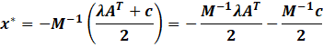
Using :
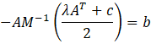

Task 2:
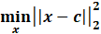
- Is this problem convex?***
- Optimal solution:

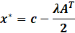
Using :
