Nicolas Escobar (escobarn)  
Harsh Reddy (hagandav)

Cloud Computing - Project 8 Report  
Bonus Credits

1. **Perform experiments on various (small, medium, large, etc) datasets**

We executed the following experiments:

**Experiment #1 (Small data set, small batch size)**

* Input data: two files with 4,000 rows each
* Infrastructure: Local VM
* Mappers: 2
* Iterations: 10
* Centroids: 5
* Batch size: 1,000
* Execution time: 51,649 ms.



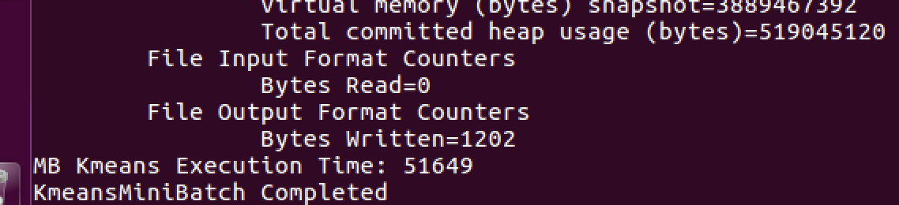

Log file execution sample:

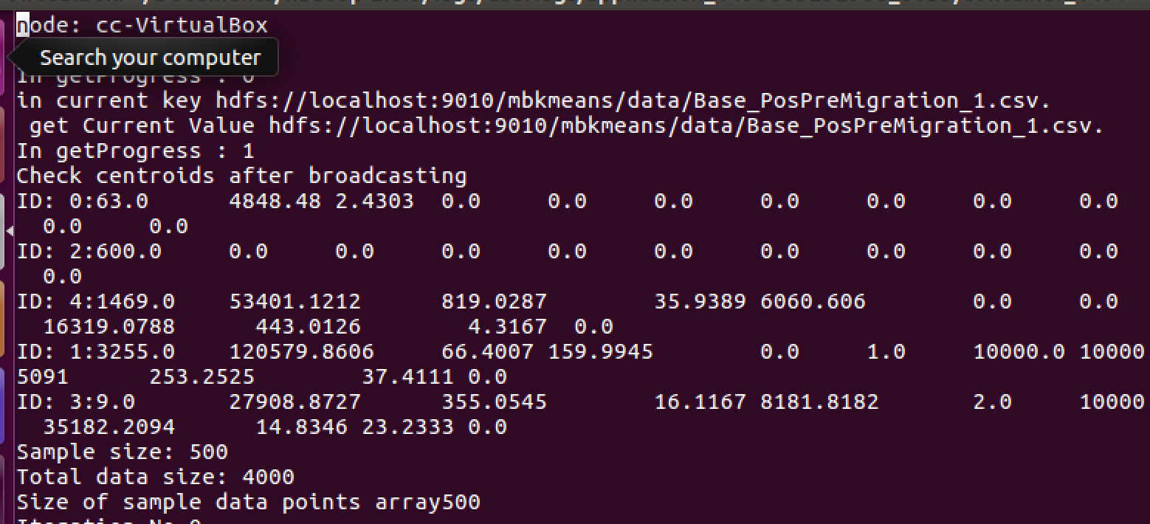

**Experiment #2 (Large data set, small batch size)**

* Input data: two files with over 50,000 rows each
* Infrastructure: Local VM
* Mappers: 2
* Iterations: 10
* Centroids: 5
* Batch size: 5,000
* Execution time: 51,426 ms.

**Experiment #3 (Large data set, big batch size)**

* Input data: two files with over 50,000 rows each
* Infrastructure: Local VM
* Mappers: 2
* Iterations: 10
* Centroids: 5
* Batch size: 80,000
* Execution time: 140,407 ms.



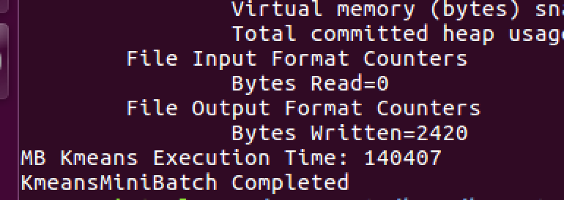

Log file execution sample:

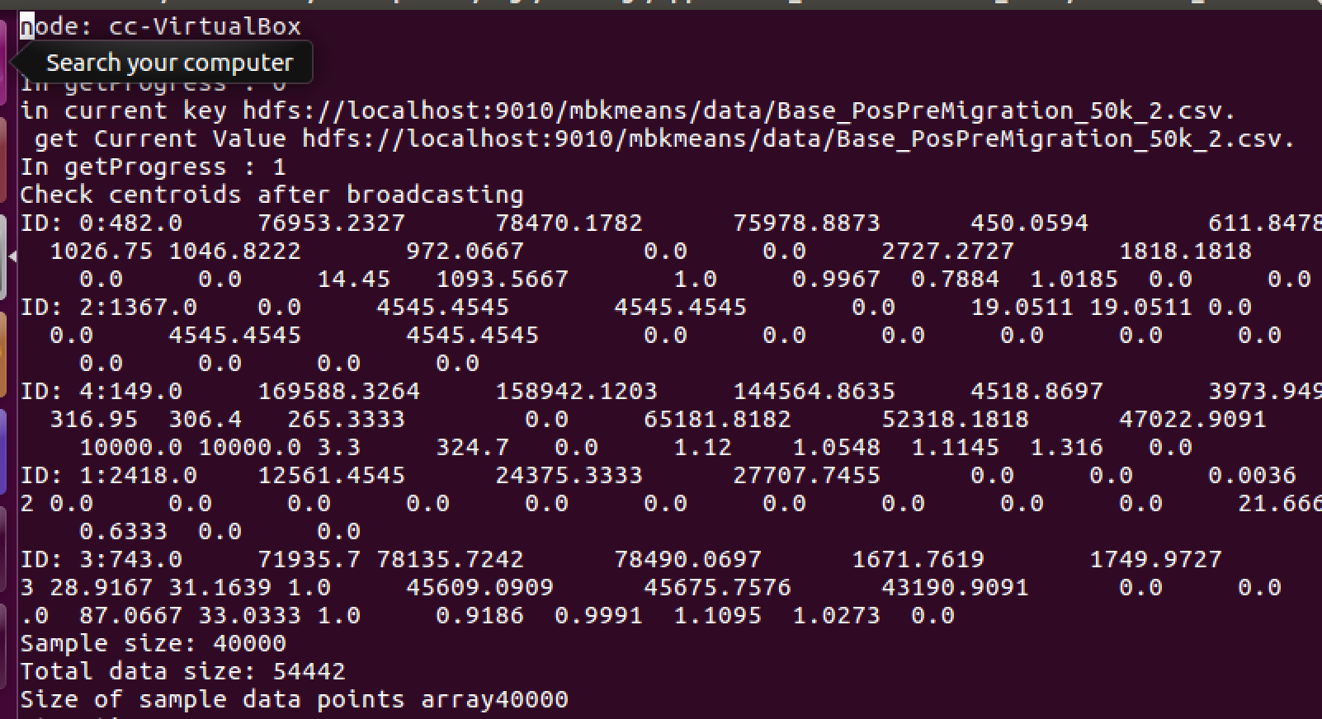

1. **Test your algorithm on at least 2 nodes on FutureSystem.**

We configured two nodes on FutureSystem which are:

* escobarn-001 🡪 149.165.158.255
* escobarn-002 🡪 149.165.158.27

These nodes are running hadoop-2.6.5 with java 1.8 (openjdk 1.8.0_111) and harp. We followed the instructions from <https://dsc-spidal.github.io/harp/docs/getting-started-cluster/> to configure and execute the cluster.

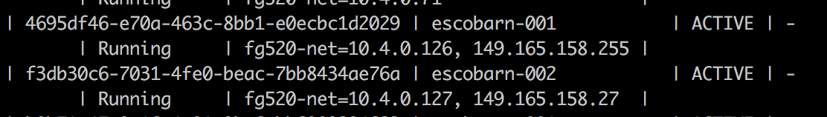

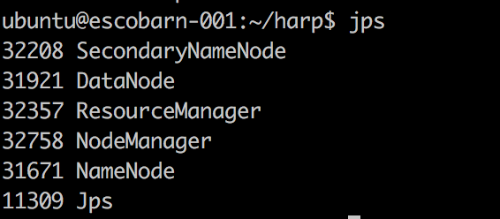

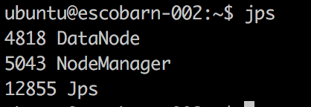

We have tested our algorithm against a large data set on the FutureSystems nodes and obtained the following results:

* Input data: two files with over 50,000 rows each
* Infrastructure: Future Systems Nodes running Ubuntu
* Mappers: 2
* Iterations: 10
* Centroids: 5
* Batch size: 80,000
* Execution time: 81,608 ms.

Screenshots of execution logs can be found below:

Sample execution logs

