CC-1

**QUESTION-1:**

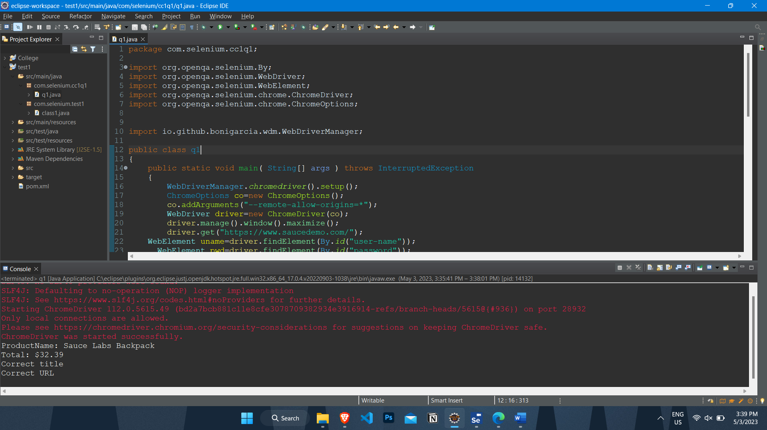

package com.selenium.cc1q1;

import org.openqa.selenium.By;

import org.openqa.selenium.WebDriver;

import org.openqa.selenium.WebElement;

import org.openqa.selenium.chrome.ChromeDriver;

import org.openqa.selenium.chrome.ChromeOptions;

import io.github.bonigarcia.wdm.WebDriverManager;

public class q1

{

public static void main( String[] args ) throws InterruptedException

{

WebDriverManager.chromedriver().setup();

ChromeOptions co=new ChromeOptions();

co.addArguments("--remote-allow-origins=*");

WebDriver driver=new ChromeDriver(co);

driver.manage().window().maximize();

driver.get("https://www.saucedemo.com/");

WebElement uname=driver.findElement(By.id("user-name"));

WebElement pwd=driver.findElement(By.id("password"));

WebElement submit= driver.findElement(By.xpath("//*[@id=\"login-button\"]"));

uname.sendKeys("standard_user");

pwd.sendKeys("secret_sauce");

submit.click();

//driver.get("https://www.saucedemo.com/inventory.html");

WebElement add= driver.findElement(By.xpath("//*[@id=\"add-to-cart-sauce-labs-backpack\"]"));

add.click();

WebElement cart= driver.findElement(By.className("shopping_cart_link"));

cart.click();

WebElement check= driver.findElement(By.xpath("//*[@id=\"checkout\"]"));

check.click();

WebElement fname=driver.findElement(By.id("first-name"));

WebElement lname=driver.findElement(By.id("last-name"));

WebElement postalcode=driver.findElement(By.id("postal-code"));

WebElement cont= driver.findElement(By.xpath("//*[@id=\"continue\"]"));

fname.sendKeys("Janani");

lname.sendKeys("K S");

postalcode.sendKeys("123456");

cont.click();

WebElement prints=driver.findElement(By.className("inventory_item_name"));

System.out.println("ProductName: "+prints.getText());

WebElement print1=driver.findElement(By.xpath("//*[@id=\"checkout_summary_container\"]/div/div[2]/div[8]"));

System.out.println(print1.getText());

String t1="Swag Labs";

String t2="";

t2=driver.getTitle();

if(t1.equals(t2))

System.out.println("Correct title");

String url1="https://www.saucedemo.com/checkout-step-two.html";

String url2="";

url2=driver.getCurrentUrl();

if(url1.equals(url2))

System.out.println("Correct URL");

}

}

**QUESTION-2:**

**TASK-1:**

package com.selenium.cc1q2;

import org.openqa.selenium.By;

import org.openqa.selenium.WebDriver;

import org.openqa.selenium.WebElement;

import org.openqa.selenium.chrome.ChromeDriver;

import org.openqa.selenium.chrome.ChromeOptions;

import org.openqa.selenium.support.ui.Select;

import io.github.bonigarcia.wdm.WebDriverManager;

public class t1{

public static void main(String[] args){

WebDriverManager.chromedriver().setup();

ChromeOptions co=new ChromeOptions();

co.addArguments("--remote-allow-origins=*");

WebDriver driver =new ChromeDriver(co);

driver.manage().window().maximize();

driver.get("https://www.saucedemo.com/inventory.html");

WebElement uname=driver.findElement(By.name("user-name"));

WebElement pwd=driver.findElement(By.name("password"));

WebElement submit=driver.findElement(By.name("login-button"));

uname.sendKeys("standard_user");

pwd.sendKeys("secret_sauce");

submit.click();

WebElement sort1=driver.findElement(By.className("product_sort_container"));

sort1.click();

Select select=new Select(sort1);

select.selectByIndex(0);

System.out.println("Name(A-Z) filter is Applied");

select.selectByIndex(1);

System.out.println("Name(Z-A) filter is Applied");

}

}

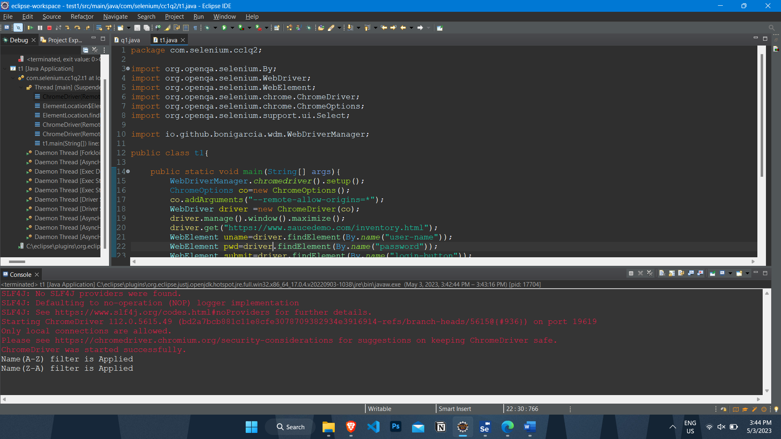

**TASK-2:**

package com.selenium.cc1q2;

import org.openqa.selenium.By;

import org.openqa.selenium.WebDriver;

import org.openqa.selenium.WebElement;

import org.openqa.selenium.chrome.ChromeDriver;

import org.openqa.selenium.chrome.ChromeOptions;

import org.openqa.selenium.support.ui.Select;

import io.github.bonigarcia.wdm.WebDriverManager;

public class t2 {

public static void main(String[] args){

WebDriverManager.chromedriver().setup();

ChromeOptions co=new ChromeOptions();

co.addArguments("--remote-allow-origins=*");

WebDriver driver =new ChromeDriver(co);

driver.manage().window().maximize();

driver.get("https://www.saucedemo.com/inventory.html");

WebElement uname=driver.findElement(By.name("user-name"));

WebElement pwd=driver.findElement(By.name("password"));

WebElement submit=driver.findElement(By.name("login-button"));

uname.sendKeys("standard_user");

pwd.sendKeys("secret_sauce");

submit.click();

WebElement sort1=driver.findElement(By.className("product_sort_container"));

sort1.click();

Select select=new Select(sort1);

select.selectByIndex(0);

String fpo=driver.findElement(By.className("inventory_item_name")).getText();

System.out.println("First product name in Name(A-Z) filter is "+fpo);

select.selectByIndex(1);

String fp1=driver.findElement(By.className("inventory_item_name")).getText();

System.out.println("First product name in Name(Z-A) filter is "+fp1);

}

}

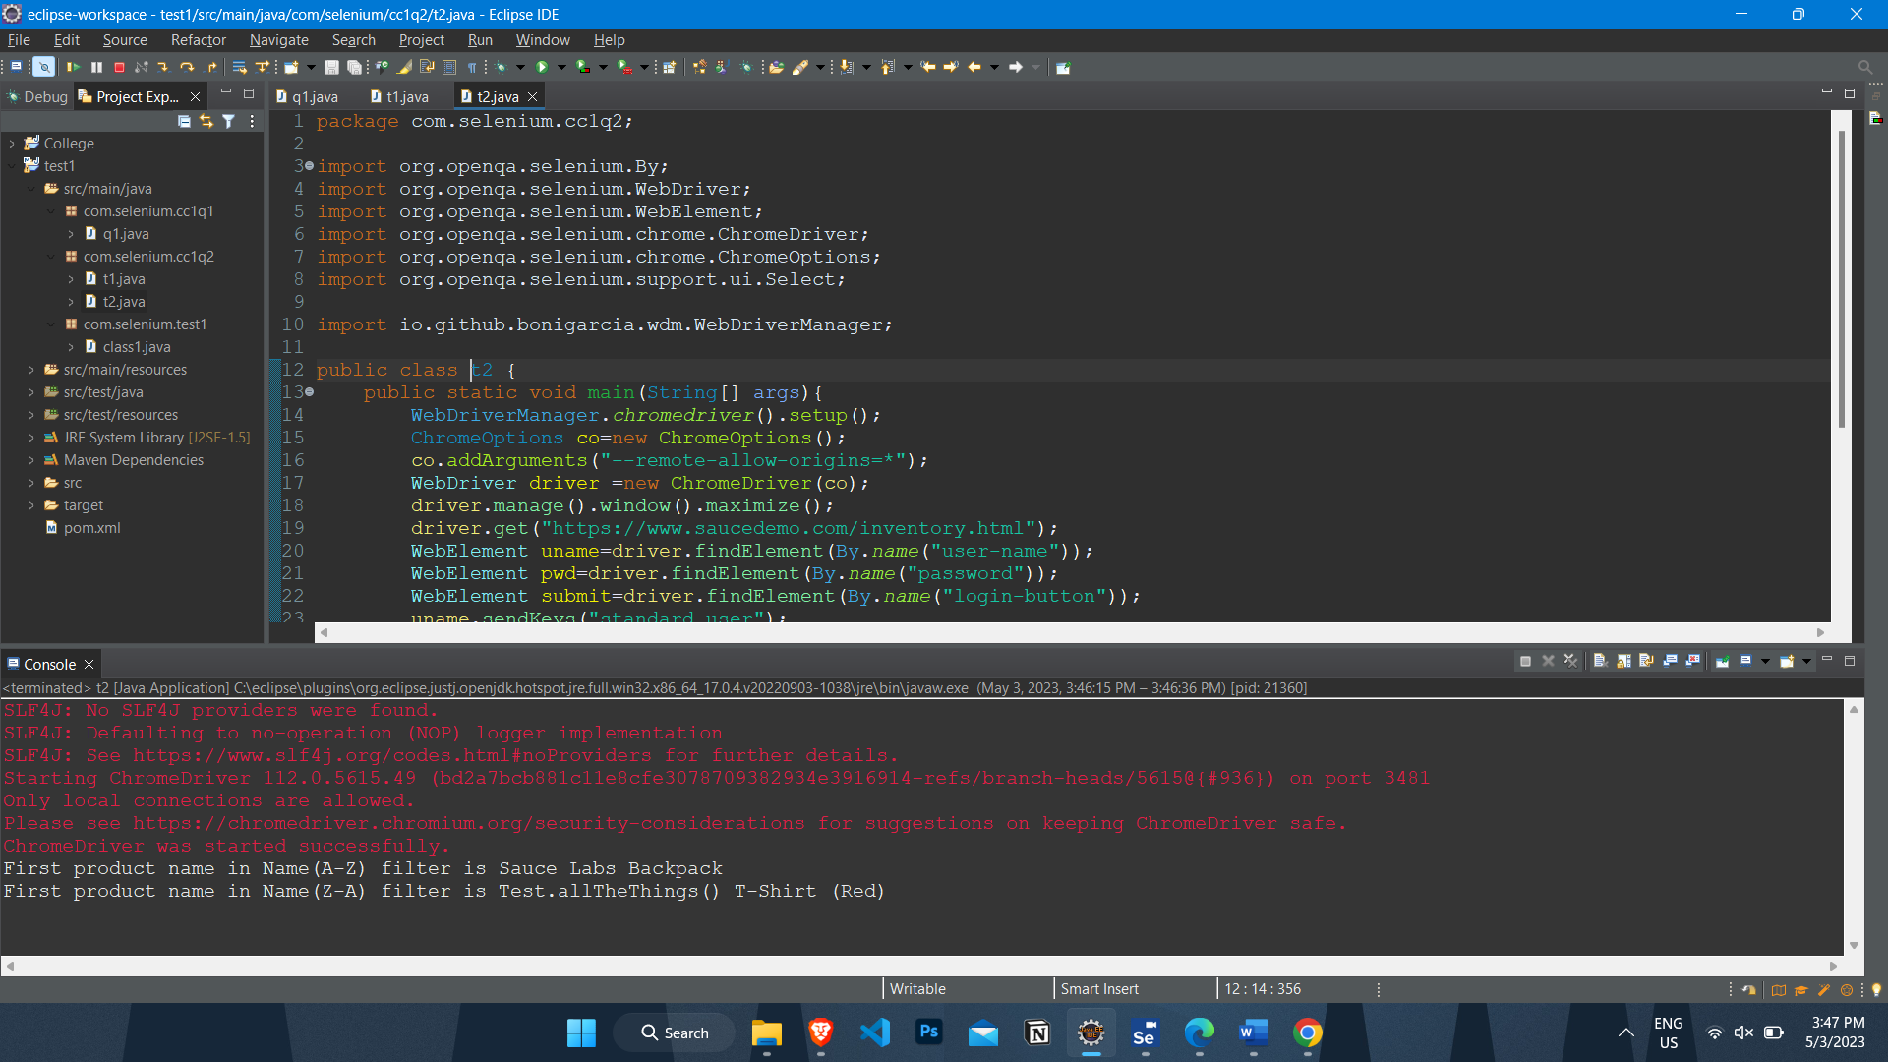

**TASK-3:**

package com.selenium.cc1q2;

import org.openqa.selenium.By;

import org.openqa.selenium.WebDriver;

import org.openqa.selenium.WebElement;

import org.openqa.selenium.chrome.ChromeDriver;

import org.openqa.selenium.chrome.ChromeOptions;

import org.openqa.selenium.support.ui.Select;

import io.github.bonigarcia.wdm.WebDriverManager;

public class t3 {

public static void main(String[] args){

WebDriverManager.chromedriver().setup();

ChromeOptions co=new ChromeOptions();

co.addArguments("--remote-allow-origins=*");

WebDriver driver =new ChromeDriver(co);

driver.manage().window().maximize();

driver.get("https://www.saucedemo.com/inventory.html");

WebElement uname=driver.findElement(By.name("user-name"));

WebElement pwd=driver.findElement(By.name("password"));

WebElement submit=driver.findElement(By.name("login-button"));

uname.sendKeys("standard_user");

pwd.sendKeys("secret_sauce");

submit.click();

WebElement sort1=driver.findElement(By.className("product_sort_container"));

sort1.click();

Select select=new Select(sort1);

select.selectByIndex(2);

System.out.print("Price(low to high) filter is Applied");

WebElement sort2=driver.findElement(By.className("product_sort_container"));

sort2.click();

Select select1=new Select(sort2);

select1.selectByIndex(3);

System.out.print("Price(high to low) filter is Applied");

}

}

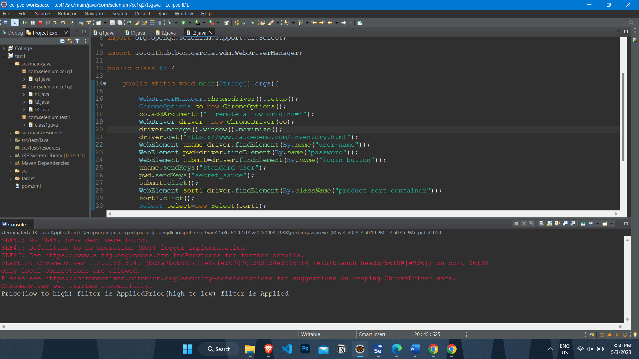

**TASK-4:**

package com.selenium.cc1q2;

import org.openqa.selenium.By;

import org.openqa.selenium.WebDriver;

import org.openqa.selenium.WebElement;

import org.openqa.selenium.chrome.ChromeDriver;

import org.openqa.selenium.chrome.ChromeOptions;

import org.openqa.selenium.support.ui.Select;

import io.github.bonigarcia.wdm.WebDriverManager;

public class t4 {

public static void main(String[] args){

WebDriverManager.chromedriver().setup();

ChromeOptions co=new ChromeOptions();

co.addArguments("--remote-allow-origins=*");

WebDriver driver =new ChromeDriver(co);

driver.manage().window().maximize();

driver.get("https://www.saucedemo.com/inventory.html");

WebElement uname=driver.findElement(By.name("user-name"));

WebElement pwd=driver.findElement(By.name("password"));

WebElement submit=driver.findElement(By.name("login-button"));

uname.sendKeys("standard_user");

pwd.sendKeys("secret_sauce");

submit.click();

WebElement sort1=driver.findElement(By.className("product_sort_container"));

sort1.click();

Select select=new Select(sort1);

select.selectByIndex(2);

String d1=driver.findElement(By.className("inventory_item_name")).getText();

System.out.println("First product name in Price(low to high) filter is "+d1);

WebElement sort2=driver.findElement(By.className("product_sort_container"));

sort2.click();

Select select1=new Select(sort2);

select1.selectByIndex(3);

String d2=driver.findElement(By.className("inventory_item_name")).getText();

System.out.println("First product name in Price(high to low) filter is "+d2);

}

}

