**Q1.**

Code:

***package Q_01;  
  
import javax.swing.*;  
public class Q_01 {  
 public static void main(String[] args) {  
 JFrame welcomeWindow;  
 welcomeWindow = new JFrame();  
 welcomeWindow.setSize(800,600);  
 welcomeWindow.setTitle("Welcome to Java");  
 welcomeWindow.setVisible(true);  
 }  
  
  
}***

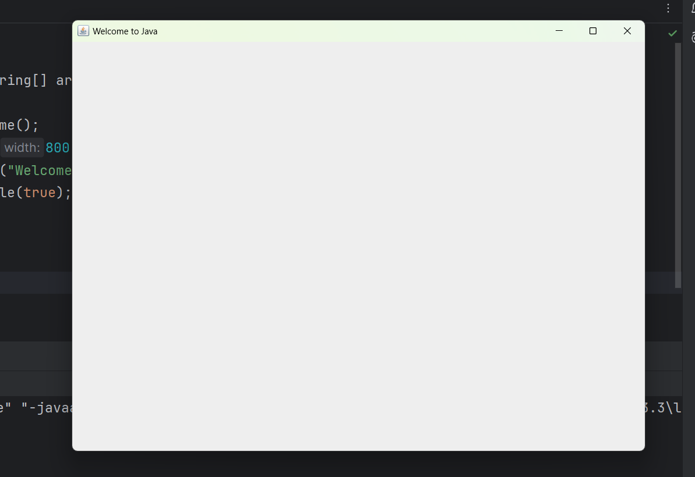Output:

**Q2.**

Code:

***package Q_02;***

***import javax.swing.*;***

***import java.util.Scanner;***

***public class Q_02{***

***public static void main(String[] args) {***

***Scanner scanner= new Scanner(System.in);***

***System.out.print("Enter your first name: ");***

***String fName = scanner.next();***

***System.out.print("Enter your last name: ");***

***String lName = scanner.next();***

***JFrame frame = new JFrame();***

***frame.setSize(300,250);***

***frame.setTitle(fName+" "+lName);***

***frame.setVisible(true);***

***}***

***}***

Output:

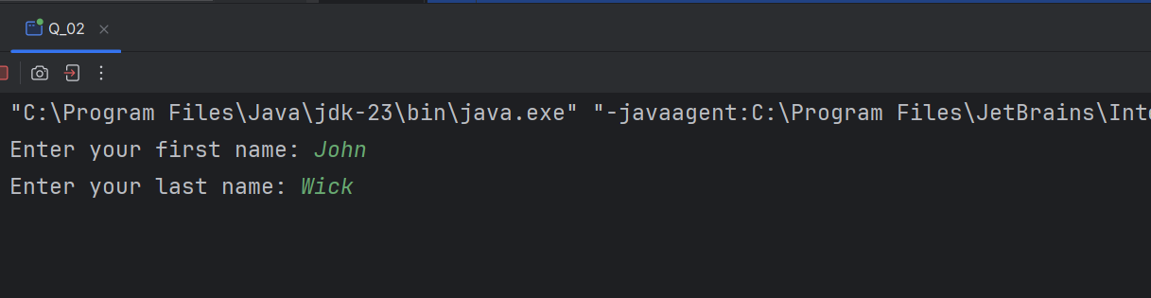

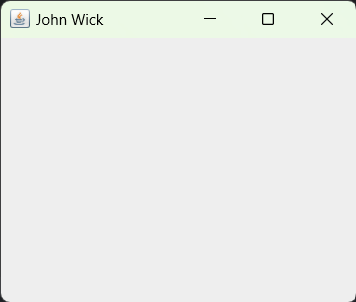

**Q3.**

Code:

***package Q_03;***

***import java.util.*;***

***public class Q_03 {***

***public static void main(String[] args) {***

***Scanner scanner = new Scanner(System.in);***

***System.out.print("Enter your first name-: ");***

***String firstName = scanner.nextLine();***

***System.out.print("Enter your middle name-: ");***

***String middleName = scanner.nextLine();***

***System.out.print("Enter your last name-: ");***

***String lastName = scanner.nextLine();***

***String middleInitial = middleName.substring(0, 1) + ".";***

***System.out.println("Formatted Name: " + firstName + " " + middleInitial + " " + lastName);***

***scanner.close();***

***}***

***}***

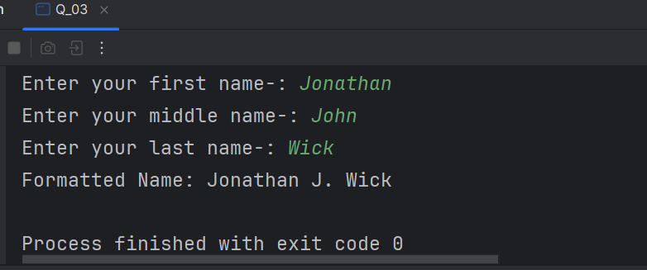Output:

**Q4.**

Code:

***package Q_04;***

***import java.time.LocalDate;***

***import java.time.format.DateTimeFormatter;***

***public class Q_04{***

***public static void main(String[] args) {***

***LocalDate today = LocalDate.now();***

***DateTimeFormatter formatter = DateTimeFormatter.ofPattern("d MMM yyy");***

***String formattedDate=today.format(formatter);***

***System.out.println("Today's Date :"+formattedDate);***

***}***

***}***

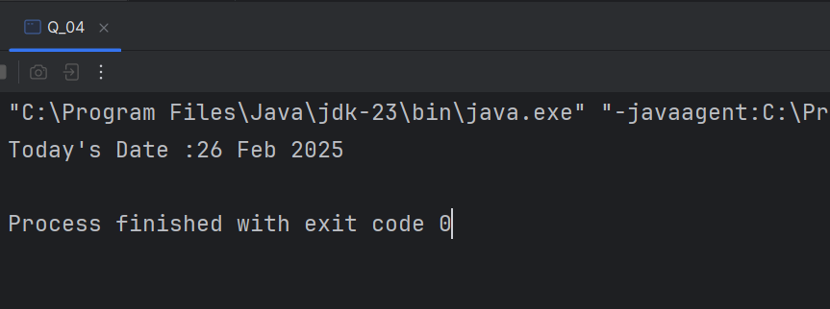Output:

**Q5.**

Code:

**package Q_05;**

**import java.time.LocalDate;**

**import java.time.format.DateTimeFormatter;**

**public class Q_05{**

**public static void main(String[] args) {**

**LocalDate today = LocalDate.now();**

**DateTimeFormatter formatter = DateTimeFormatter.ofPattern("EEEE, MMMM d, yyyy");**

**String formattedDate=today.format(formatter);**

**System.out.println("Today's Date :"+formattedDate);**

**}**

**}**

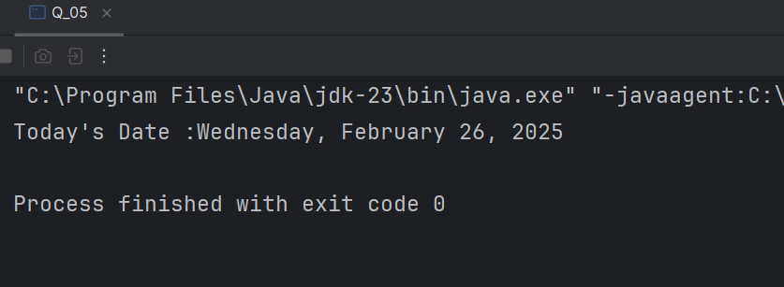Output:

**Q6.**

Code:

***import javax.swing.*;***

***import java.util.Scanner;***

***public class Q_06 {***

***public static void main(String[] args) {***

***Scanner scanner = new Scanner(System.in);***

***System.out.print("Enter the frame title: ");***

***String title = scanner.nextLine();***

***System.out.print("Enter the frame width (W): ");***

***int width = scanner.nextInt();***

***System.out.print("Enter the frame height (H): ");***

***int height = scanner.nextInt();***

***JFrame frame = new JFrame(title);***

***frame.setSize(width, height);***

***frame.setVisible(true);***

***scanner.close();***

***}***

***}***

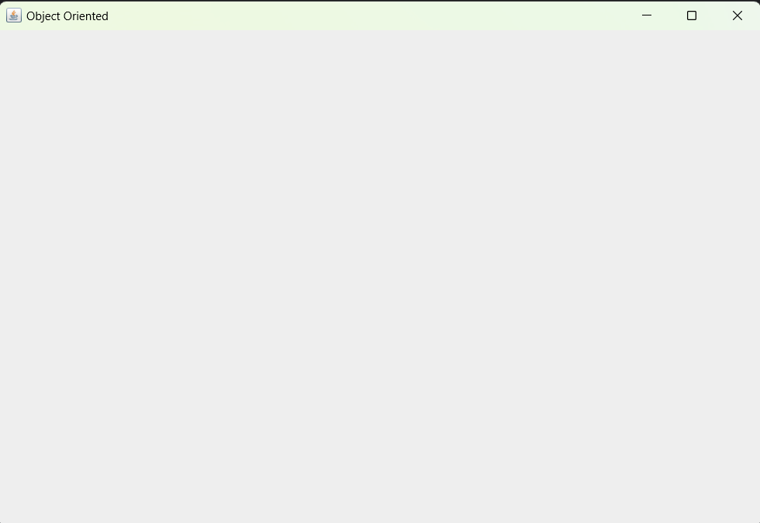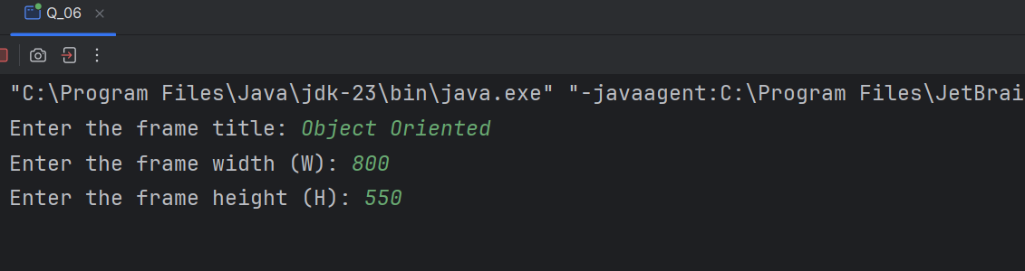Output:

**Q7.**

Code:

**import javax.swing.*;**

**import java.time.LocalTime;**

**import java.time.format.DateTimeFormatter;**

**public class Q_07 {**

**public static void main(String[] args) {**

**LocalTime now = LocalTime.now();**

**DateTimeFormatter formatter = DateTimeFormatter.ofPattern("hh:mm:ss a");**

**String formattedTime = now.format(formatter);**

**JFrame frame = new JFrame(formattedTime);**

**frame.setSize(300, 200);**

**frame.setVisible(true);**

**}**

**}**

Output:

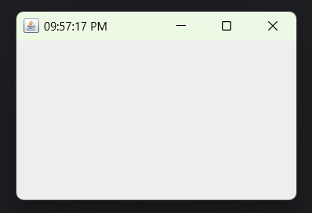

**Q8.**

Code:

**package Q_08;**

**import java.util.Scanner;**

**public class Q_08 {**

**public static void main(String[] args) {**

**Scanner scanner = new Scanner(System.in);**

**System.out.print("Enter a string containing a exclamation mark: ");**

**String input = scanner.nextLine();**

**int index = input.indexOf('!');**

**if (index != -1){**

**String before = input.substring(0,index);**

**String after = input.substring(index+1);**

**System.out.println("Before: "+ before);**

**System.out.println("After: "+ after);**

**}**

**else{**

**System.out.print("No exclamation mark found in the input.");**

**}**

**scanner.close();**

**}**

**}**

Output:

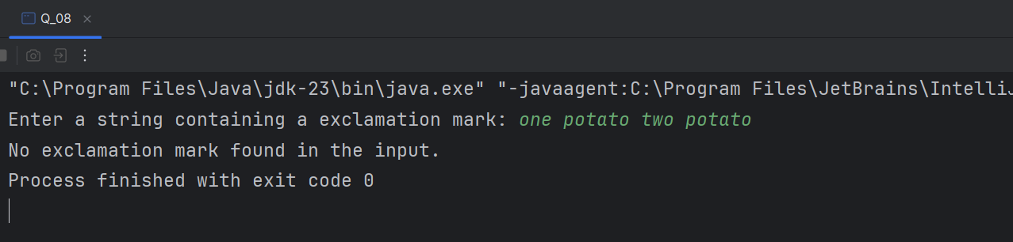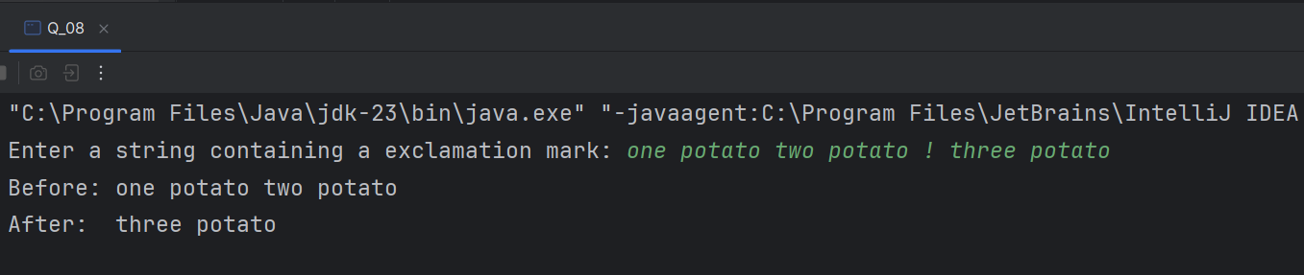

**Q9.**

Code:

**package Q_09;  
  
import java.util.Scanner;  
  
public class Q_09 {  
 public static void main(String[] args) {  
 Scanner scanner = new Scanner(System.in);  
 System.out.print("Enter a String: ");  
 String input = scanner.nextLine();  
  
 int length = input.length();  
  
 if(length>0){  
 char firstChar = input.charAt(0);  
 char lastChar = input.charAt(length - 1);  
  
 System.out.println(length);  
 System.out.println(firstChar);  
 System.out.println(lastChar);  
  
 }  
 else {  
 System.out.println("The input string is empty.");  
  
 }  
 scanner.close();  
  
 }  
}**

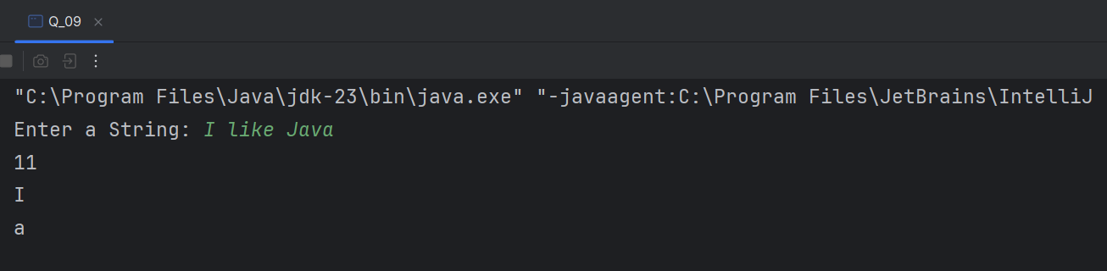Output:

**Q10.**

Code:

***package Q_10;  
  
import java.util.Scanner;  
  
public class Q_10 {  
 public static void main(String[] args) {  
 Scanner scanner = new Scanner(System.in);  
  
 System.out.print("Enter an odd-length word: ");  
 String word = scanner.nextLine();  
  
 if (word.length() % 2 == 0) {  
 System.out.println("Please enter a word with an odd number of characters.");  
 } else {  
  
 int middleIndex = word.length() / 2;  
 System.out.println("The middle character is: " + word.charAt(middleIndex));  
 }  
  
 scanner.close();  
 }  
}***

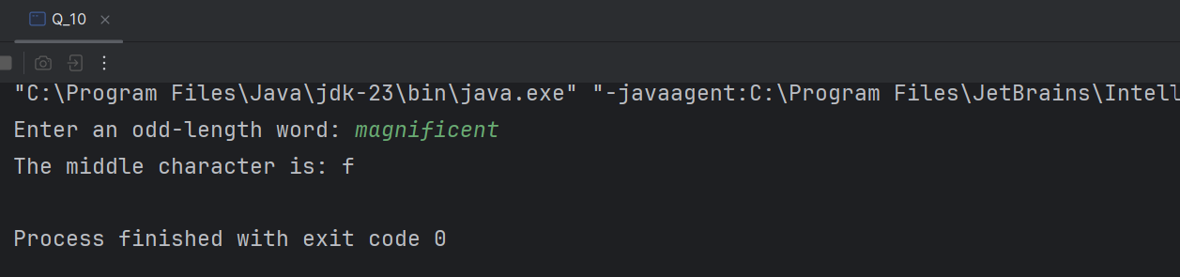Output:

**Q11.**

Code:

**import java.util.Scanner;**

**public class Q_11{**

**public static void main(String[] args) {**

**Scanner scanner = new Scanner(System.in);**

**System.out.print("Enter your full name (First Middle Last): ");**

**String fullName = scanner.nextLine();**

**String[] nameParts = fullName.split(" ");**

**if (nameParts.length != 3) {**

**System.out.println("Please enter your name in the format: First Middle Last");**

**} else {**

**String firstName = nameParts[0];**

**String middleName = nameParts[1];**

**String lastName = nameParts[2];**

**System.out.println(lastName + ", " + firstName + " " + middleName.charAt(0) + ".");**

**}**

**scanner.close();**

**}**

**}**

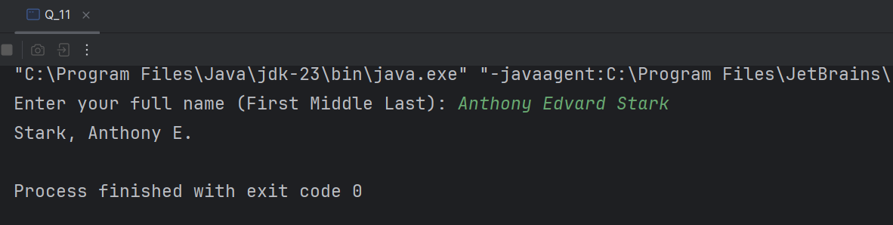Output:

**Q12.**

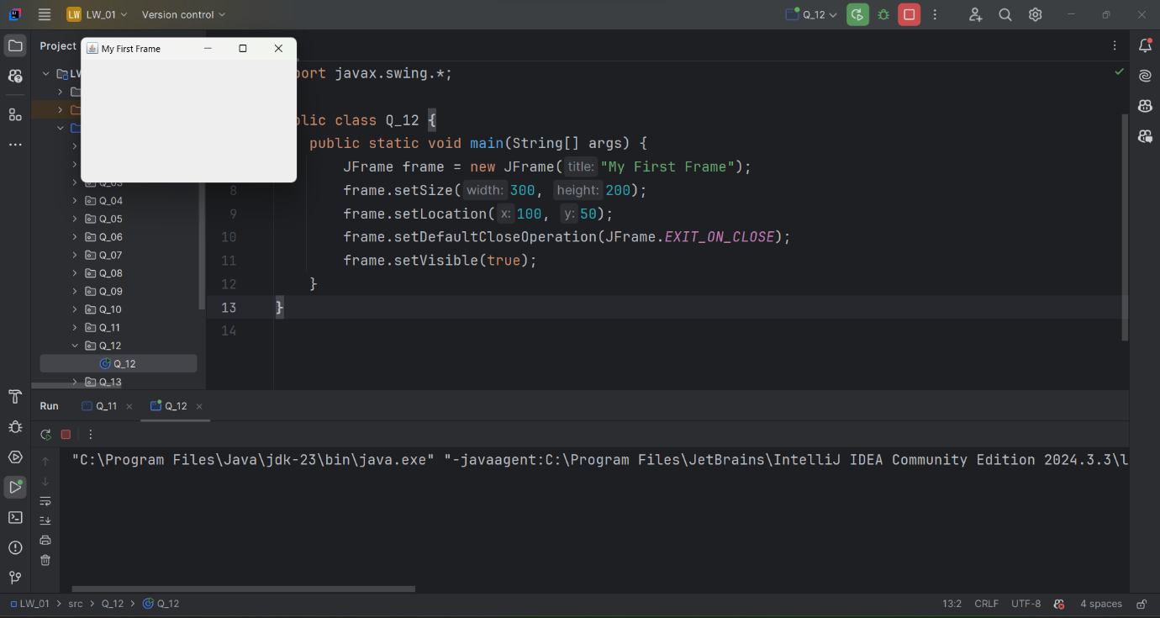Code:  
  
Output:

**package Q_12;**

**import javax.swing.*;**

**public class Q_12 {**

**public static void main(String[] args) {**

**JFrame frame = new JFrame("My First Frame");**

**frame.setSize(300, 200);**

**frame.setLocation(100, 50);**

**frame.setDefaultCloseOperation(JFrame.EXIT_ON_CLOSE);**

**frame.setVisible(true);**

**}**

**}**

**Q13.**

Code:

**import javax.swing.*;**

**class SampleWindow {**

**public static void main(String[] args) {**

**JFrame myWindow;**

**myWindow = new JFrame();**

**myWindow.setSize(500, 250);**

**myWindow.setTitle("UOK");**

**myWindow.setVisible(true);**

**try {Thread.sleep(500);} catch(Exception e) { }**

**myWindow.setVisible(false);**

**try {Thread.sleep(500);} catch(Exception e) { }**

**myWindow.setVisible(true);**

**}**

**}**

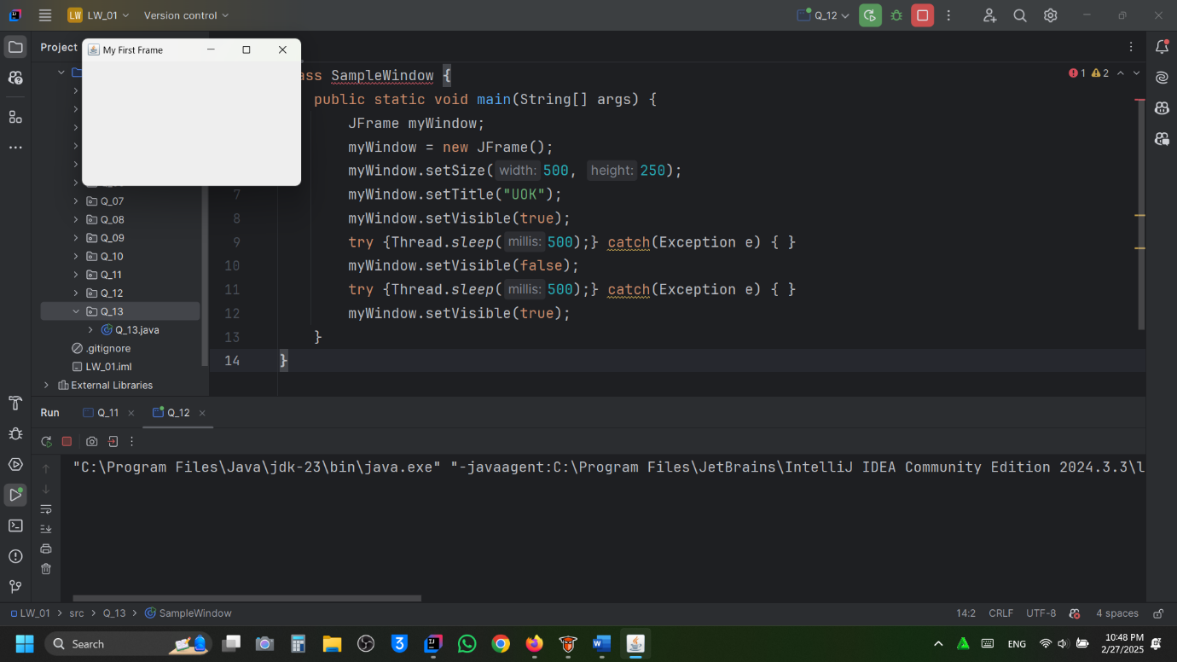Output: