CT/2021/009 Premarathna A.H.N.P

**Q1.**

**Part (a)**

**Part (b)**

**Part (c)**

**Part (d)**

Code:

***package Q_01;  
  
import java.util.Scanner;  
  
public class Q_01 {  
 public static void main(String[] args) {  
 Scanner scanner = new Scanner(System.in);  
  
 //Q_01 - part (a)  
 System.out.print("Enter vslue of A,B and C: ");  
 double A = scanner.nextDouble();  
 double B = scanner.nextDouble();  
 double C = scanner.nextDouble();  
 double resultofA = Math.sqrt(Math.pow(B,2)+4*A*C);  
 System.out.println("Result (A): " + resultofA);  
  
 //Q_01 - part (b)  
 System.out.print("Enter value of X and Y: ");  
 double X = scanner.nextDouble();  
 double Y = scanner.nextDouble();  
 double resultofB = Math.sqrt(X+4*(Math.pow(Y,3)));  
 System.out.println("This is the result: " + resultofB);  
  
 //Q_01 - part (c)  
 double productResult = Math.cbrt(X * Y);  
 System.out.println("The cube root of the product of X & Y: " + productResult);  
  
 //Q_01 - part (d)  
 System.out.print("Enter radius of the circle: ");  
 double radius = scanner.nextDouble();  
 double area = Math.PI * Math.pow(radius,2);  
 System.out.println("Area of the circle: " + area);  
  
 scanner.close();  
  
  
  
 }  
}***

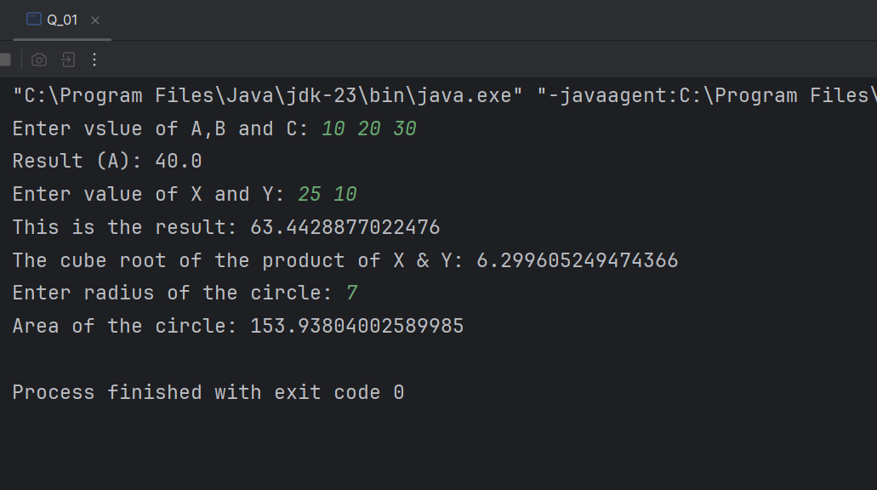Output:

**Q2.**

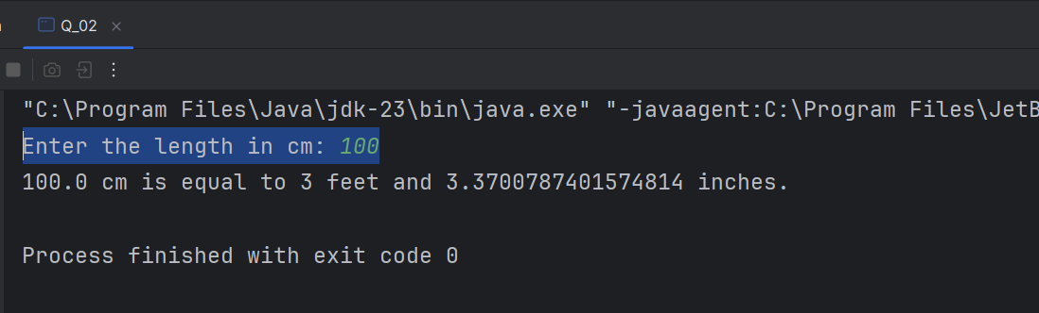Code:Output:

***package Q_02;  
  
import java.util.Scanner;  
  
public class Q_02 {  
 public static void main(String[] args) {  
 Scanner scanner = new Scanner(System.in);  
 System.out.print("Enter the length in cm: ");  
 double cm = scanner.nextDouble();  
   
 double cmPerInch = 2.54;  
 double inchPerFeet = 12;  
  
 double totalInches = cm/cmPerInch;  
  
 int feet = (int)(totalInches/inchPerFeet);  
 double inches = totalInches % inchPerFeet;  
  
 System.out.println(cm + " cm is equal to " + feet + " feet and " + inches + " inches.");  
 scanner.close();  
  
  
 }  
}***

**Q3.**

Code:

***package Q_03;  
  
import java.util.Scanner;  
  
public class Q_03 {  
 public static void main(String[] args) {  
 Scanner scanner = new Scanner(System.in);  
 System.out.print("Enter temperature (In Celsius) : ");  
 double celsius = scanner.nextDouble();  
 double fHeit = (1.8*celsius)+32;  
  
 System.out.println(celsius+ " celsius is equal to "+ fHeit + " fahrenheit.");  
 scanner.close();  
 }  
}***

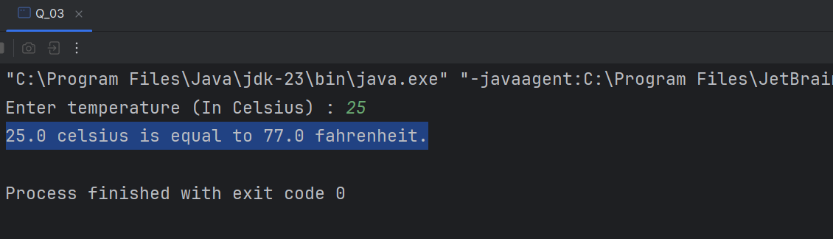Output:

**Q4.**

Code:

***package Q_04;  
  
import java.util.Scanner;  
  
public class Q_04 {  
 public static void main(String[] args) {  
 Scanner scanner = new Scanner(System.in);  
  
 System.out.print("Enter your weigh in pound: ");  
 double weight = scanner.nextDouble();  
  
 double calPerPond = 19;  
 double calPerDay = weight * calPerPond;  
  
 System.out.println("You need approximately "+ calPerDay + " calories per day.");  
 scanner.close();  
 }  
}***

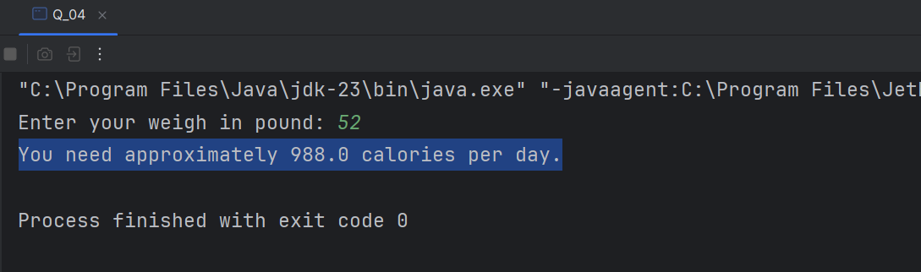

Output:

**Q5.**

Code:

***package Q_05;  
  
import java.util.Scanner;  
  
public class Q_05 {  
 public static void main(String[] args) {  
 Scanner scanner = new Scanner(System.in);  
  
 System.out.print("Enter the temperature in degrees fahrenheit: ");  
 double fHeit = scanner.nextDouble();  
 double celsius = (5.0/9.0)*(fHeit-32);  
  
 System.out.println(fHeit + "fahrenheit is equal to " + celsius + " degrees celsius.");  
 scanner.close();  
 }  
}***

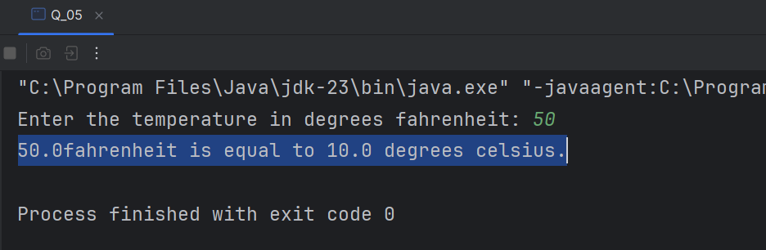Output:

**Q6.**

Code:

***package Q_06;  
  
import java.time.Year;  
import java.util.Scanner;  
  
public class Q_06 {  
 public static void main(String[] args) {  
 Scanner scanner = new Scanner(System.in);  
  
 System.out.print("Enter Your You Born: ");  
 int birthYear = scanner.nextInt();  
 int currentYear = Year.now().getValue();  
 int age = currentYear - birthYear;  
 System.out.println("Year were born in "+ birthYear + " and will be (are) " + age + " this year.");  
 scanner.close();  
 }  
}***

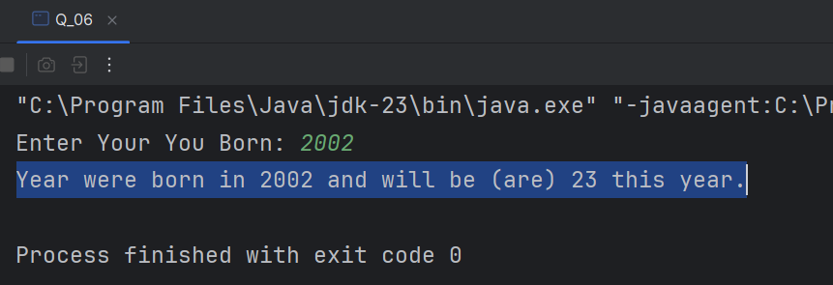Output:

**Q7.**

Code:

***package Q_07;  
  
import java.util.Scanner;  
  
public class Q_07 {  
 public static void main(String[] args) {  
 Scanner scanner = new Scanner(System.in);  
  
 System.out.print("Enter your weight (in Kg): ");  
 int weight = scanner.nextInt();  
 System.out.print("Enter your height (in cm): ");  
 int height = scanner.nextInt();  
  
 double BMI = weight / Math.pow(height/100.0,2);  
 System.out.println("Your BMI value is: " + BMI);  
  
 if (BMI >= 20 && BMI <=25){  
 System.out.println("Your BMI is Normal.");  
 }  
 else {  
 System.out.println("Your BMI is outside the normal range(20-25)!");  
  
 }  
 scanner.close();  
  
 }  
}***

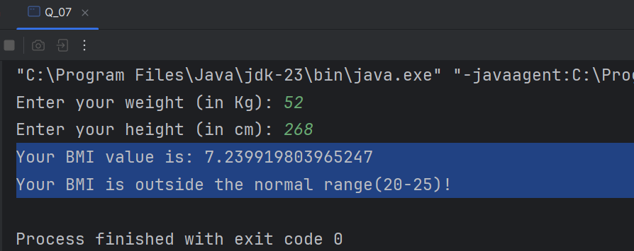Output:

**Q8.**

Code:

***package Q_08;  
  
import java.util.Scanner;  
  
public class Q_08 {  
 public static void main(String[] args) {  
 Scanner scanner = new Scanner(System.in);  
  
 System.out.print("Enter radius of the circle: ");  
 double radius = scanner.nextDouble();  
  
 double PI = 3.14;  
 double volume = (4/3) * (PI * Math.pow(radius,3));  
  
 System.out.println("Volume of the sphere: " + volume);  
 scanner.close();  
  
 }  
}***

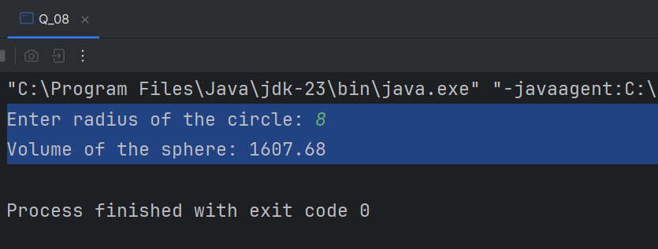Output:

**Q9.**

Code:

***package Q_09;  
  
import java.util.Scanner;  
  
public class Q_09 {  
 public static void main(String[] args) {  
 Scanner scanner = new Scanner(System.in);  
  
 System.out.print("Enter the initial investment (P): ");  
 double principle = scanner.nextDouble();  
  
 System.out.print("Enter the annual investment rate in percentage (R)-(Don't use percentage symbol): ");  
 double rate = scanner.nextDouble();  
  
 System.out.print("Enter the number of years: ");  
 int years = scanner.nextInt();  
  
 double famount = principle*Math.pow((1+(rate/100)),years);  
 System.out.println("Ater " + years + " years, your investment will grow to : " + famount);  
 scanner.close();  
 }  
}***

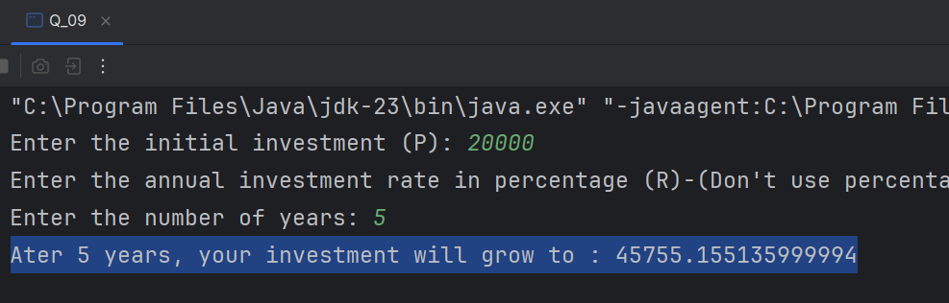Output:

**Q10.**

Code:

***package Q_10;  
  
import java.util.Scanner;  
  
public class Q_10 {  
 public static void main(String[] args) {  
 int monthsInYear = 12;  
 Scanner scanner = new Scanner(System.in);  
  
 System.out.print("Input loan amount: ");  
 double loanAmount = scanner.nextDouble();  
  
 System.out.print("Input annual interest rate (in %): ");  
 double annualInterestRate = scanner.nextDouble();  
  
 System.out.print("Enter the loan period (in years) : ");  
 double loanPeriod = scanner.nextDouble();  
  
 double monthlyinterestRate = annualInterestRate / 100.0 / monthsInYear;  
 double numberOfPayment = loanPeriod * monthsInYear;  
 double monthlyPayment = (loanAmount * monthlyinterestRate)/(1-Math.pow(1/(1 + monthlyinterestRate),numberOfPayment));  
 double totalPayment = monthlyPayment * numberOfPayment;  
  
 System.out.printf("Monthly Payment: %.2f\n", monthlyPayment);  
 System.out.printf("Total Payment: %.2f\n",totalPayment);  
  
 scanner.close();  
  
  
 }  
}***

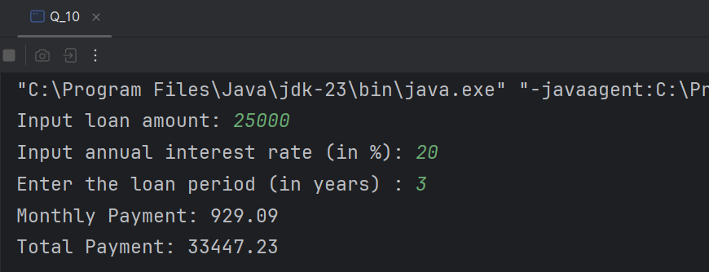Output: