**LW_04 - CT/2021/009 – Premarathna A.H.N.P**

**Q1.**

Code:

***package Q_01;  
  
import java.util.Scanner;  
  
 public class SmallestNumber {  
 public static void main(String[] args) {  
 Scanner scanner = new Scanner(System.in);  
  
 System.out.print("Enter Your First int: ");  
 int num1 = scanner.nextInt();  
  
 System.out.print("Enter Your Second int: ");  
 int num2 = scanner.nextInt();  
  
 System.out.print("Enter Your Third int: ");  
 int num3 = scanner.nextInt();  
  
 int smallestNo;  
  
 if (num1 <= num2 && num1 <= num3){  
 smallestNo = num1;  
 }  
 else if (num2 <= num1 && num2 <= num3) {  
 smallestNo = num2;  
 }  
 else {  
 smallestNo = num3;  
 }  
  
 System.out.println("The smallest No = " + smallestNo);  
 scanner.close();  
  
 }  
 }***

Output:

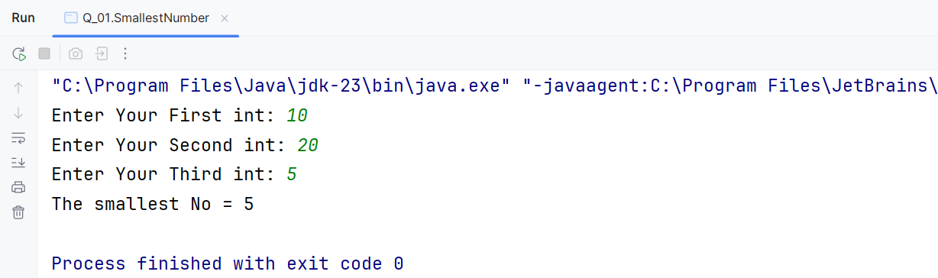

**Q2.**

Code:Output:

***package Q_02;  
  
import java.util.Scanner;  
  
public class Main {  
 public static void main(String[] args) {  
 Scanner scanner = new Scanner(System.in);  
  
 System.out.println("0.Magenta");  
 System.out.println("1.Cyan");  
 System.out.println("2.Red");  
 System.out.println("3.Blue");  
 System.out.println("4.Green");  
 System.out.print("Select one color from the above list : ");  
  
 int Selection = scanner.nextInt();  
  
 switch (Selection){  
 case 0:  
 System.out.println("You select Magenta");  
 break;  
 case 1:  
 System.out.println("You select Cyan");  
 break;  
 case 2:  
 System.out.println("You select Red");  
 break;  
 case 3:  
 System.out.println("You select Blue");  
 break;  
 case 4:  
 System.out.println("You select Green");  
 break;  
 default:  
 System.out.println("Invalid selection !");  
 }  
 scanner.close();  
  
 }  
}***

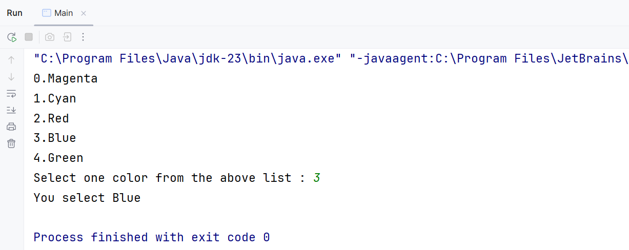

**Q3.**

Code:

***package Q_03;  
  
import java.util.Scanner;  
  
public class PowOfTen {  
 public static void main(String[] args) {  
 Scanner scanner = new Scanner(System.in);  
  
 System.out.print("Enter the power of 10 (e.g - 6,9,12,15,18,21,30,100) : ");  
 int powOf10 = scanner.nextInt();  
  
  
 switch (powOf10){  
 case 6:  
 System.out.println("The number is Million");  
 break;  
 case 9:  
 System.out.println("The number is Billion");  
 break;  
 case 12:  
 System.out.println("The number is Trillion");  
 break;  
 case 15:  
 System.out.println("The number is Quadrillion");  
 break;  
 case 18:  
 System.out.println("The number is Quintillion");  
 break;  
 case 21:  
 System.out.println("The number is Sextillion");  
 break;  
 case 30:  
 System.out.println("The number is Nonillion");  
 break;  
 case 100:  
 System.out.println("The number is Googol");  
 break;  
 default:  
 System.out.println("There is no standard name for 10 to the power of " + powOf10);  
  
 }  
 scanner.close();  
 }  
}***

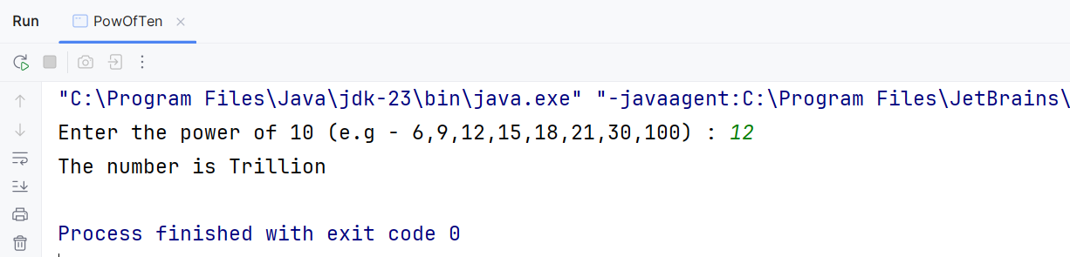Output:

**Q4.**

Code:

***package Q_04;  
  
import java.util.Scanner;  
  
public class Year {  
 public static void main(String[] args) {  
 Scanner scanner = new Scanner(System.in);  
  
 System.out.print("Enter the year here: ");  
 int Yer = scanner.nextInt();  
  
 if((Yer % 4 == 0 && Yer % 100 != 0) || (Yer % 400 == 0)){  
 System.out.println(Yer + " is a leap year.");  
 }  
 else {  
 System.out.println(Yer + " is not a leap year.");  
 }  
 scanner.close();  
 }  
}***

Output:

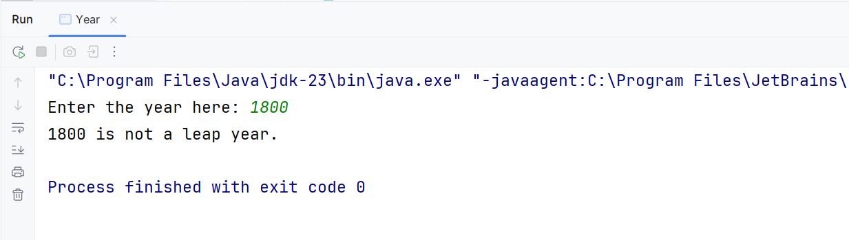

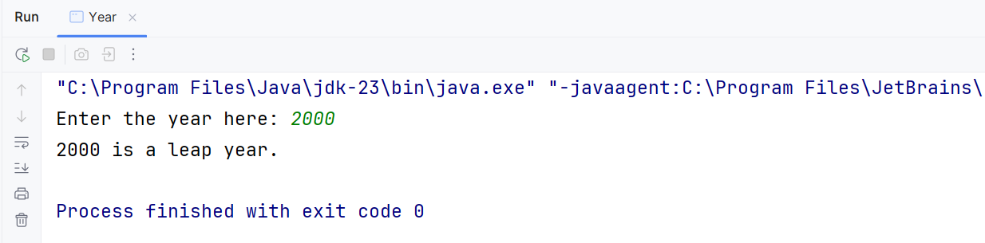

**Q5.**

Code:

***package Q_05;  
  
import java.util.Scanner;  
  
public class FoodMenu {  
 public static void main(String[] args) {  
 Scanner scanner = new Scanner(System.in);  
  
 String[] burgers = {"1. Veggie Burger", "2. Chicken Burger", "3. Cheese Burger"};  
 String[] drinks = {"1. Orange Juice", "2. Sprite", "3. Cocacola"};  
 String[] desserts = {"1. Ice-cream", "2. Fruit Salad", "3. Brownies"};  
  
 System.out.println("!....Welcome to MyJava Lo-Fat Burgers....!");  
 System.out.println("\n---Burger Menu---");  
  
 for (String burger : burgers){  
 System.out.println(burger);  
 }  
 System.out.print("Please choose a burger [1 to 3]: ");  
 int BurgChoice = scanner.nextInt();  
  
 System.out.println("\n---Drinks Menu---");  
  
 for (String drink: drinks){  
 System.out.println(drink);  
 }  
 System.out.print("Please choose a drink [1 to 3]: ");  
 int DrinkChoice = scanner.nextInt();  
  
 System.out.println("\n---Desert Menu---");  
 for (String desert : desserts){  
 System.out.println(desert);  
 }  
 System.out.print("Please choose a desert [1 to 3]: ");  
 int DesertChoice = scanner.nextInt();  
  
 System.out.println("\n---This is your order---");  
 System.out.println("\nBurger: " + burgers[BurgChoice - 1].substring(3));  
 System.out.println("Drink: " + drinks[DrinkChoice - 1].substring(3));  
 System.out.println("Desert: " + desserts[DesertChoice - 1].substring(3));//".substring(3)" - start from index 3, skipping over "1. "  
 System.out.println("\n--Thank you--");  
  
 scanner.close();  
  
 }  
}***

Output:

