**LW_05 - CT/2021/009 – Premarathna A.H.N.P**

**Q1.**

Code:

***package Q_01;  
  
public class Main {  
 public static void main(String[] args) {  
  
 for ( int i=10; i<50; i++){  
 System.out.print(i + " ");  
 if(i % 10 == 9){  
 System.out.println();  
 }  
 }  
 }  
}***

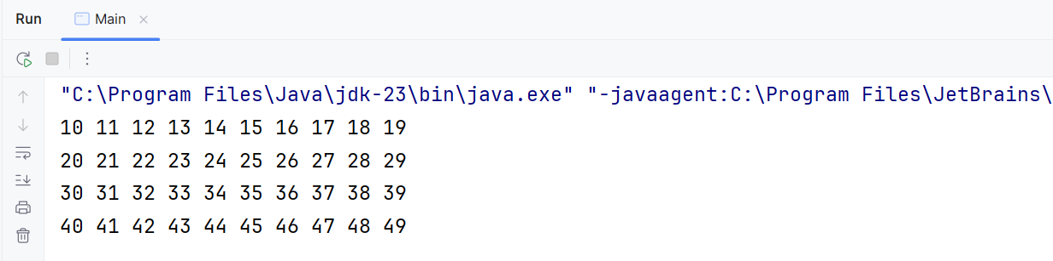Output:

**Q2.**

Code:Output:

***package Q_02;  
  
import java.util.Scanner;  
  
public class CountDigit {  
 public static int CountDig (int number) {  
 if (number == 0) {  
 return 1;  
 }  
 int count = 0;  
 number = Math.abs(number);  
  
 while (number > 0){  
 count++;  
 number /= 10;  
 }  
 return count;  
  
 }  
  
 public static void main(String[] args) {  
 Scanner scanner = new Scanner(System.in);  
  
 while (true){  
 System.out.print("Enter an integer [Please don't enter negative numbers]:");  
 int input = scanner.nextInt();  
  
 if (input<0){  
 System.out.println("---Programme Terminated---");  
 break;  
 }  
 int digitCounter = CountDig(input);  
 System.out.println(input + " has " + digitCounter + " no of digits");  
 }  
 scanner.close();  
 }  
}***

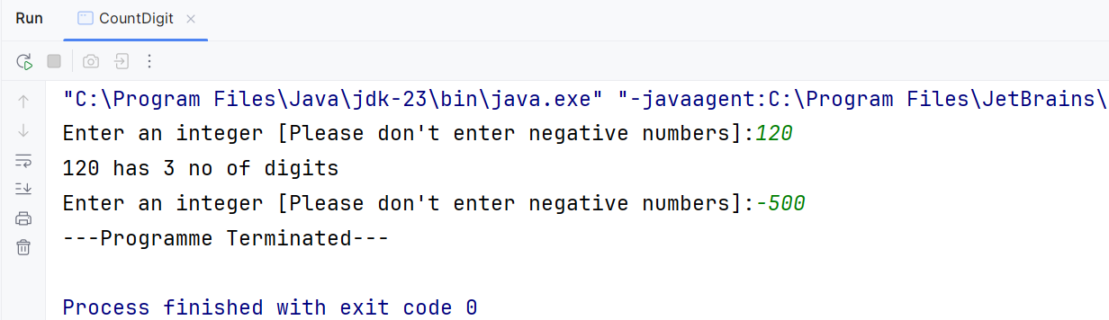

**Q3.**

Code:

***package Q_03;  
  
import java.util.Scanner;  
  
public class MultiplicationTable {  
 public static void main(String[] args) {  
 Scanner scanner = new Scanner(System.in);  
 System.out.print("Enter the number for print multification table: ");  
 int number = scanner.nextInt();  
  
 System.out.println("\nMultiplication Table");  
 for (int i = 1 ; i<=10; i++){  
  
 int Multiplication = i * number;  
 System.out.println(number + " x " + i + " = " + Multiplication);  
 }  
  
 scanner.close();  
  
 }  
}***

Output:

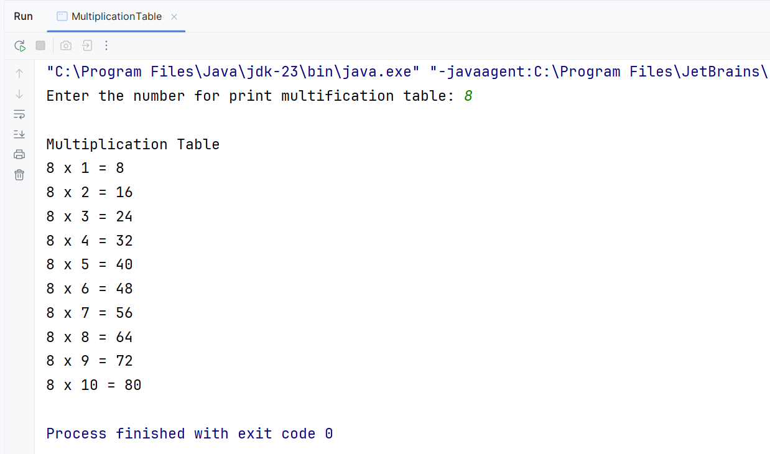

**Q4.**

Code:

***package Q_04;  
  
import java.util.Scanner;  
  
public class patternPrinter {  
 public static void main(String[] args) {  
 Scanner scanner = new Scanner(System.in);  
 System.out.print("Enter the number of rows, Do you want: ");  
 int numOfRows = scanner.nextInt();  
  
 for(int i = 1; i <= numOfRows; i++){  
 for (int x = 1; x <= numOfRows - i; x++)//for print spaces before stars  
 {  
 System.out.print(" ");  
 }  
 for(int y = 1; y <= (2 * i - 1); y++)//for print stars  
 {  
 System.out.print("*");  
 }  
 System.out.println();//for go to next row  
  
 }  
 scanner.close();  
 }  
}***

Output:

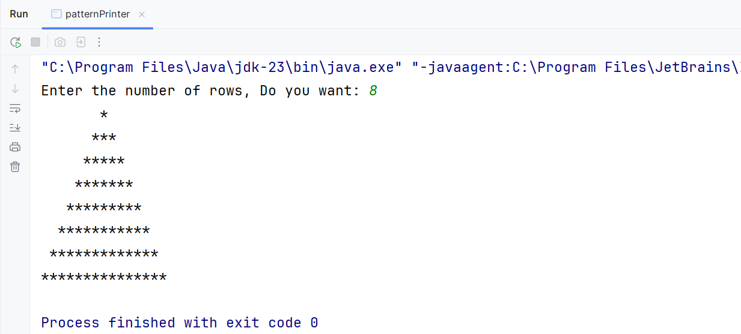

**Q5.**

Code:

***package Q_05;  
  
import java.util.Scanner;  
  
public class Palindrome {  
 public static void main(String[] args) {  
 Scanner scanner = new Scanner(System.in);  
  
 System.out.print("Enter the word oe phrase here: ");  
 String input = scanner.nextLine();  
  
 String CleanInput = input.replaceAll("[^a-z A-Z 0-9]","").toLowerCase();//for Removing Spaces  
 String Reverse = new StringBuilder(CleanInput).reverse().toString();//for reverse the phrase or word  
  
 if (CleanInput.equals(Reverse)){ //for check if it is palindrome?  
 System.out.println("'" + input + "'" + " is palindrome");  
 }  
 else {  
 System.out.println("'" + input + "'" + " is not palindrome");  
 }  
  
 scanner.close();  
 }  
  
  
}***

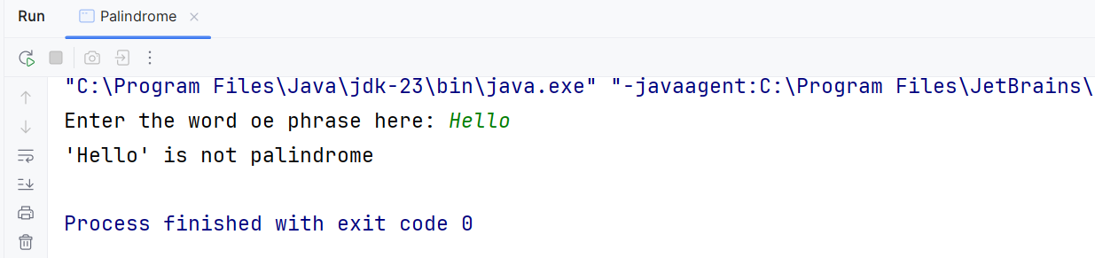Output:

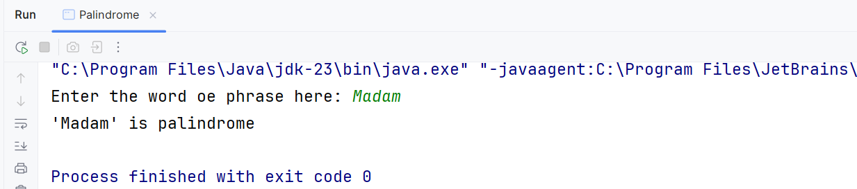

**Q6.**

Code:

***package Q_06;  
  
import java.util.Scanner;  
  
public class NumberGuesser {  
 public static void main(String[] args) {  
 int GuessedNumber = (int) (Math.random() * 100) + 1 ;  
 Scanner scanner = new Scanner(System.in);  
  
 int Guess = 0;  
 int NoOfTries = 0;  
  
 System.out.println("'I am thinking of a number beween 1 and 100'");  
 System.out.println("'Can you guess what the number ?'");  
  
 while (Guess != GuessedNumber ){  
 System.out.print(" What is your guess? : ");  
 Guess = scanner.nextInt();  
 NoOfTries++;  
  
 if (Guess < GuessedNumber){  
 System.out.println("Too low!, Try again.");  
 }  
 else if (Guess > GuessedNumber) {  
 System.out.println("Too high!, Try again.");  
 }  
 else {  
 System.out.println("Your guess is right! , Guess it in after" + NoOfTries + " tries.");  
 }  
 }  
 scanner.close();  
 }  
}***

Output:

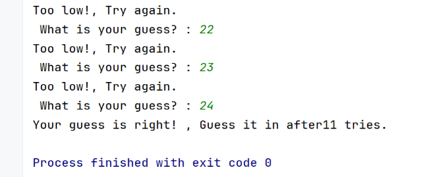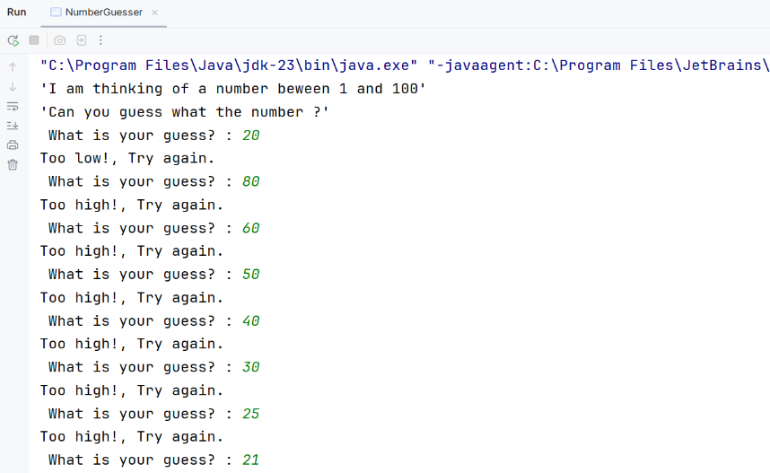

**Q7.**

Code:

***package Q_07;  
  
import java.util.Scanner;  
  
public class wordReplacer {  
 public static void main(String[] args) {  
 Scanner scanner = new Scanner(System.in);  
  
 System.out.print("Enter a sentence : ");  
 String sentence = scanner.nextLine();  
  
 System.out.print("Enter the word to be replaced : ");  
 String ThewordtobeChanged = scanner.nextLine();  
  
 System.out.print("Enter the replacement word : ");  
 String replacementWord = scanner.nextLine();  
  
 String updatedSentence = sentence.replaceAll("\\b" + ThewordtobeChanged + "\\b", replacementWord);  
  
 System.out.print("Updated Sentence -> " + updatedSentence);  
  
 scanner.close();  
  
  
 }  
}***

Output:

