AI CONFIGURATION & ARCHITECTURE

HORIZON GRID
AI Guide

Version: 0.1.0
Documentation prepared: 2026-08-17

PREPARED FOR EVALUATION

Table of Contents
Right-click here and choose "Update Field" (or press F9) to generate the Table of Contents.

HORIZON GRID Standalone AI Backend Guide — Configuring, Testing, Switching, and Trusting the AI Layer

Why this document exists
tech-03-ai-architecture.md already covers the AI layer's architecture from a source-code-reading point of view — the two-call structure, the grounding/cross-check mechanisms, the Verdict/RiskAssessment data model. user-07-ai-analysis.md already covers what an analyst actually sees on an investigation page and how to check an AI-written claim against the real evidence behind it. This document sits alongside both: a single, hands-on guide for whoever is actually setting up and operating the AI layer — how to add credentials for each of the five supported backends, test a connection before trusting it, switch the active backend at runtime with zero downtime, run a side-by-side comparison between two backends on the same evidence, and understand precisely what the platform does and does not guarantee about the AI's output. Everything below is drawn directly from backend/app/ai/service.py, backend/app/ai/schemas.py, the five per-backend client modules (ollama_client.py, anthropic_client.py, bedrock_client.py, gemini_client.py, groq_client.py), backend/app/ai/connection_test.py, backend/app/core/runtime_config.py, backend/app/api/routes/ai_config.py, backend/app/api/routes/runtime.py, and backend/app/ai/dashboard_summary.py — nothing here is inferred from the feature's general shape.

1. The Five Supported Backends
Backend | Config value | Mode | Credential(s) | Default model
Ollama | ollama | Local — runs on your own machine, no API key, no per-token cost | None (just a reachable base URL) | llama3.2:3b
Anthropic | anthropic | Direct API | One API key (  sk-ant-...  ) | claude-sonnet-4-5-20250929
AWS Bedrock | bedrock | Cloud, via AWS | Bedrock bearer token,  or  an IAM access key + secret | global.anthropic.claude-sonnet-4-5-20250929-v1:0
Google Gemini | gemini | Cloud | One API key | gemini-2.0-flash
Groq | groq | Cloud, fast inference | One API key | llama-3.3-70b-versatile

All five client classes expose the identical call_claude_json(system_prompt, user_prompt, json_schema, tool_name, max_tokens) method, which is what lets app/ai/service.py treat every backend interchangeably without branching on which one happens to be active. Ollama is the default specifically because it needs neither a key nor a paid quota — Bedrock needs IAM provisioning, Gemini and Groq need a cloud account with billing/quota set up, Anthropic needs only a key but still a funded account.

2. Where You Configure This
There are two places to touch AI configuration, and they serve different moments:
- The Setup Wizard's AI Configuration page — the first-run (or "Reconfigure") path, covered in full in standalone-windows-installation.md. It lets you pick a backend, enter its credentials, and test the connection before the platform ever starts. Every AI Configuration field is pre-filled with the real current values on a reconfigure run.
- Manage Providers → AI Providers tab (/providers in the running platform, requires the provider:manage permission — ADMIN only) — the day-to-day path for adding a second backend, rotating a key, or changing the default model without re-running the wizard. This is a real, dedicated UI tab (frontend/app/providers/page.tsx), separate from the IOC Providers, Audit Log, and Network Access tabs alongside it, and every change here "takes effect on the next investigation immediately — no restart, no editing files," per the page's own on-screen description.
Each backend appears as its own card on the AI Providers tab (ProviderConfigRow), showing exactly the credential fields that backend actually needs — nothing generic or one-size-fits-all:
Backend | Fields shown on its card
ollama | base_url
anthropic | api_key
bedrock | bedrock_api_key  ,  aws_access_key_id  ,  aws_secret_access_key  ,  aws_region
gemini | api_key
groq | api_key

Every card also carries a model-ID field, a Test Connection button, a Save button, and — for whichever backend isn't already active — a Set Active button. A backend that is currently active shows an "Active" badge instead of the Set Active button.
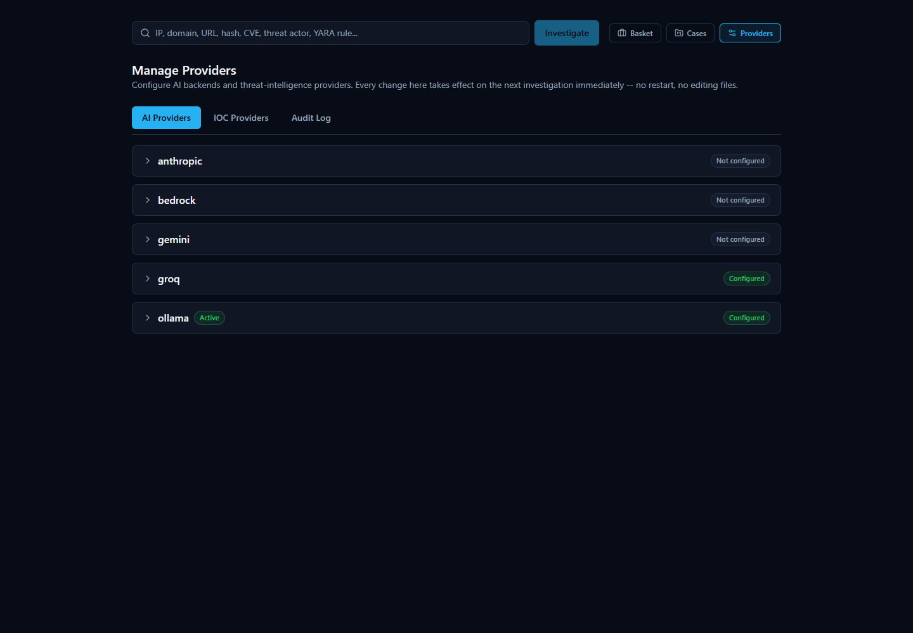

3. Adding and Configuring Each Backend

Ollama (local)
Field: base_url (model is a separate field, not a credential). The backend process runs inside Docker while Ollama itself normally runs directly on the host machine, so the base URL is nothttp://localhost:11434 from the container's point of view — it defaults to http://host.docker.internal:11434, which Docker Desktop on Windows resolves to the host automatically. If Ollama runs somewhere else on your network, point this at that host instead. There is nothing to redact here: Ollama needs no API key at all.
Before pointing the platform at a model, that model has to actually be pulled on the Ollama instance (ollama pull llama3.2:3b or whichever model you intend to use) — the connection test below will tell you plainly if it isn't.

Anthropic (direct API)
Field: api_key (a real sk-ant-... key from the Anthropic Console). This is the simplest cloud backend to provision: unlike Bedrock, there's no IAM policy or model-access grant to request, and unlike Gemini, there's no separate cloud project to create — the key alone, on a funded account, is sufficient.

AWS Bedrock
Bedrock supports two independent auth schemes, and you only need one:
- Bedrock API key (bearer token) — the bedrock_api_key field, populated from AWS IAM's own "Generate API key" button. This is the preferred path: the platform sets AWS_BEARER_TOKEN_BEDROCK from this value and botocore's own token-provider chain picks it up automatically.
- Classic IAM access key + secret — aws_access_key_id + aws_secret_access_key (plus aws_region, defaulting to us-east-1), for an account that grants bedrock:InvokeModel through a normal IAM user or role instead of a bearer token.
Whichever scheme you use, the account/role needs actual model access granted for the configured model_id in that AWS region — a correctly-formed credential with no model access will fail the connection test with a specific "model not found or not enabled in this account/region" message rather than a generic authentication error, so read the test result's exact wording before assuming the key itself is wrong.

Google Gemini
Field: api_key, from a Google AI Studio / Cloud project with the Gemini API enabled and billing configured. The key is sent via the x-goog-api-key header rather than a ?key= query parameter — deliberately, since request URLs (including query strings) are what get written to plain HTTP logs, and a query-string key would otherwise land in those logs on every call.

Groq
Field: api_key, from the Groq console (console.groq.com). Groq is a distinct inference provider from "Grok" (xAI) — this is api.groq.com, an OpenAI-compatible chat-completions API.
Groq's model field is the one that behaves differently from the other four: instead of a fixed dropdown, the platform discovers Groq's real, currently-available model list live, by calling Groq's own GET /v1/models with whatever key you've just typed (POST /api/v1/ai/groq/models on the backend, wired to the wizard/UI's model field). This exists because Groq's hosted model lineup changes over time — a hardcoded list would silently go stale as Groq deprecates or introduces models. If no key has been entered yet, or the live call fails, the field falls back to a short static list (llama-3.3-70b-versatile, llama-3.1-8b-instant, openai/gpt-oss-120b) that is explicitly not treated as exhaustive — whatever model ID you actually submit to a real chat-completion call is sent as-is; Groq's own API is the only authority on whether it exists, not this fallback list.
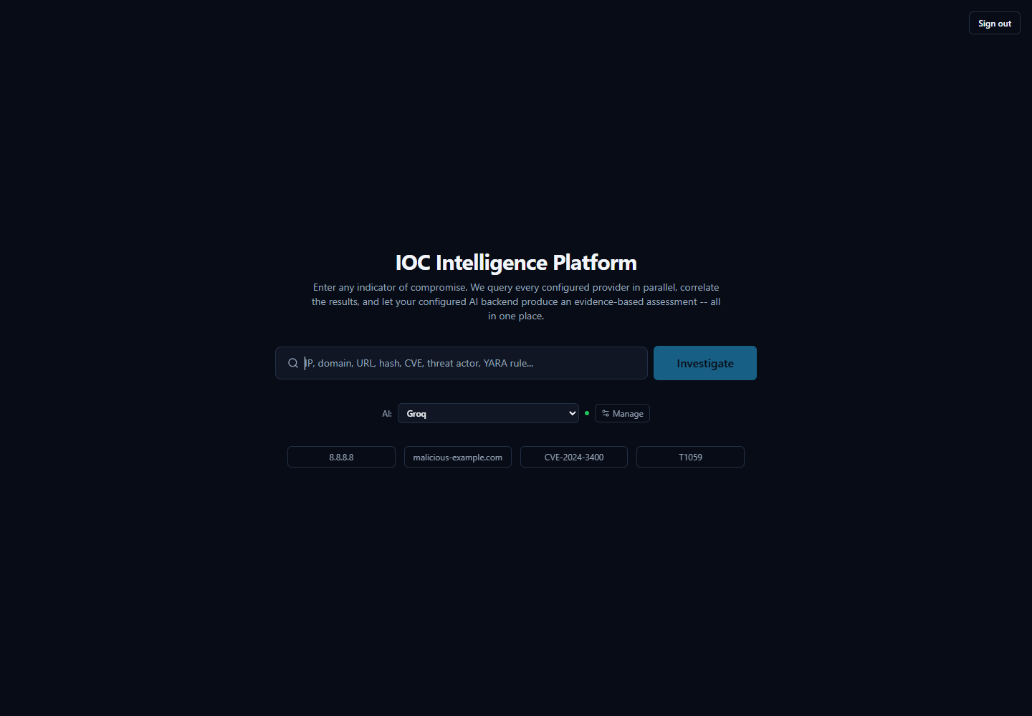

4. Testing a Connection Before You Trust It
Every one of the five backends has a real, live "does this actually work" check — POST /api/v1/ai/test (app/api/routes/ai_config.py's ai_test_connection(), calling app/ai/connection_test.py's test_ai_connection()), gated behind the same provider:manage permission as everything else on this page. Two properties hold for every backend, without exception:
- It always tests the candidate credentials you just typed, never whatever is already saved. This is a deliberate trust-model choice, shared with the equivalent IOC-provider test: you can safely try a new key in the field before overwriting a working one, and testing never mutates the stored configuration.
- It makes one real, minimal round trip to the backend's own API — a one-word "reply with exactly one word: pong" prompt — and reports what actually happened: whether it succeeded, which model actually replied, and the real measured latency in milliseconds. Nothing about the result (model name, latency, success) is simulated.
The failure messages are specific rather than a generic "failed," because each backend's real HTTP status codes are interpreted individually: a 401/403 reports as an authentication problem ("check your API key"/"check your credentials and IAM permissions"), a 404 reports as the specific model ID not being found or not enabled on that account, and a 429 reports as a rate limit with a note that the key itself may still be valid. Ollama's own connection test additionally refuses to test an unsafe outbound URL (assert_safe_outbound_url) and, on a 404, tells you directly to ollama pull <model> first rather than leaving you to guess why a locally-hosted model didn't respond.
Clicking Save after a successful test persists the credential into the runtime-mutable configuration store (not just .env); a separate record-test call then stores that result so the AI Providers tab can show "last tested: ok, N minutes ago" the next time you open it, without silently re-testing on every page load.
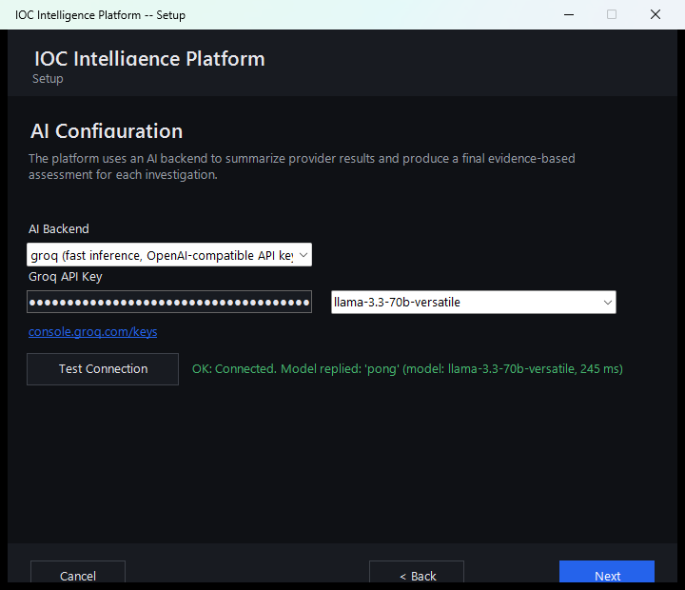

5. Switching the Active Backend at Runtime — Zero Downtime
Every backend's credentials and model ID can be saved without making that backend active — configuring Groq doesn't stop Ollama (or whichever backend is currently active) from continuing to serve every AI call until you explicitly switch.
Switching is one action: clicking Set Active on a backend's card in the AI Providers tab, or picking a different entry from the compact "AI: [dropdown]" control next to the home page's search bar (AiQuickSwitch.tsx) — both call the identical POST /api/v1/runtime/ai-active. This persists which backend row in the provider_runtime_configs table has is_active = true, and the effect is immediate: the very next AI call anywhere in the platform — the next per-provider summary or final assessment, for any in-flight or brand-new lookup, and the next Dashboard executive-summary generation — uses the newly active backend and its credentials. There is no container restart, no .env edit, and no redeploy involved.
What makes this possible mechanically is that app/ai/service.py's _get_ai_client() resolves which backend/credentials to use on every single call, not once at process start. The resolution order is:
- An explicit backend_override, used only by the AI-comparison feature (§6 below) to name a specific non-active backend for one comparison run, without changing the platform-wide active backend.
- The currently active runtime-configured backend — a fresh database read of provider_runtime_configs on that exact call.
- The legacy, frozen Settings singleton (.env-derived), kept only as a fallback for an install where no runtime config has ever been seeded at all.
Because step 2 is a fresh read every time rather than a cached value from process start, and because each of the five client classes accepts constructor overrides so a fresh, correctly-credentialed instance can be built per call instead of reusing a stale singleton, "switch AI backend" really is a config change with immediate effect, not a code change or a restart.
If the resolved backend's is_configured check fails (a backend selected active with no working key/URL), the platform raises immediately with a clear message naming the problem, rather than letting the request fall into a confusing low-level failure — e.g. an httpxTypeError on a None header, or Gemini silently sending the literal string "None" as an API key and getting back an ordinary-looking 4xx.
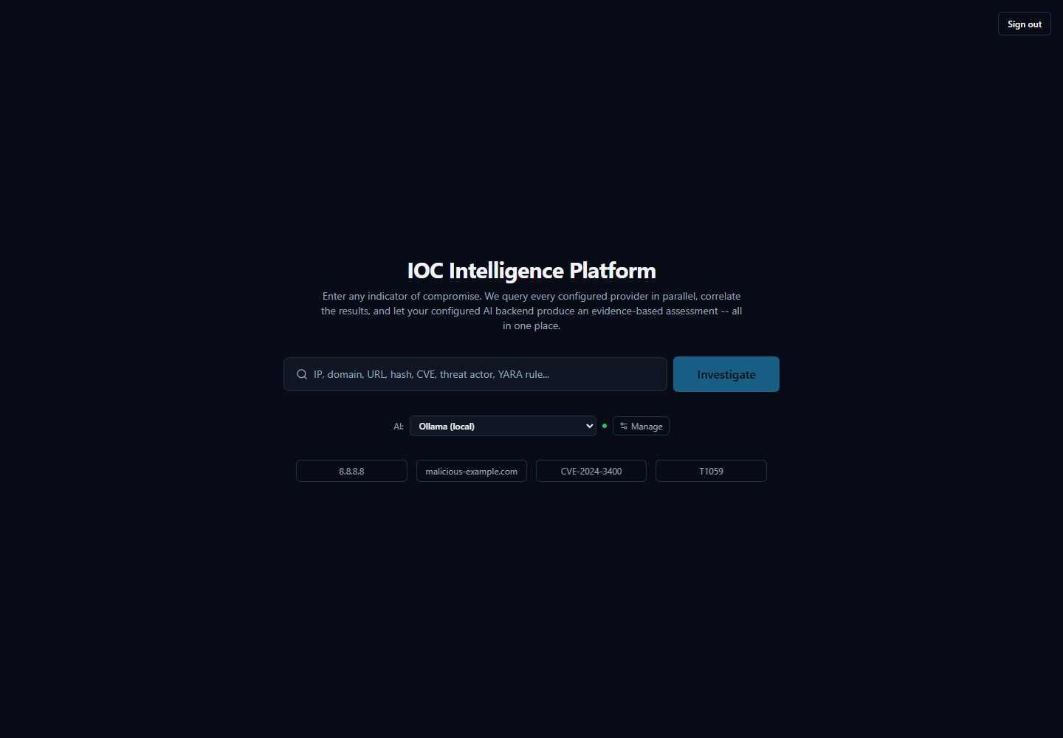

6. AI Backend Comparison — Reanalyzing the Same Evidence
Because the active backend can change between one lookup and the next, an analyst can also deliberately ask "what would a different backend have concluded from this exact same evidence?" without re-running the whole investigation. This is the AI Comparison panel on a completed investigation's page (AiComparisonPanel.tsx), and it maps directly to POST /api/v1/lookup/{lookup_id}/reanalyze.
A reanalysis run:
- Never re-queries any IOC provider. It rebuilds provider_summaries from the already-persisted AISummaryRecord rows and rebuilds the correlation result purely from already-persisted correlation-edge rows — the exact same reconstruction the original investigation's own final-assessment step used, just replayed from storage instead of freshly computed.
- Recomputes the deterministic score from the same persisted evidence (provider results, correlation, and any Security Assessment Toolkit findings — including findings added to this lookup after the original investigation ran) rather than reusing whatever score the original assessment happened to persist. This is deliberate: every backend compared side-by-side against the same evidence must show the identicaloverall_risk_score/confidence_score/malicious_probability/severity, differing only in AI-authored prose and verdict choice among the options those numbers actually support. A backend that appeared to "compute" a different score would defeat the entire point of a same-evidence comparison.
- Never overwrites the original assessment. Every result — the original plus every later comparison — is written as its own row in final_assessment_records, tagged with the ai_backend/ai_model that produced it and an is_primary flag distinguishing the original from a comparison. GET /api/v1/lookup/{lookup_id}/assessments returns the full set for side-by-side review.
In the UI, picking a backend from the dropdown and clicking "Analyze with <backend>" appends a new card to the list, each one labeled "Original" or "Comparison" alongside its backend/model, its verdict badge, and its risk/confidence/malicious-probability numbers. Neither result is presented as more authoritative than the other — the value is in the second opinion itself, and in the ability to see two backends actually agree (or disagree) on the same underlying evidence.
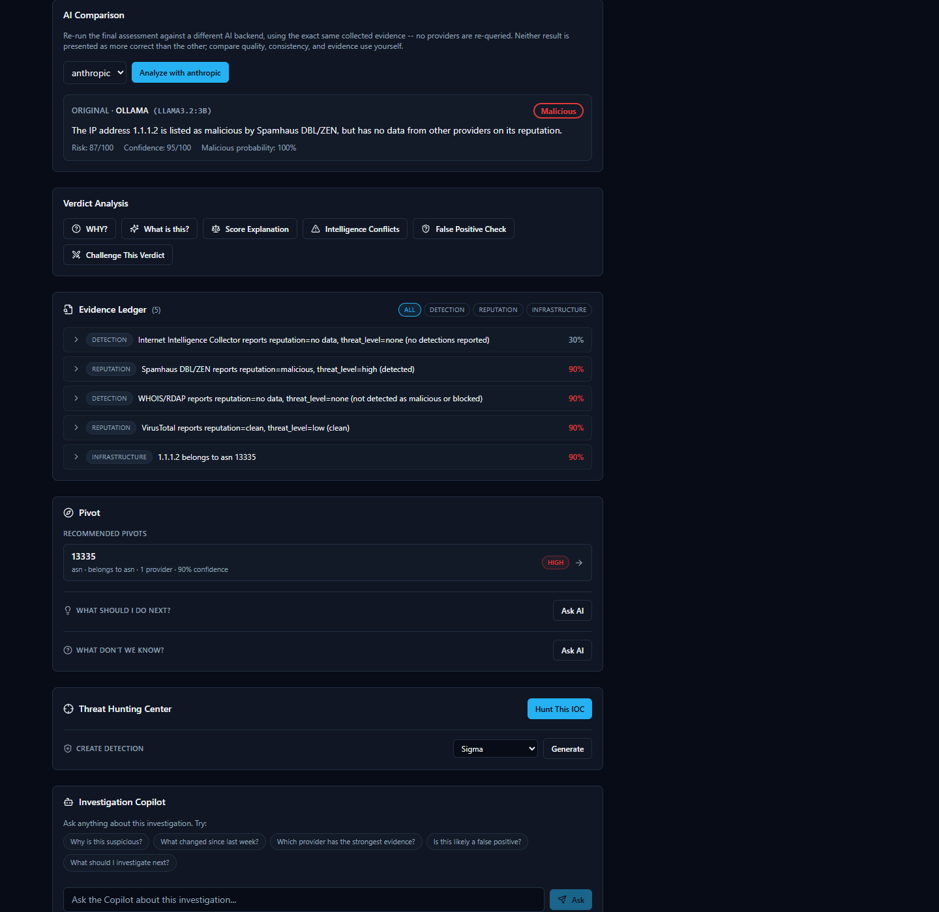

7. The Three AI Outcomes — And Why "Skipped" Is Not a Failure
Every FinalAssessment this platform ever produces carries an explicit ai_outcome field, one of exactly three values (app/ai/schemas.py's _AIOutcome), set at all three of generate_final_assessment()'s return points in service.py:
ai_outcome | What it means | When it happens
success | The AI backend was called, its structured output validated, and the response was returned. | The normal path.
skipped_no_evidence | A  correct decision  never to call the AI at all — there was nothing to analyze. | provider_summaries  is empty  and  the correlation engine found zero edges.
failed | A  genuine generation failure  — the AI was called but every retry attempt still raised. | E.g. a rate-limited or unreachable backend, or output that never validated.

The distinction between skipped_no_evidence and failed exists specifically so a later reliability metric — the Dashboard's ai_success_rate KPI — can tell "there was genuinely nothing to analyze" apart from "the AI was asked and it broke," rather than lumping both into one number. ai_success_rate explicitly excludes skipped_no_evidence from both the numerator and the denominator of its calculation: an investigation where no provider returned any data is not a strike against the AI's reliability, and counting it as one would make a platform with excellent AI reliability look artificially worse purely because some investigations legitimately had zero evidence to work with.
The skipped_no_evidence path exists because of a real, reproduced failure, not a hypothetical one: looking up the EICAR antivirus test file's actual MD5 hash (44d88612fea8a8f36de82e1278abb02f, a standard, harmless, industry-wide AV test file) with every relevant provider left unconfigured — meaning zero real evidence of any kind reached the prompt — still caused a small local model (llama3.2:3b) to return final_verdict="highly_malicious" and malicious_probability=92, fabricating an "association with ransomware and trojans" wholesale from its own pretrained knowledge of a famous hash, directly violating its own system-prompt instruction never to fabricate. No prompt wording fixed this reliably — the model already had that instruction and ignored it — so the platform doesn't call the AI at all whenever provider_summaries and correlation.edges are both empty: an empty-evidence case has exactly one correct answer (unknown, all risk fields at their real deterministic value, an honest "no provider returned usable data" message) regardless of which backend happens to be configured, so deterministic code produces it instead of hoping a model declines to guess.

8. Prompt Architecture, at a High Level
tech-03-ai-architecture.md §3 already covers the two structurally distinct call types in detail — summarize_provider() (one call per provider that returned real data, grounded only in that provider's own JSON) and generate_final_assessment() (one call per lookup, grounded in every provider summary plus the correlation engine's output, never in raw provider JSON again) — along with the grounding/cross-check mechanisms that filter the model's agreeing_providers/disagreeing_providers claims and flag ungrounded MITRE mappings. That material isn't repeated here; this section adds one mechanism that document doesn't cover: how a single provider's raw payload is actually shaped before it reaches summarize_provider()'s prompt at all.

Field-length pruning (_prune_for_prompt())
The module's own docstring states that raw provider JSON should never reach a prompt unbounded — this is the one call site (summarize_provider(), not generate_final_assessment(), which is already bounded by construction since it only ever sees already-distilled summaries) where that rule has to be actively enforced, because a single provider's raw response can be enormous.
This was tuned against two real, reproduced failures, not designed abstractly:
- NIST NVD's configurations field. For a genuinely critical CVE (CVE-2021-44228, Log4Shell), this field runs to hundreds of nested CPE-match entries — dozens of times longer than the actual signal (verdict, cvss_score, cvss_severity, description). Feeding it to the model unbounded buried the CRITICAL severity under noise the model's attention gravitated to instead, reproduced on two different backends (a local 3B model and a hosted 70B model), both calling a CVSS 10.0 remote-code-execution vulnerability "benign" or "unknown risk."
- A single uniform cap wasn't the fix. A flat 800-character cap fixed NVD but broke MITRE ATT&CK, whose description field is that provider's only signal-bearing field (no separate short verdict/score field the way NVD has) and routinely runs 600–1,800+ characters for a real technique — the cap silently chopped legitimate signal mid-sentence, the same "AI loses the signal" failure this function exists to prevent, just from the opposite direction. Raising the same uniform cap to 4,000 characters fixed MITRE but then broke NVD a second way: NVD's references field (a bare list of URLs, 7,851 characters observed) and configurations (67,721 characters observed) both blew past a per-field cap of 4,000 combined, pushing a real Groq call to an HTTP 413 against Groq's per-minute token limit.
The actual fix distinguishes why a field is long, not just how long: a str field (prose, like MITRE's description) gets a generous 2,000-character cap, since long prose is far more likely to be genuine single-field signal; a list/dict field (inherently structural or repetitive — CPE match entries, URL lists, raw report objects) gets a tighter 800-character cap regardless of provider, since every oversized list/dict field examined across both NVD and AbuseIPDB turned out to be low-signal bulk, never the primary carrier of a verdict. Short, scalar fields — the ones actually carrying a verdict — pass through untouched either way, and a truncated field is marked as truncated (with its real original length) rather than silently cut.

9. The Deterministic-Score Lock — Why the AI Can Narrate a Score but Never Set One
This is the single most load-bearing design fact in this layer, and it exists because of directly observed failures, not as a theoretical safeguard.
app/scoring/engine.py computes overall_risk_score, confidence_score, malicious_probability, and severitybefore any AI call happens at all, from the deterministic combination of provider-verdict consensus and correlation-graph evidence. By the time generate_final_assessment() runs, those four numbers already exist and are already correct — the AI's job for this part of its output is narration and justification, never computation.
The user prompt hands the model those four values in an explicit "Deterministic risk assessment (already computed — GIVEN, do not recalculate)" block, and the system prompt instructs the model to echo them back verbatim into the risk object and choose a final_verdict consistent with them — never to invent different numbers, and never to let a verdict contradict them. That instruction alone, however, is not what actually enforces this — testing showed prompt wording by itself was not reliable enough, especially against a small local model:
- RiskAssessment's own field validator (_reject_0_to_1_scale) had to be added because llama3.2:3b was directly observed defaulting to a 0–1 probability convention (returning 0.5 for "50%") despite the field's explicit 0–100 description.
- FinalAssessment's _verdict_must_agree_with_risk validator had to be added because the same small model was directly observed emitting self-contradictory pairs in a single response — e.g. final_verdict="malicious" alongside a malicious_probability around 10–20 — that pass each individual field's own validation but make no sense together.
So the platform does not rely on the model getting this right. After a response validates, generate_final_assessment() unconditionally overwritesrisk.overall_risk_score, confidence_score, malicious_probability, severity, scoring_engine_version, and scoring_breakdown with the real, already-computed values from the scoring engine — regardless of what the model actually emitted for those fields. Critically, it does not stop at swapping the numbers in: it re-runs FinalAssessment.model_validate() on the entire object with the real risk spliced in, which re-executes every validator on the model — including _verdict_must_agree_with_risk — against the values that are actually about to be persisted, not just against whatever the model itself originally emitted. A model that emitted a self-consistent-but-wrong pair (its own invented malicious_probability=92 alongside final_verdict="malicious") would sail through the validator on its own numbers; only re-validating against the real numbers can catch a verdict that flatly contradicts them. If that re-validation fails, the same retry loop that already exists for a first-pass validation failure gives the model one more attempt, still working from the same given numbers. ai_backend and ai_model are overwritten the same mechanical way, with the real, code-derived identity of whichever backend actually produced the call — never left to a model's own (possibly wrong, possibly absent) self-report.
The practical upshot: re-analyzing the same evidence with a different backend (§6) will always show the identical score, every time, no matter which of the five backends produced it or how that backend chose to phrase its reasoning — because the score was never the AI's to decide in the first place.

10. The Executive Summary's Honest AI/Template Disclosure
The Dashboard's AI-generated executive narrative (GET /api/v1/dashboard/executive-summary, app/ai/dashboard_summary.py) follows the identical discipline as §9, applied to KPI numbers instead of a risk score: app/core/dashboard.py's get_kpis() is the only source of truth for every number the narrative states, and the AI is handed those seven KPI values as given facts it must not recalculate, round, or restate differently.
If the AI call fails outright, or its output fails validation on both the original attempt and its one retry, the endpoint does not error and does not return a blank summary — it falls back to _template_fallback_narrative(), a deterministic, template-built sentence constructed directly from the same real KPI numbers (e.g. "There are currently N active investigation(s) in progress and N open case(s)..."). Whichever path actually produced the text, the response's source field honestly says so — "ai" or "template_fallback" — rather than letting a fallback silently look like a real AI success. The Dashboard's Executive Summary card surfaces this directly as a visible badge reading "AI-generated" or "Template fallback" next to the narrative, so nobody reading it mistakes a template sentence for an AI-authored one.
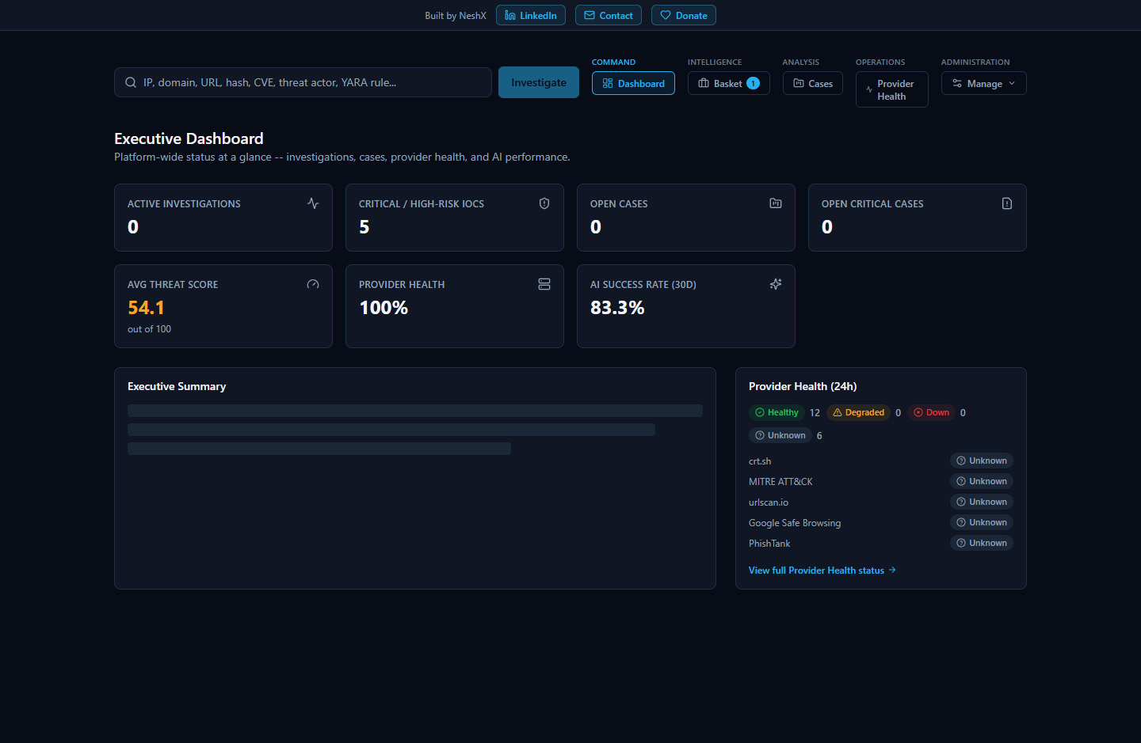

11. Known Limitation: A Local Ollama Backend Serializes Concurrent Requests
This is a real, tested, and already-documented characteristic (also noted in tech-09-performance.md and the project's FINAL_RELEASE_QA_REPORT.md), not a newly discovered issue: when the platform is configured to use a local Ollama model, that single local model processes generation requests one at a time. Under light or moderate use this is unnoticeable, but under heavy concurrent load — for example, several analysts triggering investigations or Dashboard executive-summary generation at the same moment — requests queue up behind one another rather than running in parallel, and per-request latency grows accordingly.
Two things are true about this limitation and worth stating plainly:
- It never affects data correctness. The underlying KPI numbers, deterministic risk scores, and provider evidence are always the same real values regardless of how long the AI narrative itself takes to generate — this is purely a latency characteristic of a single local model instance, not a correctness gap.
- It does not touch the Dashboard's core KPI tiles or the Provider Health page, both of which are pure database reads, unaffected by AI backend choice or load, and both of which were separately load-tested to 25 concurrent requests with a genuine 100%-success outcome (see tech-09-performance.md).
An administrator who expects many concurrent users should consider a cloud backend (Anthropic, Bedrock, Gemini, or Groq) rather than Ollama specifically to get consistently fast AI generation under concurrent load — the runtime-switching mechanism in §5 makes this a config change, not a re-deployment.

See Also
- tech-03-ai-architecture.md — the architectural deep dive: the two-call structure, the full grounding/cross-check mechanism, and the Verdict/RiskAssessment data model.
- user-07-ai-analysis.md — the analyst-facing view: what the AI shows on an investigation page, how disagreement between providers is presented, and how to verify an AI claim against real evidence.
- standalone-windows-installation.md — the Setup Wizard's AI Configuration page, in the context of a full first-run installation walkthrough.
- tech-09-performance.md / tech-10-limitations.md — the broader performance and limitations picture this guide's §11 is one specific piece of.

