OPERATIONS

HORIZON GRID
Operations Guide

Version: 0.1.0
Documentation prepared: 2026-08-17

PREPARED FOR EVALUATION

Table of Contents
Right-click here and choose "Update Field" (or press F9) to generate the Table of Contents.

Operations Guide
This chapter is written for the person who has to keep a running HORIZON GRID install healthy day to day -- not the person building it. It answers "what is actually running on this machine," "how do I check it's okay without reading code," "how does the cache/background job actually behave," "how do I back this up," and "what do I actually watch on the dashboards." The full technical detail behind each of these -- Celery internals, Redis key schemes, the Compose/Kubernetes deployment topology, the complete environment-variable reference -- already exists in the Background Processing and Caching and Deployment and Troubleshooting chapters; this chapter summarizes only what an operator needs and points back to those chapters rather than re-deriving them.

1. What's actually running
A Windows-installed platform is, underneath the Start Menu shortcuts, eight Docker containers defined by docker-compose.yml (plus docker-compose.prod.yml as a production override -- see the Deployment chapter for exactly what that override changes). None of them carry an explicit container_name: in the compose files, so Docker Compose names them by its own default rule, <project>-<service>-<replica>. Because the installer copies the platform into a directory literally named app (%ProgramFiles%\IOC Intelligence Platform\app\), the Compose project name is app, and the real container names on an installed copy are:
Container | Image / build | Role | Restart policy
app-backend-1 | built from  backend/ | FastAPI API, port 8000 -- runs  alembic upgrade head  then Uvicorn on every start | none -- a crash stays down until recreated
app-frontend-1 | built from  frontend/ | Next.js UI, port 3000 | none
app-postgres-1 | postgres:16-alpine | primary datastore -- investigations, cases, users, runtime provider config | none
app-redis-1 | redis:7-alpine | provider-result cache, lookup rate limiter, Celery broker + result backend (three logical DB indexes on one process) | none
app-neo4j-1 | neo4j:5-community | correlation graph (malware/threat-actor/campaign/CVE/MITRE-technique relationships) | none
app-opensearch-1 | opensearchproject/opensearch:2.17.0 | search/indexing backend | none
app-celery_worker-1 | same backend image,  command: celery ... worker | executes the one scheduled task (see §3) | unless-stopped
app-celery_beat-1 | same backend image,  command: celery ... beat | fires that task's schedule every hour; runs no task itself | unless-stopped

The asymmetry in the last column is deliberate, not an oversight: only the two Celery containers auto-restart. backend, the four datastores, and frontend do not, so a crashed backend or database stays down until an operator (or the wizard's own polling during install) explicitly brings it back -- docker compose up -d <service>, or the Start/Restart Platform Start Menu shortcuts, which wrap that same command.
All four datastores publish their host ports to 127.0.0.1 only (Postgres 5433, Redis 6379, Neo4j HTTP 7475/Bolt 7688, OpenSearch 9200, on this install -- see the real-ports note in the System Overview chapter). Only backend (8000) and frontend (3000) are published on every interface, since those are the two services meant to be reachable from other machines on the LAN.
[MISSING FIGURE: standalone-operations-guide-diagram-1.png]

2. Day-to-day health checks
Four independent ways to answer "is the platform okay right now," from fastest/shallowest to slowest/deepest:
- GET /health (e.g. http://localhost:8000/health, no auth, outside /api/v1) -- the shallowest possible check. It returns {"status":"ok","service":"HORIZON GRID"} the instant Uvicorn accepts connections, and it does not check Postgres, Redis, Neo4j, or OpenSearch -- only that the backend process itself is up. This is exactly what the Setup Wizard polls for up to three minutes after docker compose up, and what a Kubernetes readiness/liveness probe would hit in that topology. A failure here means the backend process itself is down or unreachable; it says nothing about whether the datastores behind it are healthy.
- Service Status (Start Menu shortcut, wraps Service-Status.ps1) -- the one-click version of the above, built for an administrator who has never typed a Docker command. It runs docker compose ps against both compose files, then separately checks the backend health endpoint and the frontend, and reports Docker Desktop's own running state -- three independent yes/no answers in one screen (containers listed, Backend API: OK/NOT RESPONDING, Web interface: OK/NOT RESPONDING, Docker Desktop: Running/NOT RUNNING).
- Diagnostics (Start Menu shortcut, wraps Diagnostics.ps1) -- the deeper option when Service Status shows a problem. It zips docker compose ps, the last 200 lines of every container's logs, the setup log, a prerequisite-check run, and a redacted copy of .env (variable names and character counts only, e.g. VIRUSTOTAL_API_KEY=***REDACTED***(set, 32 chars) -- the real .env is never included) into a single dated file on the Desktop. It's written to be handed to someone else for support without exposing a single real credential.
- GET /api/v1/providers/health and GET /api/v1/dashboard/kpis -- the application-level view, covered in §6 below, for "is the platform's actual intelligence-gathering work succeeding," as distinct from "is the container up."
For anyone comfortable at a terminal, the same information Service Status gathers is docker compose -f docker-compose.yml -f docker-compose.prod.yml ps and docker compose ... logs <service> run from the install directory -- structured JSON logs (structlog, configured before anything else in app/main.py), so a startup failure lands in the same greppable format as a runtime one.

3. How provider-result caching works, operationally
Every IOC provider's result is cached in Redis (logical DB /0, shared with the lookup rate limiter) for one hour by default (provider_cache_ttl_seconds, config.py:126). The two operational facts worth internalizing:
- The cache is positive-only. A write only happens when a provider's call actually succeeds (ProviderStatus.OK). A provider that currently has no data for an IOC (NO_DATA), or that errored, times out, or was rate-limited, is never cached -- it gets queried again, in full, on every subsequent lookup of that same IOC until it eventually returns OK. There is no negative-result caching and no cache metrics/hit-rate counter exposed anywhere -- the only per-lookup signal is the from_cache boolean on each provider result.
- There is no manual invalidation. No "force refresh" flag exists on the investigation endpoint and no cache-busting API exists. If a provider's underlying data has genuinely changed and a fresher read is needed sooner than the hour, the only lever available today is waiting out the TTL.
The practical, user-visible symptom of this design -- already documented from the analyst's side in the Health & Troubleshooting chapter -- is that a repeat lookup on the same IOC within the hour comes back noticeably faster. That's this cache working as intended, not a shortcut being taken with the data.
Full mechanics (Redis key scheme, the two call sites that read/write it, why a Redis outage takes down the cache and the rate limiter and Celery's broker/backend simultaneously) are in the Background Processing and Caching chapter -- not repeated here.

4. What the background job actually does
It is worth being precise about scope here, because the names "Celery worker" and "Celery beat" invite the assumption of a general task queue: there is exactly one registered Celery task in this codebase, run_osint_crawl, and Celery Beat fires it once every 3600 seconds. It does not process exports, does not re-run failed lookups, and does not do anything else -- those are not implemented, despite being named as in-scope in the Celery module's own docstring.
What that one job actually does, each hour:
- Looks at ioc_lookups for IOCs of a crawler-eligible type (domain, ipv4, malware_family, threat_actor, campaign, cve, file_name) that real users looked up in the last 24 hours, capped at 25 IOCs per run.
- If nothing qualifies, it logs that fact and exits -- normal on a lightly-used instance, not an error.
- For each qualifying IOC, it re-runs the same "Internet Intelligence Collector" OSINT provider a live investigation would use, and -- only on a successful result -- writes it into the same Redis cache described in §3, so the next analyst to look up that IOC gets a warm cache hit instead of a fresh crawl.
Operationally: if app-celery_worker-1 or app-celery_beat-1 is down, no live investigation is affected at all -- the interactive, SSE-streamed lookup pipeline never touches Celery, runs entirely inside the backend process, and has no dependency on either container being up. The only consequence of a stopped worker/beat pair is that the hourly OSINT re-crawl stops happening, which surfaces, if at all, as slightly less warm a cache for recently-investigated IOCs -- nothing breaks or errors. There is no Flower or equivalent monitoring UI bundled; the only way to see this job's history is docker compose logs app-celery_worker-1/app-celery_beat-1, or Celery's own result backend directly (Redis DB /2).

5. Backup and restore
The Start Menu's Backup Database Now shortcut (Backup-Database.ps1) is the supported way to snapshot the platform's data:
- It runs pg_dumpinside the running app-postgres-1 container via docker exec, rather than requiring a separate psql/pg_dump install on the Windows host -- the container already ships the exact matching server version.
- Output lands in the platform's data directory under a Backups subfolder as postgres-<yyyyMMdd-HHmmss>.sql.
- The 10 most recent backups are kept; older ones are pruned automatically so the folder doesn't grow unbounded across repeated backups.
- It reads the real POSTGRES_USER/POSTGRES_DB values out of the install's own .env rather than assuming the defaults, so a customized install is still dumped correctly.
- If Postgres isn't running, it says so and exits cleanly (0) rather than producing a broken partial file; if pg_dump fails or produces an empty file, it deletes the bad output and exits non-zero with the reason logged to the setup log.
The same backup also runs automatically, with no separate click, every time the Configuration shortcut is used to reconfigure or upgrade an existing install -- the Setup Wizard takes a pg_dump snapshot before it re-runs docker compose up --build against that install, so an in-place upgrade is never the first time a backup exists.
Restore is a manual, not scripted, operation. There is no Restore-Database.ps1 or equivalent Start Menu shortcut in this release -- restoring one of the .sql dumps above means, at minimum: stopping app-backend-1/app-celery_worker-1/app-celery_beat-1 so nothing is writing to the database mid-restore, then piping the dump back in against app-postgres-1 (docker exec -i app-postgres-1 psql -U ioc ioc_intel < postgres-<timestamp>.sql, adjusting user/db name to match .env if customized), then restarting the stopped services. Treat this as an administrator-only, backup-before-you-touch-it operation -- there is no undo once a restore has run.
Neo4j's correlation-graph data and OpenSearch's index are not covered by this backup -- only Postgres is. This is a real, disclosed gap rather than an oversight to plan around: the graph and search data can, in the current design, be rebuilt from Postgres-persisted investigation data if lost, but there is no dedicated backup path for either today.
[MISSING FIGURE: backup-database-shortcut-output.png]

6. Monitoring Provider Health and the Executive Dashboard
Two pages, reachable from the same Dashboard entry point in the global navigation, are the operational (not per-investigation) view of whether the platform is doing its job:
Provider Health (GET /api/v1/providers/health, under the OPERATIONS nav group) is a real, database-backed table -- every registered provider's status, success rate, average latency, and consecutive-failure count, computed from actual recorded call outcomes across four separate rolling windows: 1 hour, 24 hours, 7 days, 30 days. Two guarantees worth checking for explicitly when reviewing this page as an operator, both real bugs found and fixed during this project's own QA pass:
- A provider with zero real attempts in a given window shows Unknown, never "Healthy" -- silence is never reported as a reassuring signal.
- A provider that correctly reports "nothing found" for an indicator (NO_DATA/UNSUPPORTED_IOC) counts as a healthy outcome, not a failure -- most real-world lookups against most providers legitimately come back empty, since no single provider's dataset covers every indicator. The fix here was measured live: a real provider (OTX) moved from an incorrectly-reported "Degraded"/64% to the correct "Healthy"/100% once this was fixed.
Operationally, this page is the right place to look when an analyst reports "provider X seems broken" -- check whether it's down (genuine, repeated failures -- worth checking the credential and the vendor's own status page) versus unknown (nobody has actually called it recently, not evidence of a problem) versus a NO_DATA-heavy but still-healthy provider (working correctly, just has nothing on that particular indicator).
Executive Dashboard (GET /api/v1/dashboard/kpis, under the COMMAND nav group) surfaces platform-wide numbers with no hardcoded values: active investigations, critical/high-risk IOCs (30-day window), open cases and open critical cases, average threat score (30-day window), provider health percentage (24h window), and AI success rate (30-day window). The AI success rate deliberately excludes skipped_no_evidence outcomes from both numerator and denominator -- a correct decision not to call the AI at all (no provider data to summarize) is not counted as either a success or a failure, and the field reports null, not 0, when there's genuinely no data to compute from. GET /api/v1/dashboard/executive-summary layers an AI-written narrative on top of these same numbers, or, if the AI backend is unavailable, a real, number-accurate template narrative -- the response's "source" field ("ai" or "template_fallback") discloses honestly which one you're looking at, so a degraded AI backend is never silently disguised as a normal AI-generated summary.
A worthwhile daily/weekly habit for an operator: Provider Health for "is intelligence-gathering actually working," the Executive Dashboard for "is the platform doing useful volume, and is the AI backend actually being used successfully" -- and cross-reference both against GET /api/v1/runtime/audit-log (who changed what provider/AI configuration, and when) if either one shows an unexplained shift.
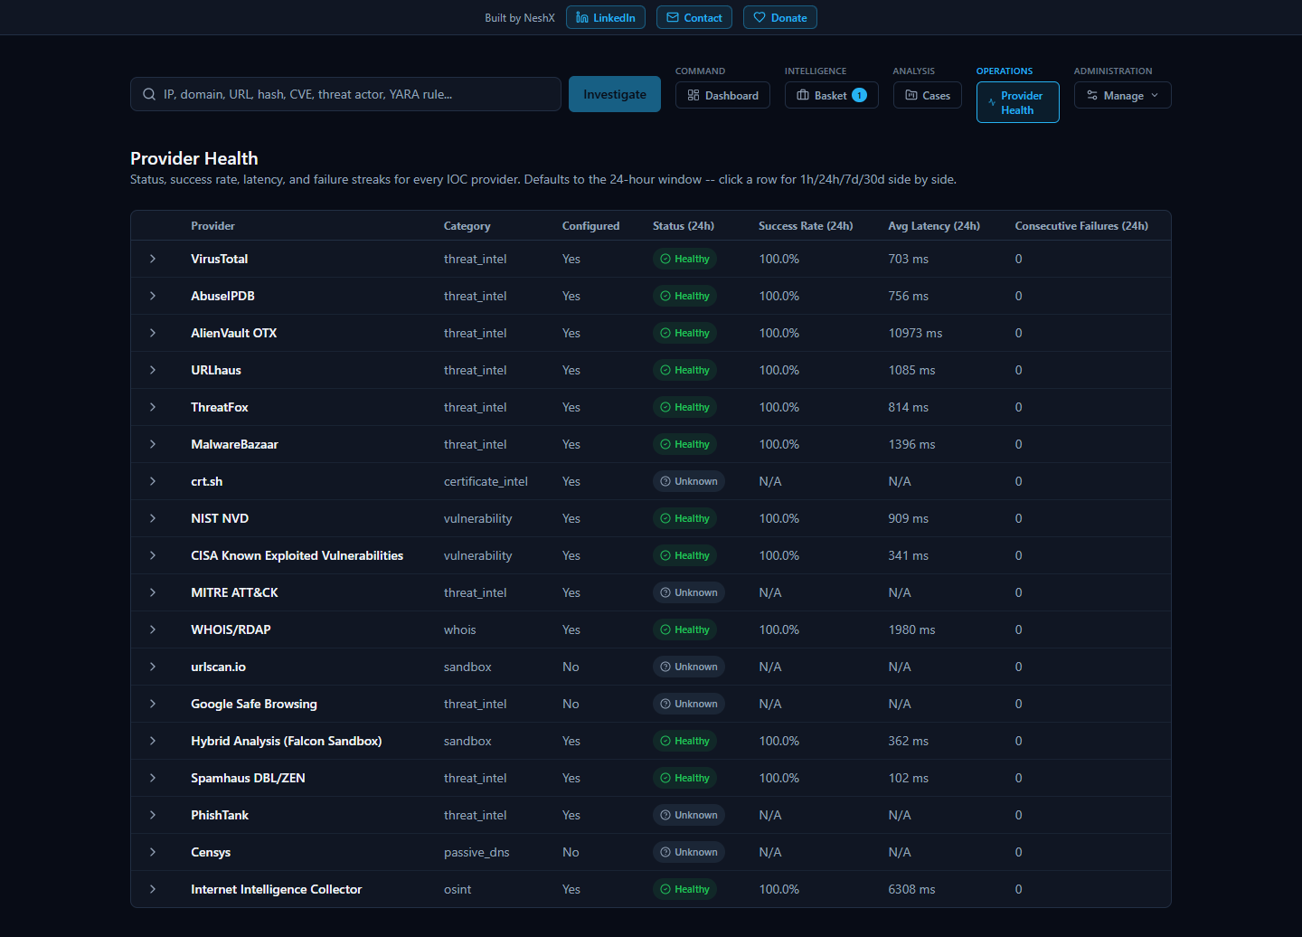
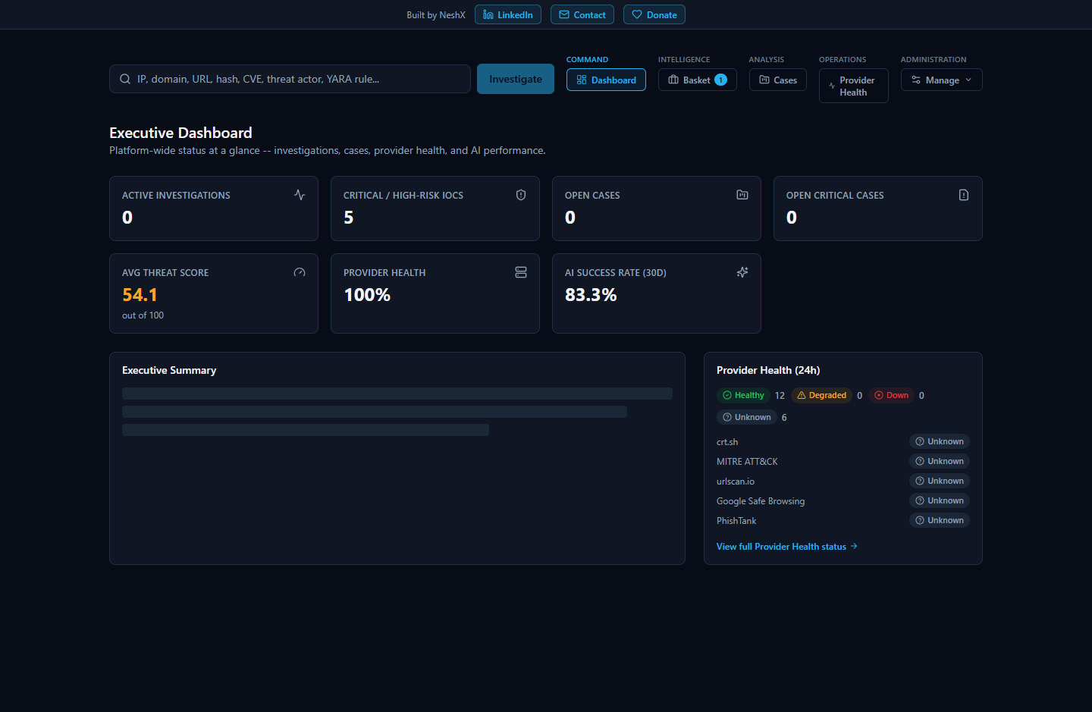

7. Database connection-pool sizing
This is a real, load-tested fix, not a theoretical tuning note, so it's worth an operator understanding what it protects against. app/core/db.py creates one process-wide async engine per process -- and that module is imported identically by app-backend-1, app-celery_worker-1, and app-celery_beat-1, meaning three separate engines with three separate connection pools exist against the same Postgres instance, even though only one of those three processes ever serves concurrent user-facing HTTP traffic.
A real load test against the live containers found a genuine complete-failure mode: 25 concurrent requests to GET /providers/health timed out 100% of the time. Two compounding root causes:
- The endpoint itself issued roughly 306 sequential DB round-trips per request (4 metrics x 4 windows x 18 providers) -- since fixed, consolidated into roughly 19 queries via SQL conditional aggregation.
- The connection pool was sized to SQLAlchemy's un-tuned library defaults and didn't account for every authenticated request holding two database connections simultaneously for its full duration -- one opened by the auth dependency, a second opened separately by the service function it calls. Pool sizing must budget for that multiplier, not one connection per concurrent request.
The fix, still in effect: pool size is now set per process role, not identically everywhere. docker-compose.yml gives app-backend-1 an explicit override (DB_POOL_SIZE=30, DB_POOL_MAX_OVERFLOW=20 -- 50 max connections), since it's the only process serving concurrent dashboard/investigation traffic; app-celery_worker-1 and app-celery_beat-1 are left on config.py's conservative code-level defaults (db_pool_size=5, db_pool_max_overflow=5 -- 10 max connections each), since between them they run one lightweight hourly task and barely touch the database. Worst case combined total: 50 + 10 + 10 = 70 connections, comfortably under Postgres's own default max_connections=100. Confirmed live after both fixes: the same 25-concurrent-request test that previously failed 100% of the time completed in 1.6 seconds at 100% success.
An operator does not need to touch this sizing in normal operation -- it's set correctly in docker-compose.yml out of the box -- but it's the number to revisit first if GET /providers/health or the Executive Dashboard ever starts timing out under real concurrent load again, before assuming it's a code regression.

Summary
Day to day, an operator has four checks available from shallowest to deepest -- GET /health, Service Status, Diagnostics, and the application-level Provider Health / Executive Dashboard pages -- and none of them require touching Docker directly. Underneath, the platform is eight app-*-1 containers, only two of which (celery_worker, celery_beat) auto-restart; caching is a positive-only, one-hour Redis TTL with no manual invalidation; the only background job is an hourly, 25-IOC-capped OSINT re-crawl that has no bearing on live investigations if it's down; backup is one click and automatic on upgrade, but restore is a manual, documented procedure with no shortcut; and the database connection pool is deliberately sized per process role, with the exact numbers and the real failure they were sized to fix given above.

