USER DOCUMENTATION

HORIZON GRID
End-User Manual

Version: 0.1.0
Documentation prepared: 2026-08-17

PREPARED FOR EVALUATION

Table of Contents
Right-click here and choose "Update Field" (or press F9) to generate the Table of Contents.

Executive Overview
HORIZON GRID is a self-hosted application that takes a single indicator of compromise -- an IOC (Indicator of Compromise), meaning a piece of evidence such as an IP address, domain name, URL, file hash, or CVE ID (a publicly catalogued software vulnerability, e.g. "CVE-2021-44228") -- and looks it up simultaneously against a wide range of third-party threat-intelligence sources. Rather than opening a dozen browser tabs and pasting the same indicator into a dozen different tools, an analyst pastes it once into a single search box. The platform queries every relevant provider in parallel, waits for their answers, automatically looks for relationships between what those providers reported, and then asks an AI model to summarize the whole picture in plain language.
This tool is built for security analysts doing IOC triage: the day-to-day work of taking an indicator that showed up in an alert, a phishing report, an incident, or a threat feed, and quickly forming a judgment about whether it is dangerous, and why. It is equally usable by a solo analyst working a single alert and by a small security team that wants a shared, self-hosted place to run lookups, keep notes, and track cases -- because the platform runs entirely on infrastructure the organization controls, nothing about the indicator or the investigation needs to leave that environment except the outbound calls to the third-party providers the analyst has chosen to configure.
The value proposition in one sentence: one search, many providers, correlated, AI-summarized, and evidence-backed -- an analyst gets in seconds what used to take many separate tools and a lot of manual cross-referencing to piece together, along with a way to check, item by item, exactly where every claim in the summary came from.

The Problem
Investigating a single indicator properly means checking it against several independent sources, because no one source sees everything. A file hash might be flagged by one antivirus engine and ignored by another. An IP address might be a known Tor exit node according to one list and a clean, unremarkable address according to another. A domain might have no reputation history anywhere but still be tied to a live vulnerability. Getting a trustworthy picture means checking multiple sources and weighing what they collectively say -- not any single answer in isolation.
In practice, that means an analyst opens a reputation lookup site, then a sandbox or malware database, then a certificate-transparency search, then a vulnerability database, then a passive-DNS tool, then a DNS blocklist -- copying and pasting the same IOC into each one, reading each result in its own format, and holding all of it in their head (or in a scratch document) well enough to notice when two sources disagree or, more importantly, when two sources are quietly describing the same underlying thing from different angles. That second part is the real cost: correlations -- "this IP resolves to infrastructure tied to this malware family, which is associated with this ATT&CK technique, which matches this hash" -- are exactly the kind of connection that's easy to spot when everything is laid out side by side, and easy to miss when it is spread across six browser tabs opened at six different times.
Multiply this by every indicator that needs triage in a day, and the real cost isn't just the minutes spent per lookup -- it's the tabs, the context-switching, the copy-paste errors, and the correlations that quietly get missed because no human is going to manually cross-reference a dozen sources for every single IOC that crosses their desk.

The Solution
HORIZON GRID collapses that whole workflow into a single search box. An analyst submits one IOC, and the platform:
- Queries every applicable provider in parallel -- rather than one at a time, so results arrive within seconds of submission instead of after a long serial wait, with each provider's individual verdict shown side by side as it comes in.
- Correlates the results automatically -- extracting relationships such as shared IPs, related hashes, malware families, MITRE ATT&CK techniques, and CVEs across the providers that reported them, and surfacing where multiple independent sources corroborate the same fact.
- Summarizes the findings with AI -- both a short summary of each provider's own result, and one consolidated final assessment that reasons over all of the provider summaries together with the correlation output, written in plain language instead of a wall of raw JSON.
That last point comes with an important caveat, and the platform is built around it rather than around hiding it: AI output is analytical assistance, not unquestionable truth. The AI model can misread evidence, and providers themselves can disagree -- a genuine, documented example is the IOC 8.8.8.8 (Google's public DNS resolver), where one provider's DNS blocklist flags it as malicious due to a query-permission error while two other providers report it as clean, and the AI's own executive summary has to explicitly reconcile that disagreement rather than paper over it. Because of cases exactly like this, every AI-generated claim on an investigation page is traceable back to the underlying evidence it was built from, through the Evidence Ledger -- a deterministic, non-AI-generated list of the concrete facts (provider results, correlation edges, and summaries) that any AI explanation is required to cite. An analyst never has to take the AI's word for it; they can always check the receipts.

Key Capabilities
- Multi-provider IOC lookup -- submit one indicator (IP, domain, URL, file hash, or CVE) and query every configured, applicable threat-intelligence provider at once, with results streaming in live as each provider responds.
- AI-assisted analysis grounded in evidence -- a plain-language summary per provider plus one consolidated final assessment, with dedicated views for "Why this verdict?", score explanations, provider disagreements, false-positive checks, and a "Challenge This Verdict" option -- all designed to be checked against real evidence, not taken on faith.
- Correlation and relationship graph -- automatic detection of relationships between providers' findings (shared infrastructure, related hashes, malware families, ATT&CK techniques, CVEs), visualized as a relationship graph the analyst can explore.
- Case management -- create a case, attach IOCs to it as the investigation grows, and add freeform analyst notes to build a record of the work.
- IOC Basket -- a saved, running list of IOCs an analyst wants to keep an eye on or revisit, with the ability to investigate or compare selected items together.
- JSON and Markdown export -- download an investigation's results in either format for use outside the platform.
- Windows installer with a guided setup wizard -- a standard installer followed by a step-by-step wizard that creates the administrator account, configures the AI backend and threat-intelligence providers (with live "Test" buttons for each), reviews network ports, and installs the platform end to end.

The User Journey
An orientation map, not a manual: what a session with HORIZON GRID looks like end to end, from one-time setup through a routine day of investigating indicators.

Setup, Once
An admin installs the platform via the Windows installer, then runs a setup wizard collecting an administrator account, an AI backend choice, and API keys for whichever threat-intelligence providers are available. After that, day-to-day use is just opening a browser tab.
Signed in, an analyst sees the home page: a single search box, ready for the first IOC (Indicator of Compromise — an IP, domain, URL, file hash, or CVE ID — a Common Vulnerabilities and Exposures identifier for a known software vulnerability — worth investigating).
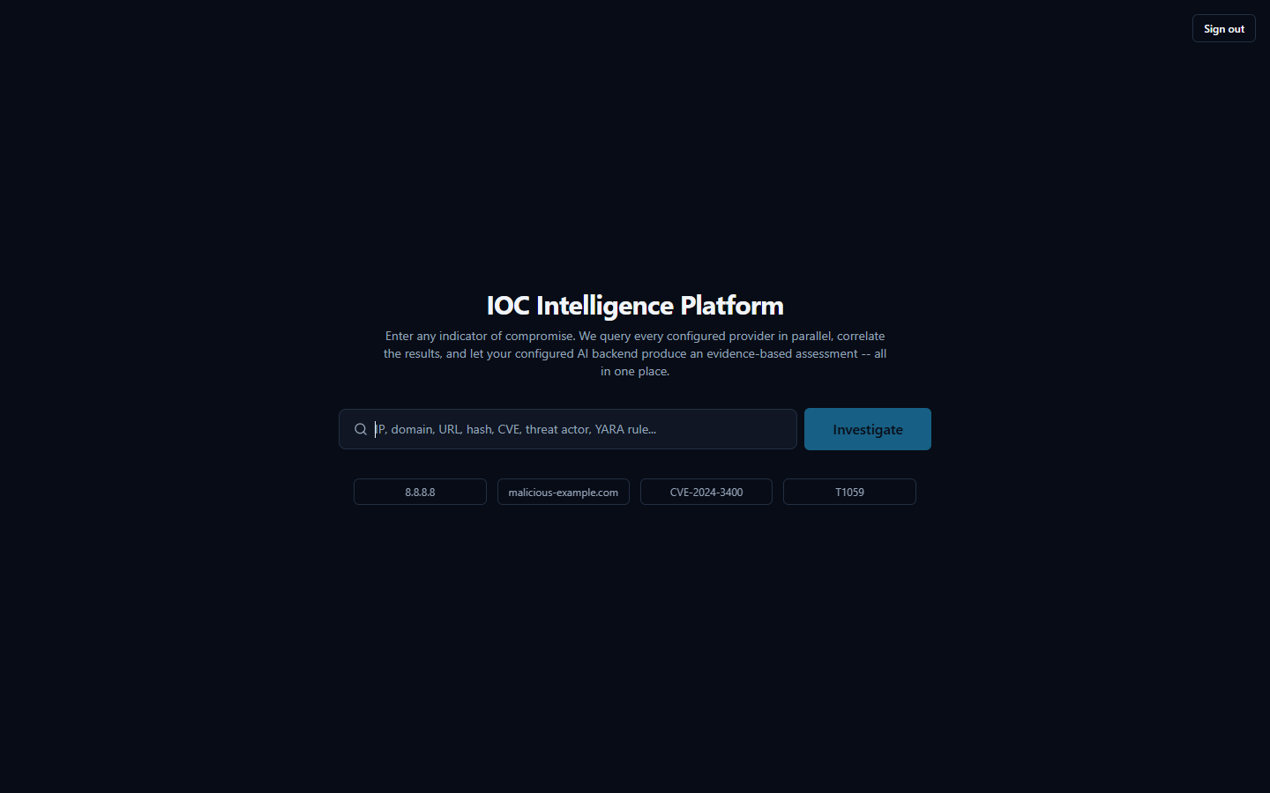
From here, the new Dashboard entry in the global navigation is a natural first stop too, before diving into a specific IOC — an at-a-glance operational view of active investigations, case load, provider health, and AI reliability across the whole team.

The Daily Loop: Submit an Indicator, Watch Evidence Arrive
This is the core workflow, repeated many times a day. The analyst types or pastes an IOC and submits it. The platform classifies the indicator type and queries every configured provider that supports it in parallel, not one after another — results stream in as each finishes. As each result arrives, the AI briefly summarizes that provider's own findings; once all providers report in, one consolidated AI call produces a Final Assessment: a verdict, a risk score, and a plain-language summary weighing everything together.
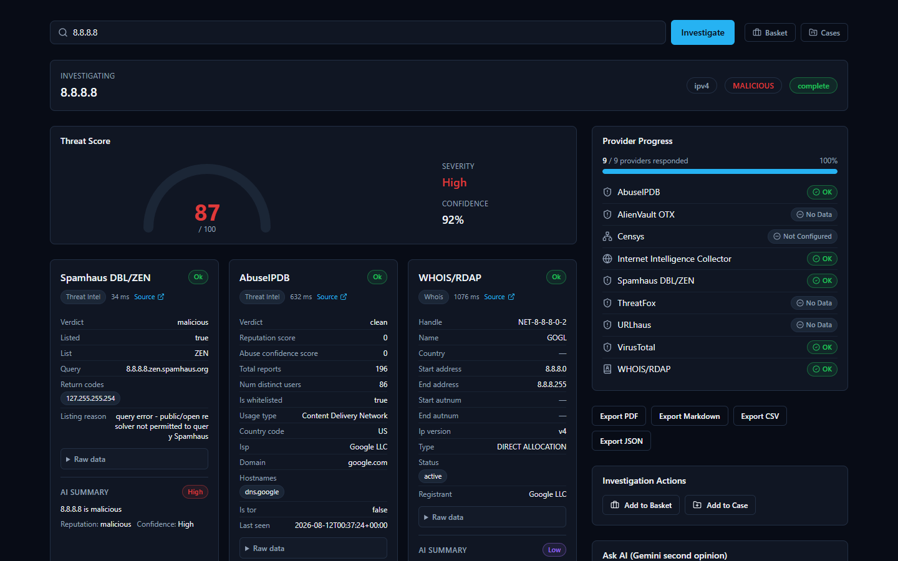

Reading the AI's Summary — and Verifying It
The AI summary is a fast way to orient, not a verdict to accept blindly — providers genuinely disagree, and the AI's job is to weigh that disagreement, not hide it. The 8.8.8.8 case above is a real example: Spamhaus calls the address malicious (it rejects lookups from public resolvers, unrelated to actual malice), while AbuseIPDB and VirusTotal both call it clean, and the Final Assessment says so explicitly. This is why every investigation includes an Evidence Ledger — non-AI-generated facts with confidence scores. When a claim looks surprising, the analyst opens the ledger and checks it against the real provider data before trusting it.
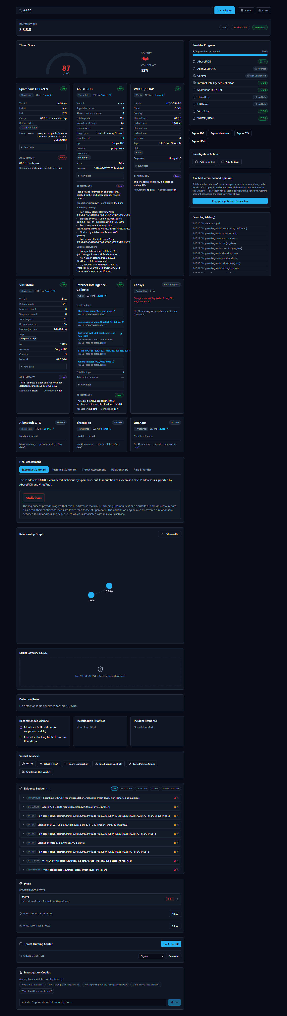

Following the Trail, Then Keeping Track
The Relationship Graph shows indicators connected to the one just searched — for 8.8.8.8, its parent ASN (Autonomous System Number) — letting the analyst pivot onward without a fresh search. Interesting IOCs go into the IOC Basket, a running list serving the purpose of a personal watchlist, or get attached to a Case with analyst notes when tied to a specific incident.

Taking Findings Elsewhere
Investigations export cleanly as JSON or Markdown today. PDF and CSV buttons exist but return an honest "Export format not yet available" message — a known gap, not a hidden failure.

Installation Guide

What the Installer Actually Does
HORIZON GRID is a self-hosted tool: instead of sending your indicators to someone else's cloud service, you run the entire product on a Windows machine you control. "IOC" stands for Indicator of Compromise — a piece of evidence such as an IP address, domain, URL, file hash, or CVE ID (a public vulnerability identifier) that a security analyst wants to investigate.
When you run the installer, you are not just copying a single program onto your machine. You are setting up a small, self-contained application stack — the platform's web interface, its own database, and several supporting background services — all bundled together and running only on this one Windows computer. The internal databases behind the platform are locked to this computer only and are never reachable from anywhere else on your network. The platform's own web interface, however, is genuinely usable from other devices on the same local network, not only from this computer — the installer sets this up automatically (a Windows Firewall rule scoped to your Private network, plus automatic detection of this machine's network address), and the app itself figures out the right address to talk to no matter which device opened it. See "Accessing From Another Computer" below for how to actually do this; if you'd rather keep the platform usable only from this machine, restrict access at your Windows firewall.
You do not need to understand how those internal pieces fit together to install and use the product. This guide only covers what you, the administrator, will see and click. A full technical breakdown of the underlying architecture is provided separately for readers who want it.

Before You Begin: Prerequisites
Two things matter before you start the installer:
- Administrator privileges. You must run the installer as a Windows administrator. The installer checks for this and will not proceed without it.
- Docker Desktop, installed and running. This is the important one to understand: the platform's real, working services — its database, its background job runners, its web server — do not run as ordinary Windows programs. They run inside Docker containers, which is a standardized way of packaging and running software in isolated, self-contained units. Docker Desktop is the engine that makes those containers run on Windows. If Docker Desktop is not installed and running before you start, the installer's prerequisite check will flag it and prompt you to fix it before continuing.
Think of the installer as putting the platform's files in place and Docker Desktop as what actually breathes life into them afterward. Both are required.

Step-by-Step: Running the Installer
The installer is a standard Windows setup wizard (built with Inno Setup, a common Windows installer framework). It walks you through a short series of screens before copying any files.
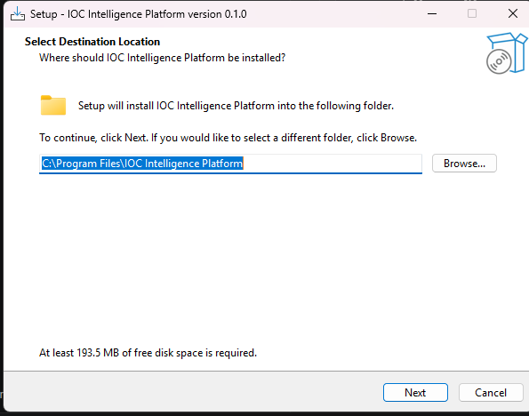
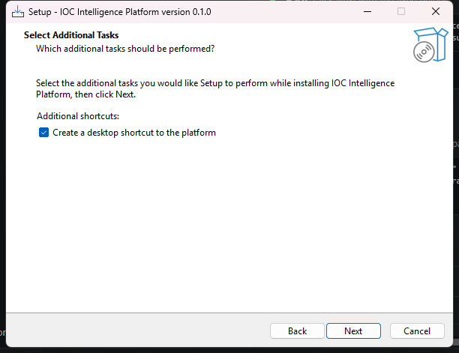
On the next screen, the installer summarizes everything it is about to do before it touches your system.
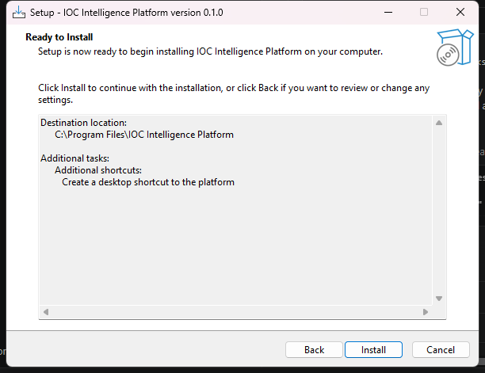
After you click through, the installer copies the platform's program files to your chosen location. This step only places files on disk — it does not yet start any services or ask you for any configuration. When it's done, you'll see the final screen:
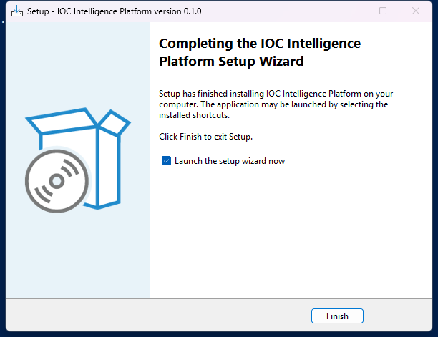

What Happens Next
Once you close the installer, the Setup Wizard launches automatically. This is a separate, second stage — a dedicated desktop application (not a web page) that collects your administrator account details, your AI configuration, and your threat-intelligence provider API keys, and then does the actual work of building and starting the Docker containers described above. That process is covered in the next section, "Setup Wizard."

Accessing From Another Computer
Once setup finishes, the platform is usable both from this computer and from any other device on the same local network — a second laptop, a colleague's desktop, even a phone or tablet's browser, as long as it's connected to the same Wi-Fi or Ethernet network. Nothing needs to be edited or reconfigured to make this work; it's set up automatically during installation.
How to connect from another device. The Setup Wizard's final page shows two links: one for using the platform on this computer, and a second one labeled for other devices on the network. Open that second link's address (it looks like http:// followed by a set of numbers and a port, for example 192.168.1.125:3000) in a browser on the other device. You'll land on the same sign-in page described in the next chapter, and everything from there on works identically to using the platform locally.
If you don't have that page open anymore, the same address is always available afterward from inside the app itself: sign in, open Providers in the top navigation, and select the Network Access tab. It shows the address for this computer and the address for other devices side by side, with a button to copy the second one so you can send it to whoever needs it.
What makes this work. The installer creates a Windows Firewall rule that allows the platform's two ports through, but only on networks Windows classifies as Private (the setting you're asked about the first time you connect to a new Wi-Fi network or Ethernet connection) — never on Public networks, and never open to the wider internet. This is deliberate: the feature is meant for a trusted home or office network, the same network your other devices are already on, not for remote access from elsewhere.
If a second device can't connect:
- Make sure both devices are actually on the same network, and that the network is set to Private in Windows (check under Settings → Network & Internet on the computer running the platform) — the firewall rule intentionally will not open the ports on a network marked Public.
- If the address shown doesn't work, your router may have assigned this computer a new network address since setup last ran (this can happen after a restart). Re-run Configuration from the Start Menu (Start Menu → IOC Intelligence Platform → Configuration) to re-detect it — no need to reinstall.
- The Network Access tab will say "Not detected" if the wizard couldn't determine a network address automatically (uncommon, but possible on unusual network setups). The platform still works fine from this computer either way; re-running Configuration is worth trying to pick it up.

First-Run Configuration
Before you ever open a browser and type in an IOC (Indicator of Compromise -- a piece of evidence such as an IP address, domain, or file hash that a security analyst wants to investigate), you'll meet HORIZON GRID's Setup Wizard. This is a native Windows desktop application (built the traditional WinForms way, not a web page you'd load in a browser) that runs once, right after the installer finishes, and walks you through every decision the platform needs before it can start working: who the administrator is, which AI model will do the analysis, which third-party threat-intelligence sources you want to plug in, and which network ports it should use on this machine.
None of these choices are permanent traps -- everything set here can be revisited later by re-running the same wizard from the "Configuration" shortcut the installer creates. But for a first-time administrator, this is where the platform's whole configuration model gets introduced, so it's worth walking through page by page.

Welcome
The wizard opens with a simple Welcome page that confirms you're about to configure HORIZON GRID and sets expectations for what's coming next: an administrator account, an AI model choice, provider setup, a network port review, and finally installation itself.
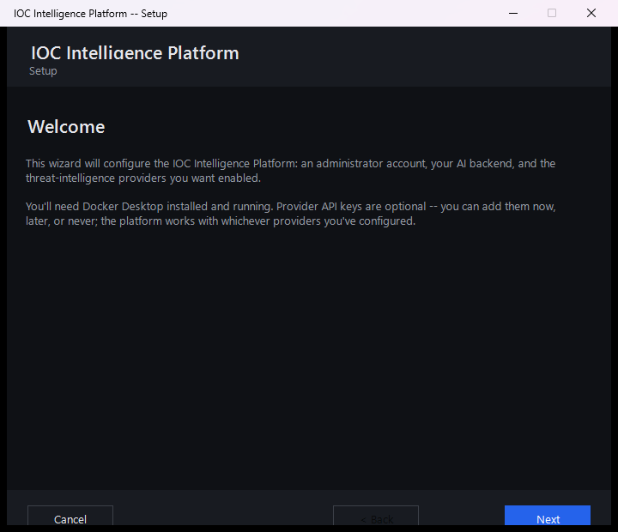

Setting Up the Administrator Account
The next page asks for the details of the very first user account: an email address, an optional full name, and a password (typed twice, to confirm it).
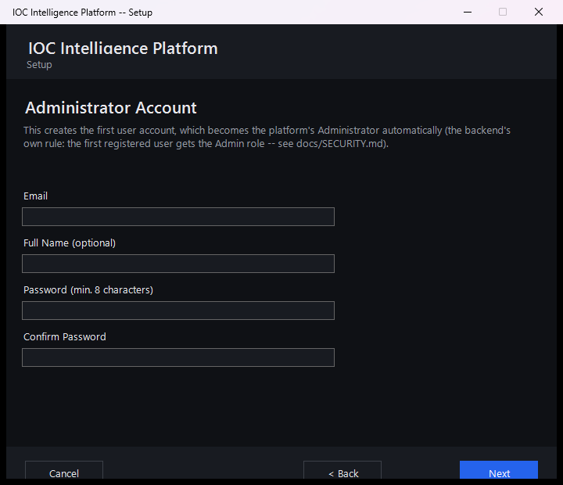
This page's own note that the first account "gets the Admin role -- see docs/SECURITY.md" is pointing at a file inside the product's source code, for developers who have it checked out -- not something you need to go find. Everything that file says about roles is covered in plain language in this manual's Security and Data Handling section, so nothing is missing if you don't have code access.
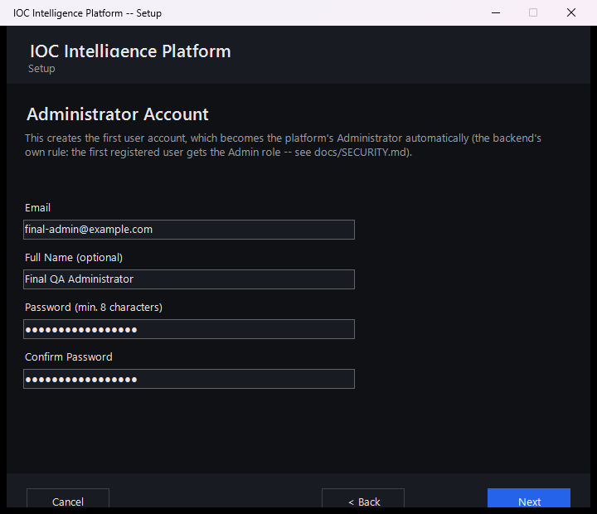
This page looks like an ordinary "create your account" form, but it quietly does something more important: whoever registers here becomes the platform's administrator, automatically, with no extra step. The platform has a simple, fixed rule for this -- the very first account ever registered on a fresh installation is automatically granted administrator rights. The moment that happens, the public sign-up page closes itself: anyone who tries to register through the web app afterward (for example, a colleague who wants an account of their own) is turned away and told to ask an administrator instead, rather than quietly being handed a lesser account. There's no separate "make me an admin" checkbox or database edit required; it's purely a matter of being first. Because the Setup Wizard registers your account before anyone else can reach the platform, filling in this page is what makes you the administrator -- and every colleague's account after that has to be created for them from the Administration page, where you pick their role up front.
If you run the wizard again later to reconfigure an installation that's already up and running, this page behaves a little differently, since an administrator account already exists. You can simply leave the email and password fields blank to keep that account exactly as it is. Or, if you'd like to sign in for this session -- which is what enables the live Test Connection buttons on the pages that follow -- re-enter your existing email and password here; the wizard will log you in without creating a new account or changing the existing one.
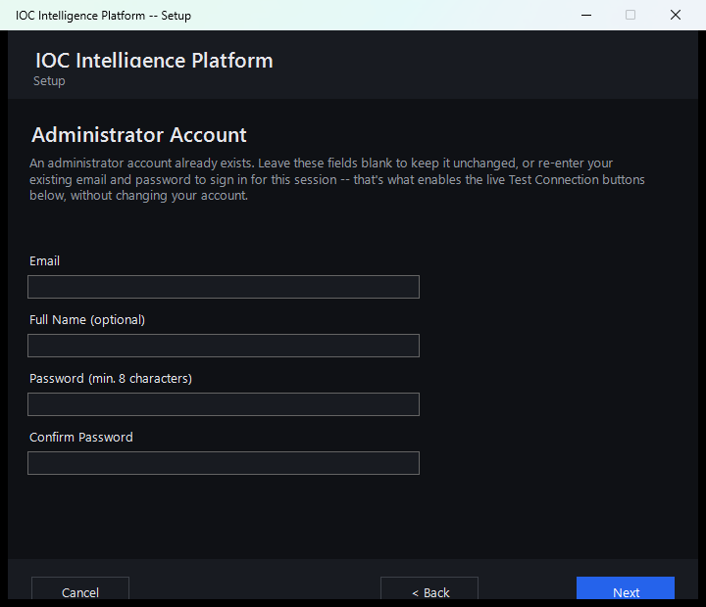

Choosing an AI Model
Every investigation the platform runs ends with an AI-generated summary that pulls together what all the different intelligence sources found. This page is where you decide which AI does that work.
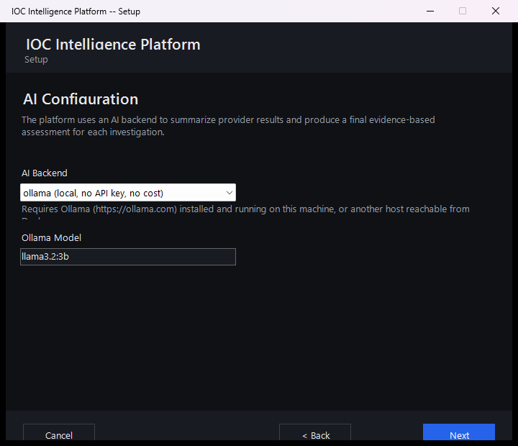
You have two broad options here:
- A free local AI model, which runs entirely on your own machine via Ollama. It costs nothing, requires no account or API key, and keeps everything on-premises -- a good default if you just want to get started.
- A cloud AI provider instead, if you'd rather use a more capable hosted AI model from a third-party service. The wizard currently supports four such providers: Anthropic, Amazon Bedrock, Google Gemini, and Groq (a fast-inference API service). Each requires an account and an API key with that provider.
Whichever backend you choose, this page now has a live Test Connection button that sends a minimal, real request to that provider and reports a genuine result -- not a placeholder or an automatic green checkmark. A working setup reports something like "Connected. Model replied: 'pong' (model: llama-3.3-70b-versatile, 245 ms)", including the real model that answered and the actual round-trip latency. A broken one reports a specific, real reason instead of a vague failure -- for example, an invalid key, an unrecognized model name, or a provider rate limit.
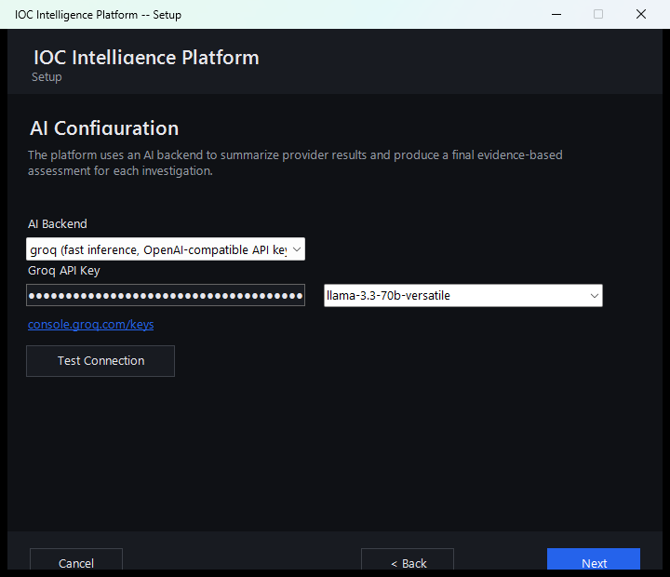
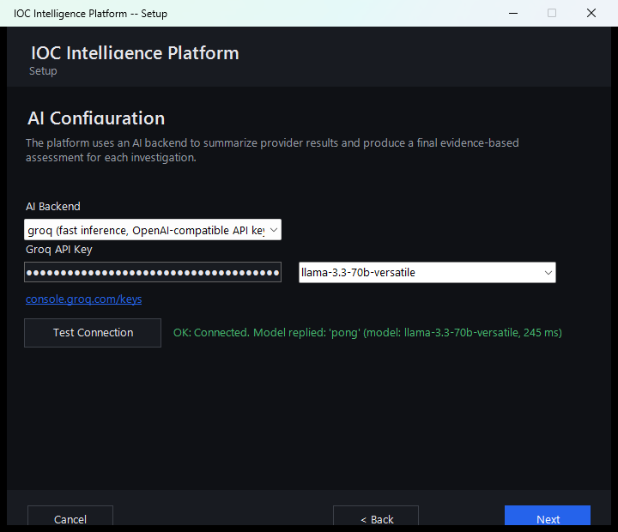
Either way, it's worth setting expectations early: the AI's job throughout this platform is to help you read and correlate a lot of raw intelligence data faster -- it is analytical assistance, not an unquestionable verdict. Later in the platform, every AI-written summary and verdict comes paired with an Evidence Ledger and "show your reasoning"-style verification tools that let you check exactly which underlying data the AI actually drew on, rather than just taking its word for it. You'll see this play out directly later in this guide, including a real case where two intelligence sources disagreed about the same IP address and the AI's own verdict was worth double-checking against the evidence.

Threat Intelligence Providers
This page is where you connect the platform to outside sources of threat intelligence -- third-party services and databases (like VirusTotal or AbuseIPDB) that have already collected information about known-malicious IPs, domains, files, and more. The wizard lets you configure up to eight such providers here.
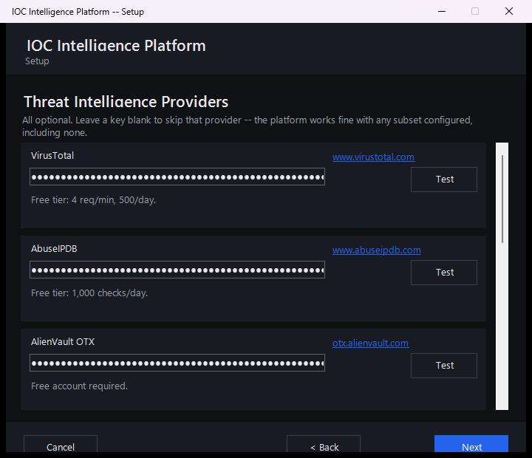
A few things worth knowing about this page:
- Every provider is optional. You don't need to fill in all eight, or even any of them, to finish setup. A couple of the providers listed here (for example, the U.S. government's NVD vulnerability database) work out of the box with no key at all -- an API key for those just raises how many requests per minute you're allowed, it doesn't switch the provider on or off.
- Each key is entered once and masked. Once typed, a key shows only as dots on screen, the same way a password field would, so it isn't left visible.
- Each provider has a live "Test" button. Clicking it immediately checks whether the key you just entered actually works against that provider's real service, so you find out about a typo or an expired key during setup rather than during your first real investigation.
In the interest of full transparency: the screenshot above is from this very evaluation of the platform, and the keys entered for VirusTotal, AbuseIPDB, and AlienVault OTX are real, working keys used to test the product -- not placeholder or example values.

Network Ports
The next page lets you review which network ports on this Windows machine the platform will use once it's installed and running.
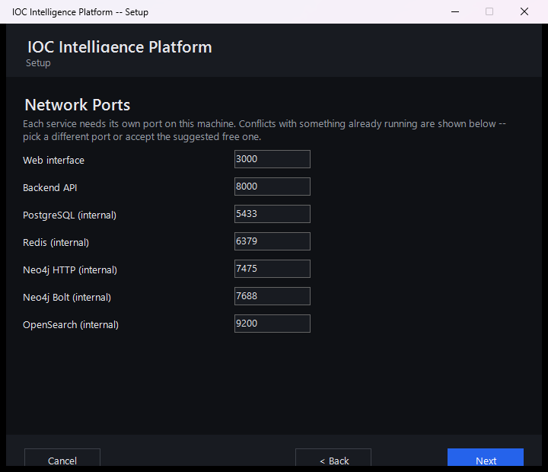
Most administrators can simply accept the defaults shown here and move on. This page exists mainly for the case where something else already running on the same machine is using one of the same ports -- in which case you can change the platform's port here before installation begins, rather than running into a conflict afterward.

Reviewing the Summary
Before anything is actually installed, the wizard shows a summary of every choice made so far -- the administrator account, the AI model selection, the ports, and how many threat-intelligence providers were configured.
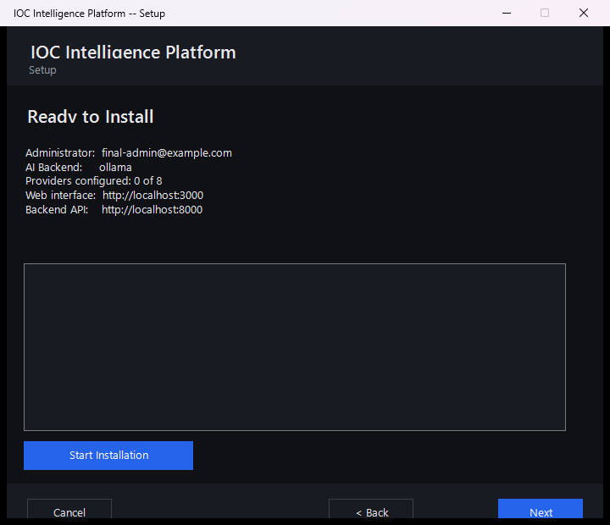
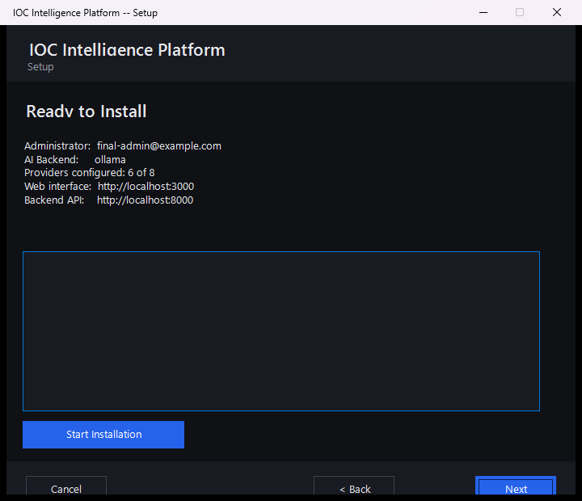
That "6 of 8" line is a good illustration of how flexible provider setup really is: it counts both the providers where a real key was entered and the providers that work with no key required at all, added together. Your own installation might show a different number -- three, six, or zero -- and the platform will install and run just as well either way. Nothing on this page is a point of no return; if something looks wrong, you can still go back and change it before clicking through to install.

Installation Complete
Once you confirm the summary, the wizard takes over and does the heavy lifting on its own: it pulls down and starts every service the platform needs, waits until the platform reports itself healthy, and then registers your administrator account using the exact details you typed in earlier -- so by the time this page appears, your account already exists and works.
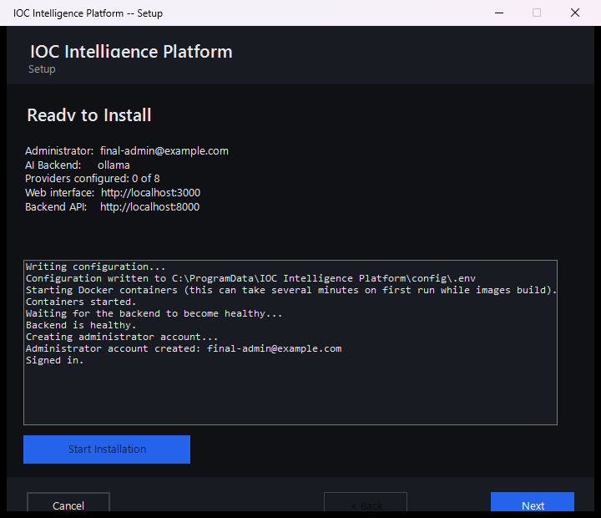
This step can take a few minutes the first time, since it's downloading and starting up everything the platform depends on. Once it's done, you're ready to open the platform in a browser and sign in with the administrator account you just created.
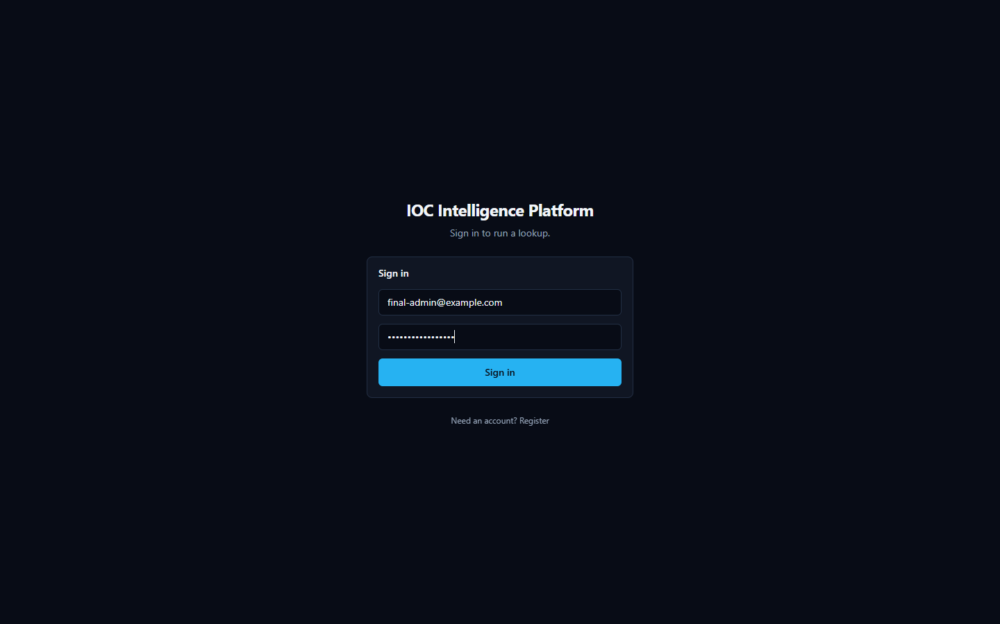

IOC Investigation
This is the core of the product: you give it one IOC, and it tells you — with receipts — what dozens of threat-intelligence sources and an AI model think about it.

What Is an IOC?
IOC (Indicator of Compromise) — a piece of evidence such as an IP address, a domain name, a URL, a file hash, or a CVE (Common Vulnerabilities and Exposures — a public catalog ID for a known software vulnerability, e.g. CVE-2021-44228) that a security analyst wants to investigate. An IOC by itself doesn't prove anything is wrong; it's a lead. Maybe it showed up in a firewall log, an email attachment, or a colleague's incident notes. The question an analyst always has to answer is: is this thing actually dangerous, and what do I know about it?
HORIZON GRID exists to answer that question fast, by querying many independent, real third-party sources at once, correlating what they say, and having an AI model summarize the result — while still giving you everything you need to check the AI's work yourself.

Starting an Investigation
There are two ways to kick off a lookup:
- Type the IOC into the search box on the platform's home page and submit it. You can paste in an IP address, a domain, a URL, a file hash, a CVE ID, or any of the other supported types (see the list at the end of this section) — the platform automatically detects what kind of IOC you gave it before it decides which providers to query.
- Click one of the suggested example IOCs offered on the same page. This drops that value straight into the search box for you — submit it the same way you would your own IOC. It's the fastest way to see the platform in action before you commit a real indicator from your own environment, and once submitted it runs an actual, live lookup, not a canned demo.
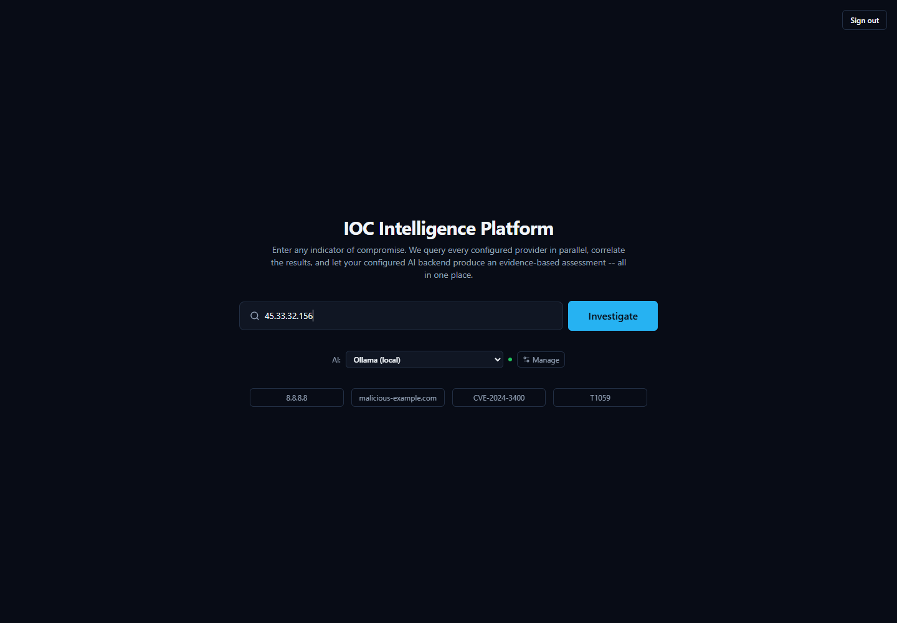
Once you submit an IOC, the platform fans out to every configured provider that supports that IOC type at the same time (not one after another), so results stream back into the page within seconds rather than making you wait for the slowest source.

Anatomy of a Real Investigation: 8.8.8.8
To show what an investigation actually looks like, walk through a real one: the IOC 8.8.8.8 — the IPv4 address of Google's Public DNS resolver, a well-known, legitimate internet service used by billions of devices. It's a genuinely interesting example, because the sources don't fully agree with each other — and that disagreement is exactly the kind of thing an analyst needs to know how to read.

The First Few Seconds

This compact view appears almost immediately and updates as more providers respond:
- Threat Score gauge — a single 0–100 number with a plain-language severity label. In this investigation it reads 87/100, "High." This number is the platform's aggregated read on the IOC once results start coming in; it is a starting signal, not a final judgment — hold that thought, because this exact example is about to show why.
- Provider Progress list — a running checklist of every provider the platform queried for this IOC type, ticking off as each one finishes. Because providers are queried concurrently, you see them complete in whatever order they actually respond, not a fixed sequence.
- Per-provider result cards — one card per source, each showing that provider's own verdict and supporting detail:
  - Spamhaus DBL/ZEN shows verdict malicious, with a reason string attached: "query error – public/open resolver not permitted to query Spamhaus."
  - AbuseIPDB shows verdict clean, with 0 abuse reports on file.
  - WHOIS/RDAP shows registration/network ownership data for the address (who the IP block is allocated to).
Already, two cards disagree with each other. Keep reading — the full page explains why, and it isn't a bug.

The Full Picture

Scroll down (or wait for later providers to finish) and the rest of the investigation appears:
- More provider cards: VirusTotal reports clean; the Internet Intelligence Collector (the platform's own OSINT — open-source intelligence, meaning publicly available, non-classified sources — crawler, pulling from sources like GitHub, Reddit, RSS feeds, and paste sites) reports its findings; Censys shows "Not Configured" — meaning that particular provider needs API credentials entered before it will run at all, not that it looked and found nothing.
- Final Assessment tabs — the AI's consolidated read on the whole investigation, written only after every provider has reported back. For 8.8.8.8, the Executive Summary tab states, in effect, that the IP "is considered malicious by Spamhaus, but its reputation as a clean and safe IP address is supported by AbuseIPDB and VirusTotal." The AI is not hiding the disagreement — it's telling you about it directly.
- Relationship Graph — a visual map of what this IOC connects to. Here it's simple: two nodes, 8.8.8.8 and its owning network, ASN 15169 (Google's autonomous system number). On IOCs with more history, this graph can grow to show shared infrastructure, related files, or campaigns.
- MITRE ATT&CK Matrix — MITRE ATT&CK is an industry-standard catalog of known attacker tactics and techniques. This tab highlights any techniques the investigation's evidence actually supports. For 8.8.8.8 it correctly reads "No MITRE ATT&CK techniques identified" — there's nothing here to map to attacker behavior.
- Detection Rules — a tab that can generate ready-to-use detection logic (for a SIEM — Security Information and Event Management system, the kind of tool a SOC uses to watch for threats — or similar tool) when the evidence supports it. For this IOC it reads "No detection logic generated for this IOC type" — again, appropriately, since there's no malicious behavior to write a detection rule against.
- Recommended Actions — AI-suggested next steps for the analyst, grounded in what was actually found.
- Verdict Analysis tools — this is the toolbox that exists specifically so you don't have to just trust the Threat Score number. Each tab lets you interrogate the AI's own conclusion:
  - Why? — asks the AI to justify its verdict, citing the actual evidence behind it.
  - What's this? — a plain-language explanation of what the IOC is.
  - Score Explanation — breaks down how the numeric score was arrived at.
  - Intelligence Conflicts — specifically surfaces where providers disagree with each other (exactly the Spamhaus-vs-AbuseIPDB/VirusTotal situation in this example).
  - False Positive Check — asks the AI to assess how likely it is that the flagged verdict is wrong.
  - Challenge This Verdict — a deliberate red-team tool: it asks the AI to argue against its own conclusion, rather than defend it.
- Evidence Ledger — for this investigation, 11 items, each with its own confidence percentage. This list is built directly and deterministically from the real provider data and correlation results — it is explicitly not itself written by the AI. That's the point: it exists so every claim the AI makes elsewhere on the page can be checked against a real, traceable record rather than taken on faith.
- Pivot — lets you jump from this IOC to a related one (for example, the ASN) to start a fresh investigation from something this one turned up.
- Threat Hunting Center — generates hunting queries or leads an analyst could run in their own environment, built only from indicators actually present in this investigation's evidence.
- Investigation Copilot — a chat box for asking follow-up questions about this specific investigation. Its answers are grounded in this lookup's own evidence rather than general knowledge, and unsupported citations get filtered out before you see them.

Why You Must Read the Evidence, Not Just the Score
This 8.8.8.8 example is worth sitting with, because it's a genuine, non-staged illustration of the platform's most important lesson: a single verdict number is a summary, not a substitute for reading the evidence.
Here's what actually happened. Spamhaus operates a DNSBL (a DNS-based block list) — a lookup service you query to ask "is this IP known to be bad?" That service refuses to answer queries that come from public, open DNS resolvers, as an anti-abuse measure protecting its own infrastructure. 8.8.8.8 is exactly that kind of public resolver — it's Google's own open DNS service. So when the platform queried Spamhaus about it, Spamhaus didn't report finding malicious activity at all; it rejected the query itself, with the reason "query error – public/open resolver not permitted to query Spamhaus." The platform recorded that rejection as a malicious verdict card, because that's the status Spamhaus returned — but the underlying reason has nothing to do with 8.8.8.8 doing anything harmful.
Meanwhile, AbuseIPDB checked its abuse-report database and found zero reports. VirusTotal checked its own reputation data and came back clean. Two independent, purpose-built sources say this address is clean; one source's result is actually a permission error dressed up as a verdict.
Notice, too, that the Threat Score gauge on the first screen still read 87/100, "High" — pulled up by that one Spamhaus flag — even though the fuller picture tells a different story. That's not a flaw the product is hiding: it's precisely why the Executive Summary text spells out the disagreement in plain words rather than quietly averaging it away, and why tools like Intelligence Conflicts and Challenge This Verdict exist on the same page. The AI's output here is analytical assistance — a fast, well-organized starting point — not an unquestionable ruling. An analyst who stopped at the gauge would walk away thinking Google's DNS resolver is a threat. An analyst who reads the provider cards, the Executive Summary, and the Evidence Ledger sees the real picture in under a minute.

Supported IOC Types
The platform automatically detects what kind of IOC you've submitted and routes it only to the providers that support that type. Types with dedicated provider coverage include:
- IP addresses (IPv4 and IPv6)
- Domains and hostnames
- URLs
- File hashes (MD5, SHA-1, SHA-256, SHA-512)
- CVE identifiers (e.g. CVE-2021-44228)
- MITRE ATT&CK techniques
- TLS/SSL certificates
- Autonomous System Numbers (ASN)
- Malware family names
- Threat actor names
- Campaign names
- File names
This is not an exhaustive list of every type the platform can classify internally, but it covers the types you'll actually get provider results back for.

Security Assessment: Active Checks Against the Target
Every provider covered so far is passive — it asks a third party what they already know about your indicator. Once an investigation completes for an IP, domain, hostname, or URL, a Security Assessment panel appears further down the page offering a genuinely different kind of check: sending real traffic to the target itself. Four checks are available — a Nmap port/service scan, a DNS record lookup, a TLS certificate inspection, and an HTTP security-header check — each described in plain language when you select it.
This never happens automatically. Unlike every passive provider, a security assessment is something you must deliberately start, and the platform requires two explicit confirmations before it will run anything:
- Retype the exact target in the confirmation box — this is a safeguard against accidentally scanning the wrong thing.
- Check the authorization box, confirming you're actually allowed to run active checks against this target. Only scan systems you own or have explicit permission to test.
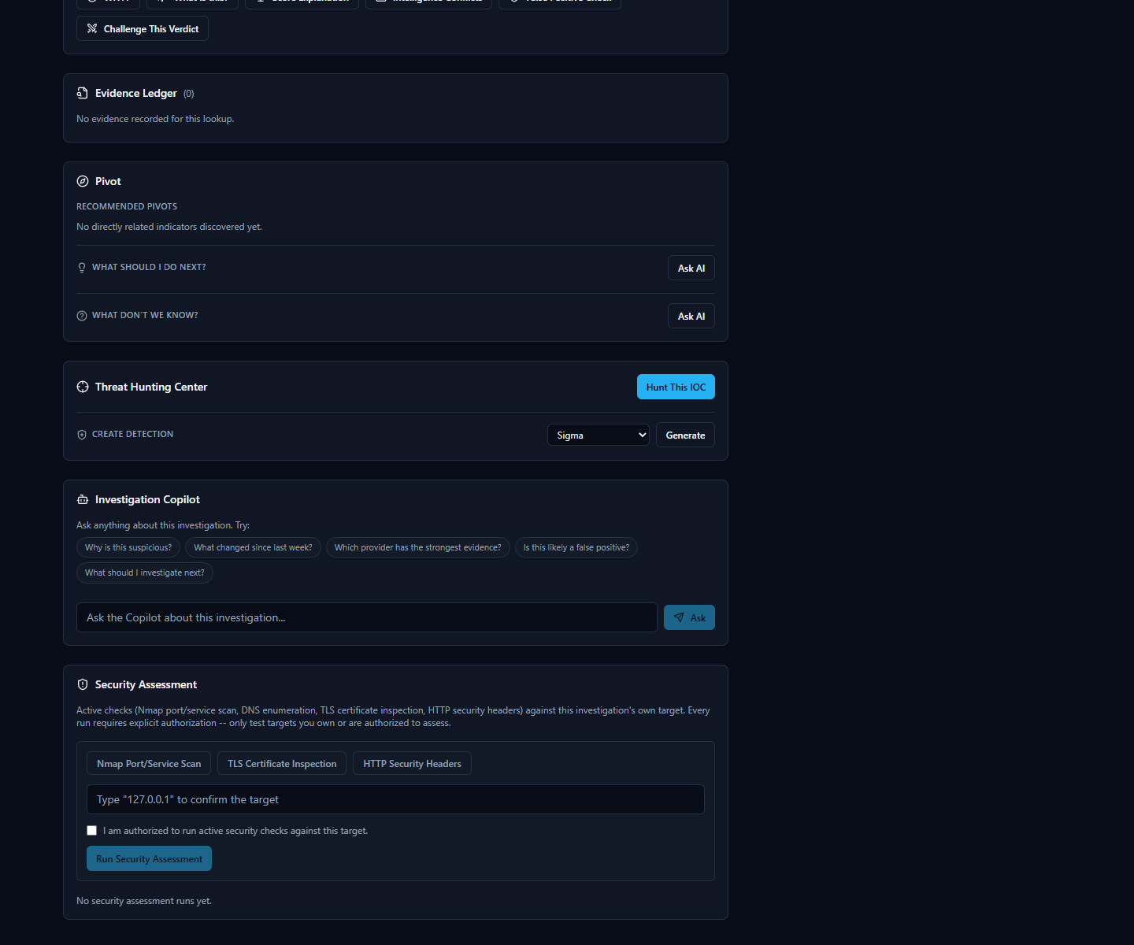
Once you start a run, results appear in a findings table with a severity badge on each row (from informational up to critical) — severities are assigned by fixed, documented rules based on what was actually found (e.g. an expired certificate, or an open port running software with a known vulnerability), never guessed. Click any finding to see exactly what was observed.
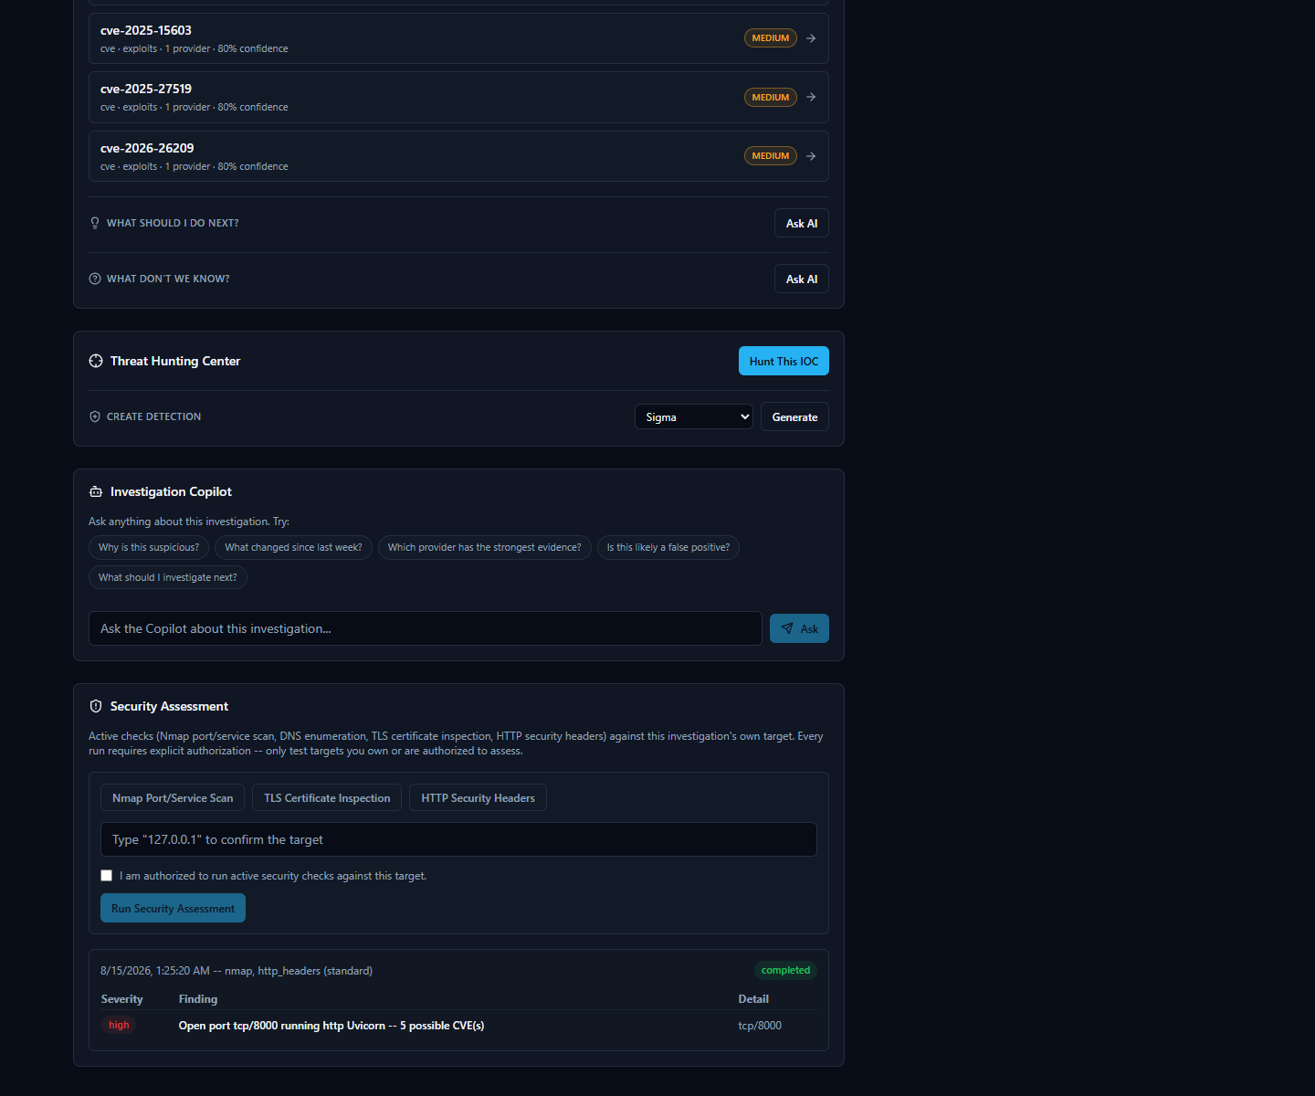
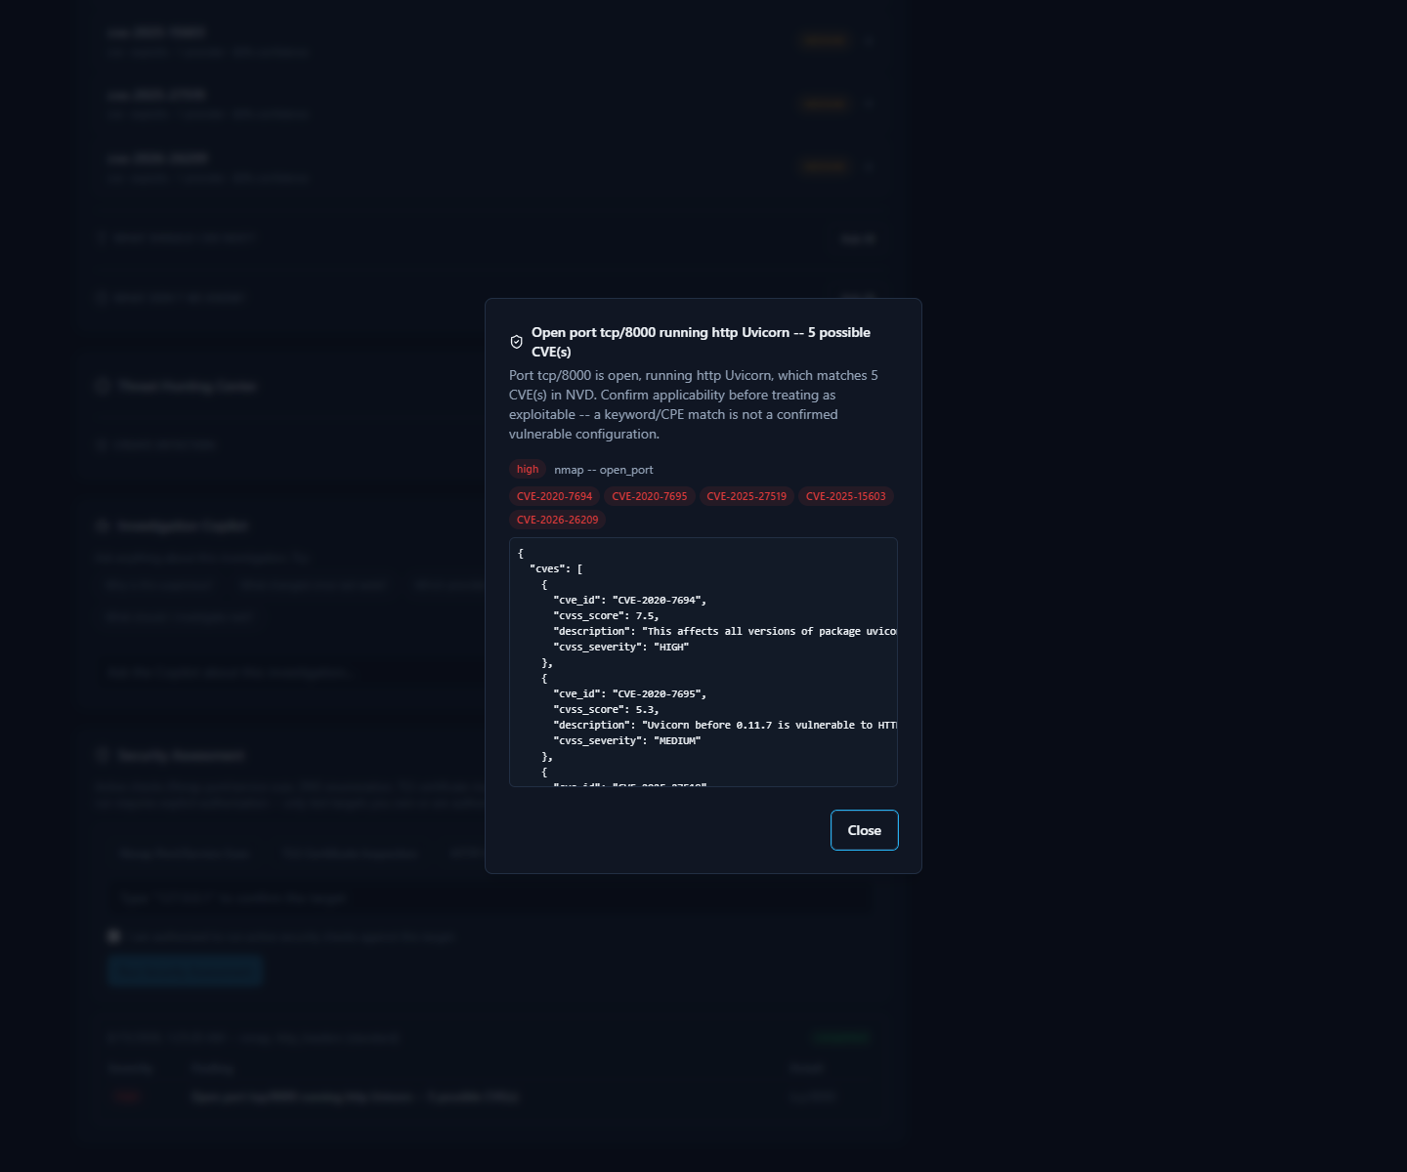
A completed run's findings feed back into the same investigation — the AI-generated assessment, risk score, and verdict at the top of the page are refreshed to account for what the security assessment found, exactly as if a new provider had reported in.

Intelligence Providers

What Is a "Provider," Exactly?
Every time you look up an IOC (Indicator of Compromise — a piece of evidence such as an IP address, domain, URL, file hash, or CVE ID that a security analyst wants to investigate) in HORIZON GRID, the tool doesn't ask one source what it thinks. It asks many.
Each of those outside sources — a malware database, a government vulnerability catalog, a domain registration lookup, a live web crawler — is called a provider. A provider is simply a specialized service, database, or feed that knows something specific about the internet: who owns this IP address, has this file hash been seen in malware before, is this CVE (Common Vulnerabilities and Exposures — a standardized ID number for a publicly known security flaw, e.g. "CVE-2021-44228") actively being exploited right now, and so on.
The platform has 16 providers built in. When you submit an IOC, it queries every provider that's relevant to that IOC's type — for example, a file hash won't be sent to a domain-registration lookup, but it will be sent to a malware-sample database — and streams each provider's answer back to you as it arrives, before combining everything into one assessment.
This section walks through what each of the 16 real providers is, in plain language: what it is, what kind of intelligence it supplies, why a SOC (Security Operations Center) analyst would care, and roughly what comes back.

Malware, IP, and URL Reputation Providers
These are the "has anyone seen this before, and was it bad?" sources — the closest thing to a criminal record check for an IP, domain, URL, or file.
- VirusTotal — A well-known, multi-engine file/URL scanning service: when you submit a hash, domain, IP, or URL, VirusTotal reports back what dozens of antivirus engines and URL scanners think of it. For a SOC analyst, this is one of the fastest ways to get a broad consensus opinion. What it returns: a detection ratio (e.g. how many engines out of how many flagged it as malicious), plus a verdict.
- AbuseIPDB — A community-driven database where network administrators and analysts report IP addresses that have attacked or abused them (brute-force logins, spam, port scanning, etc.). It only covers IP addresses. This is useful because it reflects real-world abuse reports rather than automated scanning alone. What it returns: an abuse-report count and a verdict (e.g. "clean, 0 reports").
- AlienVault OTX (Open Threat Exchange) — A large, community-contributed threat-intelligence exchange covering IPs, domains, hostnames, URLs, and file hashes. Analysts and vendors publish "pulses" describing malware campaigns, and OTX links IOCs to them. This is valuable for context: OTX can name the actual malware family or threat actor associated with an indicator, not just say "bad." What it returns: a verdict plus, when available, malware family names and threat-actor attributions.
- URLhaus — An abuse.ch project that tracks URLs actively distributing malware. It checks URLs, domains, and IPs. This is useful for catching live malware-hosting infrastructure specifically, rather than general reputation. What it returns: whether the URL/domain/IP appears in the malware-distribution database.
- ThreatFox — Another abuse.ch project, a shared IOC (Indicator of Compromise) database contributed to by the security community, covering IPs, domains, URLs, and MD5/SHA256 hashes. It's a good complement to URLhaus because it's broader than just distribution URLs. What it returns: a verdict, and often the associated malware family.
- MalwareBazaar — The third abuse.ch project, a repository of actual malware sample hashes (MD5, SHA1, SHA256, SHA512). If a file hash you're investigating shows up here, someone has already submitted that exact malicious file to the community. What it returns: a verdict and malware family/tag information for known samples.
- Hybrid Analysis — An online malware sandbox: files are actually executed in an isolated environment and their behavior is recorded. In this platform, it's used to check SHA256 hashes only (the connector's own documentation notes that hash-search-by-MD5/SHA1 and URL search are no longer supported by the underlying service). This is useful because it can reflect actual observed behavior, not just static signatures. What it returns: a verdict and summary from a prior sandbox run of that exact file, if one exists.
- Spamhaus — A long-established DNSBL (DNS-based blocklist) — a reputation list checked via a plain DNS query rather than a web API — covering IPs and domains, widely used across the email and network security industry to flag spam sources and malicious infrastructure. It's a fast, no-configuration check. What it returns: a verdict (listed / not listed), and sometimes a specific reason string from the lookup itself.
- PhishTank — A community-reported database of phishing URLs. Since phishing pages are often short-lived, having a dedicated, frequently updated phishing list matters. What it returns: whether the URL has been reported and confirmed as phishing.

Vulnerability Intelligence Providers
These answer a different question: not "is this indicator bad," but "how serious is this known software vulnerability, and is it actually being used in the wild?"
- NIST NVD (National Vulnerability Database) — The U.S. government's official, authoritative catalog of publicly disclosed software vulnerabilities. Given a CVE ID, it returns the full vulnerability description and its CVSS (Common Vulnerability Scoring System) severity score. This is often an analyst's starting point for understanding what a vulnerability actually is and how bad it could theoretically be. What it returns: description, CVSS score/severity (e.g. 10.0, CRITICAL), and related metadata.
- CISA KEV (Known Exploited Vulnerabilities catalog) — Also run by a U.S. government agency (CISA), but answering a much sharper question: is this vulnerability actually being exploited by attackers right now, not just theoretically dangerous? A CVE appearing here means it's confirmed to be actively used in real attacks — which is exactly the kind of finding that should jump a vulnerability to the top of a patching queue. What it returns: a verdict, plus vendor/product details and CISA's recommended remediation.
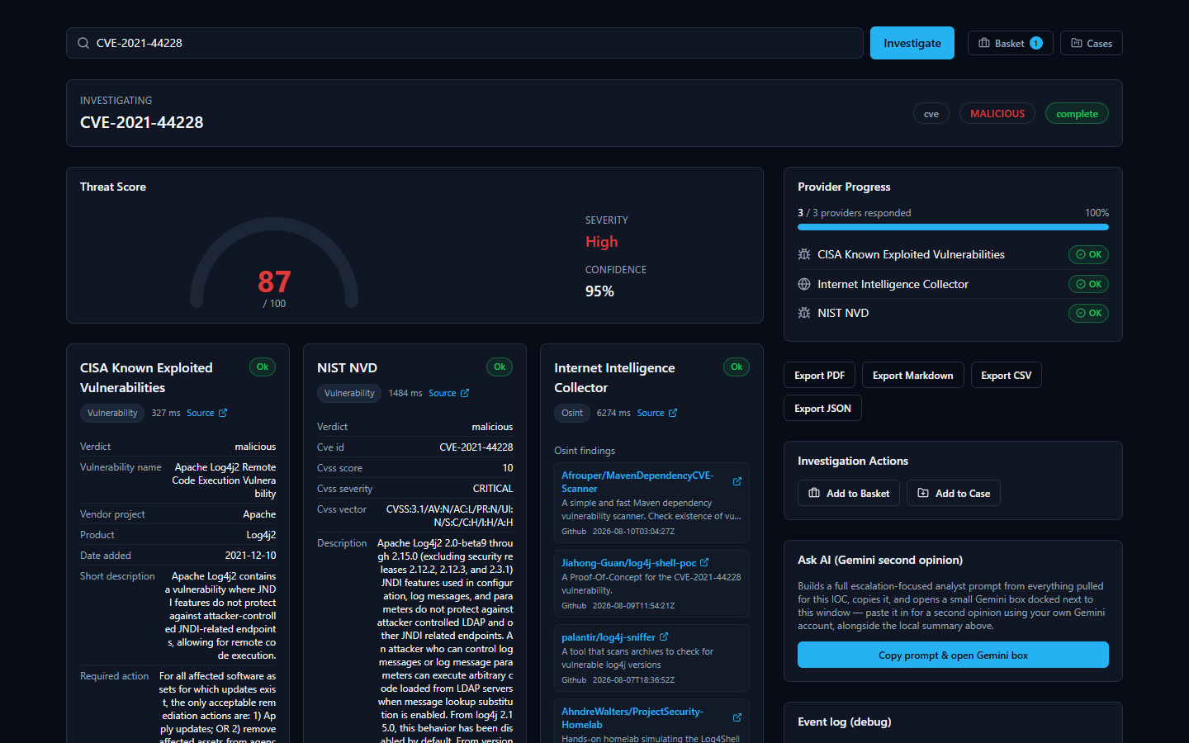

Live Web / OSINT Intelligence
- Internet Intelligence Collector — This is the platform's own OSINT (Open-Source Intelligence — information gathered from publicly available sources rather than a paid feed) crawler. It actively searches public sources like GitHub, Reddit, RSS feeds, and paste sites for recent chatter about a domain, IP, malware family, threat actor, campaign, CVE, or filename. Unlike the other providers, which query a fixed, pre-built database, this one goes out and fetches live results at the moment you run the investigation. For an analyst, this is useful precisely because it can surface very recent, informal discussion — like a proof-of-concept exploit script just published on GitHub — that a slower-moving commercial feed hasn't caught up to yet. What it returns: a list of real, live-fetched findings (e.g. matching GitHub repositories) relevant to the IOC.

Attack Technique Reference
- MITRE ATT&CK — MITRE ATT&CK is the industry-standard framework that catalogs known attacker tactics and techniques (for example, "T1055 — Process Injection"). This provider looks up a MITRE technique ID directly against the official ATT&CK knowledge base. It's mainly used behind the scenes to enrich technique references the platform's correlation engine has already identified, giving analysts the real, official name and description rather than a bare ID.

Domain, IP, and Certificate Registration Providers
These answer "who owns this, and what else is tied to it?" — infrastructure-and-ownership questions rather than reputation questions.
- WHOIS/RDAP — WHOIS and RDAP (Registration Data Access Protocol, the modern successor to WHOIS) are the standard ways to look up who registered a domain, or who an IP address / ASN (Autonomous System Number — an ID assigned to a network operator) block belongs to. This is often the very first thing an analyst checks: is this a brand-new domain registered yesterday, or a major cloud provider's IP range? What it returns: registrar/owner details, registration dates, and organizational information.
- crt.sh (Certificate Transparency) — Every publicly trusted TLS certificate (the certificate that secures a website's HTTPS connection) gets logged in public, tamper-evident "Certificate Transparency" logs. crt.sh searches those logs by domain. This is a well-known technique for discovering other subdomains or infrastructure tied to the same certificate issuer or domain — useful for mapping out an attacker's broader infrastructure. What it returns: a list of matching certificates and the domains/subdomains they cover.
- Censys — An internet-wide scanning service that catalogs what's actually running on IP addresses across the internet (open ports, services, certificates) — sometimes described as passive DNS / internet asset intelligence. This is useful for understanding what an IP is actually hosting, beyond just a reputation score. Censys is the one provider in this platform that needs two separate credentials to work — a Personal Access Token and an Organization ID — both are required, and having only one leaves it not configured.

All 16 Providers at a Glance
Provider | What It Checks | Key Required?
VirusTotal | IPs, domains, URLs, file hashes — multi-engine scan verdicts | Yes
AbuseIPDB | IPs — community abuse reports | Yes
AlienVault OTX | IPs, domains, hostnames, URLs, hashes — community threat exchange | Yes
URLhaus | URLs, domains, IPs — malware-distribution tracking | Yes (shared abuse.ch key)
ThreatFox | IPs, domains, URLs, MD5/SHA256 hashes — shared IOC database | Yes (shared abuse.ch key)
MalwareBazaar | File hashes (MD5/SHA1/SHA256/SHA512) — known malware samples | Yes (shared abuse.ch key)
crt.sh | Domains, TLS certificates — Certificate Transparency logs | No
NIST NVD | CVE IDs — vulnerability description & CVSS score | No (optional key raises rate limit)
CISA KEV | CVE IDs — confirmed active exploitation | No
MITRE ATT&CK | MITRE technique IDs — official attack-technique reference | No
WHOIS/RDAP | Domains, IPs, ASNs — registration/ownership records | No
Hybrid Analysis | SHA256 file hashes — malware sandbox behavior | Yes
Spamhaus | IPs, domains — DNS-based blocklist | No
PhishTank | URLs — community-reported phishing | No (optional key raises rate limit)
Censys | IPs — internet-wide host/certificate scan data | Yes (Personal Access Token  and  Organization ID, both required)
Internet Intelligence Collector | Domains, IPs, malware families, threat actors, campaigns, CVEs, filenames — live OSINT crawl | No

Why the Setup Wizard Only Shows 8 Providers, Not 16
If you've been through the installation wizard, you may have noticed its provider page only lists 8 entries to fill in — not 16. This is a deliberate, verified design detail, not a missing feature.

Here's the honest breakdown of why the numbers work out that way:
- 6 of the 16 providers need no credential at all and have no entry on the wizard's page: crt.sh, CISA KEV, MITRE ATT&CK, WHOIS/RDAP, Spamhaus, and the Internet Intelligence Collector. Since there's nothing to type in, there's simply nothing for a setup screen to ask for — these providers are already active the moment the platform starts, with no setup step required. (NIST NVD and PhishTank also work with no credential, but the wizard still gives each of them an optional key field purely to raise their rate limit — so they're counted in the wizard's 8 entries below, not in this list of 6.)
- The remaining 10 providers are covered by only 8 wizard entries, because three of them — URLhaus, ThreatFox, and MalwareBazaar — all share a single abuse.ch "Auth-Key." Entering that one key on the wizard's single abuse.ch field activates all three providers at once.
So the math is: 8 wizard entries → 10 providers with a wizard entry (7 individual + 3 sharing one abuse.ch key) + 6 always-on providers with nothing to configure = 16 providers total, all working from install day one. Nothing is hidden or broken — the shorter wizard list is simply an accurate reflection of which providers actually have a setting to configure.

Managing Providers From the App (No Restart)
The Setup Wizard's provider page is a first-run bootstrap, not the only place these settings live. Once the platform is up and running, every credential, model choice, and enabled/disabled state — for both IOC providers and AI backends — can be viewed and changed from inside the app itself, at any time, with no restart, no re-installation, and no editing of any configuration file by hand. This is the same underlying configuration the wizard wrote on first install; the wizard just gets you to a working starting point, and this page is where you go afterward whenever something needs to change.
You'll find it via the Providers link in the workspace navigation, which opens a dedicated page organized into four tabs.
AI Providers. This tab lists the platform's AI backends and their current status — for example, showing which ones are "Not configured," which are "Configured," and which one is currently "Active."
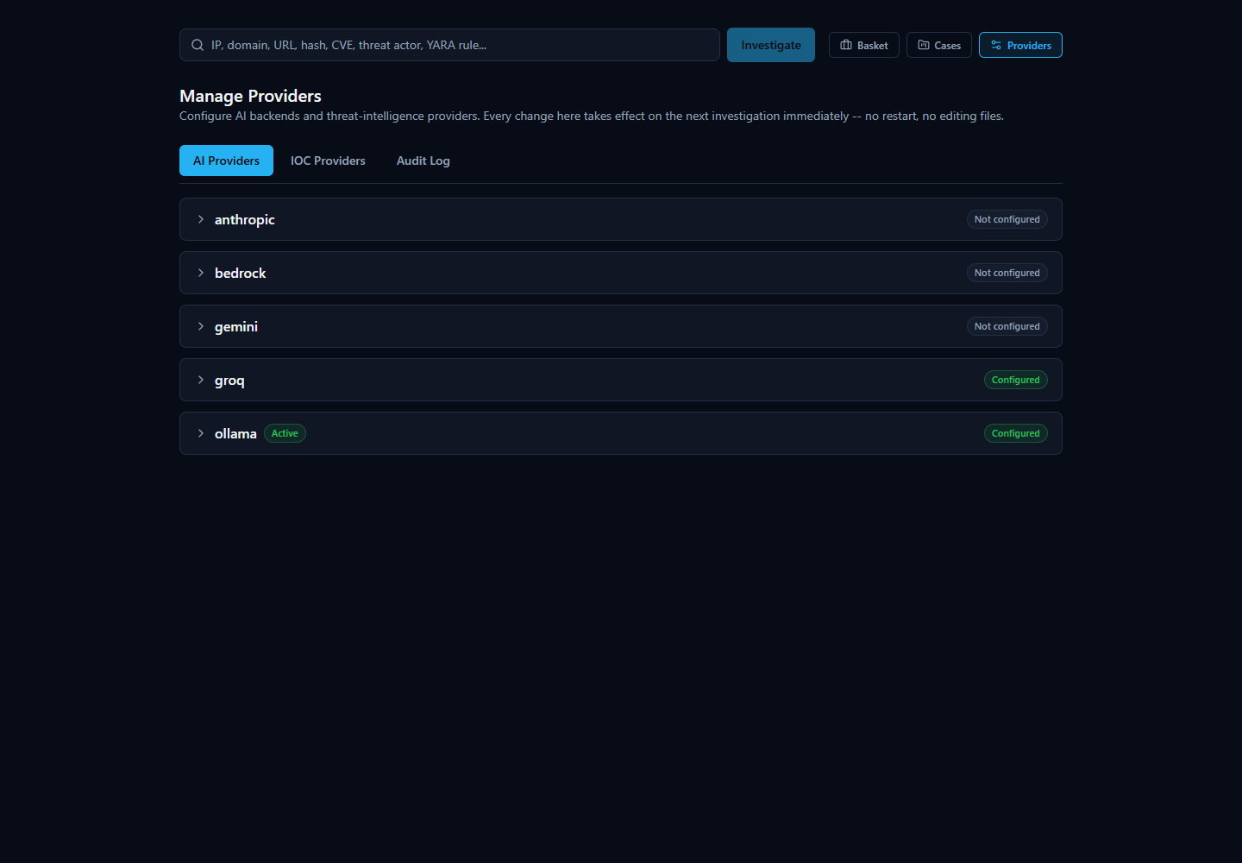
Expanding a backend's row lets you enter or update its credentials and model. An already-saved credential is never shown in plain text -- it displays as a row of masked dots followed by the last few characters, the same partial-reveal convention used by most login and payment forms, so you can recognize which key is saved without the full value ever being visible on screen or recoverable from it. From that same expanded row you can click Test Connection to confirm the credentials actually work before relying on them, and Set Active to make that backend the one the platform uses for new investigations — immediately, without restarting anything.
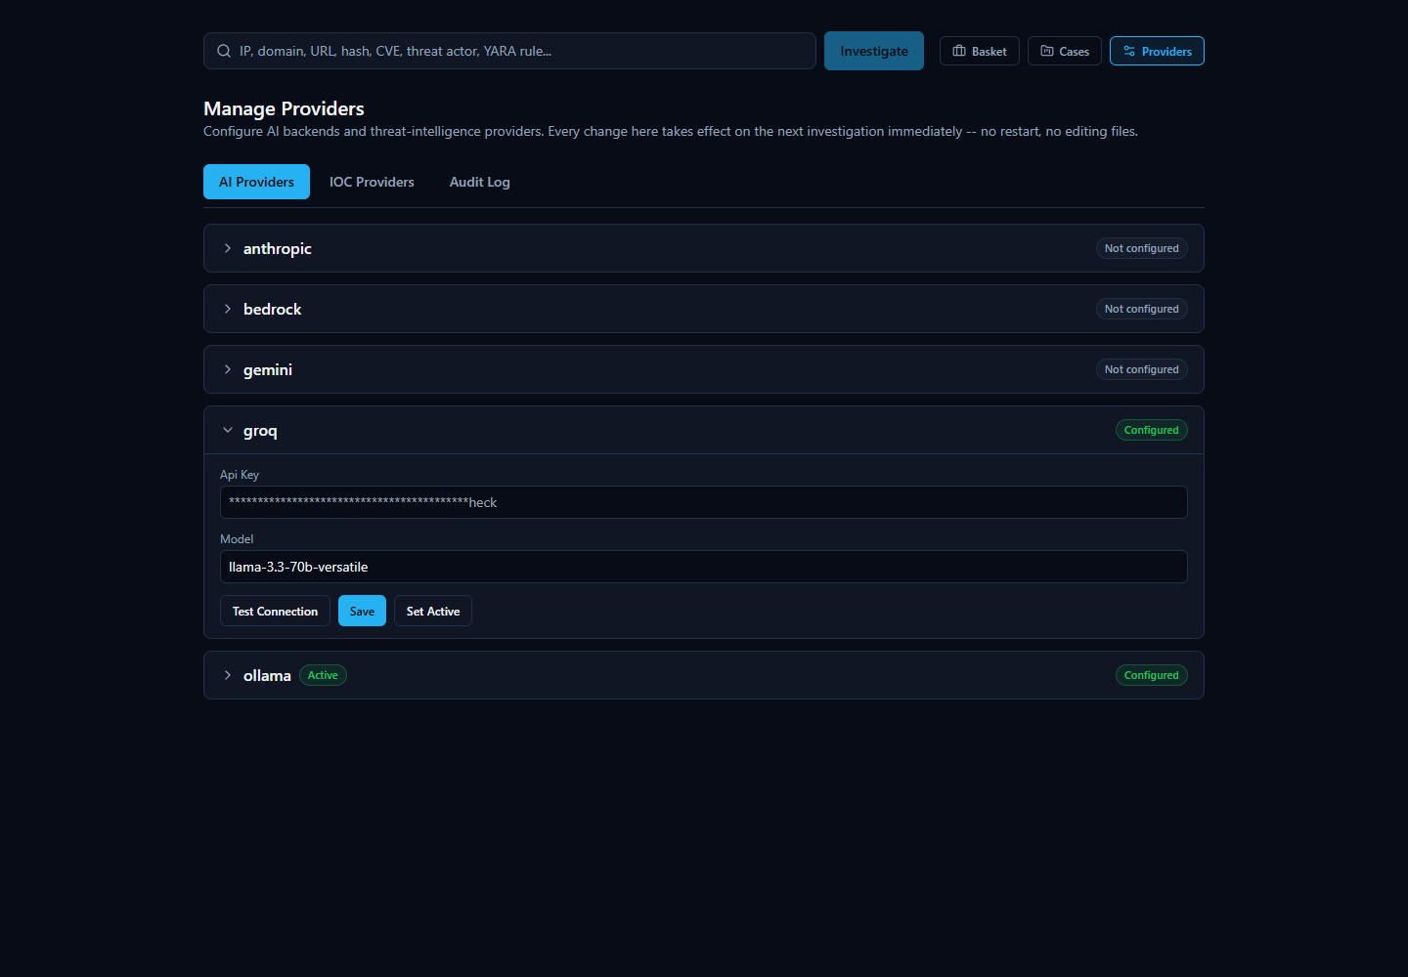
IOC Providers. This tab covers all 16 built-in providers described earlier in this section — each one configurable, testable, and individually enabled or disabled, right from this screen. Because each provider's row only asks for the exact fields that provider actually needs (a single credential for most, the shared abuse.ch key for URLhaus/ThreatFox/MalwareBazaar, or the Personal Access Token and Organization ID pair for Censys), there's no guesswork about what to fill in. Providers that need no credential at all still appear here with an enable/disable toggle, since "on or off" remains a setting worth controlling even when there's nothing to type in.
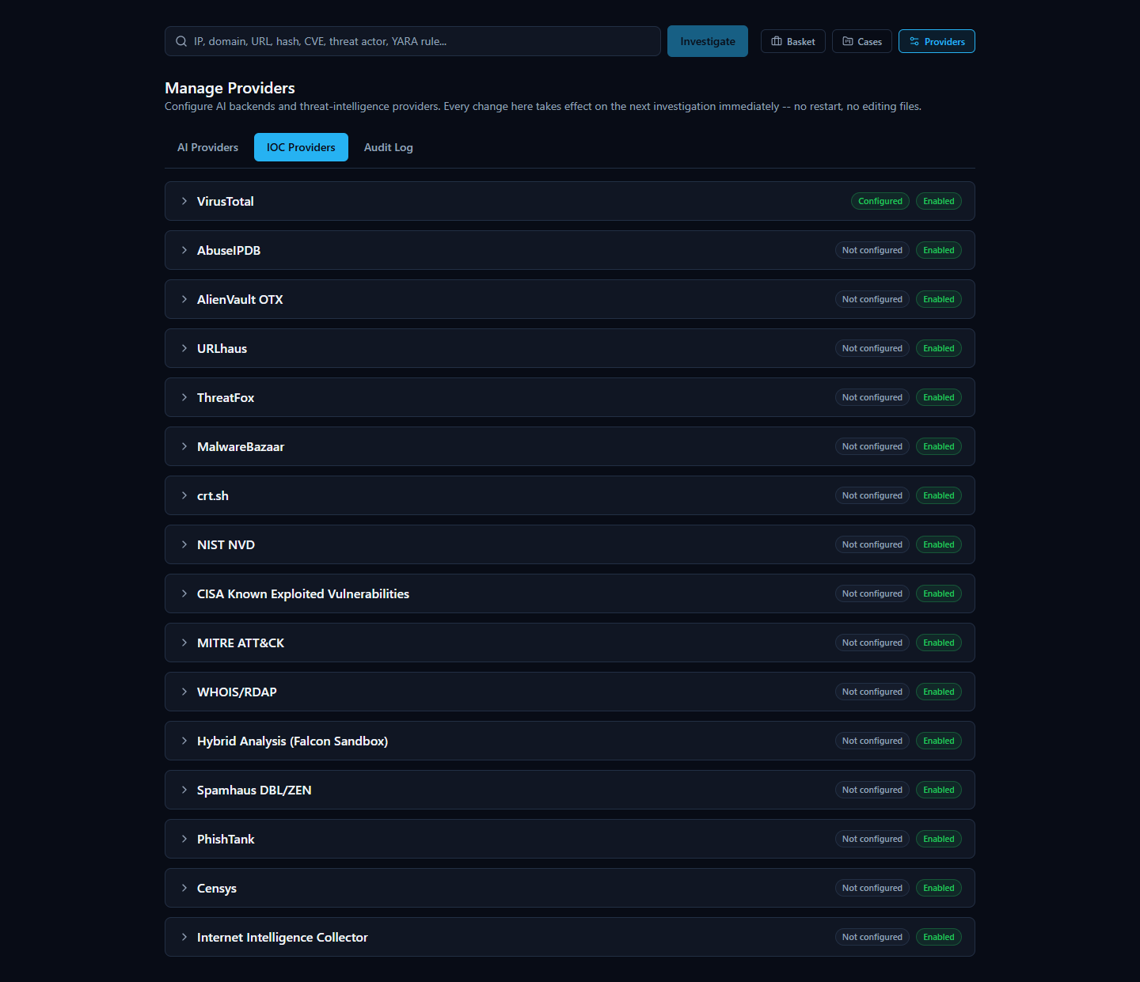
Expanding an IOC provider's row works the same way as an AI backend's: a masked credential field for exactly the input that provider needs, plus Test Connection, Save, and Enable/Disable controls. The screenshot below shows AbuseIPDB expanded with a key typed in, ready to test or save — the same flow used whether you're setting up a provider for the first time or changing an existing key.
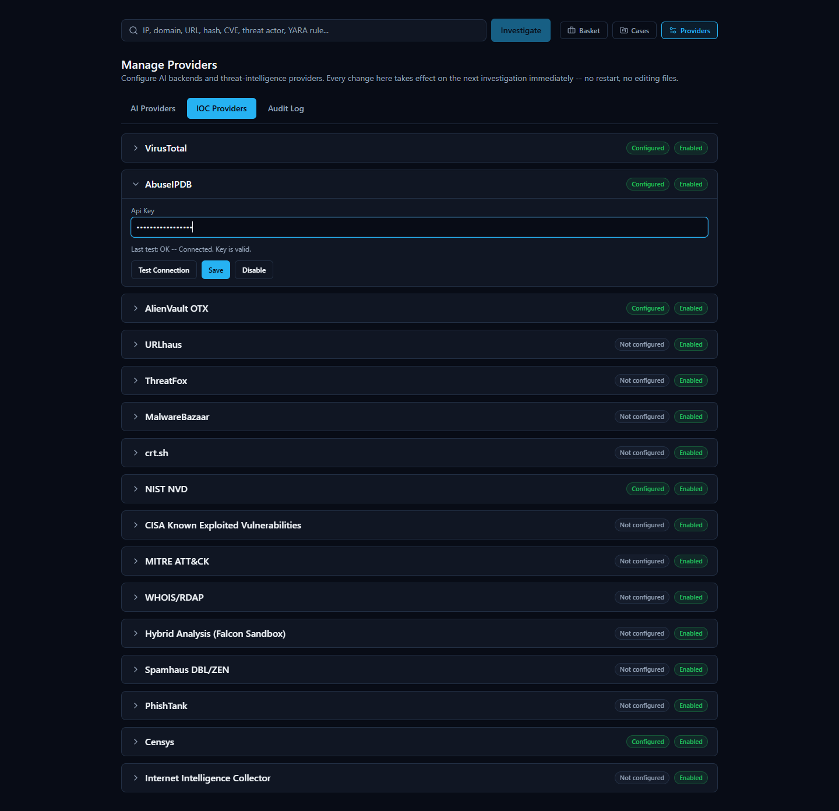
Test Connection always makes a real request to the provider rather than just checking that a field is non-empty, so an incorrect or revoked key is caught immediately with a specific reason, not a vague failure. The screenshot below shows a genuine failed test — a real "Authentication failed" response from the provider, not a placeholder message:
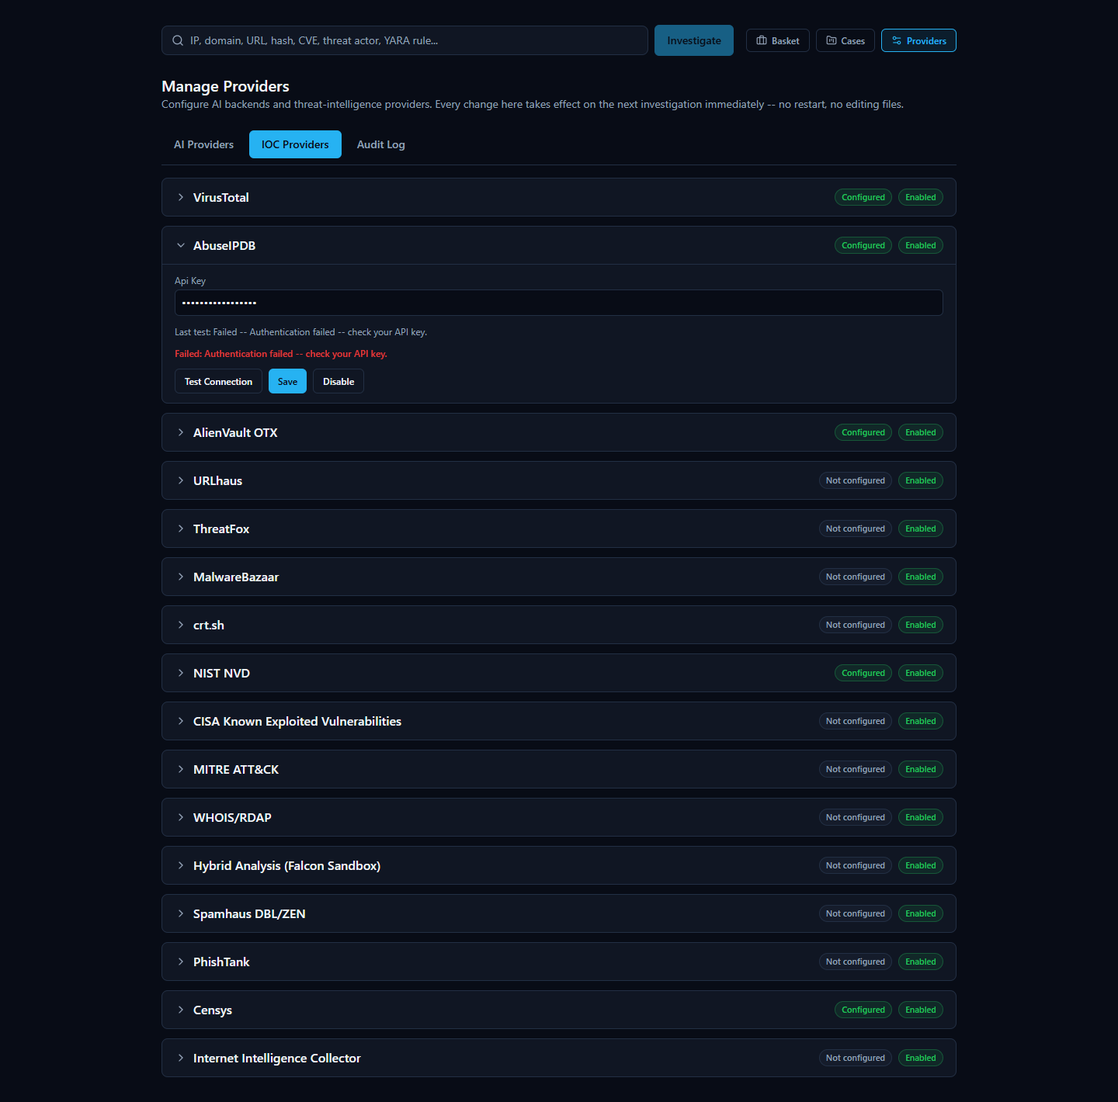
Audit Log. Every configuration change made through this page — configuring a provider, enabling or disabling one, switching the active AI backend, running a connection test — is recorded here in plain, human-readable language: who made the change and what it was. Consistent with how the platform treats credentials everywhere else, the audit log never records the actual credential value — only that a credential was configured or updated, never what it is.
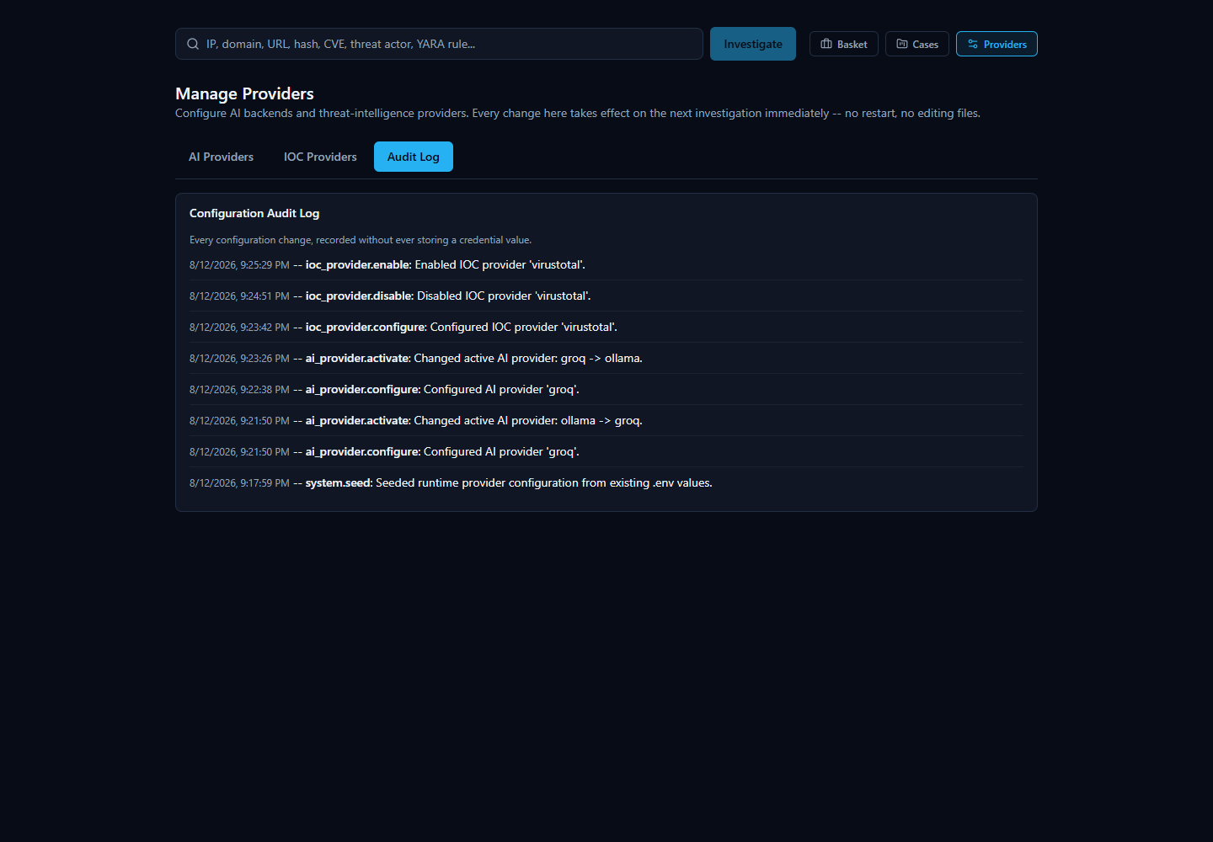
Network Access. This tab shows the address other devices on your local network can use to reach the platform (detected automatically during setup), the ports in use, and whether the local Windows Firewall rule needed for LAN access is in place — see "Accessing From Another Computer" for the full walkthrough.

A Note on Provider Disagreement
Because the platform asks many independent providers at once, they won't always agree — and that's normal, useful behavior, not a malfunction. Reputation feeds, blocklists, and community-reported databases each have their own methodology, so it's entirely possible for one provider to flag an indicator as malicious while another calls the exact same indicator clean.
When that happens, the platform's AI-generated summary tries to explain the disagreement in plain language rather than silently picking a side. That AI output should be treated as analytical assistance, not an unquestionable verdict — it's a starting point for your own judgment, not a replacement for it. Every investigation includes an Evidence Ledger (and a "Show receipts"-style breakdown of how the score and verdict were reached) so you can trace any AI claim back to the specific, real provider data behind it, rather than just taking the summary's word for it.

AI-Assisted Analysis
When you look up an IOC (Indicator of Compromise — a piece of evidence such as an IP address, domain, URL, file hash, or CVE ID that a security analyst wants to investigate) in HORIZON GRID, the platform doesn't just show you a pile of raw results from a dozen different sources and leave you to make sense of them yourself. It also uses an AI model to read that data and write a plain-language summary of what it means.
This section explains, honestly, what that AI layer actually does, what it deliberately does not do, and — most importantly — how you as an analyst can check any AI-written claim against the real evidence behind it rather than simply trusting it.

What the AI Actually Does
The platform's AI analysis happens in two distinct passes over the same investigation:
- A per-provider summary. After each individual data source (VirusTotal, AbuseIPDB, Spamhaus, WHOIS, and so on) returns its result, the AI writes a short summary of that one provider's findings — nothing else. It is only shown that provider's own data when writing this summary, so a per-provider summary can never blend in information from a different source by mistake.
- One consolidated final assessment. Once every provider has finished responding, the AI makes a second, separate call — this time it is given all of the per-provider summaries together, plus a correlation step that has already mechanically compared the providers against each other (looking for things they agree on, disagree on, or both independently point to, such as a shared malware family or IP relationship). From that combined picture, the AI writes one overall assessment: a verdict, a risk score, and prose explaining how the providers relate to and support (or contradict) one another.
Both passes run on whichever AI backend the platform has been configured to use. The platform supports several interchangeable backends — Ollama (a locally-hosted model with no external API calls), Anthropic, Amazon Bedrock, Google Gemini, and Groq (a fast-inference provider with an OpenAI-compatible API, defaulting to the llama-3.3-70b-versatile model). Whichever backend is selected on the AI Configuration page of the setup wizard is the one actually used for both the per-provider summaries and the final assessment; the platform never silently mixes or falls back to a different provider mid-investigation.
Both of these appear on the investigation page, and they answer different questions. A per-provider AI summary answers "what did this one source say?" The final assessment answers "now that I've seen everything, what's the overall picture?" You'll see one summary box per provider card, and then a single Final Assessment section (with its own Executive Summary) further down the page that speaks for the investigation as a whole.


What the AI Does NOT Do
It's just as important to understand the boundaries of this feature as it is to understand what it produces:
- The AI does not scan any files itself. It has no antivirus engine, no sandbox, and no ability to independently examine a file, URL, or IP. Every fact it summarizes came from one of the third-party providers the platform queried — VirusTotal, AbuseIPDB, Spamhaus, NIST NVD, and so on.
- The AI has no threat feed or knowledge base of its own that it consults for a verdict. It doesn't maintain a private list of known-bad indicators. Its job is strictly to read and reason over the results the providers already returned for this specific lookup — never to supply new "knowledge" of its own about whether something is malicious.
- The AI is explicitly prevented from inventing a verdict when there is no real evidence. This is a hard, code-level safeguard, not just a polite instruction to the model, and it exists precisely because the alternative was tested and failed. During validation, the platform's real EICAR test file was looked up by its actual MD5 hash (EICAR is a standard, harmless, industry-wide test file used to safely trigger antivirus and threat-intelligence detections without touching real malware). In that specific test, none of the configured providers were actually turned on for that lookup, so there was zero real evidence of any kind — no provider data, no correlation between sources. Despite that, the AI model still produced a verdict of "highly malicious," a fabricated 92% probability of maliciousness, and invented prose claiming an "association with ransomware and trojans" — none of it grounded in anything that had actually been returned. This was caught, and the platform now includes a deterministic check that runs before the AI is ever asked to weigh in: if there are no per-provider findings and no correlated relationships between providers, the platform skips the AI call entirely and returns a fixed, honest result — a verdict of "unknown," a message explaining that no provider returned usable data for the indicator, and the risk fields left at zero — rather than letting a model guess from its own general training data. In other words, when there's nothing to go on, the platform says so, instead of making something up.

How the AI Handles Disagreement Between Providers
Threat intelligence sources don't always agree, and the platform doesn't hide that when it happens — it says so directly. A good real example is the IOC 8.8.8.8 (Google's public DNS resolver): Spamhaus flagged it as malicious, but the actual reason given was a query-permission error ("public/open resolver not permitted to query Spamhaus"), not a genuine detection — while AbuseIPDB reported zero abuse reports and VirusTotal returned a clean result. The AI's Executive Summary for that investigation says so plainly: the IP "is considered malicious by Spamhaus, but its reputation as a clean and safe IP address is supported by AbuseIPDB and VirusTotal."
That's not a bug in the product — it's the AI doing exactly what it's supposed to do: surfacing a genuine conflict between sources instead of quietly picking one side, so the analyst can see the disagreement and judge it for themselves (in this case, a known, benign, heavily-used public DNS server being caught by a resolver-permission rule rather than an actual threat detection).


Verifying an AI Claim Instead of Trusting It Blindly
Every investigation gives you concrete ways to check an AI-written statement against the real underlying evidence, rather than asking you to just take its word for it:
- The Evidence Ledger. Every investigation includes a running list of individual, numbered evidence items — each one tied to a real source and carrying its own confidence percentage. This is the platform's version of "show receipts": any specific claim the AI makes should be traceable back to one or more of these concrete, checkable entries rather than floating free as an unsupported assertion.
- Verdict Analysis tools. Alongside the Final Assessment, the investigation page offers a set of tabs specifically for interrogating the verdict rather than passively reading it, including "Why?" (asks the AI to justify the verdict by pointing at specific evidence), "Challenge This Verdict" (deliberately pushes back on the AI's own conclusion to see if it holds up), and "False Positive Check" (asks the AI to reason about whether this could be a benign result mislabeled as a threat). These exist so that an analyst's natural next question — "why should I believe this?" — has a direct, built-in answer instead of requiring you to take the summary on faith.
- The AI provenance badge. Every AI-generated Final Assessment carries a small badge naming exactly which AI backend and model produced it — for example, groq / llama-3.3-70b-versatile or ollama / llama3.2:3b. This matters because, as noted above, the platform never silently switches or falls back between backends mid-investigation, so the badge is a dependable record rather than a guess: an analyst can always see precisely which AI generated a given conclusion, and can factor that into how much weight to give it (a larger hosted model and a small local model won't necessarily reason about the same evidence with the same thoroughness).


Switching AI Backends and Getting a Second Opinion
Because the platform supports several interchangeable AI backends, changing which one analyzes your work is a day-to-day action, not an administrator task. A compact "AI: [dropdown]" control sits right next to the search bar on the home page, showing whichever backend is currently selected along with a colored dot — green if that backend is actually configured with working credentials, gray if it isn't — and a Manage link through to the full provider configuration page. Picking a different backend from the dropdown changes which AI analyzes your next investigation immediately: no restart, no editing configuration files, no detour through a separate settings page.
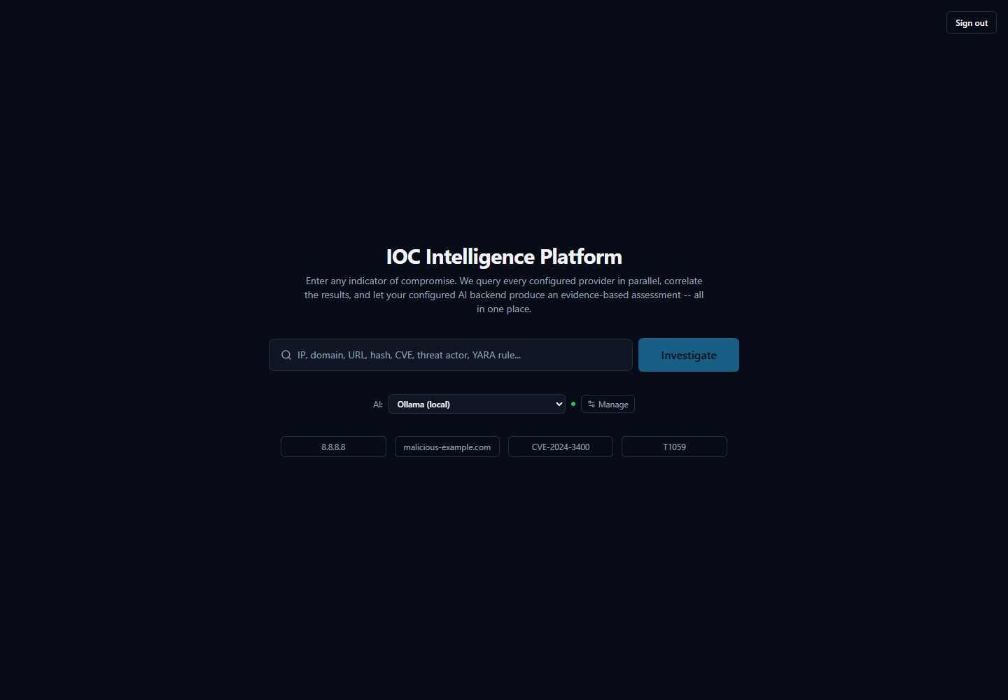
After picking a different entry from the dropdown, the control immediately reflects the new selection and its real configured status — here, switched to Groq:
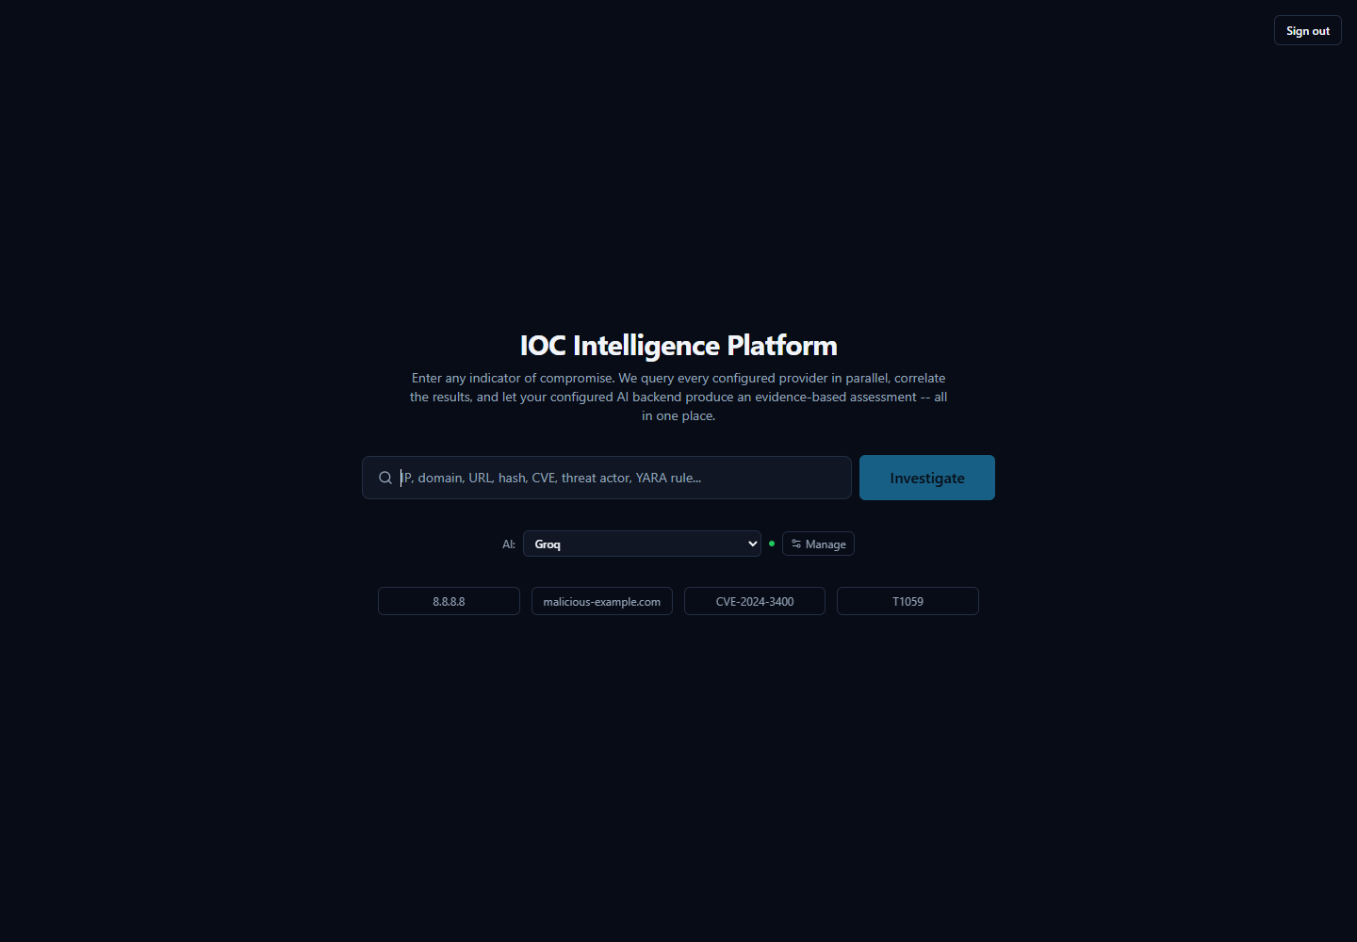
This connects directly to the point above about not trusting an AI claim blindly: if you want to check whether a verdict reflects the evidence itself rather than one particular model's read of it, you can ask a second AI to look at the same evidence and see whether it agrees. On a completed investigation's page, the AI Comparison panel lets you pick a different backend and click "Analyze with [backend]"; the platform re-runs only the final-assessment step against the evidence already collected — it does not re-query any provider — and appends that backend's independent result below the original, with each result clearly labeled by exactly which AI and model produced it. Neither result is presented as more correct than the other; the value is in having a second opinion to weigh against the first, which is especially useful for sanity-checking a verdict, or for spotting cases where two backends actually disagree.
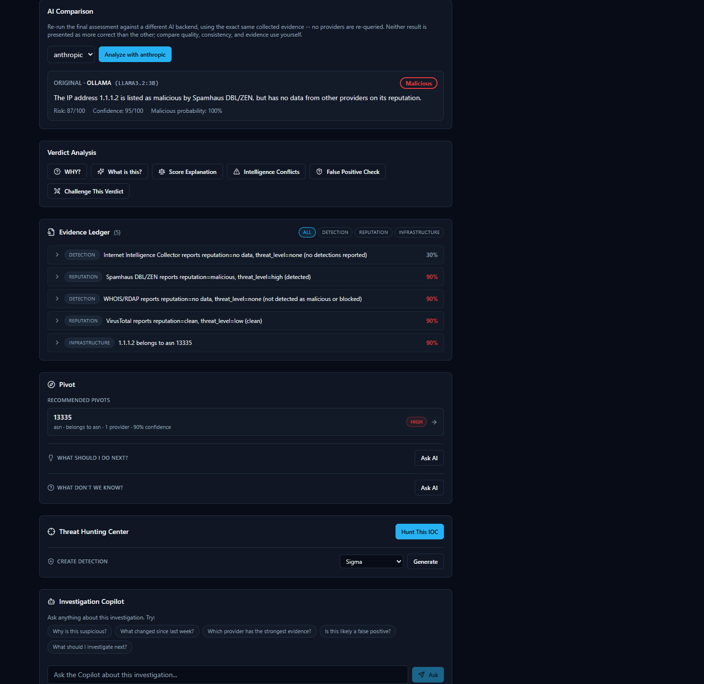

Ask AI (Gemini Second Opinion) -- a separate, manual escalation path
Alongside AI Comparison, every investigation page (both while it is still running and afterward) shows a smaller "Ask AI (Gemini second opinion)" panel in the sidebar. This is a distinct feature, not another view of AI Comparison, and works differently: clicking "Copy prompt & open Gemini box" builds a single, detailed analyst-escalation prompt from everything pulled for this IOC so far (provider results, per-provider summaries, and correlation), copies that prompt to your clipboard, and opens a small popup window pointed at gemini.google.com. You then paste the prompt into that popup yourself and read Gemini's answer there, signed in with your own personal Google account.
This matters for two reasons an analyst should know before using it. First, it is entirely manual and entirely outside the platform: the platform never sends your IOC data to Gemini itself, has no API credential or integration with Gemini for this feature, and never sees or stores whatever Gemini replies with in the popup -- unlike AI Comparison's result, a Gemini second opinion obtained this way is not saved to the investigation record. Second, because the copied prompt includes the IOC value and every provider result pulled so far, treat it the same way you would treat pasting investigation data into any other outside AI chat tool -- follow your organization's policy on what may leave the platform this way before using it on sensitive investigations.

AI analysis in this product is intended as analytical assistance, not unquestionable truth, and every AI-generated claim is designed to be traceable back to real evidence an analyst can independently check.

Evidence and Receipts

Every AI claim comes with a receipt
When the platform finishes investigating an IOC (Indicator of Compromise -- a piece of evidence such as an IP address, domain, URL, file hash, or CVE ID that a security analyst wants to investigate), it doesn't just hand you a paragraph of AI-written analysis and expect you to take it on faith. Underneath every AI explanation sits an Evidence Ledger: a list of individual, checkable evidence records, each one built directly from what a specific provider (one of the many third-party threat-intelligence services the platform queries, such as VirusTotal or AbuseIPDB) actually returned, or from a connection the platform's correlation step found between two providers' results.
The Evidence Ledger itself is not written by the AI. It is assembled deterministically from the real provider data and the real correlation output, precisely so that when the AI does write a summary, a verdict, or an answer to a question, every meaningful claim in that text can point back to one of these real records instead of being a bare assertion. Each item carries its own source, its own confidence score, and the underlying data it came from -- nothing in the ledger is invented after the fact to make an AI claim look more supported than it is.
On top of the ledger sit several different views an analyst can open on the same evidence -- for example, "Why?", "What's this?", "Score Explanation," "Intelligence Conflicts," "False Positive Check," and "Challenge This Verdict." These are different lenses on the same underlying evidence, not separate, independent opinions. Where an AI explanation cites specific evidence for a specific sentence, "Show receipts" takes you straight from that sentence to the exact evidence record(s) it's based on, instead of leaving you to wonder where a number or a claim came from.

Why this matters: never take the AI's word for it
This design exists for one reason: an analyst should never have to simply trust an AI's conclusion. The AI is analytical assistance -- it reads, summarizes, and correlates a lot of provider data quickly -- but the underlying evidence, not the AI's prose, is the actual source of truth. If a claim in a summary can't be traced to a real evidence record, that's a signal to question it, not accept it.
A genuine example from this platform makes the point well. Looking up 8.8.8.8 (Google's Public DNS server, a benign, well-known service) produces a Threat Score of 87 out of 100, rated "High" -- because the Spamhaus provider marked it malicious. But the actual reason string behind that verdict, visible in the evidence itself, is "query error -- public/open resolver not permitted to query Spamhaus" -- a policy rejection from Spamhaus's own lookup service, not a detection of malicious behavior. Meanwhile AbuseIPDB reports zero abuse reports and VirusTotal calls the address clean. The platform's own AI-written Executive Summary is honest about this: it describes the IP as "considered malicious by Spamhaus, but its reputation as a clean and safe IP address is supported by AbuseIPDB and VirusTotal" -- disagreement and all.
This isn't a bug to hide -- it's exactly the kind of case the Evidence Ledger exists for. An analyst who opens the underlying evidence record can read the literal reason for the Spamhaus verdict, recognize it as a lookup-policy quirk rather than a real threat finding, and decide for themselves whether the high score is warranted. That is the whole point: the platform surfaces disagreement and lets you check it, rather than smoothing it over into a single unquestionable number.


Correlation and the Relationship Graph

What "correlation" means here
Every provider the platform queries only knows about its own narrow slice of the picture. AbuseIPDB knows abuse reports. WHOIS/RDAP knows registration and network-ownership details. VirusTotal knows antivirus-engine detections. On their own, these are just separate lists of facts from separate sources.
Correlation is the step where the platform automatically looks across everything the providers returned and notices when two separate findings are actually pointing at the same related fact. A common example: an IP address and the ASN (Autonomous System Number -- an identifier for the network block or organization that owns a range of IP addresses) it belongs to. If one provider reports the IP address and another (or the same provider's WHOIS/RDAP data) reports which network owns it, the platform draws that as a connection rather than leaving you to notice the overlap yourself while reading two separate provider write-ups.
This happens automatically after every provider has finished responding, before the platform writes its final consolidated assessment -- so the AI's overall summary is correlation-aware, not just a stitched-together list of per-provider opinions. When more than one provider corroborates the same underlying fact, the platform's confidence in that connection increases accordingly, since agreement across independent sources is more meaningful than a single provider's claim alone.

The Relationship Graph: seeing connections instead of reading walls of text
The Relationship Graph is where these correlated connections become visible. Instead of an analyst reading through several separate provider cards and mentally cross-referencing which facts relate to which, the graph draws each fact as a node and each discovered connection as a line between nodes -- so relationships that would otherwise be buried across multiple paragraphs of provider text are visible at a glance.
In the simplest case, this might be no more than two connected nodes -- for example, an IP address and the single ASN it belongs to. In a richer investigation involving more providers and more shared facts -- such as a vulnerability with related findings pulled together from several sources -- the same graph grows to reflect however many real, corroborated connections the correlation step actually found. In every case, the graph is a visualization of the same underlying evidence discussed above, not a separate or less-verified layer -- it shows relationships the platform can already point to specific evidence for.
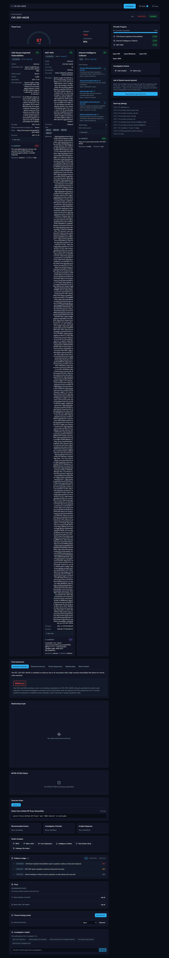

Case Management

Why group IOCs together at all?
A single IOC (Indicator of Compromise — a piece of evidence such as an IP address, domain, URL, file hash, or CVE ID that a security analyst wants to investigate) rarely tells the whole story on its own. A real incident is usually made up of several related pieces of evidence: the CVE (Common Vulnerabilities and Exposures identifier — a public catalog number for a known software vulnerability) behind an exploit attempt, the malicious IP address that tried to use it, the file hash of a payload that was dropped, and the analyst's own observations along the way.
If a SOC (Security Operations Center) analyst investigates each of those as a separate, disconnected search, several problems show up quickly:
- Context gets lost. A week later, nobody remembers that the "8.8.8.8 lookup" and the "CVE-2021-44228 lookup" and the "note about the firewall log" were all part of the same incident.
- Handoffs are painful. A second analyst picking up the investigation has no single place to see everything that's already been found — they have to be told, or re-discover it themselves.
- Nothing to report from. When it's time to write up what happened, the evidence is scattered across a browser history of individual lookups instead of living in one record.
The platform's Case feature solves this by giving an analyst one container — a "case" — that IOCs and notes can all be attached to as an investigation grows. Instead of "three unrelated searches I happened to run this week," it becomes "one case, with three pieces of evidence attached to it."

Walking through a real case
The screenshot below shows a case immediately after it was created:
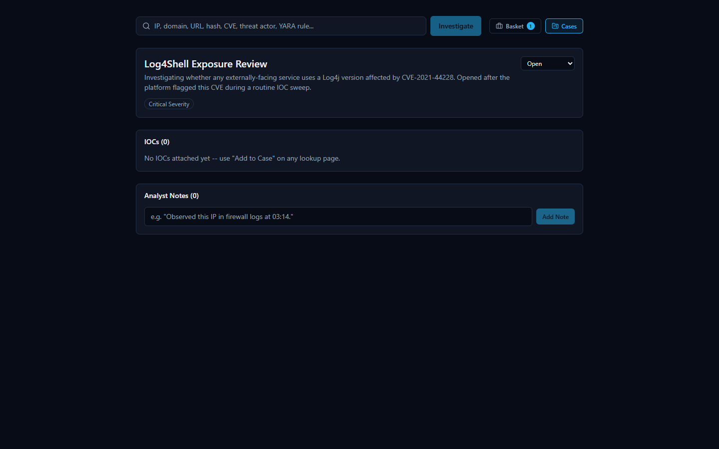
At this point the case is just a title, a severity level (here, Critical), an Open status, and a description of what the analyst is tracking — no evidence has been linked to it yet.
From here, an analyst builds the case up over the course of the investigation:
- Attaching an IOC: every investigation page in the platform (the page that shows a lookup's results) has an "Add to Case" button. When an analyst is looking at the results for an IOC — for example, the CVE-2021-44228 (Log4Shell) investigation — clicking "Add to Case" links that IOC directly to the case, so it no longer has to be tracked as a separate, disconnected search.
- Adding a note: the case also supports freeform analyst notes — short written observations that don't belong inside an automated provider result, such as "confirmed this CVE affects our externally-facing logging service; escalating to patch team."
The second screenshot shows the same case after both of those actions have happened:
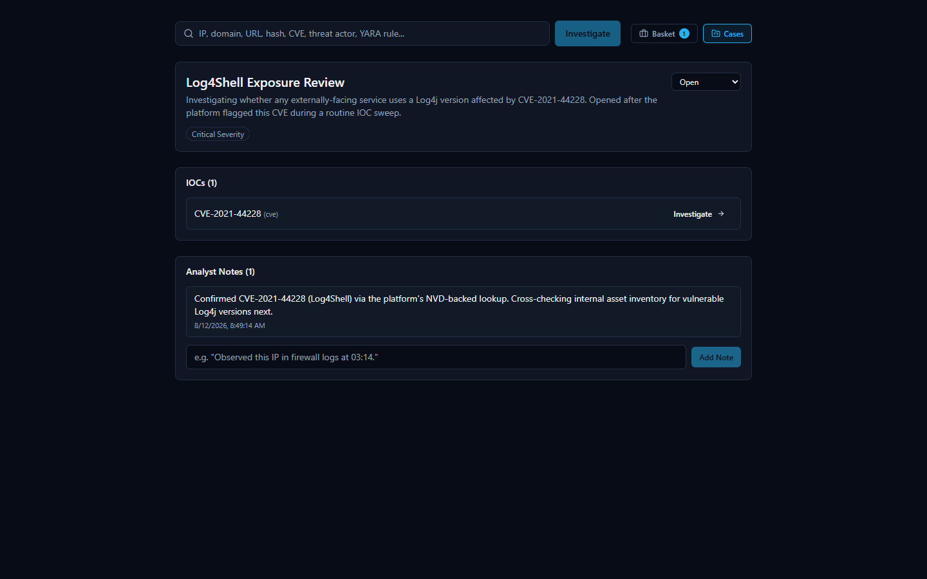
The case now shows one attached IOC (CVE-2021-44228) and one analyst note. As an investigation continues, more IOCs and more notes can be attached the same way, so that everything relevant to "Log4Shell Exposure Review" stays in one place rather than spread across separate, easily-forgotten lookups.

IOC Basket

What it is (and what it isn't called)
While working an investigation, an analyst often wants to keep track of a handful of IOCs they're personally paying attention to — not necessarily a formal case yet, just a running list of "things I'm keeping an eye on." The platform's real name for this feature is the IOC Basket (or just "Basket"). It is a personal scratch-list: an analyst adds IOCs to it while they investigate, and the Basket holds onto them for later.
It's worth being precise about naming here: this feature is not called a "Watchlist" anywhere in the product. "Basket" is its actual name. It serves a purpose an analyst might informally think of in watchlist terms — a personal running list of IOCs to come back to — but the platform's own term for it is Basket, and that's the name used throughout its interface.

Using the Basket
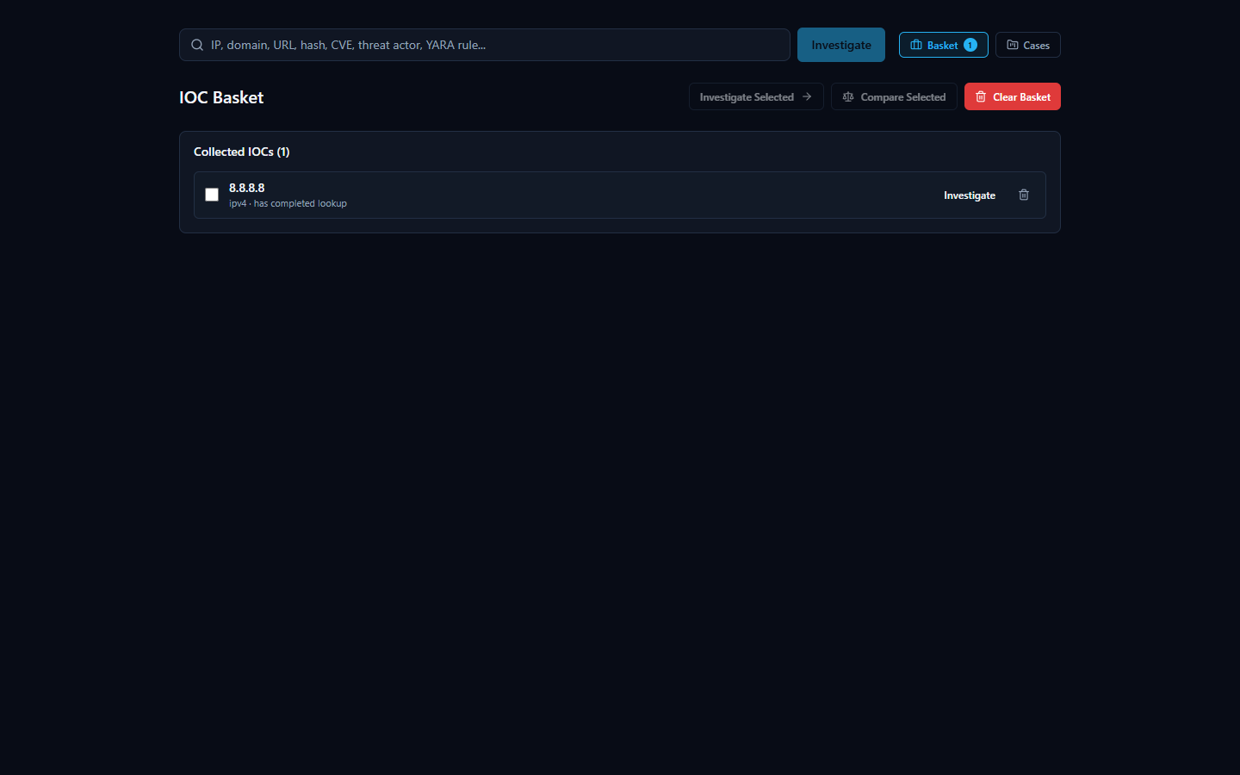
In the screenshot above, the Basket holds one collected IOC, 8.8.8.8, tagged as having already completed a lookup — so the analyst can see at a glance which basket entries already have results waiting versus which still need to be investigated.
The Basket page offers a small set of actions for working with the IOCs an analyst has collected:
- Investigate Selected — run (or re-run) a lookup on the IOCs currently selected in the Basket, rather than having to re-enter each one manually on the search page.
- Compare Selected — look at more than one saved IOC side by side, useful when an analyst wants to check whether two or more indicators they've been tracking relate to each other or share characteristics.
- Clear Basket — remove everything from the personal scratch-list once it's no longer needed.
Because the Basket is a personal list rather than a shared case record, it's best suited for the everyday "let me keep track of these while I work" habit — when something in the Basket turns out to matter for a real incident, it can then be formally attached to a Case (see the Case Management section above) so the finding isn't lost once the Basket is cleared.

Exporting Findings
Every investigation the platform runs produces a lot of material worth keeping: a verdict, a risk score, per-provider evidence, correlation results, and an AI-written summary. Once you've reviewed an investigation, you'll usually want to get some or all of that out of the browser and into wherever the rest of your work lives — a ticket, an incident report, a chat message to a teammate, or another tool entirely.
The export controls for this live in the sidebar of every investigation page. Opening them shows four buttons: Export JSON, Export Markdown, Export PDF, and Export CSV.
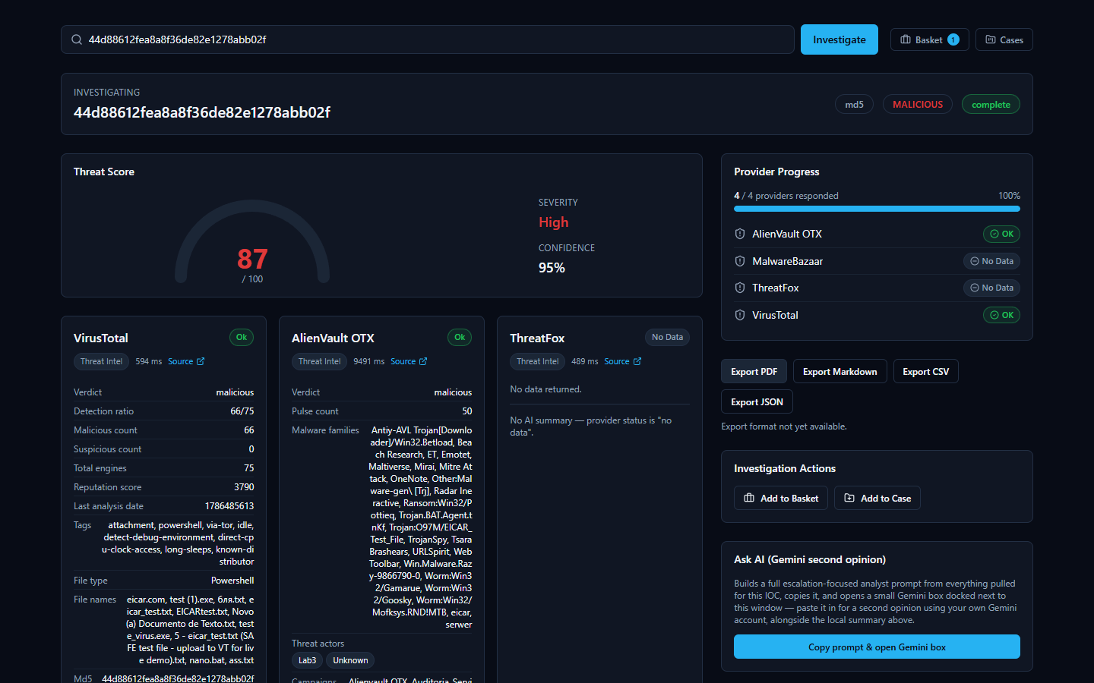
Two of these — JSON and Markdown — work today and produce a real file. Two of them — PDF and CSV — are visible in the interface but not yet built. This section covers both honestly, because that's exactly what you'll see if you click each one.

What works today: Export JSON and Export Markdown
Clicking Export JSON or Export Markdown downloads a real file to your browser's Downloads folder, built from the same investigation you're looking at on screen. Both formats carry the same underlying content, just structured for different purposes:
- Export JSON is the machine-readable version — the same assessment fields shown on screen, structured for a script, a SIEM (Security Information and Event Management system — the log-aggregation tool many SOCs use as their central alerting hub) ingestion pipeline, or another tool that expects structured data rather than prose.
- Export Markdown is the human-readable version — the same content laid out as readable text, suitable for pasting straight into a ticket, a wiki page, or an email.
Either export includes:
- The verdict and risk score the platform settled on for the IOC (Indicator of Compromise — a piece of evidence such as an IP address, domain, URL, file hash, or CVE ID that an analyst wants to investigate).
- The executive and technical summary — a plain-language explanation of what the IOC is and why it received the verdict it did, alongside the more detailed technical reasoning.
- A supporting evidence list — specific findings the AI pulled out of the per-provider results and correlation data to back up its verdict. This is a curated, AI-written excerpt list, not the full structured Evidence Ledger; for the complete per-provider findings with confidence scores on each item, use the Evidence Ledger inside the app itself (covered elsewhere in this document) — it isn't part of either export.
- Any MITRE ATT&CK mappings — techniques the evidence supports, when applicable.
- The recommended actions — practical next steps suggested for an analyst handling this IOC.
- Any detection rules the platform generated for that IOC, when the IOC type and available evidence supported generating one.
In other words, whichever format you pick, you get the verdict, risk score, and the AI's full written reasoning in one file — enough to hand this investigation off to a colleague, attach it to a ticket, or drop it into another tool without re-typing anything. If your use case specifically needs the full per-item Evidence Ledger with confidence scores rather than the AI's supporting-evidence excerpts, view that in the app itself — it isn't part of either export.

What's not available yet: Export PDF and Export CSV
Export PDF and Export CSV appear as buttons in the same sidebar, but neither is built yet. Clicking either one shows the real message the product displays: "Export format not yet available." No file downloads, and nothing crashes — the platform tells you plainly that this format isn't ready rather than pretending it worked or failing silently.
This is a known, documented scope boundary, not a defect: the two working formats (JSON and Markdown) already cover both the machine-readable and human-readable cases most analysts need, and PDF/CSV support is simply not built out yet. If your workflow depends specifically on a PDF for a report template or a CSV for spreadsheet import, use Export Markdown or Export JSON as the source material for now and convert it with whatever tool your workflow already uses.

A note on the AI-written portions of an export
Nearly everything in either export — the executive summary, technical summary, supporting-evidence excerpts, MITRE ATT&CK mappings, recommended actions, and any detection rules — comes from a single consolidated AI call, not hand-typed by a human analyst, and it is a separate thing from the platform's own non-AI-generated Evidence Ledger. Like any AI-generated analysis, an export is a starting point for your judgment, not a substitute for it. The platform's own Evidence Ledger and verdict-explanation tools (covered elsewhere in this document) are how you check an AI-written claim against the real, underlying evidence before you rely on it or pass it along in an exported report. Providers genuinely disagree on real IOCs — the 8.8.8.8 (Google Public DNS) investigation shown elsewhere in this document is a good real example, where one provider flagged it malicious and two others called it clean — and the platform's summaries are written to reflect that disagreement rather than paper over it, but it's still worth reading the underlying evidence yourself before treating an exported verdict as final.

A Real-World SOC Workflow
Every feature described so far is easier to trust once you see it used the way a SOC (Security Operations Center) analyst actually works: not by opening one tool at a time, but by following a single lead wherever it goes. The walkthrough below is not a hypothetical — it is the exact sequence an analyst followed in the platform, start to finish, while triaging a routine batch of indicators.

The lead: a CVE turns up in a routine sweep
It starts the way most real investigations do — unglamorously. The analyst is working through a list of IOCs (Indicators of Compromise: IP addresses, domains, hashes, and CVE IDs pulled from recent alerts and vendor advisories) that need to be checked against threat intelligence before the shift ends. Most will turn out to be noise. One entry in the list is CVE-2021-44228 — a CVE (Common Vulnerabilities and Exposures) identifier, the standard way the industry names a specific, publicly tracked software vulnerability. The analyst doesn't recognize the number offhand, so they submit it to the platform the same way they would any other IOC.
The results come back aggregated from multiple authoritative sources in one view. This is the payoff of an IOC lookup platform in the first place: instead of opening a CISA advisory in one tab, a NIST database in another, and a search engine in a third, the analyst gets all of it side by side, in the time it takes the providers to respond.

The CISA (Cybersecurity and Infrastructure Security Agency) Known Exploited Vulnerabilities card is the first thing that raises the stakes: CISA doesn't list a CVE unless it has confirmed real-world exploitation, and here the verdict is unambiguous — malicious, with the vendor, affected product, and remediation guidance pulled directly from that catalog. The NIST NVD (National Vulnerability Database) card independently corroborates the severity: a CVSS (Common Vulnerability Scoring System) score of 10 out of 10, rated CRITICAL, with the full official vulnerability description. Underneath both, the Internet Intelligence Collector — the platform's own OSINT crawler — has pulled in live findings from GitHub repositories actively discussing this CVE, showing the analyst that it isn't just historically significant, it's still a live topic. The analyst recognizes the number now: this is Log4Shell, the Log4j remote-code-execution vulnerability. Two independent, authoritative government-maintained sources agreeing on maximum severity is exactly the kind of signal that turns a routine sweep item into a priority.
Scrolling further confirms there's substance behind the verdict, not just a score:

The Detection Rules panel is a concrete, useful artifact: a real generated rule that gives the analyst a working draft to review and adapt rather than having to write one from scratch. As with any AI-assisted output in the platform, this rule and the Final Assessment above it are analytical assistance, not a verdict to take on faith — every claim on this page can be traced back to a real provider record or correlation edge in the Evidence Ledger below, so the analyst (or a teammate reviewing the case later) can check exactly where a specific statement came from rather than just trusting the summary text. It's a head start for the detection engineering team, not a substitute for their review before it ships to production.

Escalating: opening a case
A CVSS 10, confirmed-exploited, still-actively-discussed vulnerability isn't a one-off lookup to close and forget — it needs to be tracked, assigned a severity, and worked as its own investigation. The analyst opens the platform's Cases feature and creates a new case.

Naming the case, setting its severity to Critical, and leaving it Open turns a single search result into a tracked piece of work — something that can be picked up again tomorrow, handed to another analyst, or referenced from a ticketing system, instead of living only in the analyst's memory or a screenshot.

Attaching evidence and recording the next step
From the CVE-2021-44228 investigation page, the analyst attaches the CVE directly to the new case using the "Add to Case" button, then records what they're doing about it as an analyst note before moving on.

The note reads, in full: "Confirmed CVE-2021-44228 (Log4Shell) via the platform's NVD-backed lookup. Cross-checking internal asset inventory for vulnerable Log4j versions next." This is a small thing, but it is the difference between institutional knowledge and a Slack message that scrolls away: the case now carries a permanent record of what was confirmed, from where, and what happens next — reviewable by a teammate, a manager, or the analyst's own future self without anyone having to reconstruct it from memory.

Handing it off
The investigation still needs to leave the platform and land in wherever the team tracks incident tickets. The analyst exports the findings as Markdown, which attaches cleanly to a ticket or incident-report document as readable, formatted text. JSON export is also available for anyone downstream who wants to parse the findings programmatically rather than read them. (PDF and CSV export are not yet available in this release — the export panel says so plainly rather than failing silently, so nobody wastes time waiting on an export that isn't coming.)

Why this is faster than doing it by hand
The same investigation done manually would mean separately visiting CISA's KEV catalog, querying NVD, running a search for current OSINT chatter, writing a detection rule from scratch, and then remembering to document all of it somewhere durable — five or six separate tools and a self-imposed discipline to write anything down at all. Here, one search surfaced every authoritative source at once, the platform's own evidence trail let the analyst verify the severity claim instead of just trusting a score, and opening a case took the finding from "something I noticed" to "something the team can act on" in the same sitting. Search, correlate, verify, document, escalate — collapsing those five steps into one continuous flow is what keeps a real Log4Shell-caliber finding from getting lost in a routine sweep.

System Health

A simple yes/no answer: is the platform up?
Before trusting any investigation result, it helps to know the backend itself is actually running and reachable. The platform exposes a small, unauthenticated health-check address for exactly this purpose. Opening it directly in a browser returns a short, raw JSON reply rather than a page of graphics -- it is meant to be read by a person in two seconds, or by a monitoring script in milliseconds.
The reply is deliberately minimal:
{"status":"ok","service":"HORIZON GRID"}
There is no login, no dashboard, and no extra detail here on purpose. This endpoint exists to answer one question only -- "is the backend up right now?" -- as unambiguously as possible. If the backend is down, still starting up, or unreachable, this address simply fails to load instead of returning the reply above; that failure to load is itself the signal that something needs attention.

Checking health without touching Docker
The platform's actual runtime is a set of Docker containers, but an administrator running the Windows-installed version never needs to know that, let alone type a Docker command, just to check on it day to day. The Windows installer adds a Start Menu group that includes a Service Status shortcut and a Diagnostics shortcut, both built specifically so a routine health check is a single click rather than a terminal session.
- Service Status reports on whether the platform's services are up and healthy.
- Diagnostics is the equivalent shortcut for digging deeper when something looks wrong, without needing to know the underlying container commands.
Between these Start Menu shortcuts and the health-check address described above, an administrator has two independent, beginner-friendly ways to confirm the platform is alive -- one click, or one URL.

Provider Health

A dedicated page for "is every provider actually working right now?"
The single-page health check above answers "is the backend up." A separate, more detailed question -- "is every individual threat-intelligence provider actually working right now, or just configured" -- gets its own dedicated page. It's reachable from the new Dashboard entry in the global navigation, then "View full Provider Health status" on the Executive Dashboard's provider-health widget (or directly via the Provider Health link under the Operations group of the same navigation).
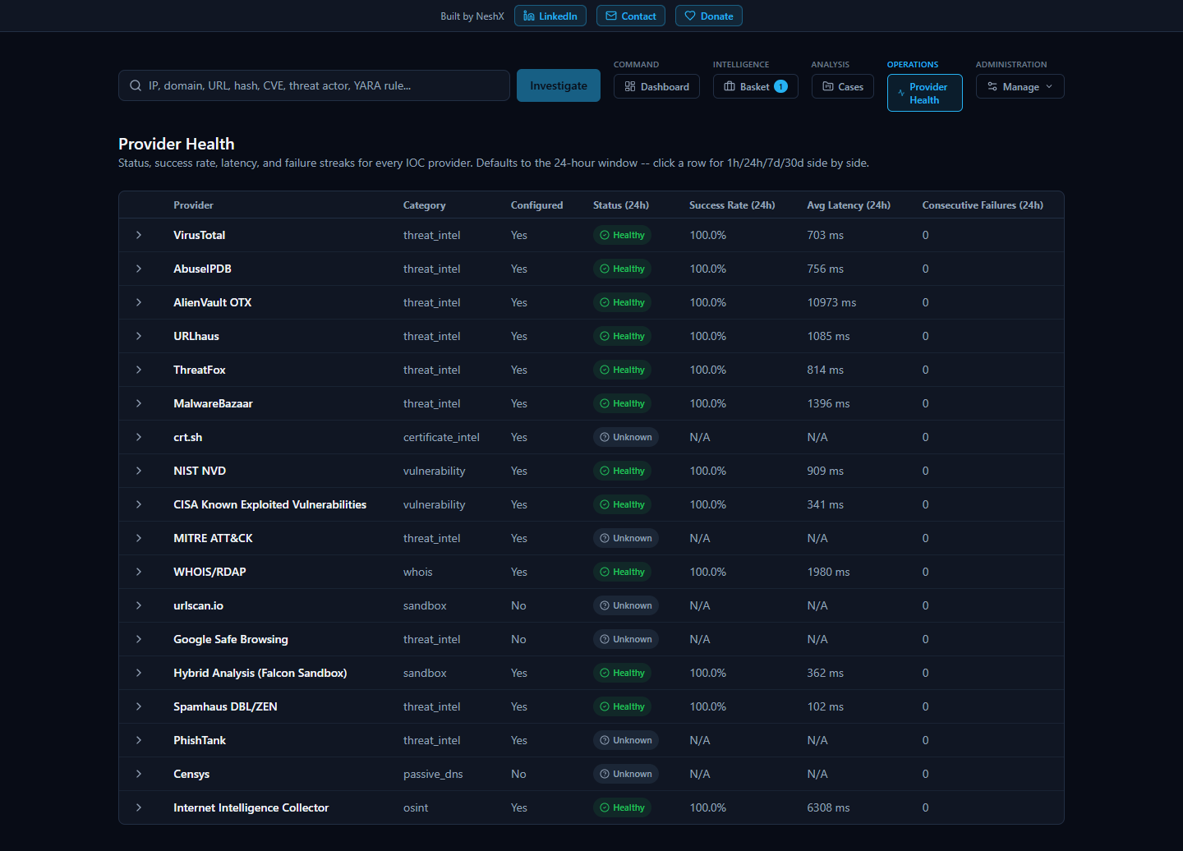
Unlike the old provider cards shown mid-investigation (still covered below), this page is not scoped to one lookup -- it is a real, database-backed table of every registered provider's status, built from the actual outcome of every real call that provider has made across the whole platform. Each row reports status, success rate, average latency, and consecutive-failure count, and reports all of that across four separate rolling windows -- 1 hour, 24 hours, 7 days, and 30 days -- so a brand-new problem and a month-long pattern are both visible without cross-referencing anything else; clicking a row expands all four windows side by side.
Status is always one of four values -- Healthy, Degraded, Down, or Unknown -- and each is always paired with its own distinct color, icon, and text label, never color alone, so the information doesn't depend on being able to distinguish colors.
A guarantee worth stating explicitly: a provider that was never actually exercised in a given window shows "Unknown," never "Healthy." Silence is not evidence of health -- a provider nobody has called in the last hour has no success rate to report for that hour, and reporting one anyway (even a reassuring one) would be reporting something the platform doesn't actually know.
A related guarantee, found and fixed as a real bug during this feature's own testing: a provider that correctly reports "nothing found" for a given indicator -- which is what most real-world lookups against most providers actually return, since no single provider's dataset covers every indicator -- counts as a healthy, successful outcome, not a failure. An earlier version of this page's health calculation miscounted that correct "no data" response as a failed attempt, which meant a provider working perfectly could have shown up as "Degraded" or "Down" simply for doing its job honestly. This was caught and fixed before release: a real provider (OTX) that had been reporting "Degraded" at 64% success under the flawed logic correctly reported "Healthy" at 100% once "nothing found" was counted as the successful outcome it actually is.

Troubleshooting
The list below is not a set of hypothetical problems -- every item was either deliberately induced and observed, or organically encountered, during the platform's own end-to-end quality-assurance pass, then either fixed or documented as an honest, known limitation. It is written for the first time something looks unexpected during an investigation of an IOC (Indicator of Compromise -- a piece of evidence such as an IP address, domain, URL, file hash, or CVE ID -- Common Vulnerabilities and Exposures, a public catalog number for a known software vulnerability -- that a security analyst wants to look up).

The AI summary says "Unknown" and every risk score reads 0
What you'll see: instead of a verdict like "malicious" or "benign," the final assessment reads "Unknown," the risk and confidence scores are both 0, and a note explains that AI summarization was unavailable.
What it means: the AI model the platform uses to summarize and correlate results (by default, a local model) could not be reached. Rather than guess and present a verdict it can't actually support, the platform is designed to report that failure honestly. During testing, this exact scenario was deliberately created by making the AI backend unreachable: every AI-dependent field correctly reported the failure instead of pretending to succeed, and every provider's own raw data (VirusTotal, AbuseIPDB, WHOIS, and so on) remained untouched and just as trustworthy as always -- only the AI-generated synthesis was affected. Restoring the connection to the AI backend and restarting immediately brought full AI functionality back on the next investigation.
What to do: re-run the Configuration shortcut to confirm the AI backend setting, verify the AI model/service it points to is reachable, and try the investigation again.
A related point, even when the AI is healthy: an "Unknown" verdict from an unreachable AI is a different situation from providers genuinely disagreeing with each other -- which the AI is designed to surface, not hide. Elsewhere in this guide, the IOC 8.8.8.8 is a real example where one provider (Spamhaus) flagged it malicious while two others (AbuseIPDB and VirusTotal) called it clean, and the AI's own summary spelled out that disagreement rather than silently picking a side. In every case, the AI's output is analytical assistance, not the final word -- every claim it makes can be checked against the underlying facts it was built from in the investigation's Evidence Ledger ("Show receipts"), rather than accepted on trust alone.

The page shows a real error, or an investigation won't load at all
What it means: this is consistent with a database outage. When the platform's database was deliberately stopped mid-request during testing, the result was a clear, fully logged error -- not a silent failure, a crash, or corrupted data. Restarting the database restored full functionality immediately, and previously saved cases and Basket entries were confirmed completely intact afterward.
What to do: use the Restart Platform shortcut (or Diagnostics, if you want more detail first), then try again. Your previously saved data is not at risk from this kind of outage.

A repeat lookup on the same IOC comes back noticeably faster
This is expected behavior, not a bug. Each provider's result is cached for up to an hour after it's first fetched, so looking up the same IOC again within that hour reuses the already-fetched provider data instead of re-querying every source from scratch. After that hour passes, the next lookup fetches fresh data again.

One provider card shows "Not Configured," "Error," or "Rate Limited" while others show real results
This is normal and expected, not a malfunction. Each provider's status is reported honestly and independently: a provider you haven't set up a key for shows "Not Configured," a provider that genuinely failed to respond shows "Error," and a provider that has temporarily hit its own free-tier limit shows "Rate Limited." None of these ever get mislabeled as one another, and -- just as importantly -- one provider having a problem never blocks the rest of the investigation from completing.

You closed the browser tab or lost your connection partway through an investigation
Provider results that had already come back before the disconnect are saved, not lost. Revisiting the investigation afterward shows every provider result that had completed up to that point, even though the investigation itself may show as failed if it didn't finish.

Clicking "Export PDF" or "Export CSV" doesn't produce a file

This is a known, honest limitation, not a bug to work around: PDF and CSV export are not yet available in this release. Rather than fail silently or crash, the platform tells you so directly with the message shown above. Export JSON and Export Markdown both work today and are the way to get an investigation's results out of the platform in the meantime.

You typed something and got "Could not determine IOC type"
This means the value entered didn't match any of the IOC formats the platform recognizes (IP address, domain, URL, file hash, CVE ID, and others). This is a deliberate, clean rejection with a clear message, not a crash -- double-check the value for typos and try again.

Security and Data Handling
This section explains, in plain language, how HORIZON GRID handles your sign-in, your provider credentials, and — most importantly — the actual indicator data you investigate. It is meant to be read by anyone using the tool, not just engineers. A far more detailed, code-level Security Architecture appendix exists later in this document for readers who want the full technical picture; this section is its beginner-friendly companion.

Signing In, and Who Becomes the Administrator
The platform is a normal sign-in-protected web application: you register an account with an email and password, then sign in from the same page each time.

A few things worth knowing about how this works:
- Your password is never stored in plain text. The platform keeps only a one-way scrambled (hashed) version of it, so nobody — not even someone with direct database access — can read your actual password back out.
- Signing in issues a temporary digital pass, not a permanent one. After you sign in, the platform gives your browser a short-lived access token that expires automatically after about 30 minutes, plus a longer-lived one (good for about 7 days) that quietly renews your session in the background so you aren't forced to re-enter your password constantly.
- The very first account created on a fresh install automatically becomes the administrator. There is no separate "make someone an admin" step to remember. When the Setup Wizard runs during installation, the account you create on its Administrator Account page is that very first account — and because it's first, the platform automatically grants it administrator-level access. Once that administrator exists, the public sign-up page closes itself: anyone who tries to register through it afterward is turned away with a message pointing them at an administrator instead. Every account after the first one has to be created by an administrator from the Administration page (see below), who chooses its role — analyst or viewer, or another administrator — up front.
- Administrators manage every other account from an Administration page, not by editing anything by hand. Once signed in as an administrator, an "Administration" link appears in the top navigation (it's invisible to non-administrators). From there you can create a new account with a specific role from the start, promote or demote an existing analyst or viewer, disable an account instantly (their access stops working on their very next click, even if they're mid-session), re-enable one, and reset anyone's password — which also signs that person out of every device they were already signed into, so they can't keep using the old password's session. Every one of these actions is recorded in the same Audit Log a provider-configuration change would be, so there's always a record of who did what and when — never including the actual password.
- There is always at least one administrator, and the platform won't let you accidentally remove the last one. Trying to disable the sole remaining administrator, or demote them to analyst/viewer, is refused with a clear error rather than silently locking everyone out of account management. An administrator also can't change their own role (another administrator has to do it) — this just prevents someone from accidentally locking themselves out of the very screen they're using.

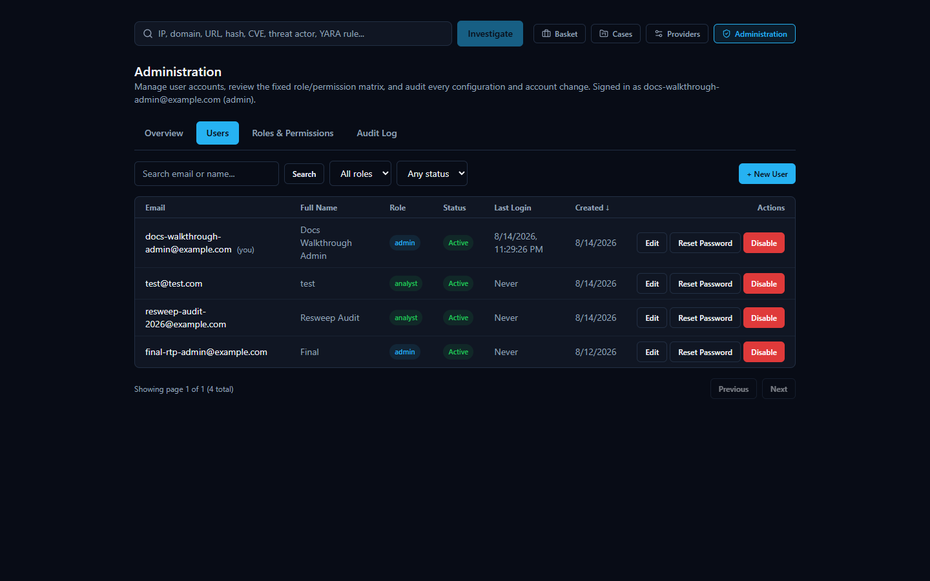
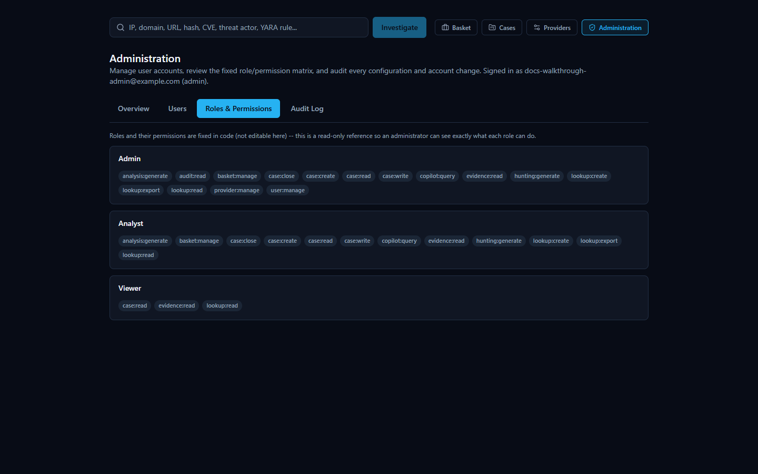
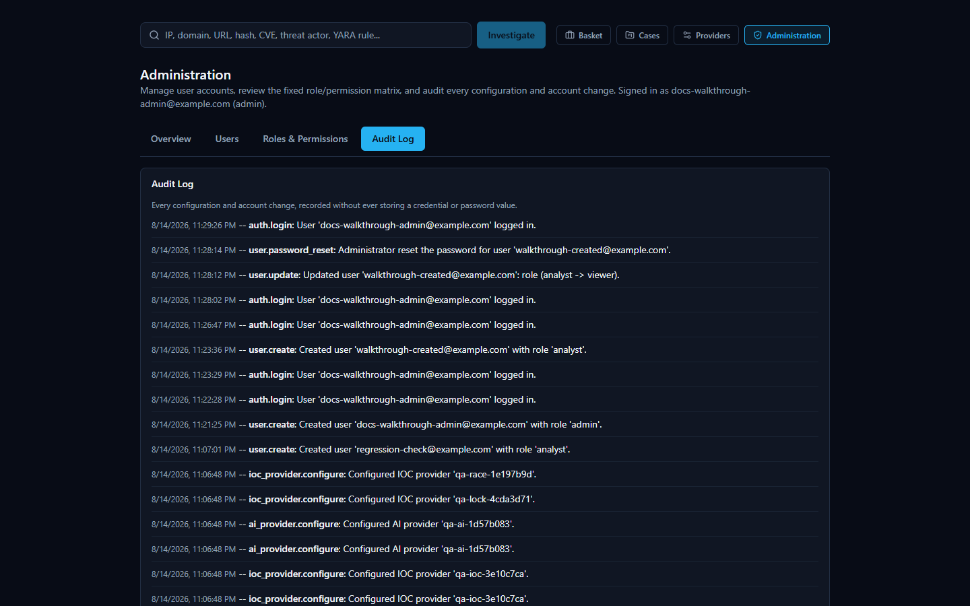

Your Provider API Keys: Entered Once, Locked Away
To query the various third-party threat-intelligence services this platform aggregates (VirusTotal, AbuseIPDB, AlienVault OTX, and others), several of them require you to supply your own API key for that service. You provide these once, during installation, on the Setup Wizard's provider configuration page — not somewhere buried in a settings menu you have to hunt for.

A few practical points:
- Keys are masked as you type them, the same way a password field is — so nothing sensitive is visible on your screen by accident, including in screenshots or over someone's shoulder.
- Keys are stored in a single configuration file, kept in a protected system folder on the machine running the platform — not inside the web application's database, and not anywhere a regular file browse would stumble across. That folder is locked down at the operating-system level so that only Administrator-level Windows accounts (and the system itself) can open it; a standard, non-administrator user account on the same computer cannot read it.
- You can revisit and change your keys later using the "Configuration" shortcut the installer creates, which simply re-runs the same wizard against your existing setup.

What Happens to an IOC You Investigate
This is the part worth reading carefully, because it's central to how the platform works and it deserves an honest explanation rather than a reassuring gloss.
When you submit an IOC (Indicator of Compromise — an IP address, domain, URL, file hash, or CVE ID, i.e. a standardized identifier for a publicly known software vulnerability, that you want to investigate) for a lookup, the platform does not just search its own local database. For every configured provider that supports that type of indicator, the platform sends the literal value you entered — the actual IP address, the actual domain name, the actual file hash — out to that provider's own service, because that is the only way those services can check it against their own intelligence. This is true across essentially the whole provider lineup: threat-intelligence services like VirusTotal, AbuseIPDB, and AlienVault OTX; public lookups like WHOIS/RDAP and Certificate Transparency; and everything in between. If a provider isn't configured (no key entered, or not applicable to that indicator type), it simply isn't contacted and contributes nothing — but any provider that is configured and supports that IOC type will see the value you're investigating.
Practically, that means: be mindful before investigating something genuinely sensitive. If you're looking up an internal hostname, an internal IP address, or a file hash tied to an active, confidential incident, remember that value is being transmitted to whichever external providers you've enabled — the same way it would be if you pasted it into any of those providers' own websites. That's simply how multi-provider IOC lookups work, not a flaw specific to this platform, but it's a habit worth having regardless of which tool you're using.

AI Analysis: Local by Default, Cloud if You Choose
Once provider results come back, the platform uses an AI model to summarize individual provider findings and produce a consolidated assessment. You choose which AI model does that work during setup.

- By default, the AI runs entirely on a local model on the same machine as the rest of the platform. In this mode, no analysis data leaves your machine at all — the model that reads the provider findings and writes the summaries and verdicts is running locally, alongside everything else.
- Optionally, you can configure a cloud AI provider instead. If you choose this, the provider findings gathered during your investigation are sent to that external AI service so it can generate the write-up. This is a deliberate trade-off some readers may want (for a more capable model) and others may not — it's your choice to make during setup, and it's separate from the provider-lookup data flow described above.
Either way, choosing the local model versus a cloud AI provider only affects where the AI writing happens — it does not change the fact, described above, that the IOC value itself is still sent to whichever threat-intelligence providers are configured, since that step happens before the AI is ever involved.

Checking the AI's Work Instead of Just Trusting It
AI-generated verdicts, summaries, and explanations in this platform are analytical assistance — a well-informed second opinion — not an unquestionable ground truth, and the platform itself is built around that idea rather than around asking you to simply trust a score.
A genuine, honest example of why this matters: a lookup on 8.8.8.8 (Google's well-known public DNS server) shows Spamhaus returning a "malicious" verdict, but for an unusual reason — its own card explains this is because open public resolvers aren't permitted to query Spamhaus directly, not because 8.8.8.8 is actually malicious. Meanwhile AbuseIPDB and VirusTotal both call it clean. The platform's own executive summary is upfront about this disagreement rather than quietly blending it into one number.


This is exactly the kind of AI verdict worth double-checking rather than accepting at face value — and the platform gives you the means to do that:
- The Evidence Ledger is a list of the underlying facts behind a verdict, each with its own confidence level. Unlike the AI's prose summaries, evidence-ledger entries are built directly and deterministically from the provider results themselves — they are not written by the AI — so they exist specifically to give you something concrete to check the AI's claims against.
- The Verdict Analysis tabs (including "Why?", "What's this?", "Score Explanation", "Intelligence Conflicts", "False Positive Check", and "Challenge This Verdict") let you interrogate a verdict rather than just read it, and are designed to surface disagreements between providers — like the Spamhaus/AbuseIPDB/VirusTotal split above — instead of hiding them.
- Behind the scenes, the platform also cross-checks the AI's own output against the underlying data it was given: if the AI cites something (for example, a specific MITRE ATT&CK technique) that isn't actually backed by the real evidence collected for that IOC, the platform flags it rather than presenting it as confirmed.
The takeaway: treat AI-generated verdicts as a starting point for your own analysis, and use the Evidence Ledger and Verdict Analysis tools when a result seems surprising, high-stakes, or — as with 8.8.8.8 — genuinely contested between providers.

Frequently Asked Questions
Do I need every provider configured to use the platform? No. Every provider that needs an API key is optional -- the platform works with any subset configured, including none. Providers that need no key at all (WHOIS/RDAP, Spamhaus, crt.sh, NIST NVD, CISA KEV, MITRE ATT&CK, PhishTank, the Internet Intelligence Collector) always run regardless. An investigation with zero paid providers configured still produces a real result from whichever free sources apply to that IOC type.
Does the AI's verdict override the provider data? No, and the platform is deliberately built so you never have to take the AI's word for it. Every AI-written summary is grounded in the Evidence Ledger -- a deterministic, AI-independent record built directly from what the providers actually returned. If an AI conclusion doesn't match the underlying evidence, the Verdict Analysis tools ("Why?", "Challenge This Verdict", "False Positive Check") exist specifically so you can check.
What happens if a provider fails or isn't configured? The investigation continues with whichever providers succeeded. A failed, rate-limited, not-configured, or disabled provider is reported with a specific status (never a generic "error"), and the AI is explicitly told that provider's data is unavailable -- which is treated differently from "the provider ran and found nothing." A missing data point is never silently read as a clean bill of health.
Can I switch AI providers without losing my current investigation? Yes. Switching the active AI backend (via the "AI:" selector on the home page, or the AI Providers tab in Manage Providers) takes effect on the next investigation immediately -- no restart. For an investigation you've already run, the "AI Comparison" panel lets you re-run just the AI analysis step against a different backend, using the same already-collected evidence, without re-querying any provider.
Why does the same IOC sometimes get a slightly different AI write-up if I re-analyze it? AI-generated text is not perfectly deterministic between calls, and different backends/models can reasonably read the same evidence differently (which is exactly what the AI Comparison feature is for). The underlying facts -- provider data, correlation, Evidence Ledger -- do not change between reruns; only the AI's synthesis of them can.
Is my data sent to the third-party providers? Only the specific IOC value you investigate is sent to whichever providers are enabled and support that IOC type -- normal behavior for any threat-intelligence lookup tool. Nothing else about your environment is sent. See the Security & Data Handling chapter for the full picture.
Where do I go to change a provider's API key later? The "Providers" link in the workspace navigation opens Manage Providers, with separate tabs for AI Providers and IOC (threat-intelligence) Providers. Changes there take effect immediately -- no restart, no reinstall, no editing configuration files.

Best Practices
- Start with the free providers, add paid ones as you need them. Because every provider is optional, there's no reason to hold off using the platform while waiting on API key approvals -- WHOIS/RDAP, Spamhaus, and the OSINT collector already provide real signal with zero configuration.
- Use Test Connection before relying on a newly-entered key. It makes one real, minimal request to the provider and reports a genuine result (authenticated, invalid key, rate-limited, unavailable) -- never just "the field is non-empty."
- Treat a disagreement between providers as a prompt to look closer, not a tie-breaker to ignore. The correlation engine and the AI's threat assessment both explicitly track agreeing vs. disagreeing providers -- when they disagree, that is itself useful signal, not noise to average away.
- Use the Evidence Ledger and "Why?" tools before escalating a verdict. A high-severity verdict backed by thin evidence is exactly what these tools are designed to catch before it turns into an unnecessary incident response action.
- Add an IOC to a Case as soon as it's part of a real investigation, not after. Cases keep the analyst's notes, IOCs, and reasoning together as the investigation develops, rather than requiring reconstruction later.
- If comparing AI backends, compare on the same evidence, not a fresh lookup. The AI Comparison panel's whole point is holding the evidence constant so the only variable is which AI produced the read -- re-running a brand-new investigation instead would also change the provider data and defeat the comparison.

Quick Reference
I want to... | Where
Investigate an IOC | Home page search box, or the search bar on any page
See which AI is currently active | "AI:" selector, home page, next to the search box
Switch which AI analyzes the next investigation | Same "AI:" selector, or Manage Providers → AI Providers → Set Active
Configure or change a provider's API key | Manage Providers (workspace nav) → AI Providers or IOC Providers tab
Test a provider or AI key before trusting it | Expand its row in Manage Providers → Test Connection
Enable/disable a provider | Manage Providers → IOC Providers tab → Enable/Disable
Compare AI backends on one investigation | Completed investigation page → AI Comparison panel
See every configuration change ever made | Manage Providers → Audit Log tab
Check why a verdict was reached | Investigation page → Verdict Analysis → "Why?"
Check the platform is actually running | System Health page
Save an IOC for later without a full case | Add to Basket
Track a multi-IOC investigation with notes | Cases
Export an investigation's findings | Export menu (PDF / Markdown / CSV / JSON) on the investigation page

