ARCHITECTURE & DESIGN

HORIZON GRID
Architecture — Data Flow, AI, Providers, Deployment, and Security

Version: 0.2.4
Documentation prepared: 2026-08-21

PREPARED FOR EVALUATION

Table of Contents
Right-click here and choose "Update Field" (or press F9) to generate the Table of Contents.

Technical Architecture Overview
HORIZON GRID is a self-hosted tool that looks up an IOC (Indicator of Compromise — e.g. an IP address, domain, URL, or file hash) against many third-party threat-intelligence sources at once, then uses an AI model to summarize and correlate the results. The backend's own self-description (backend/app/main.py) puts it this way:
"single-search IOC lookup across dozens of providers, correlated and summarized by a local Ollama model (or AWS Bedrock/Gemini/Anthropic)."
This section describes what the platform is built from at the container/process level, not the request-level data flow (covered elsewhere in this document) or the AI/provider internals (also covered elsewhere).

Container Inventory
docker-compose.yml defines seven backing services — postgres, redis, neo4j, opensearch, backend, celery_worker, and celery_beat — plus the frontend container, for eight containers running the full stack.
Container | Image / stack | Role | Implementation status
postgres | postgres:16-alpine | System of record: lookups, provider results, AI summaries, correlation edges, evidence, cases, users. | Actively used — the only datastore actually written to during a lookup.
redis | redis:7-alpine | Provider-result cache (logical DB  /0  ), per-user rate limiter, Celery message broker (  /1  ) and Celery result backend (  /2  ). | Actively used.
neo4j | neo4j:5-community  + APOC plugin | Config field and container exist to "mirror" correlation edges into a graph store, per two module docstrings. | Provisioned only — no driver instantiation, Cypher query, or read/write call exists anywhere in the backend code. Not used for anything today.
opensearch | opensearchproject/opensearch:2.17.0  (  DISABLE_SECURITY_PLUGIN: "true"  ) | Config field and container exist for an intended full-text/search index. | Provisioned only — no indexing or search client code exists in the backend. No search functionality is implemented against it.
backend | FastAPI, Python 3.12 | Core API server: IOC-type detection, provider orchestration, AI summarization/correlation, evidence building, auth, case management. | Actively used — the primary application process.
celery_worker | Celery 5.4 (same backend codebase) | Executes background jobs. | Actively used, but for exactly one job (see below).
celery_beat | Celery 5.4 beat scheduler | Triggers scheduled jobs on a timer. | Actively used, one scheduled job only.
frontend | Next.js 14.2.15 | Web UI. | Actively used.

A second compose file, docker-compose.prod.yml, is layered on top of docker-compose.yml for production use (this is what the Windows installer runs): it strips the development bind-mounts and switches the backend/frontend containers to their production start commands rather than dev/hot-reload ones.
Neo4j and OpenSearch, specifically: both are real, running containers in every deployment of this stack, and both have a corresponding settings field in the backend config (neo4j_uri/neo4j_user/neo4j_password, opensearch_url). Neither is wired into any actual code path. The correlation graph that the product presents to users lives entirely in Postgres's correlation_edges table today. Any description of a "Neo4j-backed graph" or "OpenSearch-backed search" elsewhere should be read as an architecturally-provisioned but not-yet-integrated capability, not a working feature.

Backend
The backend is a FastAPI application (backend/app/main.py) running on Python 3.12. Its notable stack choices:
- SQLAlchemy 2.0, async, with asyncpg as the Postgres driver.
- Alembic for schema migrations (backend/alembic/).
- Celery 5.4 for the one background job described below.
- structlog and prometheus-fastapi-instrumentator for logging and metrics.
The backend is also where the 16 third-party data-source connectors ("providers"), the AI summarization/correlation logic, and the authentication/RBAC (role-based access control) system live — each of those is detailed in its own section of this document.

Frontend
The frontend is a Next.js 14.2.15 application using React 18.3.1 and TypeScript, styled with Tailwind, with Zustand for client-side state, Recharts for charts, react-force-graph-2d for the relationship/correlation graph visualization, and Radix UI for primitive UI components (all per frontend/package.json).
package.json declares vitest as the test runner ("test": "vitest run"), but a repository-wide search found zero *.test.*/*.spec.* files under frontend/ — the tooling is configured but no frontend automated tests currently exist. (See the Testing and Quality Assurance appendix for the full picture, including the backend's test suites.)

Executive Dashboard and Deterministic Scoring Engine
A new Executive Dashboard (GET /api/v1/dashboard/kpis, backed by app/core/dashboard.py::get_kpis()) gives an at-a-glance operational view of the whole platform: real-time KPI tiles for active investigations, the count of critical/high-risk IOCs, open case count and open-critical case count (reported as two separate numbers, not collapsed into one), average threat score, provider health percentage, and AI analysis success rate. Every one of these is a live SQL aggregate computed against Postgres at request time — none is hardcoded, and none is cached client-side across page loads. A companion endpoint, GET /api/v1/dashboard/executive-summary (app/ai/dashboard_summary.py), layers an AI-generated 2–4 sentence narrative on top of the exact same KPI values, grounded exclusively in those numbers as given facts. If the AI backend is unreachable, or its structured response fails validation twice in a row, the endpoint falls back to a deterministic, template-generated sentence built directly from the same real KPI numbers — never an error message, and never fabricated data. This is disclosed to the user directly on the Dashboard itself: the Executive Summary card carries an "AI-generated" badge when the narrative came from the model, or a "Template fallback" badge when it didn't, so the source of the text is never ambiguous.
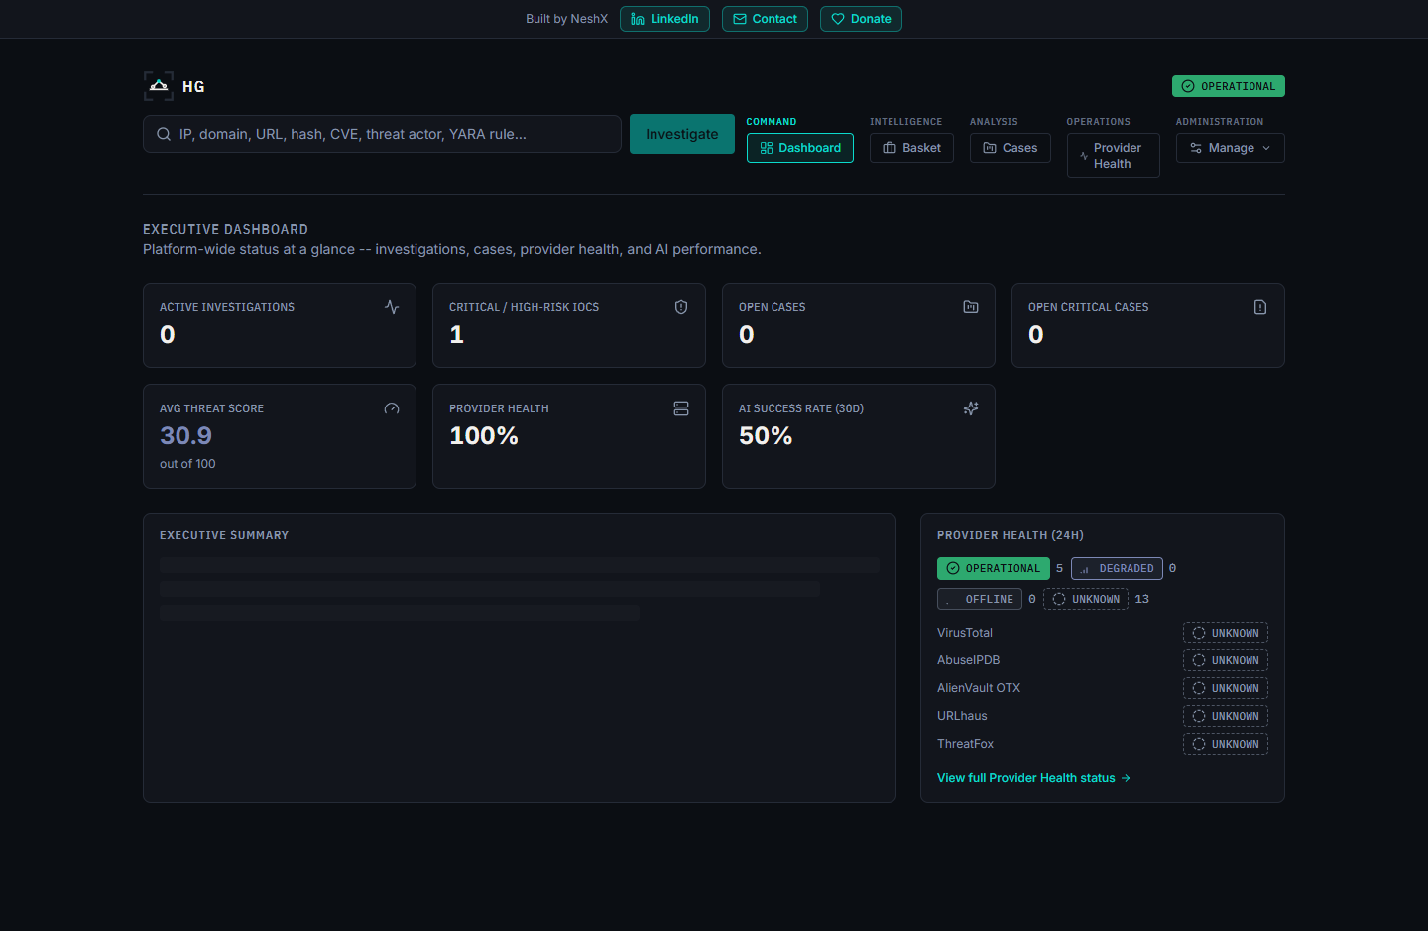
Underlying both the Dashboard's "average threat score" tile and every individual investigation's risk score is a new deterministic (non-AI) scoring engine (app/scoring/engine.py). Historically, overall_risk_score, confidence_score, malicious_probability, and the final verdict were 100% AI-generated in one call — prompt wording alone cannot reliably stop a model from overriding a number it was merely asked not to touch. The scoring engine instead computes all four values before any AI call runs, purely from already-fetched evidence: a cross-provider verdict-consensus component (weighted 65 of 100 points, with a corroboration multiplier so a single unconfirmed provider flag scores meaningfully lower than several providers agreeing) and a correlation-graph-evidence component (35 of 100 points, drawn from app/correlation/engine.py's graph and given the same corroboration treatment to resist a single source flooding it with distinct, uncorroborated edges). The AI is then handed this already-decided score as a given fact and asked only to narrate a verdict/rationale consistent with it — it can never invent or override the number, and the platform's own final-assessment validation re-checks the AI's output against the deterministic result before persisting it. Every persisted assessment records SCORING_ENGINE_VERSION, the exact version of this weighting scheme that produced it, so any historical score can always be traced back to the logic that generated it.

Celery: Scope and a Key Boundary
celery_worker and celery_beat both run the same task application, app.workers.celery_app. Exactly one scheduled task exists in the codebase: run_osint_crawl, triggered hourly by celery_beat (backend/app/workers/celery_app.py), which re-crawls OSINT (open-source intelligence) sources for IOCs that were looked up in the last 24 hours (backend/app/workers/tasks.py).
That is the entirety of what Celery does in this platform. The main, user-facing IOC lookup pipeline — the synchronous, streamed lookup reachable at POST /api/v1/lookup/stream — does not go through Celery at all. This is stated directly in a header comment in celery_app.py. A lookup request (provider fan-out, per-provider AI summarization, correlation, final AI assessment, and persistence) is handled entirely within the FastAPI backend process for the duration of that one HTTP connection, with results streamed to the browser as Server-Sent Events (SSE) as each step completes. Celery is reached only by the separate, unrelated hourly re-crawl job — never as part of answering a live lookup request.

Deployment Paths
Two deployment paths are implemented and verified in the repository:
- Docker Compose — docker-compose.yml (development) and docker-compose.yml + docker-compose.prod.yml (production). This is the path the Windows installer automates end-to-end (covered in the Windows Deployment / Installer section of this document).
- Kubernetes — the k8s/ directory contains a parallel, Kustomize-based Kubernetes deployment: StatefulSets for postgres, neo4j, and opensearch; Deployments for backend, frontend, and celery; and an Ingress resource. This is an alternative to the Docker Compose / Windows-installer path. Beyond its existence and the resource types listed above, further detail on this path (replica counts, resource limits, ingress rules, or how it is intended to be operated) is Not confirmed — it was not otherwise inspected as part of this documentation effort.

Component Diagram
The diagram below reflects verified relationships only. Solid arrows are real, active data paths confirmed in code; dashed arrows into neo4j and opensearch represent the config fields and running containers that exist but have no consuming application code.
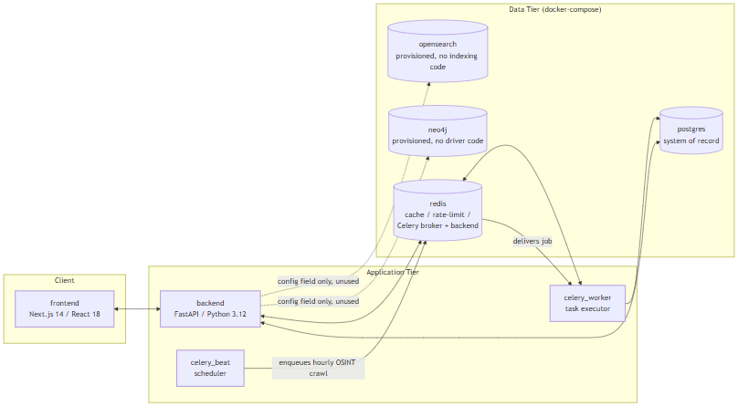
Note what is not in this diagram: there is no edge from backend to celery_worker/celery_beat for the lookup pipeline, because none exists. The live IOC-lookup path is entirely frontend <-> backend <-> postgres/redis; the Celery containers are reached only by the independent, hourly-scheduled OSINT re-crawl job described above.

Data Flow
This section traces exactly what happens, in code, when a user submits one IOC (Indicator of Compromise — a piece of evidence such as an IP address, domain, URL, file hash, CVE ID, or MITRE ATT&CK technique ID that a security analyst wants to investigate) to the platform, from the initial HTTP request through to the final "done" event. It then states plainly which of the platform's four datastores actually participate in that flow today, and which do not.
The entry point for a lookup is a single endpoint: POST /api/v1/lookup/stream (backend/app/api/routes/lookup.py). It is a Server-Sent Events (SSE) endpoint — the client opens one HTTP connection and receives a sequence of typed events as the lookup progresses, rather than blocking for a single response. The sequence below is verified directly against that endpoint's implementation.

The 9-Step Lookup Pipeline
- Rate limit check. A Redis-backed fixed-window rate limiter (RateLimiter, app/core/cache.py) rejects the request if the calling user has exceeded the configured quota — 10 calls per 60 seconds per user by default (app/core/config.py), both values configurable.
- IOC type detection.detect_ioc_type() (app/ioc/detector.py) classifies the raw input string using ordered regex and heuristic checks into one of 32 IOCType enum values (app/ioc/types.py) — for example, distinguishing an IPv4 address from a domain from a SHA256 hash.
- Lookup record created. An IOCLookup row is created in Postgres immediately, with status = RUNNING. This is the row that will later be updated with the final verdict and risk scores.
- Provider fan-out.run_all_providers() (app/providers/orchestrator.py) concurrently invokes every registered provider (of 16 total) whose supports(ioc_type) returns true for this IOC's type, using asyncio.create_task and asyncio.as_completed — providers run in parallel, not sequentially. A "provider" here is an external threat-intelligence, vulnerability, or OSINT source the platform queries (for example VirusTotal, AbuseIPDB, NVD). Each provider call passes through a Redis cache check first, then BaseProvider.run() (timeout and retry handled by tenacity, with configurable provider_timeout_seconds and provider_max_retries), producing a normalized ProviderResult.
- Per-provider persistence and summary. As each provider result arrives (not waiting for all of them), it is persisted to Postgres as a ProviderResultRecord. If that provider's status is ok, summarize_provider() (app/ai/service.py) makes one AI call for that provider alone, grounded only in that provider's own JSON response, and the result is persisted as an AISummaryRecord tagged with that provider_id. Both the raw result and the summary are streamed to the client as SSE events (provider_result, provider_summary) and committed to Postgres after every single provider completes — a deliberate design so that a client disconnecting mid-lookup does not lose already-completed provider data (lookup.py, lines 122-136).
- Correlation. Once every provider has finished, correlate() (app/correlation/engine.py) runs. This is a pure, I/O-free function: it extracts typed relationship edges from normalized provider fields (resolved_ips, related_hashes, malware_families, mitre_techniques, cves, and others), deduplicates and corroborates them — each additional provider that independently reports the same fact boosts its confidence score by a fixed increment (_CORROBORATION_BONUS_PER_PROVIDER = 0.15) — and returns a CorrelationResult (nodes, edges, deduplicated facts, provider agreement). The resulting edges are persisted as CorrelationEdgeRecord rows in Postgres and streamed as a correlation SSE event.
- Final AI assessment.generate_final_assessment() (app/ai/service.py) makes exactly one consolidated AI call, grounded in all of the per-provider summaries plus the correlation output — never in the raw provider JSON directly. The result is validated against the FinalAssessment schema, cross-checked against the deterministic correlation data by _ground_final_assessment() (which silently strips any agreeing/disagreeing provider citation that isn't actually backed by real correlation data, and separately flags — rather than removes — any cited MITRE technique that isn't backed by a real correlation edge, by setting that technique mapping's grounded field to False), and written onto the IOCLookup row as final_verdict, risk_score, confidence_score, and the full final_assessment JSON.
- Evidence ledger build.build_evidence() (app/evidence/builder.py) deterministically converts the provider results, AI summaries, and correlation edges into EvidenceItem rows. This step is explicitly not AI-generated (per the module's own docstring) — it exists so that later AI-driven explanations elsewhere in the product can cite real, checkable evidence records instead of re-summarizing from memory.
- Final SSE events. The stream emits a final_assessment event, then a done event, closing the connection.
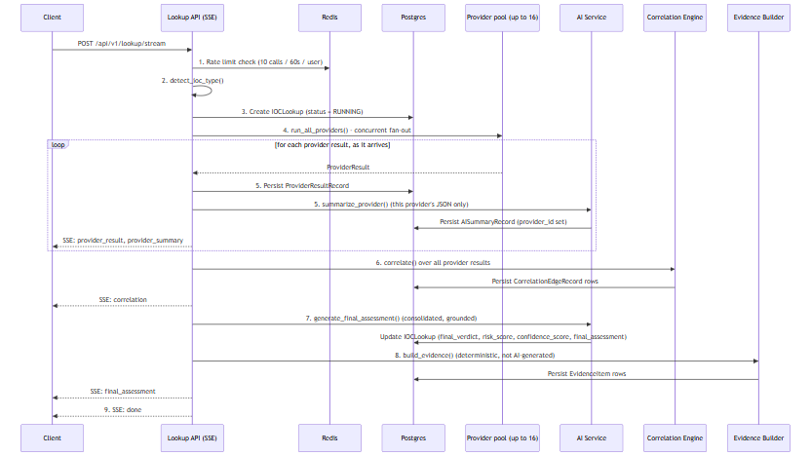

Where Data Actually Lives
The Docker Compose stack provisions four datastores — Postgres, Redis, Neo4j, and OpenSearch. Reading the pipeline above, it would be easy to assume all four are in play. They are not. This distinction matters enough that it is called out separately: only Postgres and Redis have any application code that actually reads from or writes to them. Neo4j and OpenSearch are running containers with nothing in the backend that talks to them.
Datastore | Provisioned in  docker-compose.yml  ? | Application code that uses it? | What it actually holds today
Postgres | Yes (  postgres:16-alpine  ) | Yes | Everything:  IOCLookup  rows,  ProviderResultRecord  s,  AISummaryRecord  s (per-provider and final),  CorrelationEdgeRecord  s,  EvidenceItem  s, plus users, cases, and analyst baskets
Redis | Yes (  redis:7-alpine  ) | Yes | Provider-result cache (keyed  provider_cache:{provider_id}:{ioc_type}:{sha256(value)}  , default TTL 3600s), the lookup-creation rate limiter, and the Celery broker/result-backend queues
Neo4j | Yes (  neo4j:5-community  + APOC plugin) | No | Nothing. Config fields only (  neo4j_uri  ,  neo4j_user  ,  neo4j_password  )
OpenSearch | Yes (  opensearchproject/opensearch:2.17.0  ) | No | Nothing. A config field only (  opensearch_url  )

Postgres is the correlation graph today
Step 6 of the pipeline above talks about a "correlation graph" of nodes and edges between IOCs. It is tempting to assume that graph lives in Neo4j, since Neo4j is a graph database and is sitting right there in the stack. It does not. The correlation graph is a set of rows in Postgres's correlation_edges table, queried relationally — full stop.CorrelationEdgeRecord's own docstring (models/lookup.py) and the correlation engine's module docstring (correlation/engine.py) both describe edges as being "mirrored into Neo4j," but that describes an intended future design, not current behavior. A full-repo search of backend/app for neo4j, Neo4j, or GraphDatabase (outside the Python virtual environment) turns up zero driver instantiations, zero Cypher queries, and zero read or write calls anywhere in the application. The only things Neo4j-related in the codebase are the three unused config fields and those two docstrings.

There is no search functionality
The same is true of OpenSearch, with even less ambiguity: there are no docstrings suggesting an intended integration, no indexing pipeline, and a full-repo search finds zero OpenSearch client, index, or search code anywhere in backend/app. The container runs; nothing in the product talks to it. Any full-text search a user might expect (e.g., searching historical lookups by free text) is not implemented against OpenSearch or anywhere else.

Practical takeaway
For a judge or engineer evaluating this build: treat Neo4j and OpenSearch as provisioned infrastructure for a future phase, not as working features. If asked "does this platform have a graph database backing its correlation view?" or "does it support full-text search?", the accurate answer is no — both containers exist and are healthy, but the entire correlation and evidence pipeline described in the nine steps above runs, end to end, on Postgres and Redis alone.

AI Architecture (Technical)
This section describes how HORIZON GRID's backend (backend/app/ai/) uses large language models to summarize and score an IOC (Indicator of Compromise — a hash, IP, domain, URL, CVE, etc. submitted for lookup) once raw provider data has been collected. It assumes the reader is technically literate but new to this codebase, so product-specific components — ProviderResult, CorrelationResult, AISummaryRecord, IOCLookup, EvidenceItem — are defined at first use.
All facts below are traceable to backend/app/ai/service.py, schemas.py, analysis_service.py, hunting_service.py, analysis_schemas.py, ollama_client.py, anthropic_client.py, bedrock_client.py, gemini_client.py, groq_client.py, openai_client.py, kimi_client.py, deepseek_client.py, xai_client.py, mistral_client.py, and openrouter_client.py.

1. Supported AI Backends and Selection
The active backend is a single configuration value, ai_backend (app/core/config.py line 69), defaulting to "ollama". Eleven backends are implemented:
Backend | Config value | Mode | Auth / connection detail
Ollama | ollama | Local, default | No key; talks to  http://host.docker.internal:11434  , model  llama3.2:3b
Anthropic | anthropic | Direct API | Direct Messages API, tool-forced JSON output
AWS Bedrock | bedrock | Cloud | Bedrock Converse API for Claude; supports bearer-token or IAM access-key/secret auth
Google Gemini | gemini | Cloud | Gemini  generateContent  REST endpoint; JSON-schema response mode
Groq | groq | Cloud, fast inference | OpenAI-compatible chat-completions API at  api.groq.com  ; Bearer-token auth; default model  llama-3.3-70b-versatile
OpenAI | openai | Cloud | OpenAI's own chat-completions API at  api.openai.com  ; Bearer-token auth; forced tool-calling for structured output
Kimi (Moonshot AI) | kimi | Cloud | OpenAI-compatible chat-completions API at  api.moonshot.ai  ; Bearer-token auth
DeepSeek | deepseek | Cloud | OpenAI-compatible chat-completions API at  api.deepseek.com  ; Bearer-token auth
xAI | xai | Cloud | OpenAI-compatible chat-completions API at  api.x.ai  ; Bearer-token auth
Mistral | mistral | Cloud | Chat-completions API at  api.mistral.ai  ; Bearer-token auth; forced tool-calling for structured output
OpenRouter | openrouter | Cloud, meta-router | OpenAI-compatible chat-completions API at  openrouter.ai  , routing to many underlying model vendors; Bearer-token auth

All eleven client classes expose the same async method signature — call_claude_json(system_prompt, user_prompt, json_schema, tool_name, max_tokens) — so app/ai/service.py's internal _get_ai_client() never has to branch on which backend is active (service.py lines 42-78). This is a straightforward adapter pattern: swapping backends is a config change, not a code change. groq_client.py and the five clients modeled on it (openai_client.py, kimi_client.py, deepseek_client.py, xai_client.py, mistral_client.py, openrouter_client.py) fit this pattern by targeting their vendor's own OpenAI-compatible chat-completions endpoint and using the same forced-single-tool-call technique the other backends use to coerce a structured JSON response, rather than a bespoke prompt format.
Model-list handling now splits into two groups rather than "Groq vs. everyone else": Anthropic, Gemini, and Bedrock still use a hardcoded/static model list in the codebase. Every other backend discovers its model list live instead — Groq, OpenAI, Kimi, DeepSeek, xAI, Mistral, and OpenRouter each query their own vendor GET /models endpoint (exposed to the setup wizard and API consumers via the shared POST /api/v1/ai/{backend}/models route), and Ollama lists whatever is actually pulled locally via GET {base_url}/api/tags. For the seven vendor-hosted live-discovery backends, this means the model dropdown always reflects the account's real, currently-available models rather than a list that can silently go stale as a vendor deprecates or introduces models.
Selection is fail-fast: if the currently selected backend's is_configured check returns False (e.g. anthropic selected with no API key present), the service raises a RuntimeError immediately rather than letting the request proceed into a confusing low-level HTTP failure.

2. Runtime AI Backend Switching (No Restart)
Until this session, ai_backend and every backend's credentials were read once, at process start, from .env via get_settings() (app/core/config.py) — a @lru_cache-wrapped singleton that lives for the lifetime of the container process. Switching from Ollama to Anthropic, or adding a Groq key, meant editing .env and restarting the Docker containers; there was no way to change the active AI backend or its credentials while the platform was running.
_get_ai_client() in service.py now resolves the active backend on every call, rather than once at startup, by reading a database-backed runtime-config service (backend/app/core/runtime_config.py) instead of the frozen Settings object. Resolution order is: (a) an explicit backend_override, used only by the AI-comparison feature described below; (b) the currently active runtime-configured backend — a fresh row read from the provider_runtime_configs table (kind "ai", is_active = true) on that call; (c) the legacy Settings-based value, kept only as a fallback for installs where no runtime config has been seeded yet. Each of the eleven AI client classes (ollama_client.py, anthropic_client.py, bedrock_client.py, gemini_client.py, groq_client.py, openai_client.py, kimi_client.py, deepseek_client.py, xai_client.py, mistral_client.py, openrouter_client.py) gained optional constructor parameters so _get_ai_client() can build a fresh, correctly-credentialed instance from the decrypted runtime credentials on each call instead of reusing a stale cached singleton built from .env at process start.
The practical effect: POST /api/v1/runtime/ai-active switches the active backend, and the very next AI call — the next per-provider summary or final assessment, for any in-flight or new lookup — uses the newly active backend and its credentials. No container restart, no .env edit, no redeploy.
This same on-demand resolution also underlies the AI-comparison feature: POST /api/v1/lookup/{id}/reanalyze re-runs only the generate_final_assessment() step against an already-completed lookup's existing evidence, passing a backend_override for whichever backend the analyst wants to compare against — no provider is re-queried. Every assessment ever produced for a lookup — the original plus every later comparison run — is written to a new final_assessment_records table (app/models/lookup.py), tagged with the ai_backend/ai_model that produced it and an is_primary flag distinguishing the original from comparisons; a reanalysis never overwrites or deletes an earlier result. GET /api/v1/lookup/{id}/assessments returns the full set for side-by-side review.
One further prompt-level change accompanies this: generate_final_assessment() now also receives an explicit unavailable_providers list — providers that were applicable to the IOC but failed, timed out, were rate-limited, or were not configured/disabled for this run — rendered in the prompt as a distinct "Providers unavailable this run" section, together with a system-prompt rule never to read an unavailable provider's absence as "found nothing" or "reported clean." This closes a gap that predates runtime switching but became more visible once providers could be disabled live: without it, the AI had no way to distinguish missing coverage from a genuinely clean result.

3. Two Distinct AI Call Types
The pipeline makes two structurally different kinds of AI calls, confirmed as genuinely separate in the code (not a naming convention over one code path):
 | summarize_provider() | generate_final_assessment()
Cardinality | One call  per provider  that returned OK data | One  call per lookup, after all providers finish
Input | Only that single provider's own JSON | All per-provider  ProviderSummary  objects + the correlation engine's output —  never  raw provider JSON
Stored as | AISummaryRecord  with  provider_id  set | IOCLookup.final_assessment  and  an  AISummaryRecord  with  provider_id = NULL

The AISummaryRecord.provider_id column is the actual database-level marker distinguishing the two: a model-level comment (models/lookup.py line 93) explicitly documents that a NULLprovider_id row is "the final consolidated assessment, not a per-provider one."
Why they are kept separate, per the code's own design comments (service.py lines 8-11): the final assessment is deliberately grounded in the already-summarized per-provider outputs and the deterministic correlation result rather than being handed every provider's raw JSON again. This bounds the size of the final prompt (which would otherwise grow with the number of registered providers) and forces the "master" call to reason over an already-distilled, per-provider-attributed layer instead of re-deriving everything from scratch — which is also what makes the grounding/cross-check step in §5 possible.

4. No-Evidence Short-Circuit Guard
Inside generate_final_assessment() (service.py lines 242-284), there is a hard guard: if provider_summaries is empty andcorrelation.edges is empty, the function returns a hardcoded, deterministic FinalAssessment — final_verdict=Verdict.UNKNOWN, all risk fields set to 0 — without invoking the AI backend at all.
The code comment documents the concrete, reproduced failure that motivated this guard: querying the real MD5 hash of the EICAR antivirus test file (44d88612fea8a8f36de82e1278abb02f) with zero configured providers — i.e. with no actual evidence of any kind — still caused the small local model (llama3.2:3b) to return final_verdict="highly_malicious" and malicious_probability=92, fabricating an "association with ransomware and trojans" purely from its pretrained knowledge. This directly violated the model's own system-prompt instruction to never fabricate findings. Rather than trying to prompt-engineer around this failure mode, the team chose to bypass the model entirely whenever there is structurally no evidence to reason over — a deterministic guard is unconditionally reliable where a prompt instruction was not.

5. Grounding / Cross-Check Mechanism
Even when the AI backend is called, its structured output is not trusted at face value — it is cross-checked against the deterministic correlation data. Two related mechanisms implement this:
_ground_final_assessment() (service.py lines 137-190), run on every generate_final_assessment() result:
- Filters the model's agreeing_providers / disagreeing_providers lists down to only the provider_ids that actually appear in the correlation edges, in provider_agreement, or in known_provider_ids (the set of providers that genuinely returned a per-provider summary, passed in by the caller). Anything else the model names is silently stripped.
- Sets mapping.grounded = False on any MITRE ATT&CK technique the model cited that is not backed by a real uses_technique correlation edge — so a technique mention that has no supporting evidence is flagged rather than presented as fact.
A parallel mechanism in analysis_service.py, applied to the analyst-facing explanation endpoints (WHY malicious, Challenge/red-team, Copilot Q&A, and others):
- _strip_invalid_evidence_ids() (lines 55-71) recursively removes any evidence_ids citation that doesn't match a real EvidenceItem.id belonging to that specific lookup.
- _backfill_evidence_ids_from_prose() (lines 74-112) does the reverse repair: it recovers citations the model correctly referenced in free-text prose but failed to place into the structured evidence_ids field — but it only ever adds an ID that has already been confirmed real; it never invents one.
Together, these mean every AI-authored claim that reaches storage or the UI has either been matched against a real EvidenceItem/correlation edge or explicitly marked/stripped as unsupported — the deterministic correlation and evidence layers act as a check on the generative layer, not the other way around.

6. Verdict and Confidence Data Model
The Verdict enum (app/models/lookup.py lines 22-34) has exactly 12 values: highly_malicious, malicious, suspicious, unknown, likely_benign, benign, scanner, tor_exit_node, vpn, cdn, cloud_infrastructure, dormant_infrastructure. Note that several of these are not "maliciousness" gradations at all but infrastructure classifications (tor_exit_node, vpn, cdn, cloud_infrastructure, dormant_infrastructure) — the model is expected to distinguish "this is malicious" from "this is a category of infrastructure that merits a different interpretation."
RiskAssessment (app/ai/schemas.py lines 101-131) carries overall_risk_score, confidence_score, and malicious_probability, all explicitly on a 0-100 scale (not 0-1). A field_validator automatically rescales any value it receives between 0 and 1 by multiplying by 100 — a defensive fix added because llama3.2:3b was observed defaulting to a 0-1 convention despite the 0-100 instruction.
FinalAssessment additionally carries a model_validator named _verdict_must_agree_with_risk (schemas.py lines 187-208) that rejects egregiously self-contradictory combinations — for example, a final_verdict="malicious" paired with malicious_probability < 30 is rejected rather than silently persisted. This is a second, independent layer of internal-consistency checking, separate from the evidence-grounding checks in §5.
FinalAssessment also carries two traceability fields, ai_backend and ai_model (schemas.py), populated by service.py at generation time and surfaced in the UI as a badge on the final-assessment panel. With eleven interchangeable backends now selectable, and the config free to change between one lookup and the next, these fields exist so that an analyst or judge reviewing a conclusion always knows exactly which provider and model produced it — never a silent or ambiguous backend switch. When the no-evidence guard in §4 fires, or a generation error occurs (as happens on a rate-limited call), both fields are left null rather than populated with a misleading value, consistent with this layer's broader rule of never presenting a fabricated or guessed fact as if it were real.

7. AI Data Flow
The diagram below shows data flowing into the AI layer for a single lookup: per-provider JSON feeds per-provider summaries; those summaries plus the correlation engine's output feed the one consolidated final assessment; the final assessment is grounded/cross-checked before being persisted.
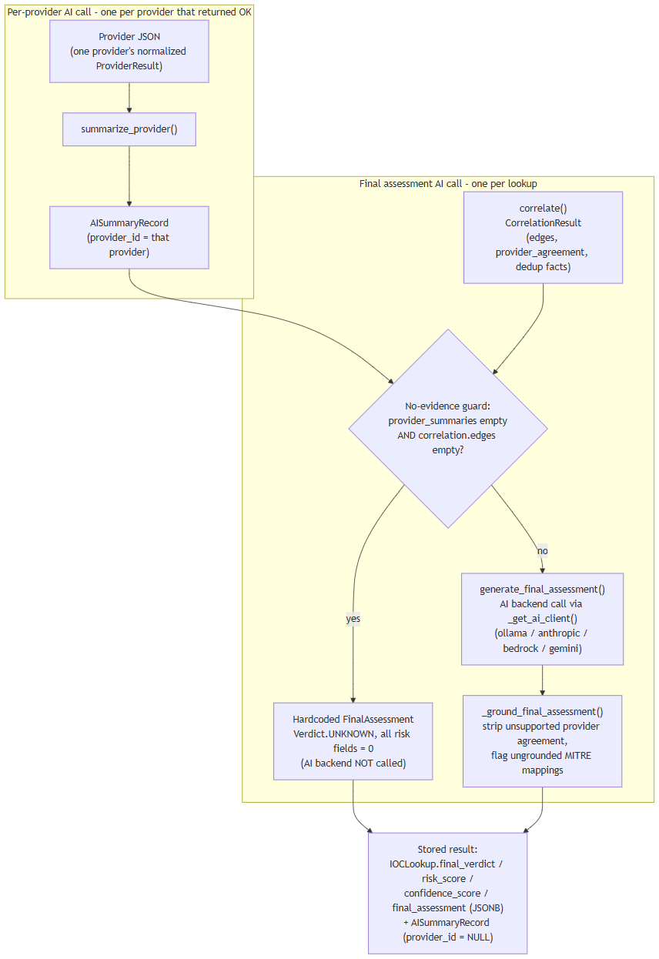

8. Beyond the Core Pipeline
analysis_service.py implements eight further grounded, evidence-cited AI features on top of the same call/grounding pattern: WHY malicious, What Is This, Provider Disagreement, False-Positive Assessment, Challenge/red-team, Smart Next Actions, Intelligence Gaps, and Score Explanation, plus Copilot Q&A and IOC comparison. hunting_service.py implements hunting-query and detection-rule generation. Both are restricted to citing only indicators/evidence that genuinely exist in the correlation graph or evidence ledger for that lookup — hunting_service.py (lines 74-79) explicitly strips any invented expansion target the model produces, following the same "never trust generated output at face value" principle applied throughout this layer.

Provider Architecture
A provider is a self-contained connector class in the platform's backend that queries one external data source — a threat-intelligence feed, a vulnerability database, a DNS blocklist, a certificate-transparency log, a sandbox scanner, or an OSINT (open-source intelligence) crawler — for information about a single IOC (indicator of compromise) submitted to a lookup. All 18 providers shipped with the platform are registered in backend/app/providers/registry.py (_ALL_PROVIDERS) and share one common interface, described below.

Common Provider Interface
Every provider implements the same three-part contract, so the orchestrator (the component that fans a lookup out to providers — see below) never needs provider-specific logic:
- supports(ioc_type) — a boolean check for whether this provider is eligible to run against the specific kind of indicator submitted. ioc_type is one of 31 values in the platform's IOCType enum (app/ioc/types.py), assigned to the raw input by the IOC-type detector before any provider runs. A provider is only invoked if supports() returns true for the lookup's detected type (e.g. hybrid_analysis only supports sha256; whois_rdap supports domain, ipv4, ipv6, and asn).
- configured — a boolean property reporting whether the provider currently has what it needs to run (typically a credential). Some providers are unconditionally configured because they require no credential at all — for example nvd has requires_key = False and configured = True unconditionally. Others require specific fields to be present — for example censys is only configured when both a Personal Access Token and an Organization ID are set; either alone leaves it not configured.
- run() (via the shared BaseProvider.run()) — executes the actual outbound call (HTTP request, DNS query, etc.) and returns a normalized ProviderResult. This call is wrapped with a timeout and retry policy applied uniformly across all providers: provider_timeout_seconds (default 20 seconds) and provider_max_retries (default 2), with exponential backoff implemented via the tenacity library (wait_exponential(multiplier=0.5, max=4)).
Before run() is invoked, each provider call first checks the Redis cache layer (described below); a cache hit skips the outbound call entirely.

Concurrent Fan-Out Execution Model
For a given lookup, run_all_providers() (backend/app/providers/orchestrator.py) does not call providers one after another. It fans out concurrently to every registered provider whose supports(ioc_type) is true, using asyncio.create_task to launch all eligible provider calls at once and asyncio.as_completed to consume each result as soon as it finishes, in whatever order calls actually complete. Each provider call independently goes through: Redis cache check → BaseProvider.run() (timeout/retry as above) → normalized ProviderResult. As each result arrives, it is persisted to Postgres and streamed to the client immediately (rather than the pipeline waiting for every provider to finish before persisting or streaming anything).
The platform's integration test suite exercises this concurrency directly against fake provider stubs (never the real network-hitting connectors), verifying parallel — not sequential — fan-out, isolation of one provider's failure from the others, cache hit/miss behavior, and correct short-circuiting of unsupported or not-configured providers.
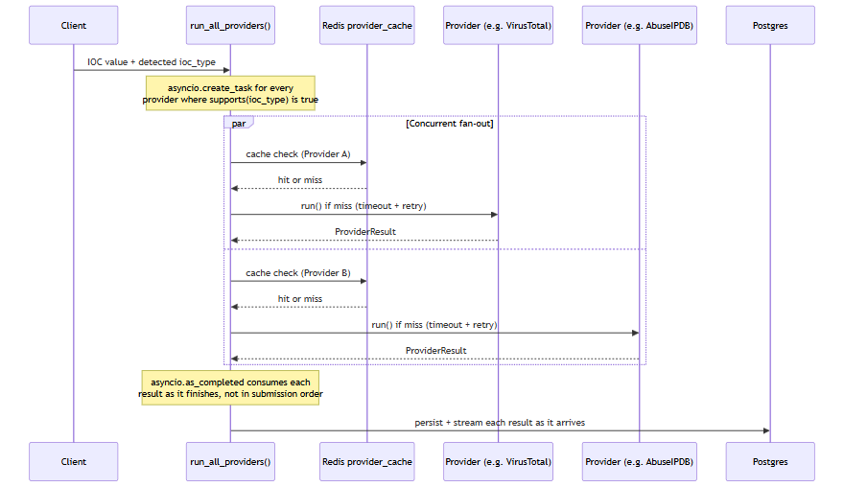
"Provider A" and "Provider B" above are illustrative stand-ins for any two of the up to 18 registered providers eligible for a given IOC type — the fan-out is not limited to two.

Redis Caching Layer
Provider results are cached in Redis to avoid repeating identical outbound lookups. The cache key format is provider_cache:{provider_id}:{ioc_type}:{sha256(value)} (app/core/cache.py), and the time-to-live is provider_cache_ttl_seconds, which defaults to 3600 seconds (1 hour). This provider-result cache lives on Redis logical DB index /0, kept separate from the Celery broker (/1) and Celery result backend (/2) that run on the same Redis instance.
Two providers additionally maintain their own cache on top of this (visible in the Notes column of the table below): cisa_kev keeps an in-memory cached copy of its catalog with a 1-hour TTL, and mitre_attack caches its STIX bundle for 1 hour. These are provider-internal caches, distinct from the shared Redis provider-result cache described above.

The 18 Registered Providers
Provider | Category | Supported IOC types | Key requirement | Notes
virustotal | threat_intel | ipv4, ipv6, domain, url, hashes | API key | v3 free tier
abuseipdb | threat_intel | ipv4, ipv6 | API key | v2
otx | threat_intel | ipv4, ipv6, domain, hostname, url, hashes | API key | AlienVault OTX
urlhaus | threat_intel | url, domain, ipv4 | abuse.ch Auth-Key | shares key w/ threatfox/malwarebazaar
threatfox | threat_intel | ipv4, ipv6, domain, url, md5, sha256 | abuse.ch Auth-Key | shares key
malwarebazaar | threat_intel | hash types (md5/sha1/sha256/sha512) | abuse.ch Auth-Key | shares key
crtsh | certificate_intel | domain, tls_certificate | none | Certificate Transparency
nvd | vulnerability | cve | none (optional key raises rate limit) | NIST NVD v2.0
cisa_kev | vulnerability | cve | none | in-memory cached catalog, 1hr TTL
mitre_attack | threat_intel | mitre_technique | none | STIX bundle, cached 1hr
whois_rdap | whois | domain, ipv4, ipv6, asn | none | python-whois (domains) + RDAP (IP/ASN)
urlscan | sandbox | url, domain | API key | urlscan.io; submit-then-poll scan model (  POST /scan/  , then poll  GET /result/{uuid}/  , which returns HTTP 404 while still processing); the poll loop is wall-clock timeboxed and reports a timeout rather than fabricating a result from an incomplete scan
google_safe_browsing | threat_intel | url, domain | API key | Google Safe Browsing Lookup API v4 (  threatMatches:find  ); a confirmed HTTP 200 with an empty/absent  matches  field is the  only  input that may ever produce a "clean" verdict
hybrid_analysis | sandbox | sha256 only | API key | v2 overview/summary endpoint; MD5/SHA1/URL explicitly unsupported per code comment (deprecated endpoints)
spamhaus | threat_intel | ipv4, domain | none | DNSBL lookup, no HTTP call (raw DNS)
phishtank | threat_intel | url | none (optional key raises rate limit)
censys | passive_dns | ipv4, ipv6 | Personal Access Token  and  Organization ID both required | Platform API v3
internet_intelligence | osint | domain, ipv4, malware_family, threat_actor, campaign, cve, file_name | none | OSINT crawler wrapping GitHub/Reddit/RSS/pastebin sources (  app/crawler/  )

A deliberately tested safety guarantee, specific to these two newest providers: both urlscan and google_safe_browsing are built so that a genuine failure — a rejected/invalid API key, an unreachable API, or a rate limit — is always reported as an error or unknown status, never as a false "clean"/"safe" result. google_safe_browsing.py's own module docstring states the invariant directly: an empty or missing matches field on a genuine HTTP 200 response is the only input that may ever produce a "clean" verdict; every other outcome — a non-200 status, a network error or timeout, or a response body that doesn't parse the way the API contract promises — routes through the same error-handling path, which always sets a {"verdict": "unknown", ...} payload rather than anything that could be mistaken downstream for a real clean scan. This was confirmed with a real, live chaos test that supplied deliberately invalid credentials to both providers' real external APIs: the invalid key was rejected with status=error, Safe Browsing's own verdict field read "unknown" (never "clean"), and the investigation's overall verdict was reported as UNKNOWN rather than benign or clean.

Wizard Coverage and the "6 Providers with No UI" Discrepancy
The Windows setup wizard (windows/wizard/Setup-Wizard.ps1, $ProviderDefs) presents a Provider Configuration screen listing exactly 8 entries: virustotal, abuseipdb, otx, abusech (a single combined entry covering the shared abuse.ch key used by urlhaus, threatfox, and malwarebazaar), nvd, hybrid_analysis, censys, and phishtank. Counting the three abuse.ch-backed connectors individually, those 8 wizard entries map to 10 of the platform's 16 backend providers. A sample of the wizard's entries was independently checked against the corresponding provider's code and matched exactly — for example, the wizard's Censys note ("Requires both a Personal Access Token and an Organization ID") matches censys.py's configured check precisely, and the wizard's abuse.ch note ("one free Auth-Key covers all three connectors") matches all three connectors reading the same abusech_auth_key setting.
The remaining 6 backend providers — crtsh, cisa_kev, mitre_attack, whois_rdap, spamhaus, and internet_intelligence — have real, working backend implementations but do not appear anywhere in the wizard's UI. This is a documented discrepancy between the wizard and the backend provider registry, but it is flagged as consistent behavior, not a bug: all six of these providers have requires_key = False — there is no credential for a user to enter in the first place. Because the wizard's Provider Configuration screen exists specifically to collect and test credentials, a provider with nothing to configure has nothing to show there. This is corroborated on the backend side: backend/app/providers/connection_test.py's handler dictionary (which powers the wizard's live "Test" button, POST /api/v1/providers/{id}/test) likewise defines no test handler for these six providers, falling back to a message that explicitly identifies them as requiring no credential.
In short: 8 wizard entries cover 10 providers that have a credential-related field to configure — 8 of those (virustotal, abuseipdb, otx, and the three abuse.ch-backed connectors, plus hybrid_analysis, censys) require a key to function at all, while 2 (nvd, phishtank) only accept an optional key to raise their rate limit rather than strictly needing one. The other 6 providers run unconditionally with no credential of any kind and correctly have no wizard entry and no connection-test handler.

Runtime IOC Provider Configuration (No Restart)
Everything described above — the configured property, the credential fields, and the enabled/disabled state of each of the platform's registered providers — was, prior to this session, entirely .env-driven and frozen for the lifetime of the running process: app/core/config.py's get_settings() is a process-lifetime @lru_cache singleton, so changing a provider's key or toggling it off meant editing .env and restarting the Docker containers before the change had any effect.
That has been replaced with a database-backed runtime layer. A new provider_runtime_configs table (backend/app/models/runtime_config.py, kind "ioc") holds one row per provider — enabled, encrypted_credentials (Fernet-encrypted, never plaintext), extra_config, and the timestamp/outcome of its last connection test. Two endpoints mutate this table: POST /api/v1/runtime/ioc-providers/{id} configures a provider's credentials, and POST /api/v1/runtime/ioc-providers/{id}/enabled flips it on or off. Neither requires touching .env or restarting anything — the very next investigation submitted after the call picks up the change.
Because each provider connector in registry.py is instantiated once and reused as a long-lived singleton for the life of the process, mutating a shared instance attribute on that singleton immediately before use would be unsafe: two investigations running concurrently — one started right after an administrator changes a provider's credentials or enabled state, while another is still mid-flight — could race and see each other's configuration. Instead, run_all_providers() (backend/app/providers/orchestrator.py) takes a single, immutable snapshot of runtime configuration — {provider_id: {enabled, configured, credentials}} — once per investigation, at the start of the fan-out, and holds it in a Python ContextVar rather than on the provider object itself. Because asyncio.create_task() copies the current context into every task it spawns, each concurrent per-provider task launched for that investigation reads from that same frozen snapshot, regardless of what an administrator does to the underlying table while those tasks are still running. Two investigations in flight at once, each with a different configuration for the same provider, therefore never see each other's values — verified with a dedicated concurrency test simulating exactly that scenario.
The provider-availability model also gained a new state to describe this. Previously a provider was either eligible (supports() true) and configured, or not; ProviderStatus now also has a DISABLED value, distinct from NOT_CONFIGURED — a provider an administrator has deliberately turned off via the enabled/disabled endpoint reports DISABLED, while a provider with no credential entered at all still reports NOT_CONFIGURED. Both are, in turn, distinguished from "not applicable to this IOC type," so the final-assessment AI prompt never conflates "unavailable" with "checked and found nothing."
Finally, POST /api/v1/lookup/stream gained an optional provider_ids field: passing a list of provider IDs restricts that one investigation to exactly those providers, regardless of how many are otherwise enabled and configured platform-wide, without affecting any other investigation.

The Same Live-Test Pattern, Extended to AI Backends
The POST /api/v1/providers/{id}/test mechanism described above — the one behind each provider's live wizard "Test" button — has a direct counterpart for the AI layer. Until this session, none of the platform's AI backends (Ollama, Anthropic, Bedrock, Gemini, or Groq — see the AI Architecture chapter for the backends themselves) had any live connection test at all; a new POST /api/v1/ai/test endpoint (backend/app/api/routes/ai_config.py, backend/app/ai/connection_test.py) now gives every one of them a real "Test Connection" button in the wizard's AI Configuration screen, mirroring the provider-side pattern rather than introducing a new one.
The same design rule that governs the provider-side tester carries over deliberately: the endpoint always tests the candidate credentials currently entered in the form, never the application's stored/active configuration. Because the test path never reads from or writes to the saved config, trying out a not-yet-saved key can never race with — or accidentally disturb — whatever backend and key the running platform is actually using for real investigations.
It is also, deliberately, not a generic pass/fail. The endpoint sends a minimal real request to the backend under test and reports one of several specific, genuine outcomes: authenticated success (with real round-trip latency and the exact model name that replied), invalid/rejected key, rate-limited, model-not-found, network error, or timeout — the same level of specificity the provider-side test handlers already establish, applied to the AI layer for the first time.

Database Architecture
HORIZON GRID's docker-compose.yml provisions four datastore containers: postgres (postgres:16-alpine), redis (redis:7-alpine), neo4j (neo4j:5-community with the APOC plugin), and opensearch (opensearchproject/opensearch:2.17.0). This section describes what each one actually does in the running system, based on direct inspection of the backend code rather than the docker-compose comments or model docstrings that describe the intended design. Two of the four -- Neo4j and OpenSearch -- are running containers with no backend code that reads from or writes to them; that gap is documented plainly below rather than glossed over.
An IOC (Indicator of Compromise) is the value a user submits for lookup -- an IP address, domain, file hash, URL, CVE ID, etc. A provider is a connector to an external threat-intelligence source (VirusTotal, AbuseIPDB, and so on) that the platform queries for a given IOC.

PostgreSQL: the system of record
PostgreSQL is the only datastore the application actually writes to during a lookup. Every table below is defined under backend/app/models/:
Table | Holds
users | Account records: email, hashed password, full name, role (  admin  /  analyst  /  viewer  ), active flag.
ioc_lookups | One row per lookup: the submitted IOC value and type, a status enum (  pending  /  running  /  completed  /  failed  ), and the final AI output --  final_verdict  ,  risk_score  ,  confidence_score  , and the full  final_assessment  as JSONB.
provider_results | One row per provider call per lookup: that provider's raw response as JSONB, plus its status and latency.
ai_summaries | AI-generated summaries as JSONB. A nullable  provider_id  distinguishes a per-provider summary from the single final consolidated assessment (null  provider_id  marks the latter).
correlation_edges | The relationship graph produced by the correlation engine: source/target type and value, relationship type, a confidence score, and provenance (which provider(s) contributed the edge).
evidence_items | The deterministic, non-AI-generated evidence ledger: an evidence-type enum (9 values), a source label, a claim, an interpretation, a confidence score (0-100), and the underlying raw data as JSONB.
basket_items | Per-analyst scratch lists of IOCs, unique per owner and IOC value.
cases  ,  case_iocs  ,  case_notes  ,  case_reports | A lightweight case-management workflow: cases with status/severity enums, the IOCs attached to a case, and analyst notes.  case_reports  exists as a table, but report generation itself is not implemented -- the field is present and permanently empty rather than populated by any code path.

Two things worth calling out because they matter for how the rest of this appendix should be read:
- The correlation graph lives in Postgres.correlation_edges is a plain relational table, populated by the correlation engine after every provider has returned, and streamed to the UI as part of the lookup. There is no separate graph database behind it today -- see the Neo4j section below.
- The evidence ledger is deliberately not AI-generated.evidence_items rows are built by a deterministic conversion step so that later AI-written explanations have real, checkable records to cite against, rather than citing their own prior output.
Schema changes are managed with Alembic (backend/alembic/), SQLAlchemy's migration tool. The application itself uses SQLAlchemy 2.0 in async mode over asyncpg.

Neo4j: provisioned, not integrated
Neo4j (neo4j:5-community, with the APOC plugin) runs as a container in docker-compose.yml, and the backend config (app/core/config.py) has neo4j_uri, neo4j_user, and neo4j_password settings for it. Some code comments describe an intended design where correlation edges get "mirrored into Neo4j" -- this appears in the CorrelationEdgeRecord model docstring and in the correlation engine's module docstring.
That design was never built. A full search of the backend application code for neo4j, Neo4j, or GraphDatabase (excluding the Python virtual environment) turns up zero driver instantiation, zero Cypher queries, and zero read or write calls anywhere in the application. Neo4j is not used for anything today. The correlation graph described above is, in its entirety, the correlation_edges table in PostgreSQL. Anyone evaluating this platform should treat Neo4j as reserved-but-idle infrastructure, not as an active graph store.

OpenSearch: provisioned, not integrated
The same pattern holds for OpenSearch (opensearchproject/opensearch:2.17.0, running with DISABLE_SECURITY_PLUGIN: "true"). The backend config has an opensearch_url setting, and the container runs as part of the stack, but a full search of the backend application code found zero OpenSearch client code, zero index definitions, and zero search calls. No indexing pipeline exists, and no user-facing search feature is backed by it. OpenSearch should be described as provisioned infrastructure only -- not as an active search index.
Neo4j and OpenSearch represent the most significant gap between the design implied by the docker-compose file and docstrings, and what the running system actually does. Both are real containers consuming real resources; neither currently does any work for the platform.

Redis: three real uses
Unlike Neo4j and OpenSearch, Redis (redis:7-alpine) is genuinely load-bearing, in exactly three ways -- all confirmed against app/core/cache.py, docker-compose.yml, and app/core/config.py:
- Provider-result cache. Each provider call is cached under a key of the form provider_cache:{provider_id}:{ioc_type}:{sha256(value)}, with a TTL controlled by provider_cache_ttl_seconds (default 3600 seconds / 1 hour). A repeat lookup for the same IOC within the TTL window skips the live provider call.
- Rate limiter. A fixed-window rate limiter, implemented in the same app/core/cache.py module as the cache, guards the lookup-creation endpoint: by default, 10 calls per 60 seconds per user (both values configurable).
- Celery broker and result backend. The celery_worker/celery_beat services use Redis as both the message broker and the result store for background jobs.
Redis is used across separate logical database indexes on the same Redis instance, rather than one shared keyspace:
Redis DB index | Purpose
/0 | Cache (provider-result cache and rate-limiter counters, both via  app/core/cache.py  )
/1 | Celery broker (  redis://redis:6379/1  )
/2 | Celery result backend (  redis://redis:6379/2  )

This separation means a FLUSHDB or eviction event against the cache database, for example, cannot collide with in-flight Celery task state, and vice versa -- they are isolated by index even though they share one Redis process. No other use of Redis was found in the codebase.
It's worth noting that the synchronous SSE lookup pipeline (POST /api/v1/lookup/stream) does not go through Celery at all -- it runs providers directly and streams results back over the same request. The only scheduled Celery job in the system is an hourly OSINT re-crawl (run_osint_crawl) for IOCs looked up in the last 24 hours; Celery's broker/result-backend role is scoped to that background job, not to the interactive lookup path.

Component overview
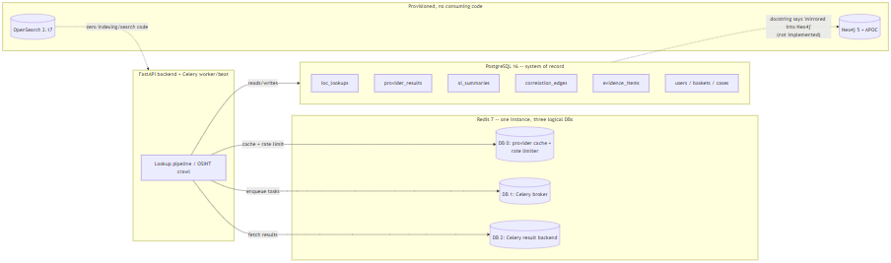

Summary
Postgres is the single source of truth for every entity in the platform, including the correlation graph. Redis does three concrete jobs -- provider-result caching, rate limiting, and Celery transport -- cleanly separated by logical database index on one instance. Neo4j and OpenSearch run as containers and appear in configuration, but as of this writing carry no application code that reads or writes to them; they should be read as forward-provisioned infrastructure, not as active components of the current architecture.

Windows Deployment Architecture
This section documents the Windows installer for HORIZON GRID: an Inno Setup package (a Windows installer-authoring tool that compiles a self-extracting setup executable) plus a WinForms configuration wizard (.NET's native desktop UI framework — this is not an Electron or browser-based installer). Together they package the same Docker Compose-based runtime described elsewhere in this document for a single-machine Windows install; they do not reimplement the platform as a native Windows service. Docker Compose remains the actual runtime underneath the installer, per an explicit header comment in windows/installer.iss.

What the Installer Actually Does
installer.iss copies the following into %ProgramFiles%\IOC Intelligence Platform\app\ (Inno Setup's {autopf} constant):
- backend/
- frontend/
- docker-compose*.yml (including the production overlay, docker-compose.prod.yml, which strips the development bind-mounts and switches the backend/frontend containers to production start commands)
- docs/
- README.md
- the windows/scripts and windows/wizard PowerShell used for post-install configuration and day-to-day operation
Architecture restriction. The installer sets ArchitecturesAllowed=x64compatible, restricting installation to 64-bit-compatible Windows systems. This is consistent with — and enforced a second time by — the prerequisite checker's own verification of a 64-bit Windows 10-or-later host (below): the same constraint is checked once at install-package level and once again at runtime. The source material does not document any further stated engineering rationale (e.g. no claim is made here about 32-bit or ARM64 support one way or the other beyond this).

Prerequisite Checks
Before any files are copied, a [Code]-section step in installer.iss runs Check-Prerequisites.ps1, which verifies:
- 64-bit Windows 10 or later
- Administrator privileges
- At least 8 GB RAM (soft check)
- Sufficient free disk space
- Docker Desktop installed and running
- Docker Compose v2 available
- The ports the platform needs are free
Failures surface a "Continue anyway?" prompt rather than a silent abort — the check is advisory-with-friction for at least some of these conditions, not a hard, unbypassable gate.

File Layout: Program Files vs. ProgramData
The installer follows the standard Windows split between read-mostly program binaries and writable per-machine application data (windows/scripts/Common.ps1, lines 28-40):
Location | Purpose | Contents
%ProgramFiles%\IOC Intelligence Platform\app\ | Installed application code | backend/  ,  frontend/  , compose files, docs, wizard/operational scripts
%ProgramData%\IOC Intelligence Platform\config\.env | Real runtime secrets and configuration | The generated  .env  consumed by Docker Compose
%ProgramData%\IOC Intelligence Platform\logs\setup.log | Install/setup logging | Setup Wizard log output
%ProgramData%\IOC Intelligence Platform\backups\ | Database backups | pg_dump  snapshots; the 10 most recent are retained

ACL Protection
Initialize-DataDirectories locks the entire ProgramData\IOC Intelligence Platform\ tree to the Administrators and SYSTEM accounts only, via icacls (Windows's command-line ACL — access control list — management tool). This is the only NTFS permission narrowing described in the source material; no per-subfolder differentiation is mentioned beyond this single restrictive ACL applied to the whole tree.
There is one additional wrinkle worth noting precisely because it affects where secrets end up on disk: docker-compose.yml's env_file: .env directive resolves relative to the Compose project directory, not to whatever path a --env-file flag might point at. Because Compose is invoked from inside {app}\app\, a helper (Sync-ComposeEnvFile) copies the real .env from ProgramData\...\config\.env into {app}\app\.env on every single Compose invocation, and **re-applies the same Administrators+SYSTEM-only ACL to that copy** each time. In other words, there are effectively two on-disk .env files with secrets in them by design (the ProgramData original and the app-directory working copy Compose actually reads), and both are kept under the restrictive ACL rather than only the first one.
Secrets themselves are generated using a CSPRNG (cryptographically secure pseudo-random number generator) — specifically .NET's RandomNumberGenerator via a New-RandomSecret helper, not PowerShell's Get-Random — and written out by Write-EnvFile.ps1.

Setup Wizard Page Flow
Setup-Wizard.ps1 is a WinForms application. On launch it self-elevates via UAC (User Account Control) if it isn't already running with a real, non-filtered elevated token. It then walks the operator through a fixed sequence of pages:
Welcome → Admin Account → AI Configuration → Provider Configuration → Port Review → Summary/Install → Finish
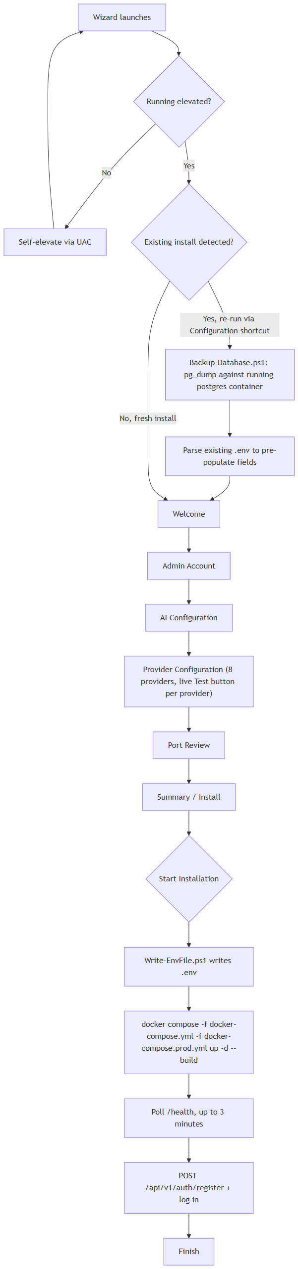
Notes on individual pages:
- Admin Account — collects the credentials for the operator account the installer will register once the stack is up. Per the platform's own registration logic, the first account ever registered against a fresh database is automatically granted the admin role, with no manual database edit required; every registration attempt after that is rejected with 403 Forbidden rather than silently creating a lesser account. That bootstrap behavior is what makes it safe for this page to simply be "create the admin account" with no separate role picker.
- Provider Configuration — presents exactly 8 of the platform's 18 registered intelligence providers, each with a live "Test" button that calls POST /api/v1/providers/{id}/test against the running backend: VirusTotal, AbuseIPDB, OTX, the combined abuse.ch group (URLhaus/ThreatFox/MalwareBazaar — one free Auth-Key covers all three), NVD, Hybrid Analysis, Censys, and PhishTank. The wizard's own inline notes match the backend's behavior exactly for the cases checked: Censys requires both a Personal Access Token and an Organization ID, the abuse.ch key is shared across three connectors, and NVD works without a key at a lower rate limit. The remaining 10 backend providers are deliberately absent from this page for two different reasons: 6 (Certificate Transparency lookups, CISA KEV, MITRE ATT&CK, WHOIS/RDAP, Spamhaus, and the internal OSINT crawler) require no credential to collect at all, so there is nothing for this page to configure and no corresponding test handler exists for them either; the other 2 (urlscan.io, Google Safe Browsing) do require a credential but are still absent from the wizard on both platforms identically — both are configured after install from the app's own Providers page instead.
- Port Review — lets the operator confirm/adjust the host ports the stack will bind, following on from the prerequisite check's "ports free" verification.

What "Start Installation" Actually Executes
Clicking "Start Installation" on the Summary/Install page runs, in order:
- Writes .env via Write-EnvFile.ps1, using the values collected across the previous pages plus CSPRNG-generated secrets.
- Runs docker compose -f docker-compose.yml -f docker-compose.prod.yml up -d --build — the production overlay swaps in production start commands and drops the development bind-mounts.
- Polls the backend's /health endpoint for up to 3 minutes, waiting for the stack to come up.
- Registers the admin account by calling POST /api/v1/auth/register with the credentials from the Admin Account page, then logs in.
Nothing here is a distinct "installer-native" install step beyond orchestrating the same Docker Compose commands and HTTP calls an operator could run by hand — the wizard's value is sequencing and validating them, not replacing them.

Start Menu Shortcuts
The installer's [Icons] section creates the following (plus an optional desktop icon):
Shortcut | What it does
Open Platform | Runs  Open-Platform.ps1  (also the default desktop icon action): checks stack health first, starts Docker Desktop if it isn't already running, starts the stack, then opens the browser to the platform.
Configuration | Re-runs the Setup Wizard. On an existing install this sets an upgrade flag (  $State.IsUpgrade  ) that changes the wizard's behavior — see Upgrade/Reconfigure below.
Start Platform | Runs  Service-Start.ps1  :  docker compose up -d  , then polls  /health  .
Stop Platform | Runs  Service-Stop.ps1  :  docker compose stop  (no  -v  flag, so container data/volumes are preserved, not deleted).
Restart Platform | Listed in the installer's icon set; the facts available do not detail its script-level implementation beyond the name (presumably a stop-then-start sequence, not confirmed).
Service Status | Listed in the installer's icon set; specific implementation not detailed in the source material beyond the name.
Backup Database Now | Manually triggers an on-demand database backup using the same  pg_dump  -against-the-running-postgres-container mechanism (  Backup-Database.ps1  ) that runs automatically before an upgrade (see below).
Diagnostics | Listed in the installer's icon set; specific implementation not detailed in the source material beyond the name.
Documentation | Opens the installed documentation (  docs/  ,  README.md  ) copied in at install time.
Uninstall | Invoked via  [Code]  in  installer.iss  ; offers "Remove Application" (keeps  ProgramData  and Docker volumes intact) versus "Remove Everything" (requires typing  DELETE  to confirm; runs  docker compose down -v  and deletes  ProgramData  ).

Upgrade / Reconfigure Flow
Re-running the Setup Wizard from the Configuration shortcut on a machine that already has the platform installed sets $State.IsUpgrade = true internally, which changes two things before the operator sees any page:
- Pre-population: the wizard parses the existing .env (from ProgramData\...\config\.env) and uses it to pre-fill the wizard's fields, so re-running Configuration is a "review and adjust" flow rather than starting from a blank slate.
- Pre-install backup: before anything else changes, the wizard backs up the database by running Backup-Database.ps1, which executes pg_dump inside the already-running Postgres container. This backup lands in ProgramData\...\backups\, alongside the same rolling most-recent-10-retained snapshots used elsewhere.
From there the wizard proceeds through the same page flow (Welcome → Admin Account → … → Summary/Install → Finish) and "Start Installation" re-runs the same docker compose ... up -d --build / health-poll sequence described above. The source material does not specify whether the final admin-account registration call is skipped or altered on an upgrade path versus a fresh install — this detail is not confirmed and should not be assumed either way without checking the wizard script directly.

Summary
The Windows installer's job is narrowly scoped: verify the host can run the stack, lay down application files under Program Files, collect configuration through a WinForms wizard, generate and lock down secrets under a restrictive ACL in ProgramData, and drive the same docker compose commands and REST calls an operator could otherwise run manually. It intentionally leaves Docker Compose as the real runtime rather than replacing it with a native Windows service, and it protects the resulting secrets primarily through NTFS ACLs (Administrators + SYSTEM only) on the .env file(s) and CSPRNG-based secret generation, rather than through any OS-level secret store.

Security Architecture
This appendix section documents the authentication, authorization, secrets-handling, network-exposure, rate-limiting, and CORS behavior of the HORIZON GRID backend (the FastAPI service that receives IOC — Indicator of Compromise — lookup requests from the web client). All claims below are traceable to source-code inspection of the platform's backend and Windows installer; anything not directly confirmed in code is marked "Not confirmed" rather than estimated.

Authentication
The backend issues JSON Web Tokens (JWT) using python-jose with the HS256 signing algorithm (backend/app/auth/security.py). Two token types are issued on login:
Token | Lifetime
Access token | 30 minutes
Refresh token | 7 days

Password storage uses passlib with bcrypt hashing — plaintext passwords are never persisted; only the bcrypt hash is stored on the users table.

First-user-becomes-admin bootstrap
POST /auth/register contains a specific bootstrap rule: the first user ever registered on a given instance is automatically granted the admin role; every registration attempt after that is rejected with 403 Forbidden ("Self-registration is closed. Ask an administrator to create your account from the Administration page.") rather than being granted a lesser role. No manual database edit is required to stand up an initial administrator account — this is also how the Windows Setup Wizard provisions the admin account at the end of installation (it calls this same registration endpoint). Every account after that first admin must be created by an existing admin, via POST /api/v1/admin/users or the /admin frontend page, which lets the admin choose the new account's role up front. docs/SECURITY.md describes this identical mechanism.

Role-Based Access Control (RBAC)
The platform has exactly three roles: admin, analyst, and viewer. Permissions are modeled as a permission-string matrix (ROLE_PERMISSIONS in app/models/user.py) and enforced per-route by a require_permission() dependency (app/auth/rbac.py) — a route either declares a required permission string or it doesn't; there is no implicit fallback check.
Documentation correction made during this review:docs/SECURITY.md states that no route enforces the provider:manage permission. That claim is stale. The provider-credential test endpoint, POST /api/v1/providers/{provider_id}/test (backend/app/api/routes/providers.py, line 24), does call require_permission("provider:manage") — confirmed directly in the route code. This endpoint is what the Setup Wizard's per-provider "Test" button invokes, so the permission gate is exercised as part of the normal install flow, not a dead code path.
Two other admin-tier permissions defined in the same matrix were checked. One remains unenforced; the other, audit:read, is now enforced as of the runtime provider/AI configuration feature described under Secrets Management below:
Permission | Status
provider:manage | Enforced — gates  POST /api/v1/providers/{provider_id}/test  and the new  /api/v1/runtime/*  provider- and AI-configuration endpoints
user:manage | Defined in the RBAC matrix; no route currently calls  require_permission("user:manage")
audit:read | Enforced — gates  GET /api/v1/runtime/audit-log

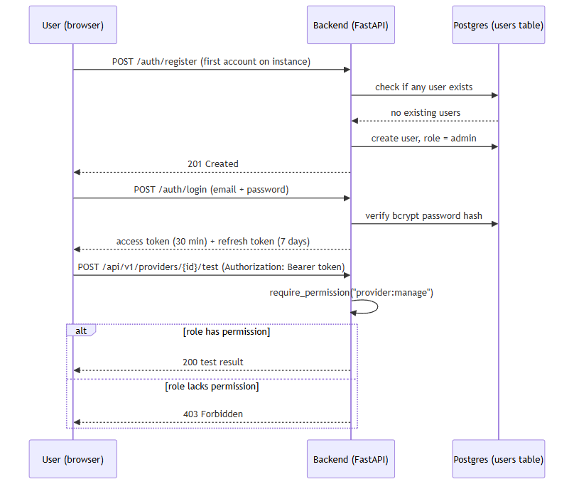

Secrets Management
Runtime configuration, including secrets, is loaded from a .env file via pydantic-settings. .env itself is git-ignored; only a .env.example template is tracked in source control.
One default value is a genuine risk if left unchanged: jwt_secret_key falls back to the literal string "change-me-in-production" when no value is set (backend/app/core/config.py, line 23). Any deployment that ships with this default unedited would have a publicly-known JWT signing secret.
On Windows installs, the Setup Wizard avoids this by generating secrets itself rather than relying on the code default: it uses a cryptographically secure random number generator (New-RandomSecret, backed by .NET's RandomNumberGenerator — explicitly not PowerShell's Get-Random, which is not cryptographically secure) and writes the result via Write-EnvFile.ps1. The resulting .env file's filesystem permissions are then locked down to the Administrators and SYSTEM accounts only, via icacls.

Setup Wizard credential-testing reliability fix
A review of the Setup Wizard's per-credential "Test Connection" buttons — used to validate both third-party provider API keys and AI-backend credentials (Ollama, Anthropic, Bedrock, Gemini, Groq) before installation is finalized — found two distinct root causes for unreliable behavior in this flow, both corrected during this review.
Session-acquisition bug. Every Test Connection button's request depends on an authenticated session token ($State.AccessToken). That token was previously set in exactly one place in the wizard: deep inside the "Start Installation" button's click handler on the final Summary page. As a result, no credential could be tested until installation had already been fully completed. On a reconfigure run in particular — where an administrator deliberately leaves the Admin Account page blank in order to keep an existing account unchanged — no login request was issued at all, so every Test Connection click failed with a "create the admin account first" message even though a working admin account and platform were already running. The fix is a new function, Get-OrCreateWizardSession (windows/wizard/Setup-Wizard.ps1), invoked on demand directly from each Test Connection click handler. It performs a login only, using whatever email and password are currently typed into the Admin Account page fields, and never registers or modifies an account.
.env serialization hardening. A second, independent bug existed in the writer responsible for persisting configuration values to disk, windows/scripts/Write-EnvFile.ps1: values were written without any escaping. A # character occurring anywhere inside a password or API key was interpreted by the .env parser as the start of a comment, silently truncating the remainder of that line, and an embedded newline in a value could similarly corrupt the file's line structure. This is fixed with a new ConvertTo-SafeEnvValue helper, applied to every value before it is written.
Neither issue involved the JWT signing or RBAC mechanisms described elsewhere in this document; both were specific to the Windows installer's wizard-to-backend session handling and its own configuration-file writer.

Encryption at rest for runtime-configured provider and AI credentials
A newer capability lets an administrator add, configure, enable/disable, and switch AI-backend and IOC-provider credentials at runtime through a Manage Providers UI, without editing .env or restarting the containers. Because this moves credential entry out of the git-ignored .env file and into the database, those values are encrypted before they are ever written.
Credentials submitted through this flow are encrypted with Fernet symmetric encryption (backend/app/core/crypto.py) and persisted as ciphertext in the provider_runtime_configs table's encrypted_credentials column — the database never holds a plaintext runtime-configured credential. This is not merely an inference from reading the code: a direct SQL query against the running database showed only Fernet-format tokens (the gAAAAAB... prefix), never a real key value.
The Fernet key used for this encryption is resolved one of two ways: an explicit, separately-configured encryption_master_key setting, if the operator has set one, or — by default — a key deterministically derived via HKDF from the platform's existing jwt_secret_key. The HKDF fallback means every existing installation already has a usable encryption key with no migration step required, but it is worth stating plainly what this tradeoff is: because the fallback key is derived from jwt_secret_key rather than generated and stored independently, it is defense-in-depth against exposure of the raw database, not HSM-grade key separation — compromise of jwt_secret_key would also expose the derived encryption key. An operator wanting stronger separation should set encryption_master_key explicitly.
Every configure, enable/disable, activate, and test-connection action taken against a provider or AI backend through this flow is separately recorded in a new config_audit_log table (timestamp, actor email, action, and a human-readable detail field). The write path for that table only ever accepts descriptive text as detail — it is not a place a credential value can be written. This was checked directly, not just by reading the code: after exercising the full configure/enable/disable/test/activate flow, a grep of the audit log table's contents and of the backend logs found no real secret value in either.

Network Exposure
Every datastore container's port mapping in docker-compose.yml — Postgres, Redis, both Neo4j ports, and OpenSearch — uses the explicit 127.0.0.1:<host_port>:<container_port> binding form, which restricts that port to the loopback interface only (not reachable from other machines on the network as ordinarily configured).
The backend and frontend containers are published differently: their compose entries use the shorthand form (e.g. "${HOST_PORT_BACKEND:-8000}:8000") with no explicit host-IP prefix. Docker's shorthand publishing binds to all host network interfaces by default — so, unlike the datastores, the backend API and frontend web app are reachable from other machines on the local network unless something else (a firewall rule, router configuration, etc.) restricts that.
Note on rigor:docker-compose.yml contains first-person comments asserting that live testing confirmed specific network-reachability behavior from another LAN machine. This section does not rely on that narrative comment as evidence — only the literal, machine-checkable YAML binding syntax described above was treated as verified fact.
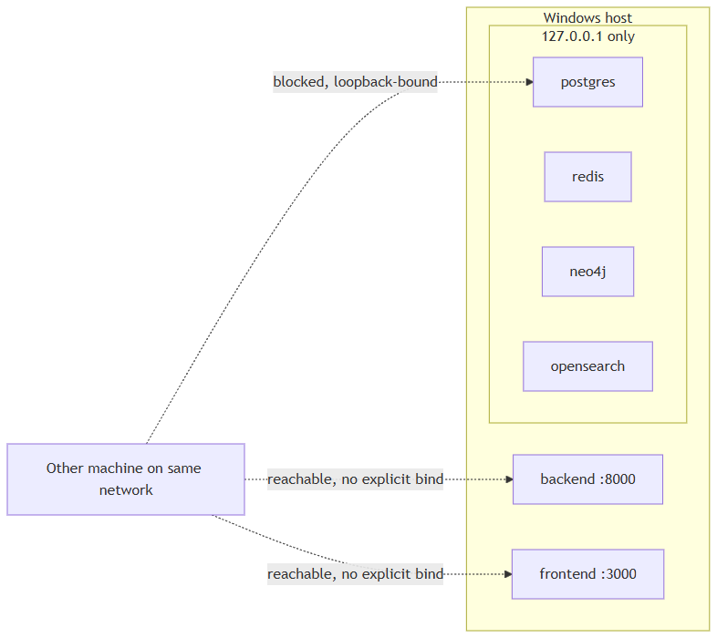

Rate Limiting
The codebase implements exactly one rate limiter: a Redis fixed-window limiter that applies solely to POST /lookup/stream (the IOC lookup endpoint), defaulting to 10 calls per 60 seconds per authenticated user — both figures are configurable.
/auth/login has a second limiter, added in a later mission-critical-reliability review (v0.2.3): a per-account Redis fixed-window limiter keyed by email (login:{email}, not source IP), defaulting to 10 attempts per 60 seconds, both configurable, returning 429 once exceeded. /auth/register still has no rate limiting of any kind.

CORS Behavior
Cross-Origin Resource Sharing is configured in backend/app/main.py (lines 27-33) and its behavior depends entirely on the debug setting:
- When settings.debug is True (the default), allow_origins is set to ["http://localhost:3000"].
- When debug is False, allow_origins is set to [] — an empty list, meaning zero cross-origin browser requests are permitted.
There is no CORS_ORIGINS environment variable or other configuration knob to adjust this. Practically, this means a DEBUG=false production deployment cannot serve a browser frontend from any other origin than the backend itself without a source-code change.

Other Input-Handling Notes
Two related facts are worth surfacing here because they feed directly into the hardening list below:
- LookupCreateRequest.value (the raw IOC string submitted for lookup) is an unconstrained str on the server side. Classification into an IOC type happens via regex-based heuristics (app/ioc/detector.py), which is pattern classification, not input sanitization.
- RegisterRequest.password carries a server-side 8-character minimum (Field(min_length=8, ...), app/schemas/auth.py), enforced by Pydantic for every account, not just the bootstrap admin — but no complexity rule (digit/symbol/case) beyond that length floor. The Setup Wizard's own UI also enforces an 8-character minimum when creating the bootstrap admin account, matching the backend constraint rather than substituting for it.

Areas for Future Hardening
Based only on the facts established above:
- Default JWT secret is a known literal.jwt_secret_key defaults to "change-me-in-production" if the operator never sets it explicitly — any instance that ships with this unedited has a predictable signing key.
- No rate limiting on /auth/register./auth/login gained a real per-account rate limiter in v0.2.3 (see Rate Limiting above); registration has no throttling against repeated attempts.
- No server-side password complexity rule beyond length. The backend enforces an 8-character minimum for every account (app/schemas/auth.py), but no digit/symbol/case requirement on top of that.
- One admin-tier permission still has no enforcing route.user:manage is defined in the RBAC permission matrix but, unlike provider:manage and audit:read, is not currently checked by any route.
- Backend and frontend ports are not loopback-restricted by default. Datastores (Postgres, Redis, Neo4j, OpenSearch) are bound to 127.0.0.1 only; the backend API and frontend web app publish on all host interfaces by default, unless the operator adds their own network restriction.
- Runtime-credential encryption key defaults to a derived, not independently-generated, secret. Unless an operator explicitly sets encryption_master_key, the Fernet key protecting runtime-configured provider/AI credentials (see Secrets Management above) is deterministically derived via HKDF from jwt_secret_key rather than generated and stored separately. That is a reasonable defense-in-depth default — it means every existing install already has a working encryption key — but it is not equivalent to HSM-grade key separation: compromise of jwt_secret_key would also expose the derived encryption key.

Linux Packaging Architecture

Application layer: unchanged
HORIZON GRID's application layer is identical on Linux and Windows. Both platforms run the same Docker Compose stack -- Postgres, Redis, Neo4j, OpenSearch, the FastAPI backend, the Next.js frontend, and two Celery workers -- built from the same backend/, frontend/, docker-compose.yml, and docker-compose.prod.yml. Neither platform bundles Node/pip dependencies or pre-built images in its installer artifact; both install them the same way, inside the containers, on the first docker compose up --build. Both platforms' Compose project directory shares the basename app, so both produce the identical Docker Compose project label (com.docker.compose.project=app). There is no architectural divergence at this layer -- it is the same code, the same images, the same runtime behavior.

Installer/lifecycle layer: the only difference
All Linux-specific work is confined to the outer packaging and lifecycle-management layer, which replaces the Windows installer stack component-for-component:
Windows | Linux
Inno Setup installer | .deb  package (  horizon-grid_0.2.0_amd64.deb  )
WinForms setup wizard | Python CLI setup wizard (terminal-based,  horizon-grid configure  )
Windows service registration | systemd unit (  horizon-grid.service  )
Start Menu shortcut group | horizon-grid  CLI entrypoint + desktop menu launcher
ProgramData config (ACL-locked) | /etc/horizon-grid/.env  (root:root, chmod 600)

The CLI wizard (linux/wizard/setup_wizard.py) follows the same flow and issues the same HTTP calls as its Windows counterpart (windows/wizard/Setup-Wizard.ps1): Welcome -> Administrator Account -> AI Configuration -> Threat Intelligence Providers -> Network Ports -> Summary -> write .env -> docker compose up -d --build -> wait for /health -> register the admin account -> confirm login. The systemd unit is registered at install time but never auto-started -- nothing runs until the admin completes the wizard, matching the Windows installer's own "nothing auto-starts before configuration" behavior.

Installed file layout (FHS)
Path | Purpose | Windows analog
/opt/horizon-grid/app/ | Application code (backend/, frontend/, compose files, docs) | Program Files
/etc/horizon-grid/.env | Config/secrets, root:root, chmod 600 | ProgramData config (ACL-locked)
/var/lib/horizon-grid/backups/ | pg_dump  snapshots | ProgramData backups
/var/log/horizon-grid/setup.log | Setup/runtime log | ProgramData  logs\setup.log
/usr/bin/horizon-grid | CLI entrypoint | --
/lib/systemd/system/horizon-grid.service | systemd unit | Windows service registration
/usr/share/applications/horizon-grid.desktop | Desktop menu launcher | Start Menu shortcut

Why no AppImage
An AppImage packages a single GUI executable for double-click launch. HORIZON GRID is a multi-container Docker Compose platform accessed via a browser, not a single GUI binary -- there is no one executable to wrap. The .deb + systemd + CLI-wizard combination is the direct Linux analog of what the Windows installer already does: neither platform reimplements the application as a native, self-contained desktop program. Docker Compose is the real runtime on both.

