DESIGN & BRANDING

HORIZON GRID
Design Overview — Visual Identity and Branding

Version: 0.2.4
Documentation prepared: 2026-08-21

PREPARED FOR EVALUATION

Table of Contents
Right-click here and choose "Update Field" (or press F9) to generate the Table of Contents.

Design Evolution

Where the UI Started
Through the earliest hardening phases (the adversarial audit, the AI provider expansion, the port-scanner cancellation work, and the mission-critical reliability pass — all documented in the Development Journey chapter), the product's UI was functional but generic: a bare search bar and a WorkspaceNav top-nav pair repeated at the top of every page, default-case headings, drop-shadowed cards, and a color palette close to the generic SaaS blue most dashboard tools default to. The product name and tagline were barely visible anywhere in the running application — a real gap once the underlying product (17 providers at the time, 11 AI backends, a deterministic scoring engine, an Executive Dashboard, a Provider Health page) had become substantial enough to deserve a real visual identity.

The Branding Pass (v0.2.4)
The last development phase before this submission was a dedicated, presentation-only branding and UI/UX pass, scoped deliberately not to touch backend logic, database schema, authentication, IOC processing, AI provider logic, provider API logic, port-scanner logic, or admin permissions — verified by a full backend regression run (383 passed, 39 skipped, zero regressions) and a clean frontend typecheck both before and after the change.
Three independent visual-identity proposals were generated and judged against each other before implementation began, rather than committing to the first idea that looked reasonable — the same "generate several candidates, synthesize the strongest one" discipline used elsewhere in this project's engineering process. The proposal that won, internally named "Datum Signal," is documented in full in the Brand Identity chapter.

Design Philosophy
The brief for this pass was explicit about the tone to hit and the tone to avoid: the product needed to read as military-inspired, rugged, operational, mission-ready, precise, technical, and high-trust — the seriousness of professional aerospace/defense operational software — without literally copying any real defense contractor, military organization, or government agency's branding, insignia, seal, or trademark, and without sliding into a "cyberpunk movie interface" of neon glow and fake-terminal effects. Every element of the final identity was built to satisfy that brief with an original mark, palette, and status language rather than borrowed or generic ones.

What Changed, Concretely
- Color. A CRT-phosphor teal-cyan primary color was chosen specifically to move away from generic-SaaS blue, paired with a warm off-white foreground against a near-black "anodized steel panel" background.
- Status language. A six-state operational vocabulary (OPERATIONAL / DEGRADED / WARNING / CRITICAL / OFFLINE / UNKNOWN) was introduced where every state pairs a distinct hue, fill density, border style, and icon — deliberately never color alone, so the product remains legible to a colorblind viewer or on a grayscale printout.
- Shape language. A "radius-contrast" rule: outer panels and cards keep a softer corner radius, while every interactive or status element (buttons, inputs, badges, chips) tightens to a sharper radius — soft containers visibly holding precise controls, read as an "operational instrument" without relying on any single color choice to sell that feeling.
- Elevation. Drop-shadowed cards were replaced app-wide with a flat fill bounded by a hairline border, so panels read as machined layers rather than floating the way a generic Bootstrap-style dashboard does.
- Typography. A three-typeface system: IBM Plex Sans Condensed for headings, the wordmark, and section labels; IBM Plex Mono — with tabular numerals — for every raw technical value (hashes, IPs, timestamps, scores); body text left untouched to avoid any risk to the existing dense data tables.
- Iconography and mark. An original, wholly geometric logo (a horizon line with two open "signal" nodes converging on one filled "detection" node) that literally depicts the tagline rather than just looking generically tactical, with no insignia, seal, shield, or existing company/military symbol of any kind.

Where It Landed
The identity was applied first to the shared components that appear everywhere (the header, cards, buttons, inputs, badges) so it took effect consistently across every page from one set of edits, then rolled out page-by-page to the ten pages sharing that header/nav, and finally into every exported report format (PDF, CSV, Markdown), each of which now carries the platform name, a generation timestamp, and an Investigation ID. The result is documented with real, live screenshots throughout this submission rather than mockups.
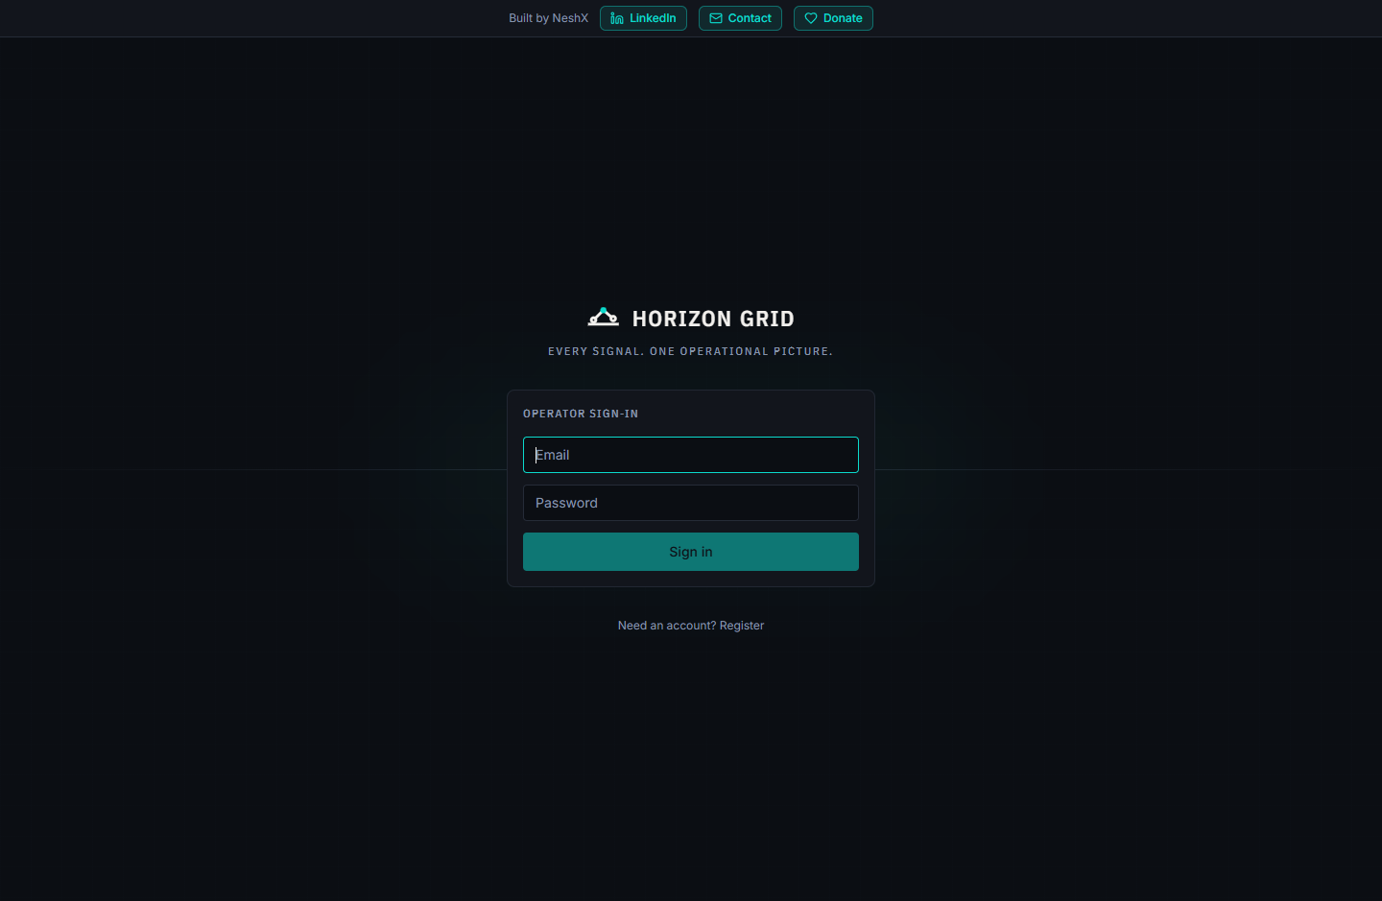

Brand Identity

Name and Tagline
HORIZON GRID — "Every Signal. One Operational Picture."
The name and tagline are meant to be read literally, not just atmospherically: "signal" is what a single provider or evidence item contributes; "grid" and "horizon" evoke a fixed reference frame that many independent signals get plotted onto; "one operational picture" is the actual product outcome — a correlated, scored, explainable view assembled from everything the platform collected, rather than a raw dump of provider responses.

Logo Concept
The mark is wholly geometric and original: a horizon line with two open "signal" nodes converging on one filled "detection" node. It is a literal depiction of the tagline — multiple signals resolving into one picture — rather than a generic shield, seal, or insignia shape. It exists in three forms:
- Full lockup — the mark plus the "HORIZON GRID" wordmark, used on the login/register screens and the About page.
- Compact lockup — the mark plus "HG" set inside a corner-bracket badge frame, used in the persistent header on every authenticated page.
- Favicon — a three-primitive degraded form of the same mark, simplified to stay legible at 16px.
No part of the mark reuses or resembles any existing military insignia, government seal, NATO symbol, or real defense-contractor logo (Lockheed Martin or otherwise) — a constraint that was explicit in this pass's own brief and was checked directly against the final design.

Color System
A CRT-phosphor teal-cyan is the primary color, chosen specifically to avoid the generic SaaS-dashboard blue most competing tools default to. It sits against a near-black "anodized steel panel" background with a warm off-white foreground — dark enough to read as an operational console, warm enough to avoid the colder, more generic near-black-and-electric-blue palette associated with stock "hacker" UI kits.

Status Indicator Language
Every operational status in the product — provider health, system health, investigation state — is expressed through one shared six-state vocabulary: OPERATIONAL, DEGRADED, WARNING, CRITICAL, OFFLINE, UNKNOWN. Each state is encoded through a distinct hue, fill density, border style, and icon simultaneously, so the state is never carried by color alone. This same vocabulary is what Provider Health's four real status categories (Healthy/Degraded/Down/Unknown) map onto — mapped honestly (Healthy→Operational, Down→Offline) rather than inventing new states for data the backend doesn't actually report.

Typography
- IBM Plex Sans Condensed — headings, the wordmark, section/panel labels.
- IBM Plex Mono, with tabular numerals — every raw technical value: IP addresses, hashes, timestamps, coordinates, counts, and scores.
- Inter (unchanged) — body copy, left untouched to avoid disturbing the product's existing dense data tables.

Shape and Elevation
Outer containers (panels, cards) keep a softer corner radius; interactive and status elements (buttons, inputs, badges, chips) use a visibly sharper radius — a deliberate contrast meant to read as soft panels precisely containing exact controls. Cards are a flat fill bounded by a hairline border rather than drop-shadowed, so the interface reads as machined layers rather than a floating card stack.

Navigation and Panels
The persistent header (BrandHeader) pairs the compact logo lockup with a live system-status indicator sourced from the real GET /health/detailed endpoint (polled every 60 seconds, never hardcoded), the global search bar, and the existing workspace navigation grouped by function (Command / Intelligence / Analysis / Operations / Administration). Section headers throughout the product (CardTitle) render as uppercase, letter-spaced, muted "instrument-panel" labels by default — an "operational readout" register applied once at the shared-component level so it took effect consistently everywhere without a per-page edit.
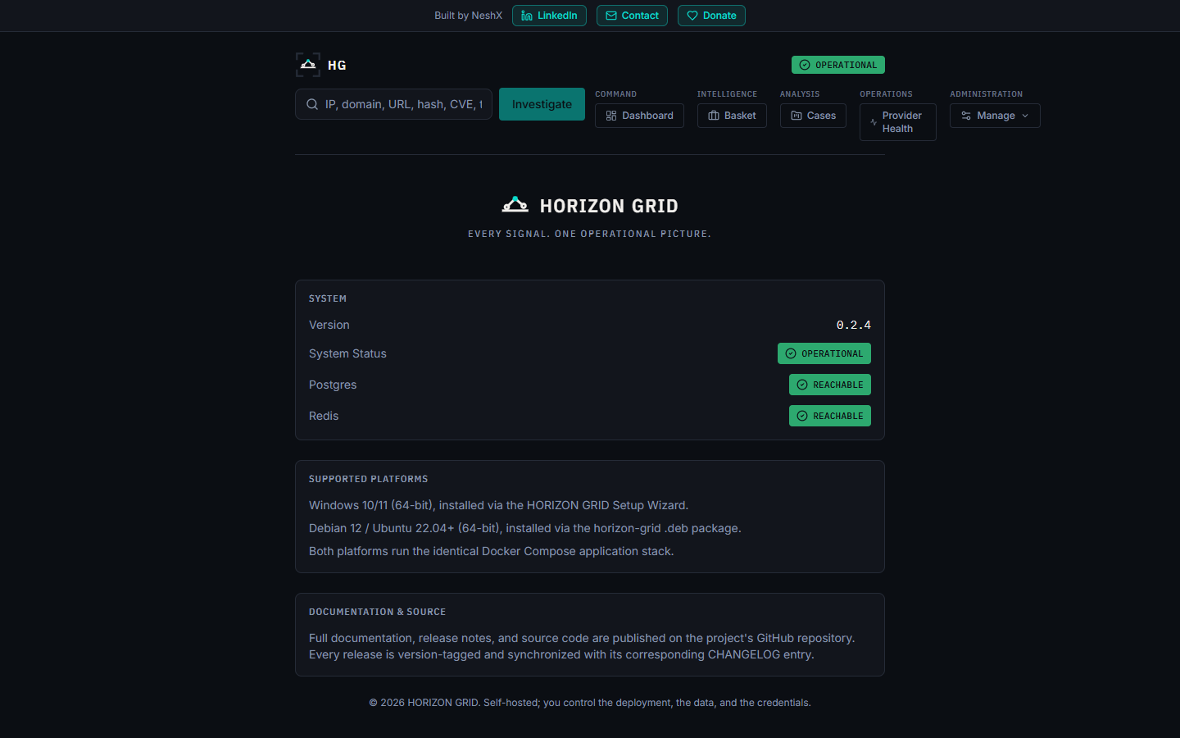
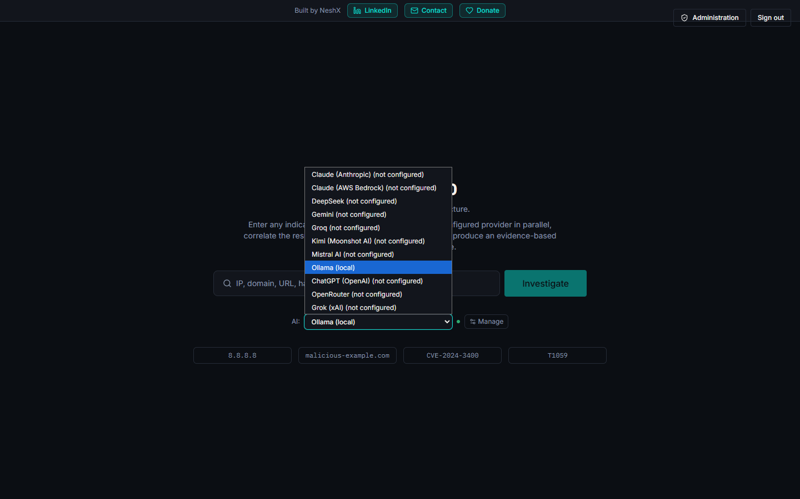

Why This Design Was Chosen
The identity had to satisfy two requirements that are easy to satisfy separately but hard to satisfy together: look like professional, mission-ready operational software, and be demonstrably original — no real insignia, seal, or defense-contractor mark anywhere in it, and no cyberpunk-movie neon-glow excess either. "Datum Signal" was the strongest of three independently generated candidate identities, chosen because its status language and shape language carry the "operational instrument" feeling structurally (through contrast, iconography, and a consistent status vocabulary) rather than through any single borrowed visual trope.

