*Retrieve recent IIS logs*

# Overview

*All code used for the assignment is available in Git Repository (*<https://github.com/neshevajoana/iislogs>)

The goal in the assignment was to retrieve IIS logs. Azure gives us the functionality of collecting VM Diagnostic data that includes IIS logs to store in a storage account. After, the Storage account can be added to a Log analytics workspace so we can query IIS logs from any VM instance. This can be done using Azure Portal which would be outlined below, but I decided to include automation for some of the tasks. I provided a basic infrastructure ARM template and Powershell scripts to set up some aspects of my environment. The parameters in the templates could be modified to fit an already existing environment that does not have the services already installed.

## The Portal

Below are the steps that I took to get IIS logs to be exported to a Storage Account:

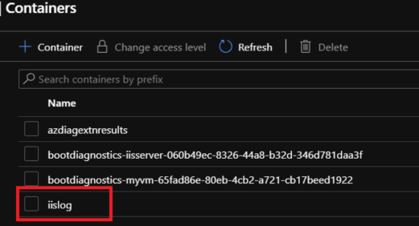

VM has to have the Microsoft.Insights.VMDiagnosticSettings extension installed, which will allow IIS logs to be stored in a container on the Diagnostic Storage account.

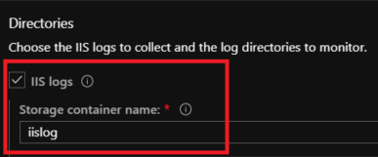

Once the logs are available in the Diagnostic Storage account then we can add it to a Log Analytics Workspace, allowing me to perform log queries. Azure provides some IIS sample log queries that can be used.

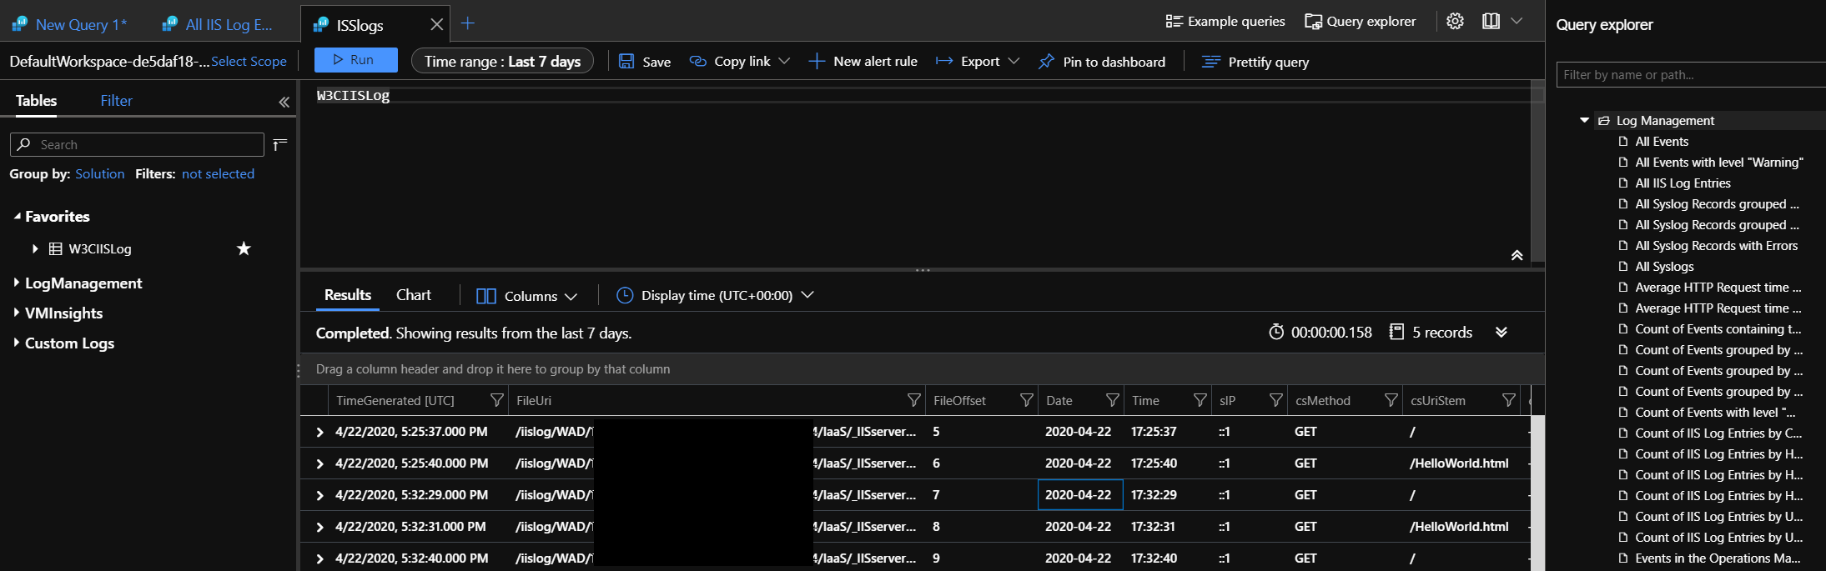

## Azure Devops

In order to have a more Devops/Automation approach I created a JSON that is used to deploy cloud services that were needed when the task was done in the Portal. The JSON template deploys a VM that has Diagnostic extension (WAD configuration are sent to IIS logs container). The template also provisions an Automation Account that would be used for DSC after the VM is deployed.

The Git repository contains :

* JSON file used as ARM template to deploy Azure Resources ([vmdiagndeploy04.25.json](https://github.com/neshevajoana/iislogs/blob/master/vmdiagndeploy04.25.json))
* Powershell script used to deploy new RG and new RG deployment ([vmdiagdeploy04.25.ps1](https://github.com/neshevajoana/iislogs/blob/master/vmdiagdeploy04.25.ps1))
* DSC configuration file that installs all IIS Features on target VM ([dsctest1.ps1](https://github.com/neshevajoana/iislogs/blob/master/dsctest1.ps1))

The screenshot below shows the Build Pipeline in Azure Devops:

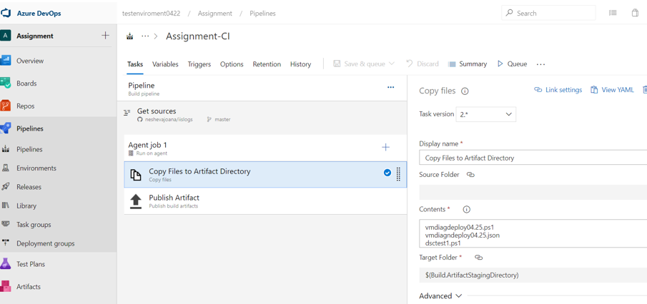

The screenshot below shows the Release Pipeline:

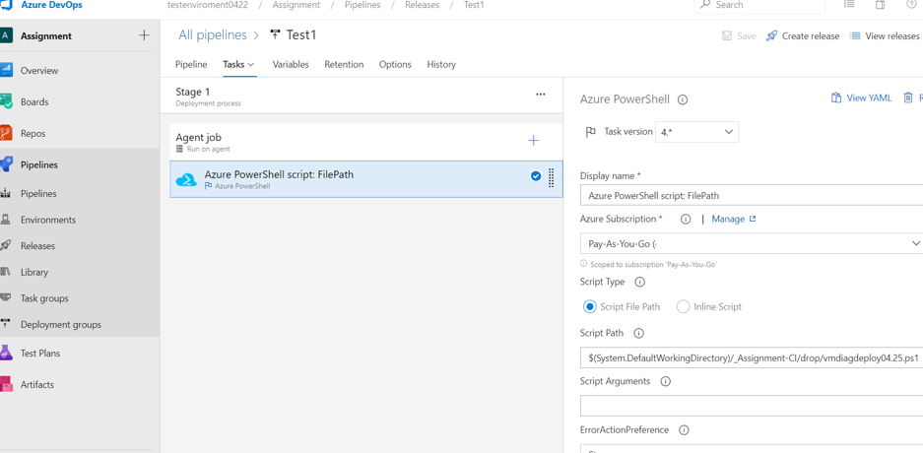

Deployed ARM template deploys the resources below :

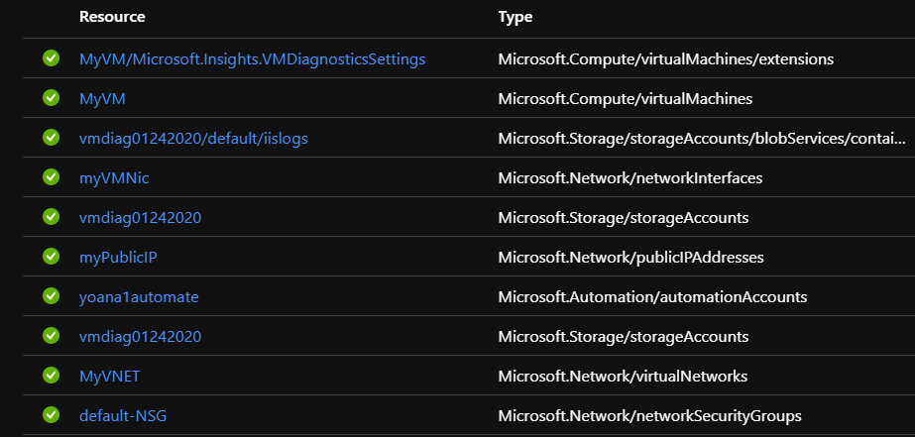

I then used the created automation account to manually configure and compile DSC scripts, assigning it to the VM. Note: With more time, I probably could have automated this process further with cmdlets like Start-AzAutomationDscCompilationJob. The compiled DSC script was successfully applied to the node:

