DTN monitoring System Manual

Introduction
This manual is to provide information of New Zealand E-Science Infrastructure's (NeSI) Data Transfer Node monitoring system. The monitoring system provides a platform for gathering, archiving and presenting information related to DTN's activity.
The system is built using server-client architecture where server gathers data reported by number of clients and archive the data, and client gathers system and data transfer information from nmon and FlowMon module. Server receives the data and stores it into CSV files, and produce graphs from the data archived.
The source of the system can be found at: https://github.com/nesi/DTN_Monitoring_system

Design
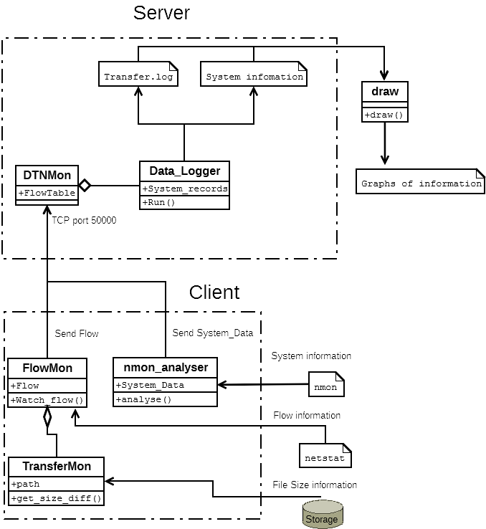Fig 1: Design of DTN monitoring system
The system consists in two components, server and client. Fig 1 shows the architecture of the system. Server is a single python module, “DTNMon.py”, which is responsible for listening to TCP port 50000 for clients to connect and send their transfer and system information. When it has received the data, it de-serializes the data using cPickle package and determines the type of data it has received. After the classifying the data type, it write the data into CSV files with Data_Logger class.
For transfer information, “transfer.log” is used to store Time of transfer, Sender IP, Receiver IP and Goodput in Mb/s. For system information, a file with IP address as its filename is used to store Machine name, Recorded time, network socket read, network socket write, CPU user time and CPU system time.
The client consist of number of monitoring modules, “FlowMon.py” and “nmon_analyser.py”. “FlowMon.py” script monitors network ports of the local machine it is running using “netstat” command, checks TCP port > 50000 which is default GridFTP port for transferring data. When the port is connected to transfer data, it checks the size of the files in transfer location each second and calculate the difference as the transfer rates per second. The transfer rates and IP addresses of both participant of the transfer i.e. sender and receiver is stored in a Flow object. The flow objects are serialised using cPickle and sent to the server each minute.
“nmon_analyser.py” runs nmon for one minute repeatedly and analyse output to extract system information (CPU user time, system time, socket read and write). The extracted system information is stored in ”System_Data” object and the original output of “nmon” is removed to save storage space. The system_record objects are serialised using “cPickle” and sent to the server each minute.

Requirement

Network configuration
To establish connection between client and server, TCP port 50000 needs to be open and accessible from the client. This port is used to send system and transfer information from clients to the server. IP address of the server and all IP addresses of DTNs that need to be monitored should be specified in the “runclient.sh” and “runserver.sh” scripts. These IP addresses are used to identify the transfer flows in “FlowMon”.
IP address used for each machine to transfer data also need to be specified by each DTN needs to be configured in the script. This address is used to translate local IP address to the IP address used in the transfer, in case if it is behind NAT.
Data location of the transfer needs to be specified in the scripts to calculate transfer size.

Dependency

Server and client
- Nmon package installed within the executable path. Tested version : nmon for linux, TOPAS-NMON build AIX 6.1
- Python version > 2.6 within the executable path. Not compatible for python 3.
- netstat within the executable path. Tested version: netstat 1.42 for linux and AIX build 6.1

Server
- matplotlib python package (for plotting)
- scipy python package (for plotting)
- numpy python package (for plotting)

Expected output

Nmon
“Nmon” outputs system information using its own CSV format. To work with the monitoring system, it needs to provide the system information in the following way.
- A row starts with 'AAA,host' needs to be followed by name of the host
- The first row starts with 'NET, network I/O' needs to have columns of name of the interfaces. The column of the interface name should be the same column used to show the socket read and write bytes in the following rows that starts with 'NET'.
- The first row starts with 'PCPU_ALL' (in linux, CPU_ALL) needs to have columns of the list of physical processors. The column of the processor name should be the same column used to show the socket read and write bytes in the following rows that starts with 'PCPU_ALL'.
- The actual informational node should starts with a row starts with 'ZZZZ' and the row should have column contains time of the measure followed after the 'ZZZZ' column.

Netstat
The “netstat -nt” output should provide information about TCP flows in the following way.
- Each field should be separated by spaces
- Hostname should be resolved into IP
- 4th field should show the local address, 5th field should show the foreign address and 6th field should show the connection status. Connection status should show 'ESTABLISHED' when it is connected

How to use the system

Deploying
The system comes with python scripts and bash scripts. All of the scripts needs to be placed in a directory where the user have permission to create directory and files. Also, user need to have permission to access the package required to run the system, specified in section 3.

Running
You need to run the server first with running runserver.sh file, providing the necessary configuration information in the top of the file. Edit the file as required and execute the file. It will show you what modules are started as background process with their PIDs. The server will gather reported information from the client and place it the directory named with the date string, in the result directory (e.g. result/2016-01-15/). In each directory, the transfer.log file will be generated to record transfer information. In addition, a file for each system will be generated following with their IP address as a filename.
To run the client, edit the runclient.sh file to configure. Running the file will also show you what modules are started as background process with their PIDs. The client will gather transfer flow information and system information and report to the server.

Plotting
You can use the draw.py file to generate plots from the data gathered. To run the script, you will need to have python with matplotlib module installed. You can run the script by issuing $python draw.py and it will list result directory which is separated by each day. You can choose which day by giving the index number and enter, or 'a' for generating plots for the all days.
Draw.py will generate a PDF file for each host, showing its socket read/write, transfer rate and CPU usage. The file will reside in the same folder as in the data.

Terminating
You can terminate the system by running a terminate.sh script. It sends sigterm signal to each python script process using PID which showed when it was started ($kill -9 PID to terminate the script). If the PID is unknown, then PIDs can be revealed by '$ps aux|grep python'. The following script need to be terminated.
- python DTNMon.py (in case it is the server)
- python FlowMon.py
- python nmon_analyser.py

Adding measures to the monitoring system

Adding more system information from nmon output
It is possible to add more system information from nmon output to the system by modifying the following script.
- In nmon_analyser.py, find analyse() function in Nmon_analyser class. Inside the for-loop, there is if-else statement where you can add a routine to retrieve information from nmon output. Adding another elif statement at the end of the last elif statement will enable to retrieve more information, and the data can be added to the 'current_data' object as a variable name of your choice.
- You can access the variable from 'system_record' object in the write_output function in Data_logger class in DTNMon.py. You can write it out to the file by adding another argument in log_file.write('{0}, {1}, {2}, {3}, {4}, {5}\n').format()) call. Adding {6} in the write call and actual variable as the last argument in format() call will write the value to the file with IP as the filename.

Adding measure from other tool
To add measure from another tool, you can write your own module with a data structure.
- The object contains information can be sent to TCP port 50000 after appending it into a python list with the first element being as a string of IP address of the client. e.g.) a = ['192.168.1.1',object]. This should be serialised using cPickle and sent to the DTN monitor server.
- In DTNMon.py, you can import the data structure and define another routine in main() function. Inside the if-else statement, add another elif isinstance(result[1],object) to create routine for handling the data. The data then can be added to the system_to_update object as a member variable and can be retrieved 'system_record' object in the write_output() function in Data_logger class in DTNMon.py. You can define your writing routine at the end of the write_output() function.

Issues

Netstat
The port status reported from netstat has few seconds delay. If we rely on this information on how long the transfer was, there is lack of accuracy for +- 1 seconds for start and +- 5 seconds for the end time. This is due to Globus on how it handles transfer sessions and the way we use netstat in our script. Because we use netstat each second, the start time cannot be more accurate than a second. On the other hand, Globus do not close the transfer sessions immediately after the transfer because of various reasons, such as waiting on other sessions for data striping. In such case, it leaves the transfer session opens for few seconds even after all the bytes are transferred. Because netstat is not able to distinguish whether it is the end of the transfer or just due to TCP's congestion control, we are not able to measure more accurate time for the end of the transfer.

File size increases
The throughput of file size increases and from the globus web pages does not match. This is partially because the time between each measure is not exactly one second, which explained in the previous section for netstat's lack of accuracy.
Other possible problem is from taking snapshots with different time periods. Our system measures file size changes each seconds while Globus online measures throughput over few minutes and calculate average and they differ from how they measure throughput based on.

nmon TCP socket statistics
nmon provide statistics about physical network interface, however it is the total bytes transferred by the specific interface. This also includes non-transfer network activity, such as ARP and also any other network activity if they shares the same physical interface.
In most cases, this is not a serious concern because a network interface is dedicated for data transfer and non-transfer network activity is not significant compared to the transfer activity in terms of volume, however if the network interface used to transfer data is shared with other network activity.

Monitoring GPFS performance
The current system is not able to monitor GPFS performance in detail. To measure the performance of GPFS, GPFS Current Activity Monitor (gcam, https://github.com/impredicative/gcam) can be used with python 3, however it will require knowledge of GPFS configuration.
Appendix A
Nmon log format example (AIX)
AAA,progname,topas_nmon
AAA,command,/usr/bin/topas_nmon -f -s 1 -c 60 -d
AAA,version,TOPAS-NMON
AAA,build,AIX
AAA,disks_per_line,150
AAA,host,dtn1
AAA,user,syu051
…..
BBBV,030,DISK BLOCK SIZE: 512 CRITICAL VG: no
CPU_ALL,CPU Total dtn1,User%,Sys%,Wait%,Idle%,Busy,PhysicalCPUs
PCPU_ALL,PCPU Total dtn1,User ,Sys ,Wait ,Idle , Entitled Capacity
SCPU_ALL,SCPU Total dtn1,User ,Sys ,Wait ,Idle
CPU01,CPU 1 dtn1,User%,Sys%,Wait%,Idle%
……
BBBN,000,NetworkName,MTU,Mbits,Name
BBBN,001,en1,1500,10240,Standard Ethernet Network Interface
BBBN,002,lo0,16896,0,Loopback Network Interface
NET,Network I/O dtn1,en1-read-KB/s,lo0-read-KB/s,en1-write-KB/s,lo0-write-KB/s
NETPACKET,Network Packets dtn1,en1-reads/s,lo0-reads/s,en1-writes/s,lo0-writes/s
NETSIZE,Network Size dtn1,en1-readsize,lo0-readsize,en1-writesize,lo0-writesize
NETERROR,Network Errors dtn1,en1-ierrs,lo0-ierrs,en1-oerrs,lo0-oerrs,en1-collisions,lo0-collisions
……
BBBP,404,netstat,"::1%1 ::1%1 UH 0 0 lo0 - - "
BBBP,405,emgr -l
ZZZZ,T0001,23:26:57,27-JAN-2016
CPU01,T0001,2.0,16.0,0.0,82.0
CPU02,T0001,0.0,0.0,0.0,100.0
……
SCPU08,T0001,0.00,0.00,0.00,0.00
CPU_ALL,T0001,19.3,50.3,0.0,30.4,,8
PCPU_ALL,T0001,0.08,0.20,0.0,0.01,0.40
SCPU_ALL,T0001,0.08,0.20,0.0,0.01
BBBL,21,Flags,LPARed DRable SMT Shared UnCapped Migratable Not-Donating AMSable.
……
PROC,T0001,0.00,0.00,441,35400,489,77,24,45,0,0,0,0,0
FILE,T0001,0,1545,0,749899,24159,0,0,0
NET,T0001,1.3,0.0,1.3,0.0
NETPACKET,T0001,5.0,0.0,5.0,0.0
NETSIZE,T0001,261.0,0.0,263.8,0.0
……
DISKWRITESERV,T0001,0.0,0.0,4.6,0.0,0.0,0.0,0.0,0.0,0.0,3.3,0.0
DISKWAIT,T0001,0.0,0.0,0.0,0.0,0.0,0.0,0.0,0.0,0.0,0.0,0.0
ZZZZ,T0002,23:26:58,27-JAN-2016
CPU01,T0002,10.0,31.0,0.0,59.0
CPU02,T0002,0.0,0.0,0.0,100.0
……
SCPU07,T0002,0.00,0.00,0.00,0.00
SCPU08,T0002,0.00,0.00,0.00,0.00
CPU_ALL,T0002,37.5,61.3,0.0,1.2,,8
PCPU_ALL,T0002,0.16,0.27,0.0,0.01,0.40
SCPU_ALL,T0002,0.16,0.27,0.0,0.01
……
Netstat example output
$ netstat -tn
Active Internet connections
Proto Recv-Q Send-Q Local Address Foreign Address (state)
tcp4 0 0 192.168.30.11.51721 10.64.1.66.1191 ESTABLISHED
tcp4 0 0 192.168.30.11.53318 10.64.1.242.657 SYN_SENT
tcp4 0 0 192.168.30.11.53033 10.64.1.67.1191 ESTABLISHED
tcp4 0 48 192.168.30.11.22 192.168.30.1.48548 ESTABLISHED
tcp4 0 0 192.168.30.11.32805 10.64.1.57.1191 ESTABLISHED
tcp4 0 0 192.168.30.11.32815 10.64.1.58.1191 ESTABLISHED
tcp4 0 0 192.168.30.11.38091 10.64.1.64.1191 ESTABLISHED
tcp4 0 0 192.168.30.11.53307 192.168.30.1.1191 ESTABLISHED
tcp4 0 0 127.0.0.1.65234 127.0.0.1.65236 ESTABLISHED
tcp 0 0 127.0.0.1.65236 127.0.0.1.65234 ESTABLISHED
tcp4 0 0 127.0.0.1.65234 127.0.0.1.65237 ESTABLISHED
tcp 0 0 127.0.0.1.65237 127.0.0.1.65234 ESTABLISHED
tcp4 0 0 127.0.0.1.65234 127.0.0.1.65238 ESTABLISHED
tcp 0 0 127.0.0.1.65238 127.0.0.1.65234 ESTABLISHED
tcp4 0 0 192.168.30.11.53313 130.216.31.108.50000 ESTABLISHED
tcp4 0 0 192.168.30.11.32798 192.168.30.1.1191 ESTABLISHED
tcp4 0 0 192.168.30.11.42618 10.64.1.59.1191 ESTABLISHED
tcp4 0 0 192.168.30.11.45321 10.64.1.60.1191 ESTABLISHED
tcp4 0 0 192.168.30.11.46422 10.64.1.65.1191 ESTABLISHED
udp4 0 0 127.0.0.1.123 *.*
udp4 0 0 192.168.30.11.123 *.*
Plot example
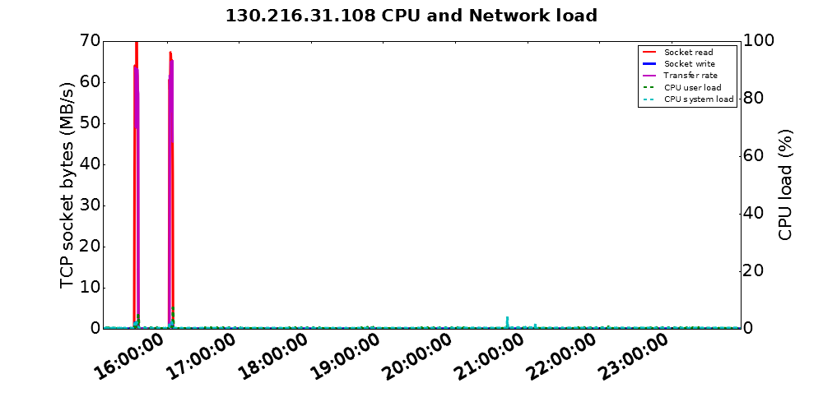
Appendix B
Psudo procedure

Server

DTNMon
“DTNMon” is a server that receives the flow information and system information and archive them into csv files. It does not require any argument to run,
It works as follows:
- Initialise a flow table to keep track of flow information.
- Open a TCP connection port 50000 and listening for incoming connections.
- Upon receiving incoming data, it checks for the data type and IP address of the client after de-serialised the data.
- If it is the flow information, update the flow table.
- Information received is put to “System_Record“ object and queued to a list of data to be written with “Data logger”.
- Start the “Data logger” to write the data in CSV format.
- Return to 2 until interrupted with “sigterm” signal.

Data logger
“Data logger” is a class in “DTNMon” that responsible for writing flow and system information to csv files.
It works as follows:
- Initialise with “system_record” from the “DTNMon”.
- If there the result directory does not exist (in the form of current datetime ‘%Y-%m-%d’), then create a new directory.
- If there is no files for system data (in the form of the client IP address), then create a new file and write headers in CSV format.
- Write system information to the system data file.
- If there is no files for flow data ( ‘transfer.log’), then create a new file and write headers in CSV format.
- Write flow data to the transfer.log file with CSV format.

Flow Table
Flow table is responsible for monitoring transfer flows to check how fast each transfer is. This also can be expanded to watch for flows that has low throughput below a certain threshold.
It works as follows:
- Initialise one-way and two-way flow table.
- When a new flow is received, set the timeout for the flow and remove any flow with its timeout exceeded from both of the table.
- If the flow in already registered in the one-way table, update the one-way flow with new timeout and throughput.
- Look for a reverse flow that matches with the new flow i.e. flow with source IP and port and destination IP and port reversed with the new flow, which is the flow information reported from the other side of the transfer.
- If the reverse flow is found and both flows are not in the two-way flow table, then add both flows into the two-way flow table, otherwise update previous flow table with new timeout and throughput.
- If the flow is not in the one-way table, add it to the table.

Client

FlowMon
“FlowMon” is a client that watches transfer connection in a machine. It constantly watches all flows that is established on TCP port > 50000 and < 51000 and sends the flow information to the “DTNMon”
To run “FlowMon” it requires 4+ arguments. The first argument is the IP address of the DTN it is running, to identify itself during the flow detection and flow table updates. The second argument is the location of data, to be used to calculate size changes during the transfer so that it can calculate transfer speed. The third argument is the IP address of “DTNMon” to send flow information to. The fourth argument and more are IP address(es) of other DTN to identify transfer flows from all flows in the DTN. Each argument must be given as a command line argument when starting the “FlowMon” i.e. “Python Flowmon 1st-arg 2nd-arg 3rd-arg 4th-arg 5th-arg ….”
It works as follows:
- Initialise “TransferMon” using the 2nd argument and start it in a separate thread.
- For each second, run “netstat” and extract TCP flow information on the machine it is running.
- From the list of DTNs IP address specified from the arguments, filter out non-transfer flows and append the list of flows to the buffer.
- For each transfer flow. Add throughput information gathered from “TransferMon”.
- Replace local IP address from the list with the DTN’s IP using the 1st argument to remove private address from the flow information.
- Each minutes, send the buffer with list of flows to the “DTNMon” on TCP port 50000 using the 2nd argument.

TransferMon
“TransferMon” is responsible for watching local storage for calculating file size differences during data transfers. It constantly watches for a data location provided and calculate file size growth to report to “FlowMon”.
It works as follows:
- With the data location provided from “FlowMon”, calculate initial file sizes for all files within the location.
- When get_size_diff() function is called, re-calculate file sizes for the location and get the size differences from the initial size.
- Update the initial size with current size and return the difference to the “FlowMon”

nmon_analyser
“nmon_analyser” runs nmon each seconds, analyse the output of nmon and report the information to the “DTNMon”.
To run “nmon_analyser”, it requires 3 arguments. The first argument is the IP address of the DTN to use instead of private IP when reporting to “DTNMon”. The second argument is the interface name to watch for transfers. The third argument is the IP address of DTNMon to report the system information. Each argument must be given as a command line argument when starting the “nmon_analyser” i.e. “Python nmon_analyser 1st-arg 2nd-arg 3rd-arg”
It works as follows:
- Runs nmon with command “nmon -f -s 1 -c” each second.
- If there is any output file created from nmon, read the contents.
- For each row starting with “AAA”, create data entry and populate TCP read/write and CPU user/system data to the entry by looking at the rows with ‘NET’ and ‘CPU_ALL’.
- Send the data to the “DTNMon” using TCP port 50000. IP address of the DTN is reported to “DTNMon” to avoid using private address.
- Return to 1 until interrupted with “sigterm”.

