Report

Frame = the output of a single lidar scan. Our lidar can obtain 2048 samples per scan.
Channel = output of a single laser. Our lidar has 32 channels in total. In our experiments, the vibrating road sign is only be covered by 15 channels.

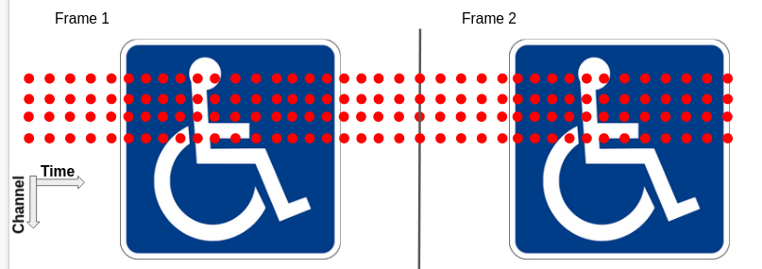
The results that are reported in here were produced by using an LSTM-FCN network. Previously, a matrix consisting of one or multiple frames with all the measurements of the 15 channels sensing the vibrating surface were used as input. In contrast, in this new attempt, the input given to the neural network are the measurements of a single channel from a single frame that can be concatenated with other channels in the same frame and channels of contiguous frames. Similar results are obtained with respect to the previous attempt, but one of the benefits of using channels instead of complete frames as a basic unit is that we are not limited by surface dimensions, up to a certain point, as previously we had fixed the number of channels per frame.
Our results with a vibrating sign use 15 channels.

Number of channels per input sample | Mean absolute error (validation) in Hertz | Mean absolute error (test) in Hertz
1 | 115.87 | 99.44
2 | 106.73 | 88.77
5 | 76.17 | 62.53
10 | 82.97 | 68.86
15 | 63.52 | 52.1
20 | 65.51 | 53.92
30 | 64.95 | 54.51

Results highlighted in violet are obtained using only channels in a single frame, whereas those highlighted in yellow correspond to using channels of two separate frames. In the next pages, the error distributions are presented for each distinct configuration of number of channels per sample. We also present the mean absolute error according to the frequency at which the sign vibrates, and finally the error distribution for 5 different frequencies.

Number of channels per sample: 1

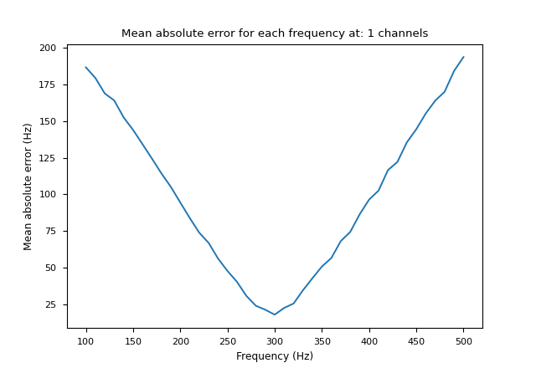
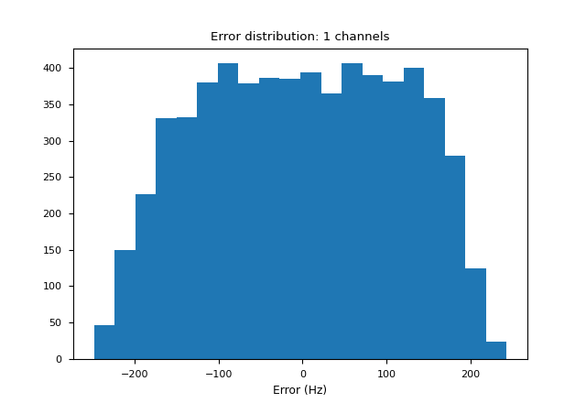
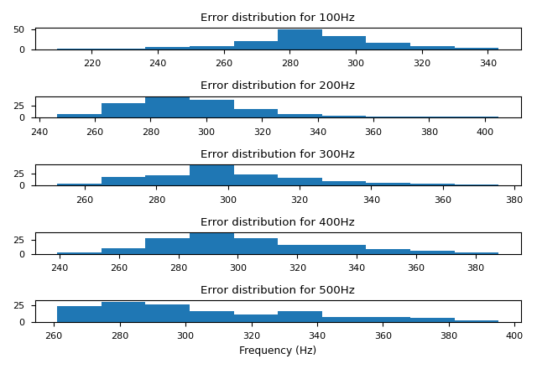
Number of channels per sample: 2

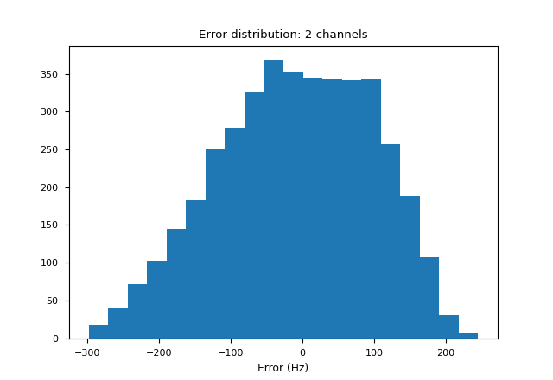
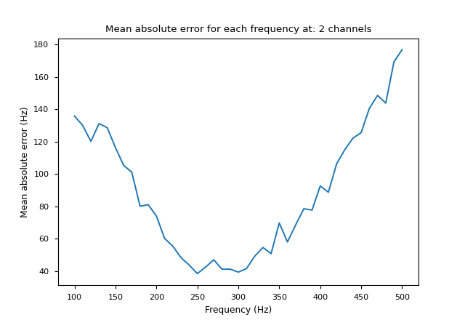
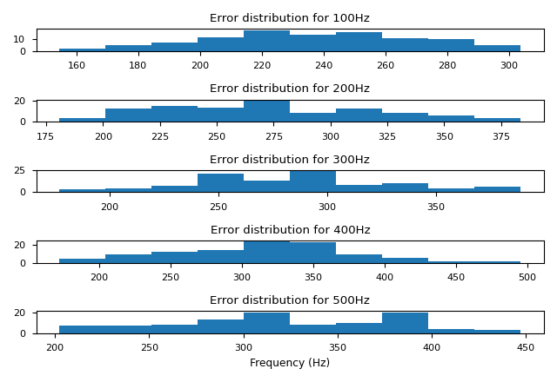
Number of channels per sample: 5

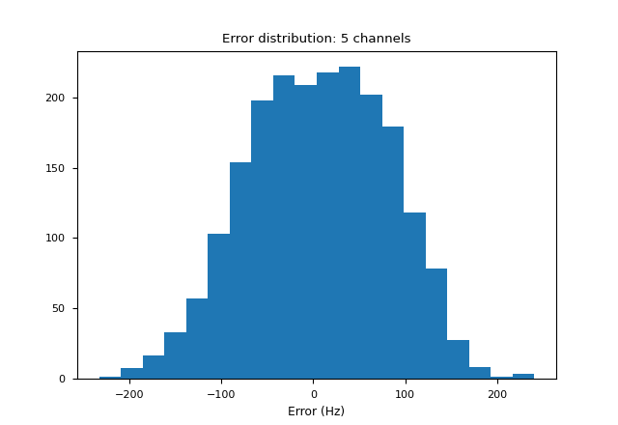
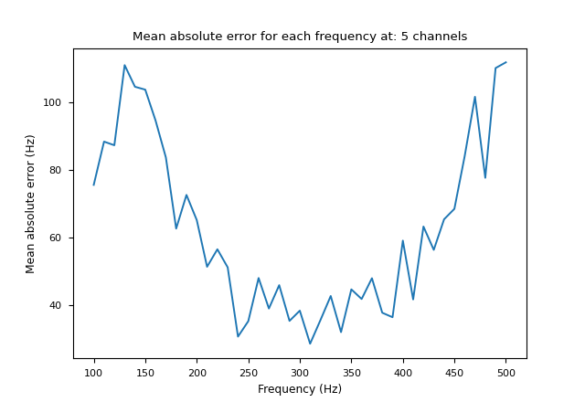
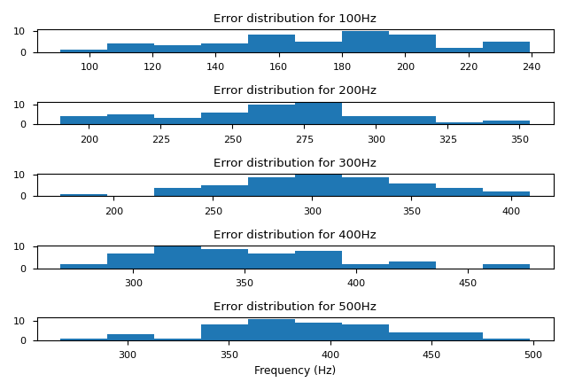
Number of channels per sample: 10

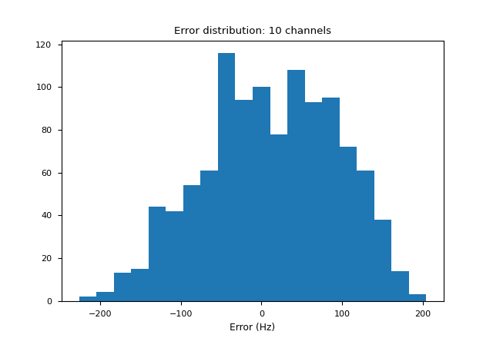
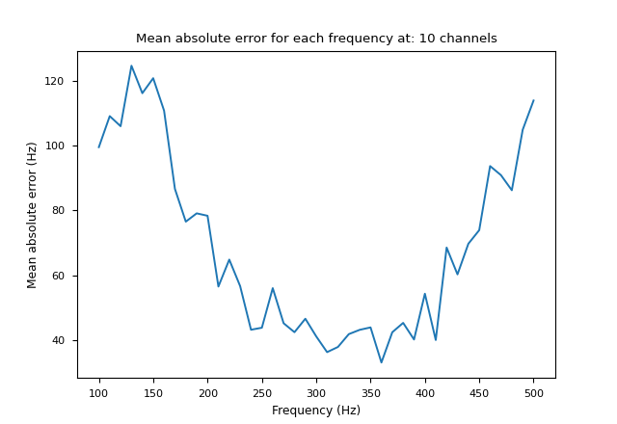
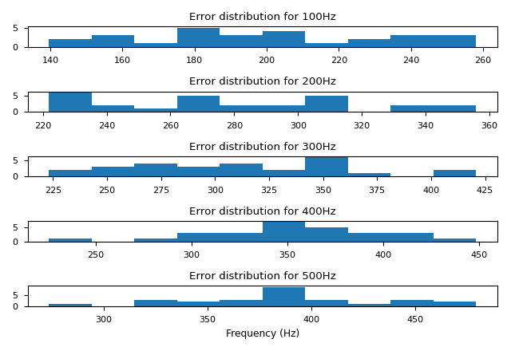
Number of channels per sample: 15
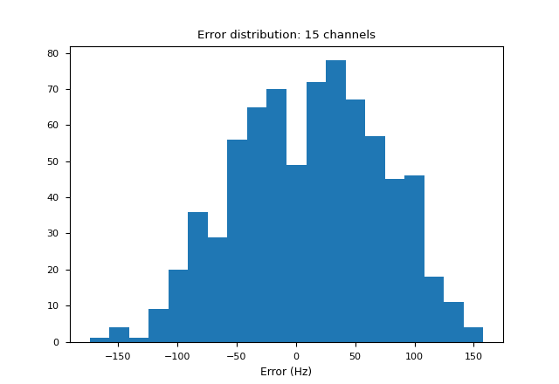
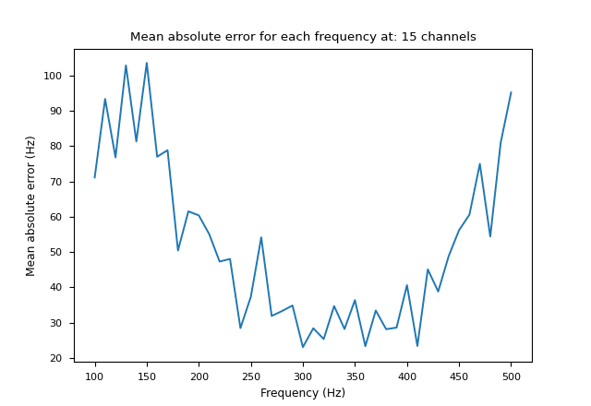
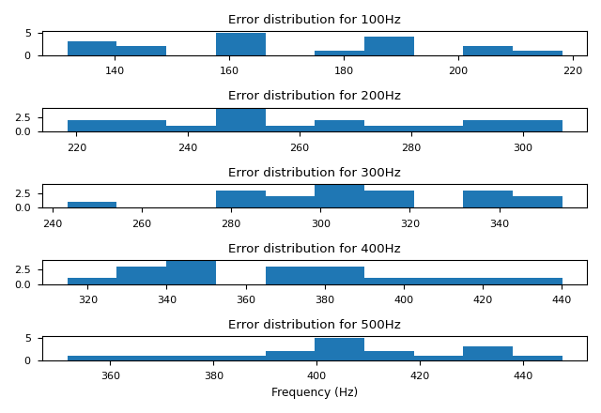
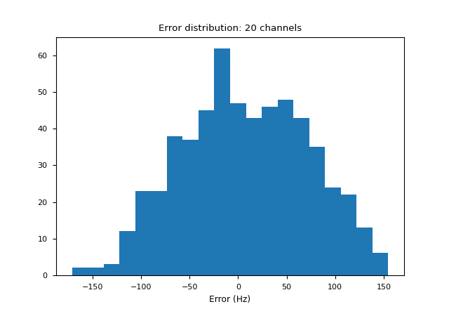
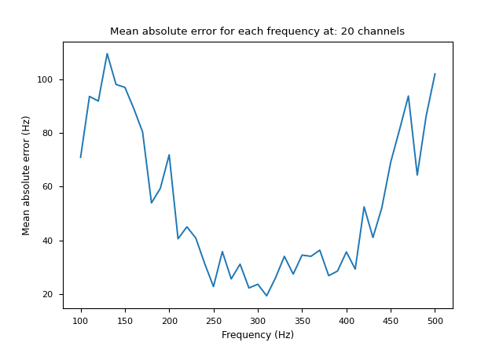
Number of channels per sample: 20 (15 from one frame and 5 from another)
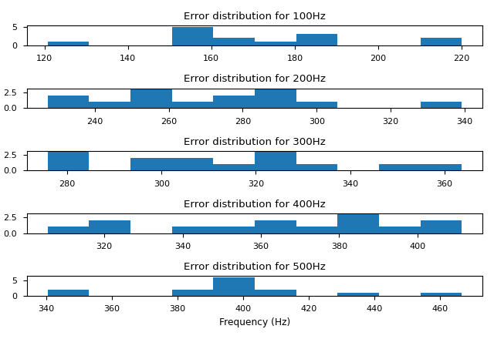
Number of channels per sample: 30 (15 from one frame and 15 from another)
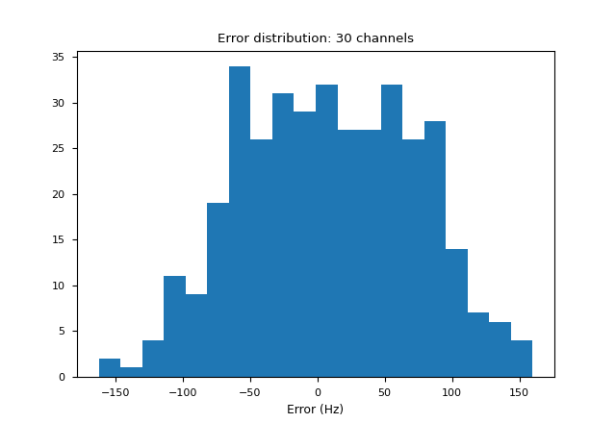
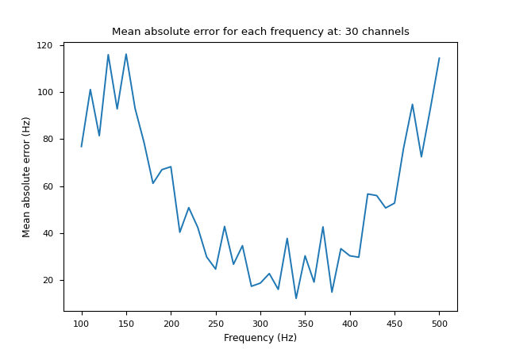
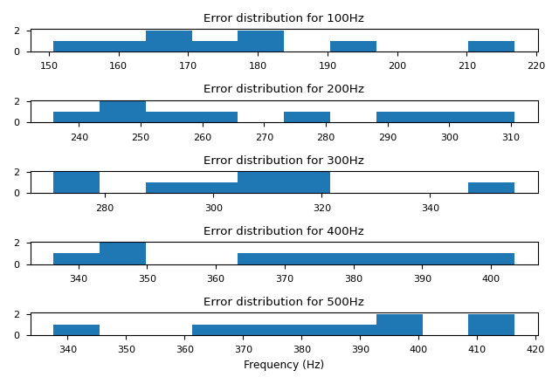
Conclusion

From the results presented in here, we can see that the model is not learning sufficient information, as the output value is stuck at ~300 Hz. As one increases the number of channels used as input, the model seems to start giving better results, but we are now limited by the amount of data we have.

One advantage of using the lidar as it is, without stopping its rotation, is that we could collect measurements of multiple objects at the same time, in a single scan.

