Probable Identity
Ver. 1.7
David Jea, Jason Liu, Mani Srivastava
UCLA

Abstract
This article proposes probable identity concept to serve as a controllable balance between usability and privacy for non-critical ubiquitous computing applications. It removes the uniqueness in user identification by associating a probability θ to an identity. The system then serves a user based on the most probable identity rather than determined identity. The probable identity model enables two characteristics in preserving privacy: intentional ambiguity and plausible deniability. Thus this mechanism lessens users’ anxieties in privacy. For possession-based identification, we propose identity tickets architecture to support probable identity. For biometric-based identification, we propose using imprecise biometric to support probable identity. We discuss and evaluate both designs. We conclude with usage scenarios in ubiquitous computing applications. We emphasize that probable identity is not a panacea to privacy protection; rather, it “compensates” privacy management especially in plausible deniability issues that currently have no effective solutions. We believe that probable identity answers some tough privacy issues in this field.

Paradigm Shift
Ubiquitous computing nowadays does “Oh! This is Alice. Let's do something for her.” However, the security requirements vary with the context of application spaces. Some require greater protection (such as homeland security alerts), while other non-critical situations may not need a very high level of security. We propose a paradigm shift for these non-critical applications and allow a system to say “Hmmm… This is probably Alice. Let's do something.” This way leads us to a simpler solution for the complex privacy issues in ubiquitous computing.

An Example Scenario
We first illustrate the idea of probable identity with an imaginary location-based service. The goal of this pseudo example is to track which cubicle a user is using and has used. The service provided is automatic personalized lighting and temperature adjustment when a user enters into a cubicle. However, instead of continuously tracking locations of every user, it guesses the most probable user during each entrance. The system does not know the exact true identity, but has a good confidence in whom the user is. When Alice walks into a cubicle, and with the probable identity, the system can choose her customized setup correctly “most” times. In those few occasions where this system picks someone else’s setup, Alice can manually fix the lighting and temperature in the cubicle. Also, Alice only knows that if the system goes wrong and misses her expectation, but she does not know whose setting has been chosen by the system for her.
In another service that this system provides, Alice wants to retrieve the usage information of the cubicles that she has visited more frequently in the past month. The system lists a number of cubicles and notes how many times she has used them. With probable identity used in the system, there are errors associated with these returned answers. However, Alice probably will not be bothered if she has in fact used a cubicle 9 times rather than 10 times. And even if she does count her total usages of one specific cubicle; she still does not know who contributes to these additional usages, thus others’ privacy is also preserved. One thing Alice does know is that no one can exactly pinpoint her whereabouts with this kind of identification.

Privacy Concerns, Definition and Contradiction
Concerns of privacy have existed since day one in pervasive computing. Mark Weiser described privacy as a key among the social issues that embodied virtuality will engender [W91]. Significant efforts have been undertaken but balancing usability, security and privacy is never an easy task in ubiquitous computing environments. Researchers use terms such as “paradoxical”, “contradiction”, “hardly be achievable” to state privacy protection in ubiquitous computing.
A precise definition of privacy is difficult. In this work, we adapt the most common one in current use by Alan Westin [W67]: “Privacy is the claim of individuals, groups and institutions to determine for themselves, when, how and to what extent information about them is communicated to others.” On the other end, the basic building blocks for ubiquitous computing are context information such as current locations or activities. The more context information acquired from a user, the more powerful is a system and the higher usability is to a user.
The problem is, when applying above definition of privacy into ubiquitous computing, the amount of “information about them” has grown to a level that individuals simply cannot afford to “determine for themselves” for every single bit of information. For example, a cellular phone that reports the location of a user every 10 seconds constitutes 8640 contexts per day. To determine daily how each of these contexts communicates to others is way beyond the willingness of any human being. The perfect privacy protection is thus logically fundamentally incompatible with perfect ubiquitous computing.

Insufficiencies in Privacy Management
Not surprisingly, current feasible solutions are to automate protection and reduce the amount of information that a user needs to manage. Price et al. [PA05] distinguish privacy protection into two groups: policy matching and noise (anonimizing, cloaking, blurring, lying, and hashing). These mechanisms serve as the fundamentals for privacy management in today’s ubiquitous systems. Without diving into the details of these mechanisms, we take a divergent route of discussing their insufficiencies in privacy protection. We expect these discussions further justify the necessity of the proposed probable identity in completing privacy protection.

Policy Matching
Policy matching allows a user to set specific rules that automates this process. To protect privacy, users define privacy policies over objects, data, and contextual information. In pawS [L02], Langheinrich uses a privacy beacon to announce the privacy policies of each service in the environment. These policies then match to the user’s predefined privacy preferences. This creates a sense of accountability. However, privacy protection cannot be static. The drawback of policy matching is the caused huge burdens on learning/using tools and continuously modifying the policies. Also, in lights of previous experiences [AG05], even in “high” privacy concern group who are technologically enthusiastic and educated, 41% rarely read privacy policies. Given the scale of ubiquitous computing environments, even with a flawless policy design, we hardly believe that users will change their behavior on start using it.

Anonymizing
Anonymizing is to remove the identity of a user. The anonymity achieves privacy by breaking the connection between “information” and “about them” such that the information no longer belongs to a specific individual and consequently removes the needs of privacy management. However, a system cannot provide personalized services to anonymous users that have no identity information.

Cloaking
Cloaking is to have the system make a user invisible by hiding her/his presence information and not revealing to others. However, cloaking only protects a user’s privacy against legal users but the “system” still knows a user’s identity and related contexts. The link between a user and a system is vulnerable to an eavesdropper.

Blurring
Blurring is to reduce data resolution. Resolution reduction is another popular method that reduces the amount of information. However, changing in context resolution still may cause information accidently leaked [H05]. For example, a friend may get suspicious if s/he is expecting a street-level resolution while sees a city-level information.

Lying
Lying is to intentionally provide false information. For example, Alice is preparing a surprise party for her husband and thus publishes her location as in the office rather than the true location. However, the art of lying is that a good lie depends on a liar’s awareness of situations [BZ07], thus it is cumbersome for a user because it requires “prevision” to keep it intact. Lying also wastes resources [BS03]. Imagine the earlier example scenario, if Alice lied about her whereabouts, the system will provide services (lighting and air conditioning in the example) to the wrong room and that generates undesired energy wastes.

Hashing and Mixed Zone
Hashing is pseudonym. One problem is that, if we somehow know the true identity of a pseudonym, we can link all pseudonym-associated contexts to that identity through deductive reasoning. Pang et al. [PGG07] demonstrate such a privacy attack by linking the requests of the network SSID to a user. They then locate his home through Wigle (an online database of observed 802.11 networks). The weakness for hashing in the architecture is that it requires a proxy for pseudonym mapping (otherwise, it becomes an anonymous access). Therefore, at least one entity can determine the true identity of a pseudonym is the innate limitation of hashing.
In [BS03], Beresford and Stajano show that they can de-anonymize all users by following the “footsteps” of each pseudonym. To ensure unlinkability, they propose a countermeasure of changing pseudonyms frequently. However, if the temporal and spatial resolutions are high enough, the observer can easily link the old and new pseudonym. To address the issue, they introduce mix zone by extending the concept of mix network and mix nodes which offer anonymous communication. In a mix zone, applications cannot distinguish users in the zone and cannot link people going into the mix zone with those coming out of it. Because they use pseudonym in a sense to provide a return address rather than establish and preserve reputation, the types of applications they focus on are limited to those cannot be accessed anonymously but do not require a user’s true identity either.

Plausible Deniability to Complete
While designing a system that incorporates above solutions is doable though difficult, the ubiquitous computing is not just for technologically savvy researchers but regular people. This means that people of all age groups and education levels have to know how to use such a system. But the wide and delicate control mechanisms in privacy protection scare them away.
In The Art of War, the influential ancient Chinese military treatise, Sun Tzu said that a good fighter is able to secure himself against the defeat, but cannot make certain of defeating the enemy. Plausible deniability empowers such a defensive mechanism in privacy protection. When a user is implicitly maintaining or appears having an association to some contexts, plausible deniability is the ability that allows the user to deny the existence of such association if necessary and others either believe or accept. Put it into cell phones, the plausible deniability is that a user can choose to ignore an incoming call by claiming that the battery was dead or there was no ringing. Put it into ubiquitous computing, the plausible deniability is that a user can deny any “information about them” (contexts) and tell white lies freely. Existing privacy management methods in general actively cover a broader aspect of privacy protection. The plausible deniability is similar to defensive missiles for each single point of context information. It allows a user to disassociate any context. Plausible deniability provides effective defenses for a user in compensating privacy protection. Together they form a complete circle in privacy protection.
Researchers have highlighted the importance of having plausible deniability in a ubiquitous system for privacy management. They propose solutions of returning unknown in default, reducing resolution or falsifying data in a predefined fashion. These solutions only solve partial of the issues. They usually require users to know-in-advances which is hardly always possible. Hong describes an ideal design for plausible deniability in ubiquitous computing [H05], “By default, plausible deniability is maintained without the end-user having to take any special action and without the end-user having to configure anything.”

Probable Identity
Plain identification links one identity to each piece of context information in ubiquitous computing. On the contrary, anonymity totally removes identities and leaves only information. This binary process either creates a definite relationship or no relationship. Probable identity injects uncertainty into an identity and a user uses θ to describe an indefinite relationship to an object or a context. The θ is the probability of an ownership that falls between 0 to 1 where (θ = 1) is the plain identity and (θ = 0) is the anonymity.
The probable identity enables two important characteristics [XL02] in preserving privacy: (1) intentional ambiguity, the ability to blur identity by changing representational accuracy of a user; a user uses θ to change the desired representational accuracy of the identity. (2) Plausible deniability, the ability to lie to a query about a user’s identity. With the incorporated uncertainty in identity, a user can deny a context without doing anything specifically. Setting θ means that, for each access, Alice can be Alice or someone else. Also, for each access that is claimed to be Alice could possibly be conducted by other users. That forms the plausible deniability.

Balancing Usability
Systems with probable identity empower users to control the privacy through one control knob, θ. This allows a strong link (θ) for a user to receive services but injects doubtful space (1-θ) to a linked context to support plausible deniability for a user. Probable identity with the controllable θ is a simple concept yet powerful mechanism. The simplicity comes from that people have already familiar with this concept in daily lives and the power comes from that people know how to use it towards their favor. People can set θ=1 (or a value that is close to 1) and control their privacy as the way they originally do. By default, the θ is set to an intermediate value such as 0.8. This allows people to enjoy services of ubiquitous computing accurately most times and automatically guarantees deniability to jitters in privacy.

Enabling Technologies
In this article, we do not focus on protocols but the underlying mechanisms that enable probable identity. We use a basic form of client-server architecture to simplify the complex computing environments. The two principals are users and service providers. A user requests desired services by sending identity and contexts to a service provider. A service provider provides services to a user according to the received information. There usually exist identity servers that manage users’ identities for all service providers. We treat them as one black box.
The common first two steps of any ubiquitous computing system are identification and authentication. Identification is the process of linking an entity with an identity. To authenticate the identity of a user, the system requires a proof from him/her. This can be what you know (knowledge-based: such as a password), what you have (possession-based: such as an ID card) or what you are (biometric: such as fingerprints) [IBM70]. The traditional password-based authentication methods require much user interactions and imperil user experiences. We thus focus on possession-based and biometric-based methods that are suitable in ubiquitous computing environments. We distinguish the two designs below.

Possession-based Probable Identity
We list the k-anonymity [S02], l-diversity [MKG06] principles for probable identity in possession-based identification,
- The server issues m identity tickets to a user and stores these tickets in a carry-on token (such as a mobile phone). Each time a user is requesting a service, s/he randomly picks one of the received tickets as the identification.
- The probable identity of θ is that, in the m tickets possessed by a user, there are m∙θ tickets link to the identity of this user and m∙(1−θ) tickets link to identities of some other unknown users.
- The l-diversity is that, within the m∙θ tickets that represent a user’s identity, there are at least l tickets with distinct values.
- The k-anonymity is that, within these l tickets, there are at least k−1 other users possess the same ticket.

k-anonymity
A user with a probable identity at θ possesses m∙θ tickets that represent her/himself plus m∙(1−θ) tickets that represent other users. With k-anonymity, each user’s ticket number is issued to k−1 other users. For an eavesdropper that can intercept and interpret any message along the communication path, k-anonymity ensures plausible deniability for a user since that there are k−1 other users can possibly originate the message. Comparing to other privacy protection mechanisms, k-anonymity also ensures that even the server cannot tell the true identity of a user.

l-diversity
The l-diversity principle [MKG06] requires at least l well-represented values for the sensitive attribute S. It is using l different identity tickets (pseudonyms) to represent one user. This prevents inference attacks by ensuring that each represented value appears only limited times. In a total diverseness, each identity is represented by a set of distinct tickets such that each ticket is a unique ticket number and does not repeat. Since only the server knows the identities-to-tickets mapping, an eavesdropper thus cannot link an identity among different identity tickets.

Privacy Threat in Possession-based Probable Identity

Privacy Threat Model
We first describe a privacy threat model for ubiquitous computing. In this environment, the two major principals are users and service providers. We assume that there exists a powerful eavesdropper: Boss. Boss is a legitimate user and can obtain any message on the network just like the attacker in the Dolev-Yao threat model. But Boss is so powerful that he can interpret all messages contents. In special cases, he can even force collaboration from service providers and retrieve all historical information. The goal of Boss is to determine whether certain contexts (such as location and time) belong to a user.

Trust Model and Forward Privacy
Within the proposed architecture, a user trusts that a server will follow probable identity guidelines to distribute identity tickets. If the server breaks this trust (for example, providing a user’s identity ticket to no others), users are then identifiable. However, when the received tickets do obey k-anonymity and l-diversity principles, no single entity (the user, service providers, and Boss) by itself can easily determine that if the prompted identity (identity ticket) is the true identity of a user.
This privacy protection only lasts to the point until Boss forces collaboration from service providers, thus breaks the trust, and does not extend beyond. This model approaches reality in a sense that Federal law enforcements (Boss) may tap phone lines (service providers) if obtained a court order (forced collaboration). This design however ensures forward privacy for a user that is, when the trusting is broken, all past privacy information is still being plausible deniability protected.

Protecting Privacy from Eavesdropping
The purpose of probable identity is to protect privacy from Boss. In this work, we define the privacy protection as the plausible deniability for a user to deny a given context. Achieving probable identity is much harder for possession-based probable identity because it requires a collaboration of many artificial factors (software, hardware, protocols, etc.) that can go wrong. A user picks a random ticket without knowing the prompted identity to the server since that s/he does not know ticket-identity mapping. On the other end, the server issues the identity tickets, knows the exact identities-tickets mapping, and provides services according to a prompted identity. However, if more than 1 user possesses the same ticket (k-anonymity), the server receives an identity ticket without knowing for sure the actual user that prompts this identity ticket. Since both initiating and receiving ends are not 100% certain that the prompted identity is the true identity, then in-between Boss cannot be certain of an identity. Boss thus fails to link a context to an identity even though he is capable of interpreting messages contents.

Statistical Inference Attacks
The probable identity still has to obey laws of probability. The statistical inference attack is that if multiple consecutive queries result larger portion of answers indicating Alice is in this neighborhood, then the chances that she is not in the neighborhood is marginal. Such replay attack can be dealt by l-diversity or reducing the frequency of picking a new identity ticket such that a malicious observer cannot obtain enough information for inferences.

Homogeneity and Background Knowledge Attacks
The homogeneity attack implies that if all k users have same contexts, then the eavesdropper concludes the user is under this context. For example, if all messages indicate that Bob is in the office and Alice is in the office (assuming they are the only users and possess each other’s identity tickets), then the eavesdropper does not need to distinguish the originator of a message but conclude that they both are in the office. The impossibility is a kind of background knowledge attacks in ubiquitous computing. Considering that after the work Alice/Bob has gone back to her/his home respectively, it is then physically impossible for a person to be at two places at a given time. The eavesdropper can now apply statistical inference attack to determine Alice or Bob’s location by counting the majority of identity tickets appeared in the sets. Machanavajjhala proposed l-diversity framework [MKG06] to give stronger privacy guarantees.

User Preferences Inference Attacks
In earlier example, we describe that Alice can manually fix the lighting and temperature if the setting is wrong due to probable identity. An associated attack is that, if an eavesdropper somehow is able to monitor the current lighting and temperature of a room, s/he then can reverse inference Alice’s true identity through this personal setting. This type of attacks comes with the “personalized” services, and there is no available countermeasure in probable identity to against such attacks. However, it is difficult to be exact certain a user’s identity simply based on manually adjustable settings. The attack may increase the suspicion of a user being Alice, but the plausible deniability for Alice still remains. A system allowing other privacy protection techniques, such as anonymizing or cloaking, also gives users the options to hide from such attacks.

Evaluation of Possession-based Probable Identity
In probable identity, users possess each others’ identity tickets, as long as there are multiple users in the zone, without unique identifier, a server cannot be certain the ownership of each context. The probable identity increases the uncertainty for an eavesdropper to determine the true ownership of a context.
We calculate the entropy of probable identity. Entropy, proposed by Shannon, is a classic expression to describe the uncertainty contained in the information. In probable identity, given an identity ticket t and n users and assuming that each user employs same value of θ, the entropy of a discrete random variable user i who issues the ticket t is determined in the following fashion. It is the summation of all products of the probability that user i issues the ticket and the log of this probability.
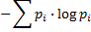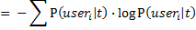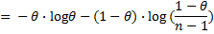
We use a scenario of two users as an example to explain above equation. Assuming Alice and Bob possesses each other’s identity tickets with θ=0.8. Given an identity ticket ‘Alice’, the probability that Alice issues this ticket is 0.8 and the probability that Bob issues this ticket is 0.2. The entropy is then -0.8*log(0.8)-0.2*log(0.2) = 0.2173. The probability for i to issue t is θ if i is the user indicated by ticket t, and the probability is (1-θ)/(n-1) if i is not the user indicated by ticket t.
Figure 1 shows the entropy of the random variable user i given an identity ticket t. The entropy increases with the number of users and a lower θ. It shows that, to protect own privacy, it is more effective for a user to reduce θ rather than to include more users in the system. For example, in a 15-user scenario with θ sets to 0.8, the entropy is ~1.03. If users are doubled (30 users), the same θ setting (θ=0.8) results an increased entropy to ~1.17. But if reducing θ to 0.7, the entropy in the 15-user scenario easily increases to ~1.40. In this case, a 0.1 decreasing in θ results higher uncertainty than doubling users. This comparison is shown in Figure 2.
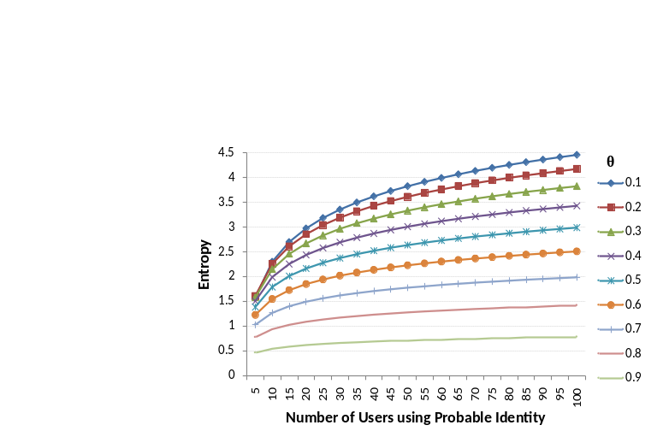
Figure 1. The entropy of user i issuing ticket t.
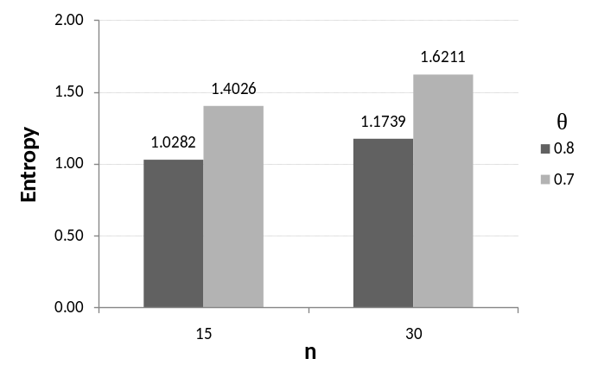
Figure 2. The comparison of 15-user and 30-user scenarios.
To evaluate the increased uncertainty with l-diversity, we adapt entropy l-diversity defined in [MKG06]. For all usage contexts produced by a user with probable identity sets to θ, the entropy l-diversity is defined by the diverseness of prompted identity tickets from one user.
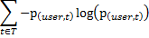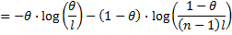
where p_{(user, t)} denotes the fraction of the presented identity tickets by the user with ticket value equals to t. T denotes all possible ticket values. l is the number of different identity tickets that map to a user and n is the total number of users.
Figure 3 shows evaluation results with θ sets to 0.8. Entropy l-diversity increases with n and l in varied rates. We observe that increasing l by 2 results a slightly greater entropy l-diversity than doubling the number of users, n. Therefore, it also indicates that increasing l-diversity is more effective to than including more users.
Both evaluation results show that providing plausible deniability in possession-based probable identity relies on a user’s awareness (θ) and proper software design (l) and less depends on forming a larger user group (n). This eases realization barrier since most of our daily lives consist of multiple social circles (families, coworkers, friends, etc.) with sizes less than tens.
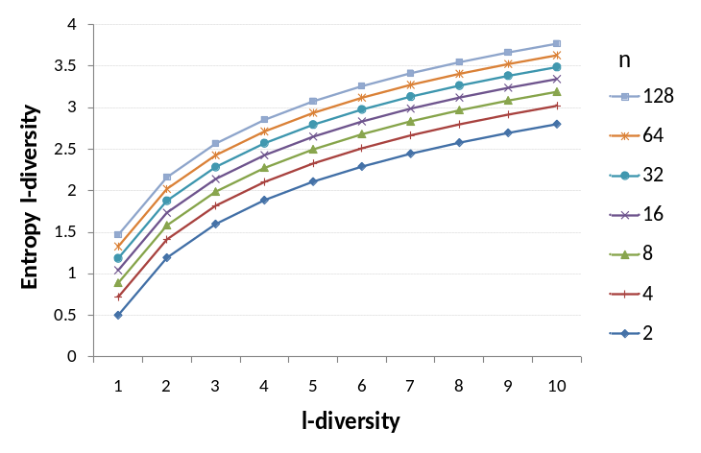
Figure 3. The comparison of entropy l-diversity with 2 to 128 users.

Biometric-based Probable Identity
The biometric authentication mechanisms identify a user based on the physiological or behavioral signatures. For biometric-based identification, we explore a new way of identification by utilizing “imprecise” biometric information that matches up to the non-critical ubiquitous computing applications. Imprecise biometrics, unlike precise biometrics, are less demanding in distinctiveness, the characteristic to distinguish two separate persons [JRP04]. For example, in fitness monitoring applications, the physiological information of weight, blood pressure and heart rate are the most popular information that people would like to record. Such physiological information has high variances and is not suitable for an exact biometric identification. However, we can ask the question what level of accuracy such a system can achieve in mapping the collected data to a user. Since this is a non-critical application, if the accuracy is sufficiently high, we can then loosen the required biometric sensitive inputs from users.
Imprecise biometric is also a natural result in biometric authentication. Among the 15 biometric identifiers listed in [JRP04], 7 of them have medium distinctiveness and 5 of them are low in distinctiveness. For example, the facial recognition has 10% false nonmatch rate and 1% false match rate, and the speaker recognition has 10-20% false nonmatch rate and 2-5% false match rate.
Such systems will certainly be less accurate among users that have close biometrics (such as twins). We can however diminish the issue through the fusion of multiple imprecise biometrics. For example, a naive Bayes classifier combines multiple sensor observations for the purpose of inferring the identity of a subject. The naïve Bayes classifier assumes that each observation is independent of every other observation, and in practice it often competes well against more sophisticated classifiers. By applying Bayes’ Theorem and independence assumptions, the probabilistic classifier is described as,
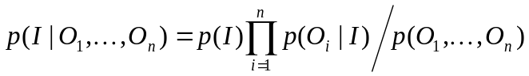,
where the class variable I is the identity of users and O is the set of sensor observations.

Privacy Protection in Biometric-based Probable Identity
For biometric-based probable identity, because the biometric information used for identification is imprecise, the resulted identity is uncertain. This is the step one in the process that affects entire system, thus the imprecise biometrics is naturally a probable identity that provides plausible deniability. The challenge is then the inherent instability. Because of the diverse physicality in the real world that we face, the guaranteeing a probable identity of θ is difficult. A newly joined user can potentially completely change another user’s θ (probability of ownership on data items) if their biometrics are close. This certainly causes confusion to users.

Exploiting Imprecise Biometrics
We have designed and deployed a fitness monitoring system for the healthy individuals in our lab based on this idea. The system uses collected imprecise physiological information (weight, blood pressure and heart rate) to identify a user. The system consists of a weight scale (A&D Medical UC-321PL) and a blood pressure monitor (A&D Medical UA-767PC). Both devices communicate with a laptop via their RS-232C ports. A data collection program written in C++ runs on the laptop to continuously record and timestamp the weight and blood pressure readings.
We have deployed this system in our lab since mid Feb, and the data points used for this article are from Feb. 14, 2008 to Mar. 28, 2008. A total
of 355 data sets were collected including 185 weight data points and 170 blood pressure / heart rate data points. The total measurement count is 222 times (most participants took measurements on both devices, but sometimes only one device was used). Users are free to take weight and/or blood pressure measurements (heartbeat rate comes with blood pressure measurement) at any time. Therefore, the user usage is in a totally casual fashion in order to be as realistic as possible. To establish ground truths, we require users to input their name before using the devices. A total of 9 users have participated, and 6 of them regularly work in lab.
Table 1 illustrates the challenge of identifying a user based on imprecise physiological information and their usage contexts. With just 9 people, we can easily find 3 groups that have very close weights. Additionally, the blood pressure and heart rate vary considerably depending on the circumstance of the user when taking the measurement.
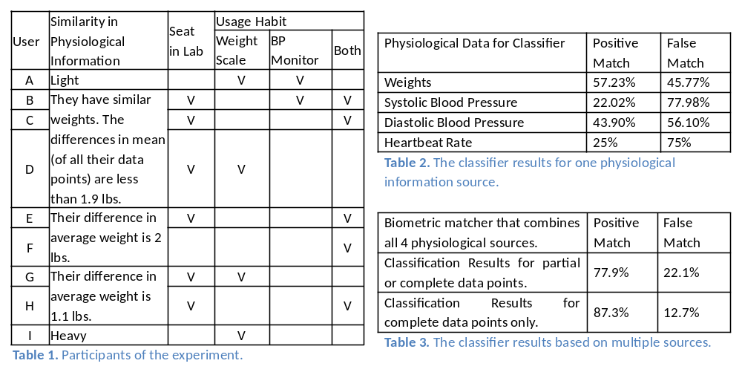
We establish Gaussian models for weight, blood pressure, and heart rate in a Bayes classifier. The mean then is updated through an exponential moving average. Table 2 shows the classifier results using only one physiological information source. Combining the four sources of information (weight, systolic and diastolic blood pressure, and heart rate) significantly enhances the accuracy in identifying a user. The biometric matcher using the naïve Bayes classifier to combine all 4 sources of physiological information improves the identification accuracy to ~78%. If the user classification is only based on complete measurements (a total of 134 measurements that have all 4 data points), the accuracy of the classifier improves to 87.3%. This result is shown in Table 3.
The physiological information we used here performs far worse than commonly used biometric identifiers. Yet with data fusion, we achieve a positive match rate of 87%. We thus estimate that systems like this can identify 8 to 15 people. This is sufficient for family usages and workplace usages.
The proposed design can also be integrated with other interfaces. People with less privacy concerns can use high-accuracy biometrics to perform identification. Extreme privacy concerned or carefree users can employ the system as a guest to perform anonymous access. Others may choose the solution proposed in this work. This satisfies users with the ability to choose the interaction they are comfortable with.

Access Control in Probable Identity
Access control is to determine who has what rights to use what resources. In this section, we use subjects to refer the human users that can perform operations in the system and objects to represents the resources (equipments, appliances, etc.) which need access control.

Identification and Delayed Authentication
Current security mechanisms tightly couple the identification and authentication steps. The authentication immediately takes place after the identification step. In probable identity, a clear separation between identification and authentication is required. In the identification phase, services are provided to a user based on the presented identity. The authentication is delayed until it is necessary. Otherwise, it demeans the purpose of injecting uncertainty into an identity.

Authorization
Authorization determines what a subject can do on an object. In discretionary access control (DAC), the identity of a subject determines its access rights and permissions. In mandatory access control (MAC), the identity determines a subject’s level of trust and the access to an object requires an equal or higher sensitivity level.
In probable identity, there are two kinds of identities for each subject: the probable identity and the proved identity. The probable identity is the identity that presented to a system in the identification phase. The proved identity is the true identity of a subject after the authentication phase. We use a mixture of DAC and MAC to support the access control in probable identity. The two kinds of identities, probable identity and proved identity, represent two sensitive levels, non-critical and critical, respectively. Therefore, an application is divided into non-critical operations and critical operations. A system then uses both DAC and MAC to grant access to a subject.

Accountability
Accountability is on the exact opposite side to plausible deniability. A user performs non-critical operations based on probable identity without authentication. With probable identities of users, we certainly cannot hold people accountable to their actions. However, critical operations are only authorized to proved identities. This provides accountability for a partial system. Similar approaches are prevalent. The UNIX ‘su’ command is used for granting user access to a different account. The parental control included in digital television services allows only authenticated parents to set monitoring and controlling functionalities (critical) while servicing contents (non-critical) to other family members. The accountability is thus only held on those critical operations on proved identities.

Role-based Access Control
The basic concept of RBAC is that users associate themselves with specific roles which in turn are associated with permissions to resources, and users grant access authorization by being members of roles. We borrow the “boundary” described in information spaces [XL02] to explore how different roles are formed in ubiquitous computing environments. The three types of boundaries are (1) physical boundaries; (2) social boundaries; and (3) activity-based boundaries. In physical boundaries, roles are separated through physical locations. For example, students whose seats are in 5F cubicles can access 5F cubicles but not 6F cubicles. In social boundaries, roles are separated through social groups such as ‘professor’ or ‘student’. In activity-based boundaries, roles are separated through activities (or events) the space owners are involved in. For example, all participants in a seminar are allowed to access the speaker’s slides.
Extending RBAC in probable identity is that, for an identity ticket presented to a system, if all possible subjects who possess the identity ticket have the same role then this probable identity is allowed to use that role to access the system. For example, Alice and Bob are both teachers and the role ‘teacher’ allows them to access classroom equipments. When a classroom receives an identity ticket ‘Alice’ trying to access the equipments, it allows the access since that all other users who possess Alice’s identity tickets (in this case, Bob) are all teachers. It thus needs not to know a proved identity for authorizing the access.

Application Usage Scenarios
We use three different scenarios to illustrate the integration of probable identity into ubiquitous computing applications. We start with the previous smart cubicle example that dictates the basic idea, and continue on a mobile tour guide to demonstrate combining probable identity into a more decentralized architecture that separates identity management and service provider. We then use a find friends/instant messaging application to show an integration of anonymous access, proved identity, and probable identity.

Smart Cubicle
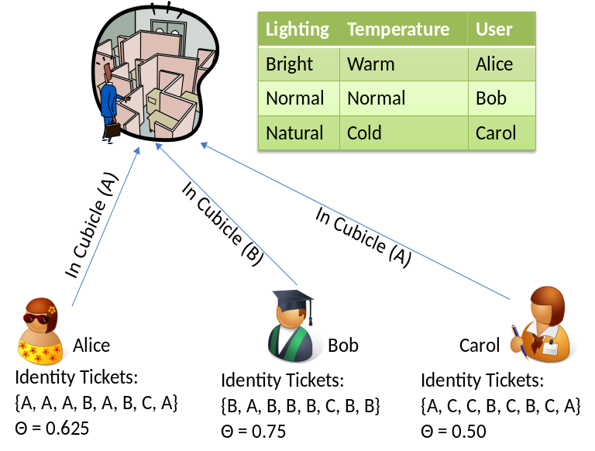
Smart cubicle provides lighting and temperature according to individual preference. It raises privacy concerns because that it records the timestamp of a user being at certain location. Therefore, based on the logs, an observer can learn who came to the rest area at what time. We have shown a sample scenario in the beginning of the article.

Prototyping Smart Room with Probable Identity
Figure 4. The Smart Cubicle application.
The operation used in this application is a function call to the lighting and temperature setting application with a parameter of the identity of the user. The application gives each user the identity tickets according to her/his θ setting and ensures a k-anonymity. When accessing a cubicle, a user issues the ‘in cubicle’ operation with a randomly identity ticket to the application. The server provides services according to the received identity ticket.

Mobile Tour Guide
We now discuss a more complicated architecture in separating identity provider and service provider. A service provider is an application that delegates identity management and authentication to a third party, identity provider. For example, websites with single sign-on authentication are designed in this fashion. The application we choose is a mobile tour guide described in [HL04]. In the scenario created by Hong and Landay, users use resolution control as the privacy management mechanism. In the below scenario, we describe a scenario that uses probable identity as an optional choice in privacy protection.

A Sample Scenario
Alice is visiting Boston these days. She has a GPS-enabled mobile device that is capable to connect to the internet. Since this is her first time in the city, Alice would like to have a mobile tour guide service. She searches online and finds this service provider, Bob, is a certificated guide that provides mobile tourist information in many major cities. Alice decides to enroll into Bob’s services and has set her interests in arts, architecture and building.
Alice assigns the exposed location resolution in a neighborhood level. She enables the probable identity for two reasons: first, she knows several friends who live in Boston and she would like to avoid peer pressures of contacting them. Alice wants to be able to tell white lies when being asked about the trip; the second reason is that she does not want to be entirely tied to the genre she specified. Occasionally, receiving tourist information based on others’ preferences are fun and surprising.
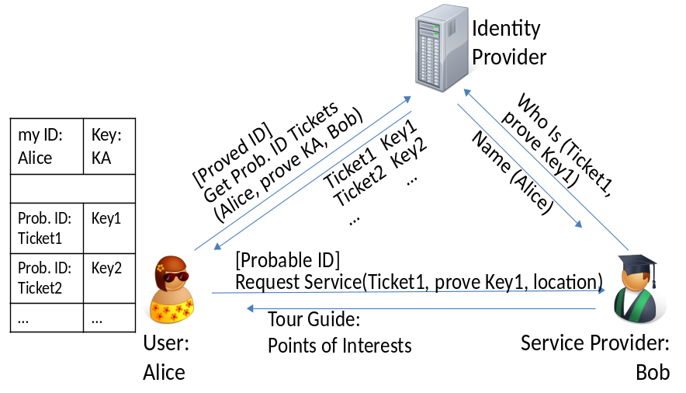
Figure 5. The Mobile Tour Guide application.

Prototyping with Probable Identity
In the mobile tour guide, the ‘get prob. ID tickets’ operation is used to retrieve identity tickets from an identity provider. Each identity ticket is associated with a credential. A user requests tourist information by sending the current location to a service provider using ‘request service’ operation. The user employs probable identity by randomly picking an identity ticket as the prompted identity to the service provider. The service provider calls ‘who is’ operation to ask the identity provider the identity represented by that ticket. With the proved credential, the server returns the identity associated to the ticket (this may be or may not be the user). The service provider then returns the points of interests based on the identity returned by identity provider.

ActiveCampus Explorer
ActiveCampus [GSB04] is a project from University of California, San Diego developed for experiments in community-oriented ubiquitous computing. Each user is given a wireless mobile device, a PDA, as the communication and localization platform. ActiveCampus Explorer application allows campus users to share location information with one another. Its main functionalities include finding friends, instant messaging, and graffiti annotating. We discuss how to design finding friends and instant messaging using probable identity.

A Sample Scenario
Alice strolls in the campus with her device showing vicinity maps. She sees a message pops on the screen with the title “Seminar: Human…” Through clicking the link, she reads the information regarding this seminar and decides to attend. After the talk, Sarah searches for her friends to have lunch together. She sees Bob is in food court and then sends him a message “lunch together?” After having an acknowledgement, she follows the map to find Bob. While she is walking in the campus, she sees a graffiti that says “Roma has the best croissants on the campus!” She then decides to stop for a croissant on the way to food court. (The scenario is similar to the one used in [GSB04].)

Prototyping Finding Friends with Probable Identity
Finding friends application is to share location information among a user and her/his buddies. We dissect the application into four operations: ‘add/delete buddy’, ’get buddy list’, ‘request contexts’, and ‘push contexts’. A user uses ‘add/delete buddy’ operation to establish personal buddy lists which stores on a server. The ‘get buddy list’ operation is the operation used for retrieving this buddy list from the server. A user uses ‘push contexts’ to update own contexts periodically and ‘request contexts’ to receive current locations of the buddies. Figure 6 shows required identification and authentication for these operations. To support these operations, the ‘prove’ is the process where both entities prove to each other the knowledge of a credential. This indicates a challenge-response protocol or a zero knowledge password protocol (such as DH-EKE).
The ‘add/delete buddy’ and ‘get buddy list’ both involve private data access, therefore they need a proved identity. To continue executing, a subject proves its knowledge to the ‘Key’ which is a credential associated with the true identity.
In ‘request contexts’ operation, the usual way is to use a proved identity to get information legally. However, the point is to prove that a user own authorization to retrieve a buddy’s contexts rather than to prove who the user is. As shown in Figure 6, each buddy id in the returned buddy list is accompanied with a credential. In ‘request contexts’, instead of proving the identity, a user gets a buddy’s contexts by proving the knowledge to the accompanied credential. The server needs not to know a user’s identity but acknowledges its possession of the key is sufficient to grant data access. The ‘request contexts’ can thus be implemented anonymously. The ‘push contexts’ operation uses probable identity to pick an identity ticket and associate it to the current context before sending to the server. Also, to prove this is a legal identity ticket, it proves its knowledge to the credentials that associated with identity tickets.
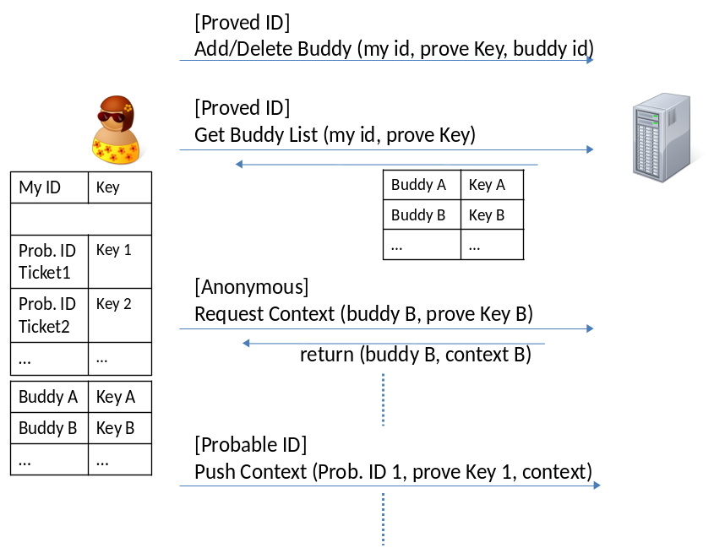
Figure 6. The Finding Friends application.

Prototyping Instant Messaging with Probable Identity
The two basic operations of instant messaging are ‘send message’ and ‘receive message’. For example, Alice sends a message to Bob when sees his online status through finding friends. On Bob side, once he receives the notifier, he uses receive message to receive this message. He then can send back messages or ignore the incoming message.
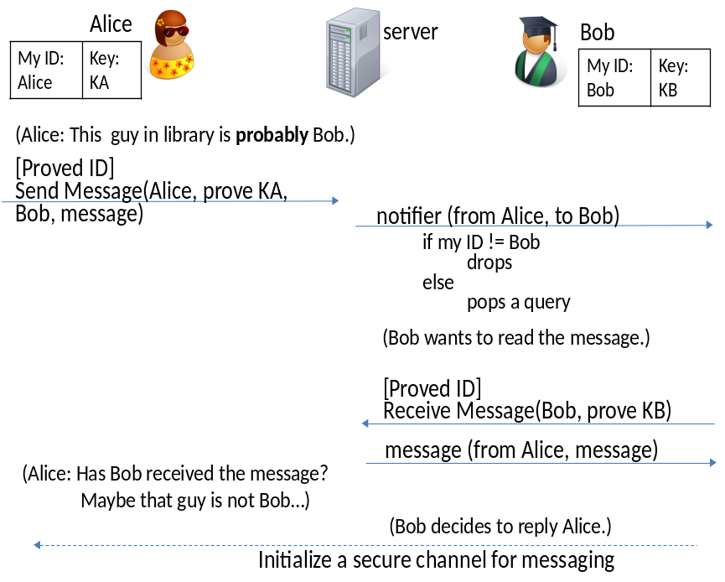
Figure 7. The Instant Messaging application.
The ‘send message’ delivers a message from an entity to another entity. To hold accountability for message contents, the sender must be authenticated (proved identity) before s/he can send any message to anyone. However, because of probable identity there are many possible receivers that have possessed the identity ticket of the intended receiver. Since the server cannot be certain of the true identity of these users, it sends notifiers to query each of these receivers to locate the intended receiver. The receiver has to be authenticated before accepting the message. Once both entities have been authenticated, they can communicate freely in a secure channel.

Conclusion
Because the identification is the first step in any system, changing to probable identity does change numerous technical aspects. For example, we shall remove unique identifiers on the link layer and establish a temporary identifier for each session. In application design, developers have to understand that a user may not be “the” user. Therefore, a system provides services without leaking personal information. On social impacts, a user sometimes will be identified as other users and vice versa. Although under probable identity framework no one knows whose identity s/he is current prompting but that does not equal to the rejection of simply knowing own identity will be used by someone. One way to moderate these impacts is to use a high θ such that these errors occur rarely. However, the impacts of adapting probable identity need further studies.
We believe that the probable identity makes senses in complying with Mark Weiser’s vision of ubiquitous computing. In the eventual goal, when technologies weaved into our daily life, we will consider most applications as non-critical that can tolerate uncertainty. Probable identity is a conceptually simple yet powerful control mechanism that serves as a right balance between usability and privacy and compensates existing privacy protection methods.
#

[W91] M. Weiser, “The Computer for the 21st Century,” Scientific Am., Sept., 1991, pp. 94-104; reprinted in IEEE Pervasive Computing, Jan.-Mar. 2002, pp. 19-25.
[W67] A. Westin, Privacy and Freedom, Atheneum Press, 1967.
[PA05] B. A. Price, K. Adam, and B. Nuseibeh. “Keeping ubiquitous computing to yourself: A practical model for user control of privacy,” International Journal of Human-Computer Studies, 63(1-2):228-253, July 2005.
[L02] M. Langheinrich, “A Privacy Awareness System for Ubiquitous Computing Environments”, Ubicomp, Lecture Notes in Computer Science, volume 2498, pp. 237-245, Springer, 2002.
[AG05] A. Acquisti and J. Grossklags, "Privacy and Rationality in Decision Making," IEEE Security & Privacy, vol. 3, no. 1, pp. 26-33, 2005.
[H05] Jason I-An Hong, An Architecture for Privacy-Sensitive Ubiquitous Computing, Ph.D. Dissertation, Computer Science, University Of California, Berkeley, 2005.
[BZ07] S.A. Bagüés, A. Zeidler, C.F. Valdivielso, I.R. Matias, "Disappearing For A While – Using White Lies in Pervasive Computing", Proceedings of the 2007 ACM workshop on Privacy in electronic society, 2007.
[BS03] A. R. Beresford , F. Stajano, Location Privacy in Pervasive Computing, IEEE Pervasive Computing, v.2 n.1, p.46-55, January 2003.
[PGG07] J. Pang, B. Greenstein, R. Gummadi, S. Seshan, and D. Wetherall, "802.11 User Fingerprinting," Mobicom '07: 13th Annual International Conference on Mobile Computing and Networking, 2007.
[IBM70] “The Consideration of Data Security in a Computer Environment”, tech. report G520-2169, IBM, 1970.
[S02] L. Sweeney. “k-Anonymity: a model for protecting privacy.” International Journal of Uncertainty, Fuzziness and Knowledge-Based Systems, 10 (7), 2002.
[MKG06] A. Machanavajjhala, D. Kifer, J. Gehrke, and M. Venkitasubramaniam. “l-Diversity: Privacy beyond k-Anonymity.” In Proceedings of the 22nd International Conference on Data Engineering, 2006.
[JRP04] A.K. Jain, A. Ross and S. Prabhakar, An introduction to biometric recognition, IEEE Trans. Circuits Systems Video Technol. 14 (2004) (1), pp. 4–20
[XL02] X. Jiang, J.A. Landay, “Modeling privacy control in context-aware systems”, Pervasive Computing, IEEE, Volume 1, Issue 3, July-Sept. 2002, pp. 59-63
[GSB04] W.G. Griswold, P. Shanahan, S.W. Brown, R.T. Boyer, "ActiveCampus: Experiments in Community-Oriented Ubiquitous Computing." IEEE Computer 37(10), p73-80, 2004
[HL04] JI Hong, JA Landay, "An architecture for privacy-sensitive ubiquitous computing", Proceedings of the 2nd international conference on Mobile systems, applications, and services, 2004.

