Probable Identity
Ver. 1.3 - 20080605

David Jea, Roy Shea, Mani Srivastava
UCLA Electrical Engineering Department¹
UCLA Computer Science Department²
{…, …, …}@ucla.edu

ABSTRACT
This paper proposes probable identity for non-critical ubiquitous computing applications. It removes the uniqueness in user identification by associating a probability with an identity. The system then serves a user based on the most probable identity rather than a determined identity. The probable identity model enables two characteristics in preserving privacy: intentional ambiguity and plausible deniability. Thus this mechanism lessens users’ anxieties in privacy and provides a balance between usability and privacy. We propose two designs that support probable identity in possession-based identification and biometric-based identification respectively. We evaluate its applicability by systematically analyze characteristics of applications. We conclude that the probable identity is applicable for nearly 30% ubiquitous computing applications and 44% location-based services. We believe that probable identity is one of the answers to tough privacy issues in this field.

INTRODUCTION
Concerns of privacy have existed since day one in pervasive computing. Mark Weiser described privacy as key among the social issues that embodied virtuality will engender [W91]. Significant efforts have been undertaken but balancing usability, security and privacy is never an easy task in ubiquitous computing environments. Researchers use terms such as “paradoxical”, “contradiction”, “hardly be achievable” to state privacy protection in ubiquitous computing. This paper proposes a probable identity concept to serve as a controllable balance between usability and privacy for non-critical ubiquitous computing applications. We drop the uniqueness in a user identity and allow a probable identity in the system. Instead of saying this data/context belongs to the user Alice, the systems says that the owner of this data/context has θ chances to be the user Alice. We call this uncertainty in identity the probable identity. (emphasis on that this is only a appendix to current privacy management, we still need all privacy management but this can captures several issues that currently has no effective countermeasures.) (throughout the paper, a user implies a user and a user agent.)

Example Scenarios
We first illustrate the idea of probable identity with an imaginary location-based service. The goal of this pseudo example is to track which rooms a user is using and has used. The service provided is automatic personalized lighting and temperature adjustment when a user enters into a room. However, instead of continuously tracking locations of every user, it guesses the most probable user during each entrance. The system does not know the exact true identity, but has a good confidence in whom the user is. When Alice walks into a meeting room, and with the probable identity, the system can choose her customized setup correctly “most” times. In those few occasions where this system picks someone else’s setup, Alice can manually fix the lighting and temperature in the room. Also, Alice only knows that if the system goes wrong and misses her expectation, but she does not know whose setting has been chosen by the system for her.
In another service that this system provides, Alice wants to retrieve the usage information of the rooms that she has visited more frequently in the past month. The system lists a number of rooms and notes how many times she has used them. With probable identity used in the system, there are errors associated with these returned answers. However, Alice probably will not be bothered if she has in fact used a room 9 times rather than 10 times. And even if she does count her total usages of one specific room; she still does not know who contributes to these additional usages, thus others’ privacy is also preserved. One thing Alice does know is that no one can exactly pinpoint her whereabouts with this kind of identification.

Paradigm Shift
Pervasive computing nowadays does “Oh! This is Alice. Let's do something for her.” However, the security requirements vary according to the context of application spaces. Some require greater security protection (like homeland security alerts), while other non-critical situations may not need a very high level of security. We propose a paradigm shift for these non-critical applications and allow a system to say “Hmmm… This is probably Alice. Let's do something.” This way leads us to a simpler solution for the complex privacy issues in ubiquitous computing.
In this paper, we first justify the necessity of probable identity. In Section 2, we present its principle, characteristics and model. In Section 3, we develop a privacy threat model that the probable identity counters. And we propose two proper designs that support probable identity in possession-based identification and biometric-based identification. We evaluate this work by showing its applicability in ubiquitous computing applications and location-based services. We believe that current solutions compromise among either sacrificing privacy for the usability or vice versa. We propose to leverage the third dimension: probable identity.

PRIVACY in UBIQUITOUS COMPUTING

Definition and Contradiction
A precise definition of privacy is difficult, if not impossible. In this work, we adapt the most common one in current use by Alan Westin [W67]: “Privacy is the claim of individuals, groups and institutions to determine for themselves, when, how and to what extent information about them is communicated to others.” On the other end, the basic building blocks of ubiquitous computing are context information. The more context information acquired from a user, the more powerful is a system and the higher usability is to a user.
The problem is, when applying above definition of privacy in ubiquitous computing, the amount of “information about them” has grown to a level that individuals simply cannot afford to “determine for themselves” for every single bit of information. For example, a cellular phone that reports the location of a user every 10 seconds constitutes 8640 contexts per day. To determine daily how each of these contexts communicates to others is way beyond the willingness of any human being. The “perfect” privacy protection is thus logically fundamentally incompatible with “perfect” ubiquitous computing.
Not surprisingly, the feasible solution is to automate and reduce the amount of information that a user needs to manage. Privacy policy, as an instance, allows a user to set specific rules that automates this process. Resolution reduction is another popular method that reduces the amount of information. Besides these, the anonymity achieves privacy by breaking the connection between “information” and “about them” such that the information no longer belongs to a specific individual and consequently removes the needs of determination. But the important facts are that we human and our surroundings change; the people we met and our interactions to them are different; the situations we face are never the same; and these make privacy protection a dynamically complicated organism that requires “prevision” to keep it intact.
Also, while designing a system that incorporates these single-aspects solutions is doable though difficult, the ubiquitous computing is not just for technologically savvy researchers but regular people. This means that people of all age groups and education levels have to know how to use such a system. And the wide and delicate control mechanisms in privacy protection scare them away. We thus agree with Johann Čas [C05] that a convincing concept that could guarantee acceptable levels of personal privacy is still missing in pervasive computing.

Insufficiencies in Privacy Management
Bhaskar and Ahamed performed a broad study on the privacy protection in ubiquitous computing [BA97]. Price et al. [PA05] distinguished privacy protection into two groups: policy matching and noise. They further divided noise into five types: anonimizing, hashing, cloaking, blurring and lying. These mechanisms serve as the fundamentals for privacy management in today’s ubiquitous systems. Without diving into the details of these mechanisms, we take a divergent route of discussing their insufficiencies in privacy protection. We expect the discussion further justifies the necessity of the proposed probable identity in completing privacy protection.

Policy Matching
Policy matching allows users to define privacy policies over objects, data, and contextual information. They protect privacy by empowering people with the ability to “control”. In pawS [L02], Langheinrich uses a privacy beacon to announce the privacy policies of each service in the environment. These policies then match to the user’s predefined privacy preferences. This creates a sense of accountability. However, any realistic definition of privacy cannot be static [BS93]. The drawback of policy matching is the caused huge burdens on learning/using the tool and continuously adjusting the policies. Also, in the light of previous experiences [AG05], even in “high” privacy concern group who are technologically savvy and educated, 41% rarely read privacy policies. Given the scale of ubiquitous computing environments, even with a perfect policy design, we hardly believe that users will change their behavior on start using it.

Anonymizing and Cloaking
Anonymizing is to remove the identity of a user and cloaking is to have the system make a user invisible. A system cannot provide personalized services to anonymous users that have no identity information. The cloaking only protects a user’s privacy against other users but the system still knows a user’s contexts. It is also vulnerable in the privacy threats model we described.

Hashing
Hashing is pseudonyms. The challenge is that, when incorporating personal preferences, it is difficult to prevent an application from mapping pseudonyms to users. Nonetheless, the fundamental problem is the deductive reasoning attacks within one pseudonym. If we somehow know the true identity of a pseudonym, then we can link all pseudonym-associated contexts to that identity. For example, if we observe that Bob has pseudonym a34, and we also know that a34 is associated to following spatial and temporal tuples {LOC_{A}, T_{A}}, {LOC_{B}, T_{B}} and {LOC_{C}, T_{C}}, then we can conclude that Bob was in these places at those time points. Pang et al. [PGG07] demonstrate such a privacy attack by linking the requests of the network SSID ‘University of Washionton’ and ‘djw’ to Prof. David J. Wetherall in University of Washington. And they further locate his home through Wigle (an online database of 802.11 networks observed around the world). Even if we change a pseudonym in every access, the architecture still requires an anonymizing proxy to map the pseudonym to personal preferences (otherwise, it becomes an anonymous access). At least one entity knows the true identity of pseudonyms is the born limitation of hashing.

Mix Zone
In [BS03], Beresford and Stajano show that they can de-anonymize all users by following the “footsteps” of each pseudonym. To ensure unlinkability, they propose a countermeasure of changing pseudonyms frequently. However, if the temporal and spatial resolution are high enough, the observer can easily link the old and new pseudonym (inference attacks). To address the issue, they extends the mix network and mix nodes that offer anonymous communication and introduce the concept of mix zone. In a mix zone, applications cannot distinguish users in the zone and cannot link people going into the mix zone with those coming out of it. They use pseudonym in a sense to provide a return address rather than establish and preserve reputation. The types of applications they focus on are those cannot be accessed anonymously but do not require the user’s true identity either.

Blurring
Blurring is to reduce data resolution. However, changing in context resolution still may cause information accidently leaked [H05]. For example, a friend may get suspicious if s/he is expecting a street-level resolution while sees a city-level information.

Lying
Lying is to intentionally provide false information. For example, Alice is preparing a surprise party for her husband and thus publishes her location as in the office rather than true location. The art of lying is that a good lie depends on a liar’s awareness of situations [BZ07]. Also, most time it protects privacy in future but not in past. More importantly, it wastes resources in ubiquitous computing [BS03]. Imagine the example scenario described in section 1.1, if Alice lied about her whereabouts, the system will provide services (lighting and air conditioning) to the wrong room and that generates undesired energy wastes.

Plausible Deniability to Complete
In The Art of War, the enormously influential ancient Chinese military treatise, Sun Tzu said that a good fighter is able to secure himself against the defeat, but cannot make certain of defeating the enemy. Plausible deniability empowers such a defensive mechanism in privacy protection. When a user is implicitly maintaining or appears having an association to some contexts, plausible deniability is the ability that allows the user to deny the existence of such association when necessary and others either believe or accept. Put it into cell phones, the plausible deniability is that a user can choose to ignore an incoming call by claiming that the battery was dead or there was no ringing. Put it into ubiquitous computing, the plausible deniability is that a user can deny any “information about them” and tell white lies freely. The bottom line is that plausible deniability does provide effective defenses for a user in compensating active privacy protection.
Previous control-based privacy management methods are ammunition for users to actively protect their privacy. In general, they cover a broader aspect of contexts due to the huge amount of context information generated in ubiquitous computing. The probable identity is like the defensive missile for each single point of context information. It allows a user to disassociate any one of contexts by injecting uncertainty into identity. Together they form a complete circle in privacy protection.
Researchers have highlighted the importance of having plausible deniability in a ubiquitous system for privacy management. They propose solutions of returning unknown in default, reducing resolution or falsifying data in a predefined fashion. These solutions only solve partial of the issues. Predefined conditions require users to know-in-advances which is hardly always possible. Injecting noises or changing in context resolution still may cause information accidently leaked. We therefore refer an ideal design for plausible deniability in ubiquitous computing to Hong’s words [H05], “By default, plausible deniability is maintained without the end-user having to take any special action and without the end-user having to configure anything.”

Probable Identity

Probable Identity for Plausible Deniability
Plain identification links one identity to each piece of context information in ubiquitous computing. On the contrary, anonymity totally removes identities and leaves only information. This binary process either creates a definite relationship or no relationship. In probable identity, a user uses θ to describe an indefinite relationship to an object or a context. The θ is the probability of an ownership that falls between 0 to 1 where (θ = 1) is the plain identity and (θ = 0) is the anonymity. Systems enabling probable identity empower users to control the privacy through one control knob, θ. This allows an adjustable link (θ) for a user to receive services through the linked context. It also injects doubtful space (1-θ) in a linked context to support plausible deniability for a user.
Probable identity with the controllable θ is a simple concept yet powerful mechanism. The simplicity comes from that people have already familiar with this concept. It is not uncommon that we heard conversations similar to: “Hi, Alice. Were you in the supermarket this morning? I saw someone who looks like you.“ And the power comes from that people know how to response such questions towards their favor. With probable identity, Alice can answer: “No, that was not me.”
The probable identity allows a trade-off between quality of service and plausible deniability. People who want to control their privacy in details can set θ=1 and use systems as the way they originally were. People who control privacy occasionally can set θ to a value that is close to 1 such that they can receive high qualities of services but is also deniable to the jitters in privacy. By default, the θ is set to an intermediate value (such as 0.8). This automatically guarantees plausible deniability, with accompanied reduced qualities of services, to those who love the benefits of ubiquitous computing but are frightened by technologies.

The Characteristics
The probable identity enables two important characteristics in preserving privacy: (1) intentional ambiguity, the ability to blur identity by changing in representational accuracy of a user; a user uses a control knob, θ, to change the desired representational accuracy of the identity. (2) plausible deniability, the ability to lie to a query about the user’s identity. With the native incorporated uncertainty in identity, a user can deny a context without doing anything specifically. For example, setting θ to 0.8 means that, for each access Alice presents to other entities, she has 80% chances to be Alice and 20% chances to be someone else.

Access Control
Access control is to determine who has what rights to use what resources. In this section, we use subjects to refer the entities that can perform operations in the system and objects to represents the resources which need access control. Since we focus on ubiquitous computing, we use the subjects as the human users and the objects as various devices (equipments, appliances, etc.) in our surroundings.

Identification and Delayed Authentication
The common first step of any ubiquitous computing system is identification, the process of linking an entity with an identity. To authenticate the identity of a user, the system requires a proof from him/her. This can be what you know (knowledge-based: such as a password), what you have (possession-based: such as an ID card) or what you are (biometric: such as fingerprints) [IBM70]. There are also context-based authentication methods where the system uses the context information (such as location) to grant user accesses [BKM03].
Current security mechanisms tightly couple these two steps. The authentication immediately takes place after the identification step. In probable identity, a clear separation between identification and authentication is required. In the identification phase, only services are provided to a user based on the presented identity. The authentication is delayed until it is necessary. Otherwise, it demeans the purpose of injecting uncertainty into an identity. This is also similar to cellular phone example. A user makes the decision of whether answering the incoming call when hears the phone ringing. But once he picks up the call, both entities of this connection expect an authenticated identity at the other end.
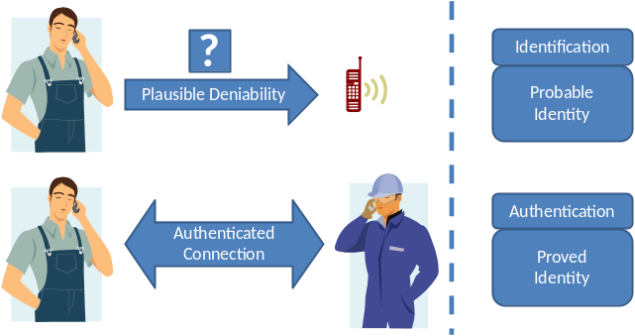

Authorization
Authorization determines what a subject can do on an object. For example, a classic operating system defines three basic actions of access: Read, Write and Execute. In discretionary access control (DAC), the identity of a subject determines its access rights and permissions. In mandatory access control (MAC), the identity determines a subject’s level of trust and the access to an object requires an equal or higher sensitivity level. In role-based access control (RABC), the identity determines its role which then determines a set of permissions that are authorized.
In probable identity, there are two kinds of identities for each subject: the probable identity and the proved identity. The probable identity is the identity that presented to the system in the identification phase. The proved identity is the true identity of a subject after the authentication phase. The system thus distinguishes between the probable identity and proved identity in authorizing the access to objects.

Accountability
Accountability is on the exact opposite side to plausible deniability. With probable identities of users, we certainly cannot hold people accountable to their actions. Therefore, an application is divided into non-critical operations and critical operations. A user performs non-critical operations based on the probable identity without authentication. However, critical operations are authorized by access control to proved identities. This provides accountability for partial systems. Similar approaches are prevalent. The UNIX ‘su’ (substitute user or switch user) command is commonly used for granting user access to an account. The parental control included in digital television services allows authenticated parents to set monitoring and controlling functionalities (critical) while servicing contents (non-critical) to other family members. The accountability is thus only held on those critical operations on proved identities.

A Mixture of DAC and MAC
We use a mixture of DAC and MAC to support the access control in probable identity. The two kinds of identities, probable identity and proved identity, represent two sensitive levels, low and high, respectively. The access control to an object is the privileged operations that a subject has and the required sensitive level of subjects.
In the example below, Table X describes access control to a coffee machine in Alice’s configuration. All subjects can execute this configuration based on the probable identity determined in the identification phase without authentication. However, a proved identity of Alice or Bob is required to read the details of this configuration. Only an authenticated Alice can modify this configuration. The mixture of DAC and MAC allows a flexible setup in application designs.
Operations | Access Control List | Sensitivity Level
Read | Alice, Bob | Proved Identity (High)
Write | Alice | Proved Identity (High)
Execute | All Subjects | Probable Identity (Low)
Table X. An access control example of a coffee machine configuration.

Role-based Access Control for Probable Identity
The basic concept of RBAC is that users associate themselves with specific roles, which in turn are associated with permissions to resources, and users grant access authorization by being members of roles. The RBAC is also desired in ubiquitous computing environments. Moyer and Ahamad propose a Generalized Role-Based Access Control (GRBAC) in [MA01] that extends the role concept to subject, object, and environment. The expressiveness of GRBAC allows context information to be included in an access decision. Zhang and Parashar [ZP04] describe a Dynamic Role Based Access Control model (DRBAC) that improves security by using context information to dynamically make access control decisions. Other extensions include temporal [BBF01] and spatial [HO03] information in access control.
We borrow the “boundary” described in information spaces [XL02] to explore how different roles are formed in ubiquitous computing environments. The three types of boundaries are (1) physical boundaries; (2) social boundaries; and (3) activity-based boundaries. In physical boundaries, roles are separated through physical locations. For example, students who have seats in 5F cubicle area can access 5F cubicle area but not 6F cubicle. In social boundaries, roles are separated through social groups such as ‘professor’ or ‘student’. In activity-based boundaries, roles are separated through activities (or events) the space owners are involved in. For example, all participants in a seminar are allowed to access the speaker’s slides.
The key of extending RBAC in probable identity is that, for a probable identity presented to a system, if all possible subjects who can use this identity have the same role then this probable identity is allowed to use that role to access the system. For example, Alice and Bob are both teachers and the role ‘teacher’ allows them to access classroom equipments. When a classroom sees a probable identity ‘Alice’ trying to access the equipments, it allows the access since that other users who could be ‘Alice’ (in this case, Bob) are all teachers. It thus needs not to know a proved identity for authorizing the access.

PROBABLE IDENTITY

The Principle
We refer the principle of probable identity to information spaces [XL02]. Jiang uses the lattice to model a principal‘s identity. The accuracy of principal p’s identity is defined as:
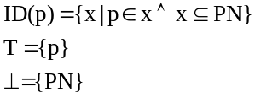
The singleton set {p} is p’s precise identification. Complete anonymity is the empty set {}. In [XL02], the set PN is a set of pseudonyms; in here, it is a set of probable identity (with different θs). T denotes the most accurate element, and ⊥ denotes the least accurate element in representational accuracy of an object. See details in [XL02].

The Model

Information Spaces
We extend the information spaces in the Approximate Information Flow (AIF) privacy model developed by Jiang, Hong and Landay in [JHL02] to embody the probable identity. The AIF model supplies three sets of abstractions: (1) information spaces (from a storage perspective); (2) the lifecycle of personal data (collection, access, and second use; from a dataflow perspective); (3) and themes for minimizing asymmetry (prevention, avoidance, and detection; from an end-user perspective). We extend the information spaces which are the core components in AIF, leaving the second and third abstraction as it is.
Information spaces [JHL02] are repository of personal data owned by data owners, data collectors, or data users. It defines properties, boundaries (described in section 3.3.5), and operations of data contained in an information space.
The three privacy-sensitive data properties are:
- Persistence of data: the lifetime of data and its degradation over time.
- Observational accuracy of data: the features a data item contains about its owner. This refers to the resolution of collected information.
- Observational confidence of data: the uncertainty of data items. There are no perfect sensors, and this refers to the reliability of collected information.
The five types of data operations are:
- Addition/Deletion/Update
- Authorization/Revocation: the ownership transfer and privacy policies of data.
- Promotion/Demotion: the lifetime, accuracy, and confidence of data.
- Composition/Decomposition: combining data from different sources or splitting data into pieces.
- Fusion/Inference: infer high-level context information from data.

Extension
The extended information spaces for probable identity includes an additional “Ownership probability of data” in data properties and a “Copy” operation in data operations. We explain the details below:
- Ownership probability of data: the likelihood of its owner is the true data owner given a data item. For probability equals to 1, it is the original information spaces where the ownership of a data item is uniquely associated to the space owner. For probability equals to 0 is the anonymous access that indicates a de-identified information. The probability in between 0 and 1 is the probable identity. Note that the degree of plausible deniability is reversed proportional to this property.
We use an example to explain the differences among these data properties. Alice wants to use a location-base service by providing her location. The observational accuracy allows Alice to set the exposed level to neighborhood (compare to a street level or a city level). The observational confidence captures the fact that her GPS device does not work well when inside a building or in a forest. The probability of ownership is that for each location Alice reports to the system, she uses ‘Alice’ 90% times and use some other names for the rest 10% times. Note that the system also requires other users to possess Alice’s identity which we describe in the next section. This ensures that when a data collector or a data user sees this data item, s/he can only conclude that Alice is “probably” in this neighborhood at the time even with a perfect GPS reading and most detail resolution in her device.
- Copy: With probable identity, a data item may have multiple owners. The fact that Alice is a more probable owner to an data item than Bob does not make Bob has less rights on the item (since the system can never prove whom the true owner of this item is.) Therefore the original copy has to be saved for other possible owners and destructive operations (such as deletion) work on a copy. The Copy operation is internal and can happen at the time when data is generated or when before destructive operations execute. For read-only operations, a pointer to data is sufficient.

ENABLING TECHNOLOGIES

Privacy Threat Model
We first describe a privacy threat model for ubiquitous computing applications. In this environment, the two major principals are users and trusted service providers. We assume that there exists a powerful super user, Big Brother, who is the boss of all service providers. Similar to the Dolev-Yao threat model, Big Brother is a legitimate user and can obtain any message on the network. However, he is so powerful that he can interpret all messages contents. In special cases, he can even force collaboration from service providers and retrieve all historical logs. The goal of Big Brother is to determine whether certain contexts (such as location and time) belong to a user.

A True Probable Identity
The purpose of probable identity is to protect privacy from Big Brother. In this work, we define the privacy protection as the plausible deniability for a user to deny a given context. We define the true probable identity as that no entity (the user, the service provider and Big Brother) by “itself” can be certain that the presented identity (to service provider) is the true identity of a user.
Although a user uses θ to control the ambiguity in identity, s/he does not know which one of her/his usages carry the true identity; a service provider receives a claimed identity and provides services accordingly. It does not know if the claimed identity is the true identity of the user; since both ends are not 100% certain that the claimed identity is the true identity, the Big Brother cannot link a context to an identity even though he is capable of interpreting all messages contents. The key of the true probable identity is that both users and service providers can say “I honestly do not know if that was my/her/his context” when facing the powerful Big Brother querying.
However, due to the asymmetric power between a user and Big Brother, this protection only lasts to the point until Big Brother forces collaboration from service providers and does not extend beyond. This model largely approaches reality in a sense that Federal law enforcements (Big Brother) may tap phone lines (service providers) if obtain a court order (forced collaboration). (forward privacy)
Note that, unlike Malice in cryptography, Big Brother is interested in watching you rather than attacking you. Within the proposed architecture, if the probable identity has been set, then there are no easy ways for Big Brother to link a certain context to a user.

Architecture
In this work, we do not focus on the protocols but the underlying mechanisms that enable probable identity. We thus use a basic form of client-server architecture to simplify the complex environments in ubiquitous computing. The two principals are users and service providers. A user requests desired services by sending her/his identity and contexts to a service provider. A service provider provides services to a user according to the received identity and contexts. In reality, there are identity servers that manage users’ identities for all service providers. We simplify them as one large server.
Considering the three identification and authentication methods, we discuss possession-based and biometric-based methods that are suitable in ubiquitous computing environments. From systems’ perspective, the possession-based methods obtain an identity passively through carry-on tokens (a token tells a system the identity of a user); the biometric-based methods actively determine an identity though acquired information (a system actively determines whom a user is). Therefore, we distinguish the two mechanisms below.

Possession-based Probable Identity
We define the k-anonymity [S02], l-diversity [MKG06] principles for probable identity in possession-based identification,
- The server issues n identity tickets to a user. Each time a user is requesting a service, s/he picks one of the tickets as the identification.
- The probable identity of θ is that, in the n tickets possessed by a user, there are n∙θ tickets link to the identity of this user and n∙(1-θ) tickets do not.
- The l-diversity is that, within the n∙θ tickets that represent a user’s identity, there are at least l tickets with distinct values.
- The k-anonymity is that, within these l tickets, there are at least k-1 other users possess the same ticket.
Under these guidelines, within probable identity, no entity by itself can directly link identities to specific contexts unless they break above rules. We explain the details below.

k-anonymity
In possession-based mechanisms, the idea is that a user obtains n lottery tickets, based on the probable identity θ, from the server in boot strap steps and stores in her/his carry-on token. These tickets represent the possible identities of a user in which n∙θ tickets represent the true identity of this user and n∙(1-θ) are identities of some other unknown users. Each time when a user wants to access a service, s/he randomly picks one of the possessed tickets for the identification. Since the owner does not know which ticket is mapping to which identity, s/he uses a ticket without knowing the prompted identity to the server. On the other end, the server issues the tickets and knows the exact mapping of a ticket to an identity. However, if more than 1 user possesses the same ticket, the server still does not know that the actual user that plays this identity ticket when seeing an identity ticket. This is the k-anonymity.
To illustrate it, we first assume each user maps to exactly one ticket number. Under this assumption, a user possesses n tickets with n∙θ identical tickets plus n∙(1-θ) other tickets for a probable identity at θ. With k-anonymity, each user’s ticket is issued to k-1 other users. For an eavesdropper that can intercept and interpret any message along the communication path, k-anonymity protects the privacy of a user since that there are k-1 other users can possibly originate the message.

Homogeneity and Background Knowledge Attacks
But the k-anonymity is insufficient in ubiquitous computing for two reasons: (1) homogeneity and (2) background knowledge attacks. The homogeneity implies that if all k users have same contexts, then the eavesdropper concludes the user is under this context. For example, Alice and Bob are coworkers and using 2-anonymity probable identity such that Alice has tickets {A, A, B} and Bob has tickets {B, B, A}. If all messages indicate that Bob is in the office and Alice is in the office, then the eavesdropper does not need to distinguish the originator of a message but conclude that they both are in the office. The impossibility is a kind of background knowledge attacks in ubiquitous computing. Consider the above example and assume that after the work Alice/Bob has gone back to her/his home respectively. Since it is physically impossible for a person to be at two places at a given time, the eavesdropper can apply probabilistic inference attack to determine Alice or Bob’s location by counting the majority of identity tickets appeared in the sets.

l-diversity
Machanavajjhala proposed l-diversity to address these issues [MKG06]. The l-diversity principle requires at least l well-represented values for the sensitive attribute S. In probable identity, this sensitive attribute is the user identity. In a total diverseness, each identity is represented by a set of distinct tickets (pseudonym) that each ticket has a unique number (represented value). This solves the homogeneity and background knowledge attack by ensuring each represented value appears only once. Since only the server knows the entire identities-to-tickets mapping, an eavesdropper thus cannot determine the true user that originates a message.
However, without k-anonymity, the l-diversity itself is insufficient to protect privacy in ubiquitous computing from boot strap attacks. In the beginning, a user has to obtain these identity tickets from a server, and the powerful eavesdropper assumed in this article can intercept, interpret and record these tickets in this boot strap process. Combining with the out-of-the-loop assistances, the eavesdropper can identify a specific user and know who the user is. For example, assuming Alice and Bob each possesses distinct tickets among {1, 2, 3, 4} that represent their identities and a fake ticket {5, 6} to support probable identity. Then a boot strap process that issues tickets {1, 3, 5} to Alice and {2, 4, 6} to Bob allows an eavesdropper to learn which tickets are of one set. Each set belongs to one of users. If Big Brother further observes, through external surveillance systems, that Alice is using ticket {1} in requesting a service, afterwards Big Brother can link the entire set of identity tickets {1, 3, 5} to Alice.

Statistical Inference Attacks
The probable identity still has to obey laws of probability. If the user continuously denies all contexts, people get suspicious. Same things apply to cell phone or instant message system, failing to answer many calls or many messages makes a user become disbelieving. The statistical inference attack is that if 10 consecutive queries result 8 answers indicating Alice is in this neighborhood, then the chances that she is not in this neighborhood is marginal. Such replay attack is hard to distinguish from consecutive queries.
Since that the probable identity only provides plausible deniability for any single context, this attack shall be dealt by privacy management techniques such as blurring or mix zone. The blurring reduces the frequency of picking another identity ticket such that a malicious observer cannot obtain enough information for inference. Combining with mix zone -users only pick new identity tickets when in the zone- confuses both the malicious observer and the server the true identity of users.

User Preferences Inference Attacks
In the section 1.1 example, we describe that Alice can manually fix the lighting and temperature if the setting is wrong due to probable identity. An associated attack is that, if an eavesdropper somehow is able to monitor the current lighting and temperature of the room, s/he then can reverse inference Alice’s true identity through this personal setting. Since this type of attacks comes with the “personalized” services, there is no available countermeasure in probable identity to against such attacks.
However, it is very difficult to be exact certain a user’s identity simply based on “adjustable” preferences information. The inference result may increase the suspicion (θ in probable identity) of being Alice, but the plausible deniability for Alice still remains as long as the θ value stays below an acceptable region. Besides, as described in section 2.2 and 2.3, probable identity is just one piece in privacy protection, other privacy management techniques shall be used together to prevent such attacks.

Biometric-based Probable Identity
Biometric authentication mechanisms [JRP04] utilize physiological or behavioral signatures to identify a user. Since it is based on the fact of “who you are”, there is no need to memorize a password or carry a card. Biometric identification therefore enhances the usability of an interface and is promising for ubiquitous applications. However, this form of identification raises considerable privacy issues. In a survey we conducted, nearly 30% (out of 77 people) of interviewers consider disclosing sensitive information such as fingerprint for non-critical applications like fitness monitoring is not worth it. The results reflect one of the public concerns described in the privacy and biometric framework published by the National Science & Technology Council (NTSC) [NTSC]. In section V.A.1, it states “The concern is that biometric systems collect a lot of unique personal information and use the personal information to make small decisions.” and asks the question “Does the individual feel he or she is giving and receiving items of equal value?”
To lessen users’ anxieties in privacy concerns, we propose the probable identity by utilizing imprecise biometrics. Imprecise biometrics, unlike “good” biometrics, are less demanding in distinctiveness, the characteristic to distinguish any two persons. For example, in fitness monitoring applications, the physiological information of weight, blood pressure and heart rate are the most popular information that people would like to record. Such physiological information has high variances and is not suitable for an exact biometric identification. However, we can ask the question what level of accuracy such a system can achieve in mapping the collected data to a user. Since this is a non-critical application, if the accuracy is sufficiently high, we can then loosen the required sensitive inputs from users.
Probable identity is also a natural result in biometric authentication. Among the 15 biometric identifiers listed in [JRP04], 7 of them have medium distinctiveness and 5 of them are low in distinctiveness. For example, the state-of-the-art in error rates of the facial recognition (10% false nonmatch rate and 1% false match rate) and the speaker recognition (10-20% false nonmatch rate and 2-5% false match rate).
In [X], we have implement a naive Bayes classifier [N04] that combines multiple sensor observations for the purpose of inferring the identity of a subject. The naïve Bayes classifier assumes that each observation is independent of every other observation, and in practice it often competes well against more sophisticated classifiers [R01]. By applying Bayes’ Theorem and independence assumptions, the probabilistic classifier is described as,
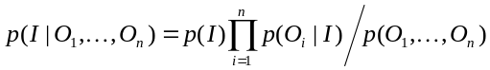,
where the class variable I is the identity of users and O is the set of sensor observations.
We deployed this system in a lab and collected 1.5 months of data from 9 participants. Our experiments show that we can achieve a correct user identification of up to 87% (with complete physiological information) and 84% (with partial/complete physiological information plus user presence context reasoning).
The proposed design for probable identity is to integrate with other interfaces. Integration of multiple interfaces naturally empowers users the “control” ability. People with less privacy concerns can use high-accuracy biometrics to perform identification. Highly-privacy-concerned or careless users can use the system as a guest to perform anonymous access. Others may choose the solution proposed in this work. In here, controlling the θ is to choose among the proper interfaces. This satisfies most users with the ability to choose the interaction they are comfortable with.

TARGET APPLICATIONS
One of the questions for the probable identity is its applicability. A concept is less meaningful if applications do not exist. However, the inherited complex nature and involved human factors make it difficult to analyze and compare the applications systematically. We develop a detail systematic analysis for application characteristics that suit probable identity. We distinguish the nature of a ubiquitous computing application into 6 sets: Information Flow, Response Time, Reaching Desire, Intimacy Degree, Resident Universe, and Revealed Contexts. Within each of these characteristics, although the exception is not uncommon but one end usually fits probable identity while the other usually does not. We explain the details below.

Information Flow

One to One - Outward
The context information flows from one entity to another entity. Each entity can be a user, an object, a device or a server. Because the two entities (sender and receiver) are clearly obvious to each other, applications of this type have a stronger desire in probable identity for both entities for two reasons: (1) to avoid unwanted obligation to respond an incoming signal; [HM01] (2) to lie about certain contexts in the necessary circumstances. Typical applications include find friends, etc.

One to One - Loopback
Another common practice is that when the information flows back to a user, meaning the sender is the receiver self. The typical usage is to exchange context information for services. Applications include city guides, etc. The probable identity is often unwanted because of the loopback characteristic where the user is supposedly the only one that has access to information. However, a user may want to employ probable identity with a very high θ to ensure service quality while preventing accidently privacy leakage.

One to Many
The information flows from one entity to multiple entities like broadcasting or multicasting. To avoid ambiguity or misuse identities, the probable identity is usually not suitable. A typical application is message boards. When a user write on own message board, all the other boards that are deployed elsewhere also display the message. One exception is that probable identity is often desired for whistleblowers (but if we could do completely anonymously instead, we probable would).
Another application is the pervasive games genre, in which, depends on the game logics, the probable identity can be introduced on purpose.

Many to Many
Very few ubiquitous computing applications have this characteristic. An example is the “presence light” concept described in [HM01] where activities in one room are transformed to the brightness of a lamp in the other house. The link is thus triggered by one or multiple users while the receiving side can also be zero, one, or many users. The anonymity is automatically embedded in this type of applications and thus no need for probable identity.

Response Time

Timely Response
The sender expects a shorter reaction time from the receiving side for this type of applications. This commonly includes requesting a service from a machine or initiating a communication to another user. The timely response requirement imposes concerns in revealing sender’s contexts or pressures in answering. People thus have a stronger desire for probably identity, the ability to tell white lies occasionally. Nonetheless, critical applications such as safety enhancement do require a clear identity to react timely and accurately.

Delay Tolerant
For some applications, responses from receivers are delay tolerant or no needed. An example application is context annotation that allows users to e-note their surroundings, points of interests, etc., for a later retrieval (either by themselves or by others). The loose time constraint in delay tolerant applications has reduced time pressures on receivers and the necessity of probable identity. However, a user could still use probable identity to against privacy jitters.

Reaching Desire

Must Through
We use the reaching desire characteristic to refer how madness that a user will be if a request has been dropped. This varies with applications, users, contexts and circumstances. For example, a health monitor application must reach to the responder in an emergency case such as a heart attack, but it is more flexible in most time. A city guide service is highly desired to a tourist but less important to a resident. Parents care whereabouts of their children more than whereabouts of their friends; on the contrast, youths are more interested in whereabouts of their friends. In principle, the higher reaching desire the lower probable identity that a user or an application should employ. Applications with this property shall not employ probable identity.

Loss Tolerant
Loss tolerant is at the other end of reaching desire which allows a weaker response to a user’s request. Non-critical applications often carry this characteristic. This type of applications can abide a reduction in quality of service caused by artificial uncertainty in probable identity.

Intimacy Degree

Intimate
Some applications involve private content that a user wants to keep it personally. A system shall well protect such information from unauthorized accesses. Applications such as the augmented memory use sensing devices to automatically document a user for a later review. In this case, the user neither wants private information leak to others nor wants to get confused by others’ experiences. For an intimate application, the contents are more important than the associated contexts. Since probable identity protects contexts rather than the contents, this type of applications does not suitable for probable identity.

Social
Social applications have less sensitive contents and a user concerns about revealing contexts more than contents. The encounter/exchanger is a social proximity application that enriches interactions among people. For example, travelers exchange tourist information when met each other. Probable identity is appropriate for these applications.

Resident Universe

In Same Universe
We use the term universe to capture the temporal and spatial contexts of users. Applications like smart home usually services users in one physical space (home) at a given time. Other examples include white board sharing in a classroom or a meeting room. For these examples, since a user’s context is already obvious to other users, employing probable identity is affectless.

In Different Universes
If the users of an application cross different temporal or spatial contexts, we describe them in different universes. The probable identity is only meaningful if the involved users possess this characteristic. Most applications are clear to tell but some are ambiguous. For example, although there is only one user in an augmented memory application, the current information is stored for future review and that is the user herself/himself in two different temporal contexts. Another example is the virtual mixed reality universe in pervasive games. These games create one big universe for all participated users to share identities and associated contexts with each other.

Revealing Identity
Applications can be divided into three types [BS03]: one allows anonymous access, one requires true identity, and one cannot operate anonymously but do not need true identity either. The last type of applications can use pseudonyms as return addresses for the services. Clearly, anonymous access removes identity information and has no privacy concerns. Probable identity thus focuses on those requiring our true identity. Probable identity naturally supports pseudonym through l-diversity. With θ set to 1, the different identity tickets act like pseudonyms for the user.
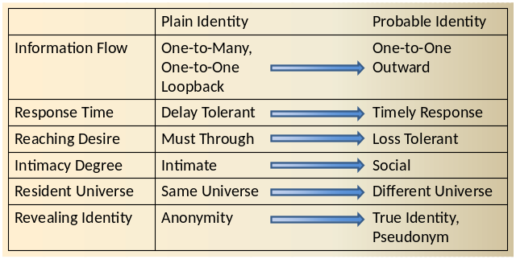

Summary
We list in Figure 1 these characteristics and their tendency on the choice of identification. Note that this serves only a general guideline and are not enforced rules. Applying probable identity is entirely application-specific and user-dependent. A rule of thumb is that if you (as a user or a developer) consider an application as “non-critical”, then the probable identity may suit it. We intentionally use the term “non-critical” loosely without first clearly define it because whether an application is critical is highly subjective.

USAGE SCENARIOS
We use three different scenarios to illustrate how to integrate probable identity into ubiquitous computing applications. We start with a personalized coffee maker that dictates the basic idea, and continue on a find friends/instant messaging application to show an integration of authenticated plain identity, anonymous access and probable identity. In the end, we use a mobile tour guide to demonstrate combining probable identity into a more decentralized architecture that separates identity management and service provider.

Personalized Coffee Maker
Personalized coffee maker provides coffee flavor according to individual preference. It raises privacy concerns because that it resides in a fixed location (assuming a rest area) and it records the timestamp when people are making, therefore, based on its logs, an observer can learn who came to this rest area at what time. We demonstrate how the simplest form of probable identity addresses privacy concerns.

Sampled Scenario
In the morning, the first thing Alice does in the office is to pour her a cup of coffee. The coffee machine can be operated manually or automatically according to a preset personal preference. She walks into the rest area and since she is busy today she decides to have coffee made automatically. She presses a button on the cellular phone and soon a cup of hot coffee is readied for her.

Prototyping Personalized Coffee Maker with Probable Identity
The operation used in this application is a make coffee function call to the coffee maker with a parameter of the identity of the user. The coffee maker gives each user the identity tickets according to her/his θ setting and ensures a 2-anonymity. When accessing this coffee maker, a user issues the make coffee operation with a randomly identity ticket to the coffee maker. Because of probable identity, the user may get a different coffee flavor rather than the one s/he prefers, therefore, the quality of service drops with a lower θ. However, it provides plausible deniability to a specific log record since the coffee machine provides services based on the probable identity rather than the true identity.
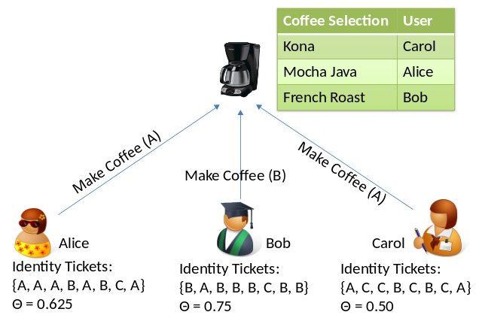

ActiveCampus Explorer
ActiveCampus [GSB04] is a project from University of California, San Diego developed for experiments in community-oriented ubiquitous computing. ActiveCampus Explorer application allows campus users to share location information with one another. The user’s vicinity is overlaid on outdoor or indoor map with nearby friends, colleagues, departments, labs, and interesting activities. Its main functionalities include finding friends, instant messaging, and graffiti annotating. Each user is given a wireless mobile device, a PDA, as the communication and localization platform.

Sample Scenario
Sarah strolls in the campus with her device shows vicinity map. She sees a message pops on the screen with the title “talk: human…” Through clicking this link, she sees the information regarding a lecture in human machine interface in engineering building. The lecture is about to start and she decides to attend.
After the lecture, Sarah searches for her friends to have lunch together. She sees Bob is nearby and sends him a message “Wanna eat?” She then sees Prof. Griswold is in food court. Since she wants to discuss with him about the lecture, she follow the map to find Prof. Griswold. She stops for a cup of coffee on the way to food court. While she is waiting in line, she sees a graffiti that says “Roma has the best croissants on the campus!” She then decides to add a croissant on her plate.
This is the scenario used in [GSB04] where the part of Sarah’s scenario with Prof. Griswold actually happened.

Prototyping Find Friends with Probable Identity
We dissect the find friends application into four operations: add/delete buddy, get buddy list, request contexts, and push contexts. A user uses add/delete buddy operation to establish personal buddy lists which stores on a server. The get buddy list operation is used for retrieve this buddy list from the server. A user uses push contexts to update own contexts periodically, and uses request contexts to receive buddies’ contexts from the server.
The first operation when starting find friends is get buddy list. This returns a list of buddies that the user has created over the usage. Each buddy id is accompanied with credential for request contexts usage. Later on, the user can issue requests to the server about the current locations of these listed friends. The names and returned locations are then overlaid on indoor/outdoor map shown in display for indication. In the meantime, the user also periodically publishes her/his current location to the server.
We then consider required identification and authentication for each of these operations. The add/delete buddy and get buddy list both involve private data access, therefore the two operations need an authenticated plain identity to continue executing. In request contexts operation, the usual way is to use an authenticated plain identity to get information legally. However, the point is to prove that the user own the authorization to retrieve the buddies’ contexts rather than to prove who the user is. As shown in Figure X, the request contexts can thus be implemented anonymously. Each buddy in the returned buddy list is accompanied with a key. In request contexts, instead of proving the identity, the user gets a buddy’s contexts by proving the knowledge to the accompanied keys received earlier through get buddy list. This anonymous access is in the application level, while the link layer uses a temporary identifier (such as DHCP) for each session. The push contexts uses probable identity introduced in this work to pick an identity ticket and associate it to the current context before sending to the server.
The “prove Key” in Figure X is the process where both entities prove to each other knowledge of the Key. This indicates a challenge-response protocol or a zero knowledge password protocol (such as DH-EKE). The server needs not to know the user’s identity but acknowledges its possession of the key is sufficient to grant contexts access.
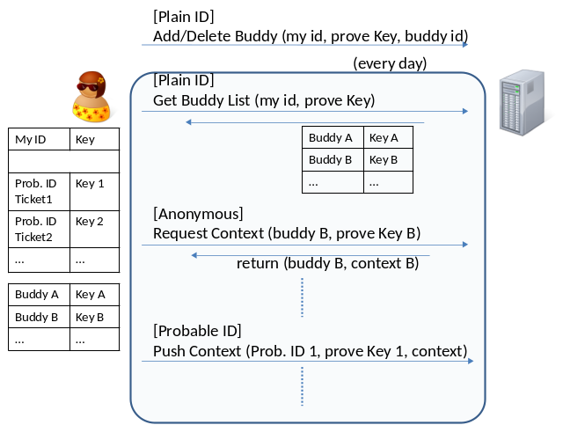

Prototyping Instant Messaging with Probable Identity
The two operations in instant messaging are send message and receive message. For example, Alice sends a message to Bob when sees his contexts online through find friends. On Bob side, once he receives the notifier, he uses receive message to receive this message. He then can send back messages or ignore the incoming message.
The send message delivers a message from an entity to another entity. To hold accountability for message contents, the sender must be authenticated before s/he can send any message to anyone. Because of probable identity in the push contexts of find friends, there are many possible receivers that hold the identity ticket of the intended receiver. Since the server cannot be certain of the true identity of these users, it queries each of these receivers to locate the intended receiver. The receiver has to be authenticated before accepting the message. Once both entities have been authenticated, they can communicate freely in a secure channel.
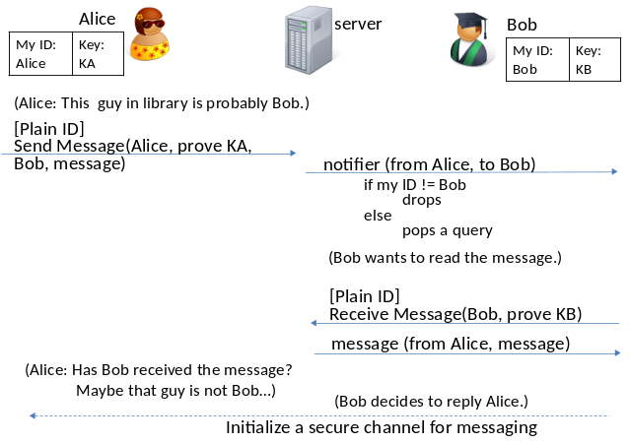

Mobile Tour Guide
We now discuss a more complicated architecture in separating the identity provider and service provider. The identity provider focuses on authentication methods and identity management. The service provider is an application that delegates authentication to a third party. Many web applications use single sign-on to authenticate users are designed in this fashion. The application we choose is a mobile tour guide described in [HL04]. In this scenario created by Hong and Landay, the user uses resolution control as the privacy management mechanism. In the below scenario, we describe a scenario that uses probable identity as an optional choice in privacy protection.

Sampled Scenario
Alice is visiting Boston these days. She has a GPS-enabled mobile device that is capable to connect to the internet. Since this is her first time in the city, Alice would like to have a mobile tour guide service. She searches online and finds this service provider, Bob, is a certificated guide that provides mobile tourist information in many major cities. Alice decides to enroll into Bob’s services and has set her interests in arts, architecture and building.
Alice assigns the exposed location resolution in a neighborhood level. She also wants to enable the probable identity for two reasons: first, she knows several friends who live in Boston and she has the peer pressures that she shall contact them if she in the neighborhood. However, she enjoys travelling alone. She thus wants to be able to tell white lies in case her friends asked about her trip; the second reason is that she does not want to be entirely tied to the art and architecture genre. She thinks some surprises in tourist information based on other users’ preferences are fun. In the situation that the information misses her expectation, Alice can manually query Bob for the specific information. She decides the probable identity θ to 0.8.

Prototyping Mobile Tour Guide with Probable Identity
In the mobile tour guide, the get prob. ID tickets operation is used to retrieve identity tickets from the identity provider. Each ticket is associated with a credential. The user requests tourist information by sending the current location to the service provider using request service operation. However, instead of providing the user employs probable identity by randomly pick an identity ticket as the presented identity to service provider. The service provider calls who is operation to ask the identity provider the identity represented by that ticket. With the proved credential, the server returns the identity associated to the ticket (this may be or may not be the user). Since the service provider does not know the mapping of the ticket to the identity, it returns the points of interests based on the identity returned by identity provider. The main criterion for probable identity is that at least more than 1 user is using the system.
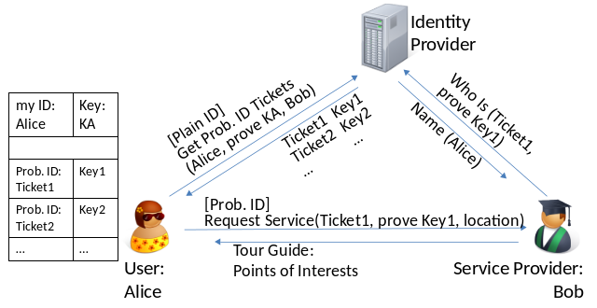

EVALUATION

Ubiquitous Computing

We however quantify the feasibility of probable identity through investigation of literatures in ubiquitous computing. We study the applications of papers published in UbiComp conference from 2002 to 2008. For each application, we analyze it with the six characteristic sets described above to determine whether the probable identity is applicable. The study gives us a broader aspect of how the probable identity can benefit current ubiquitous computing applications. Due to the space limitation, we cannot list all works we have surveyed. As a compromise, we list in Table 1 each genre the summarized characteristics that “most” applications in this genre possess. We provide the detail table online [X] for further inquiry.
Among all 10 genres, the genres that show opportunities for probable identity are finders, guides and encounter/exchanger. We thus roughly estimate that probable identity is applicable to ~30% applications in ubiquitous computing.
Note that probable identity is also applicable to applications in other genres. One example is the fitness monitoring [X] we have developed for home and workspace scenarios. In which we collect weights, blood pressures and heartbeat rates for users. In this prototype, the system establishes probable identities based on collected imprecise physiological information and reaches an accuracy of 84% (87% with assistant context information). Our experiments show its feasibility in reality. This also demonstrates how probable identity applies in different application domains.

Location-based Services
Location-based services have been a strong branch in application domains since the prevalent usage of mobile phones. It overlaps with ubiquitous computing and is a combination of mobile computing, internet and geographic information system (GIS). Due to the popularity of this kind of services, we discuss it in a separate section.
Steiniger et al. categorize location-based services into 9 genres in [SNE06]: navigation, information, tracking, games, emergency, advertising, billing, management and leisure. The tracking is in consumer level while management is for corporate markets. The leisure category includes applications of buddy finder and instant messaging. Other genres are self-explanatory. We follow this classification and list their intrinsic characteristics in Table 2.
Among these genres, navigation does not require user identity. Emergency, billing and management require exact identity. Other information, tracking, advertising and leisure genres are suitable for probable identity. The last game genre, as discussed earlier, the proper identification depends on game logic. We therefore estimate that approximately 44% of location-based services are applicable to probable identity.
Actions | Access Control List | Sensitivity Level
Get Contexts | All Subjects on Contact List | Probable Identity (Low)
Communication | All Subjects on Contact List | Proved Identity (High)

RELATED WORK

Identification and Usability
Usability is another key component in pervasive computing. For knowledge-based authentication methods, the interaction between a user and a system is obtrusive. The traditional password-based authentication methods require much user interaction and imperil user experience [B05].
The possession-based authentication methods require a user to use a specific carry-on token when accessing the system. The “always carry the token” requirement can be a heavy burden (especially at home). In addition, it does not provide the pseudonym access capabilities. Common tokens such as a driver license uniquely associate an identity to the token. Other tokens (such as a door card) provide the role of one user but do not distinguish among the same group of users. Stajano discussed the vulnerability of possession-based authentication in [FS02].
The biometric authentication mechanisms [JRP04] avoid above usability overheads by utilizing the physiological or behavioral signatures to identify a user. The biometric enhances the usability of an interface and is promising for ubiquitous applications. However, its unique, permanent and nontransferable attributes make biometric a so powerful mechanism that we should seek to protect biometric identifiers at least as well as we do our SSNs [W08].

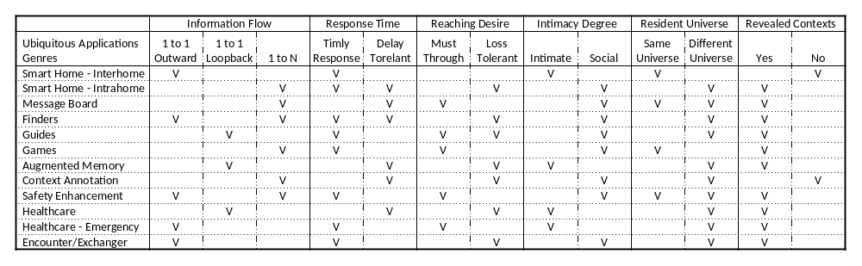
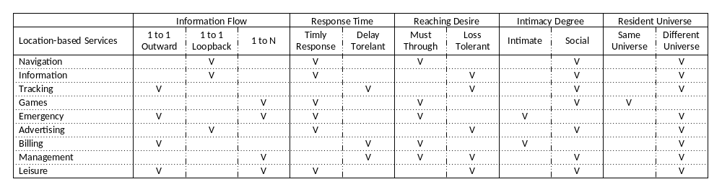
Privacy Concerns
The identification and privacy issues in pervasive computing are complex. Ranganathan [R04] analyzes five barriers and suggests a fundamental re-examination. The first “who am I talking to” problem describes the difficulty in identifying an entity. Other questions such as “will my privacy be safeguarded?” and “can I trust the device I am communicating with” capture widespread society concerns in privacy-sensitive information.
In the user studies from [BD03][K03], the authors describe that people worry about the tracking and abusing of the system. In [AG05], 89.2 percent of the sampled people reported medium or high concerns about privacy. This year (2008), in New York, workers are protesting over using palm print scanners to automate employee tracking. "The palm print thing really grabs people as a step too far." said Ed Ott, executive director of the New York City Central Labor Council of the AFL-CIO [PRI08]. A similar battle has been fought in Pittsburgh in 2006 [PRI06].
Finding the balancing between usability and privacy has no easy solutions. Jalal [AM05] states that “the very same features that make ubiquitous computing environments convenient and powerful make them vulnerable to new security and privacy threats.” Similar statements are across security and privacy literatures. The difficulty comes from inconsistencies of privacy attitudes and actual behavior of users [AG05]: (1) individuals are willing to trade privacy for convenience or small rewards; (2) individuals are seldom willing to adopt privacy protective technologies. To answer that, we rethink the very first question: what is identity?

Plausible Deniability
Lederer and Hong emphasize the broad applicability of plausible deniability and point out that systems may encounter significant deployment resistance if belying it [HL04]. Hong further describes a “strong” desire, from the interviewed users, for plausible deniability [H05]. Raento and Oulasvirta list plausible deniability as one of the five constituents in privacy management [RO05]. User-centric Privacy Framework [BZ07] uses a set of user-predefined conditions to falsify data and deliberately generate white lies that supports plausible deniability.

DISCUSSIONS

Design Impacts
Because that identification is the first step in any system, changing to probable identity does change many technical aspects. For example, on the link layer, we shall remove unique identifiers such as the MAC address in 802.11 or IMEI in GSM and establish a temporary identifier for each session.
For possession-based identification, the identity management scheme now issues identity tickets to users to support probable identity. These tickets employ k-anonymity and l-diversity principles to avoid homogeneity and background knowledge attacks. Deciding the “right” possessed tickets for each user when issuing identity tickets introduces new design challenges. However, the design does fit into most identity management architecture where an identity providers issues identities (or credentials) to users.
For biometric-based identification, we propose to identify users by imprecise physiological information. The challenge is the inherent instability. Because of the diverse physicality in the real world that we face, the guaranteeing a probable identity of θ is difficult. Also a newly joined user can potentially completely change another user’s θ (probability of ownership on data items) if their biometrics are close. This certainly causes confusion to users. However, we can mitigate these problems if deployed in a home or office scenario where the size of user pool is fixed.
A deeper impact is in application design. The developers have to understand that a user may not be “the” user. Therefore, a system provides services without leaking personal information. In the cases where an application needs true identities to proceed, it performs authentication on the participated principals before servicing users. This suggests a clear separation on the identification and authentication processes. In the identification process, a system presents probable identities to users. In the authentication process, a system verifies true identities of users. For instance, by using a Find Friend service, Alice learns the current location of a user who is probably Bob (identification). She sends an invitation to this user attempting to initialize a conversation. If this user accepts the invitation, the system must verify that this user is truly Bob (authentication) before it setups the conversation channel.
This includes a similar concept to “mix zone”; a user shall only holds identity tickets of users that are involved in her/his surroundings.

Social Impacts
To support a true probable identity, users have to cover for each other (allow others to possess my identity tickets). A user thus sometimes will be identified as other users and vice versa. Although under probable identity framework no one knows whose identity s/he is current using (they lack knowledge of mapping tickets to identities), but that does not equal to the rejection of simply knowing own identity will be used by someone. Many people do not like to share personal stuffs. Besides, it also raises confusion to a user when a data item is collected by another user but places under a different ownership. One way to moderate these impacts is to use a high θ such that these errors occur rarely. However, the social impacts of adapting probable identity need further investigation and study.

Conclusion
We believe that the probable identity makes senses in complying with Mark Weiser’s vision of ubiquitous computing. In the eventual goal, when technologies weaved into our daily life, we will consider most applications as non-critical that tolerate uncertainty. And probable identity is a conceptually simple yet powerful control mechanism that serves as a right balance between usability and privacy and compensates existing protection methods.

REFERENCES
[W91] M. Weiser, “The Computer for the 21st Century,” Scientific Am., Sept., 1991, pp. 94-104; reprinted in IEEE Pervasive Computing, Jan.-Mar. 2002, pp. 19-25.
[AM05] Jalal F. Al-Muhtadi, “An Intelligent Authentication Infrastructure for Ubiquitous Computing Environments,” Ph.D. Dissertation, Univ. of Illinois at Urbana-Champaign, 2005.
[NTSC] National Science and Technology Council, “Privacy & Biometrics: Building a Conceptual Foundation”, Sep. 2006
[N04] Richard E. Neapolitan, "Learning Bayesian Networks", Prentice Hall, 2004.
[R01] I. Rish, "An empirical study of the naive Bayes classifier". IJCAI 2001 Workshop on Empirical Methods in Artificial Intelligence, 2001.
[BKM03] J.E. Bardram, R.E. Kjær and M.Ø. Pedersen, “Context-Aware User Authentication - Supporting Proximity-Based Login in Pervasive Computing”. In Proceedings of UbiComp 2003, Oct 2003
[B05] J.E. Bardram, “The Trouble with Login - On Usability and Computer Security in Ubiquitous Computing.” Personal and Ubiquitous Computing, 9(6):357-367, 2005.
[JRP04] A.K. Jain, A. Ross and S. Prabhakar, An introduction to biometric recognition, IEEE Trans. Circuits Systems Video Technol. 14 (2004) (1), pp. 4–20
[R04] K. Ranganathan, "Trustworthy Pervasive Computing: The Hard Security Problems", Proceedings of the Second IEEE Annual Conference on Pervasive Computing and Communications Workshops, 2004
[JHL02] X. Jiang, J.I. Hong, and J.A. Landy, “Approximate information flows: Socially-based modeling of privacy in ubiquitous computing,” Proc. International Conf. on Ubiquitous Computing 2002 (UbiComp 2002), pp.176–193, LNCS 2201, Sept. 2002.
[BA07] P. Bhaskar and S.I. Ahamed, "Privacy in Pervasive Computing and Open Issues," Proceedings of The Second IEEE International Conference on Availability, Reliability and Security (ARES 07), 2007.
[BS93] V. Bellotti, A. Sellen, “Design for Privacy in Ubiquitous Computing Environments”, Proc. of 3rd Euro. Conf. on Computer Supported Cooperative Work, 1993, pp. 77-92
[XL02] X. Jiang, J.A. Landay, “Modeling privacy control in context-aware systems”, Pervasive Computing, IEEE, Volume 1, Issue 3, July-Sept. 2002, pp. 59-63
[HL04] JI Hong, JA Landay, "An architecture for privacy-sensitive ubiquitous computing", Proceedings of the 2nd international conference on Mobile systems, applications, and services, 2004
[K03] E. Kaasinen, User Needs for Location-aware Mobile Services. Personal and Ubiquitous Computing 2003. 7(1): p.70-79.
[BD03] L. Barkhuus and A. Dey. "Location-based services for mobile telephony: a study of users' privacy concerns." In Proceedings of INTERACT 2003, 9th IFIP TC13 International Conference on Human-Computer Interaction. 2003.
[PRI08] "Fingerprint Scans Replace Clocking In", The Associated Press, March 26, 2008
[PRI06] Rich Lord, "High-tech time clock could be stopped - City plan to scan fingerprints runs into controversy", Pittsburgh Post-Gazette, July 22, 2006
[FS02] F. Stajano, "Security For Whom? The Shifting Security Assumptions Of Pervasive Computing", Proceedings of International Security Symposium, 2002
[H05] Jason I-An Hong, An Architecture for Privacy-Sensitive Ubiquitous Computing, Ph.D. Dissertation, Computer Science, University Of California, Berkeley, 2005
[RO05] M. Raento and A. Oulasvirta, “Privacy management for social awareness applications,” In the Proceedings of the workshop on Context Awareness for Proactive Systems, 2005.
[BZ07] S.A. Bagüés, A. Zeidler, C.F. Valdivielso, I.R. Matias, "Disappearing For A While – Using White Lies in Pervasive Computing", Proceedings of the 2007 ACM workshop on Privacy in electronic society, 2007
[HM01] D. Hindus, S.D. Mainwaring, N. Leduc, A.E. Hagstrőm, and O. Bayley, Casablanca: Designing Social Communication Devices for the Home. CHI Letters (Human Factors in Computing Systems: CHI 2001), 2001. 3(1): p. 325-332.
[IBM70] “The Consideration of Data Security in a Computer Environment”, tech. report G520-2169, IBM, 1970.
[W08] J. L. Wayman, “Biometrics in Identity Management Systems”, IEEE Security and Privacy, vol.6, no. 2, 2008
[AG05] A. Acquisti and J. Grossklags, "Privacy and Rationality in Decision Making," IEEE Security & Privacy, vol. 3, no. 1, 2005, pp. 26-33.
[PA05] B. A. Price, K. Adam, and B. Nuseibeh. “Keeping ubiquitous computing to yourself: A practical model for user control of privacy,” International Journal of Human-Computer Studies, 63(1-2):228-253, July 2005.
[BS03] A. R. Beresford , F. Stajano, Location Privacy in Pervasive Computing, IEEE Pervasive Computing, v.2 n.1, p.46-55, January 2003
[PGG07] J. Pang, B. Greenstein, R. Gummadi, S. Seshan, and D. Wetherall, "802.11 User Fingerprinting," Mobicom '07: 13th Annual International Conference on Mobile Computing and Networking, 2007.
[W67] A. Westin, Privacy and Freedom, Atheneum Press, 1967.
[C05] J. Cas, "Privacy in pervasive computing environments - A contradiction in terms?" IEEE Technology and Society Magazine, 24(1), 24-33, 2005.
[SNE06] S. Steiniger, M. Neun and A. Edwardes, "Foundations of Location Based Services", Lecture Notes, University of Zurich, 2006.
[S02] L. Sweeney. “k-Anonymity: a model for protecting privacy.” International Journal of Uncertainty, Fuzziness and Knowledge-Based Systems, 10 (7), 2002.
[MKG06] A. Machanavajjhala, D. Kifer, J. Gehrke, and M. Venkitasubramaniam. “l-Diversity: Privacy beyond k-Anonymity.” In Proceedings of the 22nd International Conference on Data Engineering, 2006.
[L02] M. Langheinrich, “A Privacy Awareness System for Ubiquitous Computing Environments”, Ubicomp, Lecture Notes in Computer Science, volume 2498, pp. 237-245, Springer, 2002
[MA01] MJ Moyer, M Ahamad, "Generalized Role-Based Access Control," Proceedings of the 21st IEEE International Conference on Distributed Computing System, 2001, pp. 391-398.
[ZP04] G. Zhang and M. Parashar, "Context-Aware Dynamic Access Control for Pervasive Applications," Proceedings of the Communication Networks and Distributed Systems Modeling and Simulation Conference (CNDS), 2004, pp. 219-225.
[BBF01] E. Bertino, P. A. Bonatti and E. Ferrari, TRBAC: A Temporal Role-Based Access Control Model. ACM Transactions on Information and System Security, Vol4, No3 (2001) 191-223
[HO03]F. Hansen and V. Oleshchuk, SRBAC: A Spatial Role-based Access Control Model for Mobile Systems, In Proceedings of Nordec 2003, Gjovik, Norway (2003)
[GSB04] W.G. Griswold, P. Shanahan, S.W. Brown, R.T. Boyer, "ActiveCampus: Experiments in Community-Oriented Ubiquitous Computing." IEEE Computer 37(10), p73-80, 2004

[MFD03] G. Myles, A. Friday, N. Davies, “Preserving privacy in environments with location-based applications”, Pervasive Computing, IEEE Volume 2, Issue 1, Jan-Mar 2003, pp. 56-64
[SM03] D. Saha, A. Mukherjee, Pervasive Computing: A Paradigm for the 21st Century, IEEE Computer, IEEE Computer Society Press, pp. 25-31, March 2003.
[GSS02] D. Garlan, D. Siewiorek, A. Smailagic, and P. Steenkiste Project Aura: Towards Distraction-Free Pervasive Computing, IEEE Pervasive Computing, 1(2):22--31, April-June 2002.
[OXYGEN] MIT Project Oxygen, http://www.oxygen.lcs.mit.edu
[HSC07] J. Hong, M. Satyanarayanan, G. Cybenko, “Guest Editors' Introduction: Security & Privacy,” Pervasive Computing, IEEE, Volume 6, Issue 4, Oct.-Dec. 2007 Page(s):15 – 17
[T77] Ordway Tead,” Human Nature and Management”, Ayer Publishing, 1977
[GOV] Families by Size and Presence of Children: 1990 to 2006, The 2008 Statistical Abstract, U.S. Census Bureau
[MP01] BT. Marczak, A. Paprocki, “Blood pressure variability on the basis of 24-hour ambulatory blood pressure monitoring in a group of healthy persons”, Przegl Lek. 2001;58(7-8):762-6.
[V94] L. Vila, “A Survey on temporal Reasoning in Articial Intelligence.” Articial Intelligence 7 (1994) 4-28
[MK96] J. Ma and B. Knight, "A Reified Temporal Logic", The Computer Journal 1996 39(9):800-807
[S02] V. Stanford, "Using pervasive computing to deliver elder care", IEEE Pervasive Computing , 2002
[BSN07] G. Borriello, V. Stanford, C. Narayanaswami, W. Menning, “Guest Editors' Introduction: Pervasive Computing in Healthcare, IEEE Pervasive Computing, 2007
[VS02] V. Stanford, "Pervasive health care applications face tough security challenges", IEEE Pervasive Computing, April-June 2002
[HIPPA] The Health Insurance Portability and Accountability Act (HIPAA) Privacy Rule, http://www.hhs.gov/ocr/hipaa/
[YK05] S. Yamada And E. Kamioka, "Access Control For Security And Privacy In Ubiquitous Computing Environments," IEICE Trans. Commun., Vol.E88–B, No.3 Mar. 2005
[CZT05] H. S. Cheng, D. Zhang, J. G. Tan, “Protection of Privacy in Pervasive Computing Environments”, Intl. Conf. on Information Technology: Coding and Computing, 2005
[CKG98] B. Chor, E. Kushilevitz, O. Goldreich and M. Sudan, "Private Information Retrieval", J. ACM 45(6), pp965–981, 1998
[WGB99] M. Weiser, R. Gold, and J.S. Brown, "The Origins of Ubiquitous Computing Research at PARC in the Late 1980s." IBM Systems Journal 1999. 38(4): p. 693-696.
[WDC04] X. Wang, J. S. Dong, C. Y. Chin, S. R. Hettiarachchi, and D. Zhang, “Semantic Space: an infrastructure for smart spaces,” IEEE Pervasive Computing, vol. 3, no. 3, pp. 32–39, July–Sep. 2004.

Columns on Last Page Should Be Made As Close As Possible to Equal Length

