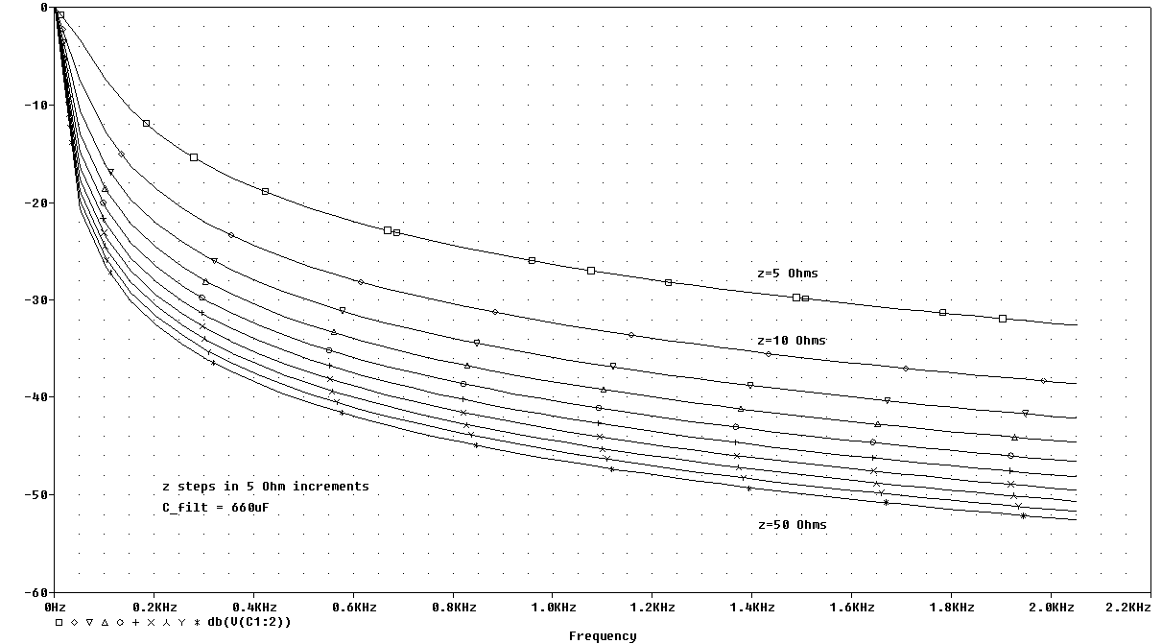
Adding additional 660uF cap at Vs+ pin of H-bridge yields an impressive 20dB+ additional improvement in noise rejection at fundamental harmonic of PWM drive chop even at extremely low motor impedance!!! (like at startup and directional changes). For higher impedance performance improves dramatically. The two motors are driven out of phase effectively doubling the dominant harmonic frequency from 600Hz to 1.2kHz and halving the I_{peak}! H-bridge conduction loss of R_{on} > 1.8 Ohms and motor DC resistance of 3.2 Ohms means Z_{worst} = 5 Ohms. Filter performance improves dramatically for increasing Z.

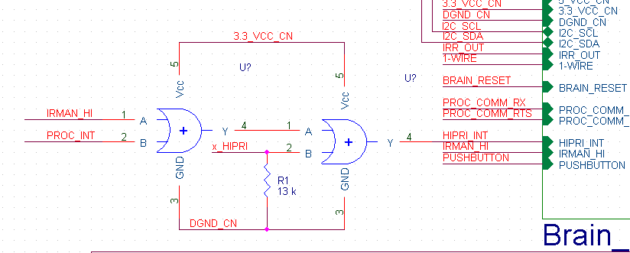
This is the original config, IRMAN, DSP/NERVE, and EXPANSION all share a hi-priority interrupt signal to the brain. This is no-longer necessary for EXPANSION modules since they have a separate interrupt line directly to BRAIN (GPIO_INT). The XYZ, does not have an extra external interrupt pin (that can wake from sleep). On the body board this was changed so that the second OR gate and waste current in the pull down resistor do not effect non-XYZ configurations. These parts are removed. The OR gate is added to the XYZ adapter board.

