Workshop Information

Preface
Welcome to the IAR visualSTATE Workshop. The purpose of this binder is to guide you through the aspects and facilities of the IAR visualSTATE software.

This binder contains selected articles, descriptions of the UML notation, common design issues with IAR visualSTATE 4 and several exercises as a supplement to the workshop.

References
IAR Systems: "Concept Guide - IAR visualSTATE version 4", 1999.

Booch, Grady et. al.: "The Unified Modeling Language - User Guide", 1999, Addison Wesley.

Douglass, P. Bruce: "Real-Time UML - Developing Efficient Objects For Embedded Systems", 1998, Addison Wesley.

Hatley, J. Derek: “Strategies for Real-Time System Specification", 1987.

Rational Software: "UML Summary version 1.1", 1997

Table of contents
1 Workshop Information 1
1.1 Preface 1
1.2 References 1
1.3 Table of contents 2
1.4 Table of figures 4
1.5 List of Tables 4
2 Methods 5
2.1 Fundamentals 5
2.2 Structured Analysis/Structured Design (SA/SD) 6
2.3 Mealy & Moore notation for state machines 7
2.4 Matrix representation 9
2.5 Unified Modeling Language 10
3 The UML notation used in IAR visualSTATE 4 11
3.1 The organization of IAR visualSTATE files 11
3.1.1 IAR visualSTATE Project 11
3.1.2 IAR visualSTATE System 12
3.1.3 IAR visualSTATE Statechart File 12
3.2 Introduction to the elements in IAR visualSTATE 4 13
3.3 Hierarchical states 13
3.3.1 What is a hierarchical state machine? 13
3.3.2 How can hierarchical state machines be used? 15
3.4 Concurrent state machines 15
3.4.1 What are concurrent regions? 15
3.4.2 How can concurrent regions be used? 16
3.5 Default states 16
3.5.1 Initial states 17
3.5.2 History states 17
3.5.3 Deep history states 18
3.6 Unit states 19
3.7 Entry and exit reactions 20
3.7.1 Entry reactions 20
3.7.2 Exit reactions 20
3.8 Internal reactions 20
3.9 Do reactions and termination transitions 21
3.9.1 Final state 22
3.9.2 Termination transition 23
3.10 Transitions 23
3.10.1 Triggers 23
3.10.2 State condition 23
3.10.3 Guard expressions 24
3.10.4 Action functions 24
3.10.4.1 Timer action functions 24
3.10.5 Assignments 25
3.10.6 Signals 25
4 Testing with IAR visualSTATE 4 26
4.1 Complete formal verification 26
4.2 Verificator setup 27
4.2.1 Reset event 27
4.2.2 Use and activation of elements 27
4.2.3 Dead ends 27
4.2.3.1 State dead ends 28
4.2.3.2 Local dead ends 28
4.2.3.3 System dead ends 29
4.2.4 Conflicting transitions 29
4.3 Manual validation 29
4.3.1 Interactive simulation 29
4.3.2 Graphical Animation 30
4.3.3 Breakpoints 31
4.4 Log & Animation 31
4.4.1 Animation 32
4.4.2 Static analysis 32
4.4.3 Dynamic analysis 33
4.4.3.1 Summary 34
4.4.3.2 Details 34
4.5 RealLink 34
5 IAR visualSTATE command line programs 35
5.1 Command line modules 35
6 How to handle old IAR visualSTATE statechart versions 36
6.1.1 Conversion from 3.x to 4 format 36
6.1.2 Using version 3.x files in a version 4 project 37
6.1.3 Troubleshooting 38
7 API & device drivers 39
7.1 Automatically generated code 39
7.2 Application Program Structure 39
7.3 Manually written code 41
7.4 API (Application Programming Interface) 41
7.4.1 Initialization 41
7.4.2 State/Event deduction 42
7.4.2.1 Event parameters 42
7.4.3 Inquiry 44
7.4.4 Text handling 45
7.4.5 Miscellaneous 45
7.4.5.1 Signals 45
7.4.5.2 Force state 45
7.4.5.3 Instances 45
7.4.6 Completion codes 46
7.5 Device drivers 46
8 Run-time requirements 47
8.1 Compiler requirements 47
8.2 Double buffering 47
8.3 Code Sizes 47
8.3.1 8-bit Compiler (IAR Motorola 68HC11) 48
16-bit Compiler (IAR Hitachi H8) 49
8.3.2 32-bit Compiler (IAR National Semiconductor CompactRISC CR32) 50
8.3.3 32-bit Compiler (Microsoft C/C++ Compiler) 51
9 Maintenance 52
9.1 visualSTATE files and name extensions 52
10 Exercises 53
10.1 Specification of a car compartment light 53
10.1.1 Functionality 53
10.2 Specification of a car window control 53
10.2.1 Functionality 53
10.3 Specification of an elevator 54
10.3.1 Functionality 54
10.4 Specification of a washing machine 54
10.4.1 Functionality 54
10.4.2 Control 54

Table of figures
Figure 2.1 The principle behind IAR visualSTATE. Real-life input is processed on the basis of the state machine models and the past inputs and can result in some real-life outputs. 5
Figure 2.2 An example of a context schema 6
Figure 2.3 First layer data flow diagram 7
Figure 2.4 A state machine expressed with the Mealy notation 7
Figure 2.5 State Event machine expressed with Moore notation 9
Figure 2.6 Matrix representation 9
Figure 2.7 Reed switch state model 10
Figure 3.1 IAR visualSTATE project structure. 11
Figure 3.2 Example of an IAR visualSTATE Project. 12
Figure 3.3 Example of using a hierarchical state machine. 14
Figure 3.4 An example of using concurrent regions 16
Figure 3.5 Use of initial states 17
Figure 3.6 An example of how to use history and deep history states. 18
Figure 3.7 State machine with the unit state 'On' 19
Figure 3.8 State machine contained in the unit state 'On' 19
Figure 3.9 An example of how to use entry and exit reactions on states 20
Figure 3.10 The use of internal reactions for volume control 21
Figure 3.11 Example of the use of a do reaction 22
Figure 3.12 The contents of the do reaction ‘DoPlayTrack’ 22
Figure 4.1 Navigator configuration dialog of the IAR visualSTATE Verificator. 27
Figure 4.2 An example of a design containing a state dead end 28
Figure 4.3 An example of a design containing a local dead end 28
Figure 4.4 A state machine with four states. 29
Figure 4.5 Manual simulation using the Validator 30
Figure 4.6 Simulation using the Graphical Animation 30
Figure 4.7 Breakpoint setup dialog 31
Figure 4.8 An example of a recorded test sequence 32
Figure 4.9 The result of a dynamic analysis 33
Figure 6.1 Navigator import dialog 37
Figure 7.1 Application Program Structure for Coder Default Configuration. 40
Figure 7.2 Access to/from an application through the IAR visualSTATE API 41

List of Tables
Table 8-1 API size with 8-bit compiler, version 4 code generation 48
Table 8-2 API size with 16-bit compiler, version 4 code generation 49
Table 8-3 API size with 32-bit IAR compiler, version 4 code generation 50
Table 8-4 API size with 32-bit Microsoft C/C++ compiler, version 4 code generation 51
Table 9-1 visualSTATE file extensions 52

Methods
This chapter gives a short introduction to the fundamental methods behind IAR visualSTATE. It introduces different structuring methods and the principle of state/event-driven real-time systems. Different state/event machine notations will be introduced.

Fundamentals
When designing large complex systems, one needs to consider that both past and present events, internal as well as external, might change the behavior of the system. The system might behave in different ways depending on the past inputs. It can be difficult to model this kind of behavior only using a process model. Finite state machines are very well suited for modeling this kind of behavior [Hatley, J. Derek, 1987].

It is possible to divide state machines into two categories: continuous or finite. Continuos-valued inputs, outputs and internal elements characterize continuous state machines. Discrete-valued inputs, outputs and internal elements characterize finite state machines.

Finite state machines can be divided into combinational and sequential finite state machines.
The outputs from a combinational state machine are uniquely determined by its current input whereas past inputs have no influence. The output from a sequential machine is determined by both its current and past inputs.

IAR visualSTATE is a software development tool that can be used when developing state machine-based control logic. IAR visualSTATE is based on sequential finite state machines where inputs from external devices send events into the IAR visualSTATE engine. Depending on the event, one or more actions will be generated. 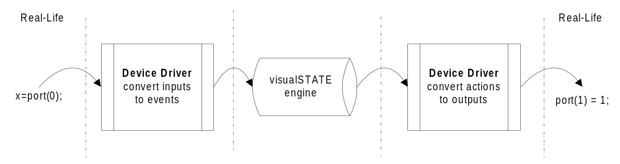
Figure 2.1 The principle behind IAR visualSTATE. Real-life input is processed on the basis of the state machine models and the past inputs and can result in some real-life outputs.
The externally generated inputs are processed first by the device driver which recognizes the hardware pattern and subsequently informs the IAR visualSTATE engine, which acts according to the state machine model (changes states, execute actions etc.). Actions executed are converted in the output part of the device driver.

The state machines designed in IAR visualSTATE can be designed using two different notations: S/E notation based on the Mealy notation for state machine or using the UML notation. These notations will be described in the next chapters.

Structured Analysis/Structured Design (SA/SD)
One way of structuring software is to use the Ward/Mellor method which is called SA/SD method (structured analysis/structured design). Another possibility is to use the so-called “Unified Modeling Language” (UML). The principles behind these two will be shortly described here. The different notations for state machines will also be introduced.

When using the SA/SD method to structure the software, the software can be designed in different levels. The highest level is called the context schema. The context schema shows the interaction between the system and its environment.

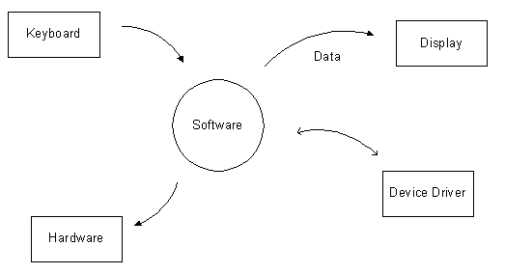

Figure 2.2 An example of a context schema

In the example in Figure 2.2 the system receives input from a keyboard and from some kind of device driver and can send outputs to some kind of hardware, a display and the device driver.

The system is then further structured by creating data flow diagrams (DFD) on different levels. The data flow diagrams can consist of control processes (CP) and data processes (DP). The data processes handle all processing of data whereas the control processes handle the control logic. The different processes can communicate using different flows: control flows (CF), data flows (DF) and continuos control flows (CCF). Certain rules apply to the use of these flows. See an example of a data flow diagram in Figure 2.3.

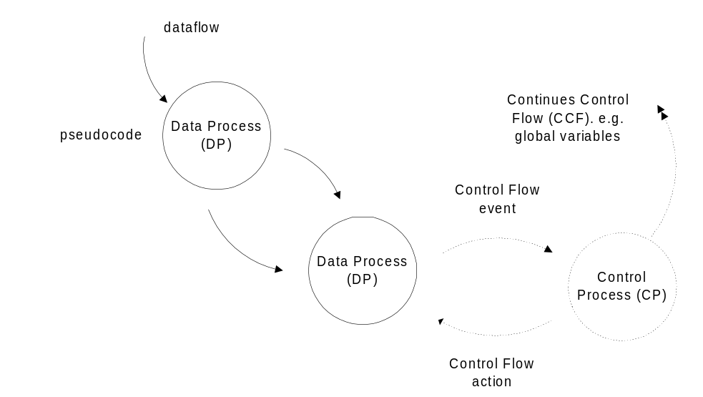
Figure 2.3 First layer data flow diagram

The data process is based on some user-written code (specified using “pseudo-code”) where the control process ends in some kind of mini specification involving state/event machines or pseudo-code. If we compare control processes to state machines then control flows can be modeled as events or actions in state machines. Continues control flows could represent the current state combination.

Mealy & Moore notation for state machines
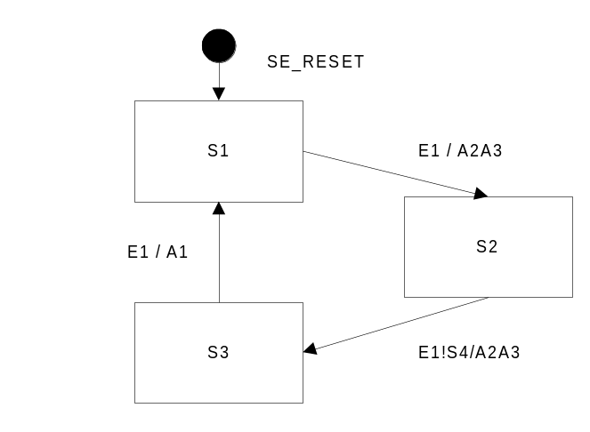A given design is described by either one or more state machines, where each state machine can be in one and only one state at a time. To move from one state to another, one or more predefined conditions must be fulfilled.

Figure 2.4 A state machine expressed with the Mealy notation

The following rules applies for state machines:
- Each state machine is in one and only one state at a time
- A transition must be triggered. Otherwise the state machine is in a stable condition.
- One and only one event per transition can bring a change in that condition.

It is possible to have state conditions, both negative (! state name) and positive (state name) conditions. These state conditions are a part of the conditions that must be fulfilled for the transition to fire. A positive state condition is a condition that specifies that another state machine must be in a certain state whereas a negative condition specifies that another state machine cannot be in a certain state. Several actions can be added on each transition. The actions could for example be implemented as function calls. It is also possible to use so-called “force states” where it is possible to force another state machine into a certain state. A transition can be divided into two parts, a condition side and an action side. All conditions on the condition side must be fulfilled when the event occurs for the transition to be fired.

Instead of using diagrams to represent the state machines it is also possible to use a rule notation instead, see the notation in Example 1.
Example 1
E CSV : NSV AV

where E is the event, CSV is the current state vector containing the source state of the transition and state conditions; NSV is the next state vector containing the destination state and force states and AV is the action vector containing the actions to be activated. Both positive and negative condition can be used in the current state vector. Actions are always executed first, before shifting to next state.

Example 2
E1 S1 : S2 A2 A3
Example 3
E1 S1 !S4 : S2 A2 A3

In Example 3 state S1 is the source state of the transition and !S4 is a negative state condition.

Another notation for state machines is called the Moore notation. The Moore notation uses a different approach to state representation. Instead of using actions on transitions, Moore uses so-called entry and exit actions. These actions are specified on a specific state. Entry actions are executed each time the state is entered while exit actions are executed when the state is left. The two notations can express the same functionality.
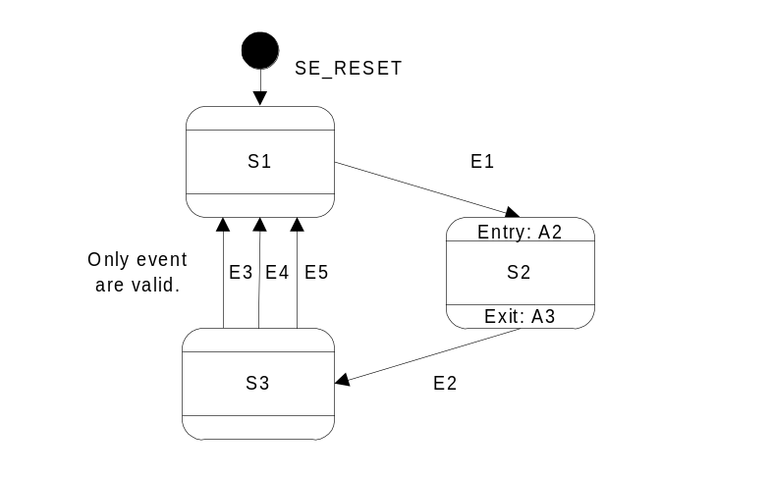
Figure 2.5 State Event machine expressed with Moore notation
In Figure 2.5 the action A” is activated each time state S2 is entered and the action A3 is activated each time the state is left.

Matrix representation
State machines can also be expressed as matrices. The syntax is as follows,

- The top left corner containing the name of the state machine.
- The left column describes current state.
- The top rows describe events or event and state conditions if used.
- Each cell represents a transition

Each cell is divided into two parts, one containing the next state and one containing the actions and force states. The matrix below represents the same control logic as described in the diagram in Figure 2.4.

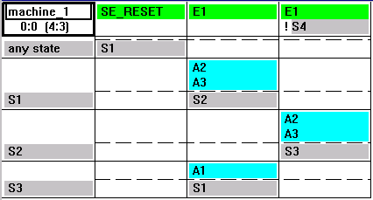
Figure 2.6 Matrix representation
One of the cells specify that when the event E1 occurs and the current state is state S1, then the actions A2 and A3 will be sent and a state change from state S1 to state S2 will occur. The “any state“ row is used when initializing the state machine. When the event SE_RESET occurs, the state machine will be initialized to state S1. Once the state machine has been initialized the transitions specified in the “any state“ row will be activated when the event SE_RESET event occurs – no matter which state the state machine is in.

Unified Modeling Language
The UML is a language for specifying, visualizing, constructing and documenting for example software systems. The UML definitions comprise the following,

- UML Semantics
- UML Notations Guide

The UML specifies a modeling language that incorporates basic object-oriented modeling concepts.

The UML notation includes a new notation for state machines. This notation is used in IAR visualSTATE version 4. Contrary to the Mealy and Moore notations this notation is based on hierarchical state machines. Concurrency can be used at any level in the state hierarchy. Variables are introduced and can be used as conditions or modified within the design. Action functions can be used on transitions and as entry and exit reactions. It is possible to apply some memory to the state machines. The notation used in IAR visualSTATE will be described in Chapter 3.

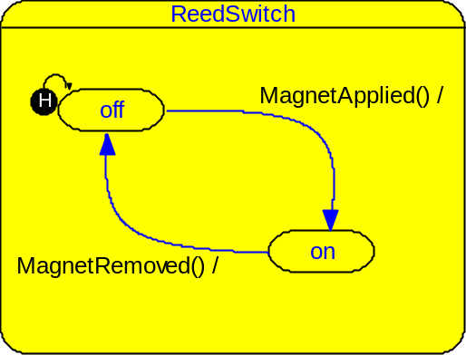
Figure 2.7 Reed switch state model
The above figure shows a simple on-off state behavior as a Reed Switch described using the UML-notation for state machines. The black circle marked with the letter H at the off state indicates a history state. History states will be described in Chapter 3.5.2.

The UML notation used in IAR visualSTATE 4
This chapter can be used as inspiration before designing IAR visualSTATE 4 models, or as help or inspiration during the actual design phase. The chapter gives a description of the “building blocks” that can be used in IAR visualSTATE version 4.

The organization of IAR visualSTATE files
In IAR visualSTATE there are a number of different types of files. The files are grouped together in different blocks to ensure the logical consistency of the final application. These blocks are termed IAR visualSTATE Projects and IAR visualSTATE Systems.

The practical handling of IAR visualSTATE Projects, IAR visualSTATE Systems and IAR visualSTATE files is by means of the tree browser of the IAR visualSTATE Navigator.

IAR visualSTATE Project
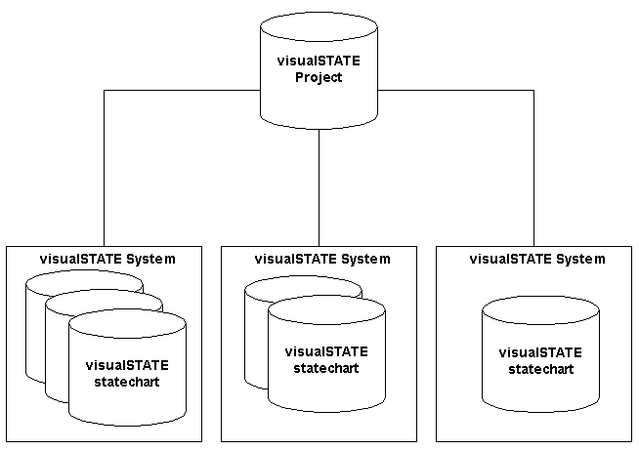
Figure 3.8 IAR visualSTATE project structure.
An IAR visualSTATE Project (extension .vsp) is a collection of IAR visualSTATE Systems. The IAR visualSTATE Systems group the individual statechart files (extension .vsr). Thus each IAR visualSTATE Project is capable of containing several statecharts as shown in Figure 3.8.

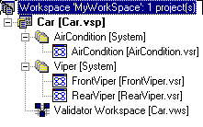
Figure 3.9 Example of an IAR visualSTATE Project.
In addition to binding IAR visualSTATE Systems and statecharts together, an IAR visualSTATE Project contains elements that are shared across IAR visualSTATE Systems.

The IAR visualSTATE Project data is stored in an IAR visualSTATE Project file (extension .vsp).

Figure 3.9 shows a screenshot of the workspace browser of IAR visualSTATE Navigator. It shows an IAR visualSTATE Project named 'Car'. The Project contains two IAR visualSTATE Systems, one named 'AirCondition' and one named 'Viper'.

IAR visualSTATE System
An IAR visualSTATE System is a collection of one or more statechart files, i.e. the logical representation of state/event models.

If state/event models are grouped in the same IAR visualSTATE System, they can communicate with each other. Thus their behavior can be affected by the behavior of the other state/event models within the same IAR visualSTATE System.

For example, if you want to create a state/event model for a car light that is to react to the behavior of the model for the car locking system, it is a good idea to include the two models in the same IAR visualSTATE System. If two models within an IAR visualSTATE Project are to operate independently of each other, an IAR visualSTATE System for each model should be created (see Figure 3.8).

In target, the logical unit or object of IAR visualSTATE is the IAR visualSTATE System. Thus when an event occurs, it is interpreted on a per System basis.

So although an IAR visualSTATE System may contain more than one hierarchical state machine, the event occurs for all state machines in this particular System.

In IAR visualSTATE version 4 it is possible to design three types of System
- S/E System
- UML System
- Safe UML System.

S/E Systems are designed using the Mealy notation for state machines while UML systems are designed using the UML notation for state machines. The Safe UML notation ensures you the possibility to completely verify your design.

IAR visualSTATE Statechart File
A visualSTATE Statechart file (extension vsr) is a file that contains the logic information about the designed model, for example states and transitions. The Statechart file represents a way of modularizing a visualSTATE System. When a visualSTATE System is split into more than one visualSTATE Statechart file, it is
possible to gain the benefits of team development on the same System.

There are two different logical interpretations of a visualSTATE Statechart file:
If a visualSTATE System only consists of one visualSTATE Statechart file, then the topstate of the visualSTATE Statechart file represents the topstate of the visualSTATE System (see Topstate, page 26).

If the visualSTATE System consists of more than one visualSTATE Statechart file, then two more levels in the state hierarchy will automatically be introduced:
1 A visualSTATE System topstate.
2 A region for each visualSTATE Statechart file.

The topstate of each visualSTATE Statechart file will then be inserted as a state in a region in the topstate of the visualSTATE System.

Introduction to the elements in IAR visualSTATE 4
Compared to the flat Mealy notation for state machines used in IAR visualSTATE versions prior to version 4, the hierarchical UML notation used in version 4 is much more expressive.

In IAR visualSTATE version 3.x and version 2.x the only “bricks” available were events, states and actions. In IAR visualSTATE version 4 it is possible to use signals, timer actions, variables and constants as well. By using variables it is possible to perform arithmetic and logical calculations and use these calculations as conditions for transitions to be triggered.

Hierarchical states
The Mealy notation for state machines is based on so-called “flat” state machines (or one level state machines). This means that states cannot have “parents” or “children”, but are all placed at the same level.

In IAR visualSTATE 4 the fundamental principles of the UML notation is used. This notation supports the use of hierarchy in the state machines.

What is a hierarchical state machine?
A state machine can be hierarchical in that it consists of more than one level. Figure 3.10 shows an example of using a hierarchical state.

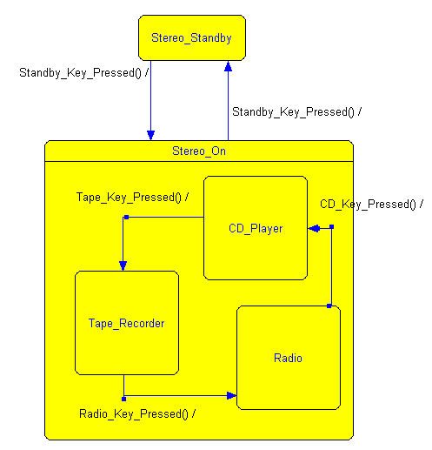
Figure 3.10 Example of using a hierarchical state machine.
Figure 3.10 illustrates a very simplified version of a stereo system. The stereo system can either be in standby mode or it can be turned on. This is represented by the two states 'Stereo_Standby' and 'Stereo_On'. Only if the stereo system is turned on, it makes sense to have an active state machine to control whether the stereo system is playing CD (state 'CD_Player'), tape (state 'Tape_Recorder') or radio (state 'Radio'). This logic is therefore placed in the state 'Stereo_On'.

One and only one state will be active in each state machine at a time. That is, only state 'Stereo_Standby' or state 'Stereo_On' can be active and only one of the states in state 'Stereo_On' can be active (if state 'Stereo_On' is active – otherwise none of these states are active).

This design is equivalent to the following design in a flat state machine notation: Create a model with two concurrent state machines: A state machine with the states 'Stereo_Standby' and 'Stereo_On' and a state machine with the states 'CD_Player', 'Tape_Recorder' and 'Radio'. To achieve the same functionality as when using the state hierarchy, all transitions between the states 'CD_Player', 'Tape_Recorder' and 'Radio' must have positive state condition to the state 'Stereo_On'.

The example shown above has two levels of hierarchy, but it is possible to have more than two levels. The state 'Stereo_On' is called a superstate because it contains states at a lower level. The states at the lowest level are called simple states. The state 'Radio' in Figure 3.10 is a simple state.

How can hierarchical state machines be used?
Using state hierarchy when designing state machines can serve more than one purpose. Hierarchy can be used to achieve a better overview when designing and it can be used to make some state machines “internal” to one particular state.

If we look at the very simple stereo system in Figure 3.10, this model could be the basis for a more advanced model. The model provides a good “first try” overview. At this time it is of no interest how, for example, the CD player is controlled internally.

When we get to the level where we are ready to design the control of the CD player, the use of hierarchy can provide some advantages. The state machines that only control the CD player and no other parts of the stereo system can be placed in a new level under the state CD_Player.

Imagine that our simple stereo system has a button for each of the numbers from zero to nine. If the selected source is radio, then the buttons could be used to change channel. But if the current source is CD player, the same buttons could be used to select which track to play from the CD. By separating the control of the radio and the CD player into different superstates, the same events generated by pressing a number buttons can directly be used for different purposes in each state without generating any conflicts.

Concurrent state machines
In the flat state machine notation, concurrency is achieved by separating the design into different state machines. This is also possible in the hierarchical notation, but concurrency can now be achieved at all levels in the state hierarchy.

What are concurrent regions?
In the example in Figure 3.10, only one state at each level is active at a time. If we imagine that we expand our stereo system to have a display where status information can be presented to the user, we might want the display control to run independently from the rest of the control logic in the stereo system. This is possible when using concurrent state machines. In visualSTATE, concurrent state machines in a superstate are called concurrent regions. See the example in Figure 3.11.
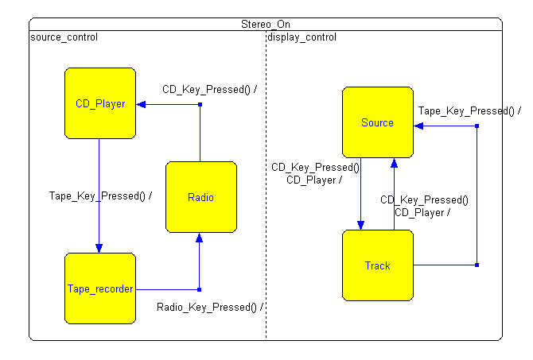
Figure 3.11 An example of using concurrent regions
The display control is running in parallel with the source control.

In the example in Figure 3.11, we added some more functionality to the state 'Stereo_On'. The state now has two concurrent regions, one called 'source_control' and one called 'display_control'. If the stereo system is playing a CD and the CD key is pressed, the display will then show the track number instead of the source. If the CD key is pressed again or the source is changed to radio, the source will be displayed again.

How can concurrent regions be used?
Concurrency allows the user to create distinct state machines for handling each independent state machine. Concurrency can be used at all hierarchical levels. It is implemented by creating concurrent regions in superstates, or by adding more than one Topstate or by adding more regions to the Topstate.

Default states
In IAR visualSTATE version 3.x and 2.x a so-called No Condition State Table is needed to initialize the state machines. If the IAR visualSTATE 3.x Diagram Designer is used, initialization can be by means of boundary points.

In IAR visualSTATE version 4 initialization is by means of default states. The default state is the state a state machine enters when it is activated. Default states are closely related to the concept of initial, history and deep history states. These three states are pseudostates. They can have one and only one outgoing transition. This transition, which is called the initial transition, enters the default state.

Initial states
When you want to simulate your design using the IAR visualSTATE 4 Validator or you want to use the generated code, you must specify the state combination the system should be in at startup. Adding initial states to all state machines can do this. An initial state is a state that is entered each time the state machine, where it belongs, is activated. This also implies that a state machine must have one initial state, but not more than one such state. An initial state is a pseudostate and the state machine will immediately, i.e. within the same step, leave the initial state and enter the default state. Thus a state machine is actually never in the initial state. See an example of how to use initial states in Figure 3.12.
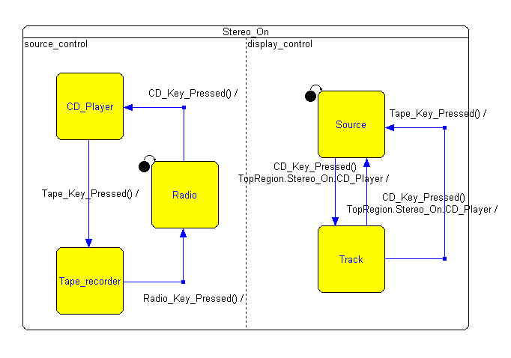
Figure 3.12 Use of initial states
In the example in Figure 3.12, the states 'Radio' and 'Source' have been selected as initial states. At startup the current state combination will be the states 'Radio' and 'Source'. If a state machine contains more than one superstate, the initial states for all levels under these superstates will also be used when going from one superstate to the other.

History states
In the IAR visualSTATE version 4 notation it is possible to obtain some kind of memory in the state machines. By using the so-called history states it is possible for a superstate to remember which state or state combination was active the last time this superstate was active, see Figure 3.13.

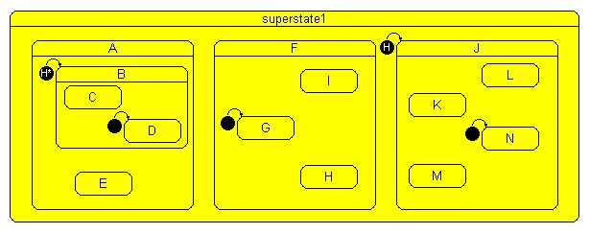
Figure 3.13 An example of how to use history and deep history states.

The example in Figure 3.13 shows how to use history states. The history state symbol is a solid circle with an H in it. The symbol that contains the letter H followed by an * is the symbol for deep history. Deep history states will be described later.

In Figure 3.13 the superstate called 'superstate1' contains three superstates, state 'A', 'F' and 'J'. State 'J' is marked with a history state. The first time 'superstate1' is activated the superstate 'J' will be activated since the history state "points" to this state. The second time when 'superstate1' is activated, the superstate last activated in 'superstate1' will be the one that is entered. The first time the state is activated, it matters which state the history state points to, but after that, the most recently activated state will be entered instead.

This kind of memory can for example be useful if some of the state machines can be "interrupted" by e.g. some external processes and then need to return to whatever the status was before the interruption. For example imagine a dishwasher that is interrupted by the door being opened while washing. When the door is closed again, the dishwasher must continue what it was doing when interrupted.

A history state only remembers the states entered at its own superstate level - not the states at lower or higher levels.

Deep history states
A deep history state will "remember" the last active state of the level where it is placed and all levels below this. In the example in Figure 3.13, a deep history state is used in the superstate 'A'. The first time state 'A' is activated, it will go into the state combination 'B' (pointed to by the deep history state) and state 'D' (pointed to by an initial state). The second time this state is entered, either state 'B' or state 'E' will be activated - depending on which one of them was active when state 'A' was left. If state 'B' is activated, the same will apply to states 'C' and 'D'.

Please note that initial states are still necessary at the levels below the level where deep history states are used - they are necessary to specify the state combination the first time the state is entered.

Unit states
Unit states are used to modularize statechart diagrams. The run-time behavior of a unit state is the same as the run-time behavior of a superstate. The difference between the two concepts is only with regard to their graphical representation in a statechart diagram.

The use of unit states offers a good overview of a highly complex system. If you choose to design a unit state, it is possible to move advanced control logic of a state to another statechart diagram instead of representing it in a superstate. An example of the use of a unit state is illustrated in Figure 3.14.

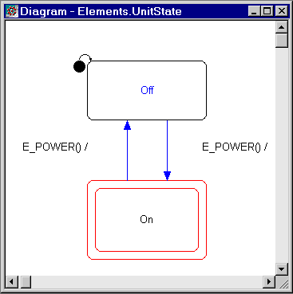
Figure 3.14 State machine with the unit state 'On'
Figure 3.14 shows a device which can be in two different states: 'Off' and 'On'. State 'On' again can have two different states: 'Auto' and 'Manual' (as shown in Figure 3.15). The state 'On' is represented as a unit state.

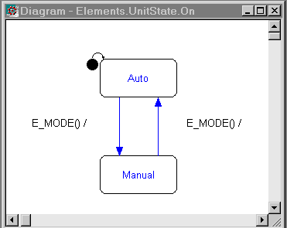
Figure 3.15 State machine contained in the unit state 'On'

Entry and exit reactions
It is possible to send actions when a state is entered or left without adding the actions to specific transitions. The actions can instead be added as entry or exit reactions, see also chapter 2.3.

Entry reactions
When entering a state, it is possible to send out actions. These actions will be sent after the actions specified on the transition itself have been sent. Entry reactions are used when the same action must be performed each time the state is entered and is equal to placing this action on each transition going to the state. Entry reactions can be sending out actions (called action functions in IAR visualSTATE version 4) or assigning a variable a certain value (for a description of assignments, see section 3.10.5). Signals can also be sent (see section 3.10.6). An example of how to use entry reactions is shown in Figure 3.16.
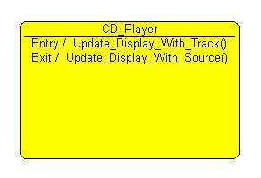
Figure 3.16 An example of how to use entry and exit reactions on states
The entry reaction will be executed when the state is entered and the exit reaction will be executed when the state is left.

In the example shown in Figure 3.16 we added some functionality to the state 'CD_Player'. When this state is entered, we update the display to write the track number the CD is playing. When leaving the state we change the display to show the source again. This is done using the exit reaction 'Update_Display_With_Source ()'.

Exit reactions
Actions can also be executed when leaving a certain state. These actions must be added as exit reactions. Exit reactions can replace actions placed on all transitions leaving the state. See an example of how to use exit reactions in Figure 3.16.

Exit reactions can consist of action functions, assignments and signals.

Internal reactions
Normally a transition will cause a state change. We can have transitions that have the same source and destination, but then all entry and exit reactions will be activated and default states will be entered. The UML notation includes a transition that will not lead to any state change. This type of transition is called an internal reaction. Internal reactions are specified for a certain state like the entry and exit reactions.

Imagine that we applied a volume control to our stereo system. We assume that our stereo system has two buttons for this purpose – one for turning up the volume and one for turning it down. These buttons will only be used for the volume control and it is only possible to use them when the stereo system is turned on. We can place the volume control as internal reactions in the state 'Stereo_On', see Figure 3.17.
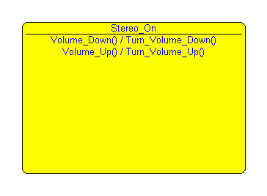
Figure 3.17 The use of internal reactions for volume control
In the example in Figure 3.17, the state 'Stereo_On' is shown without the states at the lower levels. Two internal reactions have been added to the state, one to handle the event corresponding to the “turn up” key being pressed, and one to handle the event corresponding to the “turn down” button being pressed. If we receive the event 'Volume_Down', we activate the function 'Turn_Volume_Down()' no matter which state combination the lower levels of this state are in. The same applies if we receive the event 'Volume_Up'. Then we send the action function 'Turn_Volume_Up()'.

Note that the internal reaction will not cause any state changes but presumes that the state containing the internal reaction will still be active after firing the internal reaction. If we use one of the events 'Volume_Up' or 'Volume_Down' on a transition that leaves the state 'Stereo_On' it will lead to a state conflict.

Do reactions and termination transitions
A do reaction is an ongoing activity that is invoked when its parent state is entered. It is active until it enters its final state or leaves its parent state. No other conditions than entering the state are allowed when a do reaction is invoked.

In visualSTATE a do reaction is logically interpreted as a separate state machine that is concurrent to whatever state machines may be contained in its parent state. The actual content of the do reaction is modeled in a separate statechart diagram. In the example shown in Figure 3.18, the do reaction is activated in the parent state 'Playing'.
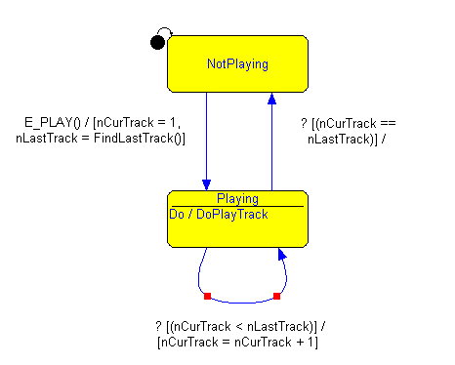
Figure 3.18 Example of the use of a do reaction

The do reaction contains a simple state named 'PlayTrack' and a final state named 'PlayTrackFinal', (see Figure 3.19).

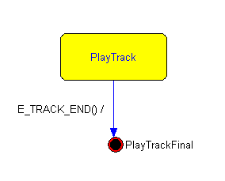
Figure 3.19 The contents of the do reaction ‘DoPlayTrack’

Final state
In the UML, a final state is used to visualize that an object or a state machine has completed its operation. In visualSTATE the use of final states is restricted to do reactions (see Figure 3.19). Final states are closely connected to termination transitions. When the conditions for a transition to a final state are satisfied, visualSTATE evaluates all transitions from the parent state of the do reaction that do not have a trigger. If all guard conditions of one of the transitions are satisfied, then the transition will fire. If none of the transitions can fire, the do reaction actually enters the final state.

Please notice that it is not possible to have a transition leaving a final state.

When the do reaction is in the state 'PlayTrack', and the event 'E_TRACK_END' occurs, the guard conditions on the two transitions leaving the state Playing will be evaluated. In this case only one of the guard conditions can be true so the state machine will either re-enter the state Playing and hence the do reaction 'DoPlayTrack', or it will enter the state 'NotPlaying'.

Termination transition
A termination transition is used in conjunction with a state that includes a do reaction (see Figure 3.18). A transition is said to be a termination transition if the following conditions are satisfied:
- The transition leaves a state that includes a do reaction.
- The transition trigger is not set.

Please be cautious when designing termination transitions because contradiction between the transitions may easily arise.

Transitions
A transition consists of a condition side and an action side. The condition side specifies the conditions that must be fulfilled for the transition to be activated e.g. which event that must occur and which state combination another part of the state event system must be in. The action side specifies which other actions to take when the transition is triggered in addition to changing state.

In the UML notation the condition side is expanded so that it is possible to have a guard consisting of a logical or arithmetic expression using variables. A new kind of “transition trigger” that can replace an event is introduced: Signals.

The action side is expanded to hold expressions where a variable is assigned a value.

Triggers
In IAR visualSTATE 4 all transitions need a trigger in the form of an event or a signal. The only exception from this rule is the so-called termination transitions, described in the section about do states, see chapter 3.9. A transition can only have one trigger. See later for a description of the use of signals.

It is possible to specify an argument for a certain event. This argument can be used when calling action functions or it can be stored in a variable for later use.
Imagine that our stereo system had a loudness button. The button is a “toggle” button that can be either activated or deactivated. If we specify only one event telling if the key was pressed we can add an argument telling whether loudness is activated or deactivated. For example we could use an event like the following: 'Loudness_Key_Pressed (int LoudnessOn)'. The argument 'LoudnessOn' must then be set to zero if loudness is deactivated, and one if it is activated.

State condition
A state condition can be set as a condition for the transition to fire. It is possible to specify that a certain concurrent state machine must be in a certain state for the transition to fire. Or that the concurrent state machine must not be in a certain state for the transition to fire, which is called negative state condition. For example a transition can have the condition 'Event1 StateB' meaning that when the event 'Event1' occurs, we check the current state of the state machine containing state 'StateB'. If this state machine is in 'StateB', the transition will be fired – otherwise it will not be fired. The event 'Event1' must occur again before we check the condition again.

Guard expressions
In the UML notation it is possible to operate on variables when designing the models. Variable expressions can be used as conditions on transitions or they can be modified on the action side of a transition.

A variable can be of different basic C types such as 'int', 'unsigned int', 'float' or 'double' (see the IAR visualSTATE 4 Reference Guide for a detailed description of the legal variable types).

An expression like the following can be used as a condition on transitions. Such expressions are called Guard expressions in IAR visualSTATE 4.

Example 4
x > y / (z – 7)

where x, y and z are variables, e.g. of the type integer.

Guard expressions must contain a comparison operator (>, <, >=, <=, !=, ==) and can only contain one variable on the left side. The right side can contain a sequence of variables separated by arithmetic or logical operators. See the IAR visualSTATE 4 Reference Guide for further information on the syntax and legal operators.

Action functions
Some of the actions that must be performed are performed using action functions. The action functions are implemented as calls to e.g. a C function with the same name as the action function. Action functions can have arguments and return values. The return values can be used in guard expressions or in assignments (see the description of assignments below). Take a look at the following action function prototype,
Example 5
float Action1 ( int Argument1, float Argument2 )

The action called 'Action1' takes two arguments, one of the type 'integer' and one of the type 'float'. It returns a value of the type 'float'.

Timer action functions
Timer action functions are a special case of action functions. They are reserved for starting a timer that may make an event occur upon timeout. Return type of timer action functions is 'void'.

Timer action functions accept two arguments. The first argument is the event and the second argument is the number of ticks before a timeout occurs.
Example 6
void TimerAction ( EventName, TimerTicks )

For the target application, it is recommended that the software developer ensure the following with regard to timer action functions,

- Specify a timer action function for starting a timer, for example from a timer pool, with the specified number of ticks before a timeout.
- Furthermore, ensure that the event to be sent is saved.
- Upon timeout, the timer response routine should send the event to IAR visualSTATE to have it processed.

During simulation with the IAR visualSTATE Validator, a timer will automatically be started when a timer action is activated. The timer start, sending an event, etc. are handled automatically by IAR visualSTATE. The user has the option of selecting the time that one timer tick should correspond to.

Assignments
It is possible to assign a value to a certain variable by adding so-called assignments to the action side of a transition, or to entry reactions, exit reactions or internal reactions.

An assignment consists of a left side and a right side separated by the operator =. The left side can only contain a variable. The right side can be an expression of variables and operators. An assignment could look like this,
Example 7
x = (y >> z ) & (q | 3)

See the Help File of the IAR visualSTATE 4 Designer for a further description of the syntax of assignments and legal operators.

Signals
An event in IAR visualSTATE can be considered an external trigger. If one wishes to make two state machines “communicate” without using external events, signals from one state machine can be used to activate transitions in another state machine.

A signal is a trigger that can only be activated from the inside of IAR visualSTATE. That is, to activate a signal, the signal must be sent from the action side of a transition.

Signals are stored in an internal signal queue and will be processed before events. Signals are handled automatically in the target code, the user only have to specify the size of the signal queue to be used in the target (this is done using the IAR visualSTATE Navigator).

Note that sending out more than one signal on the action side of a transition can cause the system to go into an infinite loop where no external events will ever be processed. Please notice this when using signals.

Testing with IAR visualSTATE 4
This chapter contains a short description of how to test the control logic designed with IAR visualSTATE. There are two different kinds of test that can be performed. The application can be verified to ensure the consistency of the model and it can be validated to ensure the functionality of the model. The validation can be done directly on the state chart model or on the C code running on the target.

Complete formal verification
The formal verification tool of IAR visualSTATE 4, called the Verificator, performs an exhaustive check of all states that can be reached in a computation. This means that every combination of events and states of all machines are checked. With the possibility of designing applications with several thousands of state combinations, manual check is not a realistic test method. The Verificator can test for so-called dead ends in the design, conflicting transitions, reachable transitions and the use and activation of elements.

Verificator setup
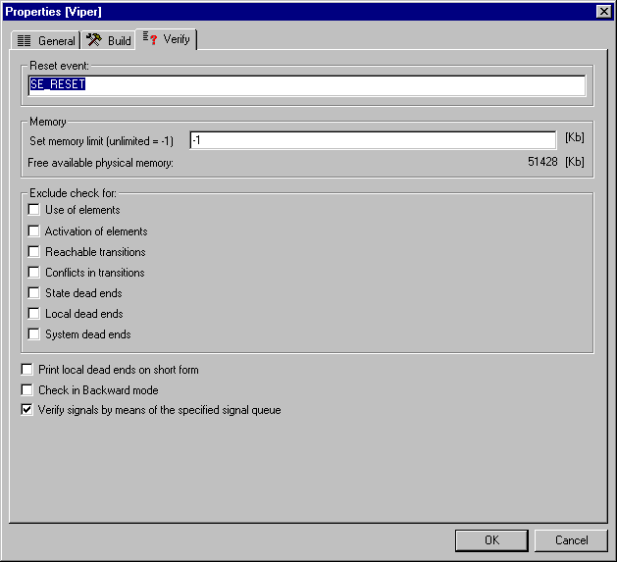

Figure 4.20 Navigator configuration dialog of the IAR visualSTATE Verificator.
The IAR visualSTATE Verificator perform eight different checks see Figure 4.20. Each check can be excluded to speed up the overall verification time.

Reset event
All state machines must be reset using the same reset event. The IAR visualSTATE Verificator will verify that all state machines are initialized with the same event. The Verificator has an option for specifying the reset event; this can be specified from the Navigator.

Use and activation of elements
The Verificator will check if all the elements that have been created in the model are used on some of the transitions. If the elements are not used on any of the transitions, a warning will be given. If some of the elements are only used on transitions that can never be activated, these elements will be reported as never activated elements.

Dead ends
Dead ends are conditions that cause the state machine to enter state combinations where no trigger, e.g. signal or event (except the reset event) can perform a change in the state combination.

State dead ends
A state dead end is a state that cannot be left once it has been entered. So the state machine stays in the state until the state machine is restarted with the resetting event.

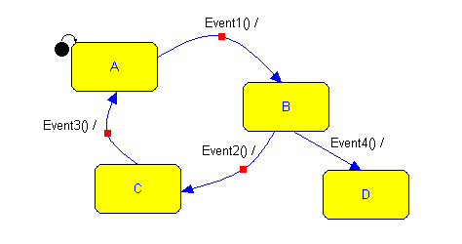
Figure 4.21 An example of a design containing a state dead end
Figure 4.21 shows an example of a design containing a state dead end. Once state 'D' is entered it cannot be left again – unless the reset event is sent.

Local dead ends
A combination of states from more state machines that prevent a state machine from changing state is a local dead end. Local dead ends can block your system in an undesired manner. In order to deal with them you have to consider whether this will be a problem or a desired behavior of your system. Local dead ends will almost always be a result of transitions with condition to other state machines.
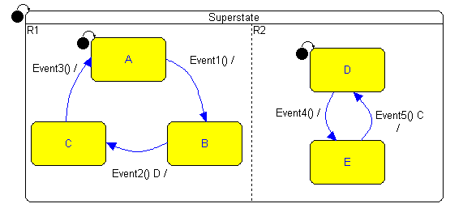
Figure 4.22 An example of a design containing a local dead end
In Figure 4.22 and example of a design containing a dead end is shown. Consider sending the following event sequence: the reset event, 'Event1', 'Event 4'. The state combination will then be 'B' and 'E'. If we now send 'Event2' the state machine in region 'R1' will not be able to move since the other state machine is not in state 'D'. If 'Event5' is sent the state machine in region 'R2' will not move since the other state machine is not in state 'C'. Thus none of the state machines can leave their current state unless the reset event is sent.

If the design contains more than these two state machines the dead end is referred to as a local dead end. If the design only contains these two state machines the dead end is referred to as a system dead end (see section 4.2.3.3).

System dead ends
A system dead end is a combination of states from all state machines, which prevents the complete system from changing state, unless the system is reset. If your system contains a system dead end you should seriously consider changing your design.

Conflicting transitions
If more transitions, that leave the same state, go to different destinations and are triggered by the same event, then there is a risk that some of these transitions might be conflicting. This happens if there is a situation where the conditions of more than one of these transitions are fulfilled and the transitions have different next states. Then it will not be possible to determine which state to change to and the system will then not be deterministic. These conflicts must be solved before the use of the system.

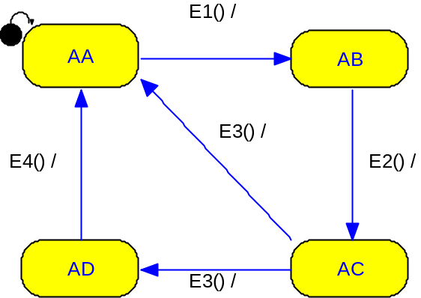

Figure 4.23 A state machine with four states.

In Figure 4.23 the event 'E3()'will cause conflicting transitions, because the event 'E3()' could perform either a state shift to 'AD' or 'AA'. This error must be corrected by either deleting one of the transitions triggered by 'E3()'or by using another event as trigger on one of the transitions. If the system is implemented in target without correcting the conflict it will lead to a run-time error.

Manual validation
Once it has been tested that the state chart model is consistent it is time to test the functionality of the application. To determine if the system fulfills the specification it is possible to perform a manual test of the systems, called a validation. This is done using the IAR visualSTATE Validator. The validation can be done directly on the state charts or on the C code running in the target.

Interactive simulation
Simulation is one of the key features of the IAR visualSTATE Validator. It makes it possible to send events into the system and see how the system reacts to this. You will be able to see the current state combination, the guards, and you will have information about which events that can trigger something in you system right now. You can follow the actions generated, including the action functions, assignments, the signals generated and the changing of system states, transition by transition.
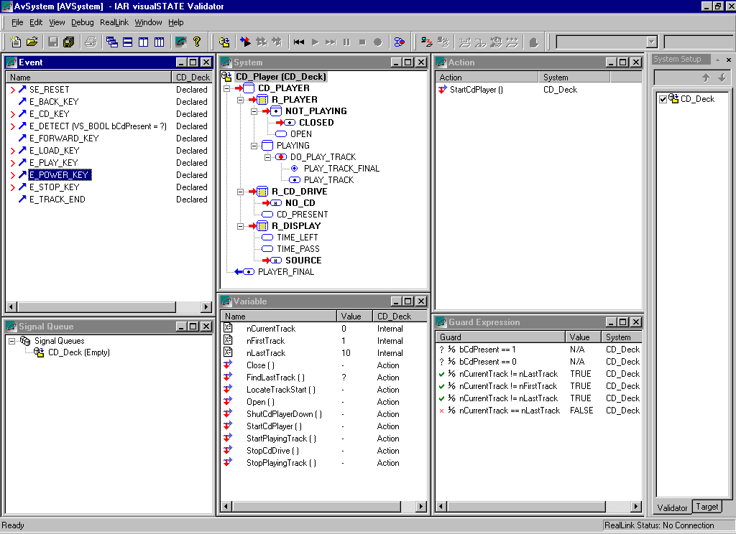
Figure 4.24 Manual simulation using the Validator

Graphical Animation
When simulating it is possible to get a graphical overview of the system. From the Validator the Designer can be opened in simulation mode. Then it is possible to follow the simulation in the state chart view. See an example in Figure 4.25.

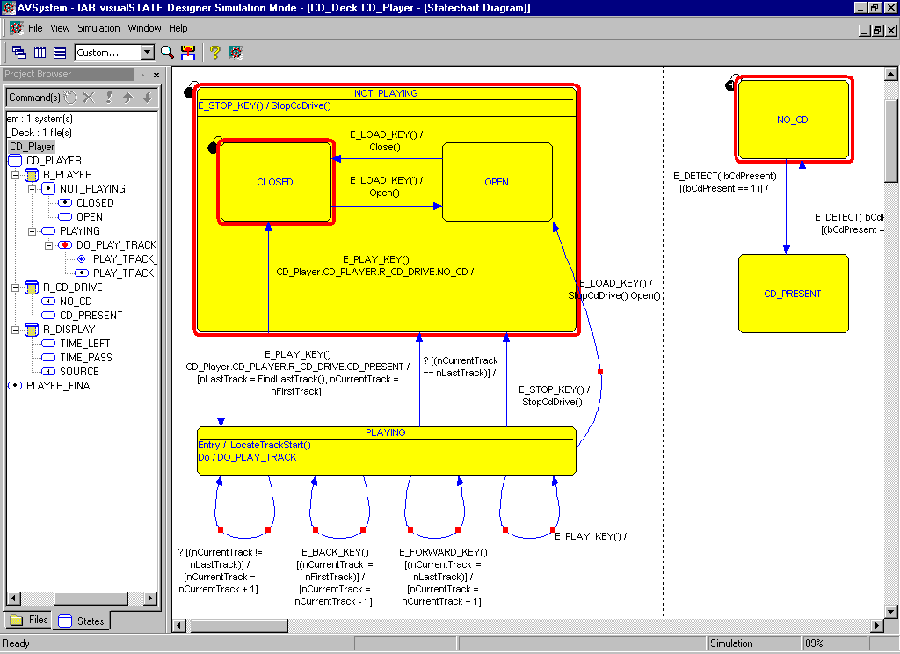
Figure 4.25 Simulation using the Graphical Animation

Breakpoints
You can set breakpoints in your application when debugging it. A breakpoint is a set of conditions where deduction should be stopped when the conditions are fulfilled, allowing you to examine the state combination, variables and actions. A breakpoint can consist of one or several conditions. If more than one condition is defined for a breakpoint, they all have to be fulfilled before a break is performed. Using breakpoints can make it easier for you when optimizing or error correcting your design.

You can also use the breakpoint to specify conditions that should for example never be fulfilled at the same time since that would mean an error in the design. You can then activate the breakpoints whenever testing the application. The breakpoints can be saved in a file if you would like to use them again in a later test.

A breakpoint can be defined on events, signals, variables, current state and next states, and action functions. It is possible to have a variable expression evaluated before and after a deduction is performed. The breakpoint pre-deduct conditions are evaluated just before deductions starts. The post-deduct conditions are evaluated just after the deduction.

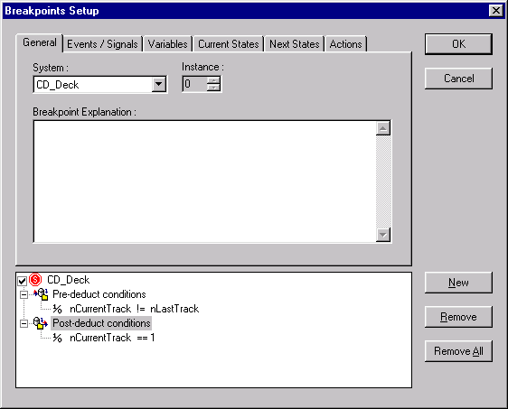
Figure 4.26 Breakpoint setup dialog

Log & Animation
In IAR visualSTATE it is possible to record and repeat a test sequence. Once the test sequence has been recorded it is possible to find the test coverage of this particular test sequence. Before you start simulating, you create a new log-file and enable recording. The log-file contains information that will let you make a complete run-time animation similar to your manual deduction steps. The animation feature replays the recorded sequence. If you made some smaller changes in your design since you recorded the test sequence, then during replay it is possible to check that the output (state changes, variables and action functions) is the same as the output recorded. This will immediately give a hint of the effect caused by a design change.

Animation
You need to initialize the system each time you start the recording of a new log-file; otherwise the “match” feature will report errors immediately when you start animating your application. The animation window shows the recorded sequence, where it is possible to single step through each deduction or use the "free run” feature, simulating a run-time environment.

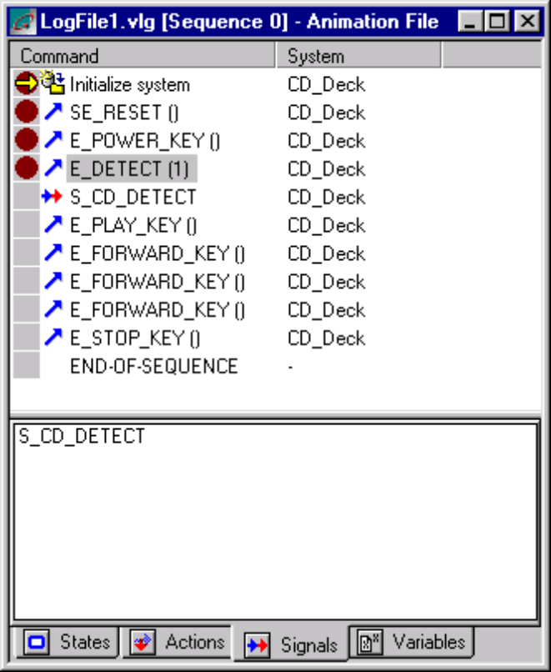
Figure 4.27 An example of a recorded test sequence
During the individual steps, the lower view shows the results of the deducted outcome, state combination which action and/or signals that are fired and the values of the variables. Furthermore, the animation has a set of useful commands,

- Free run.
- Run to cursor.
- Stop Point. Place a point on a sequence line, indicating the free run to pause.
- Pause. Continuing where you paused.
- Stop. Restarts the sequence.
- Step Forward. Perform the next command in the file.
- Undo. Undo the last action.

Static analysis
A static analysis helps to locate transitions where specific elements of your systems are used. The elements for which transitions can be analyzed are,

- Events
- Actions
- Signals
- Internal- & External-variables

Dynamic analysis
A dynamic analysis calculates the test coverage of a specific test sequence. After you have performed a validation or recorded a test sequence it is possible to perform the dynamic analysis to see what the test coverage was for this particular test. It is also possible to see what still needs to be tested to obtain a 100% test coverage. Once all the elements listed in the analysis have a test coverage of 100% you know that you have sent all events, activated all the action functions and all the transitions at least once. This test sequence can be used later when for example doing the test of the device driver code in the target.

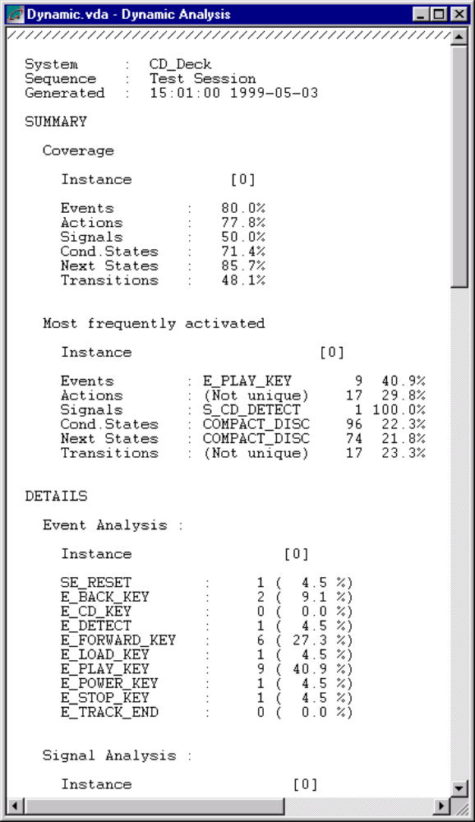
Figure 4.28 The result of a dynamic analysis

The dynamic analysis consists of a Summary and Details section.

Summary
The summary section calculates coverage percentages and finds the most frequently activated elements of those covered.

Details
In the details section you will see how many times a specific element was activated during the validation.

RealLink
Another possibility when testing is to use the RealLink facility. With RealLink it is possible to monitor and control the run-time behavior of the visualSTATE model in the target application. Some RealLink communication code is added to the target code. Then the target and the PC are connected using a communication module. It is then possible to send events to the target and monitor what is going on in the target application. The Validator is used when simulating. You can also use the Graphical Animation. Pre-recorded test sequences can also be used.

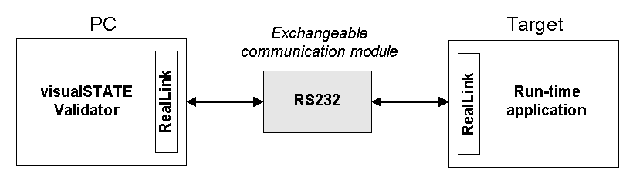
Figure 4.29 RealLink connection between the Validator and target
The connection between the Validator and the target is established by means of a communication module (see Figure 4.29). RealLink supports multiple communication formats. As standard visualSTATE is shipped with a communication module designed for RS232 communication.

IAR visualSTATE command line programs
This chapter describes how to activate the IAR visualSTATE programs from the command line. This might be relevant if for example batch files are used to compile and link the final application.

Command line modules
Both the IAR visualSTATE Coder and the IAR visualSTATE Verificator modules are developed in a stand-alone executable version.

Example 8
coder.exe -Pproject.vsp

This command will generate the C code for the VS System located in the project "project.vsp". All build options for this project is specified in the project file. This means that the code will be generated using the exact same options, file names and output directory etc. as if the code was generated from the Navigator.

Example 9
verificator.exe project.vps system0

This command will start a complete verification of the VS System 'system0' located in the project 'project.vsp',

How to handle old IAR visualSTATE statechart versions
It is possible to use IAR visualSTATE models in version 4 that were generated with IAR visualSTATE versions older than version 4. In order to be able to modify the models with version 4 programs, the models must be converted from version 2.x or 3.x TXT file format to version 4 VSR file format. In the following, the TXT file format will be called version 3.x format.

You can also import version 3.x models into version 4 projects without conversion. In this case, the IAR visualSTATE version 3 Matrix Designer must be used to modify the models.

Conversion from 3.x to 4 format
IAR visualSTATE version 3.x models can be converted to version 4 by using the program Convert3to4.exe. The program will convert the specified TXT file into a VSR file and create a new project file (VSP file format).

A number of TXT files can be converted at the same time and placed in the same project file. The TXT files can be placed in different systems of the project file. If the files are placed in the same system, their logic will be merged into one VSR file, thereby allowing shared elements between the different models. However, each TXT file will still be converted to one VSR file.

If the converted files are placed in separate systems, the files will be logically independent.
The conversion program must be run from a DOS command prompt. The program has the following call syntax,
Example 10
-P<Project> 1{-S<System> 1{-F<File>}}

where,

- 1{...} means that this option can be used one or more times
- 'Project' is the name of the destination project (use the extension '.vsp')
- 'System' is the system name
- 'File' is the name of the TXT file to convert.

To place more than one converted file in a system, specify a sequence of files using the '–F' option. To place more than one system in a project, specify a sequence of systems using the
'–S' option.
Example 11
Convert3to4 –Pproject.vsp –Ssystem –Fmobile.txt

- The version 3.x file 'mobile.txt' will be converted to a VSR file named 'mobile.vsr'
- A project file named 'project.vsp' will be created
- The project file contains one system called “system” which contains 'mobile.vsr'.
Example 12
Convert3to4 –Pproject.vsp –Ssystem –Fparity.txt –Frecsel.txt

Two VSR files are generated: 'parity.vsr' and 'recsel.vsr'. Both files are added to the same VS System called “system”. When, for example, code is generated for this project, the logic of the two VSR files will be merged.

Using version 3.x files in a version 4 project
It is possible to use version 3.x models without converting them to version 4 format but it will then be necessary to use IAR visualSTATE version 3.0 applications to modify the models.

To include a version 3.x model in a version 4 project, you have to import the TXT format files by means of the IAR visualSTATE Navigator version 4, as follows,

- Create or load a project.
- Create a system and select “Import”.

The following dialog box will now be displayed,
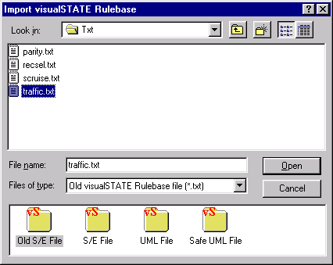
Figure 6.30 Navigator import dialog

- From Files of type, select “Old IAR visualSTATE Rulebase file (*.txt)” and select the file you want to import.
- Select the “Old S/E File” notation (if the file is a genuine old txt file, this is done for you).

If you used the version 3.x-project files (with extension SEP) and the merge option was enabled in the IAR visualSTATE Workshell 3.x, then place the TXT files in the same system.
If you do not want to merge the TXT files, then place them in separate systems.
It is possible to have projects containing TXT files as well as VSR files. You must then use different IAR visualSTATE Designer versions to modify the files.

Note: It is not possible to share elements between the two file types.

Troubleshooting
If you have problems converting files saved with the IAR visualSTATE Matrix Designer version 3.x or 2.x you should try to save the files using the IAR visualSTATE Matrix Designer 3.x where you de-select the option “Compress Cells”. Then try to convert the saved files. This will not affect the logic of the model.

API & device drivers
This chapter will provide some necessary information on how to program the source code to be used in the final application. The source code can be divided in two different types: The automatically generated code and the code that the user must write manually.

Automatically generated code
All the code representing the designed control logic is automatically generated. This code should not be modified. If it is necessary to modify the control logic the IAR visualSTATE environment should be used to do this.

To be able to use the automatically generated code some API functions included in the IAR visualSTATE environment must be used. The functions are available as C source code. Some of the functions are used to initialize all variables in the IAR visualSTATE system, a function is used to send an event to the system, a function is used to call the action functions, another one changes the state of the system on the basis of the event etc.

Application Program Structure
Figure 7.31 below shows which IAR visualSTATE Coder-generated header files and SEM Library Basic header files that must be included in the application program for the IAR visualSTATE Coder default configuration.
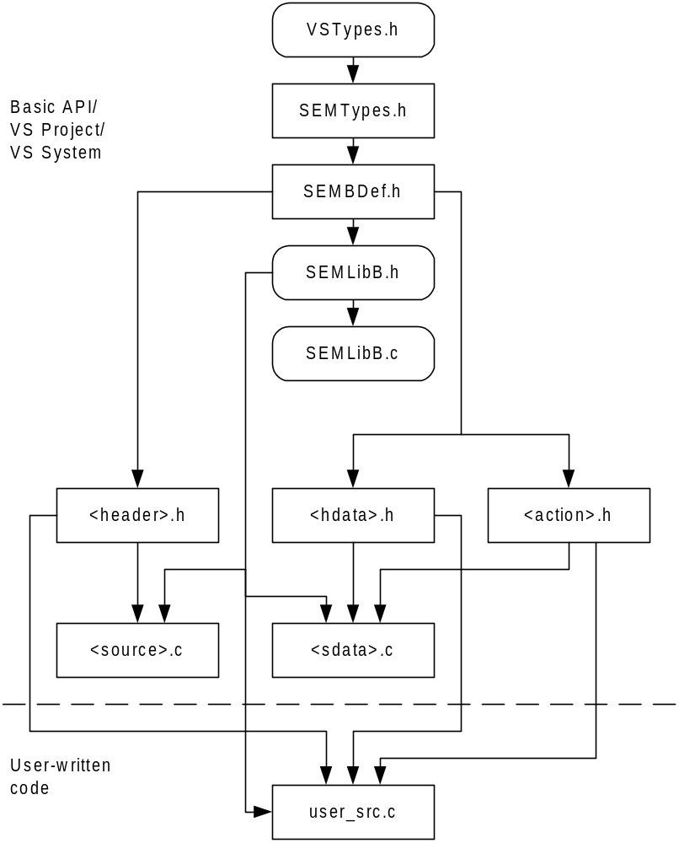
Figure 7.31 Application Program Structure for Coder Default Configuration.
For the user written application program (the user_src.c file) to work properly it must be structured as follows,

- Include the following header files in the user-written source file:
The Basic API header file SEMLibB.h.
All Coder-generated header files, i.e. <header>.h, <hdata>.h, <action>.h

- Write code which interfaces to the Basic API. First call all the required initialization functions. Then call the Basic API functions in sequences as described in section 7.4.2, Retrieving names and explanations, and Retrieving and setting states.

- Include the following source files in a make file:
The Basic API source file SEMLibB.c.
All Coder-generated source files, i.e. <source>.c, <sdata>.c
The user-written source file.

- Apply a compiler and linker to the make file. Note that the compiler must be able to locate the API header file VSTypes.h (in the SEMLibCommon directory).

Manually written code
The user must manually write two different types of code, a part containing a main-loop where the IAR visualSTATE API functions are called and a part to handle the device drivers and interface from IAR visualSTATE to the device drivers.

The user must write some code to convert the physical inputs to IAR visualSTATE events and to convert the IAR visualSTATE action functions to physical outputs. If the control of the external devices is not implemented using IAR visualSTATE, the device driver code will not be different from the usual device driver code.

API (Application Programming Interface)
The API functions can be grouped into five categories,

- Initialization
- State/Event deduction
- Inquiry
- Text handling
- Miscellaneous
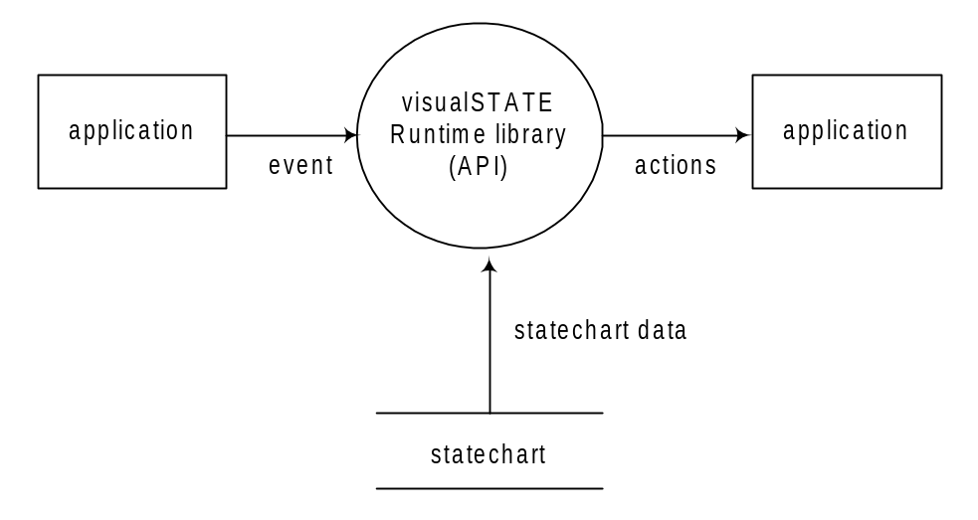Figure 7.32 Access to/from an application through the IAR visualSTATE API

Initialization
Before calling any other API functions this group of functions must be addressed first to initialize the VS System. The function SEM_Init () should always be called as the first visualSTATE API function. If you use variables or signals in your design you have to initialize these using the appropriate initialization functions. The function SEM_InitAll () will call all the listed initialization functions.

Prototypes,
- void SEM_Init ( void );
- void SEM_InitInternalVariables ( void );
- void SEM_InitExternalVariables ( void );
- void SEM_InitSignalQueue ( void );
- void SEM_InitAll ( void );

State/Event deduction
The API functions grouped here form the function that the main loop should consist of. The data flow in a deduction can be described in this way; the application program receives the event from the environment. The event is converted to an index integer, used by the SEM_Deduct. The SEM_Deduct is called to initialize the state/event deduction. If the event has parameters, they must be specified together with the event as arguments to the SEM_Deduct function.

Event parameters
Because events can have parameters, like this,
Example 13
Event1 ( VS_INT8 iCount, VS_FLOAT fValue );

it is necessary for the SEM_Deduct to receive those parameters to insure that the parameters iCount and fValue is handled as intended. To be able to call the function SEM_Deduct with a variable number of parameters, the library <stdarg.h> need to be included the source project.

Calling SEM_Deduct with the above parameters should be done like this,
Example 14
#include <stdarg.h>
if ( EventNo == Event1 )
{
/* Both the iCount and fValue should be assigned a value, properly handled in the event queue function. */

if ( SEM_Deduct ( EventNo, iCount, fValue ) == SES_OKAY )
{
/* Handle the transition action side. */
}
}

After a successful completion of the call to SEM_Deduct the function SEM_GetOutput is called successively until all action expressions are found. Optionally, instead of calling the SEM_GetOutput, it is possible to find all action expressions by one call to the SEM_GetOutputAll, this function returns an array with all actions. The SEM_GetOutput are also handling the assignment fulfillment.

After each successful completion of SEM_GetOutput the returned actions must be executed. The SEM_Action is a macro that with the action index points to a function pointer table, which again point to your written functions.

The function pointer table (FPT) contains addresses to all your action functions. In chapter 2.3, Figure 2.4, where the action A1, A2 and A3 were used, the FPT would be organized like this,
Example 15
void (* VSAction[])(void) =
{
A1,
A2,
A3
};

meaning that calling index '1' route the action function to 'A2'. The action functions will be executed in the order in which they are specified on the transitions.

When the actions are completed, meaning that all specified information about that transition is completed, the system is ready to change state. The SEM_NextState shift state and update the current state vector. Optional the SEM_State can be called to read the internal state vector of the VS System. The application program can interpret the states returned by this function.

Using the SEM_Machine, SEM_State and SEM_StateAll could inform you during run-time which state combination your system is in. This could be used for the purpose of sending status messages. Reconsider the scenario mentioned in chapter 2.3, Figure 2.4, were the use of SEM_Machine and SEM_State could be like this,
Example 16
void ShowCurrentState ( )
{
SEM_STATE_TYPE StateNo;
SEM_STATE_MACHINE_TYPE MachineNo;

if ( cc = ( SEM_Machine ( S2, &MachineNo ) ) != SES_FOUND )
Errorhandling ( cc );

if ( cc = ( SEM_State ( MachineNo, &StateNo ) ) != SES_FOUND )
Errorhandling ( cc );

printf ( "Current state is : %d", StateNo );
}

Because each state machine is given a consecutive number it is impossible to determine which state machine a given state is located in, therefore the SEM_Machine points that out.

Prototypes,
- unsigned char SEM_Deduct ( EventNo );
- unsigned char SEM_GetOutput ( *ActionNo );
- unsigned char SEM_GetOutputAll ( *ActionVector, MaxSize );
- SEM_Action ( ActionNo );
- SEM_TableAction( Table, ActionNo );
- unsigned char SEM_NextState ( void );
- unsigned char SEM_NextStateChg ( void );
- unsigned char SEM_State ( StateMachineNo, *StateNo );
- unsigned char SEM_StateAll ( *StateVector, MaxSize );
- unsigned char SEM_Machine ( StateNo, *StateMachineNo );

Below is shown an example of how the API can be accessed. The overall principle is, first of all, to initialize the engine and variables, secondly to feed events into the engine, receive and process the resulting actions and finally request a state change. The functions included in the visualSTATE Basic API is typed in bold (please also notice that all Basic API functions are prefixed with “SEM_”)
Example 17
void OS_VS_Process(void)
{
/* Define action expression variable. */
SEM_ACTION_EXPRESSION_TYPE actionExpressNo;

/* Define and initialize. In this case the reset event is SE_RESET. */
SEM_EVENT_TYPE eventNo = SE_RESET;

/* Initialize the VS System. */
SEM_Init();

/* Initialize external variables if used */
SEM_InitExternalVariables();

/* Initialize internal variables if used */
SEM_InitInternalVariables();

/* Initialize signal queue if signals are used */
SEM_InitSignalQueue();

if ((cc = DEQ_Initialize()) != UCC_OK)
HandleError(cc);

/* Do forever */
for(;;)
{
/* Deduct the event. */
if ((cc = SEM_Deduct(eventNo)) != SES_OKAY)
HandleError(cc);

/* Get resulting action expressions and execute them. */
while ((cc = SEM_GetOutput(&actionExpressNo)) == SES_FOUND)
SEM_Action(actionExpressNo);
if (cc != SES_OKAY)
HandleError(cc);

/* Change the next state vector. */
if ((cc = SEM_NextState()) != SES_OKAY)
HandleError(cc);

/* Get next event from queue */
while (DEQ_RetrieveEvent(&eventNo) == UCC_QUEUE_EMPTY)
OS_Wait (OS_VS_EVENT_PENDING, INFINITE);
}
}

Inquiry
The event inquiry ,SEM_Inquiry, is called to prepare finding the given event that can activate something given the current state combination. As the function will inquire events on the basis of the internal current state vector, the processing of the previous event should be finished, i.e. the previously called function should be SEM_NextState or SEM_NextStateChg (or SEM_Init). All events are found by continuos calls to the function SEM_GetInput. Optionally, the SEM_GetInputAll finds all events that can be used to the state shift.

Prototypes,
- unsigned char SEM_Inquiry ( void );
- unsigned char SEM_GetInput ( *EventNo, *EventList );
- unsigned char SEM_GetInputAll ( *EventVector, *EventList, MaxSize );

Text handling
The text functions could be used for getting name and explanation of the specified identifier. There are three identifier types, 'EVENT_TYPE', 'STATE_TYPE' and 'ACTION_TYPE'. Both the SEM_NameAbs and SEM_ExplAbs return the pointer to the ACSII name of the specified identifier.

Prototypes,
- unsigned char SEM_Name ( IdentType, IdentNo, *Text, MaxSize );
- unsigned char SEM_NameAbs ( IdentType, IdentNo, **Text );
- unsigned char SEM_Expl ( IdentType, IdentNo, *Text, MaxSize );
- unsigned char SEM_ExplAbs ( IdentType, IdentNo, **Text );

Miscellaneous
Besides all the functions mentioned above, the API contains miscellaneous functions that can be useful when developing the application. It is possible to ask for the number of signal in the signal queue and to force the current state combination into a certain state combination.

Signals
When using signals, see chapter 3.10.1, it is important to notice that signals have higher priority than events. Because the signals are handled first, signals that generate further signals can cause a possible race condition or a live lock.

The generated signals are added to the internal signal queue, which size you must specify before building the code. This queue is a variable that contains a finite specified number of elements. It is possible to enable an error message during run-time that notifies that adding the next signal causes a full queue situation. The size of the signal queue can be verified by the Verificator.
A special API function is usable during target testing, SEM_SignalQueueInfo returns the actual used signal queue size.

Prototypes,
- void SEM_SignalQueueInfo ( *NofSignals );

Force state
Using the SEM_ForceState function it is possible to write a new state combination in the current state vector, overruling the current state combination. This could give some non-deterministic behavior, which could cause dead ends. The function should be used with care but can be useful for the purpose of for example error handling.

Prototypes,
- unsigned char SEM_ForceState ( StateNo );

Instances
If a number of identical VS Systems must be used in the application, as when controlling 10 identical devices, the solution is to use instances. The VS System exists in only one location in the memory. The only information multiplied is the current states and internal variables. Thus for each instance, a copy of the current states and internal variables is kept. This means that it is illegal to change instance when states may be changing, i.e. in the middle of a SEM_Deduct - SEM_GetOutput - SEM_NextState sequence.

Prototypes,
- unsigned char SEM_InitInstance ( void );
- unsigned char SEM_SetInstance ( Instance );
- unsigned char SEM_SaveInstance ( Instance );

Using instances IAR visualSTATE handle a complete set of independent internal variables and current state vector. This means that when shifting between the instances, the values of those will be saved and loaded to meet the select instance values obtained just before changing instance.

Completion codes
Each API function with return type specified, return a completion code according to the given result and situation. It is always important to check the completion code after each function call.

Device drivers
It is necessary when using visualSTATE (as well as when not using visualSTATE), to write some code to handle the devices used for the application. The device driver code that must be written when using visualSTATE is not any different from the code you need when not using visualSTATE. You just have to remember to provide the right interface to the events and actions functions you have defined in visualSTATE.
Example 18
void ScanButtons( struct Queue *pQueue )
{
static signed int iLastScan;
signed int iScan = (~_SIM.PORTF1 & 0xFF);

if( iScan != iLastScan )
{
if( ( iScan ^ iLastScan ) & 0x80 )
{
if( iScan & 0x80 )
AddEventToQueue( pQueue, ePlusRight );
}
if( ( iScan ^ iLastScan ) & 0x40 )
{
if( iScan & 0x40 )
AddEventToQueue( pQueue, eMinusRight );
}
iLastScan = iScan;
}
}

Run-time requirements
Reading this chapter gives you some ideas about the code size (ROM) of the IAR visualSTATE API using the most common C compilers. Issues like compiler requirements and double buffering are also taken into consideration.

Compiler requirements
The code that is generated by visualSTATE is ANSI C code. Most ANSI C compliant compilers are able to compile and link the code generated by visualSTATE. Some non-ANSI C compliant compilers can also compile and link the visualSTATE generated code. Below is a list of some of the requirements for the compiler in order to be able to compile the visualSTATE code.

- If event parameters are used, the stdarg.h library must be included.
- Compilation directives, e.g. #if, #else, #ifdef etc. must be supported
- The use of typedef must be supported
- A structure should be able to contain more than 255 bytes

Double buffering
Double buffering is used in connection with the evaluation of guards. Double buffering ensures that during the evaluation of guards, the operands used in the evaluation have the same value as they had just before the deduction started. In this way the execution of the state charts will always be deterministic.

All variables used in both assignments as well as guard expressions, will be double buffered, it the assignments and guard expressions can be activated by the same event.

Code Sizes
In the following, some examples of the sizes of the Basic API are shown, using different compilers.

8-bit Compiler (IAR Motorola 68HC11)
Table 8-1 below shows the code size of the API function for a small and a large memory model after compilation of the SEM Library Basic with an IAR Motorola 68HC11 compiler.

API function | Memory model  (size in bytes)
 | Small | Large
SEM_Init | 47  (50) | 53  (56)
SEM_InitSignalQueue | 10 | 10
SEM_SignalQueuePut | 46 | 47
SEM_SignalQueueGet | 39 | 42
SEM_InitInstance | 33 | 38
SEM_SetInstance | 79 | 89
SEM_SaveInstance | 74 | 83
SEM_Deduct (generated by the Coder) | 351 | 372
SEM_GetOutput | 691  (715) | 777  (804)
SEM_GetOutputAll | 81 | 81
SEM_NextState | 98 | 107
SEM_NextStateChg | 134 | 147
SEM_Inquiry | 15 | 16
SEM_GetInput | 345 | 391
SEM_GetInputAll | 86 | 86
SEM_Name | 201 | 201
SEM_NameAbs | 117 | 117
SEM_Expl | 195 | 195
SEM_ExplAbs | 112 | 112
SEM_State | 29 | 29
SEM_StateAll | 55 | 55
SEM_Machine | 29 | 29
SEM_ForceState | 33 | 31
Total | 2827  (2890) | 3022  (3092)
Table 8-1 API size with 8-bit compiler, version 4 code generation
The values in brackets are the sizes with SEM_NextStateChg enabled and SEM_NextState disabled.

16-bit Compiler (IAR Hitachi H8)
Table 8-2 below shows the code size of the API function for a small and a large memory model after compilation of the SEM Library Basic with an IAR Hitachi H8 compiler.

API function | Memory model  (size in bytes)
 | Small | Large
SEM_Init | 76  (82) | 116  (124)
SEM_InitSignalQueue | 20 | 26
SEM_SignalQueuePut | 72 | 100
SEM_SignalQueueGet | 62 | 86
SEM_InitInstance | 52 | 76
SEM_SetInstance | 102 | 144
SEM_SaveInstance | 98 | 138
SEM_Deduct (generated by the Coder) | 454 | 646
SEM_GetOutput | 936  (968) | 1414  (1474)
SEM_GetOutputAll | 80 | 84
SEM_NextState | 130 | 194
SEM_NextStateChg | 180 | 276
SEM_Inquiry | 22 | 26
SEM_GetInput | 480 | 706
SEM_GetInputAll | 90 | 102
SEM_Name | 160 | 222
SEM_NameAbs | 102 | 176
SEM_Expl | 160 | 222
SEM_ExplAbs | 102 | 176
SEM_State | 26 | 40
SEM_StateAll | 48 | 72
SEM_Machine | 26 | 36
SEM_ForceState | 30 | 50
Total | 3380  (3468) | 4938  (5088)
Table 8-2 API size with 16-bit compiler, version 4 code generation
The values in brackets are the sizes with SEM_NextStateChg enabled and SEM_NextState disabled.

32-bit Compiler (IAR National Semiconductor CompactRISC CR32)
Table 8-3 below shows the code size of the API function for a small and a large memory model after compilation of the SEM Library Basic with an IAR National Semiconductor CompactRISC CR32 compiler.

API function | Memory model  (size in bytes)
 | Small | Large
SEM_Init | 74  (80) | 90  (98)
SEM_InitSignalQueue | 20 | 26
SEM_SignalQueuePut | 66 | 80
SEM_SignalQueueGet | 58 | 72
SEM_InitInstance | 50 | 60
SEM_SetInstance | 100 | 118
SEM_SaveInstance | 96 | 112
SEM_Deduct (generated by the Coder) | 420 | 462
SEM_GetOutput | 1022  (1058) | 1244  (1286)
SEM_GetOutputAll | 82 | 82
SEM_NextState | 140 | 160
SEM_NextStateChg | 196 | 226
SEM_Inquiry | 22 | 26
SEM_GetInput | 480 | 600
SEM_GetInputAll | 86 | 86
SEM_Name | 156 | 156
SEM_NameAbs | 114 | 114
SEM_Expl | 156 | 156
SEM_ExplAbs | 114 | 114
SEM_State | 24 | 24
SEM_StateAll | 54 | 54
SEM_Machine | 24 | 24
SEM_ForceState | 30 | 30
Total | 3452  (3550) | 3954  (4070)
Table 8-3 API size with 32-bit IAR compiler, version 4 code generation
The values in brackets are the sizes with SEM_NextStateChg enabled and SEM_NextState disabled.

32-bit Compiler (Microsoft C/C++ Compiler)
Table 8-4 below shows the code size of the API function after compilation of the SEM Library Basic with a Microsoft C/C++ compiler.

API function | Size in bytes
SEM_Init | 89  (96)
SEM_InitSignalQueue | 35
SEM_SignalQueuePut | 87
SEM_SignalQueueGet | 87
SEM_InitInstance | 60
SEM_SetInstance | 122
SEM_SaveInstance | 113
SEM_Deduct (generated by the Coder) | 423
SEM_GetOutput | 1280  (1314)
SEM_GetOutputAll | 125
SEM_NextState | 174
SEM_NextStateChg | 234
SEM_Inquiry | 29
SEM_GetInput | 639
SEM_GetInputAll | 131
SEM_Name | 266
SEM_NameAbs | 139
SEM_Expl | 266
SEM_ExplAbs | 139
SEM_State | 32
SEM_StateAll | 65
SEM_Machine | 32
SEM_ForceState | 36
Total | 4451  (4552)
Table 8-4 API size with 32-bit Microsoft C/C++ compiler, version 4 code generation

The values in brackets are the sizes with SEM_NextStateChg enabled and SEM_NextState disabled.

Maintenance
For IAR visualSTATE systems, the following files should always be stored,

.vsp files (IAR visualSTATE project)
.vsr files (IAR visualSTATE statechart)

These files are absolutely necessary for purposes of maintenance and reuse, whereas the following types of files could be labeled “nice-to-have” files,

- The C-code generated automatically by the IAR visualSTATE Coder
- Workspace files from IAR visualSTATE Navigator and IAR visualSTATE Validator
- Files generated during test using the IAR visualSTATE Validator

visualSTATE files and name extensions
The most commonly used visualSTATE file types are listed in the table below,

File extension | Description
vsp | visualSTATE project file, contains system information, the statechart file information, global element declarations, state conditions between topstates and visualSTATE Coder options
vsr | visualSTATE Statechart file, contains local element declarations and logic
bk<x> | visualSTATE Designer backup files
vst | visualSTATE Designer interval backup files
nws | visualSTATE Navigator workspace files
vws | visualSTATE Validator workspace files
vlg | visualSTATE Validator log files and animation files
vsa | visualSTATE Validator static analysis files
vda | visualSTATE Validator dynamic analysis files
___ | visualSTATE Validator workspace backup files
Table 9-5 visualSTATE file extensions

Exercises
The purpose of the exercises in this section is to give you an understanding of specifications and how to make them into complex or simple designs. Each specification can be designed with or without the hierarchical methods. Please be aware that the specifications just represent simple examples. It is better to focus on getting a nice design than to make sure to get all the details of the functionality right.

Specification of a car compartment light

Functionality
- The car compartment light will be turned on when one or more of the doors are opened.
- In the compartment there is a manual switch which makes it possible to select the following three light options,
Off - even when the doors are opened, the light will not be turned on.
Door-sensitive mode
On - turns on the light.
- When the door is locked from the outside, the light should go off.
- The car compartment controls makes no distinction between the different doors.

Extra: The light should be turned off gradually - in a 10-step process. Only when the car is locked the lights should go off immediately.

Specification of a car window control

Functionality
- Two buttons control the window, one for moving the window up, and one for moving the window down.
- When one of the buttons is pressed, the window should move up or down by 10% of the total distance.
- Pressing a button down a second time within 2 seconds should cause the window to move to the complete open/closed position.
- If an arm or head is detected in the window frame, the window should open completely.
- The car contains several automatically operated windows, but each window is operated individually.

Specification of an elevator

Functionality
- The elevator is controlled by only one button by which it is possible to order the elevator to the floor where you stand.
- The elevator comprises three floors meaning that the elevator cannot move directly from floor 1 to 3, but must pass through floor 2. Consequently movement from floor 3 to 1 requires passing floor 2.
- The elevator’s initial position is floor 1.
- Pressing a button on a certain floor means that the elevator moves to that floor.
- For security reasons, it should only be possible to open the door when the selected floor is reached.
Hint: By using the history state tool the elevator will “remember” the floor position.

Specification of a washing machine

Functionality
A program selector controls the machine. Functionality is as follows,

- Water is taken in through 1 of 3 valves. Water for pre-washing is taken in through Valve 1, water for rinsing is taken in through Valve 2 and water for main-wash is taken in through Valve 3.
- When starting the pump, used water is pumped out. A sensor tells when the machine is empty of water, or when the machine is full of water.
- An engine turns the washing cylinder in both right and left direction. The engine runs slowly during washing and fast during spinning. When spinning the direction is not changed.
- During washing the cylinder turns 6 times to the right and 6 times to the left. A pulse counter register each time the cylinder passes the top point.

Control
- There is only one washing program.
- The pre-wash runs for 7 minutes.
- Rinsing runs for 3 minutes.
- The main wash runs for 9 minutes.
- Rinsing runs for 3 minutes.
- The pump runs until the machine is empty of water.
- There is only one rinse after the main wash and one rinse after pre-wash.
- Spinning speed is twice the normal wash speed and is running for 1 minute.

Hint: The most optimal is to design the application using parallel state machines.

Valid parameter types do not include pointers (*, &). However it is possible to use the void pointer.

