**AGENTS**

**Perceiving** its environment through **sensors**

**Acting** at environment through **actuators**

Agent = Architecture(sensors,actuators) + Program(thinking mechanism)

Perceive, Think, Act

Dual world = agent + environment

first step=specify task environment

**Task environment = PEAS**

Performance measure (agent can measure itself)

Environment

Actuators ()

Sense (sensors)

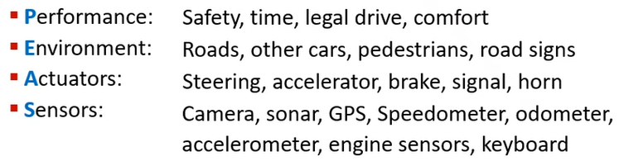 self driving car

Properties of TEAS

Observable: -**Fully**(chess) -**Partially**(vacuum cleaner,car)

Agent: -**Single**

-**Multi** --> -Competitive -Collobarative(car)

Certainty: -**Deterministic**(öngörülebilir,chess) --> -strategic

-**Stochastic**(partially observable,olasılıksal olarak bilinir)

-**Episodic**(diğer partın sonucunu etkilemiyor) -**Sequential**(current decision effects all future decisions,car)

-**Static**(env not change while agent think) -**Dynamic**(have to decide each moment)

-**Discrete**(distinct states,chess) -**Continious**(car)

Rules of the game, environment -**Known**(outcomes of actions are given) -**Unknown**(learn on the go)

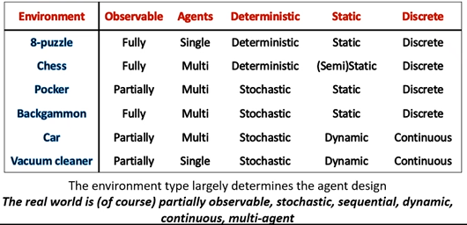

Deterministic: depends on current state

Fully observable and deterministic – chess

Episodic: divide into episodes

Static: (chess,poker,games) Dynamic: (car)

Unknown: (new vacuum cleaner)

Agent Types

1.Simple reflex: condition -> action. No history. (present)

2.Model-based: does not consider future (keep track of +past)

3.Goal-based: choose btw different alternatives (+future -> what will happen if i do this?)

4.Utility-based: many conflicted goals. max Happiness (+goals)

-Goal based – problem saving agents

Considers the impact of actions on future states

Learning Agents (Goal and Utility based)

4 components:

Leraning Element: improves performance element

Performance: chooses actions

Critic: how well the agent

Problem Generator: suggests innovative actions

How the components work together?

-Atomic Representation – states (i am in antalya)

-Factored Representation – states + attribute values (and weather is sunny)

-Structured Representation – states include objects have attributes have relationships to other objects relation btw dif states. (NLP-context)