Image: 2d distrubiton of intensity or color

To process images, must:

– obtain images—capture the scenes via hardware

– represent images—encode them numerically

Large pinhole = blurry image

Small pinhole = sharp but noise (hard to collect enough light

Refraction – kırılma özelliği

Lenses – gather more light, need to be focus

Projection

Mapping from world to image

Not 1 to 1 (3d-2d)

How many

1. Perspective projection (human)

2.Orthographic projection (phone lenses)

Affine transformations

- Scaling

- Reflection

- Rotation

- Translation: add constant to x – koordinatları

Aperture: controls the lens opening / depth of field (arkası blur)

Exposure: light amount of sensor

metin içeren bir resim

Açıklama otomatik olarak oluşturulduShutter speed: faster-less light-sharp – fast car

Slower - blur

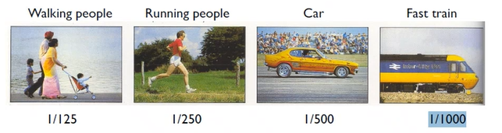

Image Representation

Discretization

-sampling(in space) -quantization(in brightness)

Digital image: 2d dicrete function f

Pixel: smallest element f(x,y)

With alpha: png – not background

Color Spaces

Hue: rengin kendisi

Saturation: yüksekse cart

Lightness(value): parlak - light amount