# **Capstone Project Report**

## 

## 

## 

## **The Relationship Between Gun Background Checks and Gun Death Rates**

## 

## **Introduction**

### **Summary**

This report presents a detailed analysis of gun background checks per capita and age-adjusted gun death rates across the United States for the year 1999 to 2019. It explores the data's complexities, discusses the challenges encountered, and provides insights into regional trends. The analysis also highlights states with extreme values, addressing data quality and tidiness issues while offering implications for public policy and safety.

This project explores the relationship between gun background checks per capita and age-adjusted gun death rates across the United States. The purpose is to identify patterns, trends, and potential policy implications of the data collected from 1999 to 2019.

### **Objectives**

* To analyse the correlation between gun background checks per capita and gun death rates.
* To visualise the geographic distribution of gun background checks and death rates in 2019.
* To identify states with notable trends and suggest areas for further research and policy development.

## 

## **Materials and Methods**

**Data Sources**:

* Background check data was retrieved from the FBI’s National Instant Criminal Background Check System (NICS).
* Gun death rates were sourced from the Centers for Disease Control and Prevention (CDC).

**Data Processing**:

**Cleaning and Preprocessing**:

* The datasets underwent cleaning procedures, where missing data, particularly in age-adjusted death rates, were addressed by calculating midpoints of the confidence intervals. This approach minimised the impact of missing data on the analysis.
* Both datasets were aligned by state and year identifiers to ensure consistency. This involved merging the datasets on common columns and ensuring that state names and abbreviations matched. This also ensures accuracy in the analysis.
* Per capita metrics and age-adjusted rates were calculated to standardise the analysis across varying population sizes.

**Data Quality and Tidiness Issues**:

* The datasets initially contained various redundant columns and inconsistencies in state naming conventions (e.g., “New-York State” vs. “New York”). These were resolved by standardising names and removing unnecessary columns.
* Also, columns were assigned their appropriate data types to ensure and aid proper analysis.

**Analytical Techniques**:

* **Statistical Analysis**: Descriptive statistics to understand the data distribution. Employed to ascertain mean values and variability (standard deviation) for both yearly and state-wise trends.
* **Correlation analysis:** Used to explore the relationship between checks per capita and death rates.
* **Trend Analysis:** Used to observe how background checks and gun deaths have evolved over time.
* **Geospatial Analysis**: Employed to visualise the geographical distribution of gun death rates and background checks in the most recent year (2019), helping to identify regional patterns and hotspots.

### **Tools Used**

* Python for data manipulation and analysis.
* GeoPandas and shapely for geospatial analysis.
* Matplotlib for generating plots.

## 

## **Results**

### **Descriptive Analysis**

Descriptive statistics provided an overview of the data, revealing significant variability in both background checks and death rates across different states and years.

**Trends Analysis**:

**Figure 1:** Trends in gun background checks and gun death rates (1999-2019)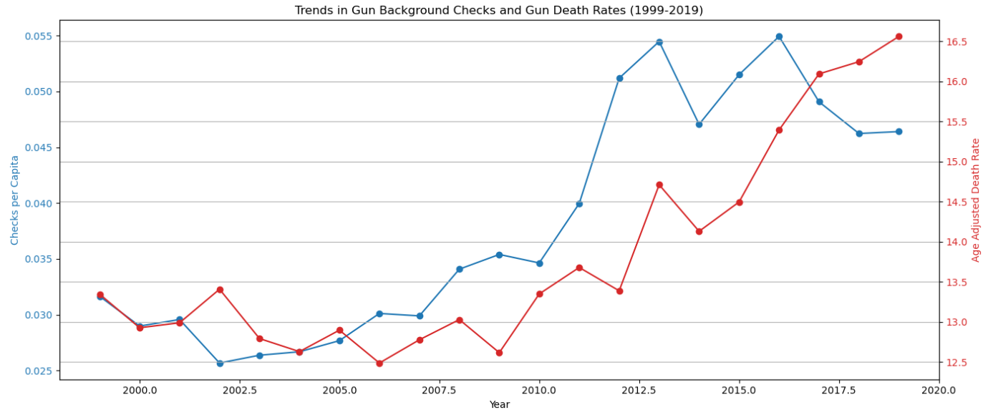

As shown in figure 1 above, an increase in background checks per capita was observed from 1999 to 2019, with significant variability in the standard deviation over the years. Age-adjusted gun death rates showed fluctuations but generally increased, peaking in 2019.

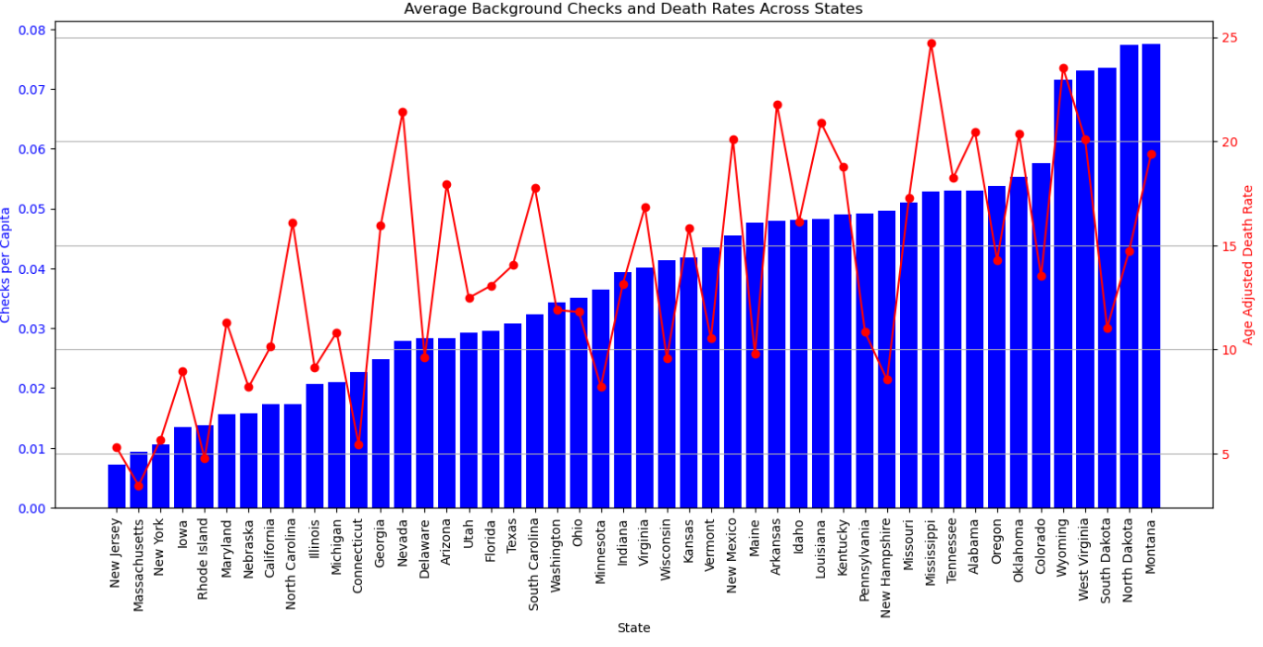

**Figure 2:** Average background checks and death rate accross states (1999-2019)

Highest Checks Per Capita: Montana showed the highest checks per capita, suggesting either a high level of gun purchases or efficient enforcement of background checks.

Lowest Checks Per Capita: New Jersey had the lowest, which might indicate stringent gun control laws or lower gun ownership rates.

Highest Death Rates: Mississippi reported the highest age-adjusted death rate, highlighting potential issues in gun violence or lack of effective gun control measures.

Lowest Death Rates: Massachusetts had the lowest, possibly reflecting effective legislation and public health interventions.

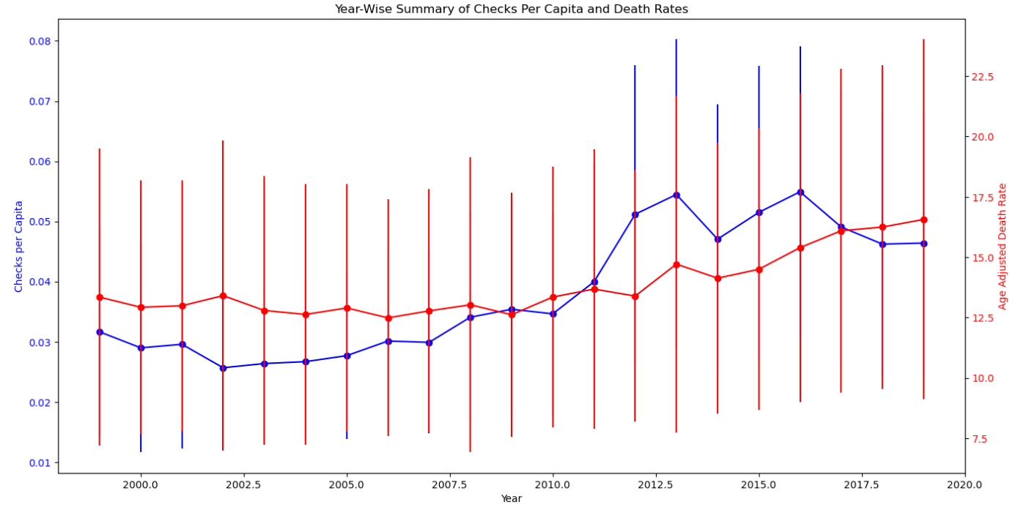

**Figure 3:** Year-wise summary of background checks per capita and death rates

### Figure 3 above showed a noticeable increase in checks per capita (blue line) over the years, particularly after 2012. This trend reflects a growing number of background checks relative to the population, possibly due to increased firearm purchases or stricter enforcement of background checks. The standard deviation (error bars) indicates moderate variability across states, with some years showing more consistency in the data than others.

### Also, the age-adjusted death rate exhibits fluctuations, but there is a discernible upward trend starting around 2013, peaking in the later years. The error bars suggest increased variability in death rates across states, particularly in the latter years. This could reflect differing state-level factors impacting gun violence.

### **Correlation Analysis**

A moderate positive correlation (0.538879) was observed between checks per capita and age-adjusted death rates, suggesting that as the number of background checks per capita increases, there tends to be an increase in the gun death rate. However, this correlation is not strong enough to imply causation, and other factors might play significant roles.

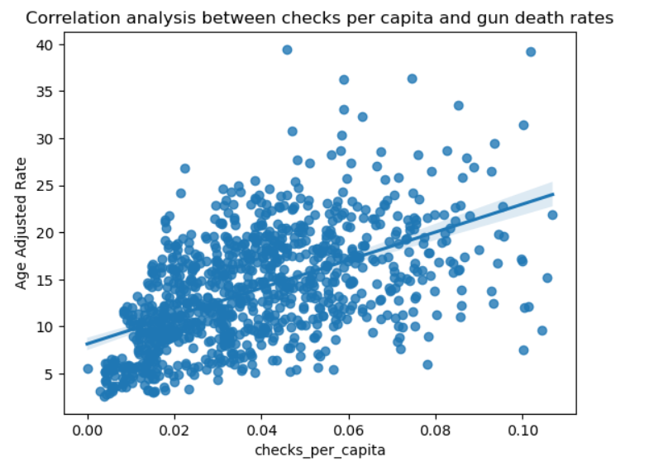

**Figure 4:** Correlation analysis between checks per capita and gun death rates

### **Geospatial Analysis**

Maps generated for 2019 showed distinct geographic patterns:

* **Regional Patterns**: The analysis revealed clear regional differences, with the Midwest and Southern states generally exhibiting higher death rates and checks per capita.
* **Hotspots**: States like Wyoming, Alaska, and Mississippi emerged as hotspots for high death rates, while states like New Jersey and Massachusetts demonstrated lower rates.

## 

## 

## 

## 

## **Figure 5:** US map showing gun background checks per capita (2019)

## 

## 

## 

## 

## 

## 

## 

## **Figure 6:** US map showing age adjusted gun death rate (2019)

## **Discussion and Conclusion**

### **Key Findings**

**1. Data Quality and Tidiness Issues**:

* **Inconsistent State Naming**: Initial inconsistencies in state naming conventions across datasets (e.g., “New-York State” vs. “New York”) were resolved through standardisation, but these discrepancies underscored the challenges in merging diverse datasets.
* **Handling of Missing Values**: Missing data, particularly in the age-adjusted death rates, were managed by imputing values based on confidence intervals. This approach helped maintain the integrity of the analysis but also highlighted the importance of complete and accurate data reporting.

**2.**  **Correlation Between Background Checks and Gun Death Rates**:

* The analysis revealed a moderate positive correlation between background checks per capita and gun death rates. This suggests that while background checks are increasing, they alone may not be sufficient to curb gun-related fatalities. Other factors, such as socio-economic conditions, enforcement of laws, and cultural attitudes towards guns, play significant roles.

**3.** H**igh Death Rates Despite High Background Checks**:

* States like Montana and Mississippi had both high checks per capita and high death rates, indicating that increased background checks do not necessarily equate to lower gun deaths. This finding highlights the complexity of the issue and suggests that background checks, while important, need to be part of a broader strategy to effectively reduce gun violence.

**4. Regional Disparities in Gun Death Rates and Background Checks**:

* **Midwest and Southern States**: These regions showed higher age-adjusted gun death rates and background checks per capita. States like Mississippi and Wyoming were particularly notable for their high death rates, suggesting significant challenges related to gun violence in these areas.
* **Northeastern States**: Generally, the Northeastern states exhibited lower rates of both gun background checks and gun-related deaths. States like Massachusetts and New Jersey had some of the lowest death rates and checks per capita, indicating effective gun control policies or cultural factors that discourage gun violence.

#### **Recommendations**

**1. Policy and Legislative Recommendations**:

* **Targeted Gun Control**: States with high gun death rates despite extensive background checks, like Mississippi, may need to implement more stringent gun control measures, or be modelled using states with high background checks but low death rates for effective gun control policies.
* **Support for At-Risk Regions**: Federal and state governments should consider providing additional resources and support to states with high gun violence rates. This could include funding for community-based violence prevention programs, mental health services, and law enforcement training.

**2. Need for Comprehensive Strategies**:

* **Beyond Background Checks**: The findings suggest that background checks alone are not a panacea for gun violence. A more holistic approach is needed, incorporating community education, economic development, and mental health interventions, particularly in regions with high gun death rates.
* **Regional Approaches**: Given the significant regional disparities, a one-size-fits-all approach to gun control is unlikely to be effective. Policymakers should tailor strategies to the specific needs and circumstances of each state, taking into account local culture, socio-economic conditions, and existing gun laws.

**3. Further Research**:

* **Understanding Correlations**: The moderate positive correlation between background checks and gun death rates warrants further investigation. Researchers should explore the underlying causes of this relationship, considering factors such as illegal gun ownership, differences in law enforcement practices, and the impact of socio-economic variables.
* **Improving Data Collection**: To support more effective policy making, there is a need for improved data collection and reporting on gun-related incidents, background checks, and law enforcement actions. This includes standardising data across states and ensuring that all relevant variables are captured consistently.

**4. Public Awareness and Education**:

**Community Outreach**: Public health campaigns and community outreach programs are essential in educating the public about the risks of gun ownership and promoting safe practices. These efforts should be particularly concentrated in states with high gun death rates and should involve collaboration between government agencies, non-profits, and local communities.

## 

## **Conclusion**

The findings of this report underscore the complex nature of gun violence in the United States and the limitations of relying solely on background checks as a preventive measure. The data highlights significant regional disparities and the need for tailored, multi-faceted approaches to reduce gun-related fatalities. By addressing these issues through informed policy-making, comprehensive strategies, and continued research, the U.S. can make meaningful progress in reducing gun violence and improving public safety.

Further research is recommended to explore these relationships in more detail and to develop targeted interventions based on regional needs and characteristics.

## 

## **References**

* kaggle.com
* Google dataset
* Stackoverflow