|  |
| --- |
| **Destination Analysis and Targeted Marketing for Egyptian Tourism** |

### **Ramy Anwar El-Adl** [ramy.a.eladl@gmail.com](mailto:ramy.a.eladl@gmail.com)

### **Mohamed Khaled** [m.salem250@gmail.com](mailto:m.salem250@gmail.com)

### **Amr Essam** [amrmoustafa5@gmail.com](mailto:amrmoustafa5@gmail.com)

### **Omnia Gad** [omnia.gad92@gmail.com](mailto:omnia.gad92@gmail.com)

### **Nesma Silman** [Nesma.silman@gmail.com](mailto:Nesma.silman@gmail.com)

**1. Introduction**

## Tourism is an essential aspect of Egypt’s economy, and understanding the preferences and interests of tourists can help promote specific locations as an appealing tourist destination effectively. To achieve this goal, we will conduct comprehensive research and gather data from various sources. We will then use machine learning algorithms to analyze this data and identify patterns and trends that can help us understand tourists' preferences better.

By leveraging the power of machine learning, we will gain valuable insights into the key factors that motivate tourists to choose specific destinations. This information will enable us to develop effective marketing campaigns that target specific tourist segments and promote Egypt's unique attractions.

We are excited to embark on this journey and look forward to working on this project. We are confident that our efforts will help position Egypt as a top tourist destination and boost the country's tourism industry.

## **2. Project Objectives**

## Destination Analysis: Conduct an in-depth analysis of popular tourist destinations in selected countries to identify key factors that attract visitors. This analysis will include factors such as cultural heritage, natural landscapes, historical significance, recreational activities, and overall experience.

## Tourist Preferences: Collect data through online platforms to understand tourists' preferences and their experiences in various destinations. This will help identify the aspects of these destinations that resonate most with tourists.

## Comparative Analysis: Compare the findings from different tourist destinations to identify common themes and patterns. Determine the unique selling points and competitive advantages of Egypt as a tourist destination in comparison to other countries.

## **3. Expected Deliverables**

## Comprehensive analysis of popular tourist destinations in selected countries.

## Detailed report on tourist preferences and what they find appealing in these destinations.

## Comparative analysis highlighting Egypt's unique selling points and competitive advantages.

**4. Dataset and Features**

We started the project by preparing a list of familiar tourist places in Egypt and Turkey, and then extended the data to add places from Thailand. This list was obtained from Chatgpt. Our initial data included each place and the category to which this place could be assigned. Below is a description of the features used,

* **Location**: The city in which each place is located.
* **Country**: The country in which each place is located.
* **Historical Significance**: Relates to the importance of the location in terms of its historical events, heritage, and cultural value. It allows travelers to explore the rich history and traditions of the place.
* **Natural Beauty**: Encompasses the scenic landscapes, biodiversity, and natural wonders that the location offers. It appeals to travelers seeking aesthetically pleasing environments and outdoor experiences
* **Adventure Activities**: Includes various thrilling and exciting experiences such as hiking, rock climbing, ziplining, or any other adrenaline-pumping activities that cater to adventurous travelers.
* **Accessibility**: Refers to how easily a location can be reached or explored by different means of transportation. Good accessibility allows for smooth travel and exploration.
* **Shopping**: Describes the availability of shopping opportunities in the location, including markets, malls, and unique local products. It attracts travelers interested in purchasing souvenirs or experiencing the local retail scene.
* **Nightlife**: Represents the entertainment and social activities that take place during the evening and nighttime. It appeals to travelers looking for vibrant nightlife experiences, such as clubs, bars, or cultural events.
* **Water Sports:** Encompasses a variety of activities that take place in water bodies, like swimming, snorkeling, kayaking, or surfing. It attracts travelers who enjoy aquatic adventures.
* **Wildlife Viewing:** Focuses on the opportunities to observe and appreciate the local fauna and wildlife in their natural habitats. It appeals to nature enthusiasts and wildlife photographers.
* **Scuba Diving**: Specifically refers to the underwater diving activity that involves using self-contained underwater breathing apparatus (scuba). It allows travelers to explore the marine world and its diverse ecosystems.
* **Type**: This may refer to the categorization of the destination, such as whether it is a beach resort, a historic city, an eco-tourism destination, or an adventure sports hub. It helps travelers choose a location based on their preferred type of travel experience.

Then we moved to the second step in which our main source of data was <https://tripadvisor.com/.> This is considered the world's largest travel site. The site includes data about tourist destinations around the world and their reviews.

Using web scraping, we collected all the URLs of these places on Trip Advisor website, and used the URLs to extract the reviews written about these places and its metadata as well as reviewers' data, and we used Levenstein distance technique to ensure that our collected data belongs to our places of interest.

Pre-processing steps were taken on the collected reviews, and we used Vader to perform sentiment analysis on each review and identify its polarity. Our exploratory analysis included insights about the countries from which the reviewers came from, and the season in which the visit took place -based on the assumption that the reviews were written nearly in the visit’s season. We also calculated the % of positive reviews per place. We took steps to perform topic modeling on our data using Gensim library. However, the outcome wasn't informative enough. So, we skipped this step.

Finally, we used machine learning to cluster the places.

**5. Methodology and Conclusion**

We set out with the objective of grouping the list of locations by utilizing the categories gathered during the initial phase. Our goal was to generate distinct clusters, each consisting of comparable places. We experimented with creating 7, 6, 5, and 4 clusters. And we observed the Elbow Method and silhouette below,

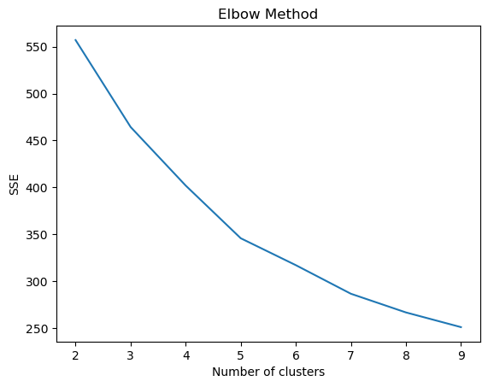

* Silhouette score for k=4: 0.27775321651688833
* Silhouette score for k=5: 0.298341387444546
* Silhouette score for k=6: 0.3213010496381913
* Silhouette score for k=7: 0.3218767204461577

**Visualizing the relation between the categorizes and the number of clusters:**

* **4 Clusters:**

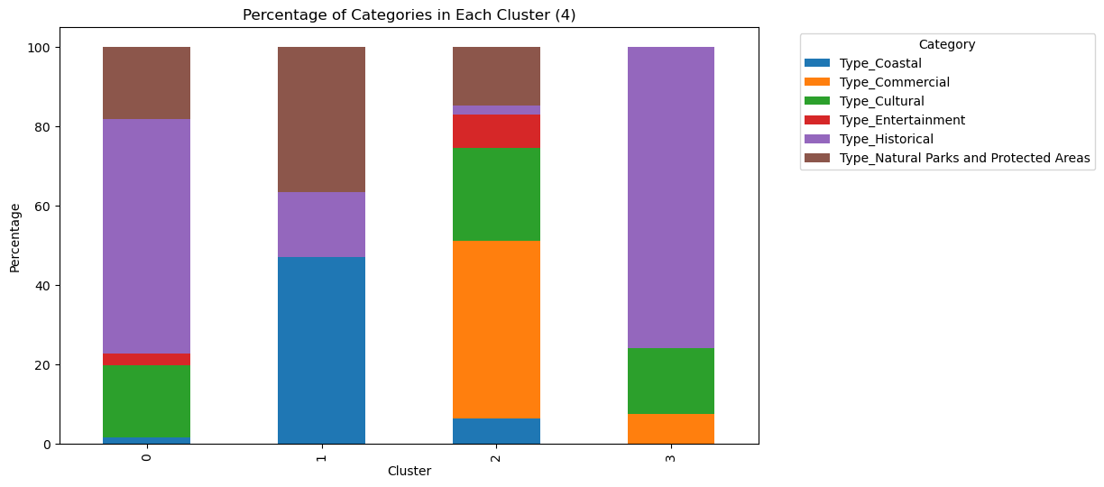

* **5 Clusters:**

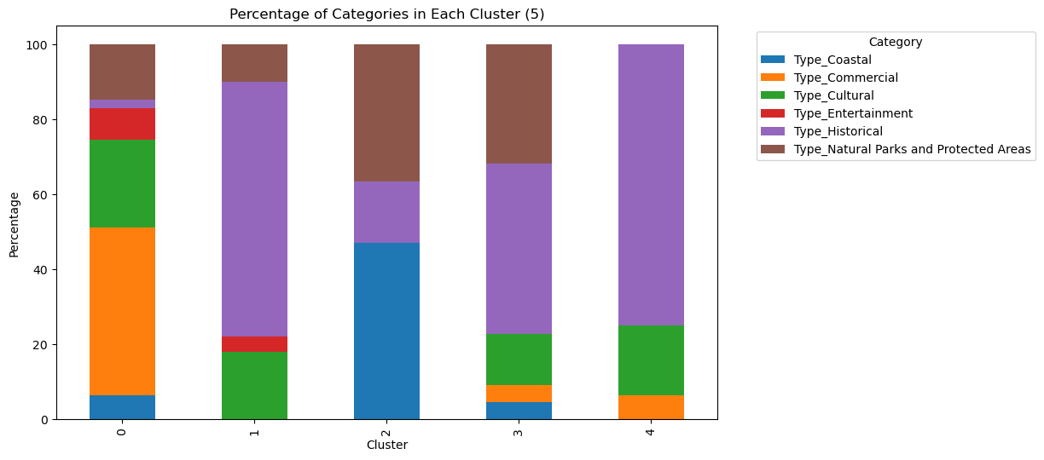

* **6 Clusters:**

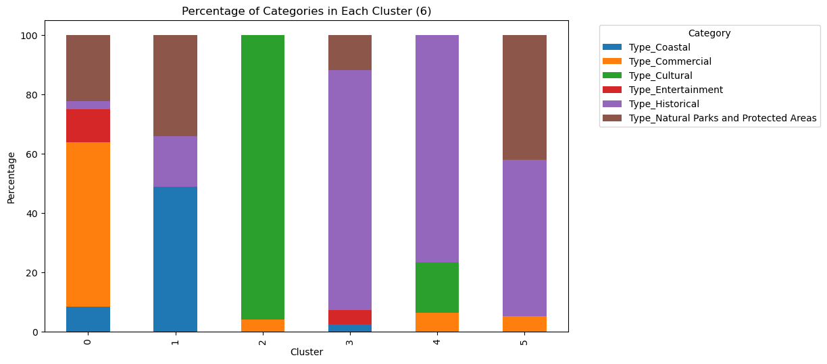

* **7 Clusters:**

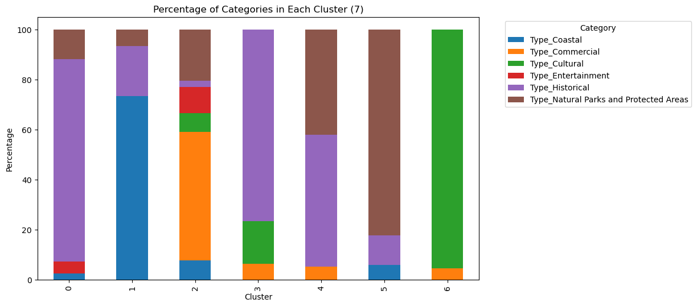

### Following the above comprehensive analysis, we notice that categories are more dispersed for clusters 4, 5 & 7 than for cluster 6. Moreover, considering the Elbow method and silhouette outcome, we concluded that the optimal number of clusters for our study is 6-clusters.