Nicole Spar
10 October 2026
Biometry Midterm Part 1
Deep-sea Pelagic Mollusk Distribution Across the Northern Gulf of Mexico
Intro
Deep-sea pelagic mollusks are an understudied group, particularly in the Gulf of Mexico. The aim of this project is to better understand how the distribution of deep-sea mollusks in the Gulf of Mexico changes across the continental shelf to the open ocean. In the Gulf of Mexico, the Loop Current and Eddies are pertinent to the diversity and productivity across the continental shelf, particularly for upwelling and dispersal (Clark, 2019). Deep-sea pelagic mollusks including Cephalopods, Heteropods, and Pteropods demonstrate many key ecosystem services in the marine environment. Cephalopods, which include squid and octopuses, are often key predators in the deep-sea which is a major factor in trophic dynamics. Micronekton such as Heteropods and Pteropods, or sea elephants and sea butterflies respectively, are ubiquitous throughout marine environments and can be helpful indicators of ocean health. Furthermore, across all three groups, diel vertical migration is common and promotes nutrient inputs from more surface level waters to the deep-sea (Shedler, 2020). Diel vertical migration is a daily migration from the mesopelagic to the epipelagic often for feeding and predator avoidance. Understanding the distributions of these animals will offer important insights into population dynamics within these groups and into anthropogenic impacts on these populations. This project will analyze the common species from each group for geographical and vertical distribution, as well as possible size differences across the population distribution.
Methods
The data was collected by Deep Pelagic Nekton Dynamics of the Gulf of Mexico (DEEPEND) for the Deep-Sea Benefits research project. The data was collected throughout 3 research cruises over 3 years using a discrete depth trawling net to collect deep-sea pelagic mollusks. The net used was a MOCNESS (Multiple Opening/Closing Net and Environmental Sensing System) net with 3mm mesh. Additionally, various environmental variables were collected via a sensor when sampling. The data collected includes species identification, species counts, standard length measurements, sampling coordinates, depths, and dates. Standard length measurements include mantle length for cephalopods and total length for heteropods. No length measurements were taken for pteropods.
To understand the population dynamics, species richness across the research cruise sampling sites were graphed as points on a map to visualize how the diversity changes throughout the various locations in the Gulf of Mexico (Package “maps” Reference Manual, n.d.) (CDav, 2014). In addition, a bar graph of species richness as a function of sampling depth across the 3 groups to analyze the diversity throughout the water column. To expand on that, a scatterplot for each Mollusk group was graphed to visualize how species count change with varying sampling depths to understand the vertical distribution of the common species. Finally, standard length measurements of cephalopod and heteropod species were analyzed across the various depths using a line graph.
Results
Figure 1. demonstrates a general trend of increased species diversity as you move down the continental shelf. The species’ richness at each sampling site is higher at sites that are a greater distance from the bathymetry contour of the continental shelf on the map.
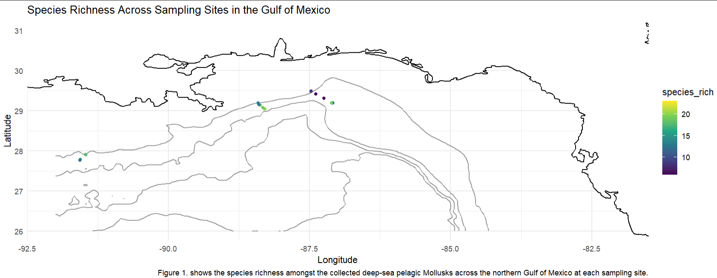
The vertical distribution results shown in Figure 2. demonstrate greater variability with less distinct trends. The surface depths from 0-100m have the highest total species richness, followed by the lowest total species richness at the adjacent depths from 100-200m and the at 600-700m. The 0-100m range also has the highest species richness for all 3 Mollusk groups. Cephalopods demonstrate the greatest variability of species richness across all depths
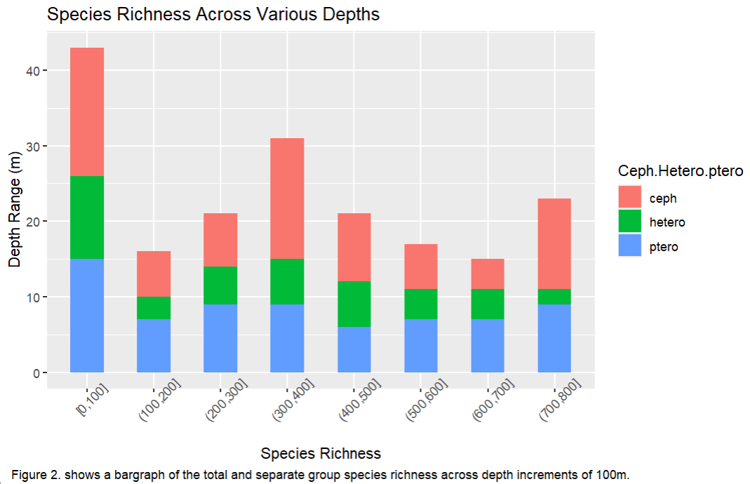
The vertical distribution by species as seen in Figure 3. reveals the more specific trends. In the cephalopod distribution, Pterygioteuthis sp. and Cranchia scabra have high abundances in shallower depths with steep declines in abundance at 400m and 150m, respectively. The only group that has an increase in abundance at deeper depths is Abralia redfieldi. As for the heteropods, most of the species are similar in abundance with some flucations, and with a high peak at 100m in Pterotrachea coronata. Finally, in the pteropods, there is also similar abundance across species, but Clio pyramidata has the highest abundance throughout the various depths.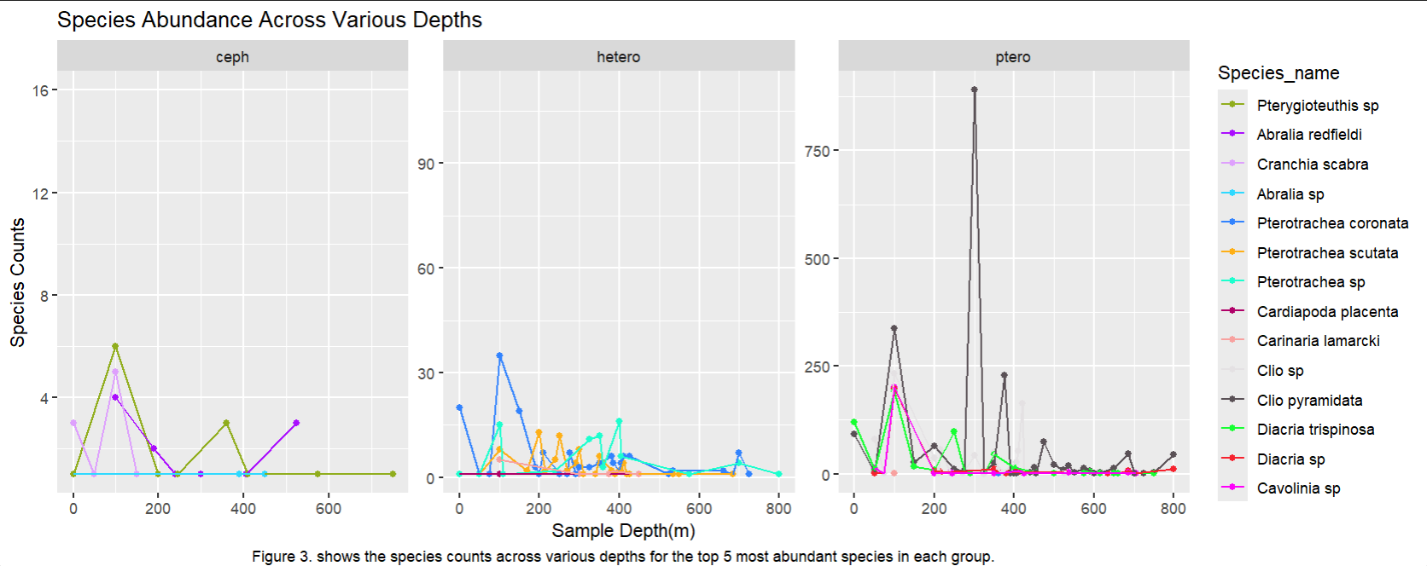
Finally, the results for size changes across various depths did not seem to indicate any significant trends. Figure 4a. and Figure 4b. demonstrate a large number of fluctuations in both cephalopod and heteropod species throughout all the depths that were sampled. In heteropods (Figure 4b.), there seems to be an increase in size at deeper depths for two species: Stigmatoteuthis arcturi and Bolitaena pygmaea. This lack of distinct trends could be due to limited sample size of collected specimens across each species.
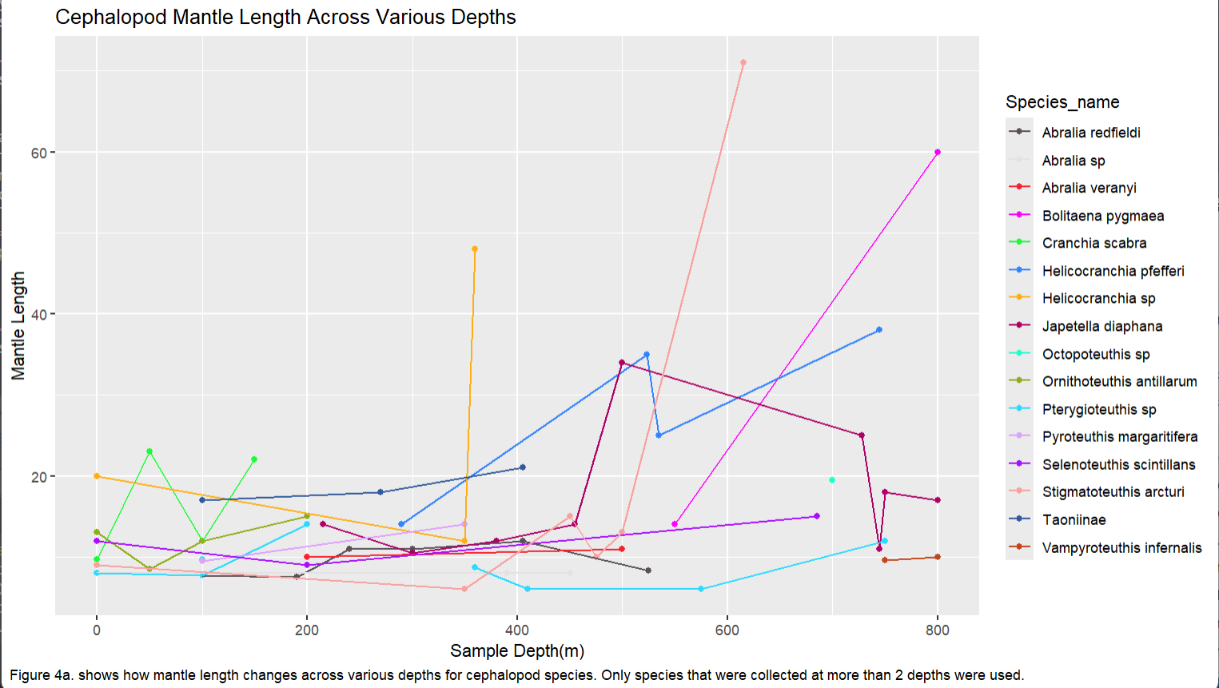
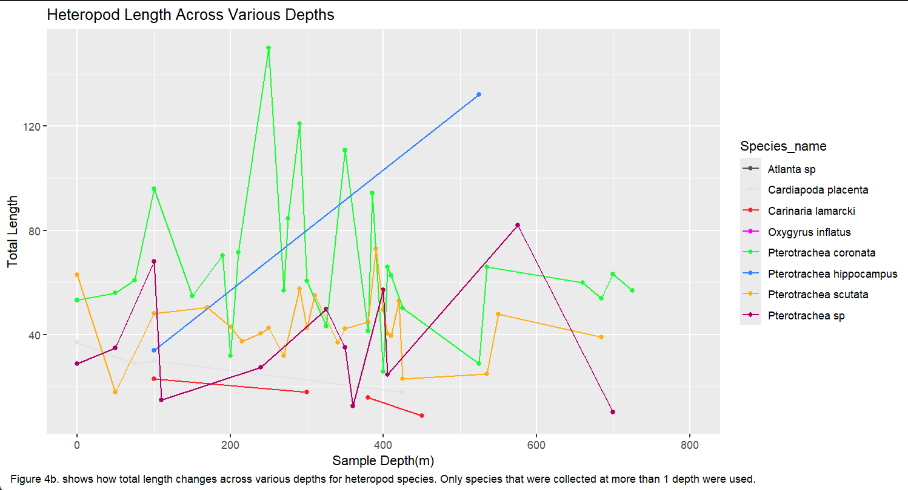

Citations
References
CDav. (2014, December 7). Add bathymetry lines to ggplot using marmap package and getNOAA.bathy [Forum post]. Stack Overflow. https://stackoverflow.com/q/27214282
Clark, K. A. (2019). Species Abundance, Spatial and Vertical Distributions of Large Heteropods (Pterotracheidae and Carinariidae) in the Northern Gulf of Mexico [M.S., University of South Florida]. https://www.proquest.com/docview/2248610695/abstract/820CFAE1D4A64683PQ/1
Package “maps” reference manual. (n.d.). Retrieved October 13, 2026, from https://cran.r-universe.dev/maps/doc/manual.html
Shedler, S. M. (2020). Large Thecosome Pteropods of the Northern Gulf of Mexico: Species Abundance, Spatial and Vertical Distribution with a Temporal Comparison of Shell Thickness [M.S., University of South Florida]. https://www.proquest.com/docview/2405340862/abstract/8EA8C36536B54620PQ/1

R Packages
Wickham H, Averick M, Bryan J, Chang W, McGowan LD, François R, Grolemund G, Hayes A, Henry L, Hester J, Kuhn M, Pedersen TL, Miller E, Bache SM, Müller K, Ooms J, Robinson D, Seidel DP, Spinu V, Takahashi K, Vaughan D, Wilke C, Woo K, Yutani H (2019). “Welcome to the tidyverse.” _Journal of Open Source Software_, *4*(43), 1686. doi:10.21105/joss.01686
<https://doi.org/10.21105/joss.01686>.

Wickham H, Hester J, Bryan J (2024). _readr: Read Rectangular Text Data_. doi:10.32614/CRAN.package.readr <https://doi.org/10.32614/CRAN.package.readr>, R package version 2.1.5, https://CRAN.R-project.org/package=readr

H. Wickham. ggplot2: Elegant Graphics for Data Analysis. Springer-Verlag New York, 2016.

Coombes KR, Brock G, Abrams ZB, Abruzzo LV (2019). “Polychrome: Creating and Assessing Qualitative Palettes with Many Colors.” _Journal of Statistical Software, Code Snippets_, *90*(1), 1-23. doi:10.18637/jss.v090.c01 <https://doi.org/10.18637/jss.v090.c01>.

D. Kahle and H. Wickham. ggmap: Spatial Visualization with ggplot2. The R Journal, 5(1), 144-161. URL http://journal.r-project.org/archive/2013-1/kahle-wickham.pdf

Becker RA, Wilks AR, Brownrigg R, Minka TP, Deckmyn A (2025). _maps: Draw Geographical Maps_. doi:10.32614/CRAN.package.maps <https://doi.org/10.32614/CRAN.package.maps>, R
package version 3.4.3, <https://CRAN.R-project.org/package=maps>.

Pante E, Simon-Bouhet B, Irisson J (2025). _marmap: Import, Plot and Analyze Bathymetric and Topographic Data_. doi:10.32614/CRAN.package.marmap <https://doi.org/10.32614/CRAN.package.marmap>, R package version 1.0.12,<https://CRAN.R-project.org/package=marmap>.

