* **Create a database called "contact"**
* **Create a collection called "contactlist"**

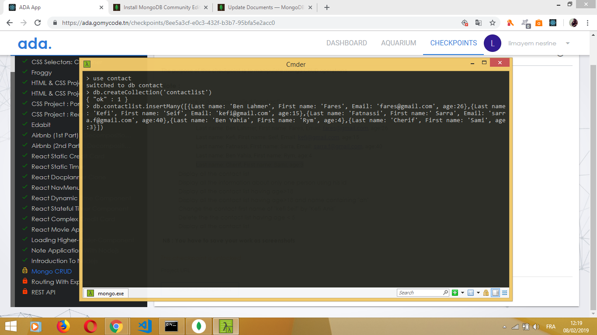

* **Insert persons in "contactlist"**

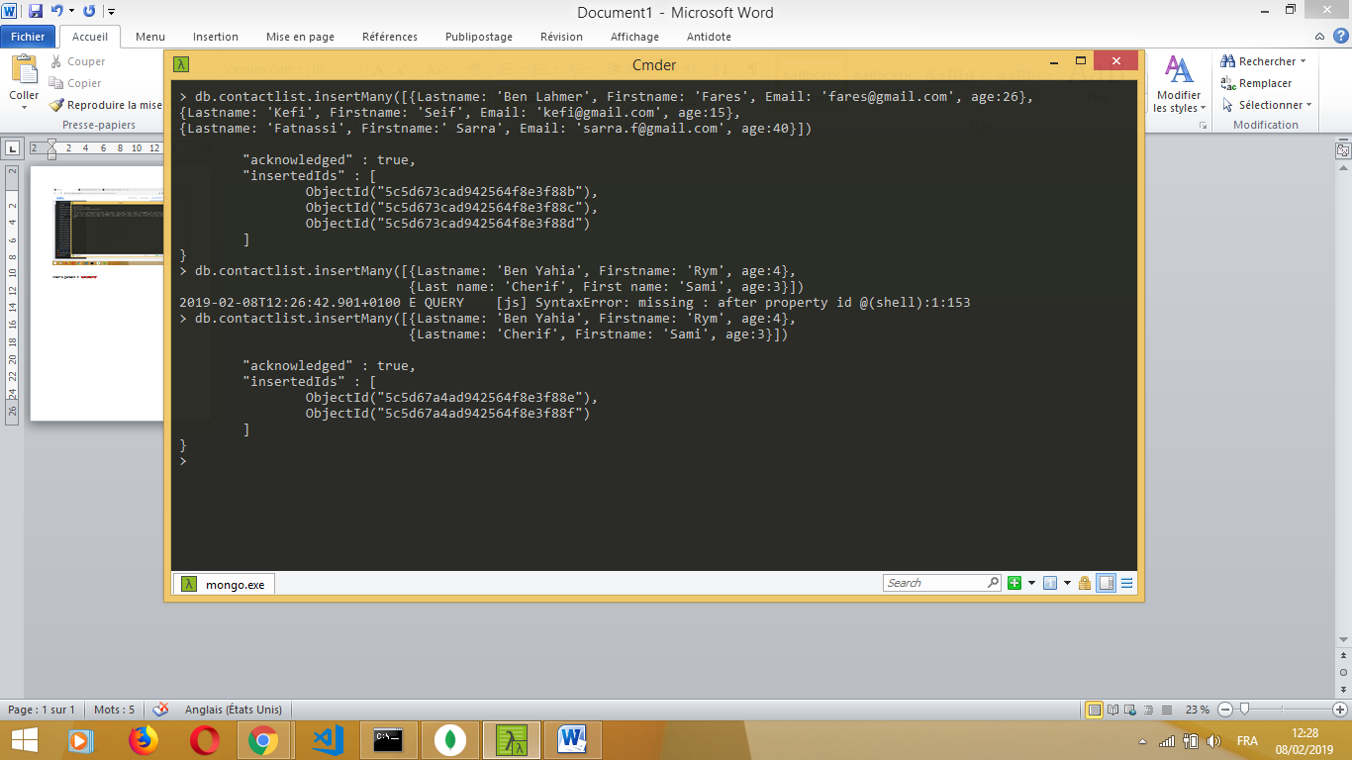

* **Display all the contact list**

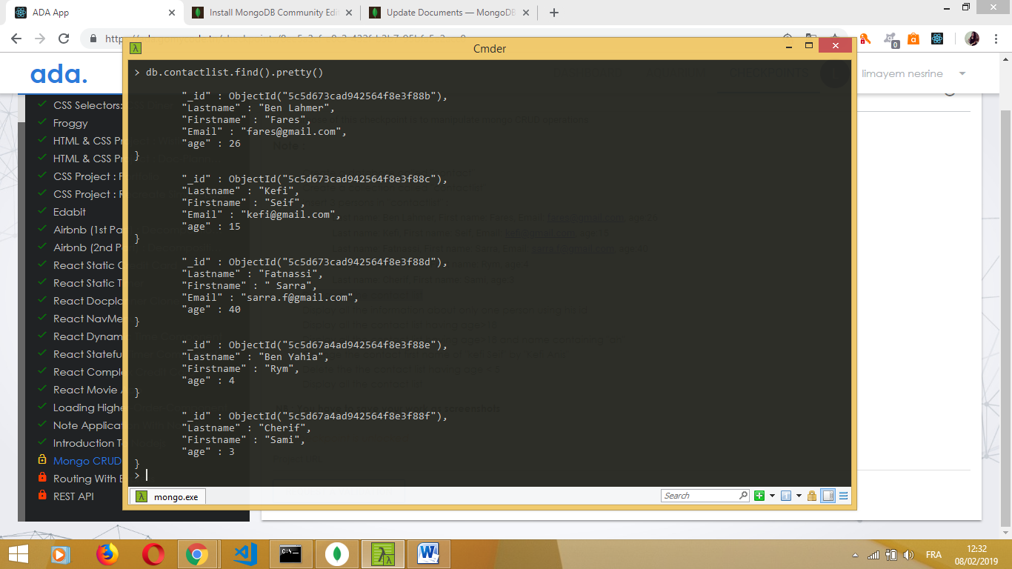

* **Display all the information about only one person using his id**

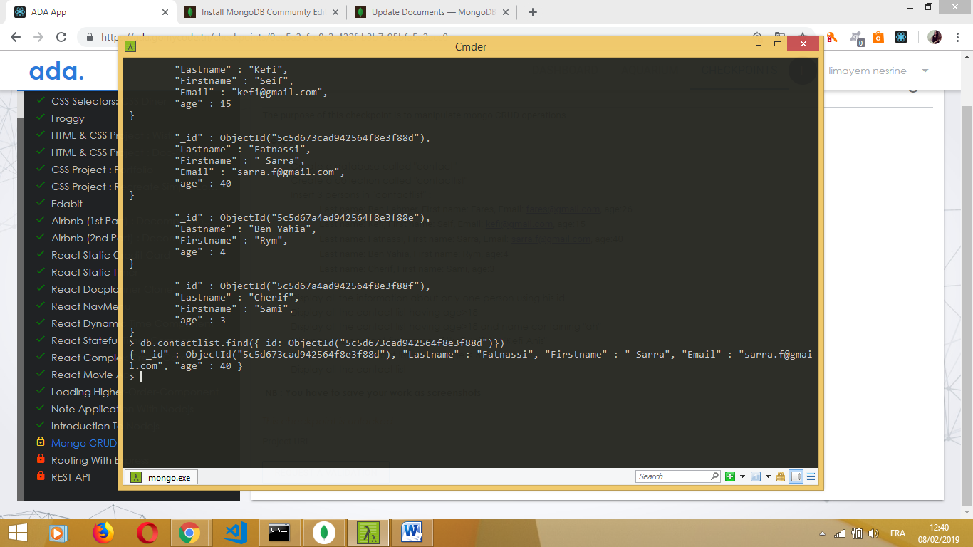

* **Display all the contact list having age>18**

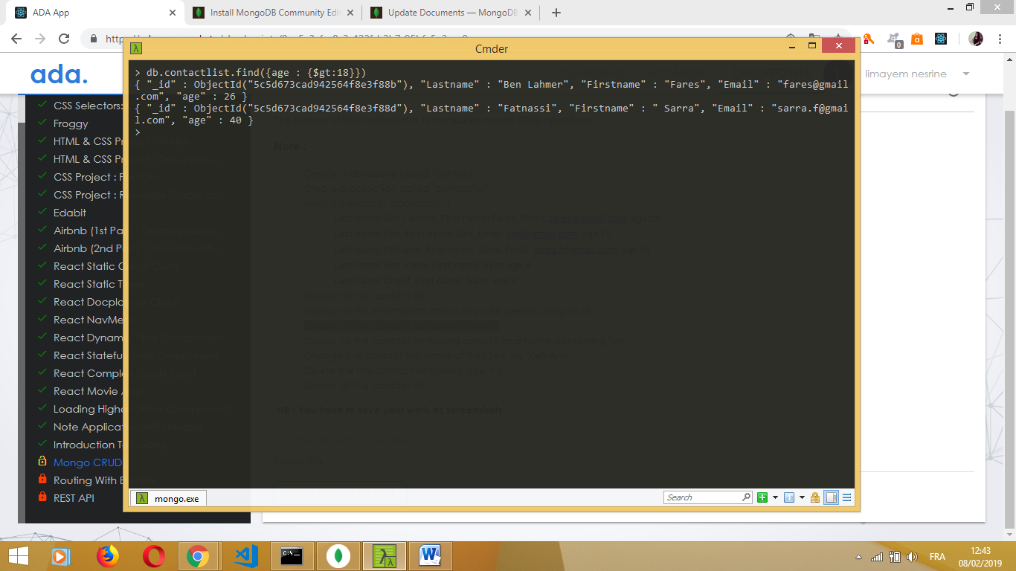

* **Display all the contact list having age>18 and name containing "ah"**

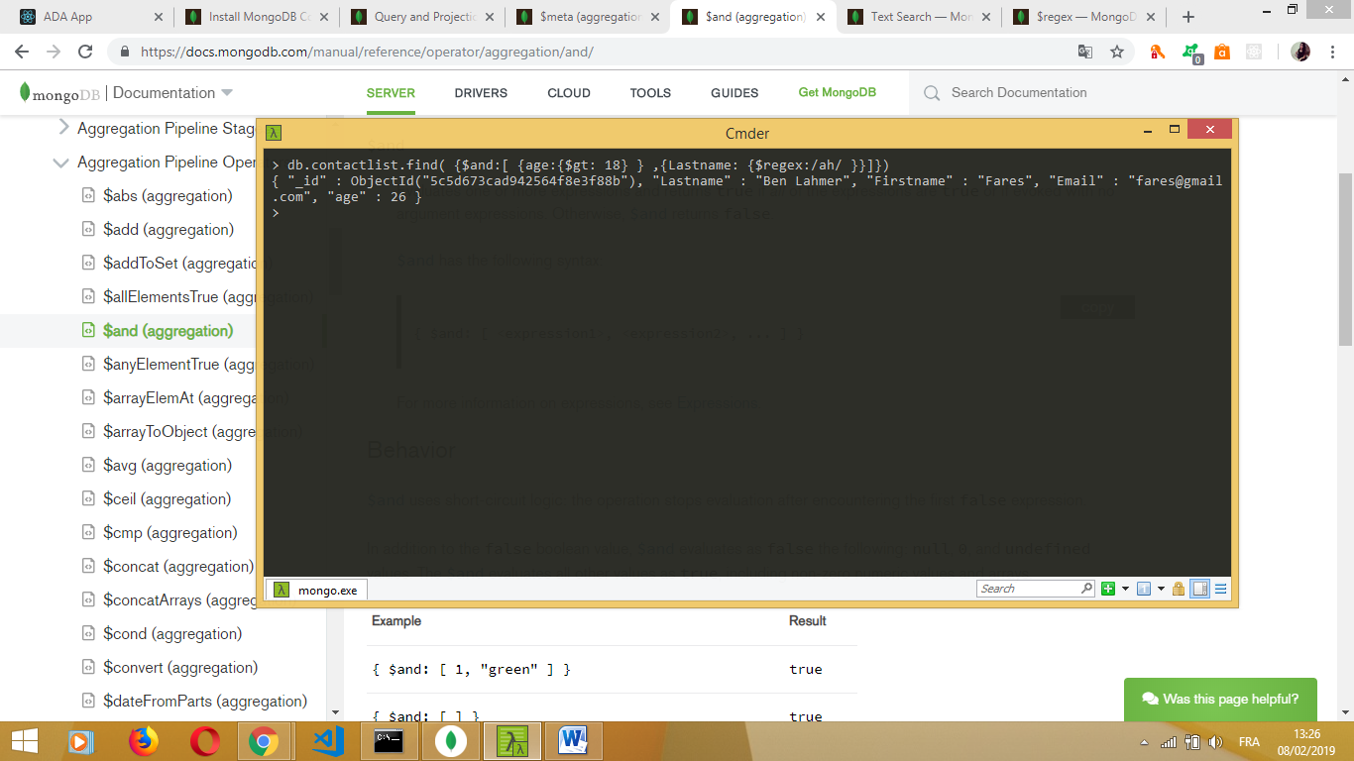

* **Change the contact first name of "kefi Seif" by "Kefi Anis"**

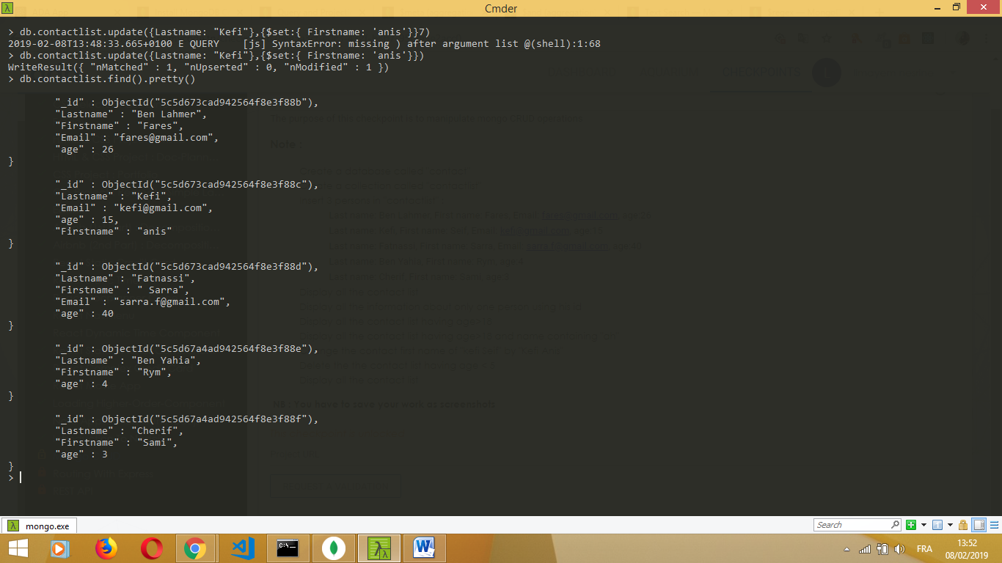

* **Delete the the contact list having age < 5**
* **Display all the contact list**

