Задание 1. Черепашка по имени Наташка

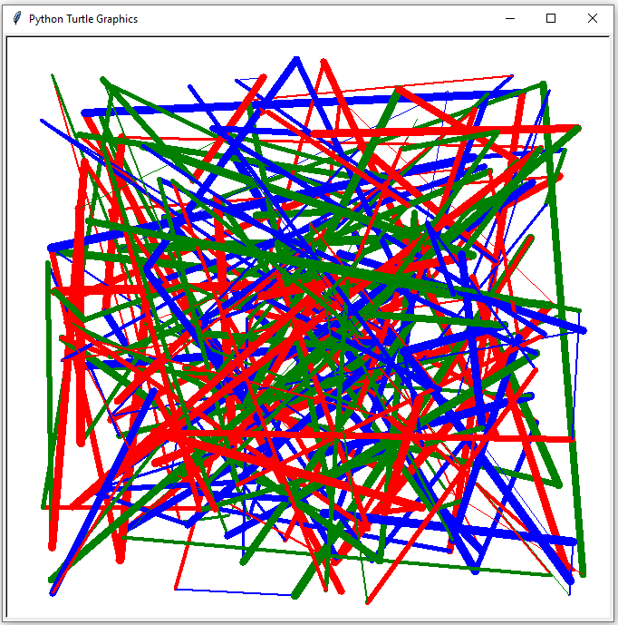from turtle import *  
from random import randint, choice  
  
окно = Screen()  
  
саша = Turtle()  
саша.speed(100)  
цвета = ['red', 'green', 'blue']  
  
while 1:  
 x = randint(-300, 300)  
 y = randint(-300, 300)  
 w = randint(1, 10)  
 саша.color(choice(цвета))  
 саша.width(w)  
 саша.goto(x, y)

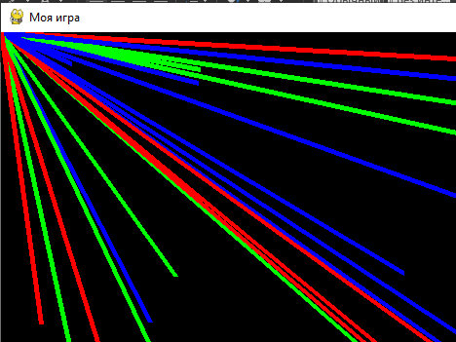from pygame import *  
from pygame.locals import *  
from random import *  
  
*# pygame.init()*W = 800  
H = 600  
FPS = 5  
S = display.set_mode((W, H))  
display.set_caption('Моя игра')  
clock = time.Clock()  
colors = ['red', 'green', 'blue']  
ok = 1  
while ok:  
 for e in event.get():  
 if e.type == KEYUP and e.key == K_ESCAPE or e.type == QUIT:  
 ok = 0  
  
 x, y = randint(0, W), randint(0, H)  
 draw.line(S, choice(colors), (0, 0), (x, y),5)  
 display.flip()  
  
 clock.tick(FPS)

Запоминаем предыдущие координаты

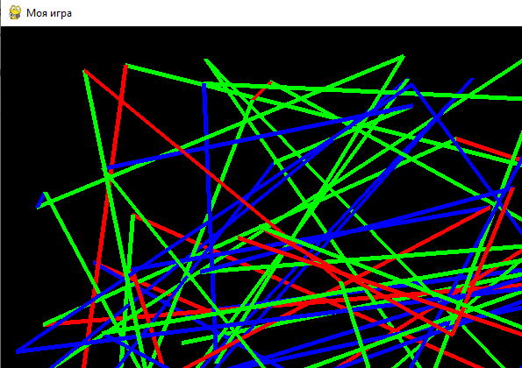x1, y1 = randint(0, W), randint(0, H)  
while ok:  
 for e in event.get():  
 if e.type == KEYUP and e.key == K_ESCAPE or e.type == QUIT:  
 ok = 0  
  
 x2, y2 = randint(0, W), randint(0, H)  
 draw.line(S, choice(colors), (x1, y1), (x2, y2), 5)  
 x1, y1 = x2, y2  
 display.flip()  
  
 clock.tick(FPS)

S = display.set_mode((W, H))  
display.set_caption('Моя игра')  
clock = time.Clock()  
colors = ['red', 'green', 'blue']  
ok = 1  
x1, y1 = randint(0, W), randint(0, H)  
S.fill('red')  
while ok:  
 for e in event.get():  
 if e.type == KEYUP and e.key == K_ESCAPE or e.type == QUIT:  
 ok = 0  
  
 x2, y2 = randint(0, W), randint(0, H)  
 color = (randint(0,255), randint(0,255), randint(0,255))  
 draw.line(S, color, (x1, y1), (x2, y2), 5)  
 x1, y1 = x2, y2  
 *# display.flip() # Обновляет весь объект Surface* display.update() *# Обновляет часть отображения интерфейса  
 # S.fill('red')* clock.tick(FPS)