Risk-Adaptive Continuous Authentication for Mobile Money (GaitAuth)
Project Deliverables, Verification Metrics, Policy Engine & Submission Dossier

1. Project & Repository Access Links
Resource / Component | Access Link / Identifier | Operational Scope
GitHub Code Repository | https://github.com/nessa360/risk-adaptive-mobile-money-gait-auth | Public / Full Source Code
FastAPI Local Swagger UI | http://localhost:8000/docs | Interactive OpenAPI Testing
Android Testing Route | http://10.0.2.2:8000/ (or LAN: 192.168.1.185:8000) | Host Loopback Gateway
Evaluation Dataset Source | WISDM Smartphone & Smartwatch Biometrics | Public Benchmark (Weiss et al., 2019)

2. Experimental Verification Results (E1 Baseline)
Biometric verification evaluated under subject-disjoint protocol on WISDM (30 dev, 11 unseen test subjects) across non-overlapping 10s windows (6x128 at 50 Hz).
Metric Parameter | Measured Value | Academic & Engineering Interpretation
Evaluation Subjects | 11 unseen subjects | Strictly isolated from training to avoid data leakage
Genuine Trials | 119 comparisons | Intra-subject comparisons across distinct walking windows
Zero-Effort Impostor Trials | 1,190 comparisons | Pairwise inter-subject comparison trials
Equal Error Rate (EER) | 20.17% | Intersection point where FAR(theta) ≈ FRR(theta)
Operating Threshold (theta) | 0.9971 | Selected cosine similarity boundary balancing verification
Verification Accuracy | 77.62% | Overall discrimination accuracy across all trials
False Acceptance / Rejection | FAR: 23.19% | FRR: 14.29% | Demonstrates uncertainty requiring multi-tier IAM defense

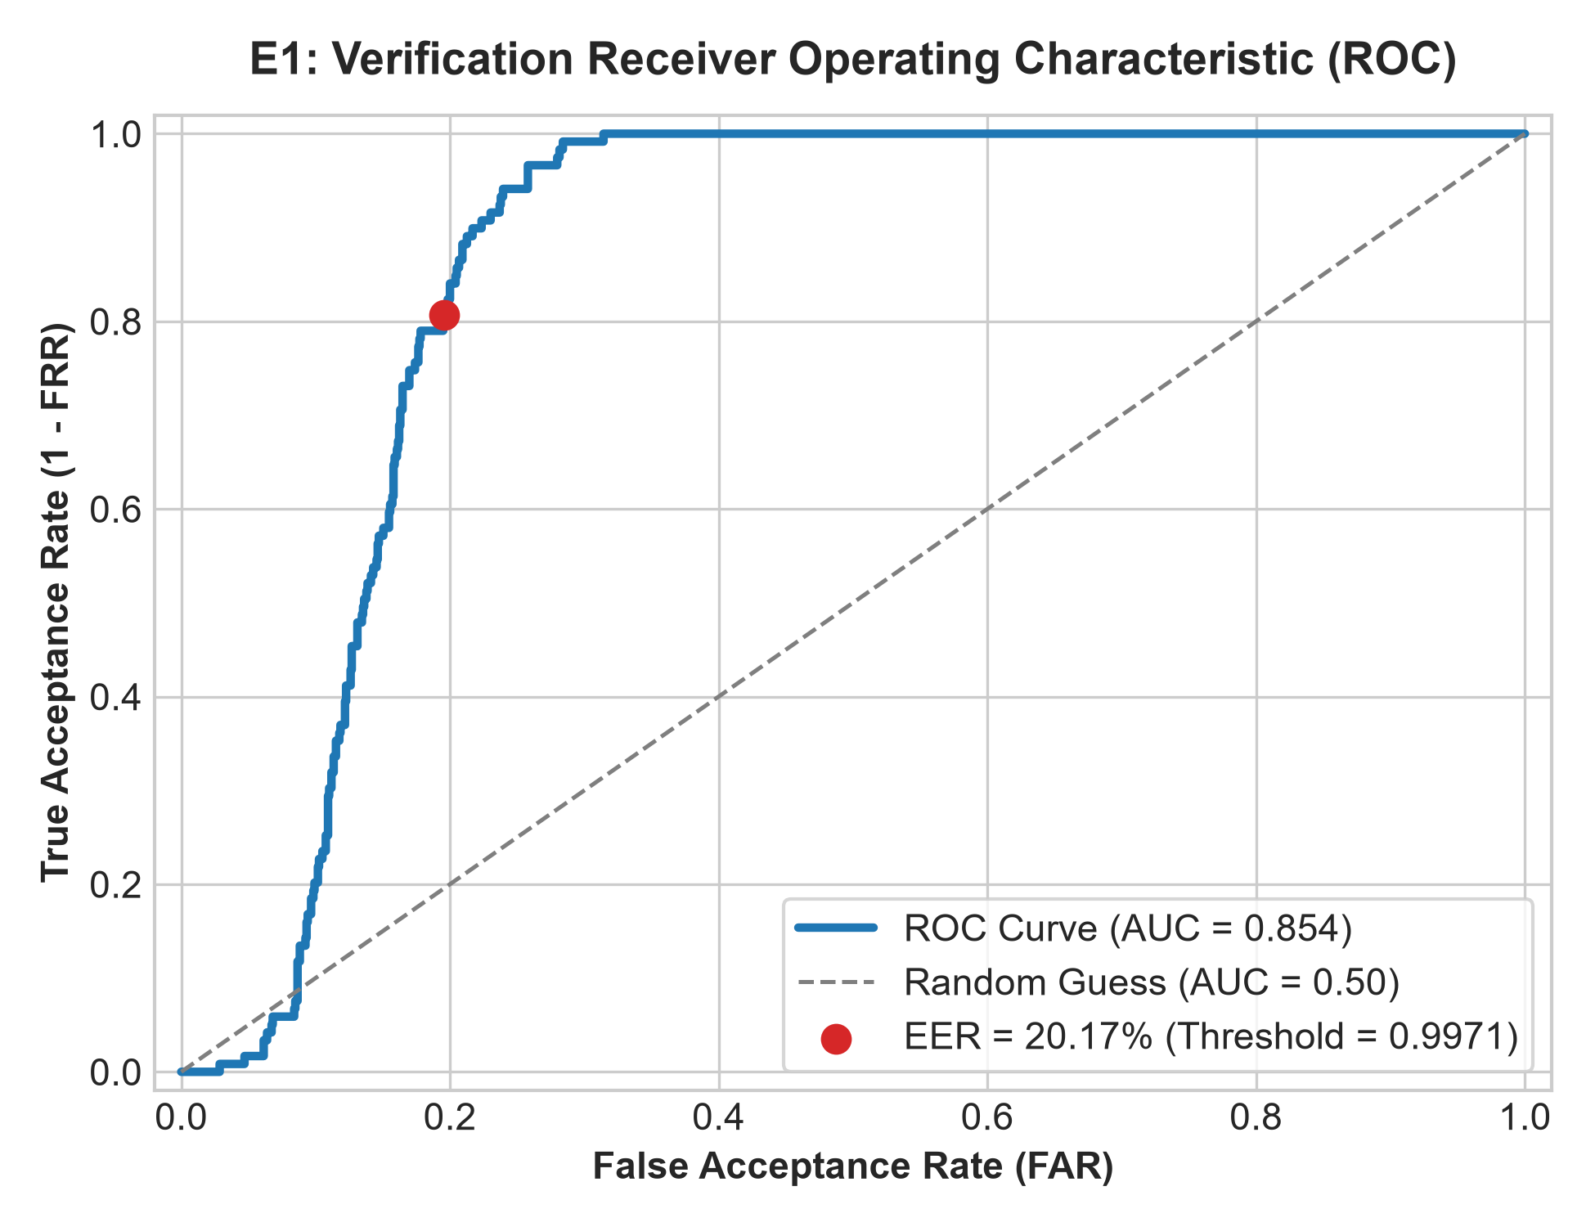  Figure 2: E1 ROC Curve (EER = 20.17%) | 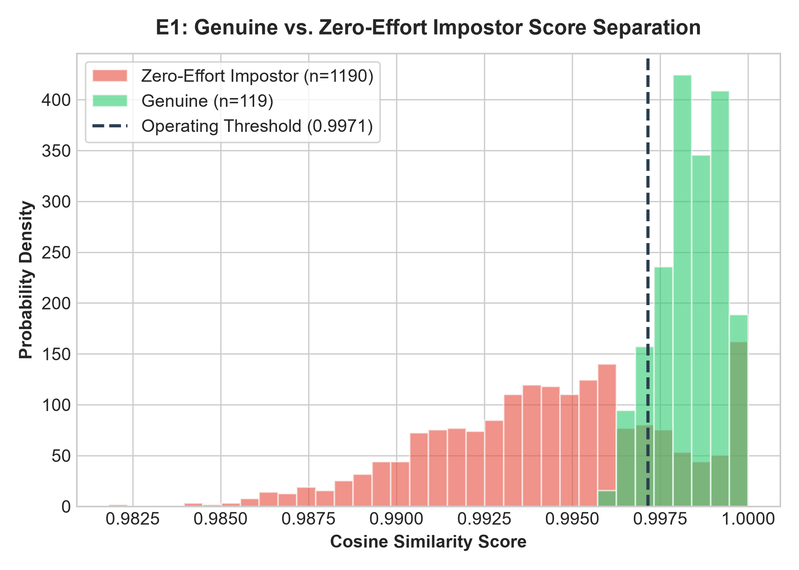  Figure 3: Genuine vs. Impostor Distribution

3. Baseline Comparison: Open-Set vs. Closed-Set
Model Architecture | Operating Paradigm | Test Accuracy | Macro F1-Score
Support Vector Machine (SVM) | Closed-Set Multiclass | 0.00% | 0.0000
Random Forest (RF) | Closed-Set Multiclass | 0.00% | 0.0000
k-Nearest Neighbors (k-NN) | Closed-Set Multiclass | 0.00% | 0.0000
CNN-LSTM Embedder (Proposed) | Open-Set Metric Embedder | 77.62% | 0.7762

4. Host Computational Profiling (E5 Benchmarks)
Processing Pipeline Stage | Execution Latency | Peak Working Memory
Signal Slicing & Resampling | 0.082 ms | < 0.08 MB
ONNX CNN-LSTM Model Inference | 0.913 ms | 0.38 MB
Policy & Threshold Resolution | 0.012 ms | < 0.01 MB
Total Host Pipeline Round-Trip | ~1.06 ms | < 0.40 MB

5. Risk-Adaptive IAM Policy Engine Matrix
Confidence Tier | Transaction Context | Decision | UX Workflow
High (s >= 0.80) | Amount <= 100 GHS & Known Contact | ALLOW | Zero-friction approval
High (s >= 0.80) | Amount 101 - 500 GHS | STEP_UP_LIGHT | 4-digit PIN verification
High (s >= 0.80) | Amount > 500 GHS | STEP_UP_STRONG | 6-digit SMS OTP challenge
Medium (0.45 <= s < 0.80) | Amount <= 50 GHS & Known Contact | STEP_UP_LIGHT | 4-digit PIN verification
Medium (0.45 <= s < 0.80) | Amount > 50 GHS or Unknown | STEP_UP_STRONG | 6-digit SMS OTP challenge
Low (s < 0.45) | Any Amount / Any Recipient | DENY | Transaction terminated

6. End-to-End Functional Test Suite
Test ID | Subsystem | Evaluation Scenario & Observed Behavior | Verdict
TS-01 | Android Sensor | 50 Hz IMU acquisition maintained in ring buffer without dropping frames | PASS
TS-02 | Hardware Fallback | Static emulator detects underfilled buffer; injects 6x128 synthetic baseline | PASS
TS-03 | Networking | Retrofit connects via 10.0.2.2; logs HTTP 200 payload round-trip | PASS
TS-04 | Prototype ALLOW | Score >= 0.80, 25 GHS: frictionless transfer completes without prompt | PASS
TS-05 | Prototype STEP-UP | Score 0.45-0.80 or > 100 GHS: modal challenges PIN; valid input clears transfer | PASS
TS-06 | Prototype DENY | Divergent score < 0.45: transaction intercepted with Security Alert dialog | PASS

