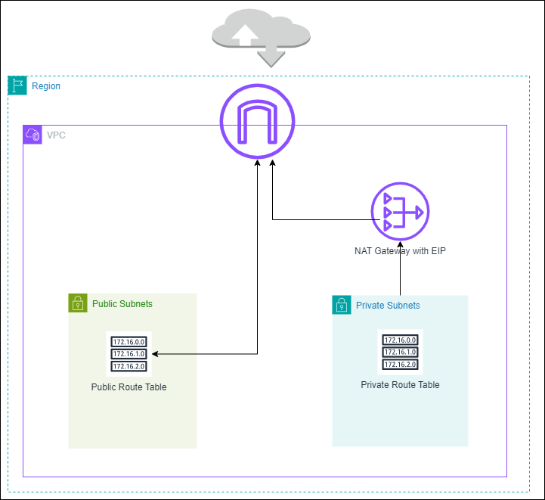

* Private subnets are not exposed to the internet, while public subnets are.
* The public route table has a default route pointing to an internet gateway, allowing traffic to flow to and from the internet. The private route table has a default route pointing to a NAT gateway, allowing outbound internet access for resources in the private subnet.
* Internet gateway allows resources within the VPC to access the internet via the public subnets.
* NAT gateway is used to enable instances in the private subnet to initiate outbound traffic to the internet. The NAT gateway is associated with an Elastic IP created earlier.