**AIM:** Write a Python function to print missing characters to make string pangram.

**PROGRAM:**

**a=input()**

**a=set(a.strip())**

**a.remove(chr(32))**

**b="abcdefghijklmnopqrstuvwxyz"**

**b=set(b)**

**b=b.difference(a)**

**b=list(b)**

**b.sort()**

**print("".join(b))**

**LINK:** <http://103.53.53.18/mod/vpl/view.php?id=235>

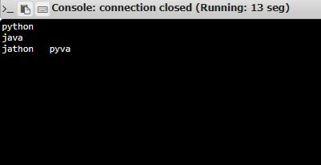**OUTPUT:**

**RESULT:** Thus the phyton pangram program was printed and calculated