Dreaming of 1983: A Tribute to David Bowie's Serious Moonlight Tour

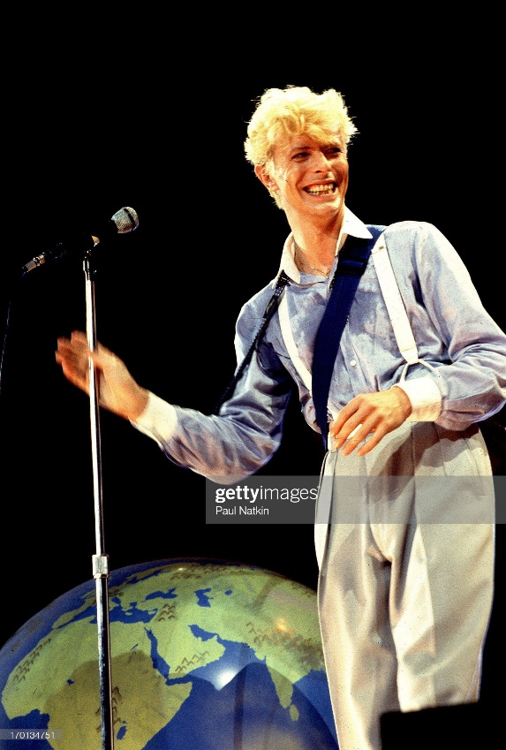

An overjoyed David Bowie grabs the mic.

# Intro: Where’s the Time Machine?

I am a huge fan of David Bowie. When I got the chance to make a tribute page as a freeCodeCamp certification project, I immediately thought of David Bowie’s Serious Moonlight tour. I usually don’t like live music, but there’s something really special about this concert that wows me every time I listen to it. Unfortunately, I was born about 20 years too late to attend in person, but if I could borrow a time machine just once, I would go back to 1983 and try to buy tickets. As luck would have it, we have the next closest thing: video and audio recordings!

Now, I feel I need to give a bit of a disclaimer before we proceed.

For me to fully express my feelings about the concert, I have to discuss what I’ve experienced listening to “Recordings of Independent Origin.” They are at best a legal grey area, at worst illegal. However, there have been many instances of artists making official releases out of these recordings. Bowie himself has released two such live concert CDs: [*Live Santa Monica '72*](https://www.amazon.com/Live-Santa-Monica-DAVID-BOWIE/dp/B001FAZYOQ) and [*Live Nassau Coliseum '76*](https://www.amazon.com/Live-Nassau-Coliseum-76-2CD/dp/B01N7J2LMO).

For legal reasons, I must say that I do not condone nor endorse any of these recordings. I will refrain from mentioning any specifics besides concert dates and locations. My goal is not to encourage anyone to seek these out—I am merely expressing my admiration for Bowie and all of the supporting artists that made this concert amazing.

## Video: The HBO Film

The HBO film was probably the first way most people experience the Serious Moonlight tour (or the [David Bowie channel on YouTube](https://www.youtube.com/c/davidbowie/search?query=1983)). The HBO VHS and DVD releases were the only official video recordings available to consumers for a long time, and it's incomplete! Setlist.fm has [the setlist](https://www.setlist.fm/setlist/david-bowie/1983/pacific-coliseum-vancouver-bc-canada-1bd5a5b4.html) that was used for that performance—“TVC15” and both encores are missing for a total of five songs. Why? Best guess is they cut the footage down to fit on a standard VHS. The DVD version restores no additional footage. Does it exist somewhere?

In 2022, PBS “restored and remastered in High-Definition” the HBO film. This version is (at this point in time) [available for streaming](https://www.pbs.org/show/david-bowie-serious-moonlight/) for PBS members. Don’t be tricked by the HD photograph they use for the page though. That set me up for a huge disappointment when I first watched it. It’s the quality of a very good VHS tape, and much better quality than the DVD release. Color has been restored, artifacts on the right and left edges have been removed, and the harsh lighting has been toned down. There’s no additional footage, but it’s definitely a better watching experience!

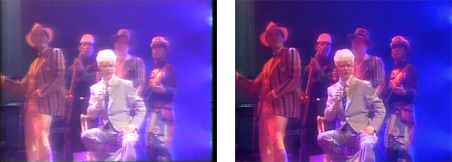  
A comparison of the DVD release (left) and the color improvements of the PBS remaster (right).

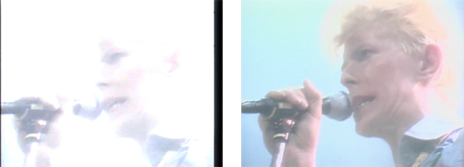

Overexposed footage on the DVD release (left) compared to the PBS remaster (right).

At this point, I’ve given up on there ever being a complete copy of the tour on video. That doesn’t rule out some footage existing in a vault somewhere but it’s been almost 40 years. Oh, and the “Modern Love” music video doesn’t really count either. The audio track isn’t from the concert, and it was recorded during a [different performance](https://en.wikipedia.org/wiki/Modern_Love_(song)#Music_video) of the tour. So that brings us to audio recordings.

## Audio: Official & Independent Origin

In 2018, we finally got an [official release](https://www.amazon.com/Serious-Moonlight-Live-Remastered-Version/dp/B07MBHQYR5) of the Serious Moonlight concert on CD. It's basically remastered audio from the HBO film and is also *incomplete*. There are four songs missing from the end of the concert (according to [setlist.fm](https://www.setlist.fm/setlist/david-bowie/1983/pacific-coliseum-vancouver-bc-canada-1bd5a5b4.html)): “TVC15,” “Star,” “Stay,” and “The Jean Genie.” For some reason, they were able to include “Modern Love,” which is the final song of the night.

The only way to listen to the concert in its entirety is via Recordings of Independent Origin. There's probably one for each day of the concert out there somewhere, and the quality ranges from fantastic to terrible. What I find so interesting about this tour is how the setlist evolves and how some performance days focus on different sections of the band.

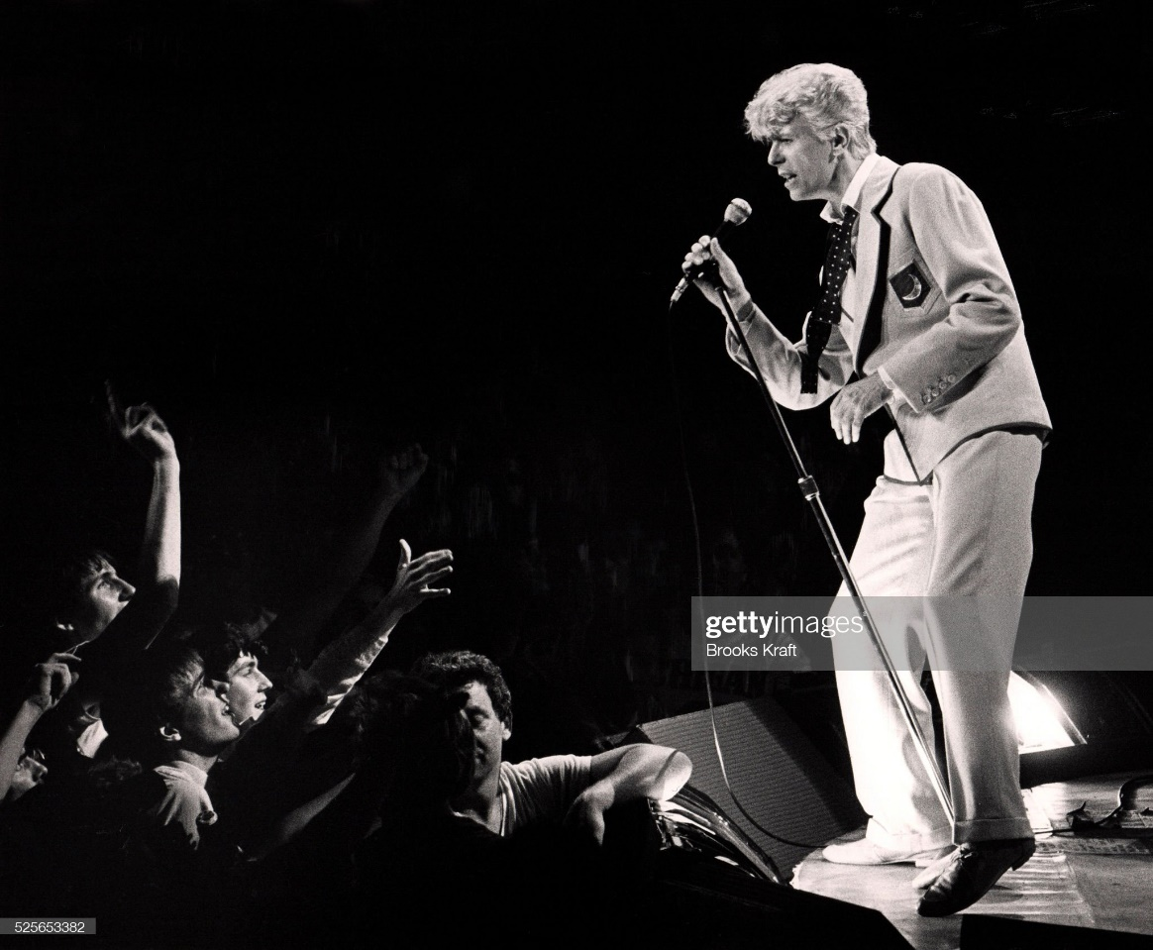

Carmine Rojas (left), David Bowie (center), and Carlos Alomar (right).

# Setlist: A Love Letter to All Fans

Most concert tours are meant to promote album releases and the Serious Moonlight tour was promoting the release of *Let’s Dance*. One would expect most of the songs picked for the tour would be from that album, right? Wrong!

**The setlists for the concert were mostly comprised of songs released in the 1970s.**

Most of the songs in the setlist are from the 1970s. It’s not like Bowie didn’t have enough material from the 1980s to pull from—he could have used more songs from *Scary Monsters* or *Let’s Dance*. Instead, only 23% of songs in the setlist were ones Bowie released in the 1980s.

**The Glass Spider tour setlist mostly comprised of songs from Never Let Me Down (1987).**

In comparison, the Glass Spider tour relies heavily on the album being promoted, *Never Let Me Down*. There are ten songs from that album in the setlist, followed by *Scary Monsters* and *Let’s Dance*. Glass Spider is a visual storytelling experience, and the songs Bowie has chosen represent the story he’s telling. At the same time, it’s very obvious that the Glass Spider tour is tied to his new album and the music he’s released in that decade.

**From across all setlists, Station to Station (1976) was the most represented album, followed by Let's Dance (1983).**

*Let’s Dance* isn’t even the most represented album in the tour, that honor goes to *Station to Station*. The setlists do change throughout the tour, so this only represents an overall trend. The first day of the tour ([May 16, 1983 - Forest, Belgium](https://www.setlist.fm/setlist/david-bowie/1983/vorst-nationaal-forest-national-vorst-forest-belgium-2bf4c0a6.html)) uses 5 out of the 6 songs on *Station to Station*. About halfway through the tour ([September 17, 1983 – Oakland, CA](https://www.setlist.fm/setlist/david-bowie/1983/oakland-alameda-county-coliseum-oakland-ca-53d0ebe1.html)) that number has dwindled down to four out of six. The last day of the tour ([December 8, 1983 - Kowloon, Hong Kong](https://www.setlist.fm/setlist/david-bowie/1983/hong-kong-coliseum-kowloon-hong-kong-sar-china-43d0ebc3.html)) it is three out of six, with songs from *Let’s Dance* finally outnumbering *Station to Station* by one.

Overall, the setlists had a lot of Bowie’s best hits from throughout his career. (Maybe some of his favorites too—I haven’t heard many other people claim that “Red Sails” is one of their favorites.) *Let’s Dance* was Bowie’s first **big** commercial hit. It was released the month before the tour started, and brought in a lot of new fans. In a [1987 interview](https://www.latimes.com/entertainment/music/la-et-david-bowie-archive-19870419-story.html) with Robert Hilburn for the L.A. Times, Bowie describes the Serious Moonlight tour as “a way of introducing myself to people who were just getting interested in my music.” He wanted to share more than just *Let’s Dance* through this tour, and it benefitted both new and longtime fans.

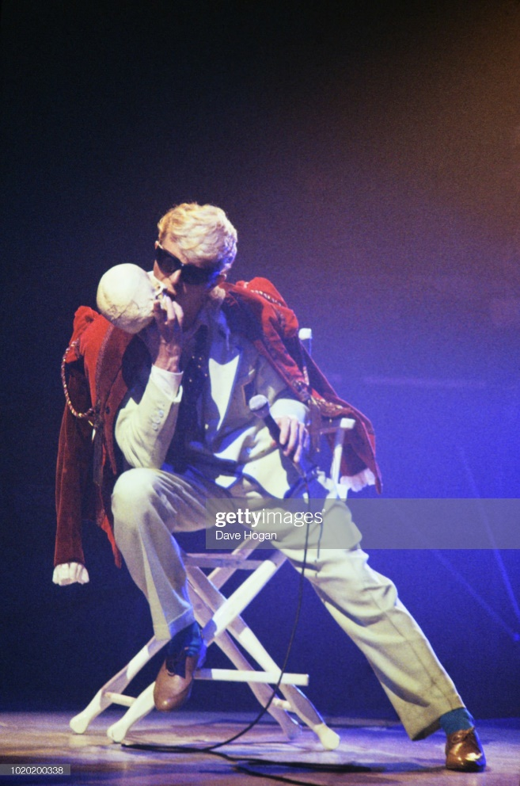

Bowie with the infamous skull prop used during "Cracked Actor" performance.

# Performance: Sound and Vision

Along with the setlist that was meant for everyone, appeals to all fans, has something for any Bowie fan. The concert performance itself, both the audio and visuals, was excellent. One of Bowie’s best. Probably won’t appeal to everyone though. Heavy emphasis on brass section may turn off fans who favor the rock sound more. Funny thing about that though: depending on what day you attended (or listen to), the band will change which section gets the solos.

## Different Day, Different Sound

This is most noticeable with the song “Breaking Glass.” Sometimes the main solo is done just by Earl Slick on guitar, sometimes it’s done by Lenny Pickett on sax. The HBO version has the sax solo, also July 25th 1983 NYC, also August 14th 1983 Forum Inglewood.

Guitar solo: May 20th 1983 Frankfurt, July 13th 1983 Montreal Forum.

Differences in sound on different days. Sax/brass focus vs. guitar focus. Different vocal performance, Bowie forgetting lyrics or switching them. Mention day where he changes Heroes lyrics?

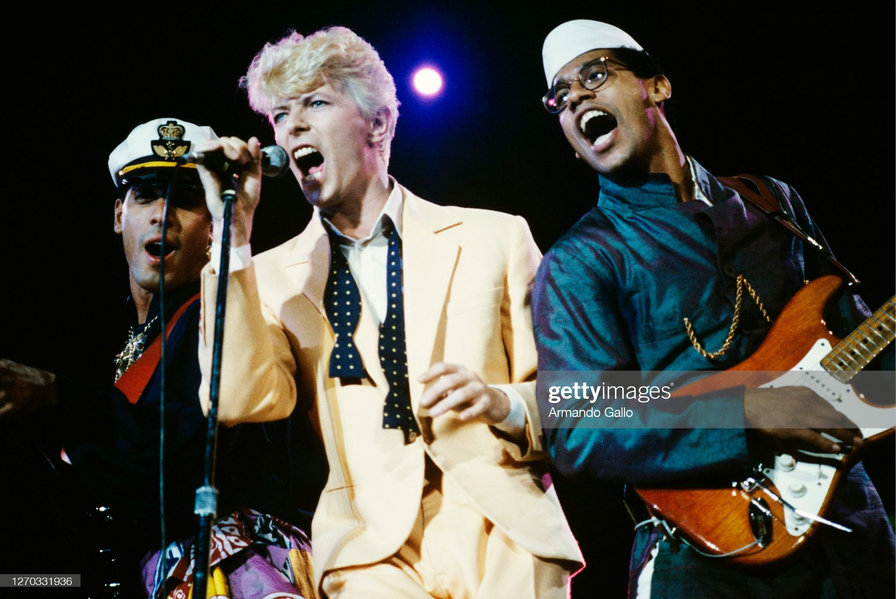

## Bowie & The Band: Chemistry, Charisma

Lorem. Emotional vocals. Incredible energy in the performance. Charismatic Bowie. Really good chemistry between all the band members. They’re having so much fun. Normal guy Bowie can mess up too—has a habit of mixing up or forgetting lyrics. Not perfect, not unreachable, relatable. Gigglefit band intro.

What a guy.

Mention stevie ray, link to <https://www.rollingstone.com/music/music-features/stevie-ray-vaughan-biography-texas-flood-excerpt-863263/>

### 

### Crowd Interactions

Describe some crowd interactions. A girl getting up on stage and breaking his acoustic guitar (07-20-1983: Philadelphia). The inflatable leg from 6-30.

# Conclusion

Every day, every performance, there’s a different experience. More time to spend with Bowie and the band. Bowie’s passing makes these Recordings of Independent Origin more special. Serious Moonlight in particular was Bowie sharing his best songs (of the time) with us. And those songs share his feelings, his experiences, and even the fictional stories he wants to tell. There’s a bit of him in each song. A lot of these small moments throughout the concert really reveal another side to Bowie, it wasn’t Ziggy or Aladdin Sane or Halloween Jack or the Thin White Duke. It was just him. He was a highly charismatic, humorous, and endearing person, especially once you experience these human-making (humanizing) moments. Down to earth. Bring him down to earth from the Ziggy Stardust persona. The Serious Moonlight tour reveals Bowie as just another human, very easy to connect with, the man behind the superstar. He was just being himself, made himself vulnerable? Best opportunity to spend time with Bowie. An unreal connection. Breaks free from a character persona, is just himself. Bring it together with the chameleon momentarily revealing itself, or finally doing so—he’s also a dork in Blue Jean.

## Credits

David Bowie (vocals, guitar, saxophone) | Earl Slick (guitar) | Carlos Alomar (guitar)

Carmine Rojas (bass guitar) | Tony Thompson (drums, percussion) | Dave Lebolt (keyboards, synthesizers)

Lenny Pickett (saxophones, woodwinds) | Steve Elson (saxophones) | Stan Harrison (saxophones, woodwinds)

George & Frank Simms (backing vocals)