***Draft 17.6.23 JDB***

**Blue Center application form**

**for the development of a reef conservation programme in partnership with Coral Guardian.**

Coral Guardian is a French non-profit that was founded in 2012 to protect and restore coral ecosystems by working hand in hand with local communities. The nonprofit’s work focuses on 3 main pillars: participatory marine conservation, raising awareness and science. Coral Guardian's vocation is to share its knowledge acquired over its 11 years of experience to project leaders who want to act for the protection of coral ecosystems.

**The Blue Center** is a **training and support program** created by Coral Guardian, addressed to project leaders from local non-profit structures who want to **develop their own project to protect or restore coral ecosystems** by involving local communities.

**The candidate projects must:**

* Be proposed by a non-profit structure recognised by the local government
* Respond to an environmental issue concerning coral reefs
* Involve local communities in the development of the project
* Have a motivated project manager

**Additional documents to provide:**

* Official status of the local structure (mandatory)
* Summary table of project’s total budget (mandatory)
* Photos of project, team (optional)
* Organisation chart of the local structure (optional)
* CV of the project manager (optional)
* Communication materials if developed (optional)
* Any other documents relating to the project that are considered important
* Project sketch of concept

Use this version of the Word document to complete your answers, and when you have finished, **complete this Google Form** with your answers and submit your application through the Google Form directly.

**Applications are open until midnight on 18th June 2023 (23:59 CET). You will be contacted by Tuesday 18th July at the latest with a reply to your application.**

If you have any further questions, please do not hesitate to contact **Florina Jacob** at **bluecenter@coralguardian.org.**

**(*required questions)**

## General information

1. **Name of the project**:

Restoring Traditional Reef-Fishery Ecosystems through Coral Gardening by local fisher communities.

1. **Country \***:

Kenya

1. **Full name of the project leader** *:

Remmy Safari

1. **E-mail address of the project leader *:**

[environment@oceansalivekenya.org](mailto:environment@oceansalivekenya.org)

1. **Summary of the project \*** *(500 characters)*

With Coral Guardian expertise and guidance, we aim to enhance marine biodiversity, ecosystem resilience and improve livelihoods of local communities through coral fisheries restoration. With our partners in Kuruwitu-Kenya, we will trial innovative technology that is easily adoptable within the technical and socio-economic capacity of fishers. The results will be deployed and scaled through adaptation and domestication targeting Beach Management Units to restore fisheries in degraded coral areas.

## Detailed information

1. **Name of the local structure**: *

Oceans Alive Foundation

1. **Nature of the local structure (NGO, association, foundation,...)**: *

Non-Governmental Organization (NGO)

1. **Short mission of the local structure (limited to 300 characters)** *

We share experience and knowledge of community-based management of marine resources with traditional artisanal coastal fisher communities. We engage local action to safeguard biodiversity, ensure ecosystem sustainability, restoring fisheries and degraded reefs, to improve livelihoods of fisher families.

1. **Number of employees and/or volunteers in the local structure**: *

25 employees, of which 6 will be directly involved in the proposed project and as many as 50 volunteers annually work as student interns using our partner models as living classrooms for peer learning about marine conservation.

1. **Address of the local structure**: *

22 Kuruwitu Road, Vipingo, Kilifi County

PO Box 73-80119, Vipingo, Kilifi County.

Kenya

Email: [admin@oceansalivekenya.org](mailto:admin@oceansalivekenya.org)

1. **Date of creation of the local structure**: *

2019

1. **What is the website of the local structure, if any?**

<https://www.oceansalive.org/>

1. **Upload a logo or image that illustrates the structure or project**:

Logo

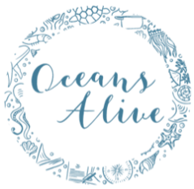

Map of Kuruwitu Co-management Area (CMA), showing 6 fish landing sites and 2 Community Conservation Areas (CCA)

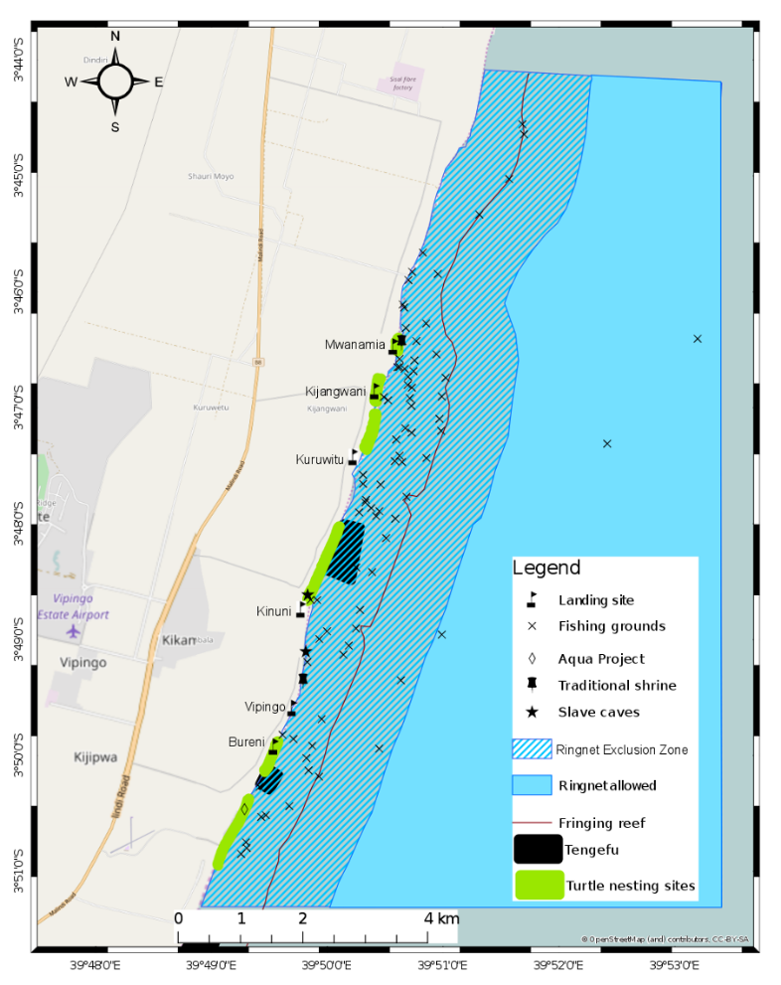

Bureni Fishermen and Turtle Watch CBO (Tengefu)

Kuruwitu Conservation and Welfare CBO (Tengefu)

Map of Kuruwitu Beach Management Unit 12,000 ha Co-management Area showing Fringe reef and fishing grounds

A Coral Nursery Table Seeded with 240 Juvenile Coral Colonies of 10 different Genus Growing on a Plug Platform

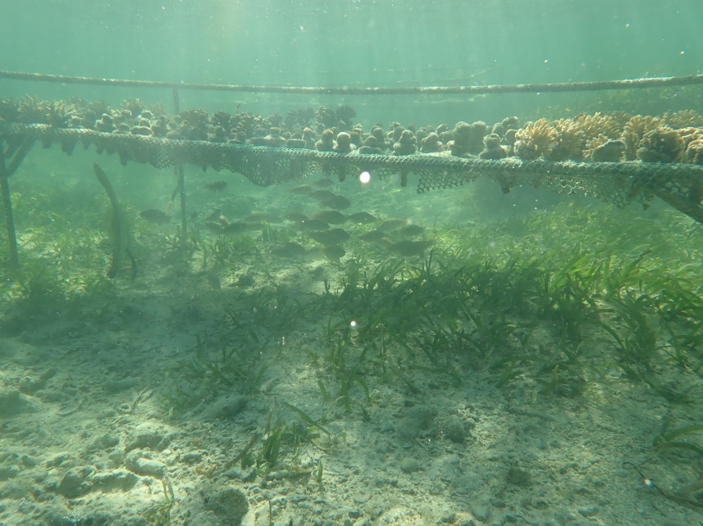

Example of a Cement Block Artificial Reef Structure with Out-planted Juvenile Corals with restored fish stocks

Example of a Coral Juvenile Colony Glued onto a Cement Plug as a Nursery Platform

Hand Drawn Sketch of Proposed Concept Using KCW-CBO Tengefu as a Coral Nursery and Extending Artificial Reef to Neighboring Fisher Communities in the Kuruwitu Beach Management Unit Co-Managed Area

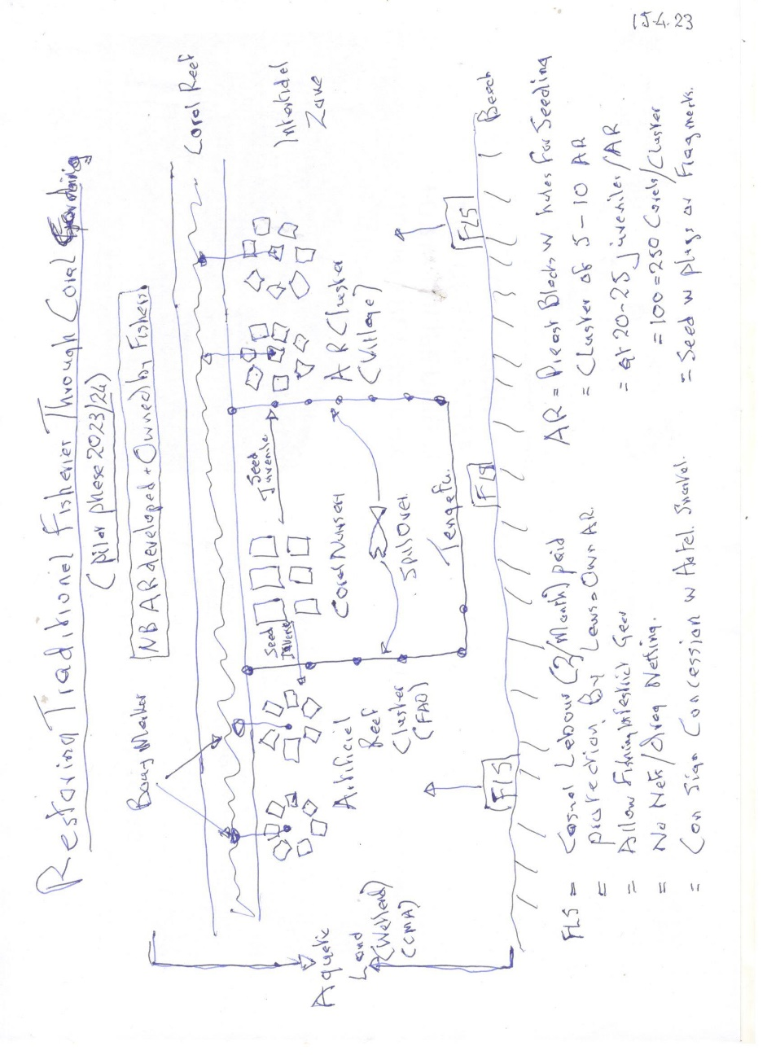

1. **GPS location of the project**: *

GPS Coordinates: -3.79592 39.83478

1. **Size of the area concerned**:

There are several Sites involved:

* The Kuruwitu Conservation and Welfare CBO operate a 30 ha Community Conservation Area (CCA) akin to a marine protected area (MPA) managed under traditional closed area law, called a “Tengefu”. The area has been under community management since 2003 and exhibited a 30% recovery in coral reef supporting 400% fish biomass and diversity increase. In addition, Coral gardening started in 2019. Current capacity is 32 table nurseries capable of 14,000 juvenile corals/year and over 10,000 out-planted to date and over 100 artificial reefs seeded. This site will be a study area of a model CCA and as a nursery to provide juvenile coral colonies to neighbouring participating fishers.
* Kuruwitu Beach Management Unit (KBMU) is a 12,000 ha co-management area (CMA) managed by fisher community in partnership with Kilifi county government authorities. The 12km nearshore fringe reef is the target for the pilot trials in out-planting through artificial reefs. The project will be working through involving 2 landing sites and awareness raising of all 6 fish landing sites, Mwanamia, Kijangwani, Kinuni, Kuruwitu, Vipingo and Bureni (see map above).
* Kilifi County BMU Network (KCBMU-NW) is a County registered association that coordinates 17 BMU activities along the 270 km of coastline. The network, shall be the future target of replication and scaling of the project best practice technology for reef fisheries restoration and protection.

1. **What are the detailed objectives of the project** *(e.g. return of biodiversity, community involvement,...)* *

The project goal is to find the most cost-effective technology, that is acceptable and easily adoptable and scaled by local fishers to encourage community participation and investment in coral gardening to restore their traditional fisheries fishing grounds. The intent is to under-go citizen science trials to find an economic model that communities can adopt. The intent is to inspire fisher community action in coral restoration through protection and out-planting, trialing with Coral Guardian partnership new approaches, testing artificial reefs and other coral restoration structures that are community accepted and operational under state and traditional laws. Through mass awareness raising, create a better understanding of the functions of the reefs towards traditional fisheries production and the importance of protection and restoration.

The project specific objectives are:-

1. Restore and conserve coral reefs and associated fish biota within the Kuruwitu Co-Management Area (CMA) to promote ecosystem resilience and improve livelihoods of dependent fishing communities.
2. Utilize sustainable, cost-effective, science-based restoration strategies/techniques to restore and conserve the coral fisheries ecosystem within the 12,000ha Kuruwitu Co-management Area for enhanced fisheries ecosystem resilience
3. Raise awareness and sensitize the local community in Kuruwitu and relevant stakeholders on the importance of coral reefs for marine biodiversity, ecosystem services and sustainable fisher livelihoods.

The project will empower the local community in Kuruwitu through provision of necessary tools and resources, monitoring programs and conservation measures. Engagement of the local community will foster a sense of ownership and responsibility.

1. **What kind of help would you like to receive?** *(pick one)*

* Regular and long-term (minimum 3 years)

1. **What do you hope to find and bring to Coral Guardian? What are your goals in joining our support program? \***

Oceans Alive (OA) seek a partnership with Coral Guardian by providing them the opportunity to interact with local community as a basis of sharing experience from South East Asia. A platform to conduct local trials to see if their technology can be domesticated to the socio-economic conditions of fisher communities in Africa. Kuruwitu BMU and Kuruwitu Conservation and Welfare CBO will be the pilot to conduct joint trials to test various ideas and models seeking best practices in coral gardening that can be upscaled. The aim is an ecosystem based approach to pilot a technology for coral protection and restoration that suits the socio-economic climate of local traditional fishing communities.

Oceans Alive and partners hope to share with Coral Guardian our experience to date in pioneering several coral fisheries protection and restoration. We have conducted trial experiments with the following techniques notably

1. Natural recovery of biodiversity, notably 30 % coral cover and 400 % fish biomass through traditionally protected community conservation areas (CCA) or “Tengefu”,
2. Table nursery using cement plugs as growth platforms for juvenile coral colonies, growing frags of corals of opportunity
3. Out-planting of nursery reared juvenile coral colonies on artificial reefs (AR) made from concrete blocks,
4. Damaged and degraded coral areas replanted using nails to tie down nursery reared juvenile coral colonies,
5. Deep water reef stars using fragments of corals of opportunity tied directly as out planted onto metal frames
6. Deep water sunken wrecks as surfaces for natural recovery of corals and fish biodiversity
7. Creation of clusters of concrete block AR tying corals of opportunity onto nails in the concrete block.
8. Using coral cut blocks used in local house construction as structures for seeding with juvenile coral colonies
9. Exploring aquatic concessions as applies to wildlife, where operators can lease aquatic land, pay fishers to protect the conservancy and offer eco-tourism based on the recovery of biodiversity
10. Coral nursery table management guide and coral restoration posters and information center.
11. Development of coral awareness and restoration booklets for schools and community appreciation on the importance of the reef.

Whereas all these trials have merit, all have cost implications and are of a technology that is beyond the economic capacity of upscaling adoption by local fishing communities. The Cost to engage community widely in a mass restoration of the 50-90% coral lost due to coral bleaching will take a large investment unless the technology can be simplified and cost effective matching local action socio-economic limitations. This includes addressing the following cost implications;

1. Cost of making metal nursery tables
2. Cost of manufacturing cement plugs
3. Cost of nursery management and maintenance
4. Cement cost of making concrete blocks for AR
5. Cost of community protection of a CCA (Tengefu)
6. Need for an underwater drill to make holes in degraded areas for out-planting juvenile corals.
7. Need for an electric drill and electricity in remote area to make holes in AR Blocks for out-planting juvenile corals.
8. Costly marine glue to cement the coral frags to grow them on the nursery plug
9. Need for diving equipment and PADI diving certification for deep water out planting.
10. Local community resistance to the Tengefu concept for fear of loss of ownership
11. The costly process of establishing a BMU and financing implementation of CMA Plan that includes reef protection and restoration

We look forward to a partnership with Coral Guardian to bring external science-based perspectives that can help refine the technology currently being employed in our partner coral reef nurseries and out planting systems. We hope that Coral Guardian experience in community-based coral restoration will bring a fresh approach to inspire our fisher community adoption and scaling up of local action in appreciation of the livelihood benefits of coral restoration to improve productivity and sustainability of the reef fishery and to open new economic options through biodiversity enhance and ecosystem resilience leading to prospects of eco-tourism investments.

1. **What is the local context of the project area (social, environmental and political)? \***

The collapse in Kenya in the 1990s of 50-90% of the coral reef due to coral bleaching had a devastating effect on the ecosystem and a knock-on effect and decline in fishery productivity. This had consequences in diminishing fisher livelihoods. This, situation is exacerbated by population growth and poverty, whereby the open access nature of the fishery meant that there was no restriction on new entrants entered the system. These new fishers had no traditional fisheries management knowledge, and this has led to overfishing. Further, the unregulated nature of the fishery, lead to use of destructive gears and illegal fishing. These illegal practices adversely affected the livelihoods of the inshore artisanal fishers. They make up 90% of the fishing community and are dependent on the fringe reef for their traditional fishing grounds.

In the absence of legislation, through concerted efforts in 2003, the Kuruwitu community was able to establish a Community Conservation Area (CCA), using the traditional laws, an approach known as ‘Tengefu’. This protection resulted in recovery of 30 % coral reef and contributed 400 % fish biomass and related biodiversity. Although replicated by 30 other CCAs along the Kenya coast, this model is not protected by legal framework.

It was not until the Kenyan constitution of 2010, that called for more participation of communities in natural resource management like fishing, that a legal framework of secure tenure and user rights emerged. Although issued in 2007, the Beach Management Unit (BMU) regulations failed to establish community rights and co-management. However, the new BMU Regulations of 2021/22, empowered BMUs as co-managers with state and county government. The BMU now had secure tenure and could invest in their fishing grounds, in a Co-Managed Area (CMA) plan. This project will help roll out this BMU plan for coral restoration for improved production of the traditional inshore reef fishery.

In addition to the fisher family benefits, the coastal fishing economy has associated value chain livelihoods that could be as much as 20-fold that of each fishing household. This ranges from boat and gear building, to fish processing and marketing to the small and medium enterprises (SME) that provision the fisher families. This especially considers women’s groups involved in fish trading and processing. Enhanced fish production will mean greater value chain benefits.

1. **Tell us about the history of the project:** *(how did you conceive or start the project?)* *

As explained in “19”, the collapse in Kenya in the 1990s of 50-90% of the coral reef due to coral bleaching and overfishing combined with destructive gears adversely affected the livelihoods of the inshore artisanal fishers that make up 90% of the fishing community. The local elders and senior beach residents got together in 2003 to form a CBO to set-up and manage a CCA, a closed area or “Tengefu”.

The project therefore builds on 20 years of CCA experience of Kuruwitu Conservation and Welfare CBO (KCW-CBO) operating under traditional laws. The remarkable 30% coral and 400% fish recovery, also contributed an outward spill over migration benefiting neighboring fishers. Further, the biodiversity spectacle created an ecotourism venue as an additional revenue stream. This has opened scope for private sector concessions to lease the site for snorkeling, and studies are underway to see if terrestrial wildlife conservancies concepts apply to marine aquatic ecosystems.

Given the growing interest and demand for technology sharing of the CCA concept and the request to support emerging BMUs, Oceans Alive (OA) was formed in 2016, and reregistered in 2019 as an NGO. OA has raised donor support to both manage the CCA but also supported the development in 2022 of the KBMU CMA Plan and now funds its implementation and coral restoration.

1. **Who are your partners on this project (and their roles)?** *
   * 1. Kuruwitu Conservation and Welfare Community Based Organisation (KCW-CBO):

KCW-CBO is a community lead conservation association managing 30 ha marine sanctuary. This pilot sanctuary or Tengefu is administered by the KCW-CBO and would serve as a Living Classroom for peer to peer training of fishers on methods for replication of CCA, for Coral Gardening and Reef Restoration, explaining ecotourism options, and ‘spillover’ effect. It shall also be the venue for nursery production of juvenile coral colonies.

* + 1. Kuruwitu Beach Management Unit (K-BMU):

The K-BMU are an association of 200 fishers that manage 12 km of fringe reef and 12,00 ha CMA. They will be the key implementers for the project. Comprising fishers and fish traders, they will be directly involved in an internship in pilot trials of various coral gardening options that could be replicated along their 12 km fringe reef. They will be the direct beneficiaries of any resultant enhancement of the inshore traditional fisheries, benefitting from the restored corals and fishery. The BMU by-laws shall govern protection of any additional CCA and artificial reef placements.

* + 1. Kilifi Beach Management Unit Network (KBMU-NW):

KBMU-NW is an association instrumental in supporting 17 BMUs, 7,000 fisher members who operate fishing grounds in 270 km of Kilifi County coastline. They shall be the voice piece of sharing information to their members for up-scaling, to meet their long-term goal of expansion of the best practice technique to the rest of the 16 BMUs within Kilifi County.

* + 1. Kilifi County Directorate of Fisheries (KCDoF):

The KCDoF represent devolved governance of the fishery and as co-managers of the BMU CMA. They are the extension arm of county government and would become the promoters of best practices that emerge. KCDoF will provide backstopping legal frameworks to safeguard the interventions by the fishers regarding fisheries management including implementation of coral restoration and Tengefu.

Field aspect

1. **Your project aims to** *(tick one or more boxes)***:** *

* Protect marine biodiversity
* **Restore marine biodiversity**
* **Raise awareness on marine biodiversity**

1. **What technical means do you plan to use? \*** *(What methods do you plan to use? How did you choose them?)*

The project shall have two citizen-science based themes:

* 1. Replication of AR Clusters trials by OA

OA and partners are experimenting with reduction in costs of their current coral gardening projects and are developing a technology to match the techno-socio-economic culture of local fishers. Two trials are proposed:

* Trial 1: Concrete block AR Clusters out-planted with juvenile coral colonies on plugs grown in the nursery: The strategy involves the KBMU nominating 10 local fishers, willing to undergo internships. 5 will be selected from each side of the KCW-CBO Sanctuary and paid a stipend for 2-3 months part-time engagement as compensation. Each will have a dedicated coral nursery table to manage. They will make their own cement coral plugs and seed the tables with 240 coral frags, each broken from coral of opportunity and glued onto the plug platform. One coral nursey table is sufficient for 10 Cement block AR each with 22 juveniles, 220 in total. Each AR has 6 blocks, 60 in all that will be prepared by each of the interns, 600 in total using the existing concrete block moulds. They will be assisted in placement in clusters of 10 AR. Each AR cluster will be owned and managed by a fisher intern guided by OA instructors and expected to keep M&E data.
* Trial 2: As above but not reliant on the nursery reared corals. Alternative design of concrete block AR Clusters will be tested to be out-planted with fragments of corals of opportunity tied onto nails in the blocks. The aim is to find a way of by-passing the expensive nursery operations. This trial will be a repeat of the above but with an additional 10 Interns.
  1. Local adaptation of best practices advocated by Coral Guardian

Anticipated is that Coral Guardian as part of the partnership will bring with them 1-2 best practices from SE Asia to undergo local trials for domestication to fisher techno-socio-economic culture.

* Trial 1 (TBD)
* Trial 2 (TBD)

The Logical Framework, Outputs and Expected Activities for a 3 year project include:

**Expected Outcome: Coral Reef Fishery based livelihoods improved and made resilient through coral gardening**

**Output 1. Project Formalization and Launch**

* 1. Briefing of KBMU and KCW-CBO Executive on project
  2. Agreement on SOP for community management of the Artificial Reefs
  3. Agreement on internship and criteria for selection of community fisher volunteers
  4. KBMU, KCW-CBO and KCBMU NW Assembly sensitization of the project
  5. Signing of Project MoU between OA, KBMU, KCW-CBO and KCBMU NW
  6. Formal launch of project

**Output 2. Community Capacity Development in Best Practices**

* 1. Technical Team & Coral Guardian develop project training strategy (phase 1 and 2)
  2. Technical team develop leaflets, posters, toolbox & guidelines
  3. Translations of training material in Swahili
  4. Testing training material
  5. Printing of training aides
  6. Technical orientation of the KBMU, KCW-CBO, and KCBMU NW Executive
  7. Training of selected fisher community participant interns

**Output 3: Community engagement in Seeding and Maintaining Coral Nursery Tables**

1. Coral Nursery tables refurbished
2. Coral plugs manufactured
3. Coral Nursery tables under production
4. Corals of opportunity seeded as fragments
5. Nursery Tables maintained/cleaned on monthly basis

**Output 4: Community engagement in production & placement of AR using Nursery Juveniles**

* 1. Block Moulds manufacture
  2. AR Assembled
  3. AR Placement and Marker Buoys fixed in clusters
  4. Juvenile corals out-planted on AR using glue
  5. Community fishers protect and harvest fish

**Output 5: Community Trials on alternative AR approach using corals of opportunity**

* 1. OA Trail 2: using block design trials with nails and corals of opportunity (Replicate 4 testing best practice)
  2. Trial 1: guided by Coral Guardian SE Asia Best practice Techniques (TDB)
  3. Trial 2: guided by Coral Guardian Techniques (TBD)
  4. Exchange visits with Coral Guardian to view SE Asia technology in situ.
  5. Living classroom demonstrations or community trials of AR alternatives

**Output 6: Community involvement in Citizen Science recording of fish and coral recovery**

* 1. Quarterly M&E measurements of coral survival and growth
  2. Quarterly M&E measurements of Fish species numbers & biomass
  3. Monthly data of fishers catch from AR trials
  4. Monthly assessment of fisher Economic benefits
  5. Routine quarterly progress reporting
  6. Annual workshop for data sharing and development of plan going forward

**Output 7: Raising community awareness and general sensitization on the importance of corals**

* 1. Develop a communication and awareness plan
  2. Communication team to capture and document the whole process in mass awareness material
  3. Conduct KBMU community stakeholder meetings, workshops to share findings and results
  4. Prepare, print and share Information Education and Communication material (posters, brochures, short films, website update)
  5. Mass awareness campaign

**Output 8: Technical Assistance and Fisher Internship Package**

* 1. Technical Advisor support: Advise on strategy and develop training aides
  2. Coral Guardian Technical support: Sharing SE Asia Technology (TBA)
  3. Fisheries Development Manager: Supervision of delivery vs work plan
  4. Communication Officer: Documenting and IEC delivery
  5. Coral Outreach Officer: Field management
  6. Coral Team Lead: Lead instructor
  7. Coral outreach trainers: 2 trainers to support interns
  8. KBMU Community Fishers internship: 20/year part-time interns
  9. Administration and project management: Project administration and finance back-up.

1. **What are the desired results in the short, medium and long term? With what key indicators do you plan to measure the impact of the project? \***

Short Term (0-1 Year): Several citizen science-based pilot trials conducted:

* 1. OA team and KBMU interns replicate 10 pilot AR clusters as trialing of the concept as a best practice of AR as FADS.
  2. Guided by Coral Guardian, Coral Team and KBMU conduct several trials adapting SE Asia technology concepts.
  3. All trials will engage the local fishing community in internships so that knowledge remains in the community.
  4. The aim is to demonstrate feasibility of SE Asia technology for mass restoration and by demonstration win the KBMU confidence to wish to scale up engagement in the principles of coral gardens
  5. Success will be measured based on techno-socio-economic applicability to local fisher culture.
  6. Formation of Coral Alliance Secretariat in Kenya, bringing together key players in Coral restoration and a pool for knowledge and resources for upscaling coral restoration initiatives

Medium Term (1-3 Years) Several successful pilot trials extended to additional areas.

1. Roll out of the AR cluster concept trials to additional 10 clusters/Year to M&E reef and fish recovery and cultural acceptance
2. Roll out of additional 2-3 pilot trails scaling of the Coral Guardian SE Asia technologies that show promise.
3. Orientation, improved knowledge and behavioral change to 30 local Schools in fisheries restoration through coral gardening, targeting over 1500 children
4. Documentation of the best practices in a guide book, manual, posters and leaflets for education of BMUs.

Long Term (3-6 Years) Scaling up to support roll out to KCBMU-network

1. Extension of best practices to additional network BMUs willing to invest in coral management.

The major indicators of the impact of the project will be on two levels;

1. Biodiversity Indicators: For each technology, this M&E includes juvenile coral colonies attachment, survival/mortality and growth rate, as well as any additional species that may undergo natural settlement/recruitment of coral larvae and juveniles. The species diversity and estimates of fish biomass (sizes and numbers), and presence of marine invertebrates and their numbers in the vicinity of the trials will also be measured and photographic records maintained. Standard protocols, such as Belt Transects, for assessing fish and marine invertebrate populations in the vicinity of the AR.
2. Techno-Socio-economic Indicators: The interns will keep records of fish catch data by species and weight which will reveal if there are any economic benefits. The KBMU fisher community opinion of the technology and their willingness to adopt and invest will be obtained through socio-economic survey/questionnaire. For each technology, a business plan shall be developed to show cost-benefit viability for mass adoption.

Social aspect

1. **How are local people involved? \*** *(How do you interact with local people in the project? Who are your main contacts in the project?)*

Local People are involved in several ways:

* 1. OA has hired a coral restoration team made up of 100 % community fishers who have been trained and now operate the coral Nursery, build AR and do out-planting. They shall be the lead instructors, training the fisher interns and CBO, BMU and KCBMU-NW members.
  2. KCW-CBO is the main contact to the sanctuary and our coordination point is through their executive committee as members of Project Management Team (PMT).
  3. KBMU executive shall be participants in the PMT and be the source of interns for training and operating citizen-based science trials and owners of any structures, like AR.
  4. KCBMU office bearers shall attend PMT and be the point of contact for sharing and scaling the best practices.
  5. Coral Guardian is expected to participate in zoom meetings of PMT, and during exchange visits.

Our approach is that fisher interns from the KCW-CBO neighboring 2 fish landing sites will be trained by OA instructors on the methods of coral gardening and be offered a stipend during the training. They shall gain knowledge and experience through hands on seeding of nursery tables, table management, AR Block construction, AR creation and placement and subsequent management. Likewise for any Coral Guardian designed pilots, we shall follow the same internship concept.

1. **Who are the direct beneficiaries of the project? \****(who are they, how do you interact with them?*)
2. KCW-CBO will benefit from the improvement of their operations and eco-tourism concessions, through welfare projects for their members.
3. KBMU will be supported through internships as peer to peer to share knowledge with BMU members and any improvement in fishery through coral interventions will benefit BMU fish value chains of fishers, fish traders and community at large through increased availability of fish.
4. OA employees shall benefit from salary support to engage in this project.
5. **Who are the indirect beneficiaries of the project? \*** *(who are they, how do you interact with them)*?
   1. The community at large will benefit from any improved fish consumption resulting from production and through coral importance awareness appreciate their environment and conservation roles.
   2. Local schools who will be exposed to coral Appreciation and awareness videos in our weekly school video screening program.
   3. Beach residents who use the beach front and fringe reef for recreational snorkeling.
   4. Guests at local hotels who can enjoy the ecosystem spectacle of coral reef snorkeling.
6. **What is the reaction of local people to the project?** *
7. KCW-CBO are being supported by OA, and as partners are committed to management of their Tengefu/sanctuary and welcome any support that would help improve income streams. They accept that the coral nursery will dedicate a number of coral nursery tables to interns to produce seed corals for the out growing trials. Also, they are willing to act as a living classroom for peer to peer training of their neighboring fisher community as interns to learn first-hand in Tengefu protection and coral nursery technology.
8. KBMU is being supported by OA in implementation of their CMA Plan, and note that coral restoration fits the CMA Plan. Further they have briefed neighboring fishers of the scope of a internship and mini-semi-closed area concept to establish AR clusters as FADS. They also welcome any intervention that would help improve the reef fishery.
9. KCBMU-NW are already engaged with OA in keeping all 17 members informed of any technology advancement worth investing in.
10. KCDoF and state Kenya Fisheries Service (KeFS) are fully supportive of OA work and have endorsed this concept as supporting BMUs implement their CMA and are planning to sponsor through World Bank a coral restoration initiative with KBMU.
11. Local hotel operators have expressed and interest to sponsor the aquatic safari concessions idea.

There has been some resistance of local fishers to expand the Tengefu concept as they feel this is depriving

Financial aspect

1. **What is the total budget required per year and for the entire duration of the project?** *
   1. Year 1: Euro 39977
   2. Year 2: Euro 39735
   3. Year 3: Euro 40026
   4. Total: Euro 119739

It must be noted whereas the concept of interns managing AR is the main theme, this could change with concepts shared and tested under Coral Guardian guidance and will lead to project budget adjustments at the time.

1. **What is the minimum wage in the country? What is the average wage in the country?** *

The minimum monthly salary in Kenya is Kenya Shillings 15,120 (2022 Statistics)

The average monthly pay is Kenya Shillings 20,123 (2022 Statistics)

1. **What would be the cost of the launching phase of the project?**

Budget for Launch is 2162.16 Euros

1. **Do you receive any other financial support for this project? If so, which ones?**

OA has several small grants to support partners in various aspects of their operations, and as relates to coral restoration we have:

* 1. Platinum Credit: support for 10 coral nursery tables (Pending)
  2. Coral Reef Care: support for 5 coral nursery tables (Pending)
  3. Athletes Media Group: Funded construction of 10 coral nursery tables
  4. Agha Khan Foundation: support 4 tables and training of 4 schools in coral restoration.
  5. Rockefeller: Support to KCW-CBO management of Sanctuary
  6. BIOPAMA/IUCN/EU: Support implementation and management of KBMU CMA and institutional strengthening of KCBMU-NW.
  7. Wildlife Direct/National Geographic: Screening to schools of ocean awareness and conservation videos.

However, none of these funding support coral restoration research and knowledge transfer to community

## Additional information

1. **Sometimes it’s just easier to voice an explanation of your project or to describe it with pictures.**

*We would love to see you pitch your project in a video of less than 2 minutes! Although not mandatory for your application, this is a great opportunity for us to dive into your world. Feel free to tell us about your story, your solution, your team or anything else you think is important. Attach a Youtube link, make sure your video is in public mode. The quality of the video is not essential. NB: Coral Guardian commits itself not to broadcast it.*

1. **Remarks:** any additional information and motivation for the project.

Most approaches to coral reef restoration target complex technologies that do not match the techno-socio-economic culture of fishers, and we hope through partnership with Coral Guardian to develop a strategy that has mass replicability by coastal communities.

**Documents to provide (max 10 elements) :**

- official status of the local structure (mandatory)

- summary table of project’s total budget (mandatory)

- photos of project, team (optional)

- organisation chart of the local structure (optional)

- CV of the project manager (optional)

- communication materials if developed (optional)

- any other documents relating to the project that are considered important