**JDB Revised Draft 19.1.23**

**(Insert cover page…see pculture report**

**OCEANS ALIVE**

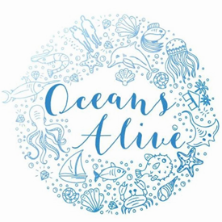

Restoration, Awareness, Research and Education (RARE)

**ANNUAL PROGRESS REPORT, 2022**

**Introduction**

**Coral Gardening**

Describe approach and modular system annex data…

**Coral Restoration Program…**

Mention KBMU, KCWA, CRC, OE, PC, AMG, etc

***Insert annex of data sets***

Refer to modular approach

**Annual Report**

This annual progress report shows a summary of the coral data in tracked throughout 2022 based on the annual work plan targets***.*** It compares the annual target with what the coral team managed to achieve and shows this as a percentage performance. It includes the following details:

1. Number table made vs target..MISSING
2. Number of plugs made,
3. Number juvenile corals in nursery
4. Number juvenile corals out-planted MISSING
5. Number AR outplantes
6. d
7. number of coral tables cleaned. Number of artificial reef structures made.

Insert Tables target by CRC, PC, AMG, OE, etc….

NB sort interface of tables



***Table* 1: *Data of the Monthly corals Out-planted Vs the Annual Target.***

*Insert major grid lines*

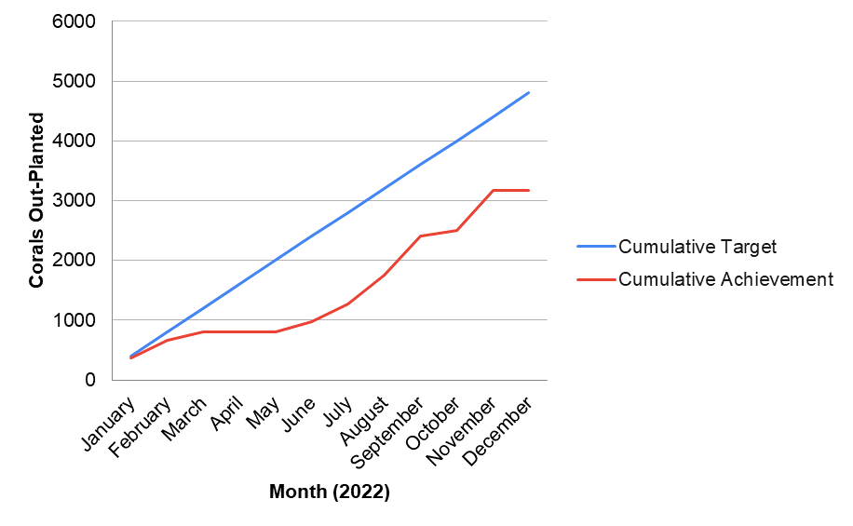

***Figure 1: Trend in Annual cumulative corals Out-planted Vs cumulative target.***

As shown **Table 1** and **Figure 1** the annual % cumulative achievement is 33% lower than the annual cumulative target of corals to be out-planted. This is due to;

1. Insufficient marine glue (NB outplanting does not need glue..can use cement??? Glue is for frags surely??? Use nails…..
2. Decision delayed by management in concurrence with community in finding other areas outside the KCWA for out-planting. WHO MADE DECISION..OA< OE, CRC, PC, ????

|  |  |  |  |
| --- | --- | --- | --- |
| **Coral Plugs Made vs Annual Target** | | | |
| *2022* | | | |
| **Month** | **Cumulative Target** | **Cumulative Achievement** | **% Achieved** |
| January | 500.0 | 700.0 | **140.0** |
| February | 1000.0 | 2000.0 | **200.0** |
| March | 1500.0 | 3350.0 | **223.3** |
| April | 2000.0 | 4950.0 | **247.5** |
| May | 2500.0 | 6350.0 | **254.0** |
| June | 3000.0 | 7550.0 | **251.7** |
| July | 3500.0 | 7950.0 | **227.1** |
| August | 4000.0 | 8550.0 | **213.8** |
| September | 4500.0 | 8550.0 | **190.0** |
| October | 5000.0 | 8550.0 | **171.0** |
| November | 5500.0 | 8550.0 | **155.5** |
| December | 6000.0 | 8550.0 | **142.5** |

***Table 2: Annual coral plugs made Vs target achieved for every month.***

**Insert major grid lines**

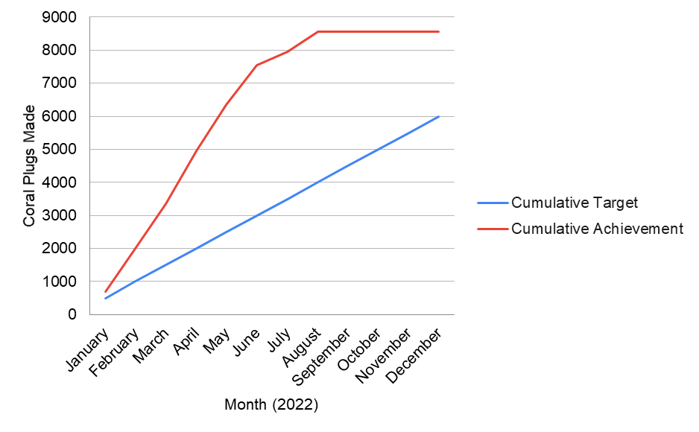

***Figure 2: Annual target and cumulative coral plugs made each month vs target.***

As shown **in Table 2** and **figure 2** the annual % cumulative achievement of coral plugs is 43% higher than cumulative target. This is due to due to;

NB if we have 4000 surplus where are they… this is waste of resources??

1. Availability of materials such as cement.
2. Planning by the coral team to achieve original numbers on plug making.

For that, this causes a higher increase in cumulative achievement as from beginning of the year upto August and a stationary stage between September to December as all factors remained constant.

|  |  |  |  |
| --- | --- | --- | --- |
| **Corals Planted (On Table) vs Target** | | | |
| *2022* | | | |
| **Month** | **Cumulative Target** | **Cumulative Achievement** | **% Achieved** |
| January | 480.0 | 1644.0 | **342.5** |
| February | 960.0 | 1644.0 | **171.3** |
| March | 1440.0 | 2604.0 | **180.8** |
| April | 1920.0 | 2604.0 | **135.6** |
| May | 2400.0 | 2844.0 | **118.5** |
| June | 2880.0 | 3574.0 | **124.1** |
| July | 3360.0 | 3814.0 | **113.5** |
| August | 3840.0 | 3814.0 | **99.3** |
| September | 4320.0 | 3814.0 | **88.3** |
| October | 4800.0 | 4054.0 | **84.5** |
| November | 5280.0 | 4534.0 | **85.9** |
| December | 5760.0 | 4534.0 | **78.7** |

***Table* 3: *Annual Corals Planted on tables???? Vs the Annual Target as a % of the Annual cumulative***

Insert major grid lines

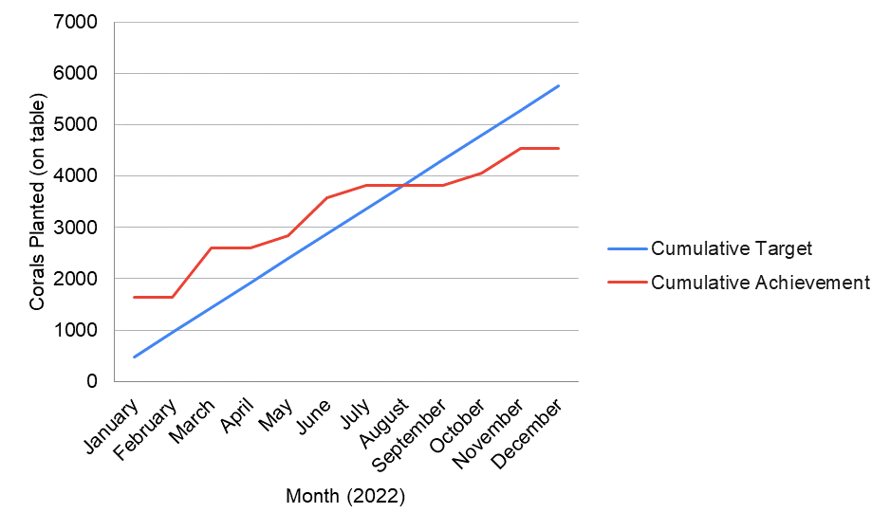

***Figure 2: Annual target Vs cumulative achievement of Corals planted on tables against every month.***

As shown in **Table 3 and figure 3** above initially upto mid-year, the annual cumulative achievement is higher than cumulative target of corals planted due to; Availability of marine glue. Above says glue caused delays..contradicts

As from mid-year upto end of the year, the annual cumulative achievement was lower than annual target due to; Decision change by management in finding other areas within the coral farm for planting corals delayed the team’s main schedule in attaining their target. Who made decision and how affects planting on tables

|  |  |  |  |
| --- | --- | --- | --- |
| **AR Structures Made vs Annual Target** | | | |
| *2022* | | | |
| **Month** | **Cumulative Target** | **Cumulative Achievement** | **% Achieved** |
| January | 4.0 | 12.0 | 300.0 |
| February | 8.0 | 25.0 | 312.5 |
| March | 12.0 | 33.0 | 275.0 |
| April | 16.0 | 41.0 | 256.3 |
| May | 20.0 | 49.0 | 245.0 |
| June | 24.0 | 61.0 | 254.2 |
| July | 28.0 | 61.0 | 217.9 |
| August | 32.0 | 61.0 | 190.6 |
| September | 36.0 | 61.0 | 169.4 |
| October | 40.0 | 67.0 | 167.5 |
| November | 44.0 | 67.0 | 152.3 |
| December | 48.0 | 67.0 | 139.6 |

***Table 4: Artificial Reefs Structures made and Outplanted Vs the Annual Target as a % of the Annual cumulative***

Check series titles

Insert grid lines

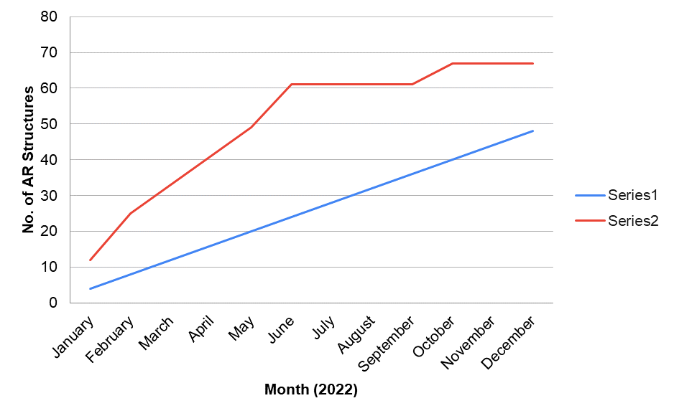

***Figure 4: Annual target Vs cumulative achievement for Artificial Reefs Structures Outplanted***

As shown **in Table 4** and **figure 4, the** annual % cumulative achievement is higher than the % annual cumulative target due to;

1. Availability of materials such as cement for ARs making.
2. Team enthusiasm
3. Availability of juveniles to out plant

Insert accumulative performance as % total number

|  |  |  |  |
| --- | --- | --- | --- |
| **Tables Cleaned vs Monthly Target** | | | |
| *2022* | | | |
| **Month** | **Monthly Target** | **Tables Cleaned** | **% Achieved** |
| January | 12.0 | 6.0 | 50.0 |
| February | 12.0 | 15.0 | 87.5 |
| March | 12.0 | 23.0 | 122.2 |
| April | 12.0 | 29.0 | 152.1 |
| May | 12.0 | 25.0 | 163.3 |
| June | 12.0 | 7.0 | 145.8 |
| July | 12.0 | 16.0 | 144.0 |
| August | 12.0 | 11.0 | 137.5 |
| September | 12.0 | 13.0 | 134.3 |
| October | 12.0 | 11.0 | 130.0 |
| November | 12.0 | 11.0 | 126.5 |
| December | 12.0 | 0.0 | 116.0 |

***Table 5: Annual corals Out-planted in degraded areas Vs the Annual Target as a % of the Annual cumulative***

***INSERT GRID LINES***

***Check series labels***

***Calculate as cumulative…***

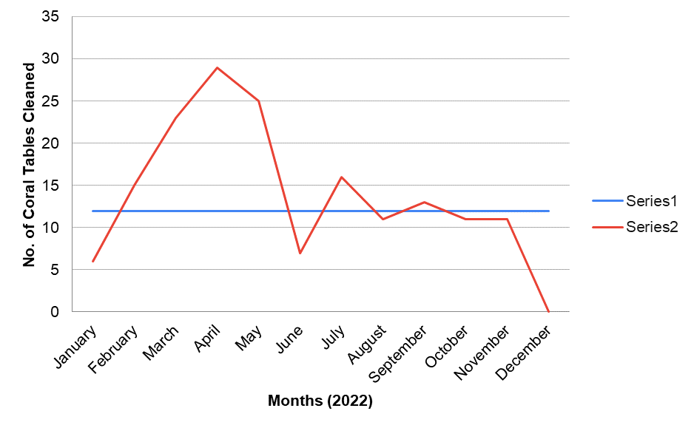***Figure 5: Annual target Vs annual cumulative achievement for Coral tables cleaned for each month.***

As seen in **table 5** initially**,** themonthly achievement was lower than monthly target. Some coral team staffs had taken their off/leave and this lowers the whole teams’ output. This suggests Poor planning

For the entire months, the annual cumulative achievement was higher than target as more staffs WHO mention students were available to provide man power in order to attain annual scale.

Decision change by the management on finding other places for coral activities consumed much time in performing other activities and therefore led to a zero output in December and lower performance for some months as shown **in figure 5….re-edit suggest poor planning by staff aand team**