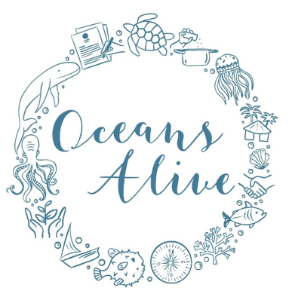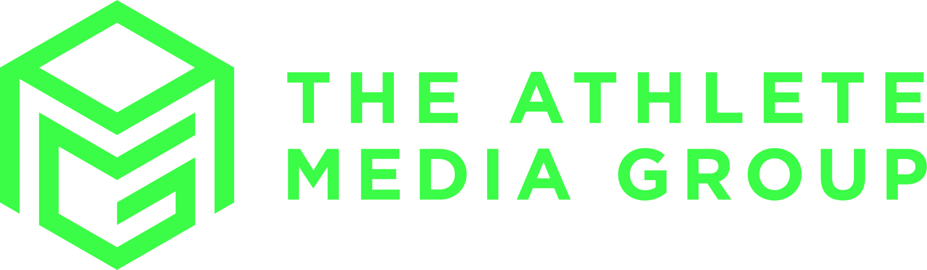

Draft 4.12.23 CTJB

**ADDENDUM TO**

**MEMORANDUM OF UNDERSTANDING (MoU)**

**Between**

**Oceans Alive**

**And**

**Athlete Media Group**

***‘Competing for Coral’ Initiative of Corals for Medals”***

**1. Parties to This Agreement:**

This MoU addendum is an agreement arrived at between the following parties:

**Party A:**

Name of the organisation: **Oceans Alive Foundation**

(Hereafter referred to as OA)

Name of CEO Desmond Bowden

Address: 22, Kuruwitu, Vipingo

Email Address: des@oceansalivekenya.org

Telephone: +254-722 511870

**Party B:**

Name of the organisation: Athlete Media Group

(Hereafter referred to as AMG)

Name of Executive: Mark Middlemas

Address: Thatch Barn, Ryewell Lane, Hoath Corner, Edenbridge, KENT, TN8 7BS

Email Address: mark@athletemedia.co.uk

Telephone: +44-7952 304340

**2. The Pitch**

This addendum modifies the SDG 14, ‘life under water’ ambitions of a 28.11.22 MOU. Since then, OA and partners have advanced their technical approach to traditional coral reef fishery restoration through coral gardening. In an effort to find a combined social, economic, environmental approach, OA has explored methods that can be applicable by local fishing communities. Trends in OA approach is moving away from coral nursery tables, to a more cost effective and community oriented strategies. The new approach involves direct planting of coral fragments onto artificial reefs located in protected clusters. This is a technology local communities can adopt and afford as an approach to restoring traditional fisheries through coral gardening. OA invites AMG under the current MOU “Corals for medals”, ***‘Competing for Coral’ initiative’*** to continue to support the 10 nursery tables as well as support new initiatives in coral restoration. The aim is to engage AMG athletes in a spectrum of actions.

This addendum to the 28.11.22 MOU is signed in agreement that AMG and OA will change their strategy of advocating athletes to move away from funding coral nursery tables to inviting them instead to sponsor villages of artificial reefs bearing juvenile corals. Also, through the AMG marketing platform, advance the athlete followers to support the ‘adopt a coral’ program.

**3. Background**

To date OA and Athlete Media Group (AMG) and community partners Kuruwitu Conservation and Welfare Community Based Organization (KCW-CBO) and Kuruwitu Beach Management Unit (KBMU) have encourage 10 athletes to sponsor 10 branded coral nursery tables with capacity for rearing a total of 4,000 juvenile corals per annum. However, the budgeted USD 500/table covers capital for infrastructure but the USD 5/coral juvenile input for operational cost for start up and year on to year on operations has not been forthcoming. In the absence of support from fans, sponsors and corporates, this operational cost has had to be borne by OA and community partners. This needs a joint marketing drive to stimulate more interest.

To reduce the operating costs of running the coral nursery tables and finding support for out-planting and artificial reefs, OA and community have experimented with a technique of significantly reduce cost and more appropriate technology for local conditions. The new strategy involves a direct planting on artificial reefs, positioned in clusters, making a coral village of 150 coral colonies. This approach by-passes the costly nursery stage and is of a technology easily adopted by community.

OA and partners, now agree to partner with AMG to change the theme of athlete sponsorship to move away from nursery tables to consider funding community engagement in setting up and running a athletes sponsored village cluster of artificial reefs. Like the tables, these will be branded in the name of the funding source.

**4. General** **Subject/Purpose/Objectives**

**4.1. Purpose**

The purpose of this MoU addendum is to be read in line with the 28.11.22 MOU:

1. To clarify the restructuring of the partnership arrangement between OA and partners, and AMG.
2. An agreement to move away from promoting coral restoration through nursery tables and more towards cluster villages of artificial reefs
3. An agreement to make a joint special effort to raise funds for operations of the established 10 nursery tables
4. This adddendum does not affect the rest of the agreement.

**4.2. Scope of Solutions**

The scope of partnership includes:

1. 10 Nursery tables operation and maintenance
2. Setting up and management of branded athlete coral villages
3. Setting up and management of memorial commemorative coral villages.
4. Establishing an annual ‘honours board’ and trophy of each athletes supporters adopting a coral
5. Global and Olympic marketing campaign and corals for medals

**5. Governing Policies**

1. **Financial Obligations**

This addendum clarifies MOU section 4.i. as follows:

1. AMG and OA shall continue to raise funds for operation costs for the 10 established nursery table branded in the name of the athlete, at USD 500/month for operations and maintenance
2. AMG shall source USD 250/coral reef village to cover capital overhead of artificial reefs construction, placement, branding and operations.
3. Additional finance sourcing to be carried out by AMG and the branding athlete is based on availing coral adoption spaces on the athlete’s branded nursery table or village for a donation amount of USD 5 per juvenile coral colony for annual operational expenses and community protection.
4. AMG and OA shall promote commemorative coral villages at USD 1200 to establish and maintain.
5. AMG shall make available USD 250 for each medal that their registered athlete performs.
6. OA shall provide AMG with invoices for the running costs of tables and establishment of each artificial reef coral village cluster, and provision certificates for coral juvenile colonies adopted annually.
7. **Disclaimer**

All other conditions of the MoU, remain unaffected except 4.ii.b., shall read as:

**4.ii.b. Athlete Media Group (AMG)**

AMG shall provide the following inputs:

1. Pay to the OA Foundation Corporative account as per agreed set donations of USD 500/month for operations of 10 nursry table
2. AMG shall seek ways to secure donations of USD 250 for each athletes coral village cluster for establishment and operation expenses, notably, but not limited to the following,
   1. Artificial Reef construction
   2. Artifical Reef placement in clusters of 6 making a village
   3. Artifical Reef seeding each with 150 coral fragments
   4. Branding labels on each cluster village acknowledging AMG and athletes
   5. Protection by community of village clusters
   6. OA technical staff support
   7. OA office services, management, accounting and administration of staff.
3. AMG and athletes shall seek ways to secure donations of USD 5/juvenile coral to the 10 branded coral nursery tables operation expenses, notably, but not limited to the following:
   1. Coral nursery tables daily routines and staff for cleaning, maintenance, recording, etc
   2. Coral colony out-planting either by drilling, nailing or on artificial reefs.
   3. Protection by community of out planted areas
   4. OA technical staff support
   5. OA office services, management, accounting and administration of staff.

**iv. Signatures of Agreement**

The parties understand and agree to the provisions of this addendum to 28.11.23 agreement, which is effective as at the date of signing.

**Party A:**

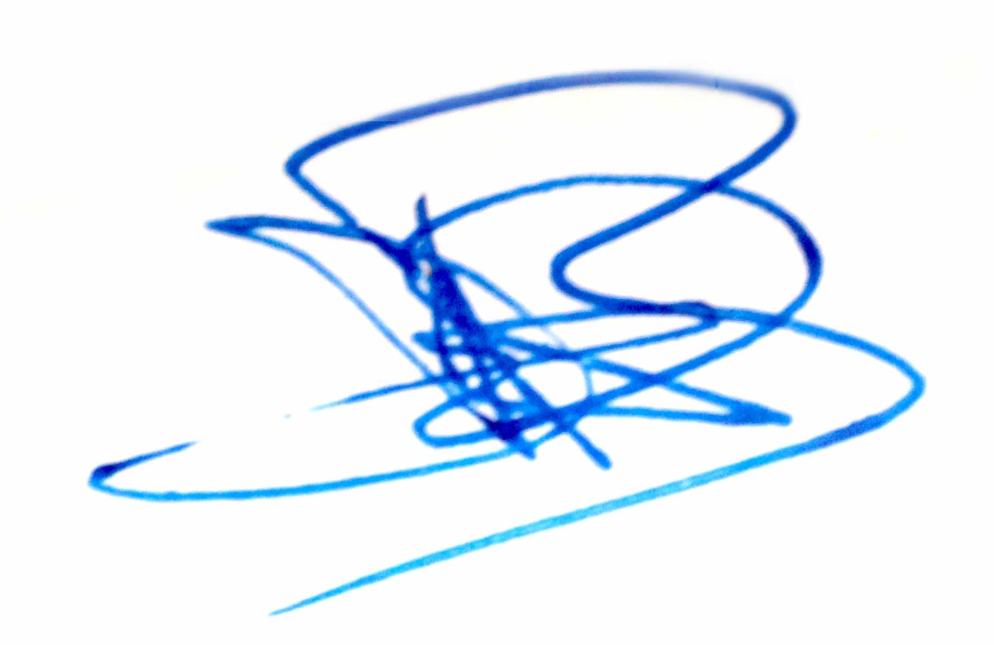Name of the organisation: **Oceans Alive Foundation**

Name of CEO: Desmond Bowden

Signature/Dated: 09/10/23

**Party B:**

Name of the organisation: **Athlete Media Group**

Name of Executive: Mark Middlemas

Signature/Dated 20.7.23

The underlisted are the agreed point source of communication:

For OA point of contact Name: Des Bowden

For AMG point of contact Name: Mark Middlemas