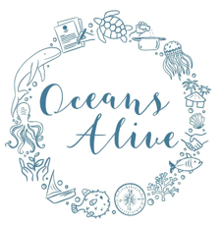Coral work-plan for October

|  |  |  |
| --- | --- | --- |
| **Activity** | **Frequency** | **Details** |
| Out-planting | 6 | 5 AMG tables and 1 Academic Families table |
| Planting | 6 | 4 Ocean Eyes tables and 2 CRC tables |
| BAR construction and placement | 36 | 216 blocks |
| Cleaning | 12 | 7 Platcorp and 5 AMG |
| Corals of opportunity finding | 4 | 1/week |
| Plug making | 900 | 1 patch/ week |
| Whole module with LEAP students | 5 | Finding COOs, planting, cleaning, BAR construction, Outplanting |