**OCEANS ALIVE**

**CORAL RESTORATION PROGRAM,**

**2022-ANNUAL REPORT**

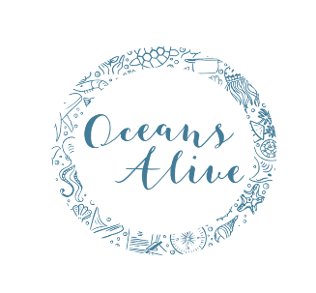

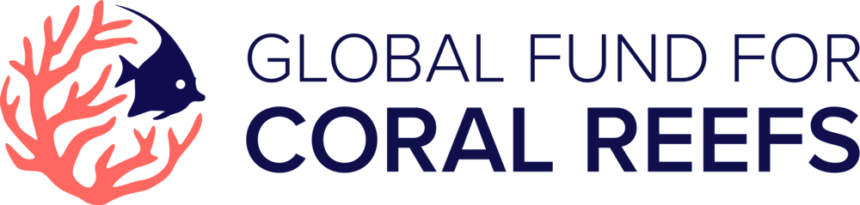



**TABLE OF CONTENTS**

1.0 INRODUCTION 4

1.1EXCECUTIVE SUMMARY 4

1.2 PROJECT APPROACH 4

1.3.0 BASELINE INFORMATION 5

1.3.1Progress in nursery table construction 7

2.0 Progress in plug making 8

3.0 Progress in coral planted on nursery tables 9

4.0 Progress in nursery tables cleaning 10

5.0 PROPOSED STRATEGY 16

5.1 INRODUCTION 16

5.2 PROJECT TEAM WEEKLY PLAN 16

5.3 MONTHLY PROGRAMME 17

6.0 EXPECTED OUTPUTS 18

6.1 OCEAN EYES 18

6.2 ENTIRE PROJECT 18

7.0 RESOUIRCES REQUIRED 19

# 

# 1.0 INRODUCTION

## 1.1EXCECUTIVE SUMMARY

This report represents coral data tracked over the entire 2022. This includes data in plug making, corals planted, tables cleaned, corals out-planted and the AR structures Made against annual cumulative targets per months using tables and graphs.

The report highlights challenges and solutions in regard to the problems for a project success while including a proposed strategy for the 2023. The project highlights the workplans in regard to weekly plans, monthly programme and expected outcomes.

## 1.2 PROJECT APPROACH

Coral reefs are under relentless stress globally referable to climate change, marine pollution that endangers reefs, sedimentation and physical damage due to water sports activities. Corals are the most critical habitats for fish production.

As a result of reduction in fish by-catch that was reported by local fishermen to Kuruwitu beach residents the near Kuruwitu beach residents was a substantial indicator of damaged reefs. To address this, Oceans Alive has experimented in coral restoration for some years under marine protected conditions in order to rehabilitate coral reefs so as to increase fish biomass within Kuruwitu marine sanctuary while taking into considerations the need of improving livelihoods of the Kuruwitu Community.

OA has been using Table nursery approach for coral restoration.

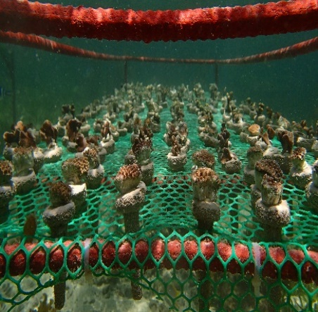

***Figure 1****: Showing table nursery method*

## 1.3.0 BASELINE INFORMATION

With the support from Platcorp, Global fund for Coral Reefs and Ocean Eyes, OA have replanted accumulated number of **7,332** corals within the marine protected areas since 2021 and had 21 coral tables under maintenance throughout the entire year-2022.

|  |  |
| --- | --- |
| **Partners** | **No. of coral tables sponsored** |
|  |  |
| 1.Ocean Eyes | 3 |
| 2.Platinum credit | 5 |
| 3.Platcorp | 5 |
| 4.Coral Reef Care | 9 (one swept away by currents deep sea) |

***Table 1:* *Showing number of tables sponsored***

***Graph 1: Showing the progress in the no. of tables against year***

The following below, are figures representing how our reefs are within the marine protected area.

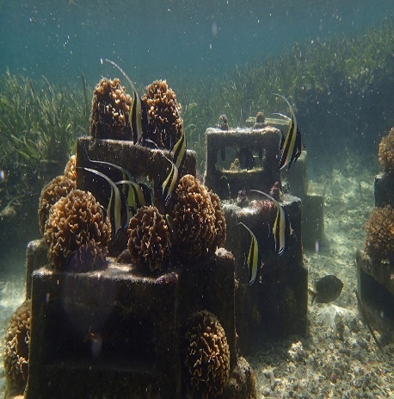 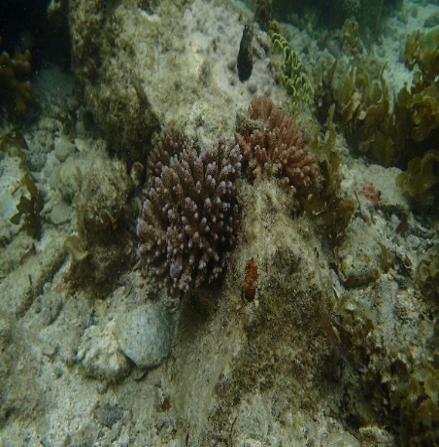***Figure 2: Showing ARS (Artificial Reef structures Figure 3: Showing Natural out -planted Reefs***

### 1.3. 1 Progress in nursery table construction

The table below shows the progress in no. of coral nursery tables from the beginning of the project upto 2022

|  |  |  |  |  |
| --- | --- | --- | --- | --- |
| **YEAR** | 2019 | 2020 | 2021 | 2022 |
| **No. of Tables** | 4 | 4 | 14 | 22 |

|  |  |  |  |  |  |  |  |  |  |
| --- | --- | --- | --- | --- | --- | --- | --- | --- | --- |
|  |  |  |  |  |  |  |  |  |  |
|  |  |  |  |  |  |  |  |  |  |
|  |  |  |  |  |  |  |  |  |  |
| |  | | --- | |  | |  |  | ***Graph 2: Showing progress in the no. of tables against year*** |  |  |  |  |  |  |
|  |  |  | 2.0 Progress in plug making |  |  |  |  |  |  |
|  |  |  | |  |  |  |  |  | | --- | --- | --- | --- | --- | | **Plugs** | **made vs** | **Annual** | **Target** |  | | 2022 |  |  |  |  | | **Month** | **Cumulative Target** | **Monthly Achievement** | **Cumulative Achievement** | **% Achieved** | | January | 500 | 700 | 700 | 140.0 | | February | 1000 | 1300 | 2000 | 200.0 | | March | 1500 | 1350 | 3350 | 223.3 | | April | 2000 | 1600 | 4950 | 247.5 | | May | 2500 | 1400 | 6350 | 254.0 | | June | 3000 | 1200 | 7550 | 251.7 | | July | 3500 | 400 | 7950 | 227.1 | | August | 4000 | 600 | 8550 | 213.8 | | September | 4500 | 0 | 8550 | 190.0 | | October | 5000 | 0 | 8550 | 171.0 | | November | 5500 | 0 | 8550 | 155.5 | | December | 6000 | 0 | 8550 | 142.5 | |  |  |  |  |  |  |
|  |  |  |  |  |  |  |  |  |  |
|  |  |  | ***Table 2: Showing progress in plug making*** |  |  |  |  |  |  |
|  |  |  |  |  |  |  |  |  |  |
|  |  |  |  |  |  |  |  |  |  |
|  |  |  |  |  |  |  |  |  |  |
|  |  |  | ***Graph3: showing cumulative no. of plugs made against the annual target***.  From the ***table*** above, the graph intimates that coral plugs made (8550) are higher than annual target (6,000) of coral plugs to be made and this was resulted by team enthusiasm and availability of cement.  Despite the fact that the team managed to achieve higher than the target, there is still a lot of plugs in the sea in which the team is required to pose in making more plugs until the available plugs are used up to avoid waste of resources |  |  |  |  |  |  |
|  |  |  |  |  |  |  |  |  |  |
|  |  |  |  |  |  |  |  |  |  |
|  |  |  | 3.0 Progress in coral planted on nursery tables  |  |  |  |  |  | | --- | --- | --- | --- | --- | | **Coral** | **planting** | **On nursery** | **tables** |  | | **2022** |  |  |  |  | | **Month** | **Cumulative Target** | **Monthly Achievement** | **Cumulative Achievement** | **% Achieved** | | January | 480 | 1644 | 1644 | 342.5 | | February | 960 | 0 | 1644 | 171.3 | | March | 1440 | 960 | 2604 | 180.8 | | April | 1920 | 0 | 2604 | 135.6 | | May | 2400 | 240 | 2844 | 118.5 | | June | 2880 | 730 | 3574 | 124.1 | | July | 3360 | 240 | 3814 | 113.5 | | August | 3840 | 0 | 3814 | 99.3 | | September | 4320 | 0 | 3814 | 88.3 | | October | 4800 | 240 | 4054 | 84.5 | | November | 5280 | 480 | 4534 | 85.9 | | December | 5760 | 0 | 4534 | 78.7 | |  |  |  |  |  |  |
|  |  |  |  |  |  |  |  |  |  |
|  |  |  |  |  |  |  |  |  |  |
|  |  |  |  |  |  |  |  |  |  |
|  |  |  |  |  |  |  |  |  |  |

***Table 3: showing progress in coral planted on nursery tables***

***Graph 4: showing cumulative target against the cumulative achieved in planting corals***

The graph stipulates that as from January to August the team attained a higher cumulative achievement than the annual target attributable to availability of manpower and team work.

While for other months, from August to December the coral team managed to attain a lower cumulative achievement than the target due to poor planning in allocation of leave calenders resulting to shortage of manpower leading to downscaling.

# 4.0 Progress in nursery tables cleaning

# 

**Th**

**e table 4** below shows cumulative numbers of tables cleaned against annual target.

|  |  |  |  |  |
| --- | --- | --- | --- | --- |
| **Coral** | **nursery** | **tables cleaned** | **Vs target** |  |
| 2022 |  |  |  |  |
| **Month** | **Cumulative Target** | **Monthly tables cleaned** | **Cumulative Achievement** | **% Achieved** |
| January | 12 | 6 | 6 | 50 |
| February | 24 | 15 | 21 | 87 |
| March | 36 | 23 | 44 | 122.2 |
| April | 48 | 29 | 73 | 152.1 |
| May | 60 | 25 | 98 | 163.3 |
| June | 72 | 7 | 105 | 145.8 |
| July | 84 | 16 | 121 | 144.0 |
| August | 96 | 11 | 132 | 137.5 |
| September | 108 | 13 | 145 | 134.3 |
| October | 120 | 11 | 156 | 130.0 |
| November | 132 | 11 | 167 | 126.5 |
| December | 144 | 0 | 167 | 116.0 |
|  |  |  |  |  |

***Graph5: showing cumulative target of coral nursery tables cleaned against achieved. As*** from the table above, the graph indicates a higher achievement than annual targets especially from March onwards due to team enthusiasm, and availability of manpower.

|  |  |  |  |  |
| --- | --- | --- | --- | --- |
| **ARS** | **Made vs** | **target** |  |  |
| 2022 |  |  |  |  |
| **Month** | **Cumulative Target** | **Monthly Achievement** | **Cumulative Achievement** | **% Achieved** |
| January | 4 | 12 | 12 | 300.0 |
| February | 8 | 13 | 25 | 312.5 |
| March | 12 | 8 | 33 | 275.0 |
| April | 16 | 8 | 41 | 256.0 |
| May | 20 | 8 | 49 | 245.0 |
| June | 24 | 12 | 61 | 254.2 |
| July | 28 | 0 | 61 | 217.9 |
| August | 32 | 0 | 61 | 190.6 |
| September | 36 | 0 | 61 | 169.4 |
| October | 40 | 6 | 67 | 167.5 |
| November | 44 | 0 | 67 | 152.3 |
| December | 48 | 0 | 67 | 139.6 |

**Progress in ARS making**

***Table 5: Showing no. of ARS made against the annual target***

***Graph 6: showing cumulative target against ARS made.***

From the table above, the graph stipulates that the number of AR structures made was higher than the annual target attributable to; Availability of Corals of opportunity (Coo), Coral team enthusiasm and availability of artificial bricks and structures made for making reefs.

**Progress in corals Out-planting in ARS and Natural substrate (NS)**

**Table 6** below shows no. of corals out-planted on Artificial Reef Structures Vs on Natural Structures.

|  |  |  |  |  |  |
| --- | --- | --- | --- | --- | --- |
| **Month** | **Out-planted on ARS** | **Out-planted on NS** | **Monthly total achieved** | **Cumulative on ARS** | **Cumulative on NS** |
| January | 114 | 249 | 363 | 114 | 249 |
| February | 0 | 300 | 300 | 114 | 549 |
| March | 99 | 35 | 134 | 213 | 584 |
| April | 0 | 0 | 0 | 213 | 584 |
| May | 0 | 0 | 0 | 213 | 584 |
| June | 173 | 0 | 173 | 386 | 584 |
| July | 257 | 38 | 295 | 643 | 622 |
| August | 492 | 0 | 492 | 1135 | 622 |
| September | 558 | 95 | 653 | 1693 | 717 |
| October | 92 | 0 | 92 | 1785 | 717 |
| November | 342 | 329 | 671 | 2127 | 1046 |
| December | 92 | 67 | 159 | 2219 | 1113 |

|  |  |  |  |  |
| --- | --- | --- | --- | --- |
| **No. of** | **corals** | **Out-planted** | **vs** | **target** |
| 2022 |  |  |  |  |
| **Month** | **Cumulative Target** | **Monthly Achievement** | **Cumulative Achievement** | **% Achieved** |
| January | 400 | 363 | 363 | 90.8 |
| February | 800 | 300 | 663 | 82.7 |
| March | 1200 | 134 | 797 | 66.4 |
| April | 1600 | 0 | 797 | 49.8 |
| May | 2000 | 0 | 797 | 39.9 |
| June | 2400 | 173 | 970 | 40.4 |
| July | 2800 | 295 | 1265 | 45.2 |
| August | 3200 | 492 | 1757 | 54.9 |
| September | 3600 | 653 | 2410 | 66.9 |
| October | 4000 | 92 | 2502 | 62.6 |
| November | 4400 | 671 | 3173 | 72.1 |
| December | 4800 | 159 | 3332 | 69.4 |

***Table 7: showing 2022 progress in out-planting on NS vs ARS***

***Graph 7: showing corals out-planted on ARS vs on NS***

As from the table above the graph stipulates that more corals were out-planted on ARS (2219) as compared to NS (1113) suming up to a total of 3332 represented in table 7 below.

***Graph 8: showing coral out-planted on degraded areas against target***

As per the table above, the graph suggests the team attained a lower cumulative achievement (3173) than the target (4,800), referable to insufficient marine glue. Despite this, the coral team spend some time in searching more areas for out-planting across the restoration area in which consumed their time.To address this OA shall improve on effective planning

# 5.0 PROPOSED STRATEGY

## 5.1 INRODUCTION

The project will take some of the 2022 escapade with slightly different approaches in processes like ARS making, whereas coral team suggested to try out-planting corals of similar species per one structure to avoid competition for space among different coral types.

In partnership with Ocean Trust, to have 100 coral stars which every star composed 15 juvenile corals summing up to 1500 corals reforested under this approach. Ocean trust will teach us in regard to implementation of the coral stars and in selection of the coral stars sites.

The target is to expand the idea of coral restoration to other areas and to come up with a system of more schools’ student’s involvement in OE project.

## 5.2 PROJECT TEAM WEEKLY PLAN

|  |  |
| --- | --- |
| **DAY/DATE** | **Activity** |
| **Monday** | **M&E report, work schedules, cleaning, planting** |
| **Tuesday** | **Planting, ARS making** |
| **Wednesday** | **ARS making** |
| **Thursday** | **Out-planting,** |
| **Friday** | **Planting, M&E visit to the coral farm** |
| **Saturday** | **Training OE students** |

The monthly programme shall follow the process below;

## 5.3 MONTHLY PROGRAMME

|  |  |
| --- | --- |
| Month 1 |  |
| Week 1 | Cleaning |
| Week 2 | Planning meetings |
| Week 3 | Team meetings |
| Week 4 | Coral Demo house making |
|  |  |
| Month 2 |  |
| Week 1 | Out- planting, (M & E) re-gluing |
| Week 2 | Out-planting, ARS making, M&E visits (Re-gluing, re-out-planting) |
| Week 3 | Training OE students, ARS making |
| Week 4 | Planting, Training OE students, ARS making, site visit |
|  |  |
| Month 3 |  |
| Week 1 | Training OE students, planting, out-planting |
| Week 2 | Training OE students, planting, Out- planting, |
| Week 3 | Cleaning, planting, training OE |
| Week 4 | Site visits, cleaning, re-out planting, Training OE students. |
|  |  |
| Month 4 |  |
| Week 1 | Training OE students, planting, cleaning, ARS making |
| Week 2 | Training OE students, cleaning, ARS& plug making |
| Week 3 | Training OE students, cleaning, ARS &plug making |
| Week 4 | Training OE students, cleaning, plug making, site visit |

# 6.0 EXPECTED OUTPUTS

## 6.1 OCEAN EYES

1. Work with 40-60 student, ages 11-14from four additional schools who are aligned to the vision of the project.
2. We will run 8x 2-hour sessions for 8 weeks (up to the end of June 2023).
3. Set up 4 additional coral tables with a total of 800 coral pieces (By the end of June)
4. Then corals will be able to show progress (if all conditions are met) by December 2023.A 90% survival rate expected.
5. We will hold 6 sessions in project design and implementation with M&E for OE.

## 6.2 ENTIRE PROJECT

1. Set up additional new 10 coral tables for a new project with a total of 2000 coral pieces which will sum up to 14 additional coral tables with 2800 coral pieces including OE new tables expected.
2. Expected to kick our annual target through getting extra support from volunteers and even interns.
3. To have project expanded by the end of the year through having more coral restoration sites /

areas.

1. To begin data collection and presentation in regard to mortality rates on various portions may it be on outplanted sites , nurseries etc.
2. To develop a coral guide book that will highlight the different coral under restoration.
3. Updating coral data tracker in every week.
4. Use coral star approach, staffs will be trained on finding sites and implementing the approach.

# 

# 7.0 RESOUIRCES REQUIRED

1. Fundings for performing our activities.
2. Materials and equipments for example thermometers for justifying our expectations in regard to temperature differences.
3. Involving other groups for manpower support like the interns (ALU), volunteers.

**Dated and Signed by CEO: ……………………………………**

**Dated and Signed by Secretary: ………………………………**