Software Requirements Specification

Version 1.0

2024-05-31

Online Food Order (Delivery)

ΔΙΑΝΝΗΣ ΙΩΑΝΝΗΣ 21390053
ΓΡΗΓΟΡΙΟΣ ΖΑΦΕΙΡΑΣ 21390060
ΕΥΑΓΓΕΛΟΣ ΚΑΡΑΝΤΑΝΑΣ 20390292
ΒΑΣΙΛΕΙΟΣ ΔΟΜΙΝΑΡΗΣ 21390055
Α/Α ομάδας: 9

Submitted in partial fulfillment
Of the requirements of
CS 310 Software Engineering

Table of Contents

1.0. Introduction 4
1.1. Purpose 4
1.2. Scope of Project 4
1.3 Operating Environment 5
1.4 Assumptions and Dependencies 6
1.5. Overview of Document 6
3.0. Requirements Specification 6
3.1 External Interface Requirements 6
3.2 Functional Requirements 7
3.2.1 Create Account 7
3.2.2 Login/Logout 7
3.2.3 Modify Account 8
3.2.4 Available Kitchens 8
3.2.5 See Menu 8
3.2.6 Find Deliverer 9
3.2.7 Check Kitchen 9
3.2.8 Pay for Order 9
3.2.9 Split Payment 9
3.2.10 Place Order 10
3.3 Detailed Non-Functional Requirements 10
3.3.1 Performance Requirements 10
3.3.2 Safety Requirements 10
3.3.3 Security 10
3.3.4 Software Quality Attributes 11
3.3.5 Business Rules 11
4.0. References 11

Glossary
Term | Definition
Author | Person submitting an article to be reviewed. In case of multiple authors, this term refers to the principal author, with whom all communication is made.
Database | Collection of all the information monitored by this system.
Deliverer | Any person who transports food from Kitchens to Members.
Kitchen | Any entity who provides food (Restaurant, ghost kitchen, etc.)
Member | A User who is a customer (i.e., someone who orders food).
Software Requirements Specification | A document that completely describes all of the functions of a proposed system and the constraints under which it must operate. For example, this document.
Stakeholder | Any person with an interest in the project who is not a developer.
User | A Member, Kitchen, or Deliverer.

1.0. Introduction

1.1. Purpose
The purpose of this document is to present a detailed description of the Online Food Order and Delivery System (the system). It will explain the purpose and features of the system, what the system will do, and the system’s limitations. This document is intended for both the stakeholders and the developers of the system and will be proposed to the stakeholders for its approval.

1.2. Scope of Project
This software system will be an Android and iOS app written in Java Swing with a MySQL Database, for use by the stakeholders. This system will be designed to connect Members to Kitchens via Deliverers. These actors will be independent from each other.
More specifically, this system is designed to allow an entity to register as either a Member, Kitchen, or Deliverer. The system then allows the Member to browse available Kitchens in their surrounding area, and place an order. Once the order is place, the system locates the nearest available Deliverer and tasks them with delivering the food. The Member pays electronically and the system automatically divides the payment between Kitchen and Deliverer. The system also contains a MySQL database containing a list of Members, Kitchens, and Deliverers.

1.3 Operating Environment
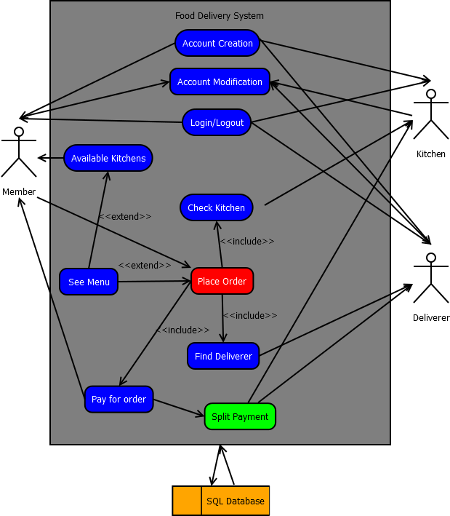
Figure 1 - System Environment

The System has three active actors and one cooperating system.
The Member, Kitchen, or Deliverer accesses the system through the app. All of the system’s functions are performed through the app.

1.4 Assumptions and Dependencies
The system assumes that all actors have a device capable of installing and executing the app (iOS 8 or higher, Android 6.0 "Marshmallow" or higher) and that they maintain a constant internet connection while using the app. If an actor disconnects from the internet, all running use cases automatically fail.

1.5. Overview of Document
The next chapter, the Overall Description section, of this document gives an overview of the functionality of the product. It describes the informal requirements and is used to establish a context for the technical requirements specification in the next chapter.
The third chapter, Requirements Specification section, of this document is written primarily for the developers and describes in technical terms the details of the functionality of the product.
Both sections of the document describe the same software product in its entirety, but are intended for different audiences and thus use different language.

3.0. Requirements Specification

3.1 External Interface Requirements
The only link to an external system is the link to the MySQL Database (the Database) ,which contains information about all users, stored in the “Users” table. Specifically, every user has an entry with their unique User ID (to be used internally), Username, Password, e-mail address, physical address, and relevant bank information to process withdrawals and/or deposits. Both Kitchens and Deliverers have an “Available Hours” column, which is left NULL on Member entries. Additionally, Kitchens have their menus stored on an entry in the “Menu” table.

3.2 Functional Requirements

3.2.1 Create Account
Use Case Name | Create Account
Trigger | The User selects the “Create Account” option.
Precondition | The User does not already have an account.
Basic Path | - The User inserts standard information (Username, Password, email, Address, and credit card).  - The User selects their user type (Member, Kitchen, or Deliverer)  - If the User selects Kitchen: Go to 3a.  - If the User selects Deliverer: Go to 3b.  - If the User selects Member: Continue to 3.  - The User reviews their details and confirms.  - The system reviews if the information is valid (if the username and email are unique, if the credit card is valid)  - If the information is invalid, return to 3.  - The account is created and the database is updated.
Alternative Paths | 3a. The Kitchen also enters their available hours and their meals.  - Head back to 3.  3b. The Deliverer also enters their available hours.  - Head back to 3.
Postcondition | The User now has an account in the database and can log in.
Exception Paths | The User may abandon the account creation at any time.

3.2.2 Login/Logout
Use Case Name | Login/Logout
Trigger | The User presses the “Log In” Button OR The User presses the “Log Out” Button.
Precondition | The User has an account on the system.
Basic Path | - If the User is not logged in, the User enters their username and password.  - If the credentials are valid, the User is logged in. If not,  - Head back to 1.
Alternative Paths | 1a. If the User is logged in, the User is logged out.
Postcondition | The login status of the User has changed.
Exception Paths | None

3.2.3 Modify Account
Use Case Name | Modify Account
Trigger | The User presses the “Modify Account” button.
Precondition | The User is logged in.
Basic Path | - The system presents the User’s information.  - The User modifies the information and submits the changes.  - The system checks that the information is still valid (same as “Create Account”, Step 4)  - If the information is invalid, return to 2.  - The database is updated.
Alternative Paths | None
Postcondition | The User’s information is updated.
Exception Paths | The User may abandon the operation at any time.

3.2.4 Available Kitchens
Use Case Name | Available Kitchens
Trigger | The Member presses the “Browse Kitchens” button OR triggered by “Place Order”.
Precondition | The Member is logged in.
Basic Path | - The system checks to see which Kitchens are available in the nearby area (via the “Available Hours” value)  - The system presents all available Kitchens.  - The Member selects a Kitchen  - This triggers “See Menu”.
Alternative Paths | None
Postcondition | “See Menu” is activated.
Exception Paths | There may be no Kitchens in the area. If so, “Place Order” fails as well.

3.2.5 See Menu
Use Case Name | See Menu
Trigger | Triggered by “Available Kitchens”.
Precondition | None
Basic Path | - The System shows the Member a list of available meals.  - The Member may browse the meals for more details. Once they are finished, they select “Exit.”  - This returns to “Available Kitchens”.
Alternative Paths | 1a. If the Member has triggered “Place Order”, they may select the meals they want to eat.  2a. Once they are done, “See Menu” sends the information back to “Place Order”  - This returns to “Place Order”.
Postcondition | The Member is aware of the Kitchen’s meals.
Exception Paths | The Member may abandon the use case. If so, “Available Kitchens” fails as well.

3.2.6 Find Deliverer
Use Case Name | Find Deliverer
Trigger | Triggered by “Place Order”
Precondition | None
Basic Path | - The System searches for an available Deliverer (matches “Available Hours” and is not delivering currently).  - The System assigns the order to the Deliverer.
Alternative Paths | None
Postcondition | The deliverer is notified to pick up the order.
Exception Paths | There may be no deliverers available. If so, “Place Order” fails as well.

3.2.7 Check Kitchen
Use Case Name | Check Kitchen
Trigger | Triggered by “Place Order”
Precondition | None
Basic Path | - The System notifies the Kitchen of the Member’s order.  - The Kitchen checks if it can prepare the order and acknowledges.  - The Kitchen prepares the order.
Alternative Paths | None
Postcondition | The order is ready for pickup.
Exception Paths | The Kitchen may not be able to prepare the order. If so, “Place Order” fails as well.

3.2.8 Pay for Order
Use Case Name | Pay for Order
Trigger | Triggered by “Place Order”
Precondition | None
Basic Path | - The System communicates with the bank’s system to check if the Member has enough money for the order.  - The System withdraws the amount.
Alternative Paths | 2x. If the order fails, the System returns the money.
Postcondition | The System temporarily holds the Member’s money.
Exception Paths | The Member may have insufficient funds. If so, “Place Order” fails as well.

3.2.9 Split Payment
Use Case Name | Split Payment
Trigger | Triggered by “Place Order”
Precondition | None
Basic Path | - The System calculates how much money has each actor earned (System, Kitchen, Deliverer).  - The System distributes the money to the respective bank accounts.
Alternative Paths | None
Postcondition | The money has been distributed.
Exception Paths | None

3.2.10 Place Order
Use Case Name | Place Order
Trigger | The Member presses the “Order Now” button.
Precondition | The Member is logged in.
Basic Path | - The Member makes their order.  - “Available Kitchens” is triggered.  - The System calculates the price of the order.  - “Pay for Order” is triggered.  - The System transfers the order information to the Kitchen.  - “Check Kitchen” is triggered.  - The System commissions a Deliverer.  - “Find Deliverer” is triggered.  - The Deliverer gets the order to the Member.  - The Member confirms the delivery.  - The money is split.  - “Split Payment” is triggered.
Alternative Paths | 2x. If anything between 3 and 6 fails,  - “Pay for Order” is triggered and the money is returned.
Postcondition | The order is complete.
Exception Paths | If any use case fails, “Place Order” fails as well.

3.3 Detailed Non-Functional Requirements

3.3.1 Performance Requirements

3.3.2 Safety Requirements

3.3.3 Security

The server which contains the SQL Database is relatively secure, as it only accepts changes made by verified applications or locally. Security on the application is of the highest importance, as the app is authorized to read and write all data on the Database. The Login/Logout use case needs to protect against malicious actors from logging in on unauthorized accounts. All use cases that read or write information operate under the assumption that the User is who they appear to be.

Software Quality Attributes

3.3.5 Business Rules

4.0. References
https://www.scribd.com/document/571129950/Online-Food-Ordering-System-MILAN

https://exinfm.com/training/M2C3/srs_template.doc&ved=2ahUKEwj8_rKYtpyGAxUeR_EDHfsGC9oQFnoECBcQAQ&usg=AOvVaw33Y46Zh7CaAjs89BBB-WId

