Учреждение образования

«Белорусский государственный технологический университет»

**Математическое программирование**

**Лабораторная работа №5**

**АЛГОРИТМЫ НА ГРАФАХ**

**(алгоритмы поиска в ширину и глубину, топологическая сортировка)**

Выполнил:

Студентка 2 курса 7 группы ФИТ

Колядко Яна Дмитриевна

**ЦЕЛЬ РАБОТЫ:** освоить сущность и программную реализацию: а) способов представления графов; б) алгоритмов поиска в ширину и глубину; в) алгоритма топологической сортировки графов.

**Задание 1.**  Ориентированный граф **G** взять в соответствии с вариантом. Осуществить алгоритмы поиска в ширину и глубину, а также алгоритма топологической сортировки аналогично примерам, рассмотренным на лекциях. Оформить отчет, включив в него **каждый** шаг выполнения алгоритмов.

|  |  |
| --- | --- |
| 6 |  |

**Поиск в ширину**

Q

|  |
| --- |
| 0 |

C

|  |  |  |  |  |  |  |
| --- | --- | --- | --- | --- | --- | --- |
| G | W | W | W | W | W | W |

D

|  |  |  |  |  |  |  |
| --- | --- | --- | --- | --- | --- | --- |
| O | I | I | I | I | I | I |

P

|  |  |  |  |  |  |  |
| --- | --- | --- | --- | --- | --- | --- |
| N | N | N | N | N | N | N |

Q

|  |  |  |
| --- | --- | --- |
| 1 | 2 | 3 |

C

|  |  |  |  |  |  |  |
| --- | --- | --- | --- | --- | --- | --- |
| B | G | G | G | W | W | W |

D

|  |  |  |  |  |  |  |
| --- | --- | --- | --- | --- | --- | --- |
| O | 1 | 1 | 1 | I | I | I |

P

|  |  |  |  |  |  |  |
| --- | --- | --- | --- | --- | --- | --- |
| N | 0 | 0 | 0 | N | N | N |

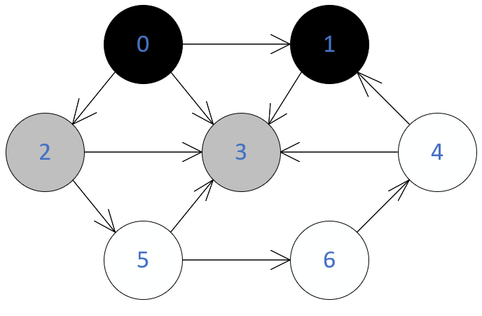

Q

|  |  |
| --- | --- |
| 2 | 3 |

C

|  |  |  |  |  |  |  |
| --- | --- | --- | --- | --- | --- | --- |
| B | B | G | G | W | W | W |

D

|  |  |  |  |  |  |  |
| --- | --- | --- | --- | --- | --- | --- |
| O | 1 | 1 | 1 | I | I | I |

P

|  |  |  |  |  |  |  |
| --- | --- | --- | --- | --- | --- | --- |
| N | 0 | 0 | 0 | N | N | N |

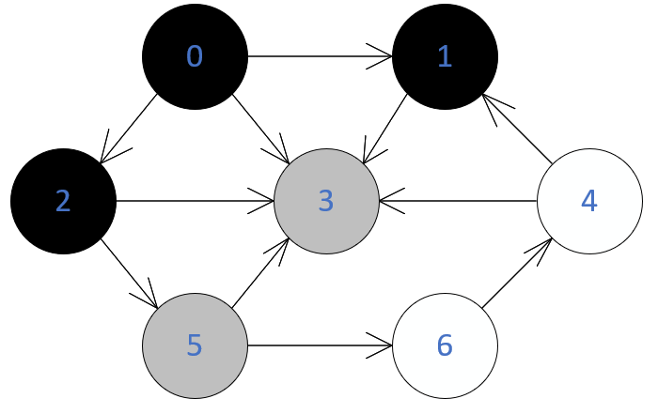

Q

|  |  |
| --- | --- |
| 3 | 5 |

C

|  |  |  |  |  |  |  |
| --- | --- | --- | --- | --- | --- | --- |
| B | B | B | G | G | W | W |

D

|  |  |  |  |  |  |  |
| --- | --- | --- | --- | --- | --- | --- |
| O | 1 | 1 | 1 | 2 | I | I |

P

|  |  |  |  |  |  |  |
| --- | --- | --- | --- | --- | --- | --- |
| N | 0 | 0 | 0 | 2 | N | N |

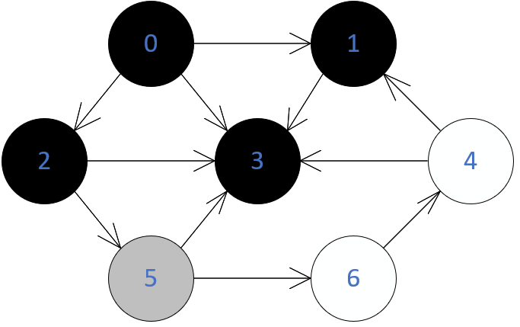

Q

|  |
| --- |
| 5 |

C

|  |  |  |  |  |  |  |
| --- | --- | --- | --- | --- | --- | --- |
| B | B | B | B | W | G | W |

D

|  |  |  |  |  |  |  |
| --- | --- | --- | --- | --- | --- | --- |
| O | 1 | 1 | 1 | 2 | I | I |

P

|  |  |  |  |  |  |  |
| --- | --- | --- | --- | --- | --- | --- |
| N | 0 | 0 | 0 | 2 | N | N |

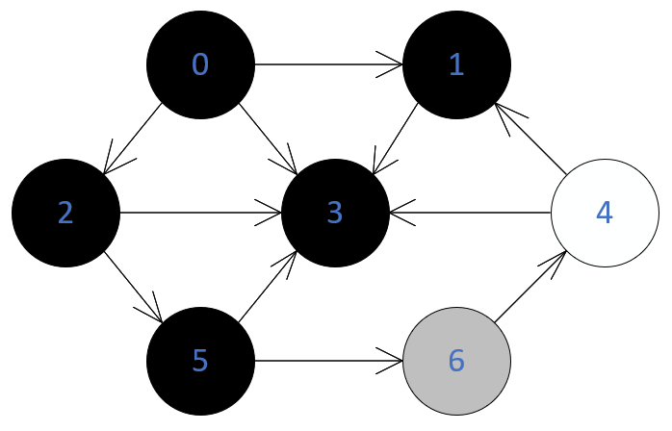

Q

|  |
| --- |
| 6 |

C

|  |  |  |  |  |  |  |
| --- | --- | --- | --- | --- | --- | --- |
| B | B | B | B | W | B | G |

D

|  |  |  |  |  |  |  |
| --- | --- | --- | --- | --- | --- | --- |
| O | 1 | 1 | 1 | I | 2 | 3 |

P

|  |  |  |  |  |  |  |
| --- | --- | --- | --- | --- | --- | --- |
| N | 0 | 0 | 0 | I | 2 | 5 |

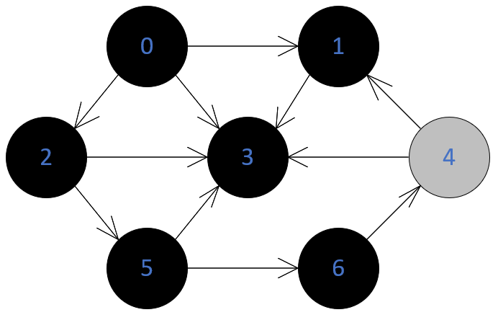

Q

|  |
| --- |
| 4 |

C

|  |  |  |  |  |  |  |
| --- | --- | --- | --- | --- | --- | --- |
| B | B | B | B | G | B | B |

D

|  |  |  |  |  |  |  |
| --- | --- | --- | --- | --- | --- | --- |
| O | 1 | 1 | 1 | 4 | 2 | 3 |

P

|  |  |  |  |  |  |  |
| --- | --- | --- | --- | --- | --- | --- |
| N | 0 | 0 | 0 | 6 | 2 | 5 |

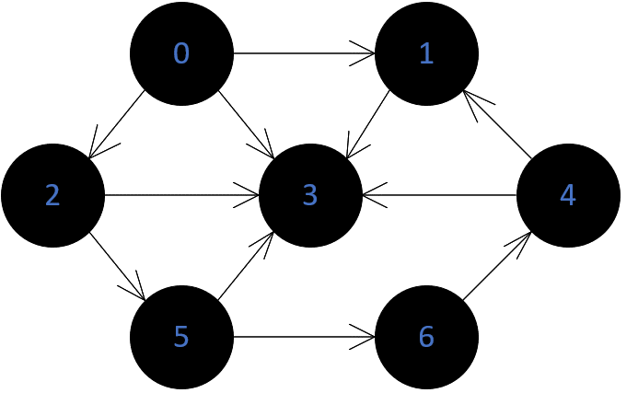

BFS-дерево:

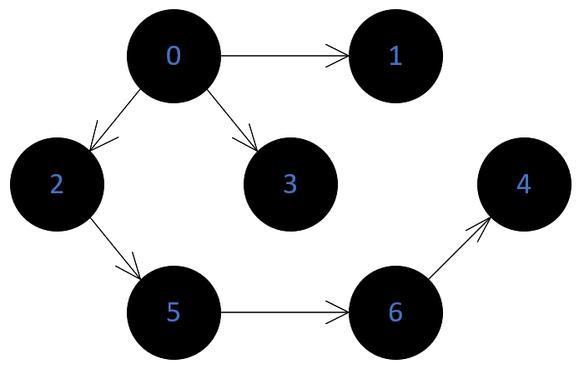

**Поиск в глубину**

t=1

C

|  |  |  |  |  |  |  |
| --- | --- | --- | --- | --- | --- | --- |
| G | W | W | W | W | W | W |

D

|  |  |  |  |  |  |  |
| --- | --- | --- | --- | --- | --- | --- |
| 1 | I | I | I | I | I | I |

P

|  |  |  |  |  |  |  |
| --- | --- | --- | --- | --- | --- | --- |
| N | I | I | I | I | I | I |

F

|  |  |  |  |  |  |  |
| --- | --- | --- | --- | --- | --- | --- |
| I | I | I | I | I | I | I |

t=2

C

|  |  |  |  |  |  |  |
| --- | --- | --- | --- | --- | --- | --- |
| G | G | W | W | W | W | W |

D

|  |  |  |  |  |  |  |
| --- | --- | --- | --- | --- | --- | --- |
| 1 | 2 | I | I | I | I | I |

P

|  |  |  |  |  |  |  |
| --- | --- | --- | --- | --- | --- | --- |
| N | I | I | I | I | I | I |

F

|  |  |  |  |  |  |  |
| --- | --- | --- | --- | --- | --- | --- |
| I | I | I | I | I | I | I |

t=3

C

|  |  |  |  |  |  |  |
| --- | --- | --- | --- | --- | --- | --- |
| G | G | W | G | W | W | W |

D

|  |  |  |  |  |  |  |
| --- | --- | --- | --- | --- | --- | --- |
| 1 | 2 | I | 3 | I | I | I |

P

|  |  |  |  |  |  |  |
| --- | --- | --- | --- | --- | --- | --- |
| N | 0 | I | 1 | I | I | I |

F

|  |  |  |  |  |  |  |
| --- | --- | --- | --- | --- | --- | --- |
| I | I | I | I | I | I | I |

t=4

C

|  |  |  |  |  |  |  |
| --- | --- | --- | --- | --- | --- | --- |
| G | G | W | B | W | W | W |

D

|  |  |  |  |  |  |  |
| --- | --- | --- | --- | --- | --- | --- |
| 1 | 2 | I | 3 | I | I | I |

P

|  |  |  |  |  |  |  |
| --- | --- | --- | --- | --- | --- | --- |
| N | 0 | I | 1 | I | I | I |

F

|  |  |  |  |  |  |  |
| --- | --- | --- | --- | --- | --- | --- |
| I | I | I | 4 | I | I | I |

t=5

C

|  |  |  |  |  |  |  |
| --- | --- | --- | --- | --- | --- | --- |
| G | B | W | B | W | W | W |

D

|  |  |  |  |  |  |  |
| --- | --- | --- | --- | --- | --- | --- |
| 1 | 2 | I | 3 | I | I | I |

P

|  |  |  |  |  |  |  |
| --- | --- | --- | --- | --- | --- | --- |
| N | 0 | I | 1 | I | I | I |

F

|  |  |  |  |  |  |  |
| --- | --- | --- | --- | --- | --- | --- |
| I | 5 | I | 4 | I | I | I |

t=6

C

|  |  |  |  |  |  |  |
| --- | --- | --- | --- | --- | --- | --- |
| G | B | G | B | W | W | W |

D

|  |  |  |  |  |  |  |
| --- | --- | --- | --- | --- | --- | --- |
| 1 | 2 | 6 | 3 | I | I | I |

P

|  |  |  |  |  |  |  |
| --- | --- | --- | --- | --- | --- | --- |
| N | 0 | 0 | 1 | I | I | I |

F

|  |  |  |  |  |  |  |
| --- | --- | --- | --- | --- | --- | --- |
| I | 5 | I | 4 | I | I | I |

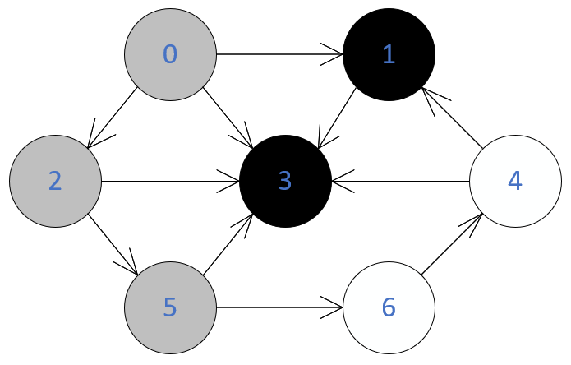

t=7

C

|  |  |  |  |  |  |  |
| --- | --- | --- | --- | --- | --- | --- |
| G | B | G | B | W | G | W |

D

|  |  |  |  |  |  |  |
| --- | --- | --- | --- | --- | --- | --- |
| 1 | 2 | 6 | 3 | I | 7 | I |

P

|  |  |  |  |  |  |  |
| --- | --- | --- | --- | --- | --- | --- |
| N | 0 | 0 | 1 | I | 2 | I |

F

|  |  |  |  |  |  |  |
| --- | --- | --- | --- | --- | --- | --- |
| I | 5 | I | 4 | I | I | I |

t=8

C

|  |  |  |  |  |  |  |
| --- | --- | --- | --- | --- | --- | --- |
| G | B | G | B | W | G | G |

D

|  |  |  |  |  |  |  |
| --- | --- | --- | --- | --- | --- | --- |
| 1 | 2 | 6 | 3 | I | 7 | 8 |

P

|  |  |  |  |  |  |  |
| --- | --- | --- | --- | --- | --- | --- |
| N | 0 | 0 | 1 | I | 2 | 5 |

F

|  |  |  |  |  |  |  |
| --- | --- | --- | --- | --- | --- | --- |
| I | 5 | I | 4 | I | I | I |

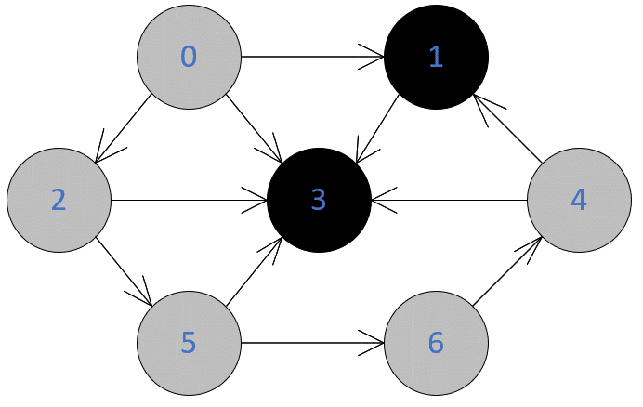

t=9

C

|  |  |  |  |  |  |  |
| --- | --- | --- | --- | --- | --- | --- |
| G | B | G | B | G | G | G |

D

|  |  |  |  |  |  |  |
| --- | --- | --- | --- | --- | --- | --- |
| 1 | 2 | 6 | 3 | 9 | 7 | 8 |

P

|  |  |  |  |  |  |  |
| --- | --- | --- | --- | --- | --- | --- |
| N | 0 | 0 | 1 | 6 | 2 | 5 |

F

|  |  |  |  |  |  |  |
| --- | --- | --- | --- | --- | --- | --- |
| I | 5 | I | 4 | I | I | I |

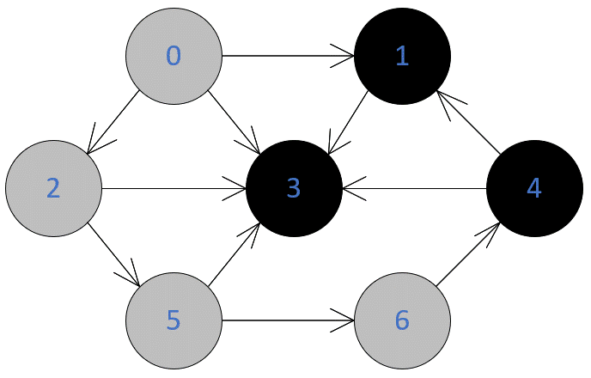

t=10

C

|  |  |  |  |  |  |  |
| --- | --- | --- | --- | --- | --- | --- |
| G | B | G | B | B | G | G |

D

|  |  |  |  |  |  |  |
| --- | --- | --- | --- | --- | --- | --- |
| 1 | 2 | 6 | 3 | 9 | 7 | 8 |

P

|  |  |  |  |  |  |  |
| --- | --- | --- | --- | --- | --- | --- |
| N | 0 | 0 | 1 | 6 | 2 | 5 |

F

|  |  |  |  |  |  |  |
| --- | --- | --- | --- | --- | --- | --- |
| I | 5 | I | 4 | 10 | I | I |

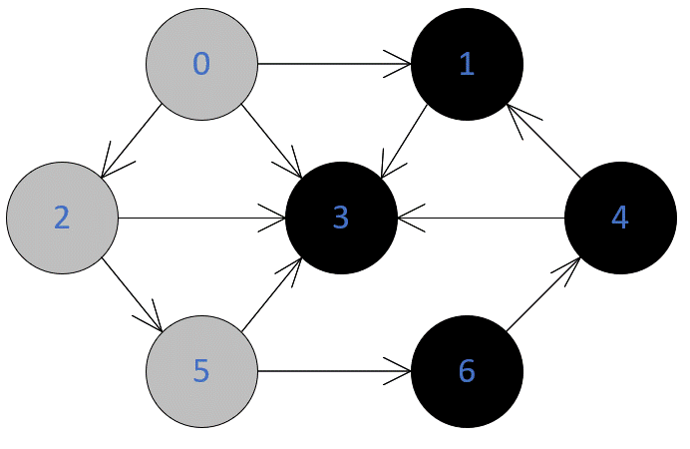

t=11

C

|  |  |  |  |  |  |  |
| --- | --- | --- | --- | --- | --- | --- |
| G | B | G | B | B | G | B |

D

|  |  |  |  |  |  |  |
| --- | --- | --- | --- | --- | --- | --- |
| 1 | 2 | 6 | 3 | 9 | 7 | 8 |

P

|  |  |  |  |  |  |  |
| --- | --- | --- | --- | --- | --- | --- |
| N | 0 | 0 | 1 | 6 | 2 | 5 |

F

|  |  |  |  |  |  |  |
| --- | --- | --- | --- | --- | --- | --- |
| I | 5 | I | 4 | 10 | I | 11 |

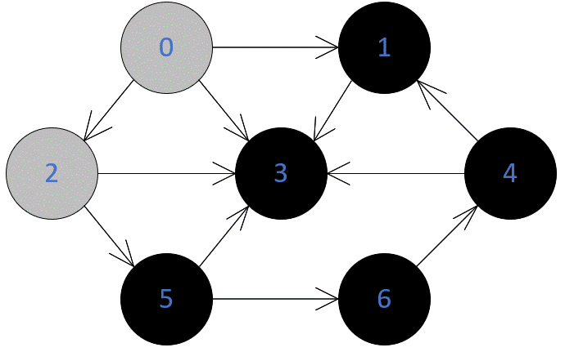

t=12

C

|  |  |  |  |  |  |  |
| --- | --- | --- | --- | --- | --- | --- |
| G | B | G | B | B | B | B |

D

|  |  |  |  |  |  |  |
| --- | --- | --- | --- | --- | --- | --- |
| 1 | 2 | 6 | 3 | 9 | 7 | 8 |

P

|  |  |  |  |  |  |  |
| --- | --- | --- | --- | --- | --- | --- |
| N | 0 | 0 | 1 | 6 | 2 | 5 |

F

|  |  |  |  |  |  |  |
| --- | --- | --- | --- | --- | --- | --- |
| I | 5 | I | 4 | 10 | 12 | 11 |

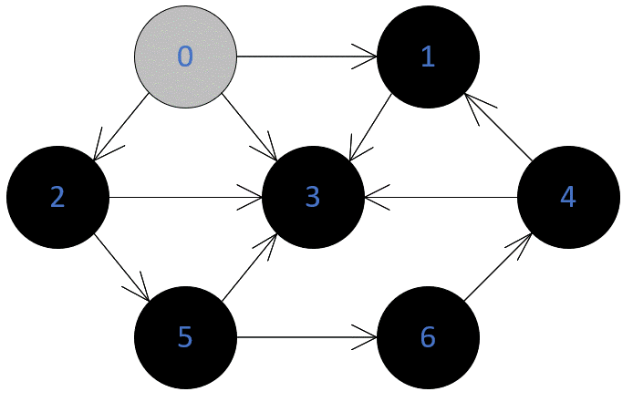

t=13

C

|  |  |  |  |  |  |  |
| --- | --- | --- | --- | --- | --- | --- |
| G | B | B | B | B | B | B |

D

|  |  |  |  |  |  |  |
| --- | --- | --- | --- | --- | --- | --- |
| 1 | 2 | 6 | 3 | 9 | 7 | 8 |

P

|  |  |  |  |  |  |  |
| --- | --- | --- | --- | --- | --- | --- |
| N | 0 | 0 | 1 | 6 | 2 | 5 |

F

|  |  |  |  |  |  |  |
| --- | --- | --- | --- | --- | --- | --- |
| I | 5 | 13 | 4 | 10 | 12 | 11 |

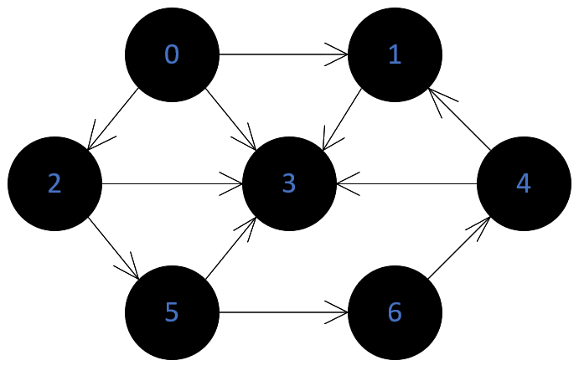

t=14

C

|  |  |  |  |  |  |  |
| --- | --- | --- | --- | --- | --- | --- |
| B | B | B | B | B | B | B |

D

|  |  |  |  |  |  |  |
| --- | --- | --- | --- | --- | --- | --- |
| 1 | 2 | 6 | 3 | 9 | 7 | 8 |

P

|  |  |  |  |  |  |  |
| --- | --- | --- | --- | --- | --- | --- |
| N | 0 | 0 | 1 | 6 | 2 | 5 |

F

|  |  |  |  |  |  |  |
| --- | --- | --- | --- | --- | --- | --- |
| 14 | 5 | 13 | 4 | 10 | 12 | 11 |

**DFS-дерево**

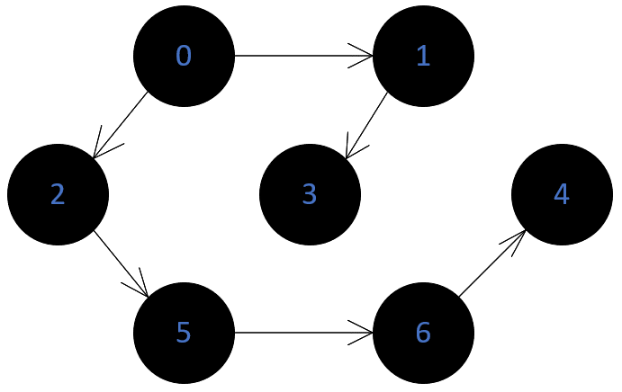

**Топологическая сортировка**

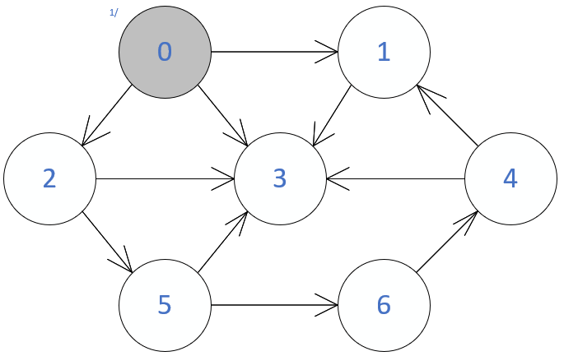

|  |
| --- |
| **3** |

|  |  |
| --- | --- |
| 1 | 3 |

|  |  |  |
| --- | --- | --- |
| 0 | 1 | 3 |

|  |  |  |
| --- | --- | --- |
| 4 | 1 | 3 |

|  |  |  |  |
| --- | --- | --- | --- |
| 6 | 4 | 1 | 3 |

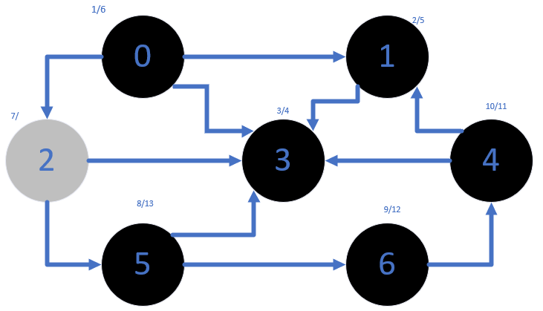

|  |  |  |  |  |
| --- | --- | --- | --- | --- |
| 5 | 6 | 4 | 1 | 3 |

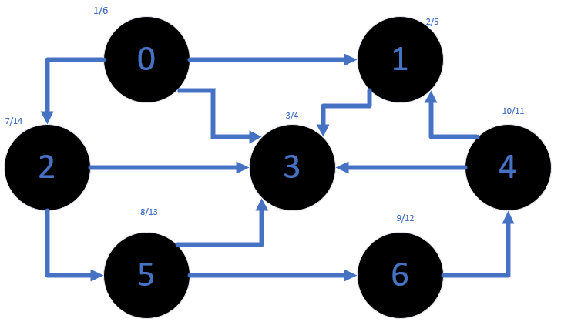

|  |  |  |  |  |  |  |
| --- | --- | --- | --- | --- | --- | --- |
| 0 | 2 | 5 | 6 | 4 | 1 | 3 |

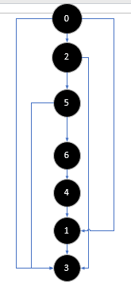

**Задание 2.** Осуществить программную реализацию алгоритмов на C++. Разработать структуры **AMatrix** и **АList**  для представления ориентированного графа матричным и списковым способом. Разработать функции преобразования из одного способа представления в другой. Разработать функцию **BFS** обхода вершин графа, используя метод поиска в ширину. Продемонстрировать работу функции. Копии экрана вставить в отчет.

**Задание 3.**  Разработать функцию **DFS**  обхода вершин графа, используя метод поиска глубину. Продемонстрировать работу функции. Копии экрана вставить в отчет.

**Задание 4.**  Доработайте функцию **DFS**,для выполнения топологической сортировки графа. Продемонстрировать работу функции. Копии экрана вставить в отчет

Вывод: Я освоила сущность и программную реализацию способов представления графов; алгоритмов поиска в ширину и глубину; алгоритма топологической сортировки графов.