Zadatak 1 (hashMap-e, ArrayListe)

- Treba odrediti koja riječ se najviše ponavlja u stringu (bez razmaka i bez interpunkcija)

- Ako se dvije riječi ponavljaju jednaki broj puta, onda se ispisuje ona riječ koja se u tekstu pojavi prva. Npr „Ana bere Masline Ana, masline” sustav će ispisati „Most repeated word: Ana – Repeated: 2 times"”

- APPLES i apples se broji kao dva (smatra se da je ovo jedna rijeć)

- Jednina i množina se različite riječi

- Česte riječi ne zbrajati "the", "a", "or", "an", "it", "and", "but", "is", "are", "of", "on", "to", "was", "were", "in", "that", "i", "your", "his", "their", "her", "you", "me", "all„

dole su stringovi iz kojih želim izvući podatke o riječi koja se najćešće ponavlja

String testString = "Lorem Ipsum is simply dummy text of the " +

"printing and typesetting industry. Lorem Ipsum has been " +

"the industry's standard dummy text ever since the 1500s, " +

"when an unknown printer took a galley of type and scrambled " +

"it to make a type specimen book. It has survived not only " +

"five centuries, but also the leap into electronic typesetting, " +

"remaining essentially unchanged. It was popularised in the " +

"1960s with the release of Letraset sheets containing " +

"Lorem Ipsum passages, and more recently with desktop " +

"publishing software like Aldus PageMaker including " +

"versions of Lorem Ipsum.";

findMostRepeatedWord(testString);

System.out.println();

String testString2 = "Penguins are aquatic, flightless birds that " +

"are highly adapted to life in the water. Their distinct " +

"tuxedo-like appearance is called countershading, a form " +

"of camouflage that helps keep them safe in the water. " +

"Penguins do have wing-bones, though they are flipper-like " +

"and extremely suited to swimming. Penguins are found " +

"almost exclusively in the southern hemisphere, where they " +

"catch their food underwater and raise their young on land.";

findMostRepeatedWord(testString2);

System.out.println();

String testString3 = "Students seek relief from rising " +

"prices through the purchase of used copies of " +

"textbooks, which tend to be less expensive. " +

"Most college bookstores offer used copies of " +

"textbooks at lower prices. Most bookstores will " +

"also buy used copies back from students at the end of " +

"a term if the book is going to be re-used at the school. " +

"Books that are not being re-used at the school are often " +

"purchased by an off-campus wholesaler for 0-30% of " +

"the new cost, for distribution to other bookstores " +

"where the books will be sold. Textbook companies " +

"have countered this by encouraging faculty to " +

"assign homework that must be done on the " +

"publisher's website. If a student has a new textbook, " +

"then he or she can use the pass code in the " +

"book to register on the site. If the student " +

"has purchased a used textbook, then " +

"he or she must pay money directly " +

"to the publisher in order to access the " +

"website and complete assigned homework. ";

findMostRepeatedWord(testString3);

System.out.println();

String testString4 = "Sunday morning rain is falling\n" +

"Steal some covers share some skin\n" +

"Clouds are shrouding us in moments unforgettable\n" +

"You twist to fit the mold that I am in\n" +

"But things just get so crazy living life gets hard to do\n" +

"And I would gladly hit the road get up and go if I knew\n" +

"That someday it would lead me back to you\n" +

"That someday it would lead me back to you\n" +

"\n" +

"That may be all I need\n" +

"In darkness she is all I see\n" +

"Come and rest your bones with me\n" +

"Driving slow on Sunday morning\n" +

"And I never want to leave\n" +

"\n" +

"Fingers trace your every outline\n" +

"Paint a picture with my hands\n" +

"Back and forth we sway like branches in a storm\n" +

"Change the weather still together when it ends\n" +

"\n" +

"That may be all I need\n" +

"In darkness she is all I see\n" +

"Come and rest your bones with me\n" +

"Driving slow on Sunday morning\n" +

"And I never want to leave\n" +

"\n" +

"But things just get so crazy living life gets hard to do\n" +

"Sunday morning rain is falling and I'm calling out to you\n" +

"Singing someday it'll bring me back to you\n" +

"Find a way to bring myself back home to you\n" +

"\n" +

"May not know\n" +

"\n" +

"That may be all I need\n" +

"In darkness she is all I see\n" +

"Come and rest your bones with me\n" +

"Driving slow on Sunday morning\n" +

"Driving slow\n" +

"\n" +

"Oh, yeah, yeah...\n" +

"\n" +

"There is a flower in your hair.\n" +

"I'm a flower in your hair.\n" +

"\n" +

"Oh, yeah, yeah, oh\n";

findMostRepeatedWord(testString4);

/* ====== ====== ====== ====== ====== ====== */

Zadatak2 **(Apstrakcija, Enkupsalacija, Nasljeđivanje, Polimofrizam, Enumeratori, HashMape, ArrayListe)**

- Napravit ćemo parkiralište

- Program će na kraju izvršavanja napisati da li je parkiralište puno i koliko je mjesta ostalo slobodno

- Postoje regularna mjesta i mjesta za invalide

- Regularna vrsta automobila se može parkirati samo na regularnim mjestima, dok se auto sa invalidskim oznakama može parkirati i na regularnim i na mjestima za invalide (ako je mjesto za invalide slobodno, auto sa invalidskim oznakama će se prvo probat tamo parkirati)

- Svako parkirno mjesto ima određenu veličinu (malo, srednje i veliko)

- Postoje tri vrste vozila, malo (motor), srednje (auto) i veliko (kamion)

- Malo vozilo se može parkirati na malom, srednjem ili velikom mjestu. Srednje vozilo se može parkirati na srednjem ili velikom mjestu. Veliko vozilo se može parkirati samo na velikom mjestu

- Parking ima 48 mjesta, 10 velikih regularnih mjesta, 24 srednjih regularnih mjesta, 9 malih regularnih mjesta i 5 srednjih invalidskih mjesta

- mamo slijedeći redoslijed dolaska automobila na parkiralište: 6 invalidskih automobila, 8 kamiona, 3 automobila, 1 invalidski kamion, 1 kamion, 1 invalidski kamion, 3 motora, 1 auto

- Nakon što smo parkirali sve automobile provjeri da li je parkiralište popunjeno

Kao malu pomoć šaljem dvije slike gdje vidimo dva primjera kako je zadatak riješen (šaljem class diagram). Možete riješiti na jedan od tih načina ili napraviti neko svoje rješenje

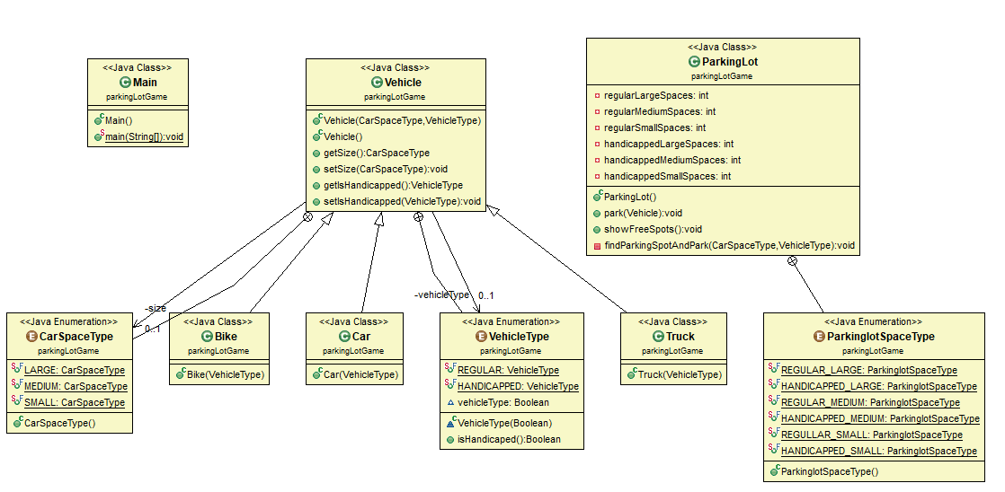

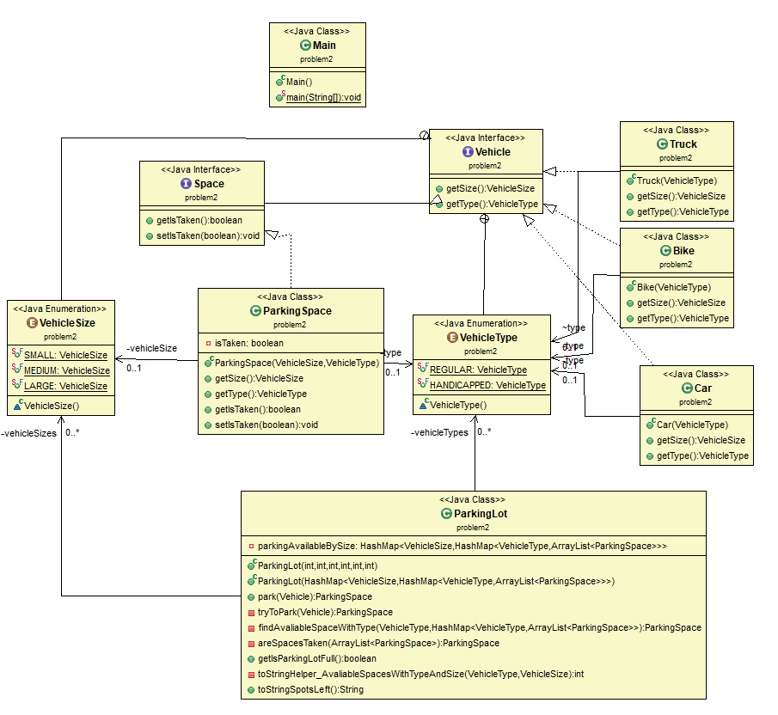

log programa mora izgledati ovako

Parking Medium Handicapped cars

The car has parked in a MEDIUM HANDICAPPED

The car has parked in a MEDIUM HANDICAPPED

The car has parked in a MEDIUM HANDICAPPED

The car has parked in a MEDIUM HANDICAPPED

The car has parked in a MEDIUM HANDICAPPED

The car has parked in a MEDIUM REGULAR

Parking Large regular trucks

The car has parked in a LARGE REGULAR

The car has parked in a LARGE REGULAR

The car has parked in a LARGE REGULAR

The car has parked in a LARGE REGULAR

The car has parked in a LARGE REGULAR

The car has parked in a LARGE REGULAR

The car has parked in a LARGE REGULAR

The car has parked in a LARGE REGULAR

Parking Medium Regular cars

The car has parked in a MEDIUM REGULAR

The car has parked in a MEDIUM REGULAR

The car has parked in a MEDIUM REGULAR

Parking Large Handicapped truck

The car has parked in a LARGE REGULAR

Parking Large Regular truck

The car has parked in a LARGE REGULAR

Parking Large Handicapped truck

The car cannot be parked at this time.

Parking Small Regular bike

The car has parked in a SMALL REGULAR

The car has parked in a SMALL REGULAR

The car has parked in a SMALL REGULAR

Parking Medium regular car

The car has parked in a MEDIUM REGULAR

Is the parking lot full? false

What spots are left?

There are 6 SMALL REGULAR spots left.

There are 0 SMALL HANDICAPPED spots left.

There are 19 MEDIUM REGULAR spots left.

There are 0 MEDIUM HANDICAPPED spots left.

There are 0 LARGE REGULAR spots left.

There are 0 LARGE HANDICAPPED spots left.

Process finished with exit code 0