PANLAR 2027 – Case report (English version for the submission form)
Severe scleromalacia perforans without identifiable systemic autoimmune disease: a therapeutic dilemma for the rheumatologist. A case report
Topic: Mixed (Miscellaneous Diseases)
Keywords: Rare/orphan diseases · Glucocorticoids · Descriptive Studies
Background/Objective (Antecedentes/Objetivo) (650 characters)
Scleromalacia perforans is a necrotizing anterior scleritis without clinically apparent inflammation, classically associated with rheumatoid arthritis and reported in granulomatosis with polyangiitis, relapsing polychondritis, and Behçet's disease. Without an identifiable systemic autoimmune disease, the rheumatologist faces a therapeutic dilemma: whether to start immunosuppression without an established systemic diagnosis or fulfillment of classification criteria when ocular integrity is threatened. Objective: To describe this dilemma in an older woman with severe scleromalacia perforans, for whom ophthalmology recommended immunosuppression.
Methods (Métodos) (171 characters)
Retrospective medical record review. Systemic manifestations, immunological profile, infectious evaluation, multidisciplinary decisions, and ocular outcomes were analyzed.
Results (Resultados) (1,451 characters)
A 71-year-old woman with no known autoimmune disease, ocular surgery, or trauma had painless right conjunctival hemorrhage since October 2024 and a temporal scleral defect since February 2025; after loss to follow-up, she was admitted in June 2026 with count-fingers visual acuity and extensive corneoscleral destruction with uveal and iris herniation (Figure 1). Targeted rheumatologic evaluation found no arthritis, ulcers, or ENT involvement. Rheumatoid factor was borderline (14.8) with negative anti-CCP, and ANA, anti-dsDNA, extractable nuclear antigen panel, anticentromere, and PR3- and MPO-ANCA were negative, with normal complement. Infectious disease evaluation (negative tuberculin skin test and serologies for syphilis and hepatitis B and C; normal chest CT) identified no infectious etiology. Without a systemic diagnosis, the indication was based on the threat to the organ: she received intravenous methylprednisolone 500 mg/day for 5 days, followed by tapering oral prednisone and azathioprine as a steroid-sparing agent, given her age and toxicity risk. The ophthalmology board estimated involvement of 60-70% of the ocular wall, and, jointly with rheumatology, immunosuppression was continued to preserve the globe and protect the left eye. The globe remained unperforated until tectonic corneoscleral patch grafting in November; the left eye, which underwent cataract surgery in October under immunosuppression, remains unaffected.
Conclusion (Conclusión) (451 characters)
Severe scleromalacia perforans may occur without identifiable systemic autoimmune disease, and the absence of classification criteria does not exclude an immune-mediated ocular process. This case illustrates the need to individualize immunosuppression according to ocular severity, through shared decision-making between ophthalmology and rheumatology, reasonable exclusion of infection, and follow-up to detect emerging systemic disease and toxicity.
Total: 2,723 / 2,750 characters. References: none.
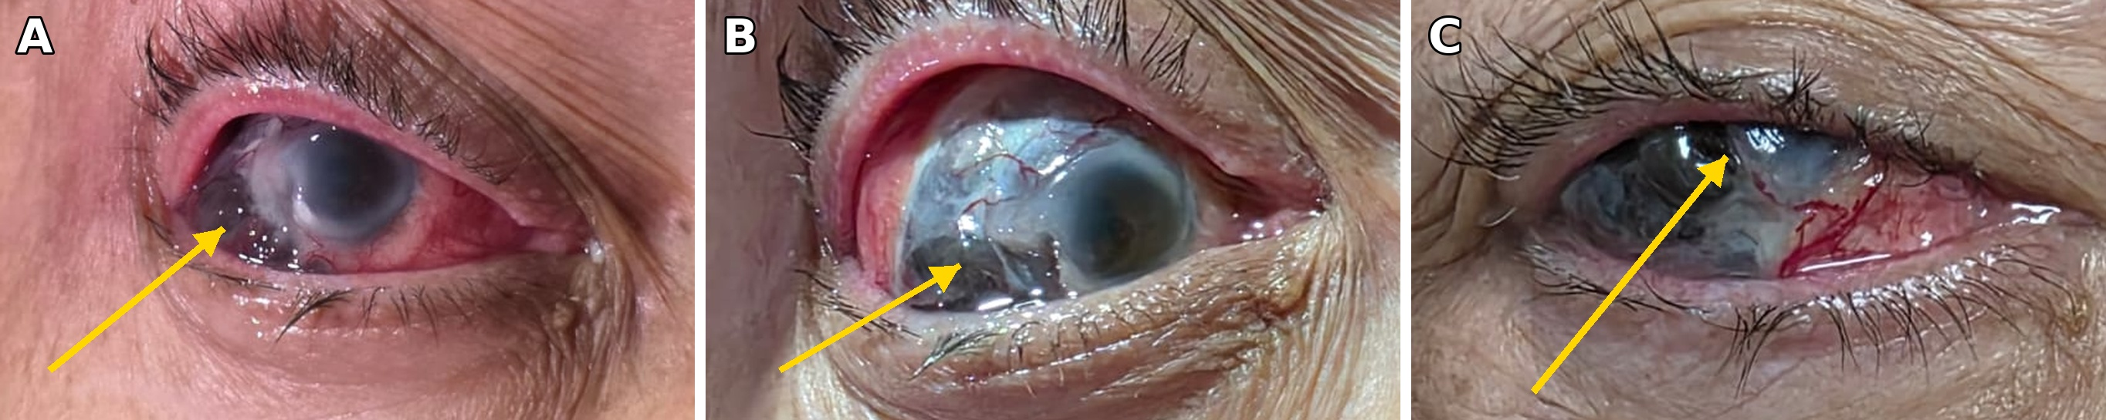
Figure 1. Right eye with scleromalacia perforans. (A) At hospital admission, extensive corneoscleral destruction with uveal tissue herniation was already present. (B) Eight days later. (C) Three months later, on prednisone and azathioprine, while awaiting corneoscleral patch grafting. Arrows: herniated uveal tissue.

