W01 Learning Activity: Dynamic Arrays
Overview
In this learning activity you will learn about the first data structure of this course, the Dynamic Array. It is similar to a fixed array, but can grow in size to accommodate any number of items.

Fixed Arrays
A fixed array is a collection of data put in memory with the following properties:

The fixed array cannot grow or shrink after it is created.
Each item in the fixed array is the same size
Each item in the fixed array is contiguous (i.e. right next to each other) in memory
It is very easy for the programming language to access any position in the array. We use the term index when referring to a position in the array. The index starts at 0. In the example array below, we will assume that index 0 begins at memory location 100. We will also assume that the size of each element in the array is 4 bytes. Using this information, we can determine the memory location for each index. Generically, we can say that memory(index) = startingAddress + (index * itemSize)

Shows a fixed array with 8 items (index going from 0 to 7) where each item is 4 bytes long. Since the starting memory address is 100, the addresses of all items (in order) are 100, 104, 108, 112, 116, 120, 124, and 128.
Fixed Array
To create a fixed array in C#, you allocate the array with a size and type, and then add items by index:

var numbers = new int[3];

numbers[0] = 1;
numbers[1] = 2;
numbers[2] = 3;
Another syntax that is a few less characters is to use a collection initializer:

var numbers = new[] { 1, 2, 3 };
Dynamic Arrays
The difference between a dynamic array and a fixed array is that the dynamic array can grow (and also shrink). This means that we can always add another item to a dynamic array. One of the common operations performed on a dynamic array is to append a new item to the end of the list. Consider the dynamic array below.

Shows a dynamic array with capacity 8 and size 7. Indices 0 through 6 are populated with 8, 12, 31, 15, 4, 42, and 27.
Dynamic Array
In the dynamic array, the size of the array is 7 and the capacity is 8. If we append another number to the array, we can use the formula described earlier to get the memory location of the next available index. We will then store the new number into the memory location just calculated.

Shows the same array with 19 added into index 7. The array is now full with capacity and size both equal to 8.
Dynamic Array that is Full
In this updated array, both the size and the capacity are now 8. If we want to append another number, we cannot just add it to the end. A dynamic array is really just a fixed size array (in this case a fixed array of size of 8) that we will discard in favor of building a bigger fixed array. If we tried to add another one, then we would be overwriting memory that likely belongs to another variable. This dangerous condition is called buffer overflow.

Shows the same array with 99 attempted to be added after index 7 in memory. Anything added after index 7 is considered overflow and is memory that belongs to another variable.
Overflowing a Dynamic Array
To properly grow the array, we have to complete the following steps:

Create a new array twice as big as the original array. Usually a dynamic array starts with capacity 0 and then increases in the following pattern: 0, 1, 2, 4, 8, 16, 32, 64, 128, etc.
Copy all the values from the original smaller array into the new larger array.
Delete the original smaller array.
Add the new item to the larger array.
Shows the previous full array. A new array with double the capacity (16) is created. ALl the values from Indices 0 to 7 from the original array are copied to the new array. The new value 99 is then added to index 8 of the new array.
Growing a Dynamic Array
Inserting in the Dynamic Array
If we wanted to insert an item somewhere besides the end of the dynamic array, we would need to be careful to maintain the order of the items in the array. In the array below, if we insert a value at the beginning of the array, all other items will need to move to the next index (i.e. move to the right).

Shows the previous array of capacity 16 and size 9. The number 20 is inserted into index 0 which causes the previous values in Indices 0 to 8 to move over by one to the right (towards the end).
Inserting into a Dynamic Array
Deleting from the Dynamic Array
If we wanted to delete an item from the array, we would need to move all items after the item removed to the previous index (i.e. move to the left). As a special case, if we wanted to remove the last item in the array, we would not need to move any other items. The typical effect of removing the last item is to just decrease the size variable by 1 while leaving the capacity the same. This means that the data is not really "deleted." If we append a new item, then the previously "deleted" item will be overwritten.

Shows the previous array of capacity 16 and size 10. The number 20 is removed from index 0 which causes the previous values in Indices 1 to 9 to move over by one to the left (towards the beginning).
Deleting from a Dynamic Array
Lists in C#
In C#, a dynamic array is created by using a List object. There are several ways to create lists in C#. Here's the most basic way to create a list of integers and add 1, 2, & 3:

var numbers = new List<int>();

numbers.Add(1);
numbers.Add(2);
numbers.Add(3);
Another syntax that is a little less characters is to use a collection initializer:

var numbers = new List<int> { 1, 2, 3 };
The following table shows the most common operations in a dynamic array and the equivalent C# List code:

Common Dynamic Array Operation Description C# Code
lookup(index) Gets the value at the specific index. value = myList[index]
append(value) Adds "value" to the next available index. myList.Add(value)
insert(index, value) Adds "value" to the specified index and moves subsequent items to the next index. myList.Insert(index, value)
remove(index) Removes the item at the specified index and moves subsequent items to the previous index. myList.Remove(index)
size() Return the size of the dynamic array. myList.Count
capacity() Return the capacity of the dynamic array. myList.Capacity
empty() Returns true if the length of the dynamic array is zero. myList.Count == 0
Looping Through Lists or Arrays
To access, display, or do something with every item in a list, the foreach loop is used. The following code will display all values in a list one at a time:

foreach(var item in myList)
{
Console.WriteLine(item);
}
This type of for loop is called an iterator because it will visit all items in the collection without the programmer needing to think about the index. We can change the for loop so that it loops through all the index values for the list instead.

// This is for a list
for (var index = 0; index < myList.Count; ++index)
{
Console.WriteLine(myList[index]);
}

// This is for an array
for (var index = 0; index < myArray.Length; ++index)
{
Console.WriteLine(myArray[index]);
}
Lists vs Arrays
Dynamic arrays seem like they are so much more useful, so is there ever a reason to use a fixed array? Of course!

Advantages of Dynamic Arrays
Expandable
Advantages of Fixed Arrays
Faster memory allocation if you know how much to store
Dynamic arrays need to expand and copy the contents once they experience overflow
Consumes slightly less memory as there is less metadata in an array
W01 Learning Activity: Evaluating Performance
Overview
To evaluate code and look for alternative solutions, it is important that we have a common method for quantifying the performance of code in terms of time. The principles we will learn can also be applied to analysis of how much memory or space is used by code to perform a task.

Big O Notation and Linear Performance
Big O notation is used to describe the performance of an algorithm (or function) for large sets of data. If we have two functions that do the same thing, we can use big O notation to compare the performance of the two functions. As a simple example, consider the following code which looks for the name "Bob" in a list of names:

bool FindBob(List nameList)
{
foreach (var name in nameList)
{
if (name == "Bob")
{
return true;
}
}

return false;
}
The size of the data in this function is based on the size of the nameList. We will say that size of the data is n. The for loop in the code means that we will potentially run n times. This worst case potential will only happen if "Bob" is not in the list of names. Therefore, we say that the big O in the worst case is O(n). In general, when we ask for the big O of a function we are asking for the worst case scenario. This function does have a best case scenario. If "Bob" is the first name in the list, then the loop will only run one time. Therefore, we can say the big O in the best case is O(1). We call O(1) constant time. When looking at code, usually a single line of code like an assignment statement is considered O(1).

If a function has O(n) performance, then we also say that the function has linear performance. Using a graphing calculator or a graphing website, we can visually see the linear performance of O(n). The graph below shows y = x which is used to represent O(n). When x (or n) gets bigger, the amount of work (y) gets larger in a linear way.

Shows the graph y=x for x in the range from 0 to 40.
Representation of O(n)
Consider the following code that has two loops in serial (one right after the other):

void MultipleLoops(int n)
{
for (int i = 0; i < n; i++)
{
Console.WriteLine(i);
}

for (int j = 0; j < n; j++)
{
Console.WriteLine(j*j);
}
}
In this function, each for loop contributes O(n) to the performance of the function. The total would be O(n) + O(n) = O(2n). If we graph this, O(2n) does look like it has a worse performance than O(n). However, if we zoom very far out to very large values of n, it is still just two times more work. If we graphed O(n2) for these large values, we can't even see the line escape the y-axis. O(n) and O(2n) are equivalent. Any coefficients in big O notation should be dropped. Therefore, instead of saying O(2n) for the function above, we will say O(n).

Shows y=x and y=2*x on the same graph for x in the range from 0 to 25. The y=2*x graph takes twice as much work (y) as y=x. Also shows y=x and y=2*x and y=x^2 on the same graph for x in the range from 0 to 6,000,000. The distance between the two graphs is the same as when we were zoomed in.
Comparison of O(n) [red] and O(2n) [purple] and O(n2) [green]
Polynomial Performance
As seen earlier, the structure of the for loops is important to analyzing the big O performance for a function. Consider the following scenario:

void MultiplicationTable(int n)
{
for (int i = 0; i < n; i++)
{
for (int j = 0; j < n; j++)
{
Console.WriteLine((i + 1) * (j + 1));
}
}
}
This function has a loop within a loop. Both loops are based on the size of the data. Instead of adding O(n) twice like we did with loops in serial, we multiply as follows: O(n) * O(n) = O(n2). The rate of increase is much higher with an O(n2) function compared to an O(n) function. The FindBob function would, in the worst case, take 1,000 checks if the list size was 1,000, but the MultiplicationTable will take 1,0002 = 1,000,000 print statements to complete for a similarly sized value of n. This results in O(n2) which is polynomial time. The graph for an O(n2) function is shown below:

Shows the graph y=x^2 for x in the range 0 to 20.
Representation of O(n2)
Caution should be used when analyzing code that contains a loop within a loop. If one of the loops is based on the size of the data but the other loop is not, it would be more accurate to characterize it as O(kn) where k is a constant. Based on the rules we learned earlier, O(kn) = O(n) when k is a coefficient. The code below would be O(n) because the inner loop is only running three times but the outer loop is based on the size of the data.

void ShortMultiplicationTable(int n)
{
for (int i = 0; i < n; i++)
{
for (int j = 0; j < 3; j++)
{
Console.WriteLine((i+1) * (j+i));
}
}
}
When we count iterations of a loops in a function, we may end up with complex polynomials that look like this. Assume that we had performance predicted at O(2n3 - 7n2 + 13n - 15). In addition to dropping coefficients, we also drop lesser exponents like (in this example) the n2 and the n. Therefore, O(2n3 - 7n2 + 13n - 15) = O(n3). This code likely has a loop, within a loop, within a loop.

Logarithmic Performance
It would seem like O(n) is the best performance you can get if we want to analyze a set of information. However, there are some algorithms that have better performance. Consider a function that had performance of O(log n). This is called logarithmic time. When graphed, the performance does not get significantly worse as the size of the data increases.

Shows the graph y=log x for x in the range 0 to 20.
Representation of O(log n)
To find a function that has this type of performance, consider a list of sorted data: 2, 7, 12, 19, 31, 54, 68, and 91. If we wanted to determine if 68 was in the list, we could search from left to right looking for 68. Instead, we are going to treat this sorted list of numbers like a phone book. If we wanted to find a name in a phone book, we would likely use our knowledge of the alphabet to get there faster. A simple process could be to go to the item in the middle of the list (or the phone book) and determine if the number we are looking for is before or after the value in the middle. By doing this, we will discard half of the values in the list in support of our search. Using the remaining numbers, we will repeat the process by going to the middle and discarding half again. If we repeat this process, we will eventually either find the number or determine that the number does not exist.

Returning to our list of numbers, we will say 19 is in the middle (we started with an even number so we will use integer division to find the middle such as numbers.Count / 2. Since 68 (the number we are looking for) is greater than 19, then we concentrate our search after the 19. The middle of the remaining numbers (31, 54, 68, and 91) is 54. Since 68 is greater than 53, we will look at the numbers afterwards. The middle of the remaining numbers (68 and 91) is 68. Since 68 matches 68, we can say the number exists and it only took us three checks.

If we look at this generically, let's ask ourselves how many checks it will take if we had n numbers in the list. The worst case would occur if the number we are looking for is not in the list. Therefore, we want to know how many checks it will take (in terms of n) until we reach the point where there is only one item left in the list to check (because that means we don't have to look any further). To solve this problem, consider how many numbers are left after each check.

After check 1, we have n / 2 left
After check 2, we have n / 4 left
After check 3, we have n / 8 left
Generally, after check c, we have n / (2c) left
Returning to the question, how many checks c are there until there is just one left. Written mathematically: n/(2c) = 1. Using logarithms, we get c = log2(n) = log(n) / log(2) which results in a big O notation of O(log n) since the log(2) is a coefficient. The secret to getting O(log n) was to continuously divide the data in half.

The process above relies on an important fact. The ability to find the middle of a list (or dynamic array as you learned previously) using a lookup operation is O(1). The next section will review why this is true.

Performance of Dynamic Arrays
Now that we have big O notation, we can characterize the performance of our data structure operations.

Function Description Performance
lookup(index) Performance of getting a value in the dynamic array using the index. Since the dynamic array is in contiguous memory, the equation address = startingAddress + (itemSize * index) can be used to get the value in a dynamic array using the index quickly. O(1)
append(value) Performance of adding to the end of dynamic array. If the dynamic array is not full yet, then the cost is based on the lookup operation to go to the next open space. If the dynamic array is full, then we need to create new memory which is twice the size and then copy the old memory. This is an O(n) operation because of the loop required. However, for large values of n, this copy doesn't happen very often. We can amortize (or spread out) the cost of the O(n) loop on all the previous appends that were filling up the dynamic array. Therefore, we say the worst case for appending in the dynamic array is O(1). O(1)
insert(index, value) Performance of inserting at the beginning or the middle of the dynamic array. When we insert anywhere but the end, then we will need a loop to move all the items from the index to the end over by one position. This requires a loop which in the worst case will require moving all items in the list. O(n)
remove(index) Performance of removing an element in the list. When we remove, we have to move all items over by one position towards the beginning of the list. This requires a loop that in the worst case will require moving all items in the list. However, in the case of removing the last item in the list, there is nothing to move over. This scenario will be O(1). O(n); except for removing the last one which is O(1)
size() Performance of returning the size of the dynamic array. The class for the dynamic array data structure will keep track of how many items are currently in the list so no loop is required. O(1)
capacity() Performance of returning the capacity of the dynamic array. The class for the dynamic array data structure will keep track of the capacity of the current list so no loop is required. O(1)
empty() Performance of checking the size of the dynamic array O(1)
Evaluating Performance of Alternative Solutions
The real benefit of using big O notation is to find a way to compare and contrast one or more functions that perform the same task. It is possible that we have written one function that functionally works very well. However, when we run the function, it is taking too long to complete. When code takes too long, the user may have a user interface that is unresponsive or the software may miss requests arriving from external sources. When this happens, we need to analyze the big O notation of our code and look for ways to improve it with a new function.

We should not be satisfied with the functionality of our code only. We should always consider the performance. In addition to looking at timing, we can also perform a similar analysis on the amount of memory our functions use. It is possible to write code in many different ways but not all solutions may have the best performance. We should always check the performance of our code especially when loops are involved. Care should be taken when multiple functions are used in software. If one function has a loop and calls another set of functions within that loop, the performance of the other functions needs to be considered to determine the big O of the calling function.

Measure Actual Execution Time
When we analyze performance, we are making a prediction. Frequently, we need to perform tests to benchmark (or measure) the actual performance of the functions we are using. In C#, we can use the System.Diagnostics.Stopwatch class to measure the execution time. Consider the following example:

public void Run()
{
var executionTime = Time(() => LotsOfLoops(100), 10);
Console.WriteLine($"Execution Time: {executionTime} ms");
}

private void LotsOfLoops(int n)
{
int total = 0;
for (int i = 0; i < n; i++)
{
for (int j = 0; j < n; j++)
{
for (int k = 0; k < n; k++)
{
total += (i*j*k);
}
}
}

Console.WriteLine(total);
}

private double Time(Action executeAlgorithm, int times)
{
var sw = Stopwatch.StartNew();
for (var i = 0; i < times; ++i)
{
executeAlgorithm(); // Calls the action passed in to this method
}

sw.Stop();
return sw.Elapsed.TotalMilliseconds / times;
}
We encapsulate all of the Stopwatch calls into the Time() function. The following may help you understand this code better:

() => LotsOfLoops(100) in the Run function creates a function that will always call LotsOfLoops with the parameter of 100 each time it's called. This is called a C# Action and is received into the executeAlgorithm parameter in the Time function.
Time(() => LotsOfLoops(100), 10); tells the Time function to execute the Action 10 times.
var sw = Stopwatch.StartNew(); creates a new Stopwatch object and starts timing right away.
sw.Stop(); ends the timer and allows the program to get the Elapsed time.
Another way to look at actual performance is to instrument the code by adding a variable that counts how much work is performed. This variable can then be returned and compared to a base case for relative performance.

public void Run()
{
var stopwatch = Stopwatch.StartNew();
var work = LotsOfLoops(1000);

stopwatch.Stop();

// This will display 1000000
Console.WriteLine("Innermost count is: {0}", work);

// The time displayed will vary based on your computer
Console.WriteLine("Execution Time in milliseconds: {0}", stopwatch.Elapsed.TotalMilliseconds);
}

private int LotsOfLoops(int n)
{
int total = 0;
int count = 0; // Variable for instrumentation

for (int i = 0; i < n; i++)
{
for (int j = 0; j < n; j++)
{
for (int k = 0; k < n; k++)
{
total += (i*j*k);
count++; // Count the number of times in the inner-most loop
}
}
}

Console.WriteLine(total);

return count;
}
Problem Solving Strategies
Scientific Method
It can be daunting to try to solve a problem (especially if you are constrained by time in an interview). While it can be tempting to either dive into code or dive into the internet to find help, we want to develop engineering discipline in our work. When we learned about science, we were introduced to the scientific method.

Shows a flow chart representing the scientific method. The process goes: Problem Statement, Research, Hypothesis, Experiment, and then Conclusions. If the conclusions suggest that the problem is solved, then we can finish knowing we have the answer. If the conclusions suggest that the problem is not solved, then we return back up to the Research step.
Scientific Method
Four Step Process
When we go directly to writing code we are short-circuiting the process. When we start out the process by researching online but use the answers without experimenting with those ideas, we are also short-circuiting the process. For the purposes of solving problems with software, consider the following four steps that align well with the scientific method:

Understand the Problem - Restate the problem in your own words. Ask questions to clarify the problem.
Plan and Design the Solution - Brainstorm ideas and write them down. Try to solve the problem manually on paper. Consider if a data structure (for example, the dynamic array) could be used to solve the problem. Write down a design (for example, flow charts, block diagrams, pseudo-code, step-by-step process, etc).
Implement the Solution - Using your design, implement the solution in a programming language.
Evaluate the Solution - Test your solution on several example inputs. Identify which scenarios are working and which ones are not. If it is working, ask yourself if it could be done better (for example, faster, with less code, with fewer variables, etc). If the solution still needs work, return back to the first step again.
Shows a flow chart representing how to solve code problems. The process goes: Understand the Problem, Plan & Design the Solution, Implement the Solution, and Evaluate the Solution. If the solution is not complete, then the process goes back to Understand the Problem.
Four Step Process to Problem Solving
W01 Individual Activity: Dynamic Arrays and Performance Analysis
Special Instructions for this Week's Activity
Each week will contain a team activity. These activities are designed to take about one hour and should be completed by multiple people working together.

You need gather for a synchronous video call, where everyone can see the code that is being written and help contribute.

For this lesson, because the teams may not be fully defined you will work on the activity individually, but you are encouraged to collaborate with others by asking and answering questions in Microsoft Teams.

Even though you will not meet with a team this week, to help you see how the process will work, this activity is set up identically to the future team activities, including the Canvas quiz that you will submit upon completion. For this lesson, you should simply answer "True" to any questions that ask if you met with your team or were on time to the meeting, etc. In future lessons, you should answer those questions honestly, according to what you actually did.

Instructions
Work through each problem, then compare your solution to the answer which is provided below.

All of the code files for this assignment will be found in the course GitHub repository in the week01/teach folder.

Using Dynamic Arrays
To ensure you have enough time for this activity, spend no more than 15 minutes implementing this method before looking at the solution to discuss.

In the week01/teach folder, open up the following code: Divisors.cs

Implement the FindDivisors() method in the Divisors class.
The method should create and return a list of divisors of the number provided into the method. The list should include the value 1 but should not include the actual number. If the number was 12, then the resulting list would be {1, 2, 3, 4, 6}. If the number was 17, then the resulting list would be just {1} because 17 is a prime number. When implementing the method, use a for loop, an if statement, and call Add.
Compare your answer with the code found in DivisorsSolution.cs. If you want to run this code, you can do so by uncommenting the appropriate line in Program.cs.
Solving a Complicated Problem
Spend no more than 10 minutes on this problem before you look at the sample solution and then move on to the next one.

Open up the following code: ArraySelector.cs

Implement the int version of the ListSelector() method in the ArraySelector class.

Come up with a plan (up to 10 minutes) on how to implement the integer version the ListSelector() method. The function takes two arrays and a selector array. The two arrays are combined together into a new array according to the selector array. The selector array only contains 1's and 2's. A value of 1 means that you should select the next number from the first array. A value of 2 means that you should select the next number from the second array. For example, if array 1 is {1, 2, 3, 4} and if array 2 is {10, 20, 30, 40} and if the selector array is {1, 1, 2, 2, 1, 1, 2, 2}, then the resulting array would be {1, 2, 10, 20, 3, 4, 30, 40}.

Compare your plan with the following sample solution:

Sample Solution (Click to Expand)
You can view the sample solution implemented in code in ArraySelectorSolution.cs. If you want to run this code, you can do so by uncommenting the appropriate line in Program.cs.
Predict, Measure, and Compare Code
In the week01/teach folder, open the file Algorithms.cs (NOTE: Do not run the code until you're asked to below)

This file contains three different methods called Algorithm1, Algorithm2, and Algorithm3. Predict the performance of each method using big O notation.

Uncomment the call to Algorithms.Run() in Program.cs. Run the code and observe the outputs. Here is what the columns in the table represent:
n - The size of the data given to the methods in this test
alg1-count - The number of loop iterations (i.e. work) done by Algorithm1
alg2-count - The number of loop iterations (i.e. work) done by Algorithm2
alg3-count - The number of loop iterations (i.e. work) done by Algorithm3
alg1-time - The time in milliseconds it took to complete Algorithm1
alg2-time - The time in milliseconds it took to complete Algorithm2
alg3-time - The time in milliseconds it took to complete algorithm3
While the alg#-count value should be the same in every execution, the time will vary each time it is executed on the same or different computers. To compute the timing numbers, the code runs the test 10 times and computes the average. This is done to account for any operating system conditions that could affect timing in some cases.

Answer the following questions. When you have answered each question, compare your response to the sample solution provided.

Do the actual results agree with the big O predictions made earlier? If not, what do you think the big O should be?
Sample Solution (Click to Expand)
The Algorithm1 function has a single for loop. This implies O(n). If we look at the actual results, we see that count is the same value as the size of the list. The Algorithm2 function has a loop within a loop. This implies O(n^2). If we look at the actual results, we see that the count is the square of the size of the data. The Algorithm3 functions finds the center of the list and then looks at the 2nd half the list. This process is repeated in which each iteration of the while loop the list is cut in half again. This implies O(log n). If we look at the actual results, we see that the count is approximately the base 2 logarithm of the size.

Which method (Algorithm1, Algorithm2, Algorithm3) has the best performance and which one the worst performance?
Sample Solution (Click to Expand)
Based on the timing data, Algorithm3 is much faster and Algorithm2 is much slower. Note that Algorithm3 is barely increasing (if at all) and Algorithm2 is growing by larger amounts as the size of the data increases. This result agrees with the big O notation from above. O(log n) is better than O(n), and O(n) is better than O(n2) when n is "large".

Looking at the results, why do we say that big O only applies when n in "large"?
Sample Solution (Click to Expand)
When n is small, the time for all three algorithms is very close to each other. Realizing that these are in milliseconds, the amount of time to see the result for Algorithm2 when n is large will start to approach 1 second unlike the other 2 functions. However, when n is small, no difference is seen by the user.
W01 Analyze: Performance
Overview
This assignment must be completed individually to ensure you are meeting all course outcomes. You should not complete this assignment with a group. If you obtain help from a tutor, the tutor should help you understand principles but should not help you answer these problems. It is an honor code violation to obtain answers for these problems from others including using the internet (i.e. sites that allow students to share their solutions).

Instructions
All of the coding files for this assignment will be found in the course week01/analyze folder in the course repository.

This assignment will be submitted as a Canvas Quiz.

Part 1: Analyze Code
In this section, you will be asked several questions that need to be answered in your response document:

Open the file Sorting.cs and determine the big O notation for the SortArray function.
Open the file StandardDeviation.cs and determine the big O notation for the three implementations of calculating the standard deviation from a list of numbers.
There are several other common big O notations that occur in various algorithms including
Merge Sort Algorithm - O(n log n) - Logarithmic Linear Time
Traveling Salesman Algorithm - O(2 ^ n) - Exponential Time
Using either a graphing calculator or a graphing website (e.g. desmos.com), put the following in order (best performance, …, worst performance) for when n is large:
O(n^2), O(1), O(2^n), O(n log n), O(log n), O(n)
Part 2: Predicting, Measuring, and Comparing - Two Sorting Algorithms
Open up the following code: Search.cs
This file contains two different functions called SearchSorted1 and SearchSorted2. Both of these functions will search for an item in a sorted list. Predict the performance of each function using big O notation and provide your answer in the response document.
Run the code and observe the outputs. Here is what the columns in the table represent:
n - The size of the data given to the functions in this test
sort1-count - The number of loop iterations (i.e. work) done by SearchSorted1
sort2-count - The number of loop iterations (i.e. work) done by SearchSorted2
sort1-time - The time in milliseconds it took to complete SearchSorted1
sort2-time - The time in milliseconds it took to complete SearchSorted2
While the sort#-count value should be the same in every execution, the sort#-time will vary every time it is executed on the same or different computers. For the timing numbers, the code ran the test one hundred times and took the average. This was done since there are some operating system conditions that could affect timing in some cases. To ensure worst case, each test tried to find a number that was not in the list.
Answer the following questions:
What is the performance using big O notation for each function (based on both your predictions and the actual results)?
Which function has the better performance in the worst case?
W01 Code: Dynamic Arrays
Due Saturday by 11:59pm Points 50 Submitting a website url Attempts 0 Allowed Attempts 3 Available until Nov 8 at 11:59pm
Purpose:
Demonstrate your ability to use dynamic arrays and solve complex problems.
Task:
Complete the steps of the W01 Prove: Dynamic Arrays InstructionsLinks to an external site..
Commit your code and push it to GitHub.
Submit your GitHub URL here.
Rubric
W01 Code: Dynamic Arrays
W01 Code: Dynamic Arrays
Criteria Ratings Pts
This criterion is linked to a Learning Outcome1. Plan: Multiples Of
10 pts
Complete
Comments show a plan in enough detail that it could be implemented by another person.
5 pts
Developing
Comments show at least some steps of a plan.
0 pts
Incomplete
Comments are not present.
10 pts
This criterion is linked to a Learning Outcome2. Code: Multiples Of
15 pts
Complete
Problem solved successfully.
7.5 pts
Developing
Problem solved partially.
0 pts
Incomplete
Problem not solved.
15 pts
This criterion is linked to a Learning Outcome3. Plan: Rotate Right
10 pts
Complete
Comments show a plan in enough detail that it could be implemented by another person.
5 pts
Developing
Comments show at least some steps of a plan.
0 pts
Incomplete
Comments are not present.
10 pts
This criterion is linked to a Learning Outcome4. Code: Rotate Right
15 pts
Complete
Problem solved successfully.
7.5 pts
Developing
Problem solved partially.
0 pts
Incomplete
Problem not solved.
15 pts
Total Points: 50
W01 Code: Dynamic Arrays
This assignment must be completed individually to ensure you are meeting all course outcomes. You should not complete this assignment within a group. If you obtain help from a tutor, the tutor should help you understand principles but should not help you answer these problems. It is an honor code violation to obtain answers for these problems from others including using the internet (i.e. sites that allow students to share their solutions).

Running and Debugging
You should not edit any files that have the comment DO NOT MODIFY THIS FILE at the top of them. Any edits you make to these files will be removed before grading.
You should not delete or rename any files in the code repository you are using for this class. You should also not delete or rename any classes in this repo. Finally, you shouldn't modify the provided method signatures in any way, including renaming them. You can create helper methods and classes if you like, and you should fill out the body of the provided methods to complete the assignments.
Running all tests for this assignment: Click on Run and Debug in the sidebar, then select this week's code assignment from the drop-down at the top. Click the green Start Debugging button next to the drop-down. The integrated terminal will show the files being compiled and then the tests being run. It will print a summary of which tests passed and failed.
Running individual tests: Navigate to the test file ending in _Tests.cs in the week's code directory. Visual Studio Code will show inline buttons to Run Test for each test method, or to Run All Tests for each test class.
Debugging individual tests: Navigate to the test file ending in _Tests.cs in the week's code directory. Visual Studio Code will show inline buttons to Debug Test for each test method, or to Debug All Tests for each test class.
If you put a breakpoint inside your code or inside the test, the only way to hit it will be by clicking Debug Test or Debug All Tests in this file.
If you want to debug by printing output to the terminal, you must use Debug.WriteLine() to do so. Using that may require you to add using System.Diagnostics; to the top of the file. Using Console.WriteLine(), as is done in other parts of the template project, will not correctly print output to the console when a test is running. Any output generated with Debug.WriteLine() will appear in the Debug Console portion of the integrated terminal when clicking Debug Test or Debug All Tests in this file.
All of the code files for this assignment will be found in the week01/code folder in the course Git repository.

Part 1: Arrays
Open up the following code: Arrays.cs
Come up with a plan on how to implement the MultiplesOf function. The function should create and return an array of multiples of a number. The starting number and the number of multiples are provided as inputs to the function. For example, MultiplesOf(3,5), where the 3 is the starting number and 5 is the number of multiples, would result in <double>{3, 6, 9, 12, 15}.
Using comments in your program, write down your process for solving this problem by step before you write the code.
Implement the MultiplesOf function. (Make sure to leave your comments in the code, even after you have implemented it.)
Part 2: Solving a Complicated Problem Using a List
Come up with a plan on how to implement the RotateListRight function. This function receives a list of data and an amount to rotate to the right.

For example, if the data is <List>{1, 2, 3, 4, 5, 6, 7, 8, 9} and an amount is 5 then the list after the function runs should be <List>{5, 6, 7, 8, 9, 1, 2, 3, 4}. If the data is <List>{1, 2, 3, 4, 5, 6, 7, 8, 9} and an amount is 3 then the list after the function runs should be <List>{7, 8, 9, 1, 2, 3, 4, 5, 6}. The value of amount will be in the range of 1 and data.Count, inclusive.

Using comments in your program, write down your process for solving this problem by step before you write the code.
Hint: There are multiple ways to solve this problem. Don't worry about trying to find the most elegant solution this week. Your solution could use modulo (%) to deal with wrapping around the index number back to 0.

Your solution alternatively could use a technique called list slicing. While you can use the syntax array[3..] for arrays, List in C# uses methods that include the word __Range to get the slice. For example, if you had a list data = <List>{1,2,3,4,5} then data.GetRange(0, 3) will give you a new list <List>{1,2,3} which goes from the beginning of the list (index 0) up for 3 values. If you wrote the slice as data.GetRange(3, data.Count - 3) then you would get the list <List>{4,5} which is index 3 to the end.

Other methods you might find helpful are:

GetRange(index, count)
RemoveRange(index, count)
AddRange(list or array)
InsertRange(index, list or array)
Add(value)
Insert(index, value)
RemoveAt(index)
See the documentation for a C# List to see all the methods available.

Implement the RotateListRight function. (Make sure to leave your comments in the code, even after you have implemented it.)
W01 Interview Question
Due Saturday by 11:59pm Points 25 Submitting a website url Attempts 0 Allowed Attempts 3 Available until Nov 8 at 11:59pm
Purpose:
Demonstrate your ability to articulate the concepts the way you would in a job interview.
Task:
Follow the W01 Job Interview Question InstructionsLinks to an external site..
Prepare a video as directed.
Submit the URL to the video.
Rubric
W01 Interview Question
W01 Interview Question
Criteria Ratings Pts
This criterion is linked to a Learning Outcome1. Advantage
10 pts
Complete
An accurate advantage of dynamic arrays is presented.
5 pts
Developing
Something was presented as an advantage, but it is not accurate.
0 pts
Incomplete
An advantage is not presented.
10 pts
This criterion is linked to a Learning Outcome2. Disadvantage
9 pts
Complete
An accurate disadvantage of dynamic arrays is presented.
4.5 pts
Developing
Something was presented as a disadvantage, but it is not accurate.
0 pts
Incomplete
A disadvantage is not presented.
9 pts
This criterion is linked to a Learning Outcome3. Professionalism
3 pts
Complete
Presentation mannerisms (such as gestures, eye contact, and background) are professional and do not contain distractions.
1.5 pts
Developing
Presentation mannerisms (such as gestures, eye contact, and background) are professional but some distractions exist.
0 pts
Incomplete
Presenter is either not shown or mannerisms are unprofessional and distracting.
3 pts
This criterion is linked to a Learning Outcome4. Clear Communication
3 pts
Complete
Words are articulated clearly and ideas are organized logically.
1.5 pts
Developing
Words are articulated clearly.
0 pts
Incomplete
The response is difficult to understand.
3 pts
Total Points: 25
Overview
This assignment must be completed individually to ensure you are meeting all course outcomes. You should not complete this assignment with a group. If you obtain help from a tutor, the tutor should help you understand principles but should not help you answer these problems. It is an honor code violation to obtain answers for these problems from others including using the internet (i.e. sites that allow students to share their solutions).

Instructions
This assignment is meant to simulate the kind of question you might receive in a job interview. It is important for you to understand the problem, develop a quality solution, and communicate it in a clear and professional manner.

You will need to record and upload a short video with your response to the question below. When making your video, please remember the following:

Show your your face.
Speak clearly.
The video should be less than 3 minutes.
The video should be uploaded as a public, but unlisted video, so the grader can see it without permissions. Most students upload to Youtube and submit a link to the video for grading, but you can upload anywhere as long as you submit a link graders can access.
Questions
In your video, provide a response to each of the following questions:

What is an advantage of dynamic arrays compared to traditional, static arrays?
What is a disadvantage of dynamic arrays compared to traditional, static arrays?
W02 Learning Activity: Stacks
Overview
A stack is a data structure that is characterized by the order in which items are added and removed. Often called "Last In, First Out" (LIFO), the stack can be used to accomplish various tasks and there is a Stack class built into C#.
Preparation Material
Stack of Pancakes
If you were going to make pancakes for your family or friends, you probably would have a plate ready to stack the hot pancakes on as they finished cooking. Each time we put a pancake onto the stack, we call this a push operation. In our pancake example, we might say that each new pancake goes onto the top of the stack. In programming, it is also common to say that the pancake is added to the back. When we take a pancake off to eat, we call this a pop operation. Notice that we push and pop from the back of the stack. Removing from the middle of the stack is not generally allowed (especially at the dinner table). Notice that the pancake at the front is the very first pancake that was cooked. If the pancakes are made faster than they are eaten, then this first pancake would get cold. A LIFO (Last In, First Out) structure like the stack can result in data not being used for a long time. This might not work well for a rotating stock system in a grocery store, but the real benefit of the stack is the ability to remember where we have been.
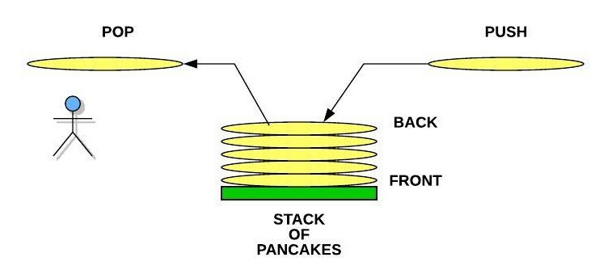Stack of Pancakes
The "Undo" Option and the Stack
One of the most common stacks that people use on a computer is related to the Undo option in word processors and editors. When we type something on the keyboard, the item is both displayed to the screen and also added to a stack. If we type the phrase "The rain in Spain stays mainly in the plain", we would expect the following commands to be put pushed onto the stack: Type "The", Type "rain", Type "in", and so forth. The last item to be pushed would be Type "plain". If we press the Undo button, the software will pop the stack and receive: Type "plain". The software will then do the opposite of this which would result in the word "plain" being removed from the screen.
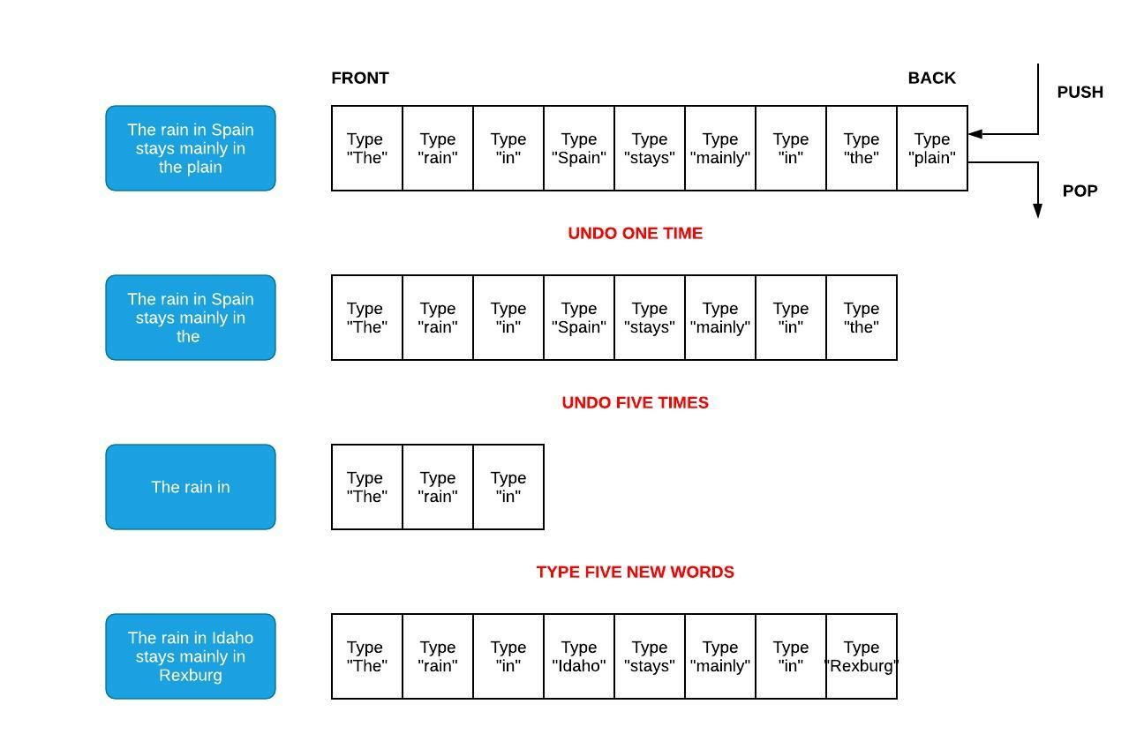Stack used to Undo Text
Since the stack is maintaining a history of what was typed, we can guarantee that pressing the Undo button will revert changes in the right order. If we popped five additional times, we would have "The rain in" remaining on the screen. If we type "Idaho stays mainly in Rexburg", we would see five new pushes to the stack. The original first three commands to display "The rain in" still remains at the front of the stack. If the Undo button is pressed enough times, then these initial words would eventually be removed.
Stacks are useful when we need to maintain history and perform an operation (for example, undo function in an editor) backwards.
Software and the Function Stack
Even if you didn't know what a stack was before today, we have actually been using stacks in all software we have written. When we call a function in our code, we are telling the computer two things:
- Which function we want to call
- Which function to go back to when we are done
The first of these is clear in our code. If we are currently in function A, then we expect to call function B. However, how do we tell the computer that we want to return to function A when function B is finished. This can be even more complicated by the fact that function B will need to call functions C, D, and E before it can finish. The computer accomplishes this by using a function stack. When a function is called, it is pushed to the stack. The current function running is always on the back of the stack. When the function finishes, it is popped off the stack. The result is that the function to return to is the one that is on the back of the stack.
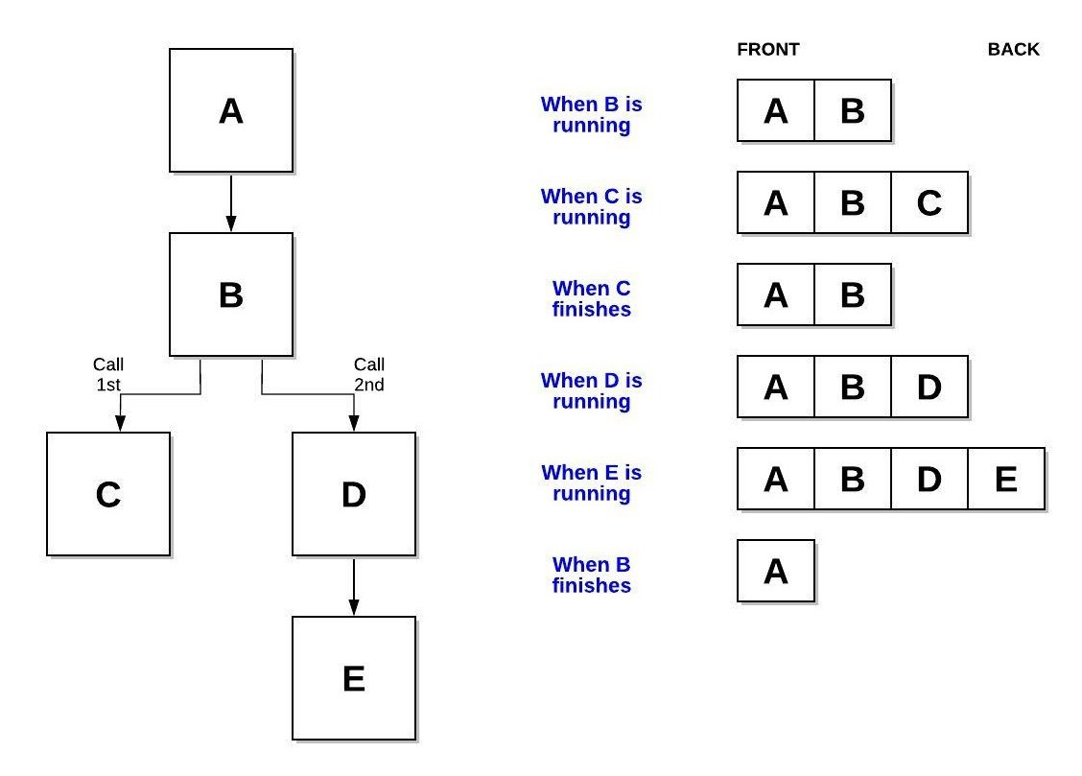Function Stack in Programming
In addition to keeping track of the function name that is running, the stack also allows us to see where in the function we were when a function was originally called as well as the memory that we were using in our function. Stacks work well for remembering where we've been and the circumstances we were in during that previous time.
When using C# or other programming languages, we will often see error messages that look like the following. Notice that the information is showing which functions have called which functions up until the point of error. This display of information comes directly from the function stack. Here's an example of a call stack dump from an error during runtime:
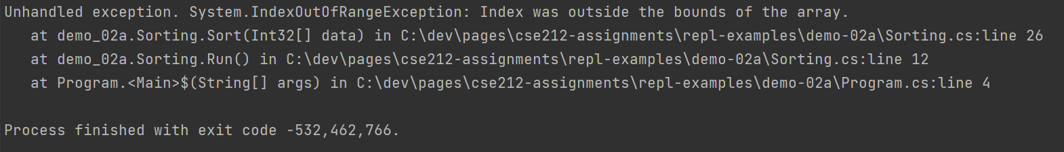C# Exception showing Function Stack
Many code editors also include a debugger. Debuggers can be used to pause execution of software so that we can see what is occurring within our code step-by-step. Part of the debugger capability is the display of the function stack (or frequently called the call stack) when the software is paused (due to a breakpoint or an exception).
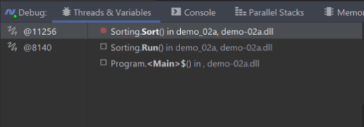Debugger showing Function Stack
Stacks in C#
In C#, a stack can be represented using an array of various data types. Because stack is a common data structure, the framework comes with a built-in Stack class. (See documentation). These methods are shown in the table below, along with the big O performance of them.
Common Stack Operation | Description | C# Code | Performance
push(value) | Adds "value" to the back of the stack. | myStack.Push(value) | O(1)
pop() | Removes and returns the item from the back of the stack. | var value = myStack.Pop() | O(1)
size() | Return the size of the stack. | var length = myStack.Count | O(1)
empty() | Returns true if the length of the stack is zero. | if (myStack.Count == 0) | O(1)
W02 Learning Activity: Queues
Overview
Previously, we learned about the stack. The Stack was "Last In, First Out" (LIFO). The queue is characterized as "First In, First Out" (FIFO) and can also be implemented using a variety of data structures including a List. In C# there is a also a built-in Queue class.
Preparation Material
Grocery Story Queue
In the example below, we can see a line at a busy grocery store used to represent a queue. The person next in line for the cashier is called the front and the person at the end of the line is called the back. When the person at the front is removed from the queue we call this a dequeue operation. When a new person joins the queue at the back, we call this an enqueue operation. Note that someone cannot cheat and enter the line in the middle of the queue.
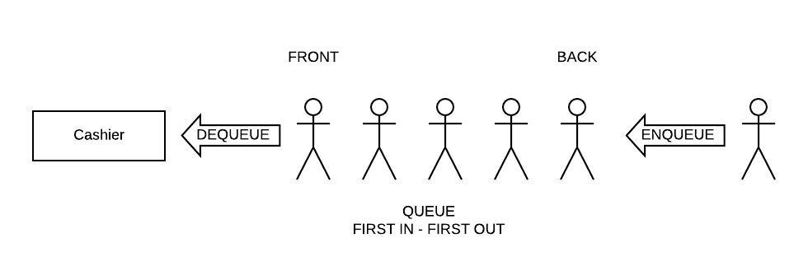Grocery Store Line Queue
Queues are used when we need to process a collection of requests in a fair and orderly way. Consider the following two common queues used in software: the Web Server Queue and the Reader/Writer Queue.
Web Server Queue
A web server receives numerous HTTP (Hypertext Transfer Protocol) requests for web pages from clients throughout the world. Each request requires the web server to send back information. The amount of time it takes to send that information makes it difficult to respond timely to all requests. This would be similar to a customer service desk that had only one phone. If the customer service agent is helping someone else, then no one would pick up your call. To solve the problem, a queue is used to pick up all the phone calls and transfer you to the customer service agent when they are ready for the next person.
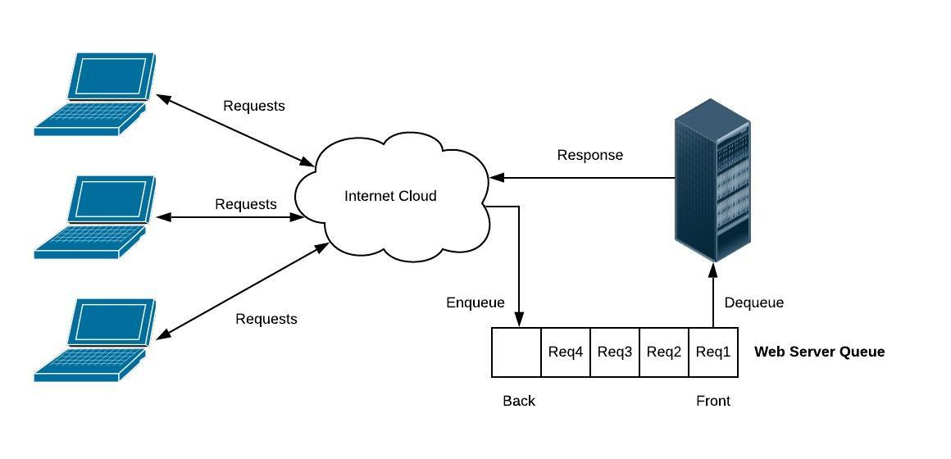Web Server Queue
The web server does the same thing. When a request is sent, it is put into a queue until the web server can process the request. In this way, all requests are received and none of them are lost. Queues frequently have a self-imposed maximum size. If a queue is full, then the software may need to send an error message back to the client.
Reader/Writer Queue
Frequently, we have the need to run different software components concurrently (for example, it looks like they are running at the same time). Each component is called a process or a thread. Each process will likely have their own set of variables that are maintained. Frequently, there is need to have shared data between the processes. The diagram below shows a variable which is being shared by multiple processes.
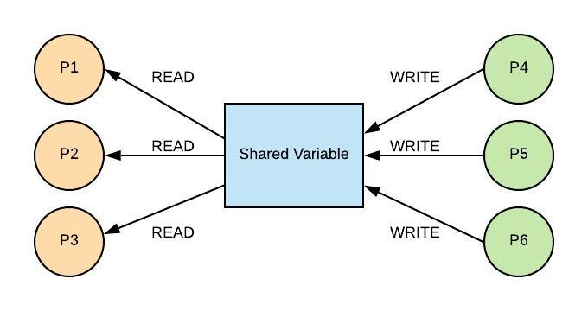Reader/Writer Problem
Processes P1 through P6 are all trying to use the variable at the same time. Processes P1, P2, and P3 are reading the variable and processes P4, P5, and P6 are writing to the variable. The concurrent reading is not a problem. However, if everyone tries to both read and write at the same time, new and modified values may be missed or overwritten. One solution is to protect the code that is writing to the shared data so that only one process can change the variable at a time. A queue is used to ensure order and integrity. When a process wants to write, it is enqueued. When a process is dequeued, it is then allowed to modify the shared variable. When the process is done, then the next process is dequeued.
Queues in C#
Queues are an abstraction that you can represent in many ways. You might create your own queue using an fixed array or a list (dynamic array). There is also a built-in data type in the Collections library which provides a Queue for optimal performance.
Common Queue Operation | Description | C# Code | Performance
enqueue(value) | Adds "value" to the back of the queue | myQueue.Enqueue(value) | O(1)
dequeue() | Removes items from the queue | var value = myQueue.Dequeue() | O(1)
size() | Number of elements in the queue | myQueue.Count | O(1)
empty() | Returns true if the length of the queue is zero. | if (myQueue.Count == 0) | O(1)
Because a queue is just an abstraction, you can implement your own queue using a List object. In that case, performance my be worse than it could be since it requires O(n) to add or remove from the front of your List - causing either the Enqueue or Dequeue operation to take longer than O(1).
Here is an example of creating a new built-in queue for characters:

var q = new Queue<char>();
q.Enqueue('A');
char ch = q.Dequeue(); // retrieves the 'A'
Video Discussion (Optional)
The following video is optional. It presents a brief discussion of the topic.
Activity Instructions
Complete each of the following:
- Open the following snippet of code: SimpleQueue.cs (Note: You should not execute this code. After you complete these practice problems, you are welcome to execute the code).
- This code has a varied mix of enqueue and dequeue operations performed on a queue. Individually, manually walk through the code and predict what the final contents of the queue will be. Even if you are good at keeping track of information in your mind, you should use a sheet of paper to keep track of the stack after each step.
- When you are done, compare your your work to this solution. If you have questions, make sure to post them to Microsoft Teams.
Key Terms
back
Refers to the location in the queue where an enqueue occurs. The last item put in the queue is found in the back.
dequeue
The operation to remove an item from the queue. The item is removed from the front of the queue.
enqueue
The operation to add an item to the queue. The item is added to the back of the queue.
front
Refers to the location in the queue where a dequeue occurs. The first item put in the queue is found in the front. If you use a dynamic array (List) this is index 0.
queue
A data structure that follows a First In, First Out (FIFO) rule. The queue is used both to maintain order in data and to remember data when there is not time to process it.
W02 Learning Activity: Understanding Code Using Reviews
Overview
We have frequently been asked to write code for either school or work. However, how often have we been asked to complete the companion activity of reading code? We have likely looked at code from websites and books, but there is a significant difference between looking at code and reading code. When we read code, we are attempting to understand the code like we would a book. If we open a book and read a few random pages, we might get a high level summary of what the book is about. However, to fully understand the book, we would need to not only read the book cover to cover, but we would also need to become acquainted personally with the diverse set of characters, follow a potentially winding plot, and discover the underlying messages woven in the story from the author. This type of reading takes effort. Reading code for understanding takes an equal amount of effort.
Preparation Material
There are multiple reasons why we might be asked to read code in our teams:
- A team member has written some code and has asked other engineers to review the code for correctness against the design and for compliance against company standards.
- A team member is asked to modify some code that was written by a former employee with or without the aid of a well documented design.
- A team member needs to integrate their software with an external library which included several code examples that demonstrate how to properly use the library.
When we read code others have written, we refer to this activity as a review. A review should follow a methodical process. Many companies will include a review checklist for engineers to use to ensure that they both understand the code and that they have checked all the coding standards. When you review code, there are several strategies that you can use including the following:
- Read code "cover to cover"
- "Execute" the code manually
- Analyze the use of data structures
Each of these methods will be discussed below. When working with these methods, we should try to employ principles learned from the scientific method. The scientific method requires us to form a hypothesis about what we think the code should be doing. As we read through the code, we will test our hypothesis and look at the results. If we are incorrect, then we can correct our misconceptions and form a new hypothesis. This iterative process is necessary to fully understand code. There are no shortcuts. We can be tempted to search for the answer online or in a book. While this may produce a faster answer, we will have not obtained full understanding of the code.
In this process, it is possible that we might find defects in the code that we were given. Code reviews are a common tool for increasing software quality. Performing these steps will require us to keep a good notebook to record our hypothesis, experiments, and conclusions. A good reviewer will always have a pen and paper ready to complete their task.
Read Code "Cover to Cover"
Unlike a book, code does not begin on page one. We need to find where the code begins and follow it as it calls functions, runs loops, and branches in different directions with decision statements. If the code has multiple functions, the creation of a structure chart (also called a calling tree) will be helpful. The structure chart will use boxes to represent functions and arrows to represent functions calling functions. Frequently drawn with the starting function at the top and working downwards, these diagrams can help us navigate through the code. On the arrows, we may frequently write the inputs and outputs related to each function. This will help us better understand the data in the code and which functions are responsible for creating, modifying, and using that data.
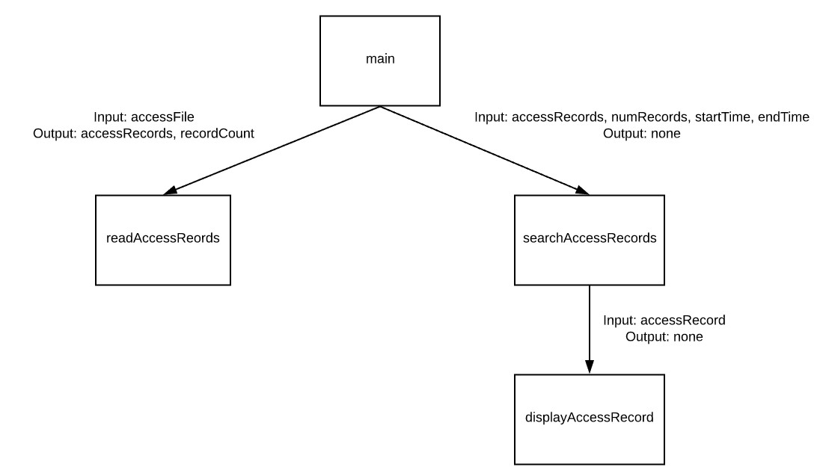Structure Chart
If the code contains classes, then creating a UML (Unified Modelling Language) class diagram to show the classes (with member data and member functions) and the relationships between the classes will help us to visualize the software and enable us to read different sections of the code based on their dependencies to others. For example, in the diagram below, we can see that the Order HAS-A (object composition shown with the filled in diamond) list of Products and that each Product IS-A either a PerishableProduct or an ElectronicProduct (inheritance shown with the open triangle). With this drawn, we would probably start with understanding the Product base class first since it has no dependency on other objects. Second, we would review the different types of Products. Finally, we would review the Order class which contains the list of the Product objects that we already understand.
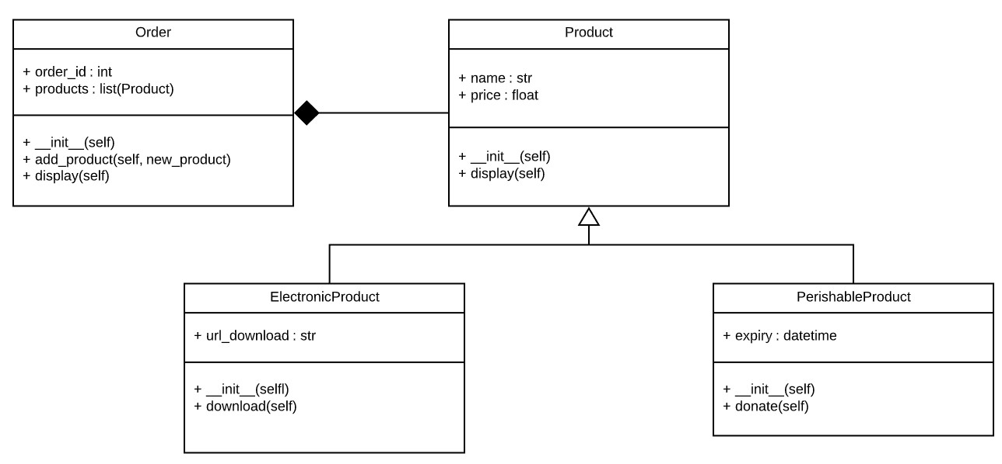UML Class Diagram
When we are looking at a single function, it can be useful to diagram the behavior of the function. Simple flow charts can quickly give us a better perspective of the loops and decisions in our code. In the flow chart, use diamonds to represent decisions, boxes to represent actions, and arrows to show flow.
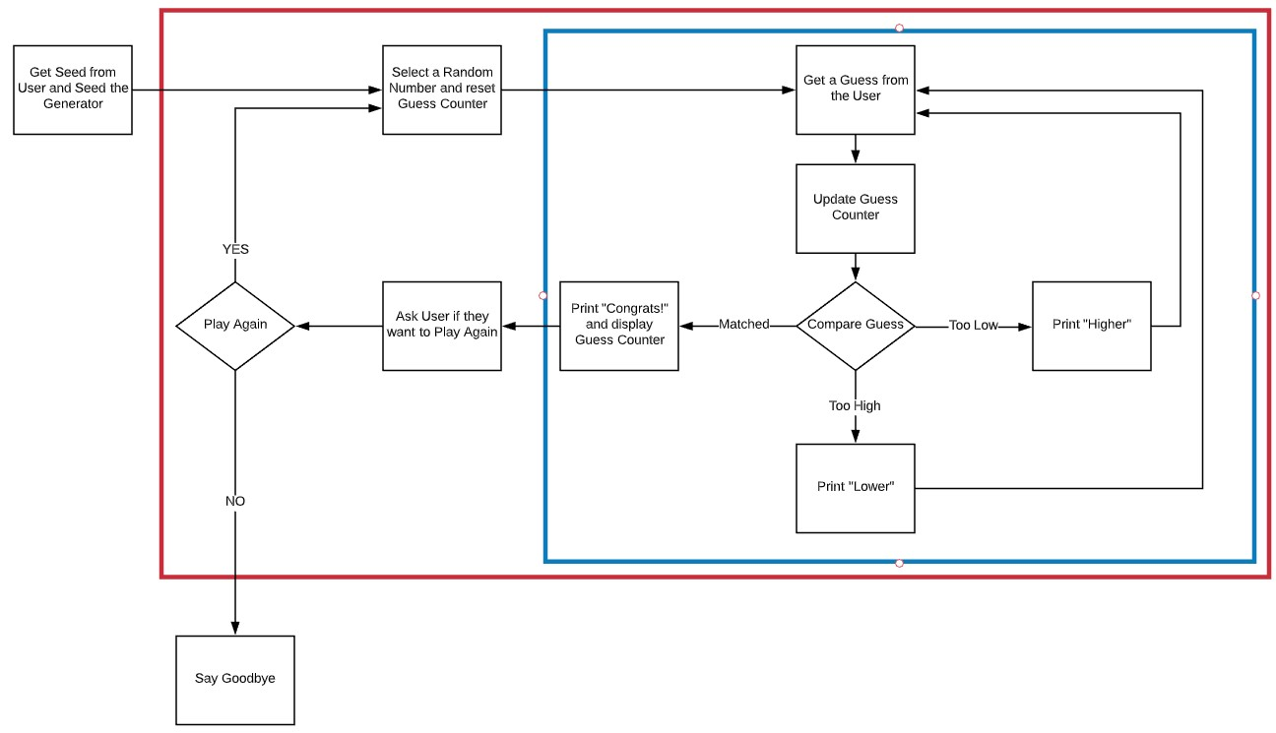Flow Chart
"Execute" the Code Manually
It is not always practical to run code that we are given. If we can, then running the code with inputs that we generate can be helpful to understand the software. However, the goal in this process is to understand the software without running the code on the computer. Instead, we are going to run the software in our minds and on paper.
If we created diagrams in the previous step from our reading of the code "cover to cover," then we can run the code from the diagrams. This is an incomplete approach but is very helpful in gaining more understanding of what the software will perform.
To execute code manually in our minds and on paper, we must start at the beginning (or if we are looking at one piece of the software, perhaps start at the beginning of one of the functions). If inputs are provided at the beginning (or at any other place along the way), we will have to develop useful inputs to see what will happen. For example, consider the following code:
public static string DoSomething(string text) {
var newText = "";
foreach (var letter in text) {
if (letter != ' ') {
var newLetter = (char)(letter + 1);
newText += newLetter;
}
else {
newText += letter;
}
}

return newText;
}

The method needs a string for an input, and so we will propose something like "Hello". We will then step through each line of code and record in our notebook the value of each variable. If we come across a code function that we don't understand (e.g. the (char) type casting), then go online to read about those. Each char is stored as an ASCII numeric code that represents a character. As soon as we add to a character letter + 1, it becomes an integer, so the (char) tells C# that it needs to consider whatever number the integer is as a char data type. When we finish evaluating our code, we get Ifmmp which appears to be a form of simple childhood encryption in which each letter in the original text is changed by one letter higher in the alphabet. When we ran the program, we noticed that you had to check if the letter was a space. It would be good to try to the test again with spaces. If we tried "Hello World", we end up with Ifmmp Xpsme. Not only does the function perform the encoding, but it also preserves the spaces.
text | letter | letter + 1 | newLetter | newText
Hello | H | 73 | I | I
 | e | 102 | f | If
 | l | 109 | m | Ifm
 | l | 109 | m | Ifmm
 | o | 112 | p | Ifmmp
This type of simple analysis by evaluating the variables, step-by-step, is often valuable to understand what the code is doing.
Analyze the use of Data Structures
When code contains a data structure like a list or a stack (and others that we will learn during the course), we should consider why the data structure was used. Data structures are used both for storing information but also to use the information in different ways.
For example, in this week's material you are also learning about stacks and queues. With this in mind, recognizing that a stack can be used to remember where we have been and potentially go reverse or backwards, when you see a stack in a program, you can form a hypothesis about what the code is doing. During the activities this week, you will be reading code that uses stacks and queues. Knowing the strengths, weaknesses, and common uses of these data structures will help you better understand the purpose and behavior of programs that contain them.
Activity Instructions
Complete each of the following:
- Review the following code for a Mystery Program.
- While reviewing this code:
  - Diagram the function calls that are made.
  - Take notes on the variables and their use.
- Without running the code, predict the output. Even if there are a few function calls that you are not familiar with, try to come up with a written description of what this program does.
- Try to predict what the rest of program would do if the integer array d had the values [2, 2, 3, 3, 3]
- When you have finished reviewing the code, compare your findings with the following solution:
Solution (Click to Expand)
This program rolls a set of 5 standard six-sided dice. It then calculates displays a score based on number number of pairs, triples, and so forth.

If the list of values were 2, 2, 3, 3, 3, the program would display a score of 30.
W02 Learning Activity: Finding Defects using Tests
The best time to find a defect is while you are "in-phase." This means that before you deliver your software to the customer you want to identify as many errors as possible. It is much more expensive to fix errors if the software has already been delivered to the customer. The two most common methods for finding defects are:
- Code Review
- Testing
Testing Code From Requirements
Even the best code reviewers may not be able to analyze all the different scenarios that the software will execute within. Testing is a process of demonstrating that specific inputs will result in expected outputs. The selection of inputs can be done systematically. We do not need to test all input combination. Often times we will write code to test your code. Consider a program that was supposed to determine if a year was a leap year. The requirements of a program would include the following:
- Every 4 years shall be a leap year.
- Every 100 years shall not be a leap year.
- Every 400 years shall be a leap year.
Based on these requirements, we can write some test cases. Notice that we are not writing test cases based on what the code does. Each test case includes an expected result. If there is an error in the code, we may incorrectly write the test case based on the faulty code. Using the requirements above, we may write the following tests:
- Test 1
  - Scenario: Year 1996 (multiple of 4 but not multiple of 100 or 400)
  - Expected Result: True
- Test 2
  - Scenario: Year 1900 (multiple of 4, multiple of 100, not multiple of 400)
  - Expected Result: False
- Test 3
  - Scenario: Year 2000 (multiple of 4, multiple of 100, multiple of 400)
  - Expected Result: True
- Test 4
  - Scenario: Year 2003 (not multiple of 4, 100, or 400)
  - Expected Result: False
Running Test Cases
Notice that each test has a detailed scenario and expected result based on the requirements. If we were given a function called IsLeapYear(int year) we could write inline test code as follows:

var result = isLeapYear(1996);
Console.WriteLine(result);

result = isLeapYear(1900);
Console.WriteLine(result);

result = isLeapYear(2000);
Console.WriteLine(result);

result = isLeapYear(2003);
Console.WriteLine(result);
If anything fails when we run the test code, then we must look manually at the output, then track down where in the code that the test failed.
Instead of printing out the results, test code in C# can use the Trace.Assert function. If the Trace.Assert function fails, then the program will exit and tell you which test (e.g. assert statement) failed. For example:

Trace.Assert(IsLeapYear(1996), "1996 should have been a leap year"); // true
Trace.Assert(!IsLeapYear(1900), "1900 should not have been a leap year"); // false
Trace.Assert(IsLeapYear(2000), "2000 should have been a leap year"); // true
Trace.Assert(!IsLeapYear(2003), "2003 should not have been a leap year"); // false
For more complicated programs, a single test scenario may require you to call multiple functions to properly set up the scenario. For example, if we were testing the enqueue and dequeue functions of a queue class, we might enqueue three numbers and then dequeue the three numbers to ensure that they came out in the correct order. The test code may look like the following:

// Test 1
// Scenario: Ensure that after adding 3 items to the queue, they
// can be removed in the proper order
// Expected Result: 100, 200, 300
Console.WriteLine("Test 1");

var queue = new Queue();
queue.Enqueue(100);
queue.Enqueue(200);
queue.Enqueue(300);

var result = queue.Dequeue();
Trace.Assert(result == 100);

result = queue.Dequeue();
Trace.Assert(result == 200);

result = queue.Dequeue();
Trace.Assert(result == 300);

In addition to finding defects, testing also has the benefit of helping the programmer better understand the requirements of the software. Whether you or another engineer wrote the code, the process of writing test scenarios will increase your understanding of what the software should do.
Testing like this is also critical in the software life-cycle where code needs to constantly be improved. In the Continuous Integration / Continuous Deployment (often abbreviated CI/CD) model of development, operating software or apps can be updated for audiences of millions of users, sometimes many times a day. For this model to work, a key part of the release process has to include rigorous testing that not only checks the functionality of the new features, but also assures regression testing to make sure the new 'fix' hasn't broken something along the way. These tests are automated with assert statements, most-often programmatically generated to get maximum coverage of the code.
Activity Instructions
- Open your course repository in VS Code and browse to the week02/learn project. (Note: Do not read through the code first. Instead, proceed with the instructions below).
- The SimpleQueue class implements a traditional FIFO queue that has an enqueue and dequeue function. Here are the detailed requirements (which can not be changed):
  - The enqueue method shall put a new item in the back of the queue
  - The dequeue method shall remove an item from the front of the queue
  - If the queue is empty, then the dequeue method shall throw an IndexOutOfRangeException
- The code contains three test cases already implemented for you. Run the code and determine if a test has failed. If the test case fails, then you know that there is one or more errors in the function related to the test. If your build crashes, you can see which lines of code the error occurred on.
- Find the errors and fix the code. All your test cases should pass when the code is fixed. There are two major errors in the code you were given.
Sample Solution
To see the sample solution, you can uncomment the lines in Program.cs to have it run the SimpleQueueSolution. Then, take a minute to look at the SimpleQueueSolution.cs file to see how the queue was updated.
Key Terms
defect
This is an error in code.
expected result
The result that you expect to receive when you run a test case. The expected result is based on your understanding of the software requirements.
process
The place where software runs. A process has code that is executed and memory used for variables in that code. Multiple processes can run at the same time. Processes can share memory.
requirements
Written description of what software should do.
test cases
Scenarios that are written to test that code behaves per the requirements. A test case will usually have test code unless the procedure is for the user to interact with the software. An expected result is written for each test case.
testing
An activity to demonstrate that the code correctly implements the requirements.
W02 Analyze: Stacks
Overview
This assignment must be completed individually to ensure you are meeting all course outcomes. You should not complete this assignment with a group. If you obtain help from a tutor, the tutor should help you understand principles but should not help you answer these problems. It is an honor code violation to obtain answers for these problems from others including using the internet (i.e. sites that allow students to share their solutions).
Instructions
All of the coding files for this assignment will be found in the course week02/analyze folder in the course repository.
This assignment will be submitted as a Canvas Quiz.
First Mystery Stack
- Examine the following code for MysteryStack1. Do not execute this code. Instead, using the techniques from the learning materials this week, analyze this code to determine its purpose and the way a stack is useful.

public static class MysteryStack1
{
public static string Run(string text)
{
var stack = new Stack();
foreach (var letter in text)
stack.Push(letter);

var result = "";
while (stack.Count > 0)
result += stack.Pop();

return result;
}
}
- Determine the output of the function if the input text is equal to the following:
  - racecar
  - stressed
  - a nut for a jar of tuna
Second Mystery Stack
- Examine the following code for MysteryStack2. Do not execute this code. Instead, using the techniques from the learning materials this week, analyze this code to determine its purpose and the way a stack is useful.

public static class MysteryStack2
{
private static bool IsFloat(string text)
{
return float.TryParse(text, out _);
}

public static float Run(string text)
{
var stack = new Stack();
foreach (var item in text.Split(' '))
{
if (item == "+" || item == "-" || item == "*" || item == "/")
{
if (stack.Count < 2)
throw new ApplicationException("Invalid Case 1!");

var op2 = stack.Pop();
var op1 = stack.Pop();
float res;
if (item == "+")
{
res = op1 + op2;
}
else if (item == "-")
{
res = op1 - op2;
}
else if (item == "*")
{
res = op1 * op2;
}
else
{
if (op2 == 0)
throw new ApplicationException("Invalid Case 2!");

res = op1 / op2;
}

stack.Push(res);
}
else if (IsFloat(item))
{
stack.Push(float.Parse(item));
}
else if (item == "")
{
}
else
{
throw new ApplicationException("Invalid Case 3!");
}
}

if (stack.Count != 1)
throw new ApplicationException("Invalid Case 4!");

return stack.Pop();
}
}
- Determine the result of the function if the following inputs were provided:
  - 5 3 7 + *
  - 6 2 + 5 3 - /
- Consider possible values for the input parameter text that would result in the function doing the following:
  - Display "Invalid Case 1!"
  - Display "Invalid Case 2!"
  - Display "Invalid Case 3!"
  - Display "Invalid Case 4!"
W02 Code: Queues
Due Nov 8 by 11:59pm Points 50 Submitting a website url Attempts 0 Allowed Attempts 3 Available until Nov 15 at 11:59pm
Purpose:
Demonstrate your ability to use Queues to Find Defects using Tests.
Task:
Complete the steps of the W02 Queues Assignment InstructionsLinks to an external site..
Change your course repository and push your updates to GitHub.
Submit your GitHub Repository URL.
Rubric
W02 Code: Queues
W02 Code: Queues
Criteria Ratings Pts
This criterion is linked to a Learning Outcome1. TakingTurnsQueue_Tests.cs: Test Results
10 pts
Complete
Test results are correctly documented in the code.
5 pts
Developing
At least one test case was documented.
0 pts
Incomplete
Test results are not documented.
10 pts
This criterion is linked to a Learning Outcome2. TakingTurnsQueue.cs/PersonQueue.cs: Code Fixed,
10 pts
Complete
The code is fixed.
5 pts
Developing
At least one error was fixed.
0 pts
Incomplete
The code is not fixed.
10 pts
This criterion is linked to a Learning Outcome3. PriorityQueue_Tests.cs: Test Cases
10 pts
Complete
Test cases are created that cover all requirements and they are documented in the code.
5 pts
Developing
At least one test case was created and documented.
0 pts
Incomplete
Tests cases missing from the code.
10 pts
This criterion is linked to a Learning Outcome4. PriorityQueue_Tests.cs: Test Results
10 pts
Complete
For each test case that was created, the test results are correctly documented in the code. (Must have at least two tests to receive credit.)
5 pts
Developing
At least one test result was documented in the code.
0 pts
Incomplete
Test results are not documented.
10 pts
This criterion is linked to a Learning Outcome5. PriorityQueue.cs: Code Fixed
10 pts
Complete
The code is fixed.
5 pts
Developing
At least one error was fixed.
0 pts
Incomplete
The code is not fixed.
10 pts
Total Points: 50
W02 Code: Queues
Overview
This assignment must be completed individually to ensure you are meeting all course outcomes. You should not complete this assignment with a group. If you obtain help from a tutor, the tutor should help you understand principles but should not help you answer these problems. It is an honor code violation to obtain answers for these problems from others including using the internet (i.e. sites that allow students to share their solutions).

Running and Debugging
You should not edit any files that have the comment DO NOT MODIFY THIS FILE at the top of them. Any edits you make to these files will be removed before grading.
You should not delete or rename any files in the code repository you are using for this class. You should also not delete or rename any classes in this repo. Finally, you shouldn't modify the provided method signatures in any way, including renaming them. You can create helper methods and classes if you like, and you should fill out the body of the provided methods to complete the assignments.
Running all tests for this assignment: Click on Run and Debug in the sidebar, then select this week's code assignment from the drop-down at the top. Click the green Start Debugging button next to the drop-down. The integrated terminal will show the files being compiled and then the tests being run. It will print a summary of which tests passed and failed.
Running individual tests: Navigate to one of the test files ending in _Tests.cs in the week's code directory. Visual Studio Code will show inline buttons to Run Test for each test method, or to Run All Tests for each test class.
Debugging individual tests: Navigate to one of the test files ending in _Tests.cs in the week's code directory. Visual Studio Code will show inline buttons to Debug Test for each test method, or to Debug All Tests for each test class.
If you put a breakpoint inside your code or inside the test, the only way to hit it will be by clicking Debug Test or Debug All Tests in this file.
If you want to debug by printing output to the terminal, you must use Debug.WriteLine() to do so. Using that may require you to add using System.Diagnostics; to the top of the file. Using Console.WriteLine(), as is done in other parts of the template project, will not correctly print output to the console when a test is running. Any output generated with Debug.WriteLine() will appear in the Debug Console portion of the integrated terminal when clicking Debug Test or Debug All Tests in this file.
Instructions
All of the coding files for this assignment will be found in the course week02/code folder in the course repository. You will commit changes to your own repository and push them to GitHub for your submission for this assignment.

For this assignment, you will write test cases and results directly in the test methods of the appropriate*_Tests.cs files.

Taking Turns Queue
Examine the following code file: TakingTurnsQueue_Tests.cs (Note: Do not read through the referenced code first. Instead, proceed with the instructions below).
The TakingTurnsQueue class maintains a circular queue of people. When a person is added, they are assigned a number of turns (a value of 0 or less means that they have an infinite number of turns). When a person is removed from the queue, they are re-added to the queue if they still have turns left. Here are the detailed requirements (which cannot be changed):
The AddPerson function shall enqueue a person into the queue.
The GetNextPerson function shall dequeue a person from the queue and return them.
When a person is dequeued and still has turns left, they shall be enqueued again.
When a person is dequeued and has an infinite number of turns (defined as having number of turns of 0 or less), they shall be enqueued again.
If the queue is empty, then an error exception shall be thrown.
Test cases are already written for you in the code. Run the tests and find the errors.
Summarize the results of the tests and the errors found within the test case documentation above each test case. Do not change the code of the test cases themselves.
Fix the code so that all requirements are implemented correctly. You know that you are done because the provided test cases will all pass.
Priority Queue
Examine the following code file: PriorityQueue_Tests.cs (Note: Do not read through the referenced code first. Instead, proceed with the instructions below).
The PriorityQueue class maintains a queue where each value put in the queue also has a priority (higher numbers have a higher priority). When you add to the queue, it goes to the back as expected. When you remove from the queue, the highest priority item is removed. If there are multiple values with the same high priority, then the first one (following the FIFO strategy) is removed first. Here are the detailed requirements (which cannot be changed):
The Enqueue function shall add an item (which contains both data and priority) to the back of the queue.
The Dequeue function shall remove the item with the highest priority and return its value.
If there are more than one item with the highest priority, then the item closest to the front of the queue will be removed and its value returned.
If the queue is empty, then an error exception shall be thrown. This exception should be an InvalidOperationException with a message of "The queue is empty."
Write your own test cases based on these requirements within the test case documentation in PriorityQueue_Tests.cs. Ensure that your tests cover all of the requirements listed above.
Run your test cases and find the errors. If your tests were not sufficient, you might not find all the errors in the code. You should summarize the results of the tests and the errors found within the test case documentation above each test case.
Fix the code so that all requirements are implemented correctly. You know that you are done because the test cases will all pass (assuming your test cases were sufficient).
W02 Interview Question
Due Nov 8 by 11:59pm Points 25 Submitting a website url Attempts 0 Allowed Attempts 3 Available until Nov 15 at 11:59pm
Purpose:
Demonstrate your ability to articulate the concepts the way you would in a job interview.
Task:
Follow the W02 Job Interview Question InstructionsLinks to an external site..
Prepare a video as directed.
Submit the URL to the public, unlisted video.
Rubric
W02 Interview Question
W02 Interview Question
Criteria Ratings Pts
This criterion is linked to a Learning Outcome1. Data Structure: Choice
7 pts
Complete
An optimal data structure was chosen.
3.5 pts
Developing
A workable data structure was chosen.
0 pts
Incomplete
A workable data structure was not chosen.
7 pts
This criterion is linked to a Learning Outcome2. Data Structure: Explanation
3 pts
Complete
The explanation shows how the data structure would be used for all the required tasks.
1.5 pts
Developing
The explanation shows how the data structure would be used for at least one of the required tasks.
0 pts
Incomplete
The explanation does not describe how the data structure would be used for the tasks.
3 pts
This criterion is linked to a Learning Outcome3. Complexity: Adding
3 pts
Complete
The correct time complexity was provided for the chosen data structure.
0 pts
Incomplete
The correct time complexity was not provided.
3 pts
This criterion is linked to a Learning Outcome4. Complexity: Removing
3 pts
Complete
The correct time complexity was provided for the chosen data structure.
0 pts
Incomplete
The correct time complexity was not provided.
3 pts
This criterion is linked to a Learning Outcome5. Complexity: Checking Empty
3 pts
Complete
The correct time complexity was provided for the chosen data structure.
0 pts
Incomplete
The correct time complexity was not provided.
3 pts
This criterion is linked to a Learning Outcome6. Professionalism
3 pts
Complete
Presentation mannerisms (such as gestures, eye contact, and background) are professional and do not contain distractions.
1.5 pts
Developing
Presentation mannerisms (such as gestures, eye contact, and background) are professional but some distractions exist.
0 pts
Incomplete
Presenter is either not shown or mannerisms are unprofessional and distracting.
3 pts
This criterion is linked to a Learning Outcome7. Clear Communication
3 pts
Complete
Words are articulated clearly and ideas are organized logically.
1.5 pts
Developing
Words are articulated clearly.
0 pts
Incomplete
The response is difficult to understand.
3 pts
Total Points: 25
W02 Interview Question
Overview
This assignment must be completed individually to ensure you are meeting all course outcomes. You should not complete this assignment with a group. If you obtain help from a tutor, the tutor should help you understand principles but should not help you answer these problems. It is an honor code violation to obtain answers for these problems from others including using the internet (i.e. sites that allow students to share their solutions).

Instructions
This assignment is meant to simulate the kind of question you might receive in a job interview. It is important for you to understand the problem, develop a quality solution, and communicate it in a clear and professional manner.

You will need to record and upload a short video with your response to the question below. When making your video, please remember the following:

Show your your face.
Speak clearly.
The video should be less than 3 minutes.
The video should be uploaded as a public, but unlisted video, so the grader can see it without permissions. Most students upload to Youtube and submit a link to the video for grading, but you can upload anywhere as long as you submit a link graders can access.
Scenario: Garden Simulator Game
You have been asked to help write a computer game that simulates planting and growing a garden. In this game, the player moves throughout the landscape trying to discover piles of seeds, which can be planted back in a garden space.

There are different kinds of seeds (for example, pumpkins, tomatoes, peas, etc.) and in each pile of seeds there may be different amounts (for example, 10, 25, 100, etc.). When the player picks up a pile of seeds it gets added to their supply basket.

After placing seeds in the supply basket, the player can then plant them. When planting seeds from the supply basket they can only plant the ones that they most recently picked up, until those seeds are all used. So for example, if they picked up a pile of pumpkin seeds, and later a pile of tomato seeds, they would have to plant all of the tomato seeds before they are able to plant the pumpkin seeds. The player cannot plant seeds if their supply basket is empty.

Once seeds have been planted, the player can water and fertilize them in any order they would like. As long as they have sufficient water and fertilizer, plants will continue to grow until they are ready to be harvested. At that point the food can be harvested, or the plant can be left alone, in which case it will eventually turn into a new pile of seeds that can be picked up.

Questions
In your video, provide a response to each of the following questions:

What would be the best data structure to model the behavior of the supply basket? Justify your answer and explain how it would be used.
What is the time complexity of adding new seeds to the supply basket?
What is the time complexity of removing seeds from the supply basket?
What is the time complexity of checking to see if the supply basket is empty?
W03 Learning Activity: Sets
Overview
Previously we learned about lists, stacks, and queues. The position of each item in these data structures was very important to the proper use of the data structure. Not all data structures worry about the order of the data. The set data structure is an example of one for which order is not important.
Characteristics of Sets
Besides the lack of order, the set has another difference. Could we add duplicate data to a list, stack, or queue? The answer is yes, and this situation is very common. However, the set is constrained to not allow duplicates. Knowing that there will be no duplicates (and because we don't care about the order) allows us to store the information in a set to make it very efficient to determine if data is in the set. This test of membership in the set is the most important operation belonging to this data structure. Using a technique called hashing, the set is able to add, remove, and test for membership in O(1) time.
Hashing and Sets
To achieve the O(1) time for set operations, we will consider a very simple example. Assume we wanted to store all positive one digit numbers (0 to 9) into an array. How would we store these numbers if we wanted to have an O(1) performance for adding, removing, or testing for membership? If we used the value to determine the index into the array, we might be able to achieve O(1). Consider the function index(n) = n. If we wanted to add the number 7, then we would use this simple function to determine the index to put the number 7 is index 7. If we wanted to add the number 4, then we would put it into our function and get the index 4. For this to work, our array will need to be exactly size 10.
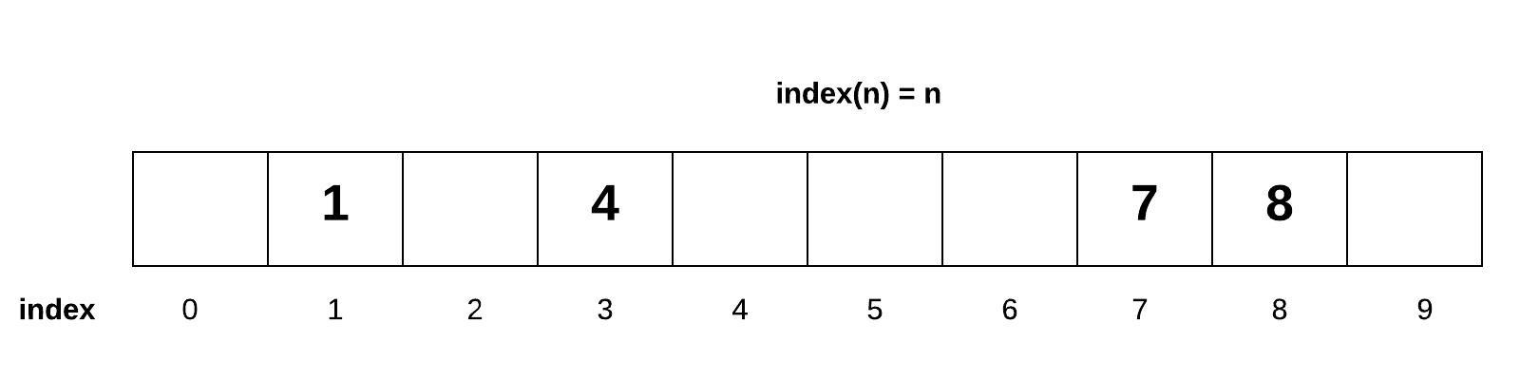Set for 1 Digit Numbers
The array above shows several one digit numbers added to our array according to the rule index(n) = n. Notice that if we wanted to know if a number existed in the array, then we would use the formula to lookup the index. This would result in an O(1) performance. Also notice that the array is not populated in the same way that we learned about dynamic arrays. We call this a sparse array because the array is not guaranteed to be filled from left to right.
We call this sparse array a set. Notice that there is only one place for each value to go. Therefore, the set does not allow duplicates because there would be no place for the duplicate value to be placed.
Imagine we changed this simple example to include all nine digit positive numbers (0 to 999,999,999). How big would the array need to be store these numbers and still achieve O(1) performance? We would need an array size of 1 billion. While this would work, the amount of memory is prohibitive. To store just one 10 digit number, we would need memory for a 1 billion sized spare array. Could we do this with something smaller such as a sparse array size of 10? We can accomplish this by using the modulo (%) operator. If we wrote the equation as index(n) = n % 10, then we would be able to store values properly. The value 353,259,253 would be placed based on index(353,259,253) = 353,259,253 % 10 = 3. The value 783,382,582 would be placed in index 2.
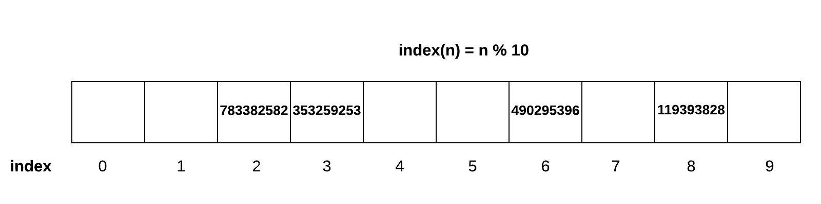Set for 10-Digit Numbers
Our formula for calculating the index for an integer can be generalized to index(n) = n % sparseArraySize. This works great for numbers; however, if we wanted to store more than just integers into our set, we would need to turn our data into an an integer value before determining the index. The formula would look like index(data) = hash(data) % sparseArraySize, where hash is a hashing function. The hashing function calculates an integer value based on the data. Because hashing is integral to using sets, C# has a method defined for every data type called GetHashCode(). The values returned by this hashing functions may vary each time the program is run, but it will be consistent during the run.
Data Type | C# Code | Hash Code
positive int | 3.GetHashCode() | 3
negative int | -3.GetHashCode() | -3
string | "cat".GetHashCode() | -1599535192
other string | "dog".GetHashCode() | -73217838
float/double | 3.14.GetHashCode() | 300063655
bool | true.GetHashCode() | 1
List/object | new List<string>().GetHashCode() | 27252167
If we only have 100 spots and there are up to 10 billion possible values, it's reasonable to expect that perhaps there is a weakness in the data structure. Using the same diagram above, what would happen if we tried to add 548,345,952? This would also be placed in index 2. This is called a conflict.
Dealing with Conflicts
There are two common ways to deal with conflict in a sparse array. The first option is called open addressing. If we use our index(n) hashing function and find that something already occupies the space (or the item in that space is not what we are looking for), then open addressing strategy will tell us move to the next available space. There are multiple ways that this can be done, but the simplest method would be to look to the right one spot at a time. The danger with this approach is that a conflict can result in the creation of more conflicts. In the example below, when 548,345,952 was added, since there was a conflict in index 2, we would move over to index 3. Since there is something in index 3 already, we have to move to index 4. Unfortunately, now any number ending in a 4 will also find a conflict. This can result in rapidly growing clusters of conflicts.
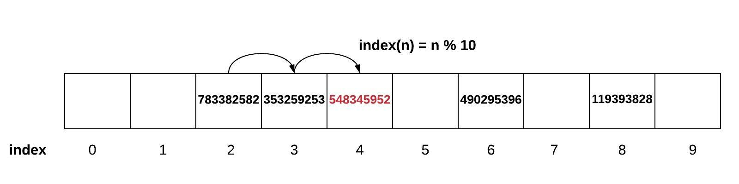Open Addressing for Conflict Management
A second option is called chaining. Instead of looking for a new place for our data, we can make a list of values that occupy the same space. This does not have the adverse effect of creating clusters of conflict.
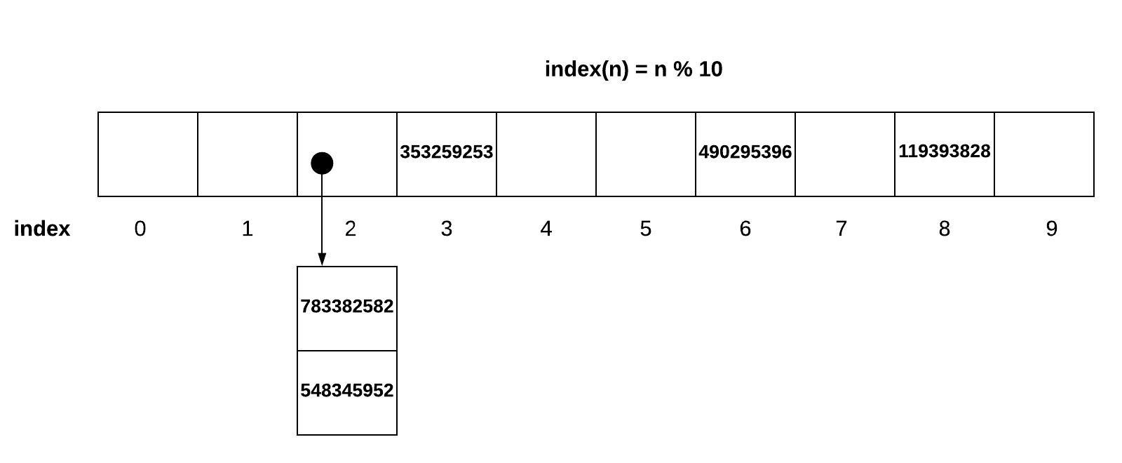Chaining for Conflict Management
In both of these options to solve conflicts, we have an adverse effect on our O(1) performance. The use of the index(n) hashing function is what gives us the O(1) timing. If we have to search through several positions to find a value, or if we have to search the chained list, we may approach O(n) if the amount of conflict is high. To avoid this, we need to increase the size of the sparse array if the amount of conflict is too high. When we increase the size of the sparse array, then we need to reposition all of the values by running the index(n) function again with the increased sparse array size.
Applications with Sets
Sets have the following key characteristics:
- Fast performance for adding, removing, and finding (membership test).
- No duplicates are allowed. Most set implementations (including C#) will not give us an error when you try to add a duplicate value. This is done so that we can easily convert from a list, which may have duplicates, to a set that contains just the unique values.
- The set does not keep values in order. This occurs because the index(n) hashing function is not based on the order the value was added.
Sets have many uses, including the following:
- Finding the unique values in a list.
- Providing quick access to unique results previously calculated.
- Performing mathematical set operations such as an intersection (common values between two sets) and union (all values within two sets).
Sets in C#
In C#, the class we use to represent this kind of set that we've talked about is HashSet. The performance of each of the operations is determined based on the hashing function.
Common Set Operation | Description | C# Code | Performance
add(value) | Adds "value" to the set | mySet.Add(value) | O(1) - Performance of hashing the value (assuming good conflict resolution)
remove(value) | Removes the "value" from the set | mySet.Remove(value) | O(1) - Performance of hashing the value (assuming good conflict resolution)
member(value) | Determines if "value" is in the set | mySet.Contains(value) | O(1) - Performance of hashing the value (assuming good conflict resolution)
size() | Returns the number of items in the set | mySet.Count | O(1) - Performance of returning the size of the set
The following code demonstrates a couple of the mathematical operations (intersection, and union) that are available from methods in the class:

var set1 = new HashSet(){1,2,3,4,5};
var set2 = new HashSet(){4,5,6,7,8};
var set3 = set1.Intersect(set2).ToHashSet(); // This will result in {4, 5}
var set4 = set1.Union(set2).ToHashSet(); // This will result in {1, 2, 3, 4, 5, 6, 7, 8}
Activity Instructions
Complete the following short coding activity to practice using Sets.

Activity: Counting Duplicates
Open the course repository and browse to the week03/learn folder.

Implement the CountDuplicates function in the DuplicateCounter class using a set. This function should make use of a set to help in counting duplicates.

Key Terms
chaining
A method of removing conflicts in a set in which all items that hash to the same index are chained together into a single data structure stored in that target index. When looking for data, the code will need to traverse the data structure.
hashing
The process of mapping an item to an index location using a hashing function. Since the function does not require searching through the data structure, hashing can result in an O(1) in the best case.
hashing function
A function that converts the value of an item to a numerical index value. The hashing function will include a modulo operation to ensure the resulting index is within range of the sparse array.
open addressing
A method of removing conflicts in a set in which a new empty location is found elsewhere in the sparse array. There are multiple ways of finding an empty location including moving over 1 index at a time until one is found. When looking for data, the code will need to follow this search strategy until something is found.
set
A data structure that maps data to an index based on a hashing function. Sets can only hold unique data because of the hashing function. Sets are useful for summarizing data and finding duplicates.
sparse array
An array that is only partially filled. To avoid conflicts in a set, a sparse array must have sufficient empty space to allow for new additions. If a sparse array gets too full, a large sparse array could be created with an updated hashing function.
W03 Learning Activity: Maps
Overview
The map data structure is similar to the set in many ways. The main difference is that sets store values. Maps, on the other hand, store key-value pairs. The key is used to lookup or find the value.
Maps are one of the most used and most important data structures you will learn about in this course.
Making the Map from the Set
The map is most commonly viewed as a table. In the map below, the first column contains a unique value called the key. The second column contains a value (not necessarily unique) called the value. The keys form a set because all the keys are unique. A map is created in software by associating a value with each item in the key set. In the picture below, the table shows the key and value pairs. The keys are hashed into what looks like a set. The values are then stored with each key value.
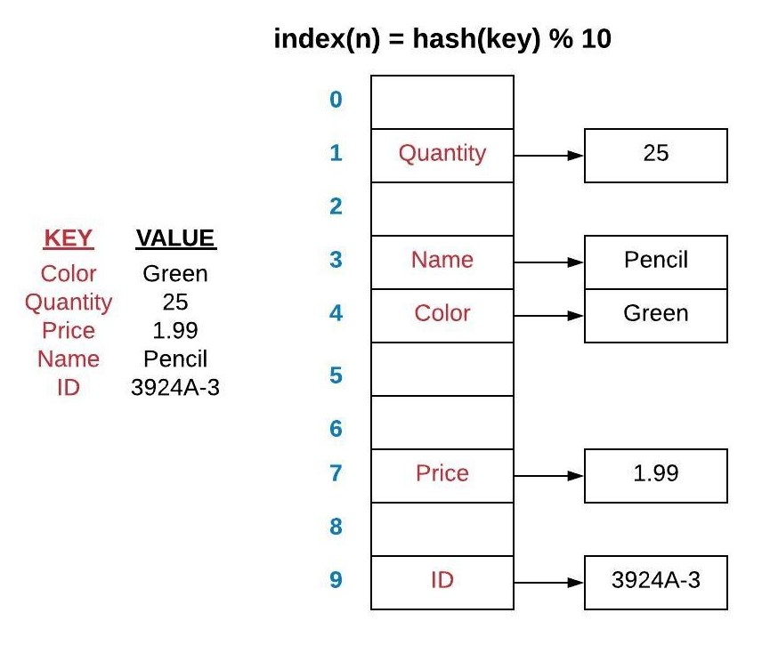Map of Colored Pencil Properties
Maps in C#
The performance of the map is the same for the set. Some programming languages call this a HashTable or a HashMap. In C#, it is called a Dictionary. The dictionary (like the set) is an object where you define your key data type and your value data type when you define your dictionary:

var dictionary = new Dictionary<string, double>();
or

var dictionary = new Dictionary<string, double>() { { "key1", 2.1 }, { "key2", 2.3 } };
Notice that you must specify the datatype of both the key and the value in angle brackets <> when you declare the Dictionary. For example, for example, Dictionary<string, double> defines a dictionary that has strings for keys and doubles for values.
Common Map Operation | Description | C# Code | Performance
put(key, value) | Adds (or replaces) a row in the map with the specified key and value. | myMap.Add(key, value) or myMap[key] = value | O(1) - Performance of hashing the key (assuming good conflict resolution) and assigning the value
get(key) | Gets the value for the specified key. | myMap[key] | O(1) - Performance of hashing the key (assuming good conflict resolution) and getting the associated value
remove(key) | Removes the row from the map containing the specified key. | myMap.Remove(key) | O(1) - Performance of hashing the key (assuming good conflict resolution) and removing the associated value
member(key) | Determines if "key" is in the map. | myMap.ContainsKey(key) | O(1) - Performance of hashing the key (assuming good conflict resolution)
size() | Returns the number of items in the map. | myMap.Count | O(1) - Performance of returning the size of the map
Objects are Maps
Whenever you create a class in any programming language, you are creating a map. Each member variable or property on the class can be considered a key, with the value being stored in that variable. Consider the following code:

class PersonDataMapping
{
public string FirstName { get; set; }
public string LastName { get; set; }
public double Age { get; set; }
}
The PersonDataMapping class maps the key of "FirstName" with the first name of the person. The lookup and access time is O(1) because the compiler knows the order and type of the variables and can jump to that part of the memory without caring how much additional data belongs to the PersonDataMapping class.
Complex Map Data
Mapping data using keys and values has been a standard among the Internet almost since the beginning. Consider the following example which is data that was received from a website about the location of the International Space Station. This data is called JSON (JavaScript Object Notation) data and is a common data format. JSON data is nothing more than a map of maps.

{
"timestamp": 1584638006,
"message": "success",
"iss_position": {
"longitude": -149.9053,
"latitude": -35.9225
}
}
If we wanted to create a mapping for this complex data, we can create custom classes to map the data appropriately:

class SpaceStation
{
public long Timestamp { get; set; }
public string Message { get; set; }
public Location IssPosition { get; set; }
}

class Location
{
public double Longitude { get; set; }
public double Latitude { get; set; }
}
An instance of the SpaceStation class is essentially a map where the keys are fixed when the program is built. This does require that you know the format of the data (including all of the value data types) before creating the class.
Once we read the JSON data from the server, we could use a JsonSerializer.Deserialize() method to convert the raw JSON data into the class object.

var spaceStation = JsonSerializer.Deserialize<SpaceStation>(json);
var lon = spaceStation.IssPosition.Longitude;
var lat = spaceStation.IssPosition.Latitude;
Console.WriteLine($"Space Station at Lon: {lon} Lat: {lat}");
Notice how IssPosition is a key in the SpaceStation object. The value for this is another object Location. To get the Longitude key, we have to go through the IssPosition using the . notation twice.
Here is another example of data that was received about the number of people that are in space.
JSON:

{
"people": [
{ "craft": "ISS", "name": "Andrew Morgan" },
{ "craft": "ISS", "name": "Oleg Skripochka" },
{ "craft": "ISS", "name": "Jessica Meir" }
],
"message": "success",
"number": 3
}
C#:

class Space
{
public Person[] People { get; set; }
public string Message { get; set; }
public int Number { get; set; }
}

class Person
{
public string Craft { get; set; }
public string Name { get; set; }
}

...

var space = JsonSerializer.Deserialize<Space>(json);
foreach (var person in space.People)
{
Console.WriteLine(person.Name);
}
Notice that the "people" key has an array for a value (using the square brackets). To display the "name" of each person, we need to loop through each of the objects in the "people" list and display the value associated with the "name" key.
Generic Dictionaries
In addition to recognizing that classes and objects are a common use of Maps, you should also be aware that the the power of a generic Dictionary is that you can define these keys dynamically, during runtime to store any data that you need to. This is highlighted in the next section.
Building Summary Tables
A map is often described as a table. If we have a large set of data that we want to summarize, we can build a summary table using a map. The summary table could contain counts, sums, minimums, maximums, or other mathematical aggregations.

var letters = new[] {'A', 'A', 'B', 'G', 'C', 'G', 'G', 'D', 'B'};
var summaryTable = new Dictionary<char, int>();

foreach (var letter in letters)
{
// If the letter is not in our summary table yet, add it
if (!summaryTable.ContainsKey(letter))
{
// The key is the letter since we want to summarize how
// many letters we have. Since it the first time we
// have seen this letter, we will set the value to 1.
summaryTable[letter] = 1;
}

// If the letter is in the table, then update the value
else
{
// We want to increase the value by 1 since we have
// already seen this letter before
summaryTable[letter] += 1;
}
}

Console.WriteLine(string.Join(", ", summaryTable));
// [A, 2], [B, 2], [G, 3], [C, 1], [D, 1]
Activity Instructions
Complete the following short coding activity to practice using Sets.

Activity: Translator Class
Open the course repository and browse to the week03/learn folder.

Implement the AddWord and Translate functions in the Translator class using a dictionary. The AddWord function should allow the user to add word translations (e.g. english to german). The Translate function should return the translation of a word. If the translation is not available for a word, then "???" should be returned instead. You will need to call AddWord multiple times to build a translation dictionary for testing. You should assume that there is only one translation for every word (and vice versa).

Key Terms
JSON
JavaScript Object Notation. A format used frequently to share data between software. JSON data uses maps and lists. The syntax of JSON is the same as Python.
key
The keys in the map form a set. Each key is unique. Keys are used to lookup value from the map.
map
A data structure that is based on the set. In addition to storing the unique values in the set, the map also includes a value associated with each key. The map has the same O(1) behavior as the set.
value
The value associated with each key within a map. Frequently, these values are referred to as key-value pairs.
W03 Learning Activity: Articulating Answers to Technical Questions
Overview
In the previous weeks, you have started to get some experience responding to potential job interview questions. This learning activity will give you some additional suggestions on ways to articulate your technical answers clearly.
Interview Questions
It can feel intimidating, but most interviews that relate to software engineering will require us to answer technical questions. These questions frequently include questions related to data structures like the following:
- How would you describe the performance of a set?
- What is hashing and why is it used with a set?
- When would you use a set instead of a list?
You want to practice questions that relate the purpose, behavior, and performance of a data structure. Your responses should be concise, lasting perhaps no more than 30 seconds. Often, these questions are asked within the context of a problem to be solved. In your group practice and individual assignment this week, you will be asked to both respond to "how" you would solve the problem and then, you will actually solve the problem by writing code.
Frequently, the interviewer is more interested in your thought process of getting to the "how" instead of the actual solution. Even so, it's a valuable exercise to also solve the problems so you are better able to describe the "how" in an actual interview.
Articulating the Answer
When you approach a problem to solve with a limited amount of time to respond, you should consider the following guidance:
- Understand the problem being asked. You should not hesitate to ask clarifying questions to avoid assumptions. For example: what is the valid range of numbers? Are duplicates allowed? Will there be invalid data in the collection? These questions serve two purposes. First, they help you to understand the problem and second, they communicate to the interviewer that you are aware of common constraints and errors that can occur in software.
- Solve the problem by walking through scenarios. Either verbally or on a whiteboard, explain the process of solving the problem for a simple example without introducing code. The simple examples usually are those in which there are no failure cases or unusual conditions.
- Identify software techniques such as data structures that can help solve the problem you are analyzing. Talk out loud about the purposes, behavior, and/or performance of the data structure you are using so that the interviewer can see your decision-making process.
- Consider boundary conditions. Think about the situations that might cause problems, such as those where the problem is large or small. For example, consider what happens with a negative number, with no items, duplicates, or any other condition that might cause a problem.
- Propose a solution. Start to discuss the scenarios that will cause your solution not to work or which may be less than efficient. Refine your solution as you discuss these scenarios.
- Don't worry about getting the answer to the problem completely right. Unlike a college coding assignment, you will likely have much less time to develop a solution in the interview.
Notice that one of the common themes of each of these items is to "think out loud" or in other words talk about the ideas you are considering as you develop your solution. Interviewers are not impressed by candidates that have memorized a solution to a common question that may have been on the internet. This is because they are not looking for the answer to this particular problem, they are looking to see your thought process and how you approach a problem. While you are talking, they are asking themselves, "Is this the kind of person I would like to work with?"
Soft Skills Matter!
As mentioned, throughout the interview process, the interviewer is trying to decide if you are a "good fit" for their team. People generally want to work with others who are curious, kind, and hardworking. They have no interest in working with someone who is rude or arrogant, no matter how smart they are.
Often, if a person does not do well with a technical answer, they may be invited back for another interview at some point in the future. However, if an interviewer says that a person is a "bad cultural fit" for the company, they will never consider this canidate again.
This is one of the reasons BYU-Idaho and this program focus so much on learning to collaborate with others.
Activity Instructions
Consider the following scenario:
Write code to find the first time in a string when a letter is duplicated.
Answer each of the following:
- What are possible scenarios to consider? (For example, think of a few strings that you would want to try with your solution.)
- What are some data structures that may be useful? And what would their performance be?
- What are the boundary conditions that you should consider for this problem?
- Outline a possible solution.
Sample Solution (Click to Expand)
There are many approaches to a problem like this, and it should be clarified with the interviewer, but consider the following:
- Possible scenarios: "abcddef" "abcddeef" "abcdefde". The solution should identify "d" in all cases.
- Useful data structures: A Set may be helpful in this case because it does not allow duplicates. Also, it has O(1) insertion and O(1) lookup for membership. If we need to keep track of how many times a letter is repeated, a Map may be helpful. It also has O(1) insertion and lookup.
- Boundary conditions: "", "abc", "aaaaaaaaaa", "abB", "ab2(:~", "nñ"
- An approach: Create an empty Set. Iterate through the string, for each character encountered, check if it is in the set. If not, add it. If you find one in the set, that is the first duplicate. If you never find one in the set, no duplicates exist.
W03 Code: Sets and Maps
Due Nov 15 by 11:59pm Points 100 Submitting a website url Attempts 0 Allowed Attempts 3 Available until Nov 22 at 11:59pm
Purpose:
Demonstrate your ability to use Sets and Maps.
Task:
Complete the steps of the Assignment Instructions.
Submit the link to your GitHub repository.
Rubric
W03 Code: Sets and Maps
W03 Code: Sets and Maps
Criteria Ratings Pts
This criterion is linked to a Learning Outcome1. Base Solution
60 pts
Complete
At least one problem was solved successfully (whether efficiently or not).
0 pts
Incomplete
No problems were successfully solved.
60 pts
This criterion is linked to a Learning Outcome2. Problem 1 - Finding Pairs
10 pts
Complete
Solved with no issues.
5 pts
Developing
Tests pass, but issues exist.
0 pts
Incomplete
Not solved.
10 pts
This criterion is linked to a Learning Outcome3. Problem 2 - Degree Summary
10 pts
Complete
Solved with no issues.
5 pts
Developing
Tests pass, but issues exist.
0 pts
Incomplete
Not solved.
10 pts
This criterion is linked to a Learning Outcome4. Problem 3 - Anagrams
10 pts
Complete
Solved with no issues.
5 pts
Developing
Tests pass, but issues exist.
0 pts
Incomplete
Not solved.
10 pts
This criterion is linked to a Learning Outcome5. Problem 4 - Maze
10 pts
Complete
Solved with no issues.
5 pts
Developing
Tests pass, but issues exist.
0 pts
Incomplete
Not solved.
10 pts
This criterion is linked to a Learning Outcome6. Problem 5 - Earthquake JSON Data
10 pts
Complete
Solved with no issues.
5 pts
Developing
Tests pass, but issues exist.
0 pts
Incomplete
Not solved.
10 pts
Total Points: 110
W03 Code: Sets and Maps
This assignment must be completed individually to ensure you are meeting all course outcomes. You should not complete this assignment within a group. If you obtain help from a tutor, the tutor should help you understand principles but should not help you answer these problems. It is an honor code violation to obtain answers for these problems from others including using the internet (i.e. sites that allow students to share their solutions).
Running and Debugging
- You should not edit any files that have the comment DO NOT MODIFY THIS FILE at the top of them. Any edits you make to these files will be removed before grading.
- You should not delete or rename any files in the code repository you are using for this class. You should also not delete or rename any classes in this repo. Finally, you shouldn't modify the provided method signatures in any way, including renaming them. You can create helper methods and classes if you like, and you should fill out the body of the provided methods to complete the assignments.
- Running all tests for this assignment: Click on Run and Debug in the sidebar, then select this week's code assignment from the drop-down at the top. Click the green Start Debugging button next to the drop-down. The integrated terminal will show the files being compiled and then the tests being run. It will print a summary of which tests passed and failed.
- Running individual tests: Navigate to the test file ending in _Tests.cs in the week's code directory. Visual Studio Code will show inline buttons to Run Test for each test method, or to Run All Tests for each test class.
- Debugging individual tests: Navigate to the test file ending in _Tests.cs in the week's code directory. Visual Studio Code will show inline buttons to Debug Test for each test method, or to Debug All Tests for each test class.
  - If you put a breakpoint inside your code or inside the test, the only way to hit it will be by clicking Debug Test or Debug All Tests in this file.
  - If you want to debug by printing output to the terminal, you must use Debug.WriteLine() to do so. Using that may require you to add using System.Diagnostics; to the top of the file. Using Console.WriteLine(), as is done in other parts of the template project, will not correctly print output to the console when a test is running. Any output generated with Debug.WriteLine() will appear in the Debug Console portion of the integrated terminal when clicking Debug Test or Debug All Tests in this file.
Instructions
This coding assignment contains five separate problems. To receive full credit on this assignment, you must successfully complete any four of the five problems. If you complete all five problems you are eligible to receive extra credit.
All of the files needed for this assignment can be found in the week03/code folder in the course repository. The start of each problem can be found in the SetsAndMaps.cs or Maze.cs code files.
Find Pairs with Sets
- Assume you have been asked in an interview to describe how you would find symmetric pairs of two letter words in a list in O(n) time using a set. You should assume that the the words are lower case, two characters long, and contain no duplicates. As an example, if the word list was [am, at, ma, if, fi] then the result would be ["am & ma", "if & fi"]. The order of the array would not matter. Note that the at would not be returned because ta was not in the list. As a special case, if the letters are the same (example: aa) then it would not match anything else (remember the assumption above that there were no duplicates) and therefore should not be returned.
- Implement the FindPairs function with O(n) time using sets.
Degree Summary
Finish implementing the SummarizeDegrees function in the SetsAndMaps class which reads a file and creates a dictionary containing a summary of all the degrees (education) that people earned as reported in the file. The degree can be found in column 4 of the file. Your code should automatically determine the degree names. You should use the following file for testing: census.txt.
Anagrams
Finish implementing the IsAnagram function to determine if two words are anagrams. Two words are an anagram if they use the same letters and the same number of letters. For example, "CAT" and "ACT" are anagrams but "DOG" and "GOOD" are not because "GOOD" has two O's. You must use a dictionary to solve this problem. It is important to note the following assumptions:
- When determining if two words are anagrams, you should ignore any spaces.
- You should ignore letter case. For example, 'Ab' and 'bA' should be considered anagrams.
Reminder: You can access a letter by index in a string by using the myString[3] notation.
Maze
Implement the MoveLeft, MoveRight, MoveUp, and MoveDown functions in the Maze class. The code provides a sample Maze in the form of a dictionary where the key represents the (x,y) coordinate in the maze and the value contains the valid movements in the format (left, right, up, down). The valid movements are set to true and false. The dictionary maze can be represented graphically as follows (note that it is assumed there is a wall going around the entire maze which means that you cannot leave the outside boundaries of the maze):
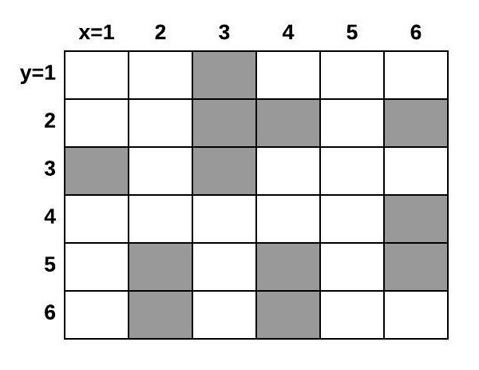Maze Visualization
Earthquake JSON Data
Finish implementing the EarthquakeDailySummary function to return an array of formatted strings of all the earthquake locations ('place' attribute) and magnitudes ('mag' attribute) for the current day from the United States Geological Service (USGS) website. The USGS Website provides details about how to interpret the data that you will receive from their server. The data uses JSON (JavaScript Object Notation) format. In C#, JSON data can be deserialized into an object. Objects are essentially a map, where the keys are the property names and the values are the property values. The difference between objects and dictionaries is that objects are defined at compile time, where dictionaries can be added to dynamically throughout the program execution.
Examine the data that you will be deserializing and use it to populate the FeatureCollection object with the right properties. You will need to create custom classes to map the data appropriately. See the reading for an example of how to interact with JSON in C#.
Each string in the returned array should be formatted to display the data like this, however the places and magnitudes of the earthquakes will be different as this data changes every day.

[
1km NE of Pahala, Hawaii - Mag 2.36,
58km NW of Kandrian, Papua New Guinea - Mag 4.5,
16km NNW of Truckee, California - Mag 0.7,
9km S of Idyllwild, CA - Mag 0.25,
14km SW of Searles Valley, CA - Mag 0.36,
4km SW of Volcano, Hawaii - Mag 1.99,
...
]
Grading
To receive full credit on this assignment, you must successfully complete any four of the five problems. If you complete all five problems you are eligible to receive extra credit.
W03 Interview Question
- Due Nov 15 by 11:59pm

- Points 25

- Submitting a website url

- Attempts 0

- Allowed Attempts 3

- Available until Nov 22 at 11:59pm
Purpose:
- Demonstrate your ability to articulate the concepts the way you would in a job interview.
Task:
- Follow the W03 Job Interview Question InstructionsLinks to an external site..
- Prepare a video as directed.
- Submit the URL to the public, unlisted video.
Rubric
W03 Interview Question
W03 Interview Question
Criteria | Ratings | Pts
This criterion is linked to a Learning Outcome1. Intersection: Approach | 4 ptsCompleteAn approach that will efficiently solve the problem is explained in enough detail that it could be implemented.  2 ptsDevelopingAn approach was explained, but it is lacking detail or is not efficient.  0 ptsIncompleteNo approach was explained. | 4 pts
This criterion is linked to a Learning Outcome2. Intersection: Performance | 3 ptsCompleteThe correct time complexity was provided for the chosen approach.  0 ptsIncompleteThe correct time complexity was not provided. | 3 pts
This criterion is linked to a Learning Outcome3. Intersection: Test cases | 3 ptsComplete3 test cases were provided.  1.5 ptsDevelopingAt least 1 test case was provided.  0 ptsIncompleteNo test cases were provided. | 3 pts
This criterion is linked to a Learning Outcome4. Union: Approach | 3 ptsCompleteAn approach that will efficiently solve the problem is explained in enough detail that it could be implemented.  1.5 ptsDevelopingAn approach was explained, but it is lacking detail or is not efficient.  0 ptsIncompleteNo approach was explained. | 3 pts
This criterion is linked to a Learning Outcome5. Union: Performance | 3 ptsCompleteThe correct time complexity was provided for the chosen approach.  0 ptsIncompleteThe correct time complexity was not provided. | 3 pts
This criterion is linked to a Learning Outcome6. Union: Test cases | 3 ptsComplete3 test cases were provided.  1.5 ptsDevelopingAt least 1 test case was provided.  0 ptsIncompleteNo test cases were provided. | 3 pts
This criterion is linked to a Learning Outcome7. Professionalism | 3 ptsCompletePresentation mannerisms (such as gestures, eye contact, and background) are professional and do not contain distractions.  1.5 ptsDevelopingPresentation mannerisms (such as gestures, eye contact, and background) are professional but some distractions exist.  0 ptsIncompletePresenter is either not shown or mannerisms are unprofessional and distracting. | 3 pts
This criterion is linked to a Learning Outcome8. Clear Communication | 3 ptsCompleteWords are articulated clearly and ideas are organized logically.  1.5 ptsDevelopingWords are articulated clearly.  0 ptsIncompleteThe response is difficult to understand. | 3 pts
Total Points: 25
W03 Interview Question
Overview
This assignment must be completed individually to ensure you are meeting all course outcomes. You should not complete this assignment with a group. If you obtain help from a tutor, the tutor should help you understand principles but should not help you answer these problems. It is an honor code violation to obtain answers for these problems from others including using the internet (i.e. sites that allow students to share their solutions).
Instructions
This assignment is meant to simulate the kind of question you might receive in a job interview. It is important for you to understand the problem, develop a quality solution, and communicate it in a clear and professional manner.
You will need to record and upload a short video with your response to the question below. When making your video, please remember the following:
- Show your your face.
- Speak clearly.
- The video should spend a maximum of 2 minutes per question when answering each of the questions listed below.
- The video should be uploaded as a public, but unlisted video, so the grader can see it without permissions. Most students upload to Youtube and submit a link to the video for grading, but you can upload anywhere as long as you submit a link graders can access.
Scenario:
An intersection of two sets contains items that are in both of the two sets.
A union of two sets contains all items that are in either set.
Questions
In your video, respond to each the following:
- Describe how you would write a function to find the intersection of two sets. Your solution should NOT use the built-in intersection method.
- Describe how you would write a function to find the union of two sets. Your solution should NOT use the built-in union method.
For each task, your response should include:
- Your overall approach.
- Step-by-step discussion of how the function would behave.
- The Big O performance of your approach.
- Highlight at least 3 test cases that you would try to make sure your approach would work.
W04 Learning Activity: Linked Lists
Linked List Structure
When we learned about the dynamic array, we saw that it was characterized by contiguous memory. Each item in a dynamic array is right next to the next item in memory. This allowed for very quick access to items in the dynamic array because memory addresses of each item could be calculated from a formula (address = startingAddress + (index * itemSize)). The queue, stack, set, and map were all based on memory organized in this way.
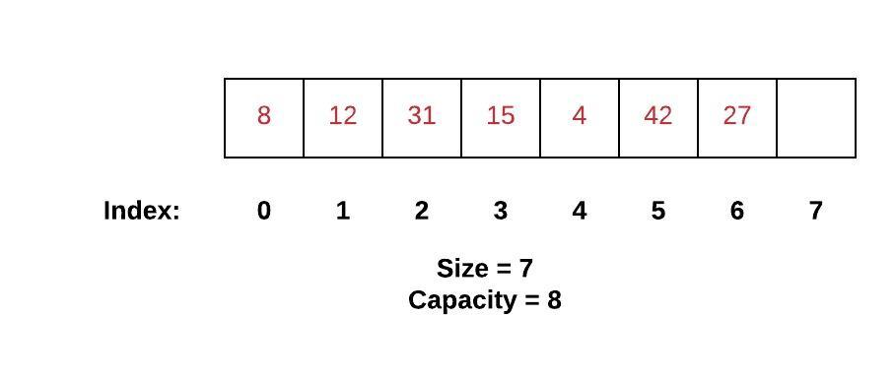Dynamic Array
A collection of data can also be stored in random places scattered throughout memory. A linked list is organized in this way. With a linked list, each element in the list is at some location in memory. There is no guarantee that one element will be next to another element. In order to keep our list together, each element (which we will call a node) will contain both the value and a link to the next node in the list. Specifically, the link will be a pointer to the location in memory that contains our next element.
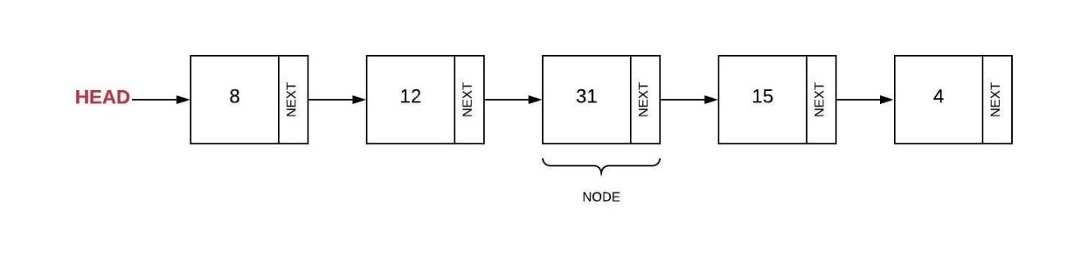Linked List
In the linked list shown above, the first node is called the head. If you know where the head is, then you can traverse the entire linked list by following the pointers. Most linked lists maintain a bi-directional linking between nodes. Bi-directional means that each node will maintain a pointer to both the next node and previous node. The doubly-linked list shown below has both a head and a tail.
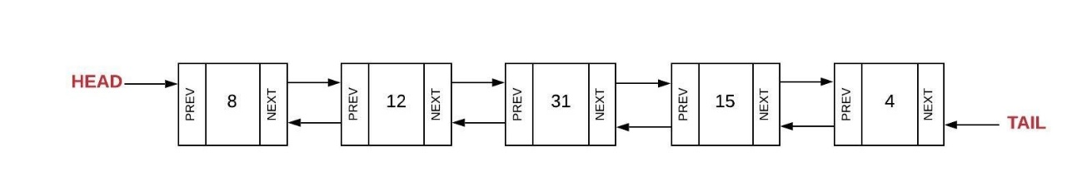Doubly-Linked List
Inserting into a Linked List
Unlike inserting into a dynamic array where we had to worry about moving items over towards the end to maintain contiguous memory, the act of inserting into a linked list only has an effect on its neighboring elements. Additionally, since we are going to use pointers to connect the nodes together, there is no need to worry about concerns such as capacity or growing the list like we did with a dynamic array. There are three scenarios to consider: insert at the head, insert at the tail, and insert at the middle.
Inserting at the head usually requires a four step process:
- Create a new node (we will call it newNode)
- Set the "next" of the new node to the current head (newNode.Next = head)
- Set the "prev" of the current head to the new node (head.Prev = newNode)
- Set the head equal to the new node (head = newNode)
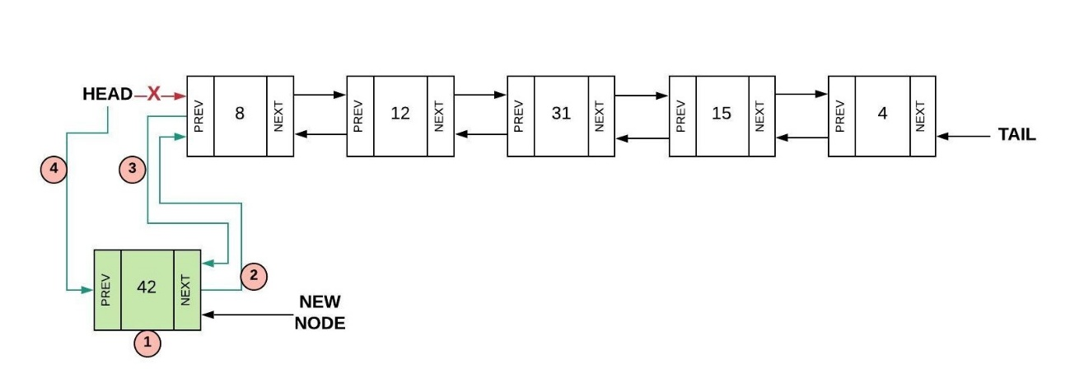Inserting at the Head of Linked List
There is a special case that exists for inserting at the head (and also inserting at the tail). If the linked list is empty (head == null)) then all we have to do is set both the head and the tail to the new node we created.
Inserting at the tail is similar to inserting at the head. The same four steps are followed but with respect to the tail the following should happen:
- Create a new node (we will call it newNode)
- Set the "prev" of the new node to the current tail (newNode.Prev = tail)
- Set the "next" of the current tail to the new node (tail.Next = newNode)
- Set the tail equal to the new node (tail = newNode)
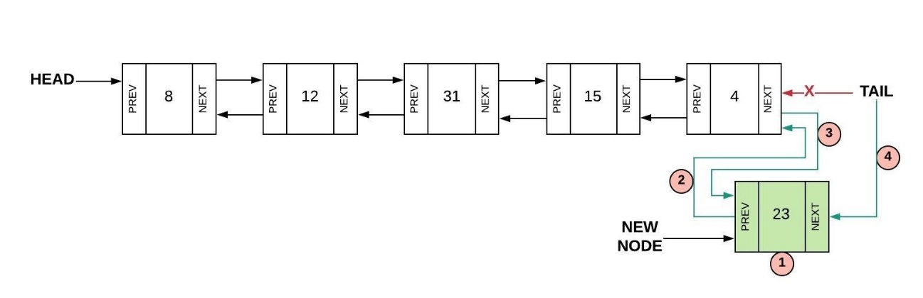Inserting at the Tail of a Linked List
The process for inserting into the middle is a little more complicated. In the picture below, we are trying to insert after node current. The process involves five steps as follows:
- Create a new node (we will call it newNode)
- Set the "prev" of the new node to the current node (newNode.Prev = current)
- Set the "next" of the new node to the next node after current (newNode.Next = current.Next)
- Set the "prev" of the "next" node after current to the new node (current.Next.Prev = newNode)
- Set the next of the current node to the new node (current.Next = newNode)
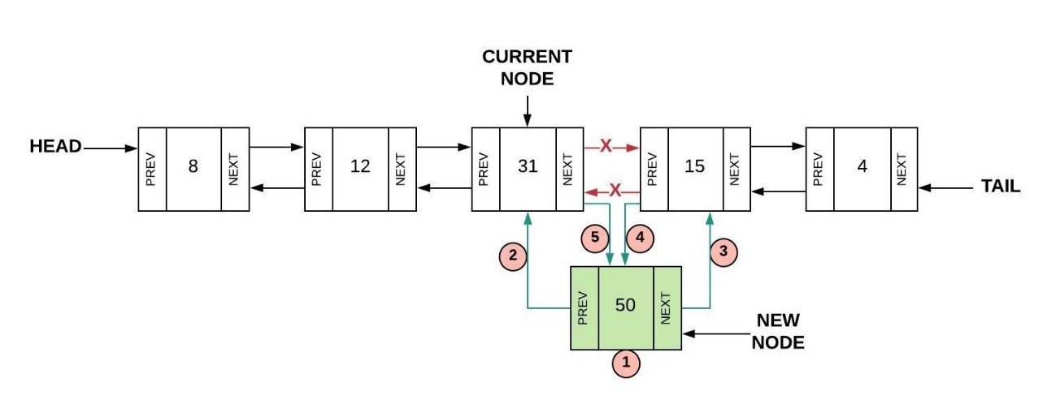Inserting in the Middle of a Linked List
Removing from a Linked List
Removing the first (the head) or the last (this tail) node from a linked list is similar and involves updating the second node (or the second to last node in the case of removing from the tail). The process for removing the first node is as follows:
- Set the "prev" of the second node (head.Next) to nothing (head.Next.Prev = null)
- Set the head to be the second node (head = head.Next)
As a special case, if there was only one node in the linked list, the head and tail would need to be set to null thus creating an empty linked list.
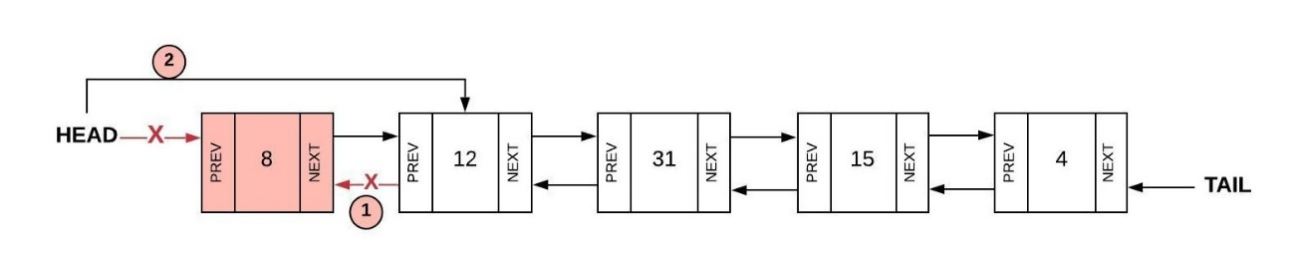Remove the Head from the Linked List
The process for removing the last node is as follows:
- Set the "next" of the second to last node (tail.Prev) to nothing (tail.Prev.Next = null)
- Set the tail to be the second to last node (tail = tail.Prev)
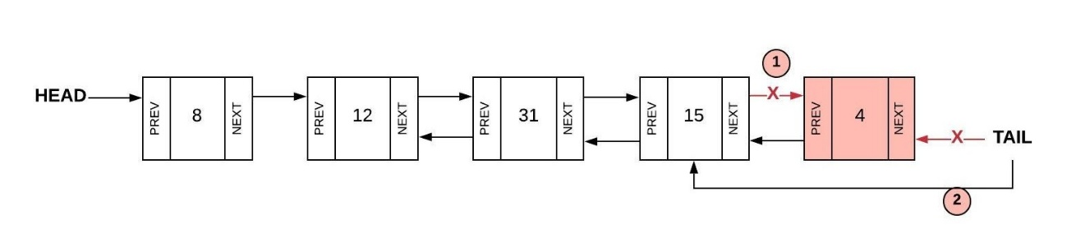Remove the Tail from the Linked List
The process to remove from the middle is not as complicated as inserting from the middle. In the picture below, we are trying to remove the node current. The process involves two steps:
- Set the prev of the node after current to the node before current (current.Next.Prev = current.Prev)
- Set the next of the node before current to the node after current (current.Prev.Next = current.Next)
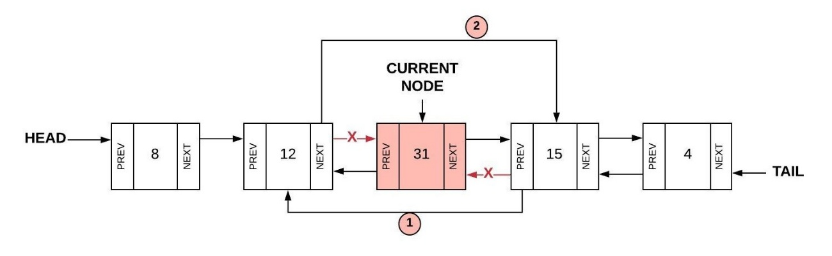Remove from the Middle from the Linked List
Accessing from a Linked List
If we want to find a value in the linked list or if we want to find a specific node (for example, the 3rd node or the 10th node), we are required to loop through the linked list. We can start at either the head (if we want to go forward through the list) or we can start at the tail (if we want to go backward through the list). To loop through the list, we will follow the "next" (or the "prev" if going backwards from tail) links until we get to the end. The following code shows a basic traversal through a linked list.

private void GoForward()
{
// Start at the beginning (the head)
var current = _head;

// Loop until we have reached the end (null)
while (current != null)
{
// Do something with the current node
Console.WriteLine(current.Data);

// Follow the pointer to the next node
current = current.Next;
}
}
Linked Lists in C#
In your assignment this week you will be writing your own linked list class. However, C# does include a linked list class LinkedList<T>. The table below shows the common functions in the LinkedList.
Common Linked List Operation | Description | C# Code | Performance
insert_head(value) | Adds "value" before the head | linkedList.AddFirst(value) | O(1) - Just need to adjust the pointers near the head.
insert_tail(value) | Adds "value" after the tail | linkedList.AddLast(value) | O(1) - Just need to adjust the pointers near the tail.
insert(node, value) | Adds "value" after node "node". | linkedList.AddAfter(node, value) | O(n) - It's not complicated to adjust the pointers to insert, but it takes a loop to find the node to insert after.
remove_head() | Removes the first item (the head) | linkedList.RemoveFirst() | O(1) - Adjusts the pointers near the head.
remove_tail(index) | Removes the last item (the tail) | linkedList.RemoveLast() | O(1) - Just need to adjust the pointers near the head.
remove(node) | Removes node "node". | linkedList.Remove(node) | O(n) - It's not complicated to adjust the pointers to remove, but it takes a loop to find the node to remove.
size() | Return the size of the linked list | linkedList.Count | O(1) - The size is maintained within the linked list class.
empty() | Returns true if the length of the linked list is zero. | if (linkedList.Count == 0) | O(1) - The comparison of the length with 0 is all that is needed.
Comparing Dynamic Array and Linked List
The dynamic array and linked list look the same to the user but because the memory is managed differently, the performance numbers are different. The table below compares these two data structures:
Operation | Dynamic Array | Linked List
Insert Front | O(n) | O(1)
Insert Middle | O(n) | O(n)
Insert End | O(1) | O(1)
Remove Front | O(n) | O(1)
Remove Middle | O(n) | O(n)
Remove End | O(1) | O(1)
We can conclude the following:
- The dynamic array has good performance at the end.
- The linked list has good performance at the beginning and the end.
Thinking back about stacks and queues, the stack did the push and pop operations from the end. Therefore, a stack can use either a dynamic array or linked list equally well. However, since a queue did the enqueue and dequeue operations from the end and the front, a queue should always be implemented with a linked list. This strong statement only applies when the size of the data is "large" (recall discussions earlier about big O). If we only have a small number of items in the queue, then both a dynamic array and linked list will run fast enough.
Activity Instructions
Complete the following activity:
On a sheet of paper, draw a doubly-linked list and follow along with the following operations shown below. You should draw new boxes and arrows, and erase boxes and arrows exactly as shown in the reading material above.
Try the process first on your own, but if you need help, feel free to reference the steps shown above to walk you through the process.
Begin with a list containing A B C D, then perform the following operations:
- Insert X at the head.
- Insert Y in between B and C.
- Remove D (the tail).
- Remove B.
Key Terms
doubly-linked list
A linked list that is bi-directional. The linked list will maintain both a head and a tail. To traverse in either direction, the node will have both a pointer to the next node and the previous node. Access to both the head and tail is O(1).
head
A pointer to the first node in the linked list.
linked list
A data structure that keeps data in order but is not in contiguous memory. To get to the next (or previous) item in the list, pointers are maintained and followed. Access to the head is O(1).
next
A pointer in each node of the linked list that points to the next node.
node
The combination of the value and the pointers representing one item in the linked list.
pointer
Refers to an address in the computer memory. Also called a reference.
tail
A pointer to the last node in the linked list. If the list has only one item, then the head and tail are the same.
value
The actual data stored in the linked list as part of the node.
previous
A pointer in each of the linked list nodes that points to the previous node.
W04 Code: Linked Lists
- Due Nov 22 by 11:59pm

- Points 100

- Submitting a website url

- Attempts 0

- Allowed Attempts 3

- Available until Nov 29 at 11:59pm
Purpose:
- Demonstrate your ability to use Linked Lists.
Task:
- Complete the steps of the Prove 04 Assignment Instructions.
- Submit the link to your GitHub repository.
Rubric
W04 Code: Linked Lists
W04 Code: Linked Lists
Criteria | Ratings | Pts
This criterion is linked to a Learning Outcome1. Base Solution | 60 ptsCompleteAt least one problem was solved successfully (whether efficiently or not).  0 ptsIncompleteNo problems were successfully solved. | 60 pts
This criterion is linked to a Learning Outcome2. Problem 1 - Insert Tail | 10 ptsCompleteSolved with no issues.  5 ptsDevelopingTests pass, but issues exist.  0 ptsIncompleteNot solved. | 10 pts
This criterion is linked to a Learning Outcome3. Problem 2 - Remove Tail | 10 ptsCompleteSolved with no issues.  5 ptsDevelopingTests pass, but issues exist.  0 ptsIncompleteNot solved. | 10 pts
This criterion is linked to a Learning Outcome4. Problem 3 - Remove | 10 ptsCompleteSolved with no issues.  5 ptsDevelopingTests pass, but issues exist.  0 ptsIncompleteNot solved. | 10 pts
This criterion is linked to a Learning Outcome5. Problem 4 - Replace | 10 ptsCompleteSolved with no issues.  5 ptsDevelopingTests pass, but issues exist.  0 ptsIncompleteNot solved. | 10 pts
This criterion is linked to a Learning Outcome6. Problem 5 - Reversed Iterator | 10 ptsCompleteSolved with no issues.  5 ptsDevelopingTests pass, but issues exist.  0 ptsIncompleteNot solved. | 10 pts
Total Points: 110
W04 Code: Linked Lists
This assignment must be completed individually to ensure you are meeting all course outcomes. You should not complete this assignment within a group. If you obtain help from a tutor, the tutor should help you understand principles but should not help you answer these problems. It is an honor code violation to obtain answers for these problems from others including using the internet (i.e. sites that allow students to share their solutions).
Running and Debugging
- You should not edit any files that have the comment DO NOT MODIFY THIS FILE at the top of them. Any edits you make to these files will be removed before grading.
- You should not delete or rename any files in the code repository you are using for this class. You should also not delete or rename any classes in this repo. Finally, you shouldn't modify the provided method signatures in any way, including renaming them. You can create helper methods and classes if you like, and you should fill out the body of the provided methods to complete the assignments.
- Running all tests for this assignment: Click on Run and Debug in the sidebar, then select this week's code assignment from the drop-down at the top. Click the green Start Debugging button next to the drop-down. The integrated terminal will show the files being compiled and then the tests being run. It will print a summary of which tests passed and failed.
- Running individual tests: Navigate to the test file ending in _Tests.cs in the week's code directory. Visual Studio Code will show inline buttons to Run Test for each test method, or to Run All Tests for each test class.
- Debugging individual tests: Navigate to the test file ending in _Tests.cs in the week's code directory. Visual Studio Code will show inline buttons to Debug Test for each test method, or to Debug All Tests for each test class.
  - If you put a breakpoint inside your code or inside the test, the only way to hit it will be by clicking Debug Test or Debug All Tests in this file.
  - If you want to debug by printing output to the terminal, you must use Debug.WriteLine() to do so. Using that may require you to add using System.Diagnostics; to the top of the file. Using Console.WriteLine(), as is done in other parts of the template project, will not correctly print output to the console when a test is running. Any output generated with Debug.WriteLine() will appear in the Debug Console portion of the integrated terminal when clicking Debug Test or Debug All Tests in this file.
Instructions
As you solve the problems, remember to use the principles learned previously in the course:
- Problem Solving Strategy: understand the problem, plan and design the solution, implement the solution, and evaluate the solution.
- Evaluate Performance of Alternative Solutions: use big O to determine the best solution.
- Understanding Code Using Reviews: analyze any code you have been given.
- Finding Defects Using Tests: write tests to determine if your solution is working.
- Articulating Answers for Technical Questions: imagine that you were asked one of these questions during an interview. Remember to ensure that you fully understand the problem and work through different scenarios manually. Consider how the data structure you are using will help you solve the problem. A notebook or a whiteboard can be very useful in this process.
All of the files for this assignment will be found in the course Git repository in the week04/code folder. You will commit changes to your own repository for your submission for this assignment.
Insert Tail
Implement the InsertTail function in the LinkedList class. The function should add a new node (Node) at the end of the linked list. Hint: Consider the code already written for InsertHead.
Remove Tail
Implement the RemoveTail function in the LinkedList class. The function should remove the last node. Hint: Consider the code already written for RemoveHead.
Remove
Implement the Remove function in the LinkedList class. The function will need to search for the node (starting at the head) that contains the value and then remove that one node. The function should not continue searching the list once a match has been found and the node has been deleted. Hint: You may be able to reuse the RemoveHead and RemoveTail functions.
Replace
Implement the Replace function in the LinkedList class. The function should search for all nodes that are equal to oldValue and then replace the value in those nodes with newValue. Unlike the remove function, this function should continue searching through the list to replace all values that match oldValue.
Reversed Iterator
The GetEnumerator function provides the ability to iterate forward through a LinkedList object using a foreach loop such as foreach (var item in myLinkedList). When a foreach loop starts, the GetEnumerator function will start. Each time the yield return statement runs, it will provide a new value to the foreach loop and pause the GetEnumerator function. When the foreach loop goes to the next iteration, it will continue running the GetEnumerator function again until it gets to the next yield return which will provide the next value to the foreach loop. You can use the following test code to see how the GetEnumerator function works:

foreach(var item in myLinkedList)
{
Debug.WriteLine(item);
}
The Reverse function is used to iterate backwards. Implement the Reverse function in the LinkedList class. Hint: Pattern your solution after the GetEnumerator function that was already written for you and that was described above. To test the Reverse function, you can use the following code:

foreach(var item in myLinkedList.Reverse())
{
Debug.WriteLine(item);
}
W04 Interview Question
- Due Nov 22 by 11:59pm

- Points 25

- Submitting a website url

- Attempts 0

- Allowed Attempts 3

- Available until Nov 29 at 11:59pm
Purpose:
- Demonstrate your ability to articulate the concepts the way you would in a job interview.
Task:
- Follow the W04 Job Interview Question InstructionsLinks to an external site..
- Prepare a video as directed.
- Submit the URL to the public, unlisted video.
Rubric
W04 Interview Question
W04 Interview Question
Criteria | Ratings | Pts
This criterion is linked to a Learning Outcome1. Stack: Explanation | 7 ptsCompleteThe response explains the way a linked list could be used to implement a stack in the optimal way.  3.5 ptsDevelopingThe response explains a possible way a linked list could be used, but it is not optimal or the explanation is not complete.  0 ptsIncompleteThe response does not explain the way a linked list could be used. | 7 pts
This criterion is linked to a Learning Outcome2. Stack: Complexity | 3 ptsCompleteThe correct time complexity was provided for each operation.  1.5 ptsDevelopingThe correct time complexity was provided for at least one operation.  0 ptsIncompleteThe correct time complexity was not provided. | 3 pts
This criterion is linked to a Learning Outcome3. Queue: Explanation | 6 ptsCompleteThe response explains the way a linked list could be used to implement a queue in the optimal way.  3 ptsDevelopingThe response explains a possible way a linked list could be used, but it is not optimal or the explanation is not complete.  0 ptsIncompleteThe response does not explain the way a linked list could be used. | 6 pts
This criterion is linked to a Learning Outcome4. Queue: Complexity | 3 ptsCompleteThe correct time complexity was provided for each operation.  1.5 ptsDevelopingThe correct time complexity was provided for at least one operation.  0 ptsIncompleteThe correct time complexity was not provided. | 3 pts
This criterion is linked to a Learning Outcome5. Professionalism | 3 ptsCompletePresentation mannerisms (such as gestures, eye contact, and background) are professional and do not contain distractions.  1.5 ptsDevelopingPresentation mannerisms (such as gestures, eye contact, and background) are professional but some distractions exist.  0 ptsIncompletePresenter is either not shown or mannerisms are unprofessional and distracting. | 3 pts
This criterion is linked to a Learning Outcome6. Clear Communication | 3 ptsCompleteWords are articulated clearly and ideas are organized logically.  1.5 ptsDevelopingWords are articulated clearly.  0 ptsIncompleteThe response is difficult to understand. | 3 pts
Total Points: 25
W04 Interview Question
Overview
This assignment must be completed individually to ensure you are meeting all course outcomes. You should not complete this assignment with a group. If you obtain help from a tutor, the tutor should help you understand principles but should not help you answer these problems. It is an honor code violation to obtain answers for these problems from others including using the internet (i.e. sites that allow students to share their solutions).
Instructions
This assignment is meant to simulate the kind of question you might receive in a job interview. It is important for you to understand the problem, develop a quality solution, and communicate it in a clear and professional manner.
You will need to record and upload a short video with your response to the question below. When making your video, please remember the following:
- Show your your face.
- Speak clearly.
- The video should be less than 3 minutes.
- The video should be uploaded as a public, but unlisted video, so the grader can see it without permissions. Most students upload to Youtube and submit a link to the video for grading, but you can upload anywhere as long as you submit a link graders can access.
Scenario: Using Linked Lists for Other Data Structures
Stacks and queues define a set of functionality that can be implemented using various internal storage techniques. In particular, they could both be implemented to use a linked list internally to store the data.
Questions
In your video, provide a response to each of the following questions:
- Explain how you would use a linked list internally to implement a Stack. Make sure to explain the way you would use the linked list AND the time complexity associated with each of the following operations:
  - Push
  - Pop
  - GetTop
  - IsEmpty
- Explain how you would use a linked list internally to implement a Queue. Make sure to explain the way you would use the linked list AND the time complexity associated with each of the following operations:
  - Enqueue
  - Dequeue
  - Size
  - IsEmpty
W05 Learning Activity: Recursion
Recursive Function Calls
Usually when we write functions, we design them so they call different functions. Recursion is a technique where a function calls itself. For example, consider the following code:

public void SayHello()
{
Console.WriteLine("Hello");
SayHello(); // This is the recursive call
}
This code will seemingly print "Hello" forever. Actually, C# will eventually stop with a Stack overflow because the SayHello function was called too many times. Notice that in this function, the first call to SayHello never has a chance to finish. In software, when a function is called, it is put onto a stack. The stack is used to keep track of what function to go back to when a function finishes. In this case, the stack is filling up.
Rules of Recursion
When we use recursion, we need to make sure we follow two important rules:
- Smaller Problem: When we call the function recursively, we need to make sure we are calling the function on a smaller problem. Without this rule, our function will run forever.
- Base Case: As we continue to call the function on a smaller problem, we need a place to stop. We must define a scenario in which recursion is not required. This is called the base case.
Applying these two rules to the SayHello function, we have the following modified code which is keeping track of how many times to say "Hello":

public void SayHello(int count)
{
if (count <= 0)
{
return;
}
else
{
Console.WriteLine("Hello");
SayHello(count - 1);
}
}
In this new code, the smaller problem is count-1 and the base case is when count is equal to (or less than) zero. When we look at this code, we should probably question the use of recursion when this could have been done with a simple for loop. Recursion should not be used for everything. When used inappropriately, recursion can result is significant performance degradation. However, when used wisely, a simple code solution can be found for complex problems.
Sample Problems: Factorials
Solving problems using recursion requires us to state the solution of a problem in terms of the problem itself (i.e., calling the function recursively). Some problems in mathematics offer good examples of recursion (performance is questionable, but the examples are sound).
A factorial involves multiplying a series of numbers. For a positive integer n (greater than 0), n! (read as n factorial) is defined as n * (n-1) * (n-2) * ... * 3 * 2 * 1. If we wanted to calculate n! using recursion, we need to define the answer in terms of the problem again. The "problem" here is the factorial function. We can rewrite n! as follows:
n! = n * (n-1)!
This solution above satisfies the first rule of recursion. To satisfy the second rule of recursion, we need to define n! for some value of n without using recursion so that our solution does not run forever. Without much math, we can solve 1! and say that it is equal to 1. We now have a base case. With our solution and base case, we can write the code:

public int Factorial(int n)
{
if (n <= 1)
{
// 1! = 1 (no recursion)
return 1;
}
else
{
// n! = n * (n - 1)!
return (n * Factorial(n - 1));
}
}
Sample Problems: Fibonacci
The Fibonacci numbers are: 1, 1, 2, 3, 5, 8, 13, 21, 34, and so forth. The sequence starts with two 1's. Each subsequent number is the sum of the two previous values. If we wanted to write a function Fib(n) which would give us the nth Fibonacci number, instead of thinking about loops, let's define Fib(n) in terms of the same Fib problem but with smaller values:
Fib(n) = Fib(n-1) + Fib(n-2)
If we implement this, eventually we will get to calls of the Fib function with smaller values of n. These smaller values of n represent the base case for recursion solution. Usually we try to think about solutions that we can easily calculate such as Fib(1) which will equal 1. However, if we look at our formula above, we will need more than one base case. Consider n=3 which will require us to use Fib(2) and Fib(1). If we then recursively solve for Fib(2), we will need Fib(1) and Fib(0). In cases like this, we will need more than one base case representing the first two Fibonacci numbers:
Fib(2) = 1
Fib(1) = 1
Our resulting code will be as follows:

public int Fib(int n)
{
if (n <= 2)
{
// Fib(2) = 1 and Fib(1) = 1
return 1;
}
else
{
// Fib(n) = Fib(n - 1) + Fib(n - 2)
return Fib(n - 1) + Fib(n - 2);
}
}
It is a useful exercise to analyze what happens when we call the Fib function. The diagram below shows the functions that are called when we run Fib(6). Notice that the call to Fib(n-1) is called before Fib(n-2) and, therefore, the Fib(n-1) must finish first. Also notice that there are many duplicate calls to the Fib function for the same value of n.
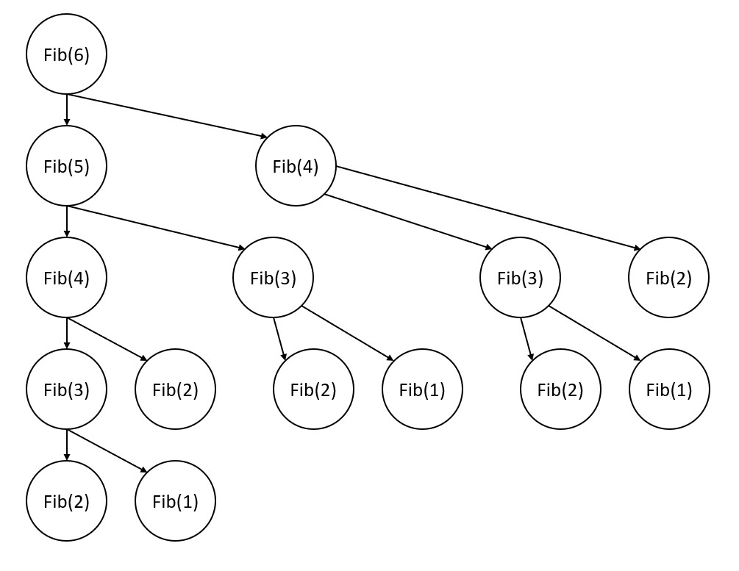Recursive Function Calls for Fib(6)
The Fib function was called a total of 15 times! This is an O(2^n) algorithm.
Memoization
We can improve the performance of the Fib function by remembering previous results as we traverse through the recursive call. Memoization is the process of remembering these previous results so that additional recursive calls are not needed. For example, once we discover that Fib(3) is equal to 2, we can store this into a dictionary with a key equal to 3 and the value of 2. This becomes a base case. If we need to calculate Fib(3) again, we will just look up the 3 in the dictionary to get the answer.
The dictionary will only be used by the Fib function and not be returned. Since the dictionary needs to be shared for all recursive calls, we will write code to create the dictionary on the first recursive call only.

public long Fibonacci(int n, Dictionary<int, long> remember = null)
{
// If this is the first time calling the function, then
// we need to create the dictionary.
if (remember == null)
remember = new Dictionary<int, long>();

// Base Case
if (n <= 2)
return 1;

// Check if we have solved this one before
if (remember.ContainsKey(n))
return remember[n];

// Otherwise solve with recursion
var result = Fibonacci(n - 1, remember) + Fibonacci(n - 2, remember);

// Remember result for potential later use
remember[n] = result;
return result;
}

...

Console.WriteLine(Fibonacci(1)); // 1
Console.WriteLine(Fibonacci(2)); // 1
Console.WriteLine(Fibonacci(3)); // 2
Console.WriteLine(Fibonacci(4)); // 3
Console.WriteLine(Fibonacci(10)); // 55
Console.WriteLine(Fibonacci(90)); // 2880067194370816120 (This one will
// not work if you do not have the
// `remember` dictionary implemented).
Sample Problems: Find Permutations
The problem is to calculate the number of ways to reorganize the letters in a word (i.e. the permutations). Mathematically, this should be n! where n is the number of letters in the word. However, using recursion, we can also display each of the permutations (so long as the number of letters is small, otherwise it will take a long time to display all the results).
Let's assume that our list of letters is ["A", "B", "C", "D"]. Thinking about smaller problems being solved recursively, we could say that the number of permutations would be the sum of the following four things:
- The number of permutations of A followed by all the different permutations of B, C, and D
- The number of permutations of B followed by all the different permutations of A, C, and D
- The number of permutations of C followed by all the different permutations of A, B, and D
- The number of permutations of D followed by all the different permutations of A, B, and C
Each recursive call to the Permutations function will need to know two things: what letters have not been used yet, and the current string that has been built so far. In the four scenarios above, after we add the A, we are left with the letters B, C, and D (the letters that have not been used yet). Additionally, after we add the A, the A should be added to the current string that we have built. The diagram below shows how these function calls will be called and how the resulting permutations will be displayed:
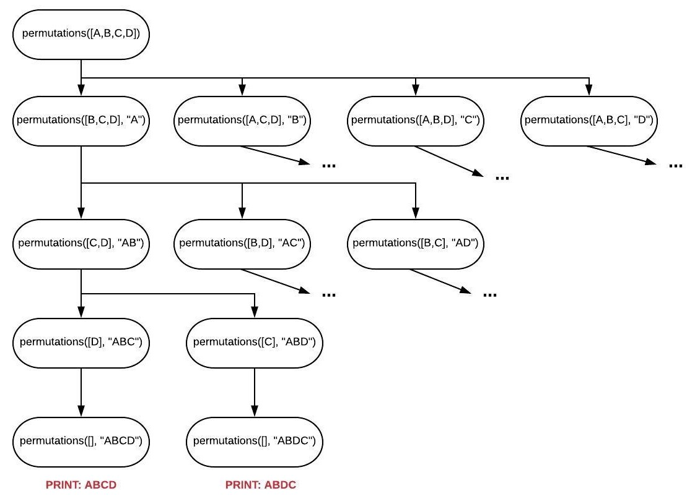Recursive Function Calls for Permutations([A,B,C,D])
We also need a base case. The simplest scenario is a list with zero letters. Here is our code:

public void Permutations(string letters, string word = "")
{
// Try adding each of the available letters
// to the 'word' and add up all the
// resulting permutations.
if (letters.Length == 0)
{
Console.WriteLine(word);
}
else
{
for (var i = 0; i < letters.Length; i++)
{
// Make a copy of the letters to pass to the
// the next call to permutations. We need
// to remove the letter we just added before
// we call permutations again.
var lettersLeft = letters.Remove(i, 1);

// Add the new letter to the word we have so far
Permutations(lettersLeft, word + letters[i]);
}
}
}

...

Permutations(list("ABC"));
// Results:
// ABC
// ACB
// BAC
// BCA
// CAB
// CBA

Permutations(list("ABCD"));
// Results:
// ABCD
// ABDC
// ACBD
// ACDB
// ADBC
// ADCB
// BACD
// BADC
// BCAD
// BCDA
// BDAC
// BDCA
// CABD
// CADB
// CBAD
// CBDA
// CDAB
// CDBA
// DABC
// DACB
// DBAC
// DBCA
// DCAB
// DCBA
Sample Problems: Binary Search
Recursion plays an important role in several searching and sorting algorithms. The binary search algorithm assumes that the data is already sorted. Just like a phone book, if you had sorted data, then the best way to find something is to look in the middle of the data set. By looking in the middle of the sorted data, we can quickly exclude half of the data with a single comparison. The binary search algorithm is as follows:
- Base Case: If the list has just one item, then check it and return the result.
- Base Case: If the number in the middle of the list is what we are looking for, then the value is in the list
- Recursion: If the number in the middle of the list is not what we are looking for, then search in either the first half (lower values) or the second half (higher values).
Calling the binary search function recursively on the list subset can either be done by creating a new list or by providing the function with the starting and ending index. The first approach will take more memory.
Here is the code for the binary search.

public bool BinarySearch(int[] sortedArray, int target)
{
if (sortedArray.Length == 1)
{
// Base case
return target == sortedArray[0];
}
else
{
// Find the middle and compare
var middle = sortedArray.Length / 2;

if (target == sortedArray[middle])
{
// We got lucky and the middle was the match
return true;
}
else if (target < sortedArray[middle])
{
// Search the first half (index 0 to middle-1) and return the result
return BinarySearch(sortedArray[..middle], target);
}
else
{
// Search the second half (index middle to end) and return the result
return BinarySearch(sortedArray[middle..], target);
}
}
}

...

Console.WriteLine(BinarySearch(new[]{1, 3, 6, 18, 20, 25, 34, 38, 89, 95, 99, 100}, 89)); // true
Console.WriteLine(BinarySearch(new[]{1, 3, 6, 18, 20, 25, 34, 38, 89, 95, 99, 100}, 1)); // true
Console.WriteLine(BinarySearch(new[]{1, 3, 6, 18, 20, 25, 34, 38, 89, 95, 99, 100}, 17)); // false
The performance of this recursive algorithm is O(log n) because we are excluding half of the list with each comparison.
Activity Instructions
Practice thinking about a simple recursive case by completing the following activity:

Consider using a recursive function to sum all of the numbers from 1 to n.

What is the "smaller version" of this problem that could be used to solve the case of adding some number such as n?
What is the base case?
Write the code of this function.
Sample Solution (Click to Expand)
Key Terms
base case
The scenario that will terminate (or stop) the recursive calls. If this is not designed properly, then the recursion will run forever.
memoization
The technique of remembering previous results found through recursion so that repetitive recursion can be avoided.
recursion
The calling of a function with the same function. This can be used to solve problems by identifying a solution which is written in terms of solving the same problem using smaller values. A base case is needed to ensure that the recursion eventually stops. The base cases are solved in the function without using recursion.
W05 Code: Recursion
- Due Nov 29 by 11:59pm

- Points 100

- Submitting a website url

- Attempts 0

- Allowed Attempts 3

- Available until Dec 6 at 11:59pm
Purpose:
- Demonstrate your ability to use Recursion.
Task:
- Complete the steps of the Prove 05 Assignment Instructions.
- Submit the link to your GitHub repository.
Rubric
W05 Code: Recursion
W05 Code: Recursion
Criteria | Ratings | Pts
This criterion is linked to a Learning Outcome1. Base Solution | 60 ptsCompleteAt least one problem was solved successfully (whether efficiently or not).  0 ptsIncompleteNo problems were successfully solved. | 60 pts
This criterion is linked to a Learning Outcome2. Problem 1 - Recursive Squares Sum | 10 ptsCompleteSolved with no issues.  5 ptsDevelopingTests pass, but issues exist.  0 ptsIncompleteNot solved. | 10 pts
This criterion is linked to a Learning Outcome3. Problem 2 - Permutations Choose | 10 ptsCompleteSolved with no issues.  5 ptsDevelopingTests pass, but issues exist.  0 ptsIncompleteNot solved. | 10 pts
This criterion is linked to a Learning Outcome4. Problem 3 - Climbing Stairs | 10 ptsCompleteSolved with no issues.  5 ptsDevelopingTests pass, but issues exist.  0 ptsIncompleteNot solved. | 10 pts
This criterion is linked to a Learning Outcome5. Problem 4 - Wildcard Binary Patterns | 10 ptsCompleteSolved with no issues.  5 ptsDevelopingTests pass, but issues exist.  0 ptsIncompleteNot solved. | 10 pts
This criterion is linked to a Learning Outcome6. Problem 5 - Maze | 10 ptsCompleteSolved with no issues.  5 ptsDevelopingTests pass, but issues exist.  0 ptsIncompleteNot solved. | 10 pts
Total Points: 110
W05 Code: Recursion
Instructions
This assignment must be completed individually to ensure you are meeting all course outcomes. You should not complete this assignment within a group. If you obtain help from a tutor, the tutor should help you understand principles but should not help you answer these problems. It is an honor code violation to obtain answers for these problems from others including using the internet (i.e. sites that allow students to share their solutions).
Running and Debugging
- You should not edit any files that have the comment DO NOT MODIFY THIS FILE at the top of them. Any edits you make to these files will be removed before grading.
- You should not delete or rename any files in the code repository you are using for this class. You should also not delete or rename any classes in this repo. Finally, you shouldn't modify the provided method signatures in any way, including renaming them. You can create helper methods and classes if you like, and you should fill out the body of the provided methods to complete the assignments.
- Running all tests for this assignment: Click on Run and Debug in the sidebar, then select this week's code assignment from the drop-down at the top. Click the green Start Debugging button next to the drop-down. The integrated terminal will show the files being compiled and then the tests being run. It will print a summary of which tests passed and failed.
- Running individual tests: Navigate to the test file ending in _Tests.cs in the week's code directory. Visual Studio Code will show inline buttons to Run Test for each test method, or to Run All Tests for each test class.
- Debugging individual tests: Navigate to the test file ending in _Tests.cs in the week's code directory. Visual Studio Code will show inline buttons to Debug Test for each test method, or to Debug All Tests for each test class.
  - If you put a breakpoint inside your code or inside the test, the only way to hit it will be by clicking Debug Test or Debug All Tests in this file.
  - If you want to debug by printing output to the terminal, you must use Debug.WriteLine() to do so. Using that may require you to add using System.Diagnostics; to the top of the file. Using Console.WriteLine(), as is done in other parts of the template project, will not correctly print output to the console when a test is running. Any output generated with Debug.WriteLine() will appear in the Debug Console portion of the integrated terminal when clicking Debug Test or Debug All Tests in this file.
As you solve the problems, remember to use the principles learned so far in the course:
- Problem Solving Strategy: understand the problem, plan and design the solution, implement the solution, and evaluate the solution.
- Evaluate Performance of Alternative Solutions: use big O to determine the best solution.
- Understanding Code Using Reviews: analyze any code you have been given.
- Finding Defects Using Tests: write tests to determine if your solution is working.
- Articulating Answers for Technical Questions: imagine that you were asked one of these questions during an interview. Remember to ensure that you fully understand the problem and work through different scenarios manually. Consider how the data structure you are using will help you solve the problem. A notebook or a whiteboard can be very useful in this process.
All of the files for this assignment will be found in the week05/code folder in the course repository. You will commit changes to your own repository for your submission for this assignment.
Problem 1: Recursive Squares Sum
Implement the SumSquaresRecursive function to find the sum 1^2 + 2^2 + 3^2 + ... + n^2 using recursion. Remember to both express the solution in terms of recursive call on a smaller problem and to identify a base case (terminating case). If the value of n <= 0, just return 0. A loop should not be used.
Problem 2: Permutations Choose
Using recursion return permutations of length size from a list of letters. This function should assume that each letter is unique (i.e. the function does not need to find unique permutations). In mathematics, we can calculate the number of permutations using the formula:
letters.Length! / (letters.Length - size)!
For example, if letters was new[]{'A','B','C'} and size was 2 then the following would be returned in the results array: AB, AC, BA, BC, CA, CB (might be in a different order). You can assume that the size specified is always valid (between 1 and the length of the letters list).
Problem 3: Climbing Stairs
Imagine that there was a staircase with s stairs. We want to count how many ways there are to climb the stairs. If the person could only climb one stair at a time, then the total would be just one. However, if the person could choose to climb either one, two, or three stairs at a time (in any order), then the total possibilities become much more complicated. If there were just three stairs, the possible ways to climb would be four as follows:
- 1 step, 1 step, 1 step
- 1 step, 2 step
- 2 step, 1 step
- 3 step
With just one step to go, the ways to get to the top of s stairs is to either:
- Take a single step from the second to last step
- Take a double step from the third to last step
- Take a triple step from the fourth to last step
We don't need to think about scenarios like taking two single steps from the third to last step because this is already part of the first scenario (taking a single step from the second to last step).
These final leaps give us a sum:
CountWaysToClimb(s) = CountWaysToClimb(s-1) + CountWaysToClimb(s-2) + CountWaysToClimb(s-3)
To run this function for larger values of s, you will need to update this function to use memoization. The parameter remember has already been added as an input parameter to the function for you to complete this task.
Problem 4: Wildcard Binary Patterns
A binary string is a string consisting of just 1's and 0's. For example, 1010111 is a binary string. If we introduce a wildcard symbol * into the string, we can say that this is now a pattern for multiple binary strings. For example, 101*1 could be used to represent 10101 and 10111. A pattern can have more than one * wildcard. For example, 1**1 would result in 4 different binary strings: 1001, 1011, 1101, and 1111.
Using recursion, insert all possible binary strings for a given pattern into the results list. You might find some of the string functions like IndexOf and myStr[..X] or myStr[X..] (string indexing) to be useful in solving this problem.
Problem 5: Maze
A maze is defined as an array of integer values. The array is defined for an n x n maze, the first n elements of the array represents the first row in the maze. The next n elements define the 2nd row and so on. You can assume that the maze will be square (same number of rows and columns). The values of the array define each maze position as:
- 0 = Wall (You can't go through this)
- 1 = Open Path (You can go through this)
- 2 = End (You want to get to this point to win)
In the code, there are two sample mazes. Each maze shows 0, 1, or 2 in each box. The blue boxes are walls and the white boxes are path ways. The solution to each maze is highlighted in red. Note that the small maze has two possible solutions and the big maze has only one possible solution.
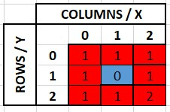Small Maze Example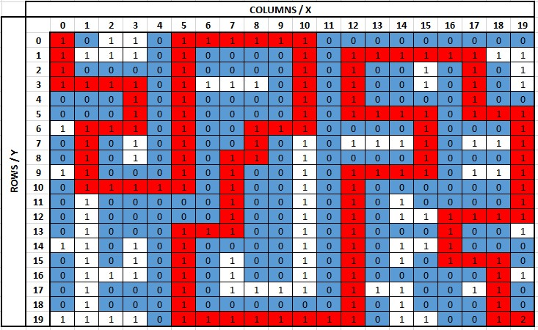Big Maze Example
The IsEnd and the IsValidMove functions are already written for you. These functions assume that the first square in the maze is (0,0). These functions also assume that you can't leave the boundaries of the maze and that you can't visit the same square in the same path (no circles). The IsEnd will return true if the x and y coordinate represent the end of the maze. The IsValidMove will return true if the movement to x and y is within the maze boundaries, does not represent a wall, and is not someplace we have already been.
The currPath variable is a list of (x,y) tuples that represent the path we are currently on. If you add a new position to the path, make sure that you add the tuple to the list so that the IsValidMove function works properly.
The goal is to implement the SolveMaze function to insert all paths to the end square into the results list using recursion. When you find a path, then adding it to the list of results will be as simple as results.Add(currPath.AsString()).
Grading
To receive full credit on this assignment, you must successfully complete any four of the five problems. If you complete all five problems you are eligible to receive extra credit.
W05 Interview Question
- Due Nov 29 by 11:59pm

- Points 25

- Submitting a website url

- Attempts 0

- Allowed Attempts 3

- Available until Dec 6 at 11:59pm
Purpose:
- Demonstrate your ability to articulate the concepts the way you would in a job interview.
Task:
- Follow the W05 Job Interview Question InstructionsLinks to an external site..
- Prepare a video as directed.
- Submit the URL to the public, unlisted video.
Rubric
W05 Interview Question
W05 Interview Question
Criteria | Ratings | Pts
This criterion is linked to a Learning Outcome1. Pitfall #1: Explanation | 5 ptsCompleteA recursion pitfall is accurately explained.  2.5 ptsDevelopingA pitfall is mentioned, but the explanation lacks accuracy, relevance, or completeness.  0 ptsIncompleteA pitfall is not explained. | 5 pts
This criterion is linked to a Learning Outcome2. Pitfall #1: How to overcome | 5 ptsCompleteA clear and accurate way to overcome the pitfall is explained.  2.5 ptsDevelopingAn approach to overcome the pitfall is mentioned but it lacks accuracy or completeness.  0 ptsIncompleteA way to overcome the pitfall is not explained. | 5 pts
This criterion is linked to a Learning Outcome3. Pitfall #2: Explanation | 5 ptsCompleteA recursion pitfall is accurately explained.  2.5 ptsDevelopingA pitfall is mentioned, but the explanation lacks accuracy, relevance, or completeness.  0 ptsIncompleteA pitfall is not explained. | 5 pts
This criterion is linked to a Learning Outcome4. Pitfall #2: How to overcome | 4 ptsCompleteA clear and accurate way to overcome the pitfall is explained.  2 ptsDevelopingAn approach to overcome the pitfall is mentioned but it lacks accuracy or completeness.  0 ptsIncompleteA way to overcome the pitfall is not explained. | 4 pts
This criterion is linked to a Learning Outcome5. Professionalism | 3 ptsCompletePresentation mannerisms (such as gestures, eye contact, and background) are professional and do not contain distractions.  1.5 ptsDevelopingPresentation mannerisms (such as gestures, eye contact, and background) are professional but some distractions exist.  0 ptsIncompletePresenter is either not shown or mannerisms are unprofessional and distracting. | 3 pts
This criterion is linked to a Learning Outcome6. Clear Communication | 3 ptsCompleteWords are articulated clearly and ideas are organized logically.  1.5 ptsDevelopingWords are articulated clearly.  0 ptsIncompleteThe response is difficult to understand. | 3 pts
Total Points: 25
W05 Interview Question
Overview
This assignment must be completed individually to ensure you are meeting all course outcomes. You should not complete this assignment with a group. If you obtain help from a tutor, the tutor should help you understand principles but should not help you answer these problems. It is an honor code violation to obtain answers for these problems from others including using the internet (i.e. sites that allow students to share their solutions).
Instructions
This assignment is meant to simulate the kind of question you might receive in a job interview. It is important for you to understand the problem, develop a quality solution, and communicate it in a clear and professional manner.
You will need to record and upload a short video with your response to the question below. When making your video, please remember the following:
- Show your your face.
- Speak clearly.
- The video should be less than 3 minutes.
- The video should be uploaded as a public, but unlisted video, so the grader can see it without permissions. Most students upload to Youtube and submit a link to the video for grading, but you can upload anywhere as long as you submit a link graders can access.
Recursion Pitfalls
Recursion is a very powerful tool, but it also has some pitfalls and is not always the right tool for all situations. For this assignment respond to the following question:
- What are two potential pitfalls of using recursion? How could you overcome these challenges (either by using an alternative technique or by doing something to help the recursion)?
W06 Learning Activity: Trees
Trees are like linked lists in that nodes are connected together by pointers. However, unlike linked lists, the nodes in a tree can connect to multiple different nodes. We will look at the following types of trees: binary trees, binary search trees, and balanced binary search trees.
Binary Trees
A binary tree is a tree where each node links to no more than two other nodes. In the picture below, the top node is called the root node. The nodes that connect to no other nodes are called leaf nodes. A node that has connected nodes is called a parent node. The node connected to the parent are called child nodes. The nodes to the left and right of any parent node form a subtree. There is always only one root node. While not shown in the picture, it is common for child nodes to also point back up to the parent node (similar to a linked list).
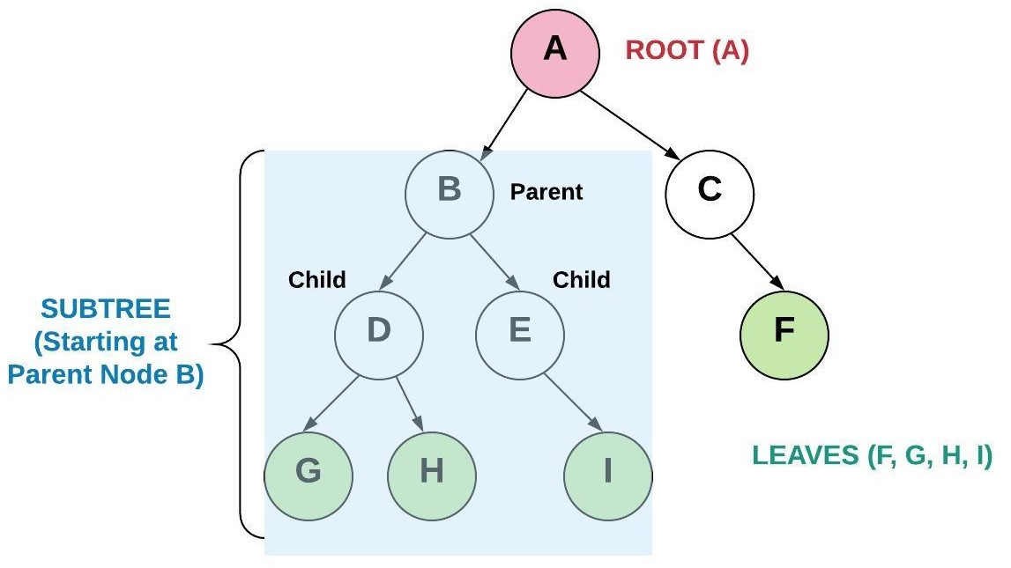Binary Tree
Binary Search Trees
A binary search tree (BST) is a binary tree that follows rules for data that is put into the tree. Data is placed into the BST by comparing the data with the value in the parent node. If the data being added is less than the parent node, then it is put in the left subtree. If the data being added is greater than the parent node, then it is put in the right subtree. If duplicates are allowed than the duplicate can be put either to the left or to the right of the root. By using this process, the data is stored in the tree sorted.
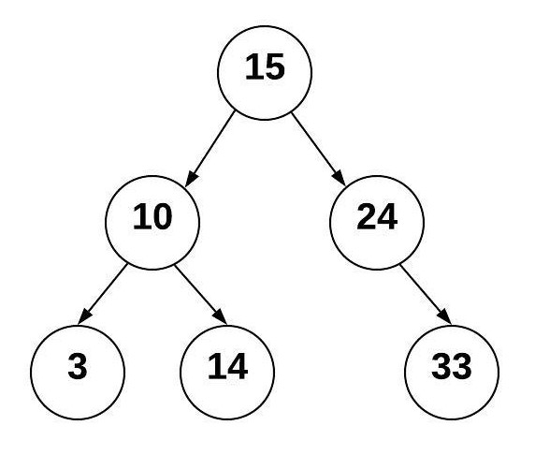Binary Search Tree
Using the tree above, we can determine where to put additional items. We always start at the root node and compare the new value with it. We keep comparing until we have found an empty place for the new node. For example, to insert the value 20, do the following:
- Start at the root node 15 and compare with the new value 20
- Since 20 is greater than 15, goto the right and visit node 24
- Since 20 is less than 24, goto the left and see there is no additional node
- Insert 20 in the empty spot to the left of 24
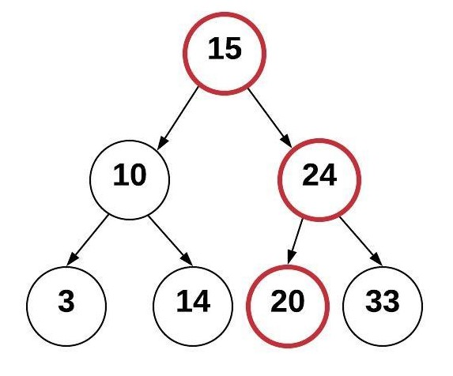Add Node to BST
The process that we used to find where to put the new node was efficient. The process that we used to actually insert the node at that position was efficient. If we had a dynamic array containing sorted values, we would have a O(log n) operation to find where to insert the new value and a O(n) operation to actually insert it at that position. If we had a linked-list containing sorted values, we would have a O(n) operation as we search for the proper location to insert a value into the proper sorted position, then a O(1) operation to actually insert the node. By using the BST, we are able to exclude a subtree with each comparison. This ability to split the job in half recursively results in O(log n). Maintaining sorted data in a BST performs better than other data structures.
However, the only reason we had O(log n) in the example above was because the tree was "balanced". To see the difference between a balanced and an unbalanced tree, we will construct a tree with the same values but in a different order. The reason why the previous tree has 15 as the root node is because 15 was added first. This time, we will add the values in the following order: 3, 10, 14, 15, 20, 24, 33 (purposefully in ascending order).
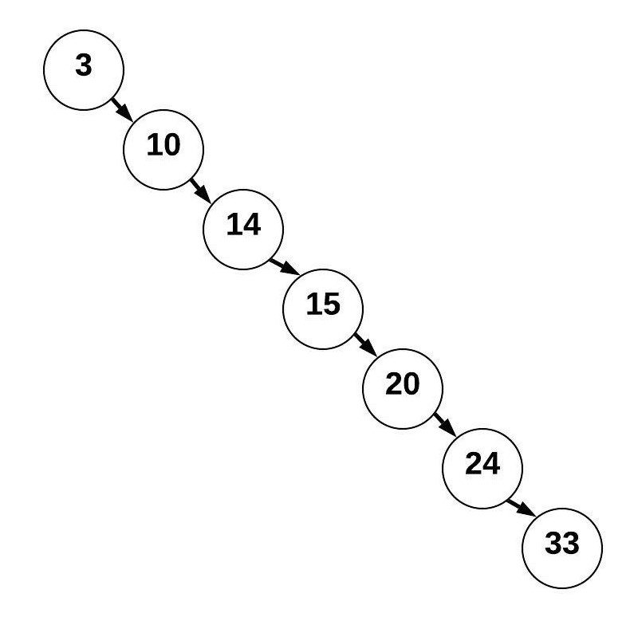Unbalanced BST
This tree is a BST but looks more like a linked list. This BST is unbalanced has a resulting performance for searching of O(n) instead of O(log n).
Balanced Binary Search Trees
A balanced binary search tree (balanced BST) is a BST such that the difference of height between any two subtrees is not dramatically different. The height of a tree can be found by counting the maximum number of nodes between root and the leaves. Since it is not reasonable to expect that the order of data will result in a balanced BST, numerous algorithms have been written to detect if a tree is unbalanced and to correct the unbalance. Common algorithms include red black trees and AVL (Adelson-Velskii and Landis) trees. The example below shows an AVL tree which is balanced because the difference of height between subtrees is less than 2.
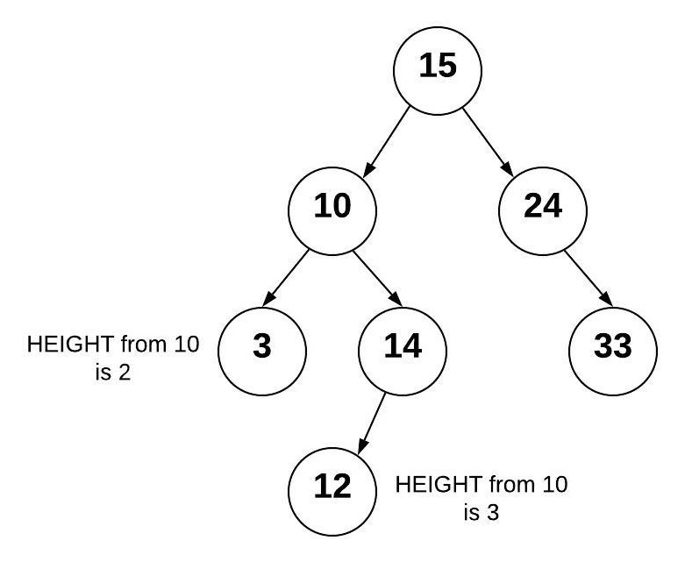Balanced AVL Tree`
If we add 13 to the right of the 12, we end up with an unbalanced AVL tree because the height of the right subtree from 10 is now 2 more than the left subtree.
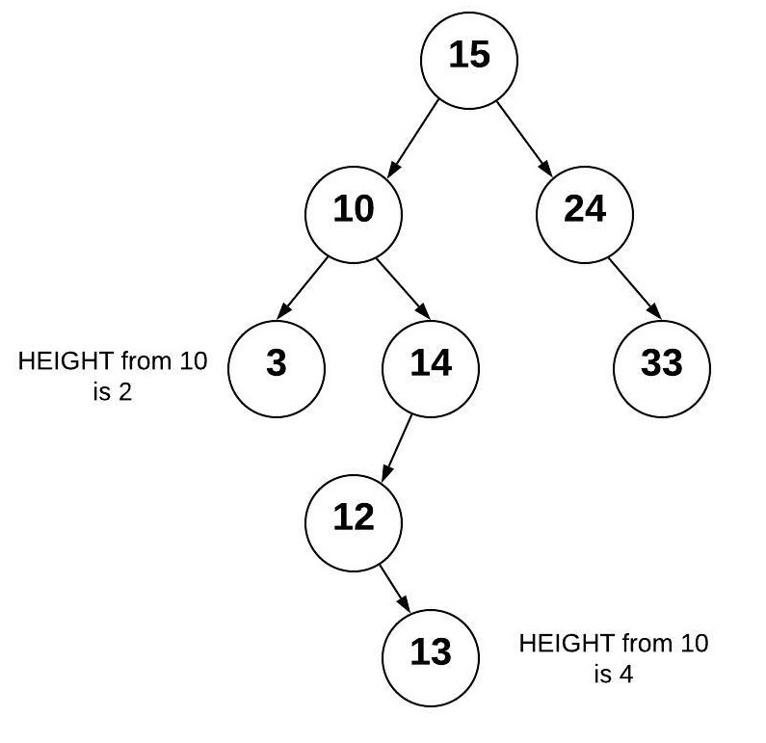Unbalanced AVL Tree after Adding Node
The AVL algorithm will detect that the tree has become unbalanced. To balance the tree, a node rotation will be performed. For our tree, we can rotate the node with 13 so that nodes 12 and 14 are children nodes of the 13. When this rotation is done, the tree returns to a balanced state. An AVL tree will always be a Balanced BST and therefore benefit from O(log n) performance.
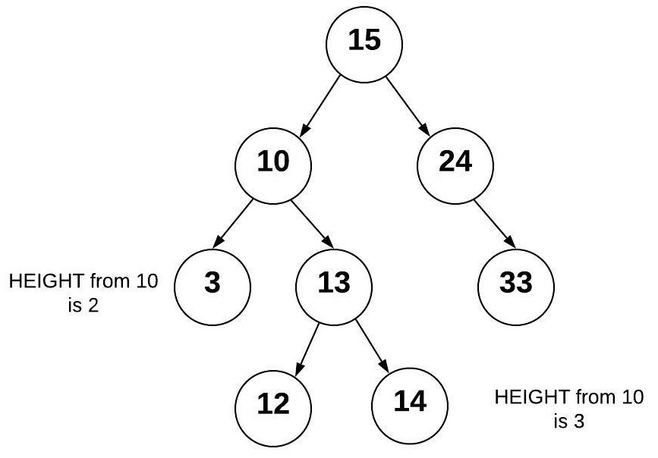Rebalanced AVL Tree
BST Operations
BST operations can be very complicated (balanced BST's offering even more complication). We will look at two operations in our study of trees: inserting and traversing.
Inserting into a BST
Inserting into a BST is a recursive operations:
- Smaller problem: Insert a value into either the left subtree or the right subtree based on the value.
- Base case: If there is space to add the node (the subtree is empty), then the correct place has been found and the item can be inserted.
The code for inserting into a BST is shown below. Some things to note are as follows:
- A node is defined as an object (in this example) of class Node. This is similar to what we saw with the linked list class. The Node class contains three things: Data (the value), Left (pointer to the left node), and Right (pointer to the right node).
- There are two Insert functions:
  - The first BinarySearchTree.Insert function is the one called by the user who wants to insert a value into the tree. This function is used to call the recursive function Node.Insert on the root node. As a special case, if the root node is empty (null), then we will put the new Node in the root without using any recursion.
  - The second Node.Insert calls itself until it finds a empty position in which to insert the value.
- We will follow a similar pattern for many of the recursive functions we write for the BinarySearchTree.
- In the Node.Insert function, we should identify the base case and the recursive calls to the correct subtrees.

public class BinarySearchTree : IEnumerable<int>
{
private Node? _root;

// Insert 'value' into the BST. If the BST is empty, then
// set the root equal to the new node. Otherwise, use
// Node.Insert to recursively find the location to insert.
public void Insert(int value)
{
if (_root is null)
_root = new Node(value);
else
_root.Insert(value); // Start inserting at the root
}
}

public class Node
{
// This function will look for a place to insert a node
// with 'value' inside of it. The current subtree is
// represented by this instance of Node. This function
// is intended to be called the first time by the
// BinarySearchTree.Insert function.
public void Insert(int value)
{
if (value < Data)
{
// The value belongs on the left side
if (Left is null)
{
// We found an empty spot
Left = new Node(value);
}
else
{
// Need to keep looking; Call Insert
// recursive on the left subtree
Left.Insert(value);
}
}
else
{
// The value belongs on the right side
if (Right is null)
{
// We found an empty spot
Right = new Node(value);
}
else
{
// Need to keep looking; Call Insert
// recursive on the right subtree
Right.Insert(value);
}
}
}
}
Traversing a BST
We traverse a BST when we want to display all the data in the tree. An in-order traversal will visit each node from smallest to largest. A similar process can be followed to visit each node from the largest to the smallest. This is also a recursive process:
- Smaller problem: Traverse the left subtree of a node, use the current node, and then traverse the right subtree of the node.
- Base case: If the subtree is empty, then don't recursively traverse or use anything.
The code for traversing a BST is shown below. In addition to understanding that there are two calls - one to start the recursion, and another to keep it going, here are some insights about creating iterators (IEnumerable) in C#:
- There is an interface IEnumerable<int> which C# uses to enable foreach loops over custom classes. In order to implement the IEnumerable<int> interface, the class must implement 2 GetEnumerator functions.
  - The first IEnumerator IEnumerable.GetEnumerator() is the required function for all IEnumerable objects, but it doesn't specify the type of item being enumerated.
  - The second public IEnumerator<int> GetEnumerator() is what is called when using a foreach loop to inform the compiler that each loop will produce an int value.

  - var bst = new BinarySearchTree();

  - foreach (var intValue in bst)
  - {
  - Console.WriteLine(intValue);
  - }
- The IEnumerator return type is generated using the yield return syntax. Whenever you use yield return, the function will always return an IEnumerator with the values of each time yield return is called. There is no way to call yield return recursively, so our implementation is to gather all values into a List using recursion, and then use yield return for all values in the List.

public class BinarySearchTree : IEnumerable<int>
{
private Node? _root;

// Yields all values in the tree
IEnumerator IEnumerable.GetEnumerator()
{
// call the typed version of the method
return GetEnumerator();
}

// Iterate forward through the BST
public IEnumerator GetEnumerator()
{
var numbers = new List();
TraverseForward(_root, numbers);
foreach (var number in numbers)
{
yield return number;
}
}

private void TraverseForward(Node? node, List values)
{
if (node is not null)
{
TraverseForward(node.Left, values);
values.Add(node.Data);
TraverseForward(node.Right, values);
}
}
}
BST in C#
In your assignment this week you will be writing your own BST class. C# does has a built-in tree called a SortedSet<T> which is an implementation of a Red Black Tree. The table below shows the common functions in a BST.
Common BST Operation | Description | Performance
insert(value) | Insert a value into the tree. | O(log n) - Recursively search the subtrees to find the next available spot
remove(value) | Remove a value from the tree. | O(log n) - Recursively search the subtrees to find the value and then remove it. This will require some cleanup of the adjacent nodes.
contains(value) | Determine if a value is in the tree. | O(log n) - Recursively search the subtrees to find the value.
traverse_forward | Visit all objects from smallest to largest. | O(n) - Recursively traverse the left subtree and then the right subtree.
traverse_reverse | Visit all objects from largest to smallest. | O(n) - Recursively traverse the right subtree and then the left subtree.
height(node) | Determine the height of a node. If the height of the tree is needed, the root node is provided. | O(n) - Recursively find the height of the left and right subtrees and then return the maximum height (plus one to account for the root).
size() | Return the size of the BST. | O(1) - The size is maintained within the BST class.
empty() | Returns true if the root node is empty. This can also be done by checking the size for 0. | O(1) - The comparison of the root node or the size.
Video Discussion (Optional)
The following video is optional. It presents a brief discussion of the topic.
Activity Instructions
Complete the following activity:
Activity: Tree Traversal Practice
There are three types of traversals that can be performed: pre-order, in-order, and post-order.
- The pre-order traversal visits the current node first, then visits the left subtree and then the right subtree.
- The in-order traversal traverses the left subtree first, then visits the current node, then traverses the right subtree.
- The post-order traversal visits the left and right subtrees first and then visits the current node.
Practice doing all three types of traversal on the following tree. Use a pencil and paper to write down the order of the nodes that will be visited. What do you notice about the order of the in-order traversal numbers?
Binary Search TreeSolution (Click to Expand)
- Pre-order: 15, 10, 3, 14, 24, 33
- In-order: 3, 10, 14, 15, 24, 33
- Post-order: 3, 14, 10, 33, 24, 15
The order of the nodes in the in-order traversal is done in a proper numerical order.
Key Terms
AVL Tree
Adelson-Velskii and Landis Tree. A balanced binary search tree that is checked unbalanced height after every modification to the tree. If the tree is unbalanced, then pre-determined algorithms are used to balance the tree.
balanced
A tree is balanced if the the height of the tree from the root to each leaf is consistent for all subtrees. The measure of consistentency will vary between algorithms but usually does not exceed a height difference of 1.
balanced binary search tree
A binary search tree which is balanced or restructured to be balanced. A balanced binary search tree has O(log n) performance when searching.
binary search tree
A binary tree that puts data less than the root to the left and greater than the root to the right. This type of a tree enables searching algorithms to be efficient.
binary tree
A tree that has up to two children for each node.
child
A child is a node connected from a parent node.
leaf
A leaf is a node that has no children.
node
An entry in a tree that contains both the value and pointers to any children nodes.
parent
A parent is a node that connects to children nodes.
Red Black Tree
A self-balancing binary search tree.
root
The first parent in a tree.
subtree
Subset of a tree made by selecting a node to be the root and including all the children from that node.
traverse
The process of visiting all nodes (and subsequently their values) in a tree. Used frequently with a binary search tree using recursion to start at the leaf node that contains the smallest value and going to the leaf node that contains the largest value.
trees
A data structure that starts with a root node and is subsequently connected to multiple nodes according to a relationship between the nodes. The tree does not have any circular loops or unconnected nodes.
W06 Code: Trees
- Due Dec 6 by 11:59pm

- Points 100

- Submitting a website url

- Attempts 0

- Allowed Attempts 3

- Available until Dec 11 at 11:59pm
Purpose:
- Demonstrate your ability to use Trees.
Task:
- Complete the steps of the Prove 06 Assignment Instructions.
- Submit the link to your GitHub repository.
Rubric
W06 Code: Trees
W06 Code: Trees
Criteria | Ratings | Pts
This criterion is linked to a Learning Outcome1. Base Solution | 60 ptsCompleteAt least one problem was solved successfully (whether efficiently or not).  0 ptsIncompleteNo problems were successfully solved. | 60 pts
This criterion is linked to a Learning Outcome2. Problem 1 - Insert Unique Values Only | 10 ptsCompleteSolved with no issues.  5 ptsDevelopingTests pass, but issues exist.  0 ptsIncompleteNot solved. | 10 pts
This criterion is linked to a Learning Outcome3. Problem 2 - Contains | 10 ptsCompleteSolved with no issues.  5 ptsDevelopingTests pass, but issues exist.  0 ptsIncompleteNot solved. | 10 pts
This criterion is linked to a Learning Outcome4. Problem 3 - Traverse Backwards | 10 ptsCompleteSolved with no issues.  5 ptsDevelopingTests pass, but issues exist.  0 ptsIncompleteNot solved. | 10 pts
This criterion is linked to a Learning Outcome5. Problem 4 - Tree Height | 10 ptsCompleteSolved with no issues.  5 ptsDevelopingTests pass, but issues exist.  0 ptsIncompleteNot solved. | 10 pts
This criterion is linked to a Learning Outcome6. Problem 5 - Create Tree from Sorted List | 10 ptsCompleteSolved with no issues.  5 ptsDevelopingTests pass, but issues exist.  0 ptsIncompleteNot solved. | 10 pts
Total Points: 110
W06 Code: Trees
This assignment must be completed individually to ensure you are meeting all course outcomes. You should not complete this assignment within a group. If you obtain help from a tutor, the tutor should help you understand principles but should not help you answer these problems. It is an honor code violation to obtain answers for these problems from others including using the internet (i.e. sites that allow students to share their solutions).
Running and Debugging
- You should not edit any files that have the comment DO NOT MODIFY THIS FILE at the top of them. Any edits you make to these files will be removed before grading.
- You should not delete or rename any files in the code repository you are using for this class. You should also not delete or rename any classes in this repo. Finally, you shouldn't modify the provided method signatures in any way, including renaming them. You can create helper methods and classes if you like, and you should fill out the body of the provided methods to complete the assignments.
- Running all tests for this assignment: Click on Run and Debug in the sidebar, then select this week's code assignment from the drop-down at the top. Click the green Start Debugging button next to the drop-down. The integrated terminal will show the files being compiled and then the tests being run. It will print a summary of which tests passed and failed.
- Running individual tests: Navigate to the test file ending in _Tests.cs in the week's code directory. Visual Studio Code will show inline buttons to Run Test for each test method, or to Run All Tests for each test class.
- Debugging individual tests: Navigate to the test file ending in _Tests.cs in the week's code directory. Visual Studio Code will show inline buttons to Debug Test for each test method, or to Debug All Tests for each test class.
  - If you put a breakpoint inside your code or inside the test, the only way to hit it will be by clicking Debug Test or Debug All Tests in this file.
  - If you want to debug by printing output to the terminal, you must use Debug.WriteLine() to do so. Using that may require you to add using System.Diagnostics; to the top of the file. Using Console.WriteLine(), as is done in other parts of the template project, will not correctly print output to the console when a test is running. Any output generated with Debug.WriteLine() will appear in the Debug Console portion of the integrated terminal when clicking Debug Test or Debug All Tests in this file.
Instructions
As you solve the problems, remember to use the principles learned previously in the course:
- Problem Solving Strategy: understand the problem, plan and design the solution, implement the solution, and evaluate the solution.
- Evaluate Performance of Alternative Solutions: use big O to determine the best solution.
- Understanding Code Using Reviews: analyze any code you have been given.
- Finding Defects Using Tests: write tests to determine if your solution is working.
- Articulating Answers for Technical Questions: imagine that you were asked one of these questions during an interview. Remember to ensure that you fully understand the problem and work through different scenarios manually. Consider how the data structure you are using will help you solve the problem. A notebook or a whiteboard can be very useful in this process.
All of the files for this assignment will be found in the course Git repository in the week06/code folder. You will commit changes to your own repository for your submission for this assignment.
Problem 1: Insert Unique Values Only
Update the Insert function of the Node class to only allow unique values to be added to the tree (thus creating a sorted set). The Insert function is already written to correctly insert values into the tree. However, the current implementation will cause duplicate values to be added to the tree.
Problem 2: Contains
Implement the Contains function in the Node class. This function is called by the Contains function in the BinarySearchTree to search for a value in the tree. If the value is found, true should be returned; otherwise return false. Hint: study the Insert function. You will need to use recursion to solve this problem.
Problem 3: Traverse Backwards
Implement the TraverseBackward function in the BinarySearchTree class. This function is called by the Reversed function to loop through the tree backwards (largest value down to the smallest value). The Reversed function allows you to write code using the foreach syntax like the following:

foreach(var value in myTree.Reversed())
{
Console.WriteLine(value);
}
Hint: study the TraverseForward function to see how traversing forward is done.
Problem 4: Tree Height
Implement the GetHeight function in the Node class to get the height of the BinarySearchTree. The height of any tree (or subtree) is defined as one plus the height of either the left subtree or the right subtree (whichever one is bigger). If the tree has only the root node, then this would be 1 plus the maximum height of either subtree which would be 0. Therefore, the height of a tree with only the root node is 1. You will need to use recursion to solve this problem.
Problem 5: Create Tree from Sorted List
Implement the InsertMiddle function (note this function is defined outside the BinarySearchTree class) so that the CreateTreeFromSortedList function can successfully create a balanced tree from a sorted list of values. If we looped through the list of sorted values and added them (using the Insert function in the BinarySearchTree class) one at a time in order, then the resulting tree would look like a linked list. This is not desirable because it results in O(n) instead of O(log n).
To achieve a balanced tree, the InsertMiddle function should find the middle of the list (or sub-list … notice that the function takes a first and last value to keep track of what part of the list you are working with) and add it to the tree. After adding the middle value, then the middle value from the first half and the middle value from the second half should be added. This process (which is recursive) will result in a balanced tree.
The purpose for having the first and last parameters is so that we do not need to create new sublists when we make recursive calls. Avoid using list slicing to create sublists to solve this problem.
Please note that you do NOT need to use a balanced algorithms like AVL or red/black trees in this problem.
Grading
To receive full credit on this assignment, you must successfully complete any four of the five problems. If you complete all five problems you are eligible to receive extra credit.
W06 Interview Question
- Due Dec 6 by 11:59pm

- Points 25

- Submitting a website url

- Attempts 0

- Allowed Attempts 3

- Available until Dec 11 at 11:59pm
Purpose:
- Demonstrate your ability to articulate the concepts the way you would in a job interview.
Task:
- Follow the W06 Job Interview Question InstructionsLinks to an external site..
- Prepare a video as directed.
- Submit the URL to the public, unlisted video.
Rubric
W06 Interview Question
W06 Interview Question
Criteria | Ratings | Pts
This criterion is linked to a Learning Outcome1. Overall Approach | 7 ptsCompleteThe approach will correctly solve the problem.  3.5 ptsDevelopingThe approach will not correctly solve the problem, or is not detailed enough to know if it will solve the problem.  0 ptsIncompleteAn approach is missing or too vague to understand. | 7 pts
This criterion is linked to a Learning Outcome2. Recursion: Base Case | 6 ptsCompleteThe base case is accurate and explained in enough detail that someone else could implement it.  3 ptsDevelopingA base case is provided.  0 ptsIncompleteA base case is not provided. | 6 pts
This criterion is linked to a Learning Outcome3. Recursion: Recursive Case | 6 ptsCompleteThe recursive case is accurate and explained in enough detail that someone else could implement it.  3 ptsDevelopingA recursive case is provided.  0 ptsIncompleteA recursive case is not provided. | 6 pts
This criterion is linked to a Learning Outcome4. Professionalism | 3 ptsCompletePresentation mannerisms (such as gestures, eye contact, and background) are professional and do not contain distractions.  1.5 ptsDevelopingPresentation mannerisms (such as gestures, eye contact, and background) are professional but some distractions exist.  0 ptsIncompletePresenter is either not shown or mannerisms are unprofessional and distracting. | 3 pts
This criterion is linked to a Learning Outcome5. Clear Communication | 3 ptsCompleteWords are articulated clearly and ideas are organized logically.  1.5 ptsDevelopingWords are articulated clearly.  0 ptsIncompleteThe response is difficult to understand. | 3 pts
Total Points: 25
W06 Interview Question
Overview
This assignment must be completed individually to ensure you are meeting all course outcomes. You should not complete this assignment with a group. If you obtain help from a tutor, the tutor should help you understand principles but should not help you answer these problems. It is an honor code violation to obtain answers for these problems from others including using the internet (i.e. sites that allow students to share their solutions).
Instructions
This assignment is meant to simulate the kind of question you might receive in a job interview. It is important for you to understand the problem, develop a quality solution, and communicate it in a clear and professional manner.
You will need to record and upload a short video with your response to the question below. When making your video, please remember the following:
- Show your your face.
- Speak clearly.
- The video should be less than 3 minutes.
- The video should be uploaded as a public, but unlisted video, so the grader can see it without permissions. Most students upload to Youtube and submit a link to the video for grading, but you can upload anywhere as long as you submit a link graders can access.
Binary Search Trees
Recall from the learning activity that a Binary Search Tree is a valid Binary Tree where all of the values in the left sub-tree are less than the current node, and all of the values in the right sub-tree are greater than the current node.
With this in mind, respond to the following prompt:
- Describe a recursive function that accepts a valid Binary Tree and determines if it is a Binary Search Tree.
W07 Assignment: Interview Cheat Sheet
- Due Dec 9 by 11:59pm

- Points 50

- Submitting a file upload

- File Types doc, docx, and pdf

- Attempts 0

- Allowed Attempts 3

- Available until Dec 11 at 11:59pm
Purpose:
- Review each of the data structures you have learned about during this course.
- Prepare a cheat sheet that you could use for preparing for future job interviews.
Task:
- Follow the W07 Interview Cheat Sheet Instructions.
- Prepare the document as instructed.
- Upload your document here.
Rubric
W07 Assignment: Interview Cheat Sheet
W07 Assignment: Interview Cheat Sheet
Criteria | Ratings | Pts
This criterion is linked to a Learning Outcome1. Dynamic Array | 9 ptsProfessionalAll columns are complete, accurate. The image and example are succinct and professional.  8 ptsGoodAll columns are complete and accurate.  6 ptsAcceptableAll columns are present, but minor errors exist.  4 ptsDevelopingAn attempt was made for at least two of the three columns.  0 ptsIncompleteNot present or fewer than 2 columns were attempted. | 9 pts
This criterion is linked to a Learning Outcome2. Linked List | 9 ptsProfessionalAll columns are complete, accurate. The image and example are succinct and professional.  8 ptsGoodAll columns are complete and accurate.  6 ptsAcceptableAll columns are present, but minor errors exist.  4 ptsDevelopingAn attempt was made for at least two of the three columns.  0 ptsIncompleteNot present or fewer than 2 columns were attempted. | 9 pts
This criterion is linked to a Learning Outcome3. Stack | 8 ptsProfessionalAll columns are complete, accurate. The image and example are succinct and professional.  7 ptsGoodAll columns are complete and accurate.  5 ptsAcceptableAll columns are present, but minor errors exist.  4 ptsDevelopingAn attempt was made for at least two of the three columns.  0 ptsIncompleteNot present or fewer than 2 columns were attempted. | 8 pts
This criterion is linked to a Learning Outcome4. Queue | 8 ptsProfessionalAll columns are complete, accurate. The image and example are succinct and professional.  7 ptsGoodAll columns are complete and accurate.  5 ptsAcceptableAll columns are present, but minor errors exist.  4 ptsDevelopingAn attempt was made for at least two of the three columns.  0 ptsIncompleteNot present or fewer than 2 columns were attempted. | 8 pts
This criterion is linked to a Learning Outcome5. Map | 8 ptsProfessionalAll columns are complete, accurate. The image and example are succinct and professional.  7 ptsGoodAll columns are complete and accurate.  5 ptsAcceptableAll columns are present, but minor errors exist.  3.73 ptsDevelopingAn attempt was made for at least two of the three columns.  0 ptsIncompleteNot present or fewer than 2 columns were attempted. | 8 pts
This criterion is linked to a Learning Outcome6. Balanced Binary Search Tree | 8 ptsProfessionalAll columns are complete, accurate. The image and example are succinct and professional.  7 ptsGoodAll columns are complete and accurate.  5 ptsAcceptableAll columns are present, but minor errors exist.  4 ptsDevelopingAn attempt was made for at least two of the three columns.  0 ptsIncompleteNot present or fewer than 2 columns were attempted. | 8 pts
Total Points: 50
W07 Interview Cheat Sheet
Overview
In software development, "Cheat Sheet" is a common term for a reference card that can be used to quickly look up information. When learning a new application or tool, people often download a cheat sheet of the keyboard shortcuts or common commands. For this assignment you will create a cheat sheet of the data structures information you have learned this semester that you could review in the future as you prepare for job interviews.
It is important to recognize that there are many data structure cheat sheets on the Internet already. The purpose of this assignment is not to find and download one. Instead, the purpose of this assignment is for you to go through the process of creating one yourself. The work that you do to review and summarize the topics you have learned will help you solidify your understanding of these concepts.
This assignment must be completed individually to ensure you are meeting all course outcomes. You should not complete this assignment within a group. If you obtain help from a tutor, the tutor should help you understand principles but should not help you answer these problems. It is an honor code violation to obtain answers for these problems from others including using the internet (i.e. sites that allow students to share their solutions).
Instructions
Create a concise document that contains a summary of the data structures we have covered this semester.
The following steps will guide you through this process:
- Download the Cheat Sheet Starting Template
- Begin with the first data structure, fill out each section. Refer back to the course materials as needed to review.
  - Graphic: For the graphic of the data structure, you need to capture the essence of the data structure and its operations in an image, using arrows, boxes, etc. You may wish to use Microsoft PowerPoint, Word or Google Slides to help create it, or you are also welcome to draw your graphic by hand and take a picture of it to include in the document.
  - Purpose and Example (3-5 sentences): Briefly describe the purpose of the data structure. Then give an example of a software scenario where you might use this data structure. Your example should be something from your own creativity and should not be one of the examples included in the reading.
  - Time Complexity of Common Operations: Document the Big-O time complexity of the worst case performance to insert a new item into the data structure and to find/retrieve an item in the collection.
- Repeat this process for each data structure in the document.

