Nestor Fernandes

604294492

EE183DA Lab 2

**Introduction:**

The purpose of this lab is to create a drum-like interface using a micro-controller, an ESP8266 board and a servo motor. Since the motor itself is to quiet to produce any actual sound, we attch mechanical appendages to it so as produce an actuator that can strike a rigid body to simulate a drum-like interface. The complete list of apparatus required for this experiment is given below:

* ESP12e Microcontroller
* ESP8266 Shield
* Standard Servo
* Continuous-Rotation Servo (optional)
* USB cable
* Mechanical appendages to the motor
* Rigid Striking surface capable of producing sound

The following picture illustrate the basic connections made to the ESP8266 shield and the servo motor.

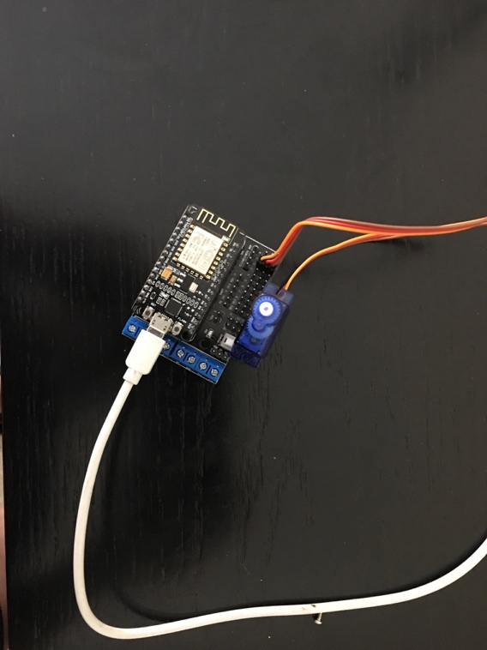

Figure Connections between ESP8266 shield and Servo Motor

**Code for analysis:** The code for the operation is given in the Servo_Motor.ino file.

**Video:**

<https://www.youtube.com/watch?v=WUVOtigKc9U>

Future Uses:

This project can have several future implications. Just in the field of music there can several enhancements made. Currently, the devices used as mechanical appendages are not truly intended for playing music. Indeed, with a higher budget, and more sophisticated programming there can be greater communication with the end user so as to program the beats in a way he would desire. Furthermore, with a more powerful motor that can effect a greater torque, real percussion can be realized. This device need not only be used for playing music. Several motors combined together can also be realized as joints to a kinematic linkage.