**Application for project printing**

*(OpenBox = PDFBox)*

**Base architecture**

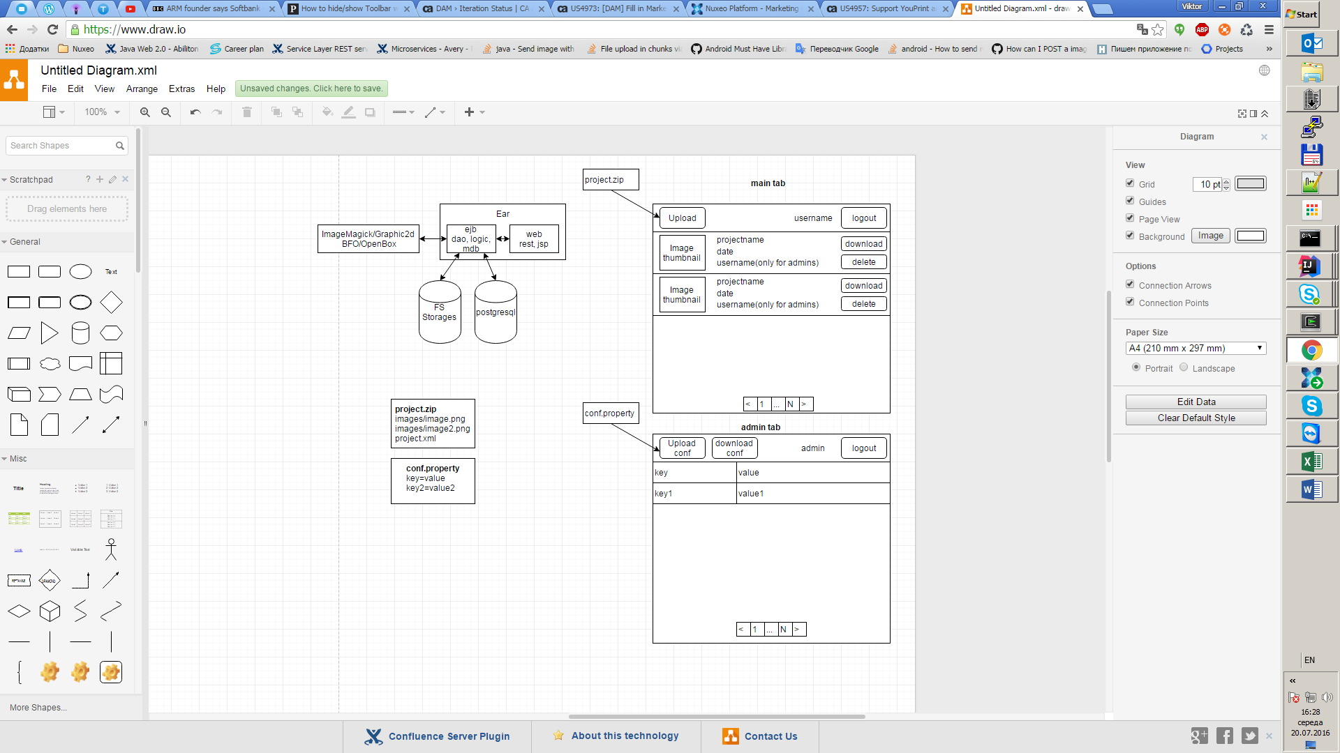

**Use cases**

I`m as user want to store my project to secured app

I`m as user want to view all my projects

I`m as user want to use server side pagination for better navigation

I`m as user want to download pdf and png generated from project

I`m as admin want to add/remove users

I`m as admin want to view all user projects

I`m as admin want edit configuration of app in separate page

I`m as admin want to edit storage location for projects

**DB**

Db will contain 3-4 tables   
users

Projects (project name, storageId, date)

Storages (storageId, path)

Configuration (key,value)

**Storages**

There will be 2 types of storages:  
1. User sources (where user project will be uploaded and unpacked)  
2. Generated sources (where result of generation will be stored)

**Configuration**Need implement mechanism for agile switch from db configuration to simple file configuration.

**Project.zip**

Zip archive with:  
images(folder with resource images)  
project.xml (file with description of project)

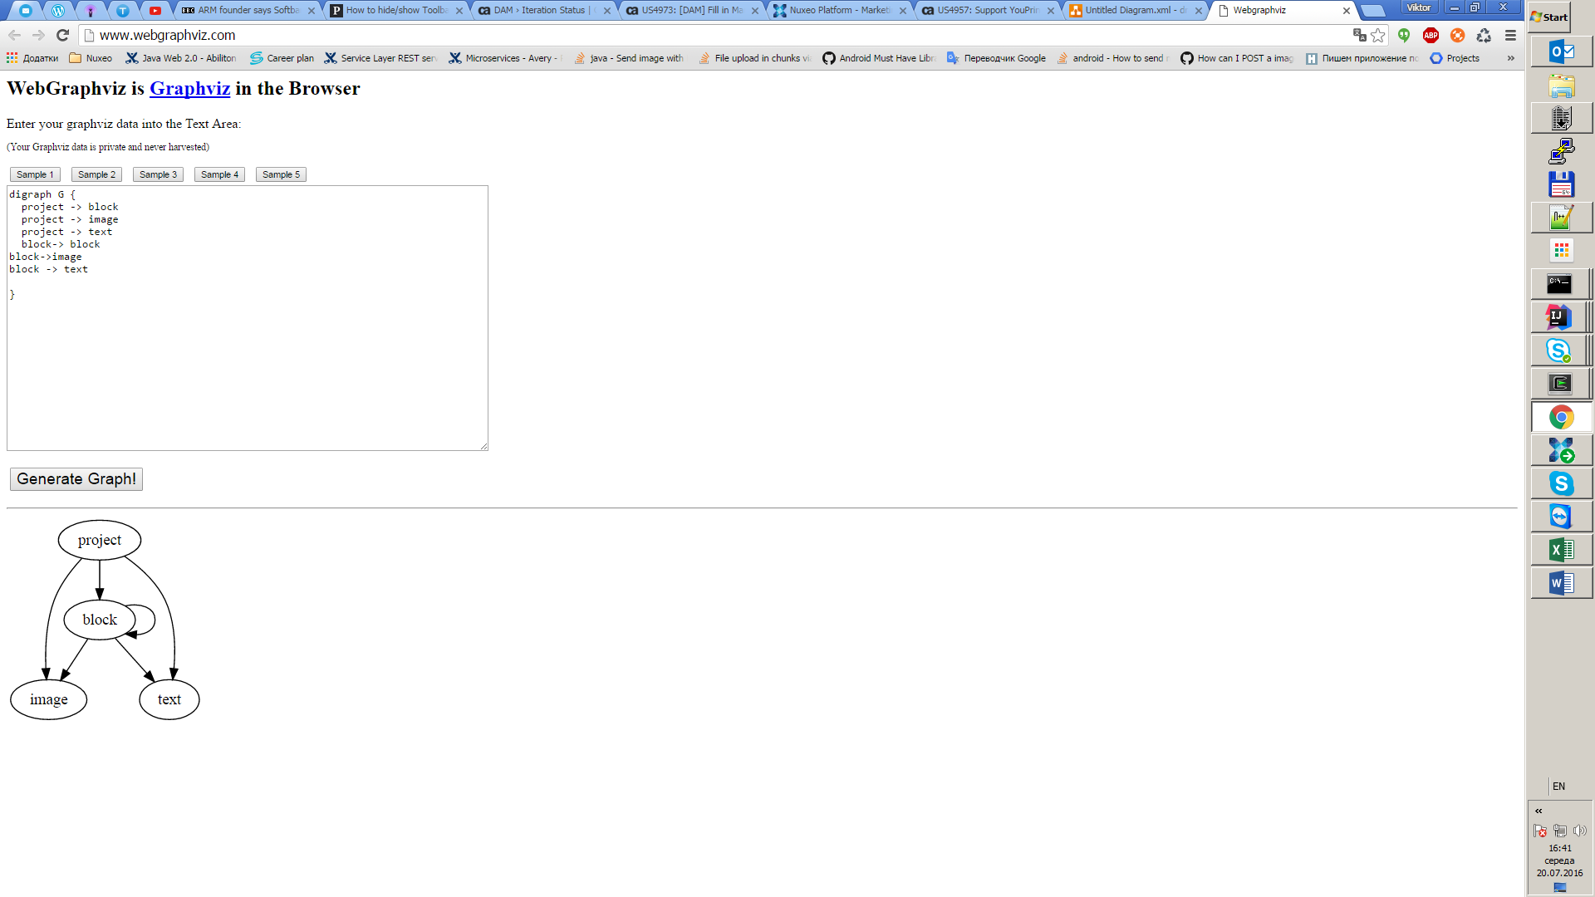

<project name="project_name" width="800" height="800">

<image x="10" y="10" width="200" height="200" imageRef="image.jpg"/>

<text x="10" y="220" width="50" height="20">Some text!</text>

<block x="10" y="260" width="400" height="400">

<image x="10" y="10" width="200" height="200" imageRef="image.jpg"/>

<text x="10" y="220" width="50" height="20">Some text in block!</text>

</block>

<block x="10" y="260" width="400" height="400">

<!--could be empty-->

</block>

<block x="10" y="260" width="400" height="400">

<!--could contain nested blocks-->

<block x="20" y="20" width="200" height="200">

<image x="10" y="10" width="200" height="200" imageRef="image2.jpg"/>

</block>

</block>

</project>

**Project validation**

Must present xml validation acc. with **xsd** schema.

Must present image validation acc. with mimetype.

Popup message must be shown if on error.

**Main flow**

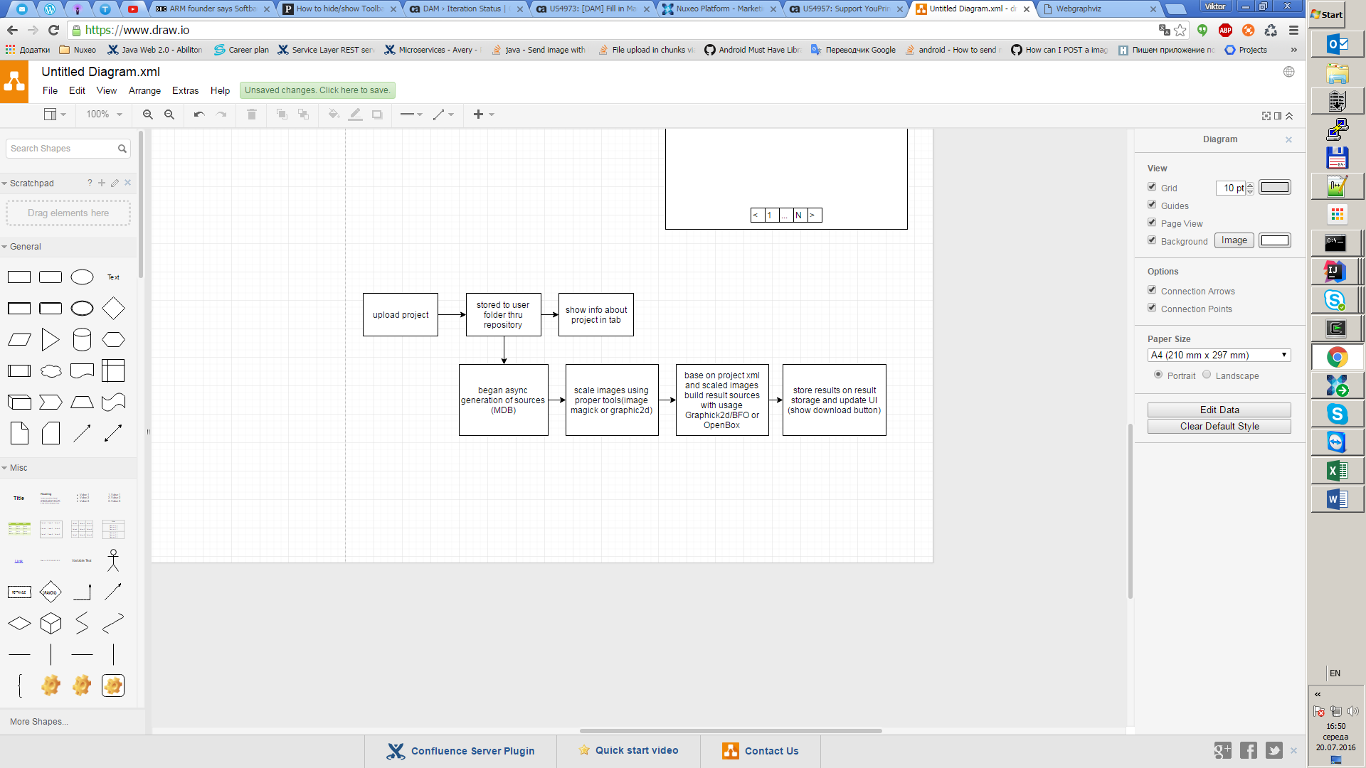

**Image scaling**

Need implement mechanism for dynamic changed image worker engine between ImageMagick and Graphic2D lib for image processing capabilities. (Setup on admin page)

**Project processing**need implement mechanism for generation image or pdf acc. With project xml with usage BFO or PDFBox for pdf and Graphic2D for PNG. (Setup on admin page)

Project processing must be async task. After finish, processing need update UI and show download button.  
Download button will download result of processing (PDF or PNG file)

**Some sketches**

