GitHub Repository: github.com/nesy43/CS449

Sprint #0 Report

Instructions

Objectives
- Make decisions on the Solitaire software development project.
- Learn unit testing and GUI programming in the language of your choice.

Deliverables and Grading Policy
Read the “CS 449 Homework Overview” document carefully and make the key decisions for the software development. Use the following template to complete your report.

- Key Decisions of the Solitaire Project (2 points)

Topic | Decision
Object-oriented programming language (if not using OOP, then justify the use of the language) | Python
GUI library (strongly encouraged) | tkinter
IDE (Integrated Development Environment) | VS Code
xUnit framework (e.g., JUnit for Java) | unittest
Programming style guide (must read it carefully) | Google Python Style Guide
Project hosting site | Github.com
Other decisions if applicable

Sample programming style guides:
- Google Java Style Guide: https://google.github.io/styleguide/javaguide.html
- Google C++ Style Guide: https://google.github.io/styleguide/cppguide.html
- Google Python Style Guide: https://google.github.io/styleguide/pyguide.html

- Unit testing (4 points)

Find a tutorial on the unit test framework you have chosen and write at least two xUnit tests of a program you have written or found elsewhere. Attach here (1) the screenshot of your program execution and (2) the source code of your program.

I have a program I created a few test cases for, the source code can be found under test_CS461Program1PartBv2.py, and the execution is: 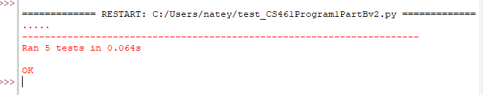

- GUI programming (4 points)

Write a GUI program in the language you have chosen for your Solitaire project. The GUI of your program must include text, lines, a check box, and radio buttons. In this assignment, any GUI program of your own work is acceptable.

Attach here (1) the screenshot of your program execution and (2) the source code of your program.

I have a program I had to make a GUI for before, and I adjusted it slightly for this. The source code can be found under CS461Program1PartBv2.py, and the execution is:
