CMP2020 Assessment 2 Report

Method

In this assessment I use a genetic algorithm (GA) to tackle the Travelling Salesman Problem (TSP). A candidate solution is represented as a permutation of city indices, interpreted as a closed tour that returns to the start. This encoding is compact and guarantees feasibility as long as crossover/mutation preserve the permutation property (Holland, 1975; Goldberg, 1989).
Parent selection is configured via SELECTION_METHOD. I implemented tournament selection (default), roulette wheel selection, and rank based selection. Tournament selection draws k individuals uniformly at random and selects the best; roulette selects proportionally to fitness after converting tour length L (a minimisation objective) to a maximisation score using a reciprocal transform; rank selection assigns probabilities by sorted order. Tournament size (k) is also configurable (Goldberg, 1989).
Recombination is configured via CROSSOVER_METHOD and CROSSOVER_RATE. I implemented order crossover (OX) as a baseline and partially mapped crossover (PMX) as an alternative for permutations. With probability CROSSOVER_RATE, two parents produce two offspring; otherwise offspring are direct copies. Both operators preserve the permutation constraint so offspring remain valid tours (Goldberg, 1989).
Mutation is configured via MUTATION_METHOD and MUTATION_RATE. I implemented swap mutation (baseline) and inversion mutation. With probability MUTATION_RATE per offspring, the chosen operator is applied: swap exchanges two positions, while inversion reverses a contiguous segment. Both maintain permutation validity, so every offspring remains a feasible tour.
Fitness is configured via FITNESS_METHOD. It can be computed as the straight-line (Euclidean) length of the tour, or as a search-based fitness that runs A* between consecutive cities on a grid and sums the path costs. To keep this tractable across many evaluations, the implementation caches pairwise A* costs so repeated lookups are fast (Russell and Norvig, 2021).
Stopping behaviour is configured via STOPPING_CRITERION. The implementation supports a fixed generation limit, or early stopping after a number of generations without improvement. I use elitism (ELITISM_COUNT) to copy the best individuals unchanged into the next generation, reducing the chance of losing the current best tour.
Design choices: I used a permutation encoding because it matches TSP structure and simplifies feasibility checks. I included both OX and PMX plus swap/inversion mutation to explore operators suited to permutations. Elitism and early stopping reduce regressions and unnecessary computation, which matters especially when using the search-based (A*) fitness. Caching A* subpaths trades memory for speed and makes repeated GA evaluations practical.
GA loop summary (generational with elitism):
- Initialise POPULATION_SIZE individuals by shuffling the city list to create random permutations (tours).
- Evaluate each individual’s fitness (closed tour length) using FITNESS_METHOD and record the current best tour.
- Repeat until the stopping criterion is met:
- Copy the ELITISM_COUNT best individuals into the next generation unchanged (elitism).
- While the new population is not full: select two parents using SELECTION_METHOD (tournament/roulette/rank); with probability CROSSOVER_RATE apply CROSSOVER_METHOD (OX/PMX) to produce offspring (otherwise copy parents); then with probability MUTATION_RATE per offspring apply MUTATION_METHOD (swap/inversion); add offspring to the new population.
- Re-evaluate fitness and update the best-so-far tour.
To reproduce my results, set the parameters in config.py. Unit tests can be run with python -m pytest. For experiments, run python run_experiments.py to generate results.csv and summary.csv, and then run python plot_results.py to produce the PNG plots used in this report.

Experiments and Results

I generated results with run_experiments.py by sweeping key GA parameters: NUMBER_OF_CITIES ∈ {8, 12}, POPULATION_SIZE ∈ {20, 30, 50}, CROSSOVER_RATE ∈ {0.2, 0.6}, MUTATION_RATE ∈ {0.01, 0.05, 0.10}, and SELECTION_METHOD ∈ {tournament, roulette, rank}. Each configuration was repeated 5 times; I report mean_best_fitness (final best tour length; lower is better) and mean_seconds (runtime), with standard deviations.
Unless stated otherwise, FITNESS_METHOD was held at its default for all sweeps, so Figures 1-2 compare GA parameters rather than changing the fitness definition.
Reproducibility: Figures 1-2 and Table 1 report marginal means (each point is averaged over the other swept parameters). All values come from summary.csv generated by run_experiments.py and plotted by plot_results.py.
Mutation rate sweep (Figure 1; Table 1): MUTATION_RATE = 0.10 achieved the best overall mean best fitness (90.67), followed by 0.05 (91.91); 0.01 was substantially worse (99.52). By size, 0.05 was best on the 8-city instances (79.15), while the 12-city instances favoured 0.10 in my logged results.
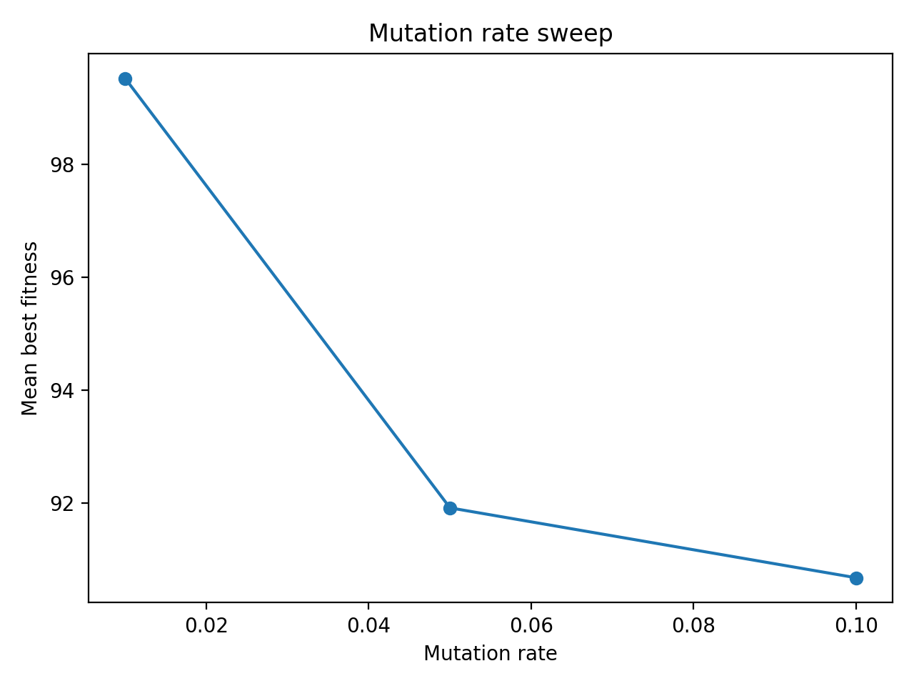
Figure 1. Mutation rate sweep (mean final best tour length)
Selection method (Figure 2; Table 1): rank selection achieved the best overall mean best fitness (93.10), followed closely by roulette (93.56), with tournament worst overall (94.74). In the 12-city breakdown from the same logs, tournament lagged behind rank/roulette (108.82 vs ~105.25), consistent with higher selection pressure reducing diversity sooner on harder instances.
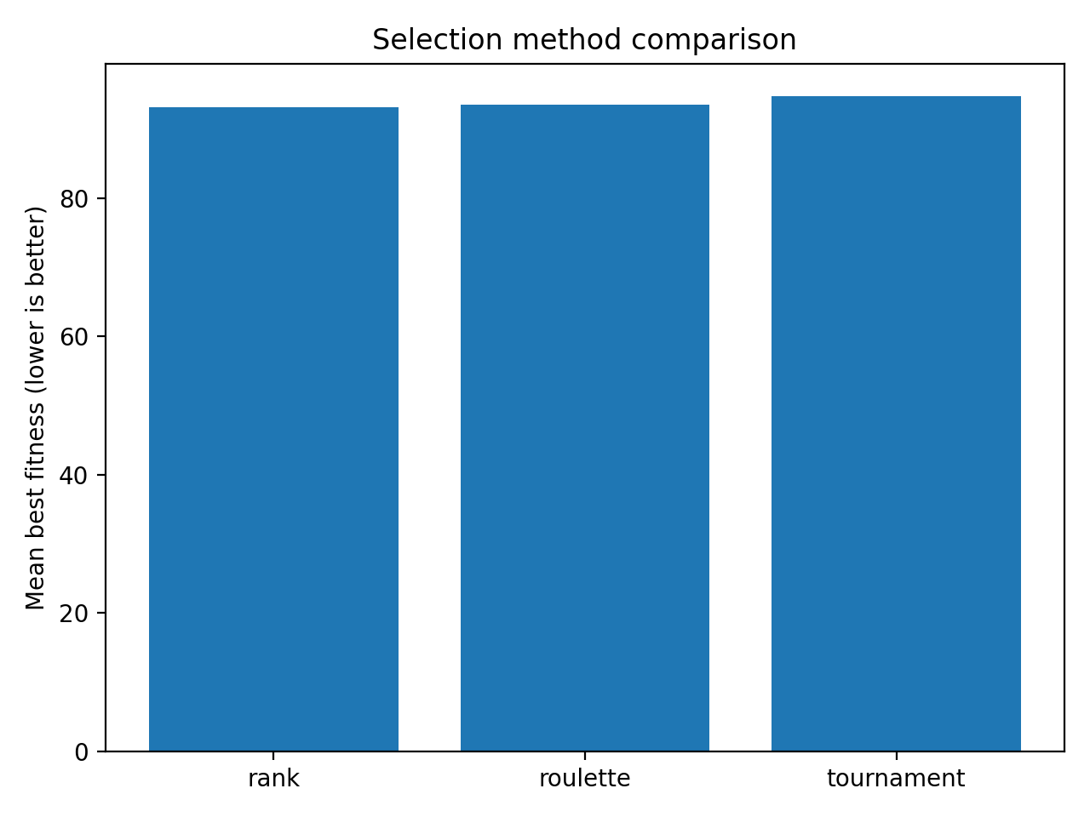
Figure 2. Selection method comparison (mean final best tour length)
Sweep | Setting | Overall mean best fitness
Mutation rate | 0.01 | 99.52
 | 0.05 | 91.91
 | 0.10 | 90.67
Selection method | rank | 93.10
 | roulette | 93.56
 | tournament | 94.74
Table 1. Summary of sweep outcomes (marginal means across the parameter sweep).
Runtime: mean runtime increased with problem size (0.0157 s for 8 cities vs 0.0189 s for 12 cities on average). Tournament was fastest (0.0147 s), roulette intermediate (0.0179 s), and rank slowest (0.0218 s), likely due to ranking overhead. Because Figures 1–2 are marginal means, a follow-up would fix all but one parameter to isolate interactions.

Alternative Approaches

Strengths and limitations of my GA approach in this coursework setting:
- Strengths: permutation safe operators (OX/PMX, swap/inversion) keep tours feasible; the approach is flexible and config-driven, so alternative operators and fitness functions can be compared consistently.
- Strengths: elitism and early stopping stabilise performance and reduce wasted computation; caching makes the A*-based fitness practical when the same city to city paths are evaluated repeatedly.
- Limitations: performance is sensitive to hyperparameters and selection pressure, with a risk of premature convergence if diversity is lost.
- Limitations: fitness evaluation dominates runtime as problem size grows; if the search based fitness is enabled, A* calls (even cached) increase computational cost substantially.
Exact methods (e.g., Held-Karp dynamic programming or integer linear programming) can guarantee optimal tours, but they scale poorly with the number of cities. In this context, where many repeated runs are needed to compare GA configurations, exact approaches become impractical for anything beyond small instances.
A strong practical alternative for symmetric TSP instances is local search. Edge exchange heuristics such as 2‑opt and 3‑opt can rapidly improve a tour, and more advanced variants such as Lin-Kernighan (and modern implementations like LKH) are competitive on large benchmarks (Lin and Kernighan, 1973; Helsgaun, 2000). Compared with my GA, local search typically offers faster convergence on a single instance, but is less naturally suited to multi-objective extensions or complex fitness definitions.
Other metaheuristics include simulated annealing and ant colony optimisation, which can also balance exploration and exploitation. In practice, hybrids are common: a GA can provide diverse starting tours and a local search operator (e.g., 2‑opt) can be applied to each offspring to intensify search, often improving solution quality and speeding up convergence without changing the overall structure.

References

Goldberg, D.E. (1989) Genetic Algorithms in Search, Optimization, and Machine Learning. Reading, MA: Addison-Wesley.
Helsgaun, K. (2000) 'An effective implementation of the Lin–Kernighan traveling salesman heuristic', European Journal of Operational Research, 126(1), pp. 106–130.
Holland, J.H. (1975) Adaptation in Natural and Artificial Systems. Ann Arbor, MI: University of Michigan Press.
Lin, S. and Kernighan, B.W. (1973) 'An Effective Heuristic Algorithm for the Traveling-Salesman Problem', Operations Research, 21(2), pp. 498–516.
Russell, S.J. and Norvig, P. (2021) Artificial Intelligence: A Modern Approach. 4th edn. Harlow: Pearson.

Self-Evaluation

I would give myself a 1st class mark for my work. For the implementation, I included all core GA components (selection, crossover, mutation, elitism, and configurable stopping), and I provided multiple interchangeable operators so the algorithm behaviour can be compared systematically. I also added reproducibility support through a central config file and scripts that regenerate the reported results.
For the report, the main claims are supported by quantitative results (Figures 1-2 and Table 1). The experiment scripts produce the summary CSV and plots directly from the same run outputs, which helps keep the report consistent with the codebase. If additional time were available, I would run a stricter set of single factor ablations to characterize interactions more precisely while keeping the report within the word limits.

