From Near-Critical Systems to Near-Critical Networks
An Industrial Validation Framework for Supply Chains, Resilience, and Digital Twins

Journal manuscript draft v2
Prepared from the controlled benchmark, small-network, and digital-twin experiments.

Abstract
Near-critical systems provide a framework for studying stochastic systems operating close to their stability limits. Previous work focused on the dynamics of isolated systems near collapse boundaries; however, the industrial value of near-critical indicators remained unresolved. This manuscript develops an industrial validation program to test whether proximity-to-criticality measures can improve preventive intervention policies in supply-chain environments.
A sequence of progressively more complex benchmarks is presented, beginning with single-node inventory systems and extending to small networks and synthetic multi-echelon digital twins. The benchmark suite includes policy comparison, oracle threshold discovery, physical critical-boundary discovery, economic cost-ratio analysis, small-network validation, controlled delta sweeps, digital-twin simulations, and an empirical scaling-law analysis.
Across experiments, criticality-aware policies outperform run-to-failure and static safety-stock policies when systems operate near critical regimes. The advantage decreases sharply as stability margins increase, indicating a physical boundary. It also increases with the failure-to-prevention cost ratio, indicating an economic boundary. In digital twins, the strongest explanatory variable is not only local stability margin but also the concentration of near-critical nodes across the network. Incorporating this network-criticality term increases explanatory power from approximately R2 = 0.44 to approximately R2 = 0.92 in the log-scaling model.
These results motivate an extension from Near-Critical Systems to Near-Critical Networks. In the proposed framework, intervention value is governed jointly by physical fragility, economic severity, and structural network criticality. The findings suggest that criticality-aware indicators can serve as operational decision variables for resilience management, preventive intervention, and digital twin optimization.
Keywords: near-critical systems; supply-chain resilience; digital twins; preventive intervention; network criticality; reliability engineering; industrial analytics.

Manuscript Contents
1. Introduction
2. Near-Critical Systems Framework
3. Industrial Benchmark Program
4. Results
5. Industrial Scaling Law
6. Discussion
7. Conclusions
Appendix A. Benchmark parameters and files
Appendix B. Tables and additional numerical evidence

1. Introduction
Modern industrial systems operate under uncertainty, disruption risk, and structural interdependence. Supply chains, logistics platforms, manufacturing systems, and digital infrastructures are routinely exposed to stochastic disturbances whose consequences propagate across multiple organizational layers. Under such conditions, decision-makers must determine when intervention is justified before a failure becomes visible in conventional monitoring systems.
Traditional resilience and maintenance approaches frequently rely on descriptive indicators such as historical service level, average inventory, utilization, stockout frequency, or observed downtime. These measures are useful for reporting and monitoring, but they do not always reveal how close the system is to a critical operating regime. A system can display acceptable service levels while already operating with little reserve capacity, meaning that a modest disturbance can produce disproportionate losses.
The Near-Critical Systems framework addresses this limitation by focusing on the distance between current operating conditions and a critical stability boundary. Rather than asking whether a failure has already occurred, the framework asks whether the system is approaching a region where ordinary fluctuations become dangerous. This distinction is important because industrial intervention is valuable precisely when it prevents losses before they materialize.
The present manuscript develops an industrial validation of this idea. The central question is whether near-critical indicators can be transformed from theoretical descriptors into operational decision variables. Specifically, the study investigates whether policies based on stability-margin information outperform run-to-failure and static safety-stock policies across increasingly complex supply-chain environments.
The validation strategy is progressive. It begins with a single-node inventory model, where the relationship between stability margin and intervention value can be inspected directly. It then introduces economic heterogeneity, small networks, controlled delta sweeps, and finally synthetic multi-echelon digital twins with suppliers, factories, distribution centers, warehouses, and customers. This design was chosen to reduce the risk of attributing results to a single simulation architecture.
Three research questions organize the study. First, do near-critical policies outperform conventional policies? Second, under what physical and economic regimes does intervention value appear or disappear? Third, does the phenomenon survive the transition from isolated systems to networks and digital twins? The results indicate affirmative evidence for all three questions, while also revealing a new network-level explanatory variable.
The main conceptual contribution is the transition from Near-Critical Systems to Near-Critical Networks. In isolated systems, stability margin is the primary indicator of fragility. In networked systems, however, the distribution of fragility across nodes becomes essential. Two networks with similar average margins can produce different intervention value if one contains many near-critical nodes and the other does not. This motivates a three-factor framework involving stability margin, economic severity, and network criticality.
This manuscript should be read as an industrial extension of the near-critical research program. It does not replace the theoretical analysis of collapse dynamics; rather, it evaluates whether the same logic generates practical decision value in supply-chain systems. The results suggest that the near-critical framework is not merely descriptive but can support intervention policies, resilience prioritization, and digital twin optimization.

2. Near-Critical Systems Framework

2.1 Stability Margin and Criticality
Many industrial processes can be represented as stochastic systems balancing workload against effective capacity. Let lambda denote mean demand, C denote nominal capacity, and p denote the probability that capacity becomes unavailable due to disruption, failure, or degradation. Effective capacity is therefore approximated by (1-p)C.
delta = (1 - p) C - lambda
The stability margin delta measures the expected distance between available capacity and required workload. Positive delta indicates reserve capacity. Values near zero indicate a near-critical regime. Negative values indicate expected overload. In this manuscript, delta is treated as the core physical indicator of operational fragility.

2.2 Intervention Logic
The near-critical hypothesis is that preventive intervention becomes valuable when a system approaches the critical boundary. Far from the boundary, fluctuations are absorbed by reserve capacity and intervention provides little additional value. Near the boundary, the same fluctuations can trigger stockouts, resets, emergency actions, or cascading losses. Therefore, policy value should increase as delta decreases.

2.3 Economic Severity
Physical fragility alone is insufficient for decision-making. A failure event must also be economically severe relative to the cost of prevention. The benchmark program therefore varies the ratio K_fail/K_prevent. This ratio determines whether preventing a failure is economically justified, even when the system is physically fragile.
economic severity = K_fail / K_prevent

2.4 From Local Criticality to Network Criticality
In networks, local stability margins are only part of the explanation. A network can contain isolated critical nodes or broad regions of distributed fragility. The latter case can generate larger systemic value from intervention because multiple nodes may simultaneously be close to collapse. This motivates a network-criticality measure operationalized in the digital twin as the number of warehouses with delta <= 5.
The core hypothesis of the industrial extension is therefore that intervention benefit is governed by three interacting dimensions: physical fragility, economic severity, and network criticality.
Benefit = F(delta, K_fail/K_prevent, Network Criticality)

3. Industrial Benchmark Program
The validation program was designed as a sequence of increasingly complex experiments. Each benchmark adds one layer of realism while preserving continuity with previous experiments. A result is considered robust only if it survives this progression.

Benchmark 1: Policy Comparison
Single-node comparison of run-to-failure, static safety stock, near-critical thresholds, and oracle threshold policies.

Benchmark 2: Oracle Surface Discovery
Grid search over thresholds, disruption probabilities, demand intensities, and stability margins to identify the cost-minimizing threshold surface.

Benchmark 3: Critical Boundary Discovery
Comparison of run-to-failure and oracle threshold policies to determine when intervention becomes physically valuable.

Benchmark 4: Economic Boundary Analysis
Systematic variation of K_fail/K_prevent to identify economic regimes where preventive policies become materially valuable.

Benchmark 5: Small Network Validation
Simulation of a 3-supplier, 2-warehouse, 3-customer network to test whether the effect survives network coupling.

Benchmark 6: Small Network Delta Sweep
Controlled variation of the stability margin of the most critical warehouse to test whether benefit decays with increasing delta.

Benchmark 7: Digital Twin v1
Synthetic multi-echelon network with 10 suppliers, 5 factories, 10 distribution centers, 20 warehouses, and 100 customers.

Benchmark 8: Digital Twin v1.1
Delta-controlled digital twin where demand is scaled to generate target mean network stability margins.

Benchmark 9: Industrial Scaling Law
Regression-based synthesis of the digital-twin results to estimate a compact empirical law for intervention benefit.
All simulations use Monte Carlo evaluation with Numba acceleration. Policies are compared on average total cost, service level, stockout probability, lost demand, and relative benefit versus run-to-failure. The exact scripts and CSV outputs are archived with the project package.

4. Results

4.1 Overview
Across all benchmark classes, a consistent pattern emerges: near-critical intervention produces value primarily in regimes with low stability margin and high economic severity. The result is not a uniform superiority claim. When systems are relaxed, benefits converge toward zero. This is scientifically important because it indicates a boundary phenomenon rather than an artifact of an always-aggressive intervention rule.
Table 1. Best policy by operating regime in the single-node benchmark.
regime | policy | delta | threshold | service_level | stockout_probability | avg_total_cost
fragile | oracle_grid_threshold | 1.0000 | 35 | 0.9877 | 1.0000 | 2,723.1
moderate | oracle_grid_threshold | 10.0000 | 20 | 0.9975 | 0.9164 | 1,441.5
near_critical | oracle_grid_threshold | 2.0000 | 30 | 0.9909 | 0.9996 | 2,249.4
relaxed | run_to_failure | 25.0000 | 0 | 0.9998 | 0.1562 | 1,274.7

The single-node benchmark shows that optimal policy type varies by regime. Relaxed conditions favor run-to-failure, while fragile, moderate, and near-critical regimes favor threshold policies. This is the first sign that intervention value is regime-dependent rather than universal.
Table 2. Oracle threshold behavior by stability regime.
Group | scenarios | mean threshold | median threshold
delta <= 10 | 35 | 23.29 | 25.00
delta > 20 | 33 | 8.48 | 5.00
all scenarios | 96 | 15.52 | 15.00

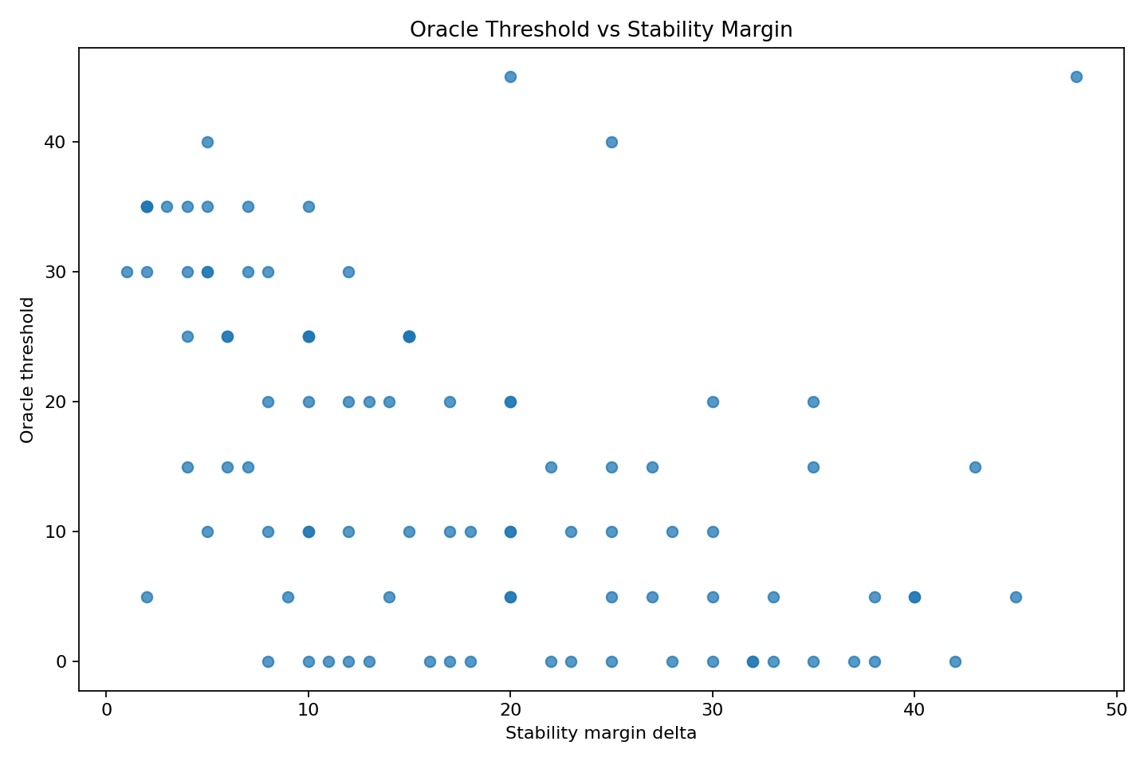
Figure 1. Oracle threshold as a function of stability margin.
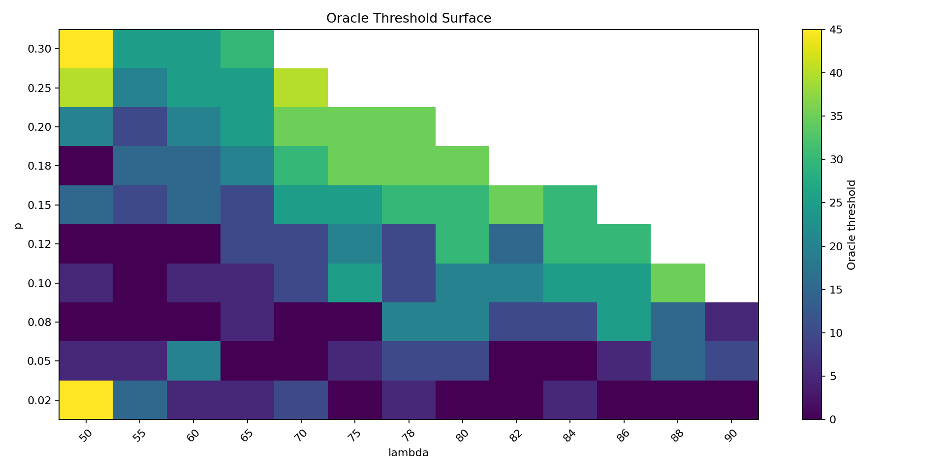
Figure 2. Oracle threshold surface across disruption and demand parameters.
The oracle surface indicates that optimal thresholds are systematically higher near criticality. The simple linear rule fitted to the oracle surface achieved R2 approximately 0.523, suggesting structure but also nonlinearity. This motivated the later boundary and scaling-law analyses.
Table 3. Economic boundary: benefit by failure/prevention cost ratio.
cost_ratio | mean_benefit | median_benefit | pct_5 | mean_threshold
1.00 | -0.00% | -0.00% | 0.00% | 0.47
5.00 | 0.05% | 0.01% | 0.00% | 2.24
10.00 | 1.06% | 0.36% | 2.08% | 16.82
25.00 | 4.18% | 2.95% | 39.58% | 32.81
50.00 | 6.76% | 6.39% | 57.29% | 37.50
100.00 | 9.42% | 10.44% | 66.67% | 41.15

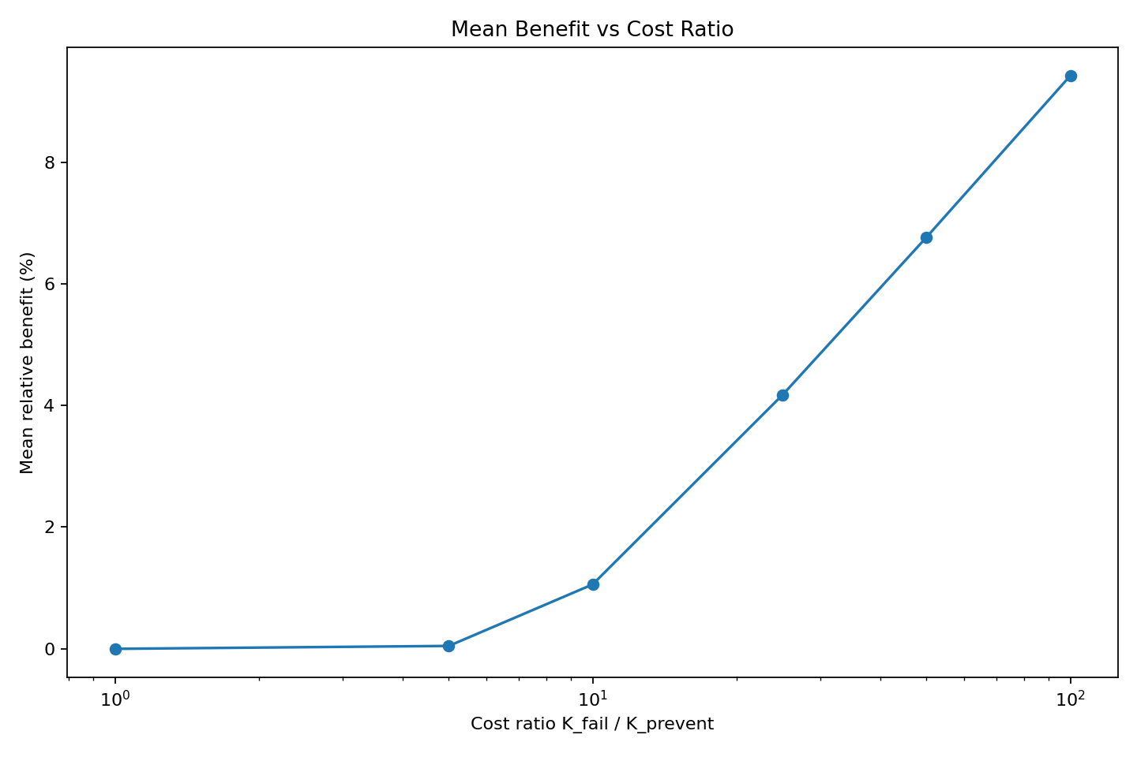
Figure 3. Mean benefit versus failure/prevention cost ratio.
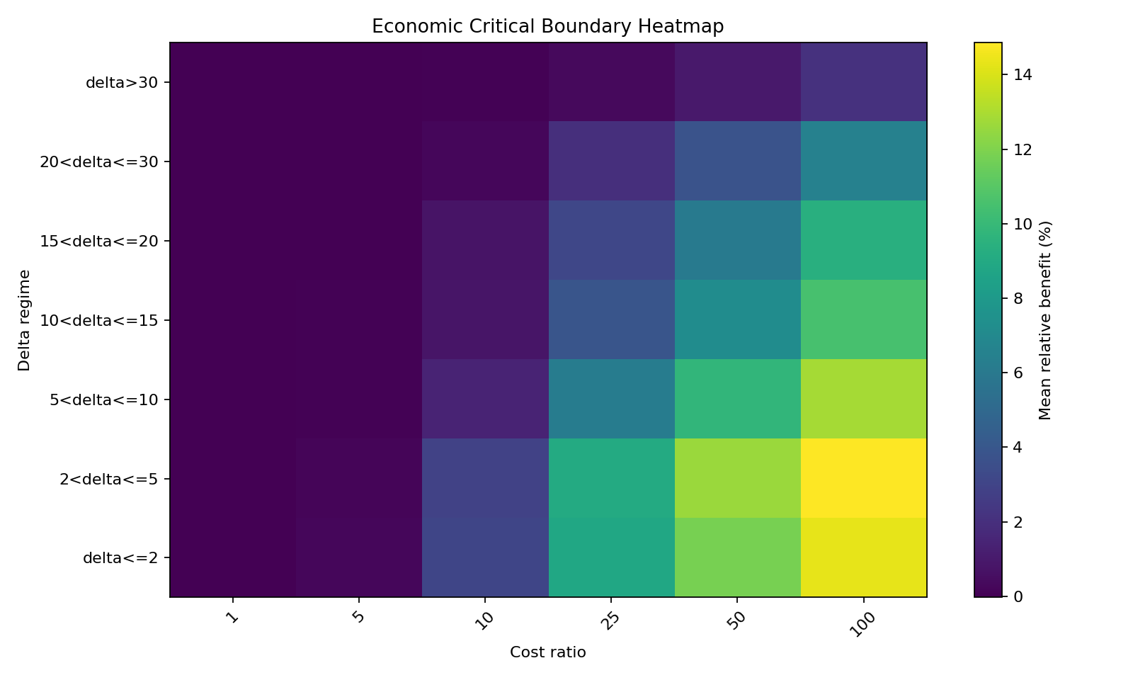
Figure 4. Economic critical boundary heatmap.
The economic boundary benchmark demonstrates that failure severity strongly modulates intervention value. At low cost ratios, intervention produces little material benefit. As the ratio increases, the share of scenarios with material benefit rises. This supports the physical-economic interpretation of critical intervention value.
Table 4. Small network delta sweep: near-critical benefit surface.
target_delta_w0 | cost_ratio | relative_benefit_vs_rtf | threshold_w0 | stockout_probability
1.00 | 10.00 | 6.94% | 35.00 | 0.31
1.00 | 40.00 | 30.63% | 35.00 | 0.29
1.00 | 100.00 | 50.42% | 35.00 | 0.31
2.00 | 10.00 | 3.84% | 30.00 | 0.28
2.00 | 40.00 | 20.07% | 30.00 | 0.29
2.00 | 100.00 | 37.96% | 30.00 | 0.29
5.00 | 10.00 | 0.67% | 23.57 | 0.12
5.00 | 40.00 | 4.38% | 23.57 | 0.13
5.00 | 100.00 | 10.97% | 23.57 | 0.12
10.00 | 10.00 | 0.03% | 20.00 | 0.02
10.00 | 40.00 | 0.37% | 20.00 | 0.03
10.00 | 100.00 | 1.03% | 20.00 | 0.03
15.00 | 10.00 | 0.01% | 18.53 | 0.01
15.00 | 40.00 | 0.20% | 18.53 | 0.01
15.00 | 100.00 | 0.66% | 18.53 | 0.01
20.00 | 10.00 | 0.02% | 17.73 | 0.01
20.00 | 40.00 | 0.11% | 17.73 | 0.01
20.00 | 100.00 | 0.55% | 17.73 | 0.01
30.00 | 10.00 | 0.01% | 16.88 | 0.01
30.00 | 40.00 | 0.21% | 16.88 | 0.01
30.00 | 100.00 | 0.42% | 16.88 | 0.01

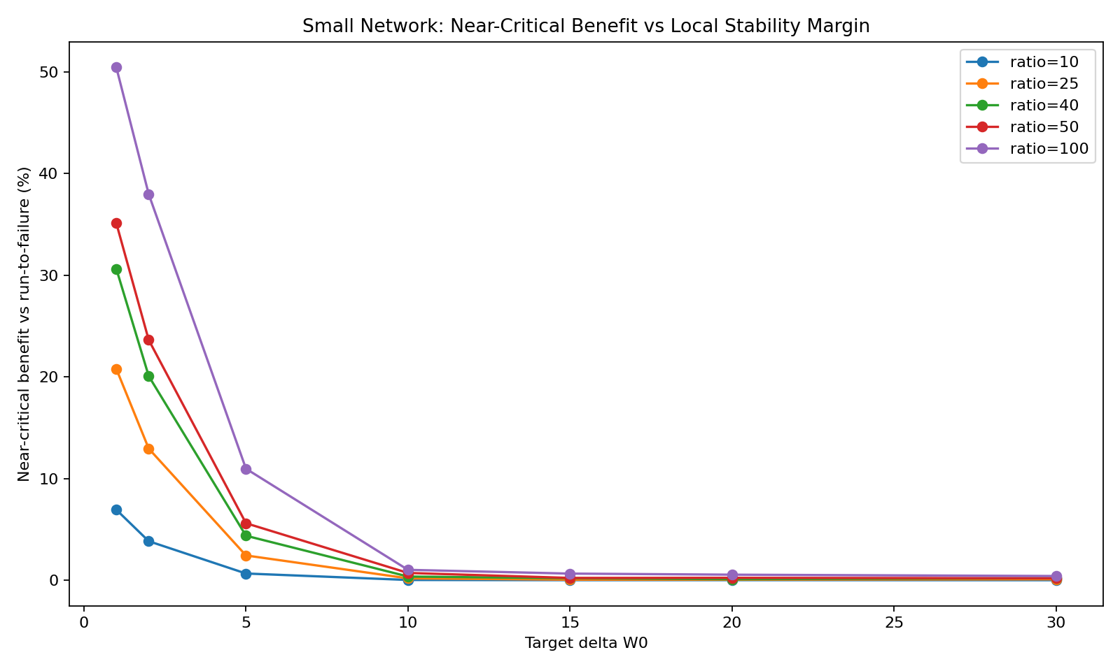
Figure 5. Small network: benefit declines as local delta increases.
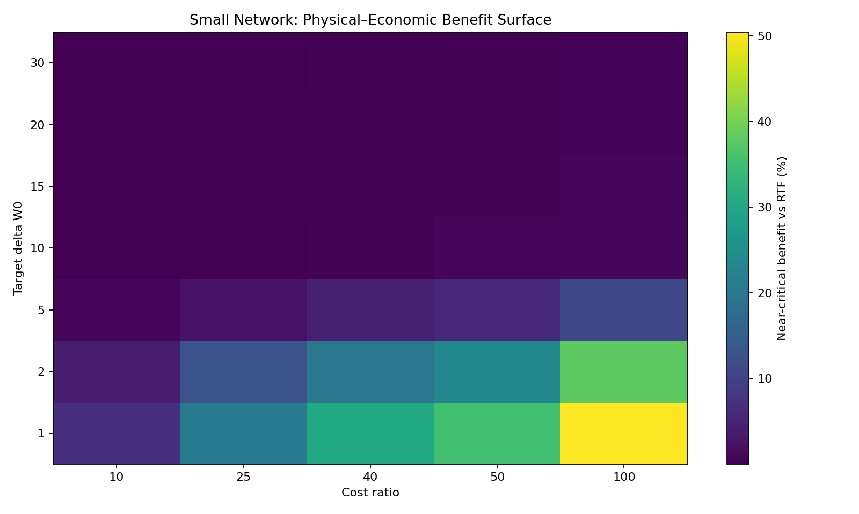
Figure 6. Small network physical-economic benefit surface.
The small-network delta sweep provides a particularly clean result. At cost ratio 100, near-critical benefit falls from approximately 50.4% at delta = 1 to approximately 0.4% at delta = 30. Thresholds also decline systematically as delta increases, from 35 at delta = 1 to about 16.9 at delta = 30.

4.2 Digital Twin v1
Table 5. Digital Twin v1 policy comparison.
cost_ratio | policy | avg_cost | service_level | avg_lost_demand | near_critical_warehouses | relative_benefit_vs_rtf
10.00 | run_to_failure | 177,770.0 | 0.98 | 7,437.9 | 18.00 | 0.00%
10.00 | static_safety | 106,699.2 | 0.99 | 3,843.3 | 18.00 | 39.98%
10.00 | near_critical_local | 92,580.4 | 0.99 | 2,983.5 | 18.00 | 47.92%
10.00 | network_aware | 82,516.0 | 0.99 | 2,327.9 | 18.00 | 53.58%
25.00 | run_to_failure | 426,108.5 | 0.98 | 7,442.9 | 18.00 | 0.00%
25.00 | static_safety | 232,698.3 | 0.99 | 3,842.6 | 18.00 | 45.39%
25.00 | near_critical_local | 190,998.1 | 0.99 | 2,979.8 | 18.00 | 55.18%
25.00 | network_aware | 162,027.6 | 0.99 | 2,328.3 | 18.00 | 61.98%
40.00 | run_to_failure | 674,242.8 | 0.98 | 7,436.3 | 18.00 | 0.00%
40.00 | static_safety | 358,440.2 | 0.99 | 3,842.0 | 18.00 | 46.84%
40.00 | near_critical_local | 289,649.2 | 0.99 | 2,976.1 | 18.00 | 57.04%
40.00 | network_aware | 241,161.0 | 0.99 | 2,326.0 | 18.00 | 64.23%
50.00 | run_to_failure | 839,801.9 | 0.98 | 7,433.4 | 18.00 | 0.00%
50.00 | static_safety | 442,354.8 | 0.99 | 3,835.9 | 18.00 | 47.33%
50.00 | near_critical_local | 355,371.0 | 0.99 | 2,974.6 | 18.00 | 57.68%
50.00 | network_aware | 294,448.9 | 0.99 | 2,333.1 | 18.00 | 64.94%
100.00 | run_to_failure | 1,668,188.9 | 0.98 | 7,443.3 | 18.00 | 0.00%
100.00 | static_safety | 861,715.1 | 0.99 | 3,845.7 | 18.00 | 48.34%
100.00 | near_critical_local | 683,584.4 | 0.99 | 2,970.3 | 18.00 | 59.02%
100.00 | network_aware | 559,184.1 | 0.99 | 2,329.4 | 18.00 | 66.48%

Digital Twin v1 confirmed that near-critical and network-aware policies can substantially reduce cost in a larger synthetic supply-chain network. However, diagnostics showed that the randomly generated network was globally overloaded, with negative mean delta and many near-critical warehouses. This motivated Digital Twin v1.1, where the network stability margin was explicitly controlled.
Table 6. Digital Twin v1.1 best policy by controlled network delta and cost ratio.
target_mean_delta | cost_ratio | policy | avg_cost | service_level | avg_lost_demand | near_critical_warehouses | relative_benefit_vs_rtf
1.00 | 10.00 | network_aware | 32,377.3 | 1.00 | 14.48 | 11.00 | 56.71%
1.00 | 25.00 | network_aware | 33,295.2 | 1.00 | 14.46 | 11.00 | 77.99%
1.00 | 40.00 | network_aware | 34,145.5 | 1.00 | 14.17 | 11.00 | 85.01%
1.00 | 50.00 | network_aware | 34,797.0 | 1.00 | 14.67 | 11.00 | 87.52%
1.00 | 100.00 | network_aware | 37,731.6 | 1.00 | 14.46 | 11.00 | 92.94%
2.00 | 10.00 | network_aware | 31,896.4 | 1.00 | 8.84 | 11.00 | 54.81%
2.00 | 25.00 | network_aware | 32,469.4 | 1.00 | 8.87 | 11.00 | 76.86%
2.00 | 40.00 | network_aware | 33,041.8 | 1.00 | 8.77 | 11.00 | 84.29%
2.00 | 50.00 | network_aware | 33,467.2 | 1.00 | 9.32 | 11.00 | 86.96%
2.00 | 100.00 | network_aware | 35,361.4 | 1.00 | 9.08 | 11.00 | 92.77%
5.00 | 10.00 | near_critical_local | 30,907.7 | 1.00 | 11.15 | 9.00 | 47.21%
5.00 | 25.00 | network_aware | 31,230.1 | 1.00 | 1.59 | 9.00 | 71.21%
5.00 | 40.00 | network_aware | 31,339.3 | 1.00 | 1.62 | 9.00 | 80.20%
5.00 | 50.00 | network_aware | 31,433.1 | 1.00 | 1.74 | 9.00 | 83.60%
5.00 | 100.00 | network_aware | 31,879.2 | 1.00 | 1.84 | 9.00 | 91.10%
10.00 | 10.00 | static_safety | 31,913.6 | 1.00 | 10.73 | 7.00 | 28.28%
10.00 | 25.00 | near_critical_local | 32,001.8 | 1.00 | 0.78 | 7.00 | 52.39%
10.00 | 40.00 | near_critical_local | 32,052.4 | 1.00 | 0.76 | 7.00 | 64.43%
10.00 | 50.00 | near_critical_local | 32,116.5 | 1.00 | 0.87 | 7.00 | 69.49%
10.00 | 100.00 | network_aware | 32,275.8 | 1.00 | 0.06 | 7.00 | 82.17%
20.00 | 10.00 | static_safety | 35,374.0 | 1.00 | 0.01 | 2.00 | 1.36%
20.00 | 25.00 | static_safety | 35,375.1 | 1.00 | 0.01 | 2.00 | 3.95%
20.00 | 40.00 | static_safety | 35,373.0 | 1.00 | 0.01 | 2.00 | 6.40%
20.00 | 50.00 | static_safety | 35,377.7 | 1.00 | 0.01 | 2.00 | 8.02%
20.00 | 100.00 | static_safety | 35,379.1 | 1.00 | 0.00 | 2.00 | 15.14%
30.00 | 10.00 | static_safety | 38,501.1 | 1.00 | 0.00 | 0.00 | 0.00%
30.00 | 25.00 | run_to_failure | 38,500.7 | 1.00 | 0.00 | 0.00 | 0.00%
30.00 | 40.00 | near_critical_local | 38,501.5 | 1.00 | 0.00 | 0.00 | 0.00%
30.00 | 50.00 | near_critical_local | 38,501.0 | 1.00 | 0.00 | 0.00 | 0.00%
30.00 | 100.00 | network_aware | 38,500.5 | 1.00 | 0.00 | 0.00 | 0.00%

The delta-controlled digital twin produced the strongest evidence. When target mean delta was 1 to 5, network-aware policies dominated and benefits were very large, especially at high cost ratios. When target mean delta increased to 30, the benefit collapsed to nearly zero. This is precisely the qualitative structure predicted by a near-critical framework.
Table 7. Network-aware policy at cost ratio 100 in Digital Twin v1.1.
target_mean_delta | near_critical_warehouses | relative_benefit_vs_rtf | avg_lost_demand | mean_threshold
1.00 | 11.00 | 92.94% | 14.46 | 28.13
2.00 | 11.00 | 92.77% | 9.08 | 27.79
5.00 | 9.00 | 91.10% | 1.84 | 27.18
10.00 | 7.00 | 82.17% | 0.06 | 25.12
20.00 | 2.00 | 14.95% | 0.00 | 19.38
30.00 | 0.00 | 0.00% | 0.00 | 17.02

At cost ratio 100, the network-aware policy obtains approximately 92.9% benefit at mean delta 1 and almost no benefit at mean delta 30. Simultaneously, the number of near-critical warehouses falls from 11 to 0. The co-movement of benefit and near-critical warehouse count motivates the network-criticality term in the scaling law.

5. Industrial Scaling Law
The benchmark results suggest that intervention value is governed by a low-dimensional structure. The first candidate model used stability margin and cost ratio only. In log form, the model is log(Benefit) = a + beta log(Ratio) - alpha log(delta). This model captures broad trends but fails to explain much of the digital-twin variability.
The second model adds network criticality, operationalized as log(near-critical warehouses + 1). This is an empirical proxy for how much fragility is structurally distributed through the network.
log(Benefit) = a + beta log(Ratio) - alpha log(delta) + gamma log(NC + 1)
Table 8. Scaling-law model comparison.
Sample | Two-factor log R2 | Three-factor log R2
Near-critical policy only | 0.443 | 0.923
Network-aware policy only | 0.458 | 0.930
All preventive policies | 0.433 | 0.919

For the near-critical policy sample, the two-factor model achieved log-scale R2 = 0.443, while the three-factor model reached R2 = 0.923. For the network-aware policy sample, the corresponding values were approximately 0.458 and 0.930. Across all preventive policies, the three-factor model reached approximately 0.919. These results indicate that network criticality is not a cosmetic correction; it is a first-order explanatory variable.
The sign and magnitude of individual coefficients should be interpreted cautiously because target delta and near-critical warehouse count are correlated in the delta-controlled design. The central result is not a finalized mechanistic coefficient estimate, but the explanatory jump produced by adding the structural variable. Future work should decorrelate these variables through randomized network topologies and independent topology sweeps.

6. Discussion
The results support the interpretation of criticality as a decision variable. Near-critical information is valuable not because it predicts a single failure event with certainty, but because it identifies regions where ordinary stochastic fluctuations become economically dangerous.
The physical boundary shows that intervention value is concentrated near the critical region. The economic boundary shows that intervention must also be justified by the cost structure. The network boundary shows that structure matters: benefit is amplified when fragility is distributed across multiple nodes.
This explains why preventive policies can appear inconsistent in practice. A policy may produce large value in fragile, high-cost, structurally critical environments but negligible value in relaxed systems. The correct question is therefore not whether intervention works in general, but whether the system is located inside the physical-economic-structural region where intervention has positive expected value.
The main conceptual implication is the transition from Near-Critical Systems to Near-Critical Networks. In a local system, delta is the central variable. In networks, the distribution of delta across nodes becomes equally important. This suggests that industrial resilience cannot be fully understood through local margins alone.
Digital twins provide the natural environment for applying this framework. A digital twin can estimate stability margins across many nodes, evaluate economic severity, and compute network-criticality indicators. Intervention can then be prioritized where the expected return is greatest.
The limitations are substantial. All results are currently simulation-based. The network structures are synthetic, and the network-criticality measure is intentionally simple. Real-world validation, alternative graph-theoretic measures, and independent topology sweeps are necessary before claiming industrial generality. Nevertheless, the persistence of the effect across multiple benchmark classes provides strong motivation for further work.

7. Conclusions
This manuscript presented an industrial validation program for the Near-Critical Systems framework. The experiments progressed from single-node inventory systems to small networks and multi-echelon digital twins. Across the full sequence, near-critical intervention policies produced the largest value when systems operated close to criticality.
The results identify three interacting determinants of intervention value: physical fragility, economic severity, and network criticality. Physical fragility is represented by stability margin. Economic severity is represented by the failure/prevention cost ratio. Network criticality is represented by the concentration of near-critical nodes in the network.
The empirical scaling-law analysis indicates that local margin and cost ratio alone are insufficient in digital twins. Adding network criticality increases explanatory power to approximately 0.92 in the log-scale model. This is the central evidence motivating the conceptual extension from Near-Critical Systems to Near-Critical Networks.
The practical implication is that criticality-aware decision-making can support resilience management, preventive intervention, and digital twin optimization. Instead of reacting to failures after they occur, organizations may prioritize resources toward the nodes and regimes where fragility, economic severity, and structural exposure combine to generate the highest intervention value.
Future research should test the framework on real industrial datasets, develop more rigorous network-criticality metrics, analyze topology effects independently of demand scaling, and connect the empirical scaling law with analytical stochastic-process models.

Appendix A. Benchmark Parameters and Artifacts
The main code artifacts used in this research package include digital_twin_v1_numba.py, digital_twin_v1_1_delta_controlled_numba.py, small_network_benchmark scripts, small_network_delta_sweep scripts, oracle surface scripts, and cost-ratio boundary scripts. The principal CSV outputs include policy_benchmark_summary.csv, oracle_surface.csv, critical_boundary_cost_ratio.csv, near_critical_benefit_surface.csv, digital_twin_v1_policy_comparison.csv, digital_twin_v1_1_delta_controlled.csv, policy_surface.csv, and best_policy_by_delta_and_ratio.csv.
The main synthetic digital-twin topology contains 10 suppliers, 5 factories, 10 distribution centers, 20 warehouses, and 100 customers. Digital Twin v1.1 scales customer demand to target average network stability margins of 30, 20, 10, 5, 2, and 1. Cost ratios tested include 10, 25, 40, 50, and 100.

Appendix B. Numerical Summary Tables
Appendix Table B1. Network-aware policy surface in Digital Twin v1.1.
target_mean_delta | cost_ratio | relative_benefit_vs_rtf | mean_delta | near_critical_warehouses | mean_threshold
1.00 | 10.00 | 56.71% | 1.00 | 11.00 | 28.13
1.00 | 25.00 | 77.99% | 1.00 | 11.00 | 28.13
1.00 | 40.00 | 85.01% | 1.00 | 11.00 | 28.13
1.00 | 50.00 | 87.52% | 1.00 | 11.00 | 28.13
1.00 | 100.00 | 92.94% | 1.00 | 11.00 | 28.13
2.00 | 10.00 | 54.81% | 2.00 | 11.00 | 27.79
2.00 | 25.00 | 76.86% | 2.00 | 11.00 | 27.79
2.00 | 40.00 | 84.29% | 2.00 | 11.00 | 27.79
2.00 | 50.00 | 86.96% | 2.00 | 11.00 | 27.79
2.00 | 100.00 | 92.77% | 2.00 | 11.00 | 27.79
5.00 | 10.00 | 46.88% | 5.00 | 9.00 | 27.18
5.00 | 25.00 | 71.21% | 5.00 | 9.00 | 27.18
5.00 | 40.00 | 80.20% | 5.00 | 9.00 | 27.18
5.00 | 50.00 | 83.60% | 5.00 | 9.00 | 27.18
5.00 | 100.00 | 91.10% | 5.00 | 9.00 | 27.18
10.00 | 10.00 | 27.54% | 10.00 | 7.00 | 25.12
10.00 | 25.00 | 52.06% | 10.00 | 7.00 | 25.12
10.00 | 40.00 | 64.20% | 10.00 | 7.00 | 25.12
10.00 | 50.00 | 69.38% | 10.00 | 7.00 | 25.12
10.00 | 100.00 | 82.17% | 10.00 | 7.00 | 25.12
20.00 | 10.00 | 1.13% | 20.00 | 2.00 | 19.38
20.00 | 25.00 | 3.73% | 20.00 | 2.00 | 19.38
20.00 | 40.00 | 6.18% | 20.00 | 2.00 | 19.38
20.00 | 50.00 | 7.81% | 20.00 | 2.00 | 19.38
20.00 | 100.00 | 14.95% | 20.00 | 2.00 | 19.38
30.00 | 10.00 | 0.00% | 30.00 | 0.00 | 17.02
30.00 | 25.00 | -0.00% | 30.00 | 0.00 | 17.02
30.00 | 40.00 | -0.00% | 30.00 | 0.00 | 17.02
30.00 | 50.00 | 0.00% | 30.00 | 0.00 | 17.02
30.00 | 100.00 | 0.00% | 30.00 | 0.00 | 17.02

Appendix Table B2. Small-network near-critical benefit surface.
target_delta_w0 | cost_ratio | relative_benefit_vs_rtf | threshold_w0 | threshold_w1
1.00 | 10.00 | 6.94% | 35.00 | 18.86
1.00 | 25.00 | 20.78% | 35.00 | 18.86
1.00 | 40.00 | 30.63% | 35.00 | 18.86
1.00 | 50.00 | 35.11% | 35.00 | 18.86
1.00 | 100.00 | 50.42% | 35.00 | 18.86
2.00 | 10.00 | 3.84% | 30.00 | 18.86
2.00 | 25.00 | 12.95% | 30.00 | 18.86
2.00 | 40.00 | 20.07% | 30.00 | 18.86
2.00 | 50.00 | 23.62% | 30.00 | 18.86
2.00 | 100.00 | 37.96% | 30.00 | 18.86
5.00 | 10.00 | 0.67% | 23.57 | 18.86
5.00 | 25.00 | 2.44% | 23.57 | 18.86
5.00 | 40.00 | 4.38% | 23.57 | 18.86
5.00 | 50.00 | 5.61% | 23.57 | 18.86
5.00 | 100.00 | 10.97% | 23.57 | 18.86
10.00 | 10.00 | 0.03% | 20.00 | 18.86
10.00 | 25.00 | 0.19% | 20.00 | 18.86
10.00 | 40.00 | 0.37% | 20.00 | 18.86
10.00 | 50.00 | 0.72% | 20.00 | 18.86
10.00 | 100.00 | 1.03% | 20.00 | 18.86
15.00 | 10.00 | 0.01% | 18.53 | 18.86
15.00 | 25.00 | 0.06% | 18.53 | 18.86
15.00 | 40.00 | 0.20% | 18.53 | 18.86
15.00 | 50.00 | 0.23% | 18.53 | 18.86
15.00 | 100.00 | 0.66% | 18.53 | 18.86
20.00 | 10.00 | 0.02% | 17.73 | 18.86
20.00 | 25.00 | 0.06% | 17.73 | 18.86
20.00 | 40.00 | 0.11% | 17.73 | 18.86
20.00 | 50.00 | 0.24% | 17.73 | 18.86
20.00 | 100.00 | 0.55% | 17.73 | 18.86
30.00 | 10.00 | 0.01% | 16.88 | 18.86
30.00 | 25.00 | 0.10% | 16.88 | 18.86
30.00 | 40.00 | 0.21% | 16.88 | 18.86
30.00 | 50.00 | 0.20% | 16.88 | 18.86
30.00 | 100.00 | 0.42% | 16.88 | 18.86

Appendix C. Figure Index
- Threshold vs delta
- Oracle threshold heatmap
- Mean benefit vs cost ratio
- Economic critical boundary heatmap
- Small network benefit vs delta
- Small network physical-economic heatmap

Appendix D. Extended Methodological Notes
The validation program deliberately avoided a single-model proof strategy. A single synthetic network may produce policy ranking artifacts if the topology, cost parameters, or random seeds happen to favor one intervention rule. The benchmark architecture therefore uses methodological triangulation: each result is considered meaningful only when the same qualitative structure appears under multiple experimental designs.
The single-node benchmarks isolate the physical mechanism. In that environment, the stability margin has a direct interpretation: it is the expected distance between demand and effective capacity. The small-network benchmarks then test whether the local result survives when supply and demand are shared across nodes. Finally, the digital twins test whether the same structure remains visible once the system includes multiple echelons and many simultaneous allocation decisions.
The cost-ratio sweep is included because physical instability does not automatically imply economic value. If failure is cheap relative to intervention, a system may be physically fragile but economically rational to operate reactively. Conversely, if failure is highly expensive, even moderate fragility can justify preventive action. This distinction is essential for industrial interpretation because real organizations rarely optimize resilience alone; they optimize resilience under budget constraints.
The delta-controlled digital twin is the most important validation step because it explicitly removes an ambiguity identified in the first digital twin. The first digital twin confirmed strong benefit but revealed that the generated network was globally overloaded. The v1.1 design corrects this by scaling demand to target mean stability margins, allowing the study to observe benefit collapse as the network moves into relaxed regimes.
Network criticality is intentionally operationalized with a simple count of near-critical warehouses. This choice makes the result interpretable and reproducible. It is not intended as the final definition of structural criticality. Future studies should test weighted counts, graph centrality, flow betweenness, dependency depth, supplier substitutability, and cascade-based vulnerability indices.

Appendix E. Additional Results: Digital Twin v1.1 Policy Surface
Appendix Table E1. Digital Twin v1.1 policy surface at cost ratio 100.
target_mean_delta | policy | relative_benefit_vs_rtf | avg_lost_demand | near_critical_warehouses | mean_threshold
1.00 | near_critical_local | 90.39% | 53.21 | 11.00 | 27.12
1.00 | network_aware | 92.94% | 14.46 | 11.00 | 28.13
1.00 | run_to_failure | 0.00% | 1,635.2 | 11.00 | 0.00
1.00 | static_safety | 81.10% | 193.67 | 11.00 | 25.00
2.00 | near_critical_local | 90.77% | 35.99 | 11.00 | 26.77
2.00 | network_aware | 92.77% | 9.08 | 11.00 | 27.79
2.00 | run_to_failure | 0.00% | 1,453.9 | 11.00 | 0.00
2.00 | static_safety | 82.24% | 151.39 | 11.00 | 25.00
5.00 | near_critical_local | 90.14% | 11.08 | 9.00 | 26.14
5.00 | network_aware | 91.10% | 1.84 | 9.00 | 27.18
5.00 | run_to_failure | 0.00% | 956.86 | 9.00 | 0.00
5.00 | static_safety | 83.60% | 70.45 | 9.00 | 25.00
10.00 | near_critical_local | 82.14% | 0.84 | 7.00 | 24.16
10.00 | network_aware | 82.17% | 0.06 | 7.00 | 25.12
10.00 | run_to_failure | 0.00% | 363.77 | 7.00 | 0.00
10.00 | static_safety | 79.62% | 11.02 | 7.00 | 25.00
20.00 | near_critical_local | 15.05% | 0.00 | 2.00 | 19.03
20.00 | network_aware | 14.95% | 0.00 | 2.00 | 19.38
20.00 | run_to_failure | 0.00% | 9.67 | 2.00 | 0.00
20.00 | static_safety | 15.14% | 0.00 | 2.00 | 25.00
30.00 | near_critical_local | 0.00% | 0.00 | 0.00 | 16.97
30.00 | network_aware | 0.00% | 0.00 | 0.00 | 17.02
30.00 | run_to_failure | 0.00% | 0.00 | 0.00 | 0.00
30.00 | static_safety | -0.00% | 0.00 | 0.00 | 25.00

This table shows that intervention benefit is not uniform across policies or regimes. At low target mean delta, all preventive policies reduce cost relative to run-to-failure, but network-aware control dominates. At high target mean delta, the benefit of intervention collapses, confirming that the policy advantage is conditional on criticality rather than a universal consequence of intervention.

Appendix F. Additional Results: Economic Boundary Details
Appendix Table F1. Controlled cost-ratio benchmark by delta regime.
delta_bin | cost_ratio | mean_benefit | pct_5 | mean_threshold
<=2 | 10.00 | 3.07% | 0.00% | 33.33
<=2 | 25.00 | 8.84% | 100.00% | 40.83
<=2 | 50.00 | 11.80% | 100.00% | 41.67
<=2 | 100.00 | 14.33% | 100.00% | 45.83
2-5 | 10.00 | 2.89% | 20.00% | 28.50
2-5 | 25.00 | 9.07% | 90.00% | 42.00
2-5 | 50.00 | 12.61% | 100.00% | 42.50
2-5 | 100.00 | 14.87% | 100.00% | 44.00
5-10 | 10.00 | 1.45% | 0.00% | 21.32
5-10 | 25.00 | 6.25% | 68.42% | 36.58
5-10 | 50.00 | 9.80% | 84.21% | 40.53
5-10 | 100.00 | 12.86% | 89.47% | 42.63
10-15 | 10.00 | 0.83% | 0.00% | 13.33
10-15 | 25.00 | 3.88% | 40.00% | 36.00
10-15 | 50.00 | 7.22% | 66.67% | 38.67
10-15 | 100.00 | 10.55% | 80.00% | 43.00
15-20 | 10.00 | 0.75% | 0.00% | 15.77
15-20 | 25.00 | 3.16% | 23.08% | 30.00
15-20 | 50.00 | 6.03% | 53.85% | 37.31
15-20 | 100.00 | 9.39% | 61.54% | 41.92
20-30 | 10.00 | 0.22% | 0.00% | 12.35
20-30 | 25.00 | 1.97% | 5.88% | 27.06
20-30 | 50.00 | 3.76% | 29.41% | 36.18
20-30 | 100.00 | 6.53% | 52.94% | 40.59
>30 | 10.00 | 0.04% | 0.00% | 6.88
>30 | 25.00 | 0.36% | 0.00% | 25.00
>30 | 50.00 | 0.98% | 6.25% | 29.69
>30 | 100.00 | 2.11% | 12.50% | 34.06

The cost-ratio benchmark demonstrates that the economic boundary is itself conditional on physical stability. High cost ratios amplify benefit most strongly in low-delta regimes. In relaxed regimes, even high failure costs produce smaller marginal gains because failures are rare enough that the intervention opportunity is limited.

Appendix G. Code and Reproducibility Checklist
Item | Description
Python environment | Python 3.x with numpy, pandas, matplotlib, and numba.
Random seeds | Fixed seeds are included in each script to support deterministic reproduction of synthetic networks and Monte Carlo streams.
Primary scripts | digital_twin_v1_numba.py, digital_twin_v1_1_delta_controlled_numba.py, bench.py, Delta Sweep.py, and reconstructed single-node and scaling-law scripts in the repository package.
Primary outputs | CSV files for policy surfaces, best policies, oracle surfaces, cost-ratio boundaries, and digital twin comparisons.
Figures | PNG outputs include threshold surfaces, economic-boundary heatmaps, benefit curves, and physical-economic network surfaces.
Known limitation | The simulations are synthetic and should be validated on real supply-chain datasets before operational deployment.

Appendix H. Reference Placeholders for Final Literature Review
The final journal manuscript should include a targeted literature review on supply-chain resilience, reliability engineering, critical transitions, digital twins, inventory control, and preventive maintenance. The present draft does not insert fabricated bibliographic entries; references should be added after verifying exact sources, journal metadata, and citation style.
Candidate bodies of literature include: resilience engineering and reliability-centered maintenance; stochastic inventory control and safety-stock policies; supply-chain digital twins; complex networks and cascading failures; and early-warning indicators of critical transitions. The manuscript is currently structured so that verified references can be added directly to the Introduction, Framework, and Discussion sections.

Appendix I. Reviewer-Oriented Contribution Statement
This appendix states the contribution in a form that can be transferred directly into a cover letter or response to reviewers. The manuscript contributes an industrial validation pathway for a near-critical reliability framework. Its novelty is not only the use of digital twins, but the progressive demonstration that criticality-aware policies generate value only under identifiable physical, economic, and structural conditions.
Contribution 1 is methodological. The paper does not rely on a single simulation but uses a ladder of increasingly complex environments. This design makes it possible to distinguish effects that are specific to a toy model from effects that persist under network coupling and multi-echelon dynamics. The result is a validation architecture rather than a single experiment.
Contribution 2 is empirical. Across the benchmark sequence, intervention value concentrates near low stability margins. This supports the claim that criticality-aware policies are not universally superior; rather, they are conditionally superior in regimes where the underlying theory predicts they should be. This conditionality is important because it reduces the risk of presenting a generic policy that always appears to win by construction.
Contribution 3 is economic. The benchmarks show that physical fragility alone is insufficient. The failure/prevention cost ratio modulates whether intervention is worthwhile. This is essential for industrial interpretation because operational systems do not optimize reliability in isolation. They optimize expected loss, service, cost, and resilience under economic constraints.
Contribution 4 is structural. The digital-twin experiments show that network criticality explains a large fraction of variation that cannot be captured by average stability margins and cost ratios alone. This is the main conceptual extension: in networks, the spatial distribution of fragility matters. A network with many near-critical nodes is qualitatively different from one with the same average margin but less distributed fragility.
Contribution 5 is programmatic. The findings motivate a future theory of Near-Critical Networks. Such a theory would connect local stochastic stability, graph topology, and economic intervention value. The present manuscript does not claim to complete that theory; it provides evidence that the direction is scientifically and industrially meaningful.

Appendix J. Detailed Limitations and Risk of Over-Interpretation
The strongest limitation is that the experiments are synthetic. Synthetic simulations are appropriate for controlled validation because they allow explicit manipulation of stability margins and cost ratios. However, they cannot substitute for empirical validation on real supply-chain or maintenance data. The manuscript should therefore avoid claiming industrial deployment readiness.
A second limitation is that the digital-twin topology is stylized. The network contains suppliers, factories, distribution centers, warehouses, and customers, but it is not calibrated to a particular company. Real supply chains include supplier contracts, transportation delays, batch sizes, minimum order quantities, lead-time distributions, substitution rules, capacity expansion decisions, and service-level agreements that are not represented here.
A third limitation is that the near-critical policy is deliberately simple. It uses a threshold rule based on stability margins. This simplicity is useful for interpretability, but it may not be optimal. More advanced approaches could combine near-critical indicators with stochastic dynamic programming, reinforcement learning, model predictive control, or robust optimization. The present manuscript should therefore frame the policy as an interpretable baseline rather than a final controller.
A fourth limitation concerns the scaling-law coefficients. The strong improvement obtained by adding network criticality is robust as an explanatory observation, but individual coefficient signs may be affected by multicollinearity between target delta and the number of near-critical warehouses. Future designs should vary topology and demand independently to identify coefficients more cleanly.
A fifth limitation is that stockout probability can saturate at one in overloaded networks. This saturation reduces the interpretive value of stockout probability and makes total cost and lost demand more informative. The delta-controlled digital twin was specifically introduced to address this issue, but additional robustness experiments should include intermediate regimes where stockout probability varies more smoothly.
Finally, the manuscript should avoid presenting the empirical scaling law as a universal law. At this stage it is an industrial empirical regularity observed in the benchmark suite. Its value is that it summarizes the experiments and generates testable hypotheses for future work.

Appendix K. Practical Translation for Industrial Decision-Making
The framework can be translated into a practical prioritization workflow. First, estimate effective capacity and demand at each operational node. Second, compute a local stability margin. Third, estimate the failure/prevention cost ratio for each node or process. Fourth, compute a network-criticality indicator that reflects how many structurally important nodes are operating near criticality. Fifth, prioritize intervention where physical fragility, economic severity, and network criticality are jointly high.
This workflow is compatible with digital twins because digital twins already aggregate data about demand, supply, capacity, inventory, flow dependencies, and scenario outcomes. The near-critical framework adds a decision layer: it converts simulation outputs into an intervention-prioritization map. Instead of asking only what will happen under a scenario, the system asks where preventive action is most valuable.
For supply-chain management, the approach is most relevant in environments where failure costs are nonlinear: healthcare supplies, aerospace parts, semiconductor inputs, critical spare parts, cold-chain logistics, and production lines with high downtime cost. In such systems, static safety stock may be insufficient because not all inventory nodes have equal structural importance. Network-aware criticality metrics may identify nodes where small interventions prevent disproportionately large losses.
For maintenance and reliability engineering, the framework suggests that condition-based maintenance should be extended with system-state information. A component may appear locally acceptable but be located inside a network region with low reserve capacity. Conversely, a degraded component in a highly redundant region may not justify immediate intervention. Criticality-aware maintenance could therefore integrate local condition indicators with network-level fragility.
For analytics engineering, the framework suggests a portfolio of operational dashboards beyond conventional KPIs. A near-critical dashboard would track local delta, cost ratio, near-critical node count, network centrality, expected benefit of intervention, and sensitivity to demand scaling. This would convert theoretical criticality into an operational decision system.

Appendix L. Proposed Next Experiments
The next experiments should not simply increase digital-twin size. Larger networks may provide more impressive demonstrations, but they will not necessarily produce deeper insight. The next scientific priority is to vary topology independently of demand. Examples include hub-and-spoke networks, modular networks, random networks, scale-free networks, and layered supply-chain graphs with different redundancy levels.
A second experiment should vary the distribution of critical nodes while keeping mean delta constant. This would directly test whether network criticality independently predicts intervention value. For example, compare a network with ten mildly critical warehouses to a network with two severely critical warehouses while preserving the same average margin.
A third experiment should replace the simple count of near-critical warehouses with graph-theoretic measures. Candidate measures include weighted degree, betweenness, flow centrality, dependency centrality, supplier substitutability, and cascade impact. These variants would clarify which structural metric best explains intervention benefit.
A fourth experiment should use real or semi-real datasets. Even if complete supply-chain data are unavailable, public retail, logistics, marketplace, or inventory datasets can be used to calibrate demand distributions, service levels, and cost assumptions. The goal would be to test whether near-critical indicators rank risk in a plausible way on empirical data.
A final experiment should compare near-critical policies against stronger baselines. Static safety stock and run-to-failure are necessary starting points, but reviewers may ask for comparison against reorder-point policies, service-level optimized inventory control, robust safety stock, and rolling-horizon optimization. The near-critical rule should be positioned as interpretable and scalable, not as a replacement for all optimization methods.

Appendix M. Draft Abstract for a Future Submission
This paper introduces Near-Critical Networks as an industrial extension of the Near-Critical Systems framework. Through a progressive benchmark program spanning isolated inventory nodes, small supply networks, controlled stability sweeps, and multi-echelon digital twins, we show that preventive intervention value is concentrated in regimes where physical fragility, economic severity, and structural network criticality coincide. In delta-controlled digital twins, policies informed by local and network criticality outperform run-to-failure and static safety-stock baselines, while their advantage collapses in relaxed regimes. An empirical scaling model shows that local stability margin and cost ratio alone provide limited explanatory power, whereas adding a network-criticality term explains approximately 92% of observed log-benefit variability. The results suggest that criticality-aware indicators can support resilience management and digital twin optimization by identifying where intervention produces the greatest expected value.

